Supplementary figures for
Mapping the underlying drivers of resistome risk across diverse environments

Monjura Afrin Rumi^{1†}, Loc Nguyen^{2†}, Benjamin C. Davis^{3,4*}, Connor L. Brown⁴, Amy Pruden^{4*}, Liqing Zhang^{1,5*}

¹Department of Computer Science, Virginia Tech, Blacksburg, Virginia, 24061
²Department of Genetics, Bioinformatics, and Computational Biology, Virginia Tech, Blacksburg, Virginia, 24061
³US Environmental Protection Agency, Office of Research and Development, Cincinnati, Ohio, 45220
⁴Department of Civil and Environmental Engineering, Virginia Tech, Blacksburg, Virginia, 24061
⁵Fralin Biomedical Research Institute at VTC: Cancer Research Center, Virginia Tech, Washington, D.C. 20012
*Corresponding author(s). E-mail(s): davis.benjamin@epa.gov; apruden@vt.edu; lqzhang@cs.vt.edu;
Contributing authors: mrumi@vt.edu; nloc@vt.edu; clb21565@vt.edu;
†These authors contributed equally to this work

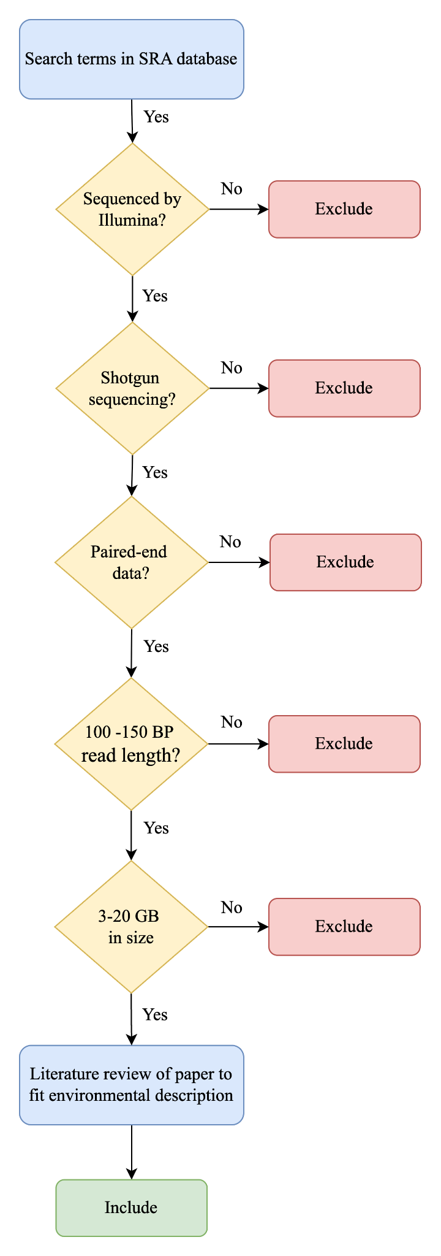
Figure S1: Logic flow diagram for selecting relevant metagenomic samples from the SRA Repository.

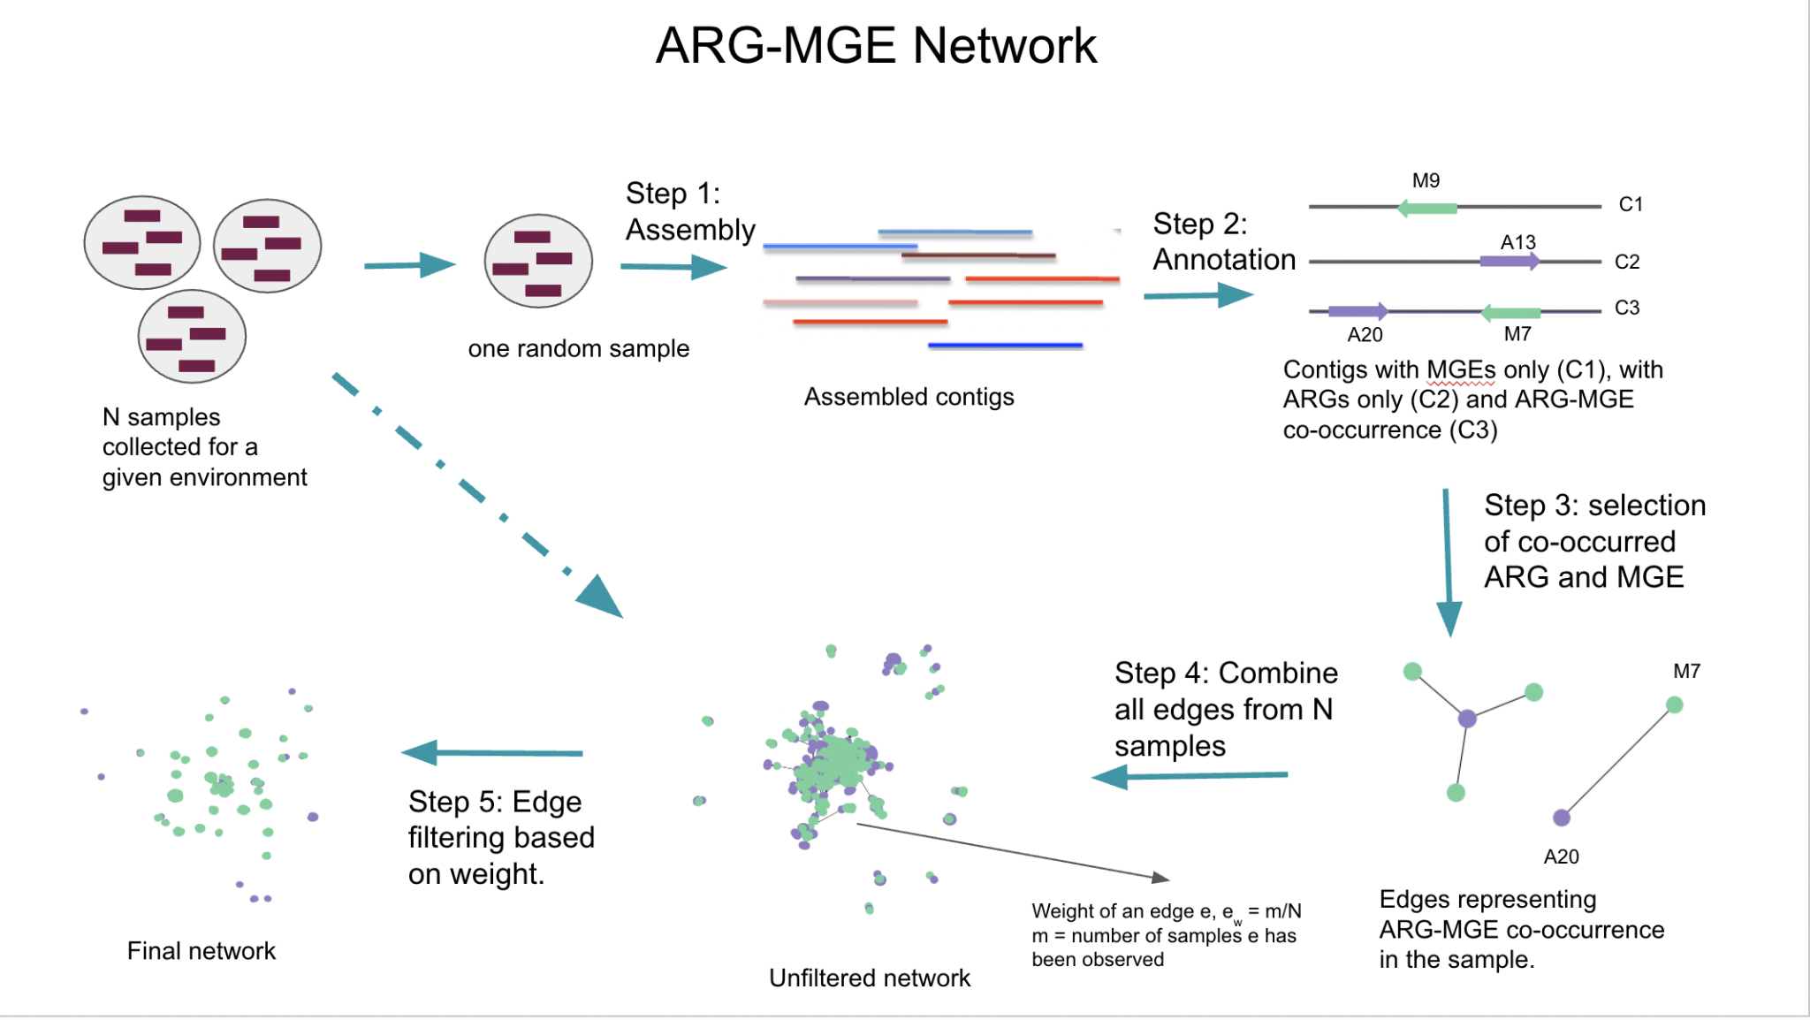
Figure S2: Step-by-step process for constructing an ARG-MGE network from all the available samples for a given environment.

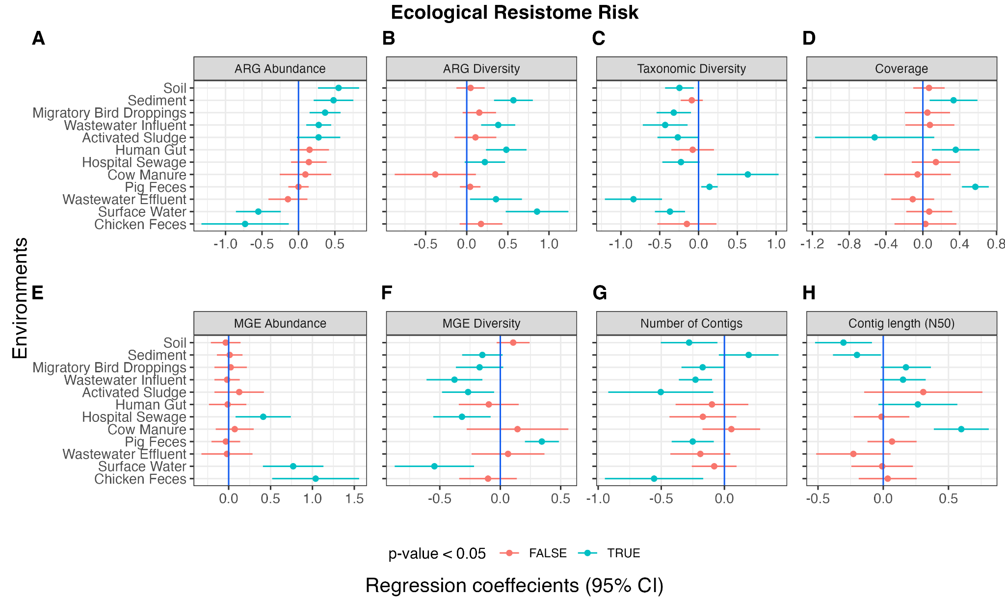
Figure S3: Linear regression coefficient plot showing the impact of (A) ARG abundance, (B) ARG Shannon diversity, (C) taxonomic Shannon diversity, (D) coverage, (E) MGE abundance, (F) MGE Shannon diversity, (G) number of contigs and (H) contig length (N50) on ERR. Regression coefficient in blue indicates statistical significance (p < 0.05) and red indicates non-significance (p ≥ 0.05).

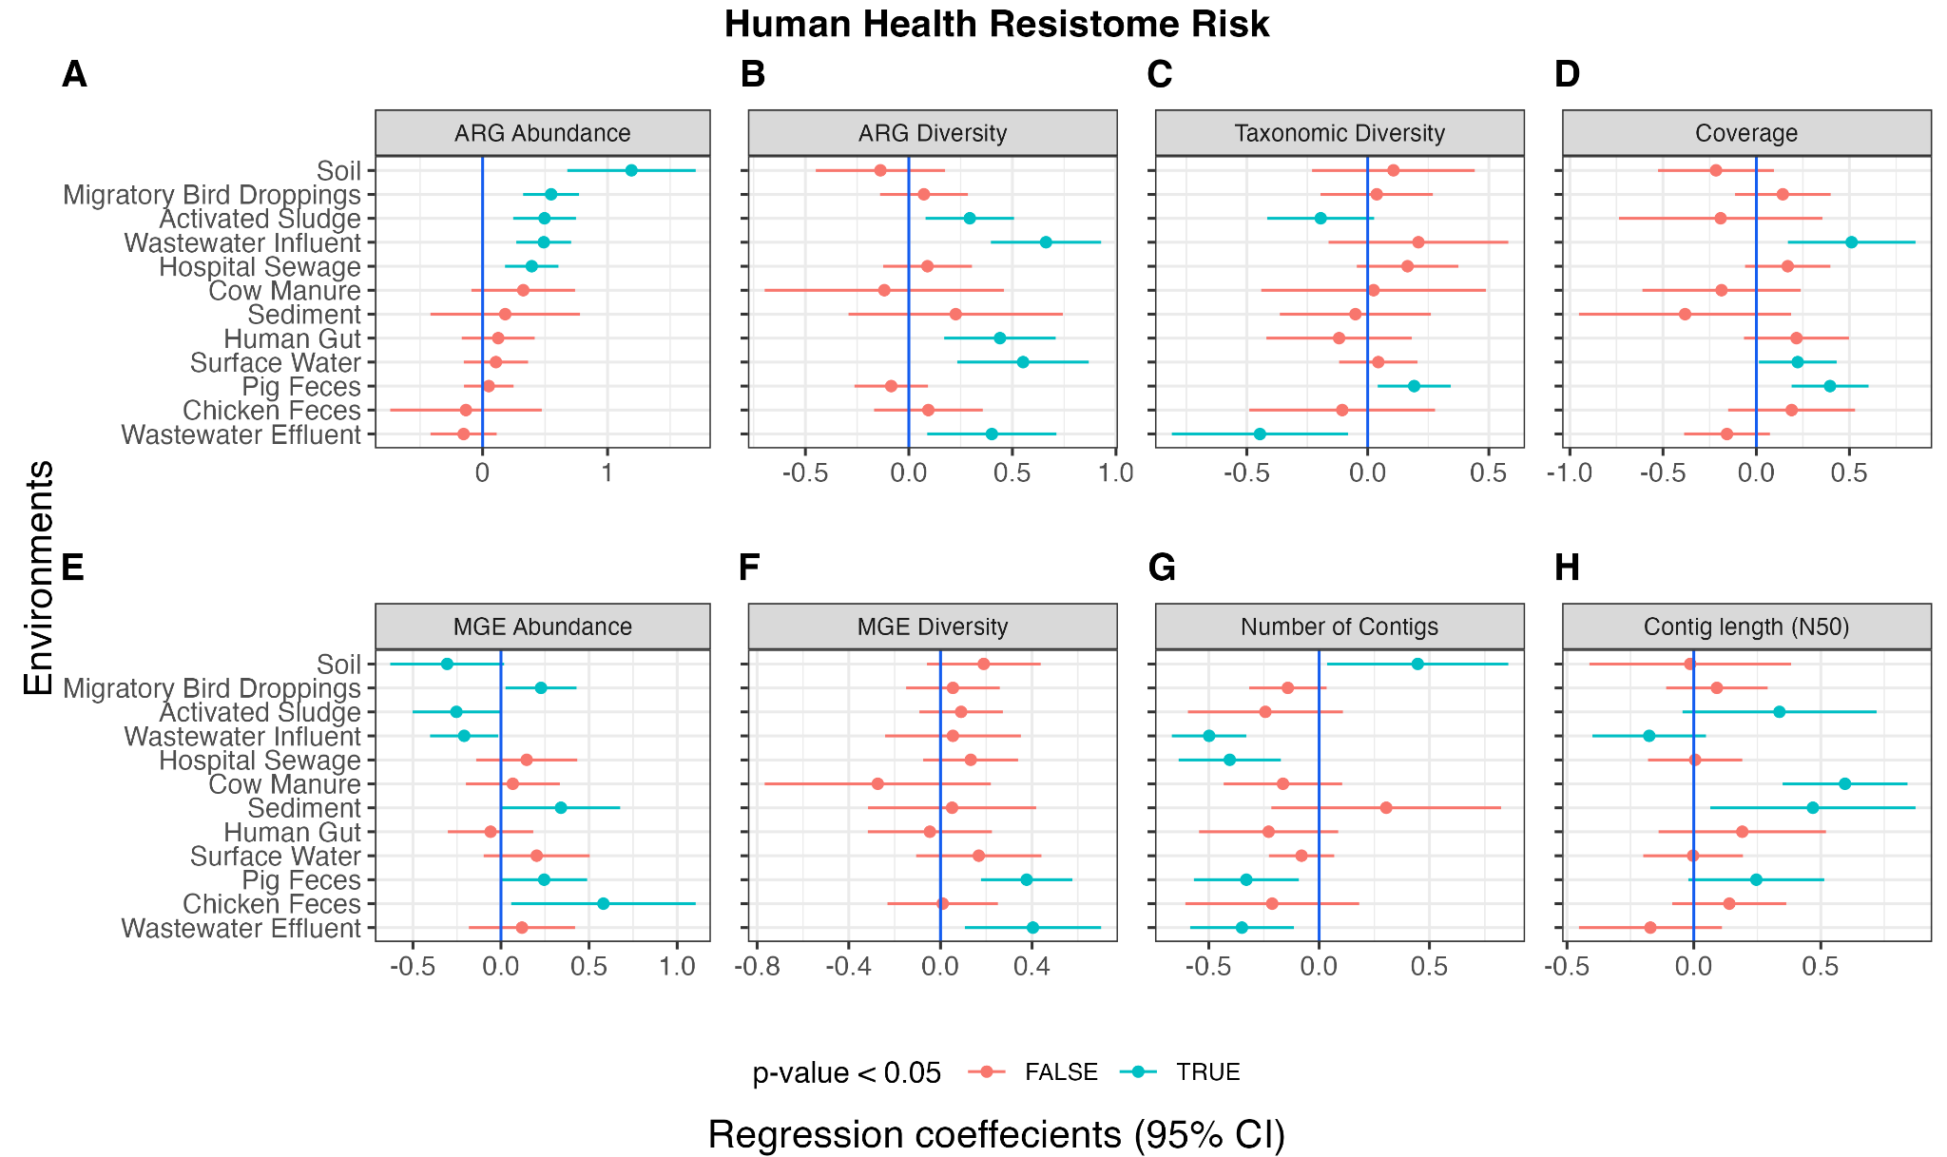
Figure S4: Linear regression coefficient plot showing the impact of (A) ARG abundance, (B) ARG Shannon diversity, (C) taxonomic Shannon diversity, (D) coverage, (E) MGE abundance, (F) MGE Shannon diversity, (G) number of contigs and (H) contig length (N50) on HHRR. Regression coefficient in blue indicates statistical significance (p < 0.05) and red indicates non-significance (p ≥ 0.05).

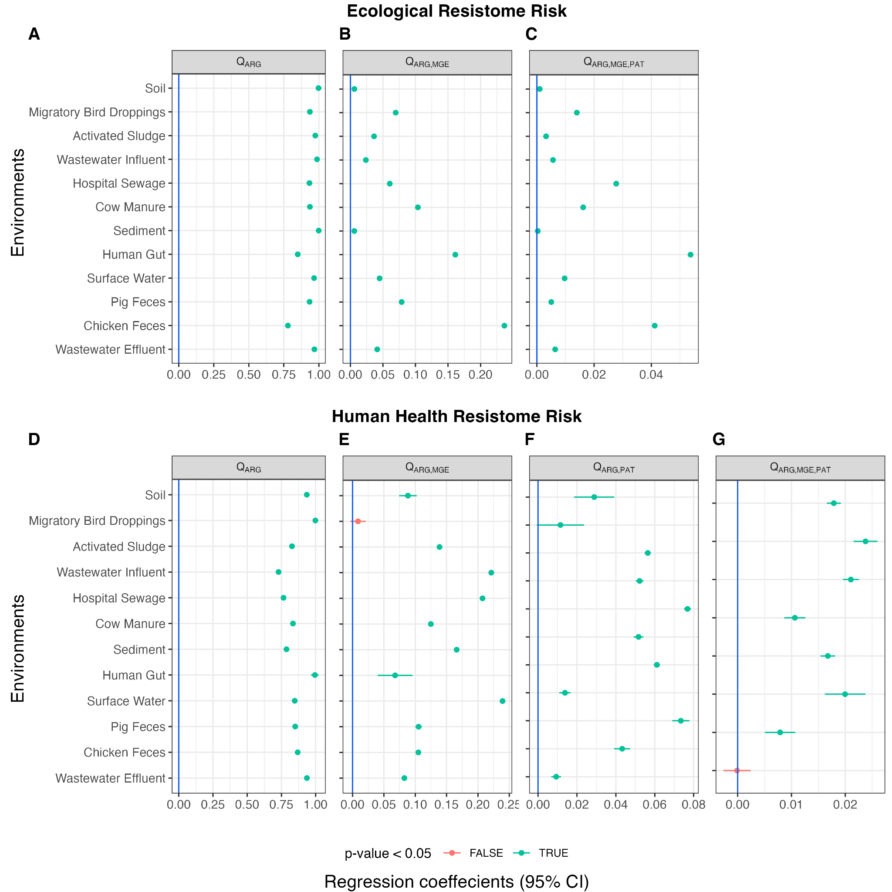
Figure S5. Linear regression coefficient plot showing the impact of (A) Q_{ARG}, (B) Q_{ARG,MGE}, (C) Q_{ARG,MGE,PAT} on ERR. Similarly, the impact of (D) Q_{ARG}, (E) Q_{ARG,MGE}, (F) Q_{ARG,PAT}, (G) Q_{ARG,MGE,PAT} on HHRR. Regression coefficient in blue indicates statistical significance (p < 0.05) and red indicates non-significance (p ≥ 0.05).

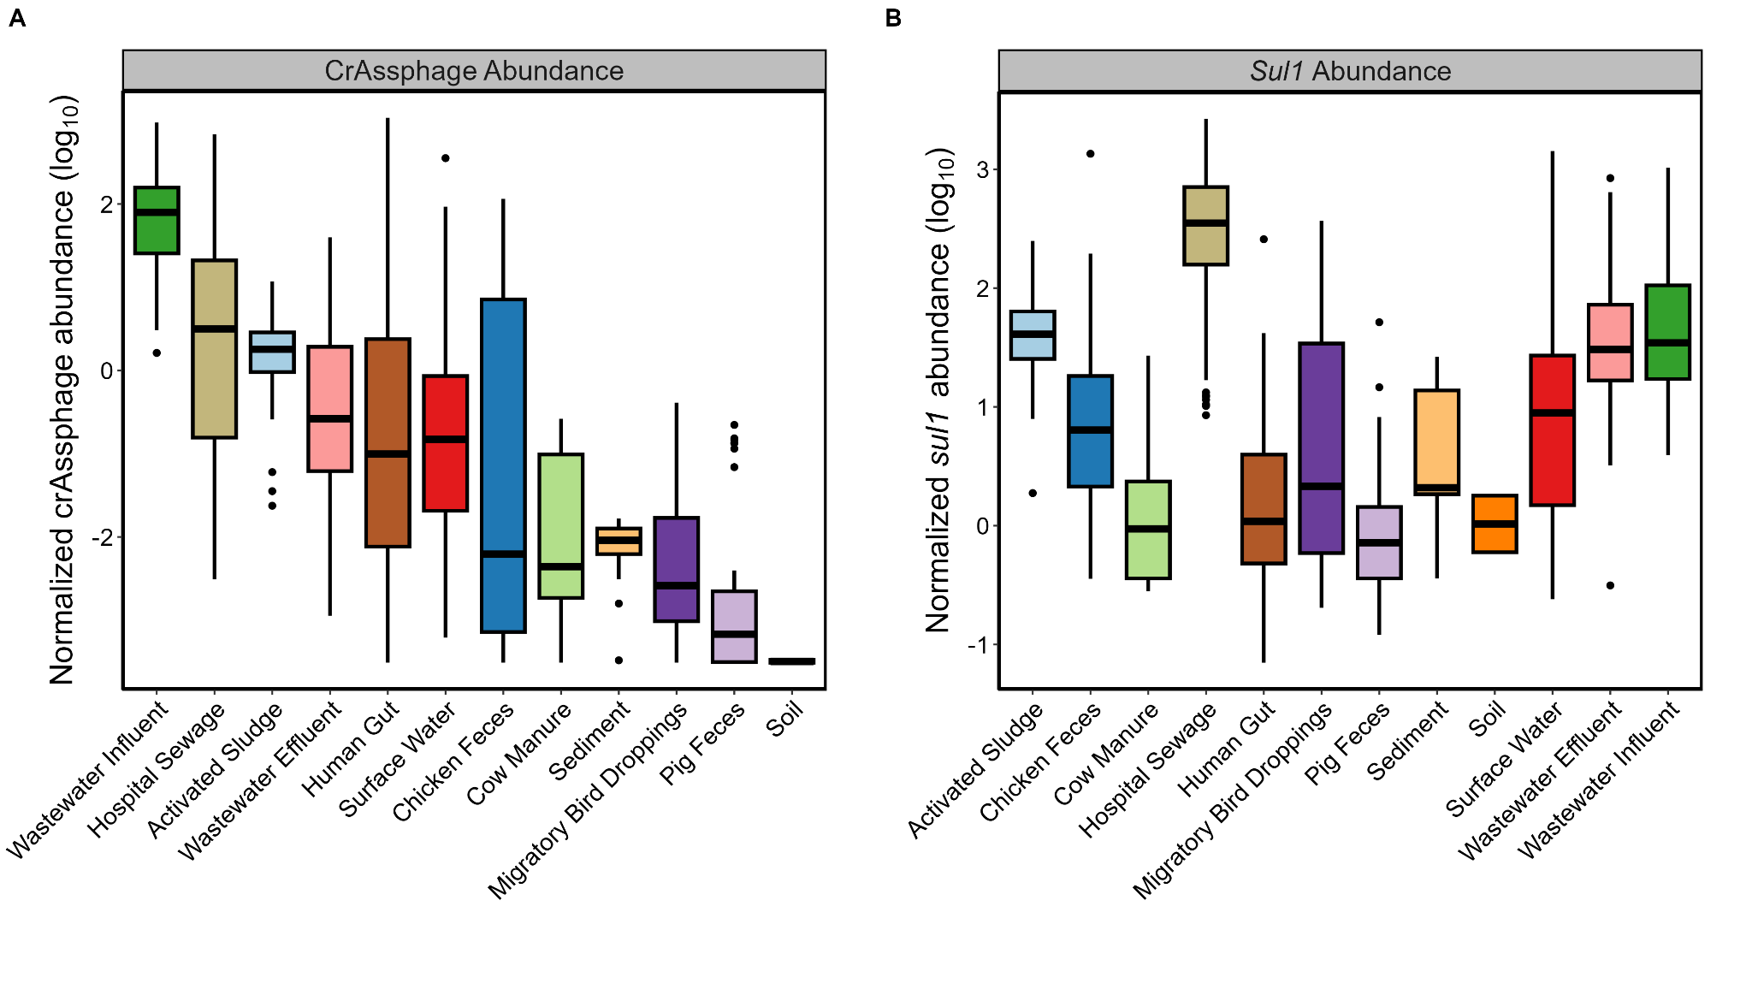Figure S6: Distribution of log-transformed (log₁₀) normalized abundance values across environments for (A) crAssphage and (B) sul1, ranked from highest to lowest average. Samples with zero mapped reads to the crAssphage or sul1 genome were excluded prior to plotting (see Supplementary Table S6 for raw abundance values).

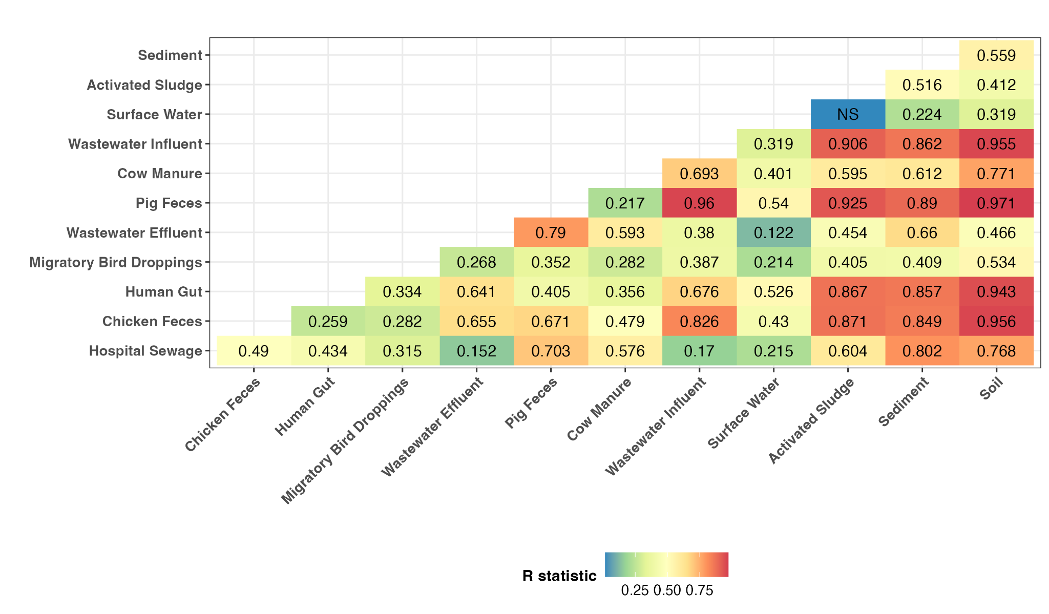
Figure S7: Dissimilarity test for pathogenicity between environments. The numbers represent R values obtained from the ANOSIM test. If p-value ≥ 0.05, the box is marked as NS indicating non-significant.

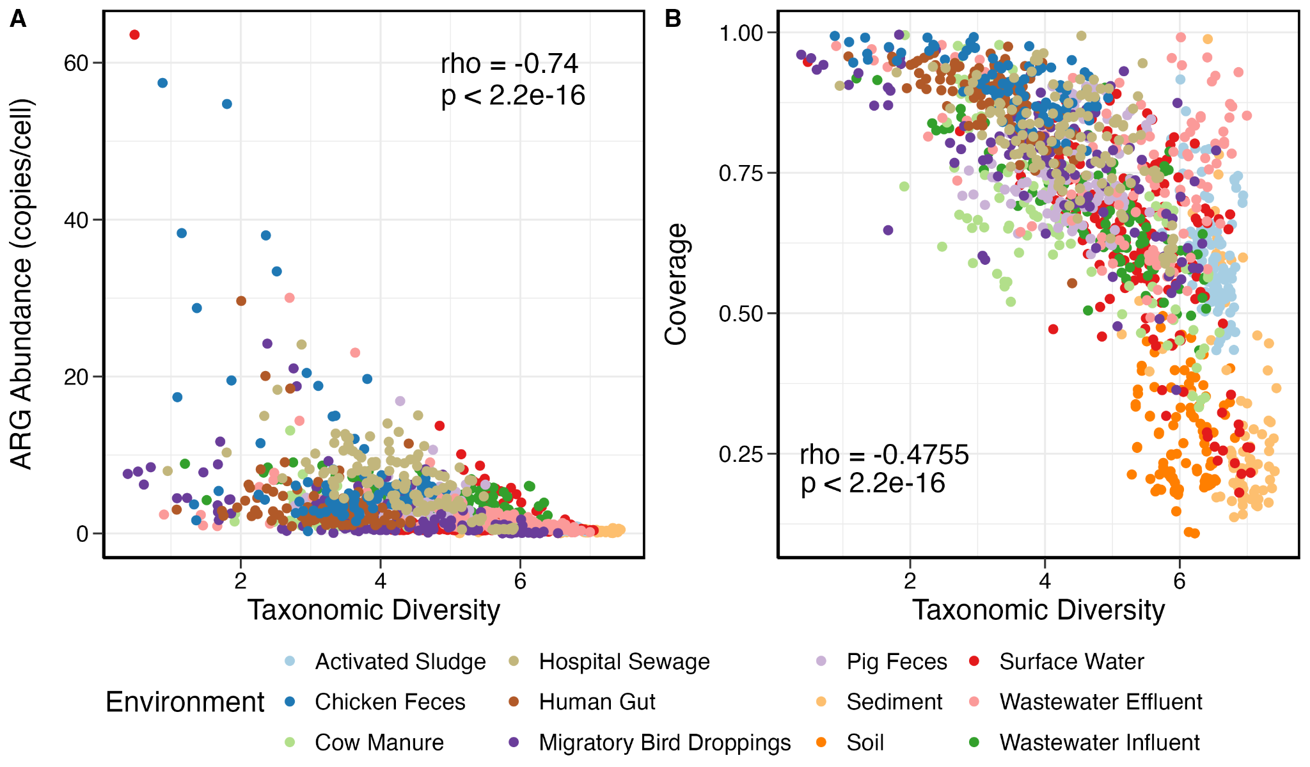
Figure S8: Spearman correlation analysis of taxonomic Shannon diversity values against (A) ARG abundance (copies/cell) and (B) metagenomic coverage across all environments.

