Appendix:
Appendix1: Ethics approval: University of the Witwatersrand: Human research Ethics Committee
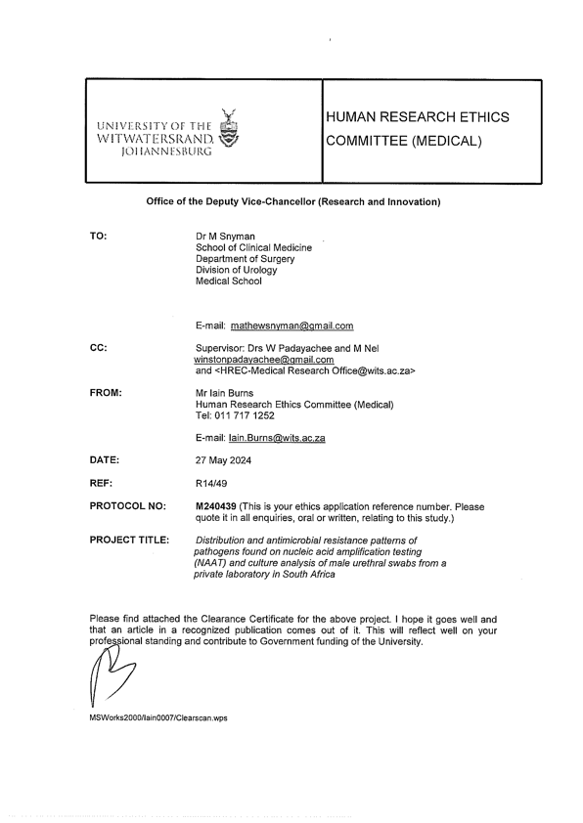

Appendix 2: Lancet Laboratories Data Use Agreement:
