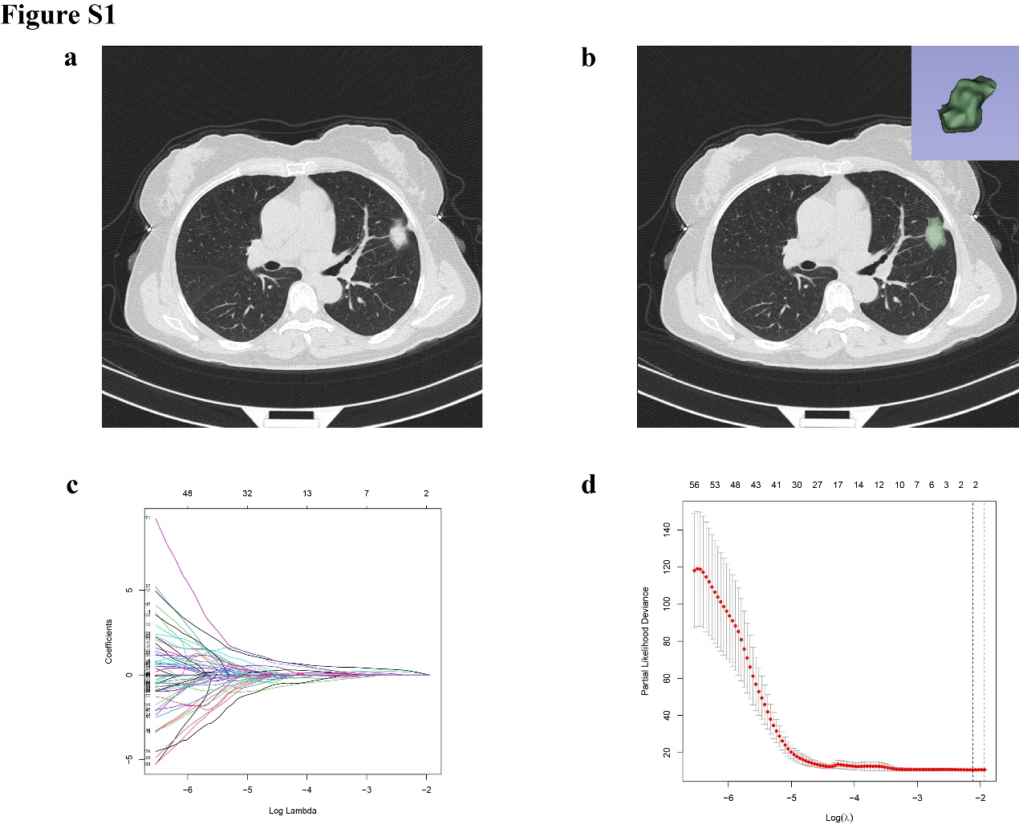
Figure S1| Feature selection and model construction using LASSO regression.
a-b) A total of 758 radiomic features with intra- and inter-observer intraclass correlation coefficients (ICC) greater than 0.75 were initially retained. LASSO regression with 10-fold cross-validation was used to identify the optimal regularization parameter (λ), achieving minimal partial likelihood deviance. c-d) Radiomic features with nonzero coefficients at the optimal λ were selected and incorporated into a logistic regression model to construct the final radiomics signature.

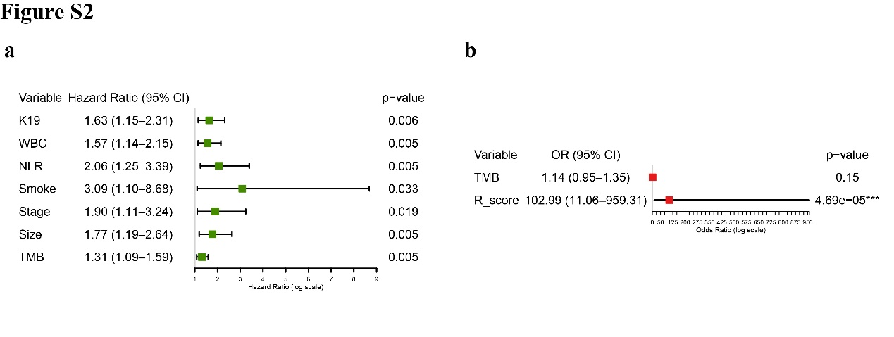
Figure S2| Identification of Clinical and Radiomic Predictive Factors
Univariate (a) and multivariate (b) Cox regression analyses identifying risk factors associated with ctDNA status. Tumor mutational burden (TMB) and the radiomic score (R_score) were ultimately identified as independent predictors, supporting the development of a clinical-radiomics signature.

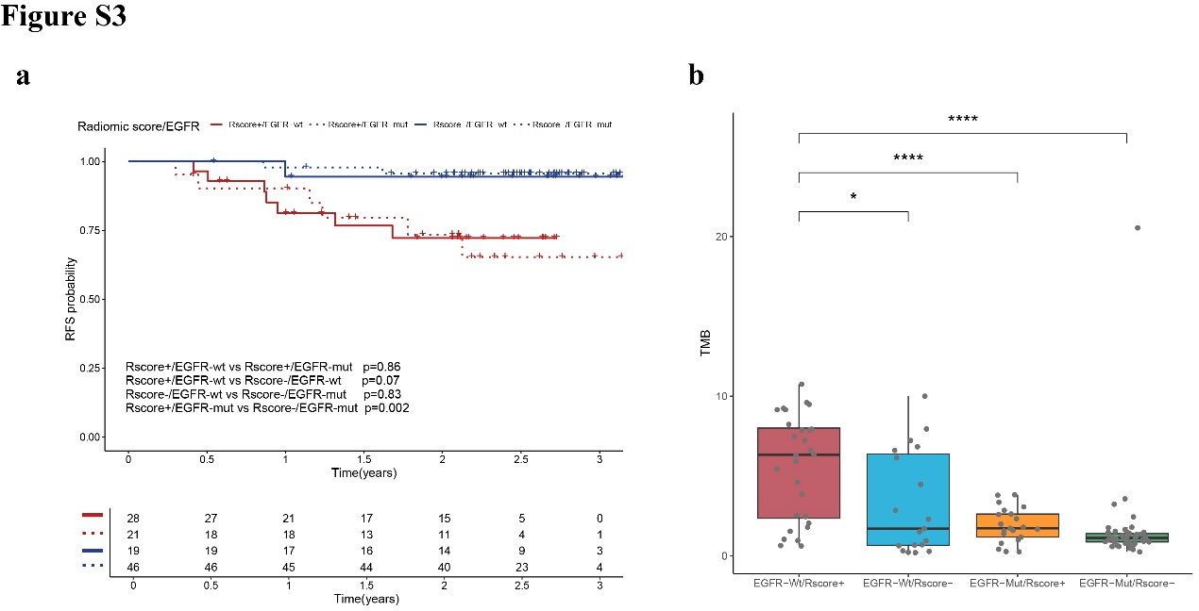
Figure S3| Prognostic relevance of radiomic risk score and EGFR mutation status.
a) RFS shows no significant difference between EGFR-Mut and EGFR-WT groups. b) TMB significantly varies among subgroups, indicating combined Rscore and EGFR status reflects tumor heterogeneity.

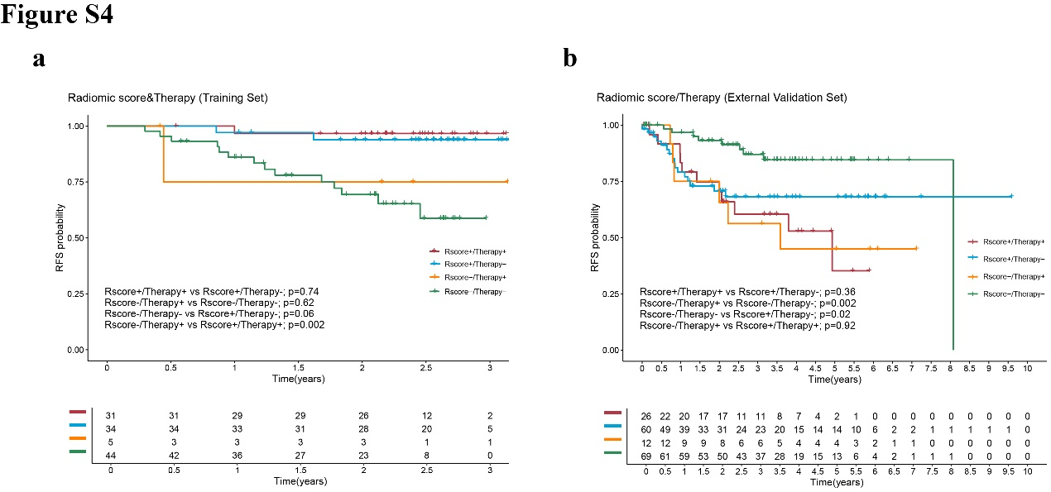
Figure S4| Radiomic Risk Score Predicts Benefit from Adjuvant Therapy.
a) In the training cohort, no significant RFS difference was observed between patients with or without adjuvant therapy (ADT) within the same Rscore group. b) In the external validation cohort, Rscore- patients receiving ADT showed worse RFS than those not receiving ADT, indicating potential overtreatment in low-risk patients.

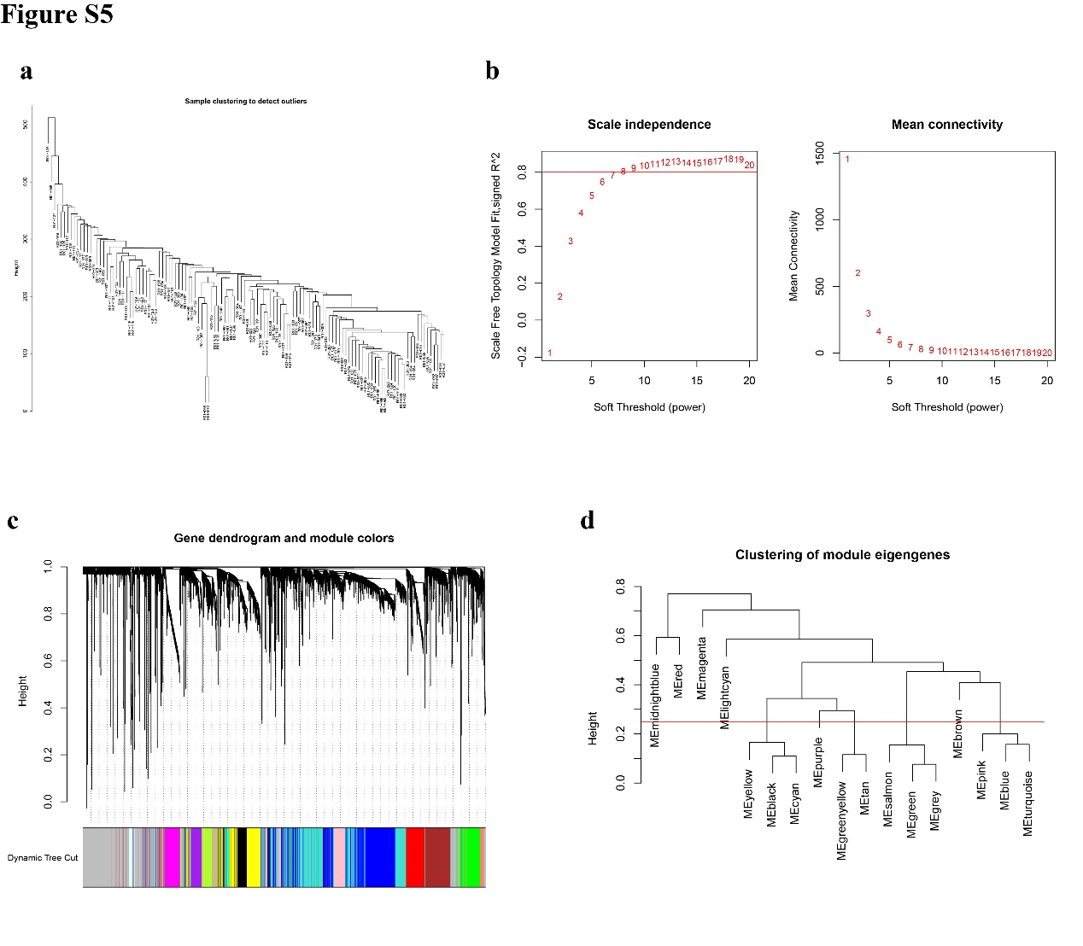
Figure S5| Network construction and module detection using WGCNA.
a) Sample clustering dendrogram used to detect and remove outlier samples prior to network construction. b) Determination of the soft-thresholding power. Left: scale-free topology fit index as a function of power. Right: mean connectivity as a function of power. Power = 6 was selected to construct a scale-free network. c) Gene dendrogram with modules assigned via dynamic tree cutting, resulting in 12 initial modules. d) Dendrogram of module eigengenes showing the clustering of modules based on their eigengene correlation. Modules with similar expression patterns were grouped together for downstream analysis.

