Supporting information

SAHA Counteracts Host Response Alterations Driven by Carbapenem-Resistant Acinetobacter baumannii: A Transcriptomic Deep Dive

Siva Singothu¹, Harshala Maruti Baddi¹, Divyasree Vulli¹, Hoshiyar Singh¹, Santosh Kumar Guru¹, Rajiv Kumar Bandaru², Vasundhra Bhandari^{1#}
¹ Department of Biological Sciences, National Institute of Pharmaceutical Education and Research (NIPER), Hyderabad, Telangana – 500037, India
² Department of General Medicine, ESIC Hospital, Sanath Nagar, Hyderabad, Telangana – 500038, India

# Correspondence
Dr Vasundhra Bhandari
Department of Biological Sciences,
National Institute of Pharmaceutical Education and Research (NIPER), Hyderabad,
Telangana – 500037,
India
Email: vasundhra23@gmail.com

Figure S1: Emap plot of enriched biological processes of DEGs in A. baumannii infected group. Dot size and dot color represent the number of genes in each pathway and their statistical significance (-log₁₀ (p-value)), respectively.

Figure S2: Emap plot of enriched pathways in the presence of SAHA after A. baumannii infection. Dot size and dot color represent the number of genes in each pathway and their statistical significance (-log₁₀ (p-value)), respectively.

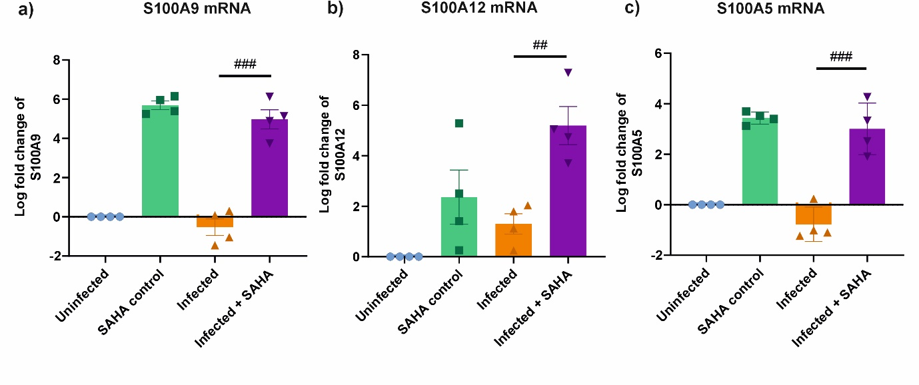
Figure S3: mRNA expression of S100A9 (a), S100A12 (b), and S100A5 (c) after A. baumannii infection in SAHA treated cells. One-way ANOVA was used for statistical analysis with tukey’s multiple comparison test. *p < 0.05, **p < 0.01, and ***p < 0.001.

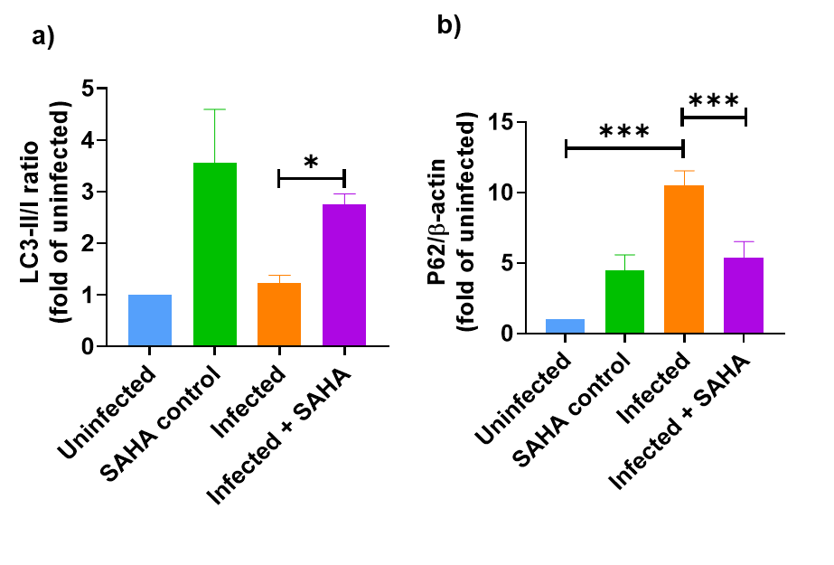
Figure S4: Graphical representation of LC3-I to LC3-II conversion (a) and P62 protein (b). One-way ANOVA was used for statistical analysis with tukey’s multiple comparison test. *p < 0.05, **p < 0.01, and ***p < 0.001.

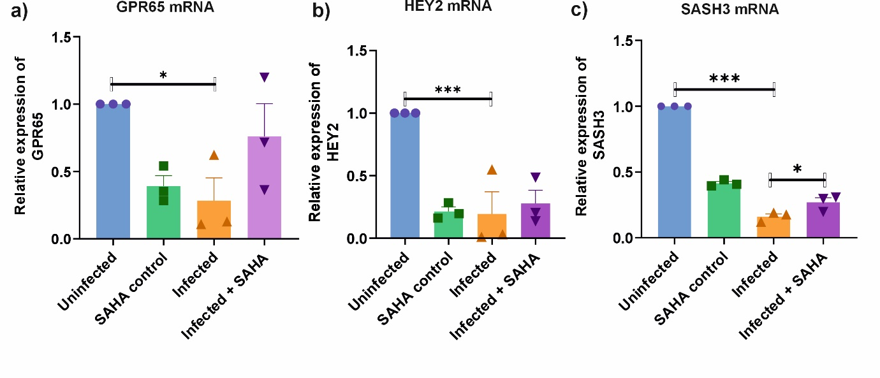
Figure S5: mRNA expression of downregulated DEGs such as GPR65 (a), HEY2 (b), and SASH3 (c) after A. baumannii infection in SAHA treated cells. One-way ANOVA was used for statistical analysis with tukey’s multiple comparison test. *p < 0.05, **p < 0.01, and ***p < 0.001.

Table S1: List of primers
S. No | Gene | Accession Id | Primers | Product length
1 | STX7 | U77942.1 | F: CCCAGTGAACAGCGTCAAAG | 150
1 | STX7 | U77942.1 | R: AGACACTCTGGAACTGGCTC | 150
2 | STX17 | BC101564.1 | F: GGCTTCAAAGTGGCAGGAAT | 224
2 | STX17 | BC101564.1 | R: GAGTGTCCAACAGCAGCAAA | 224
3 | SNAP25 | BT019684.1 | F: CTGATGAGTCGCTGGAAAGC | 158
3 | SNAP25 | BT019684.1 | R: AGCCTCCTTCATGTCTTGGT | 158
4 | GABARAP | AF161586.1 | F: AGGGGTAATGGTGGAGTTGG | 181
4 | GABARAP | AF161586.1 | R: AAGGGATTGCTGGGTTCTGA | 181
5 | YKT6 | U95735.1 | F: AGTCTTGCAGGTGTGGTCAT | 222
5 | YKT6 | U95735.1 | R: ATCTAGTTCGGCCTGCACTT | 222
6 | IL6 | M14584.1 | F: AGTCCTGATCCAGTTCCTGC | 196
6 | IL6 | M14584.1 | R: CTACATTTGCCGAAGAGCCC | 196
7 | TNFα | BC028148.1 | F: GTCAACCTCCTCTCTGCCAT | 188
7 | TNFα | BC028148.1 | R: CCAAAGTAGACCTGCCCAGA | 188
8 | IL10 | M57627.1 | F: GTTCTTTGGGGAGCCAACAG | 222
8 | IL10 | M57627.1 | R: AGTGGTTGGGGAATGAGGTT | 222
9 | GAPDH | AF26108 5.1 | F: GAAGGTGAAGGTCGGAGTCA | 198
9 | GAPDH | AF26108 5.1 | R: TGACAAGCTTCCCGTTCTCA | 198
10 | ATG16L1 | EF079890.1 | F: CGATGCACATGATGGGGAAG | 232
10 | ATG16L1 | EF079890.1 | R: CACAGTCCAGATTCGGCTTG | 232
11 | ATG4C | AJ312234.1 | F: CTGCAGAGTCGGGATGTACA | 168
11 | ATG4C | AJ312234.1 | R: CAGTTCTCAATGTGCAGCCC | 168
12 | ATG9B | BC128587.1 | F: AGGTAGGCAAGGAGAGGAGA | 195
12 | ATG9B | BC128587.1 | R: CTGTCGCCCTTCCATTTAGC | 195
13 | SNAP29 | BC009715.1 | F: GAGACCCCACCTGAACAGAA | 203
13 | SNAP29 | BC009715.1 | R: CGAAGGTGTGGGTTCTTTGG | 203
14 | SNAP47 | BC011145.1 | F: AGACCCAGGAACAGATGAGC | 161
14 | SNAP47 | BC011145.1 | R: GGGGAAGCTGACCAGAATCT | 161
15 | S100A9 | BC047681.2 | F: GGACCTGGACACAAATGCAG | 239
15 | S100A9 | BC047681.2 | R: CCTGGCCTCCTGATTAGTGG | 239
16 | S100A5 | BC093955.1 | F: GGAAGGGACAGAGATCAGGG | 243
16 | S100A5 | BC093955.1 | R: TCCCCAAGACACAGCTCTTT | 243
17 | S100A12 | BC070294.1 | F: CATTCCTGTGCATTGAGGGG | 175
17 | S100A12 | BC070294.1 | R: TGATGGTGTTTGCAAGCTCC | 175
18 | ACOD1 | NM_001258406.2 | F: CCATTGCTGTTTCCCATGCT | 203
18 | ACOD1 | NM_001258406.2 | R: GCTTGGAAGGACTTTTGGGG | 203
19 | IDO1 | M34455.1 | F: TGCAAGAACGGGACACTTTG | 185
19 | IDO1 | M34455.1 | R: CCCTTCATACACCAGACCGT | 185
20 | IL10RA | JN591377.1 | F: CACAATGGCTTCATCCTCGG | 208
20 | IL10RA | JN591377.1 | R: GTTTCACCCGGACACAGAAC | 208
21 | IFNB1 | M28622.1 | F: CTGCAACCTTTCGAAGCCTT | 213
21 | IFNB1 | M28622.1 | R: AAGCCTCCCATTCAATTGCC | 213
22 | CCL3L3 | BT006783.1 | F: CTACACCTCCCGGCAGATTC | 151
22 | CCL3L3 | BT006783.1 | R: ACTGACGTATTTCTGGACCCA | 151

