Distinct pathways, shared risk factors: Leptospirosis and chikungunya at community and city scales in Salvador, Brazil.
Authors:
Argibay, HD.¹²; Timperley, M.³; Krieger, K.³; Eyre, M.⁴; Cardoso, CW.⁵; Palma, FAG.¹; Nery Jr, N.²; Cruz, J.²; Oliveira, D.²; Santana, JO.²; Portilho, MM.²; Lustosa, R.¹; Alzate Lopez, Y.¹; Diggle, PJ.³; Ribeiro, GS.^{2,6}; Ko, AI.⁷; Reis, MG.^{2,6,7}; Jewell, C.³; Begon, M.⁸; Costa, F.¹*; Khalil, H. ⁹*
Extended data
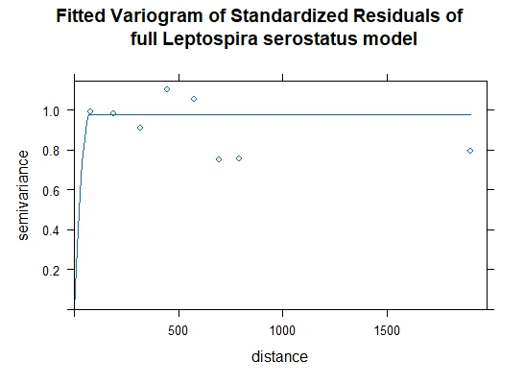
a)

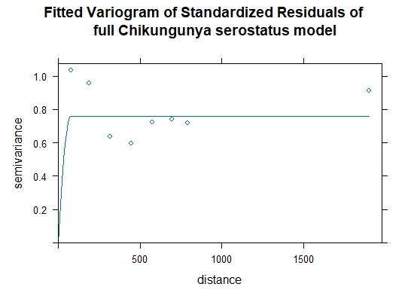
b)

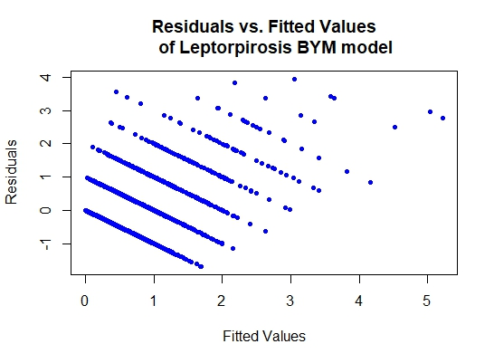
Figure 1: Semivariograms of the standardized residuals of the full model illustrating the spatial autocorrelation range of Leptospira (a) and Chikungunya vírus (b) serostatus among participants across the four studied communities in Salvador, Bahia, Brazil. Semivariogram results for Leptospira: Psill= 0.981, range= 69.31 m and for Chikungunya Psill= 0.758, range= 70.55 m.
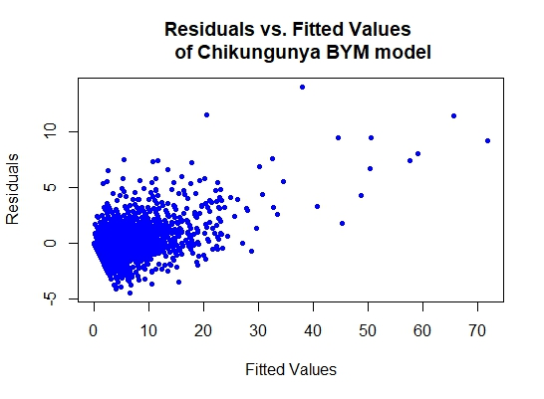
Figure 2: Residuals versus fitted values of Leptospirosis (A) and Chikungunya (B) BYM models
Figure 3: Bivariate map of the census trac predicted incidence over 100,000 habitants by the BYM INLA model for the notified cases of (A) Leptospirosis (period: year 2007 to 2022), (B) Chikungunya (period: year 2015 to 2022), and (C) combined predicted incidences in a bivariate map.

Table 1: Results from the INLA-SPDE model for Leptospirosis case notification incidence for the period 2015-2021.
 | OR (95CI)
Mean group income | 0.71 (0.57 - 0.88)
Land surface temperature | 1.08 (0.92 - 1.26)
Inhabitant density | 0.6 (0.52 - 0.69)
Proportion of house type building | 1.07 (0.92 - 1.25)
Proportion of literates | 0.85 (0.77 - 0.94)
Proportion of vegetation cover | 0.85 (0.74 - 0.97)

