Supplementary

S1 Predictor Variables

S1.1 Bioclimatic variables
Acronym | Definition
BIO-1 | Annual mean temperature
BIO-2 | Mean diurnal temperature
BIO-3 | Isothermality
BIO-4 | Temperature seasonality
BIO-5 | Maximum temperature (TMAX) of the warmest month
BIO-6 | Minimum temperature (TMIN) of the coldest month
BIO-7 | Temperature annual range
BIO-8 | Mean temperature (TMEAN) of the wettest quarter
BIO-9 | Mean temperature (TMEAN) of the wettest quarter
BIO-10 | Mean temperature (TMEAN) of the wettest quarter
BIO-11 | Mean temperature (TMEAN) of the wettest quarter
BIO-12 | Annual precipitation amounts
BIO-13 | Precipitation of the wettest month
BIO-14 | Precipitation of the driest month
BIO-15 | Precipitation seasonality
BIO-16 | Precipitation of the wettest quarter
BIO-17 | Precipitation of the driest quarter
BIO-18 | Precipitation of the warmest quarter
BIO-19 | Precipitation of the coldest quarter

S1.2 Extreme variables
Acronym | Definition
EXV-1 | Number of days with TMIN < -10°C
EXV-2 | Number of days with TMIN > 20°C
EXV-3 | Longest period with TMIN < -10°C
EXV-4 | Longest period with TMIN > 20°C
EXV-5 | Number of days with TMEAN < 0°C
EXV-6 | Number of days with TMEAN > 25°C
EXV-7 | Longest period with TMEAN < 0°C
EXV-8 | Longest period with TMEAN < 25°C
EXV-9 | Number of days with TMAX < 0°C
EXV-10 | Number of days with TMIAX > 37°C
EXV-11 | Longest period with TMAX < 0°C
EXV-12 | Longest period with TMAX < 37°C
EXV-13 | Number of days with PRE < 1mm
EXV-14 | Number of days with PRE > 20mm
EXV-15 | Longest period with PRE > 20mm
EXV-16 | Longest dry period
EXV-17 | Longest wet period
EXV-18 | Precipitation intensity

S1.3 Land-use variables
Acronym | Definition
TBET | Temperate broadleaf evergreen trees
TDT | Temperate deciduous trees
ECT | Evergreen coniferous trees
DCT | Deciduous coniferous trees
CS | Coniferous shrubs
DS | Deciduous shrubs
C3 | C3 grass
C4 | C4 grass
T | Tundra
S | Swamp
NIC | Non-irrigated crops
IC | Irrigated crops
U | Urban
B | Bare

S2 Model evaluation

S2.1 Predictor selection
S2.1.1 Bioclimatic variables
Table S2.1.1: Incorporated bioclimatic predictors (x) for each species and model setup (buffered, sampled, selection). The predictor with the highest contribution is highlighted in red, the number represents the overall rank. Predictors representing the highest interaction are highlighted in green, predictors involved in both (contribution and interaction) are highlighted in purple.
Species | Buffered | Sampled | Selection | BIO1 | BIO2 | BIO3 | BIO4 | BIO5 | BIO6 | BIO7 | BIO8 | BIO9 | BIO10 | BIO11 | BIO12 | BIO13 | BIO14 | BIO15 | BIO16 | BIO17 | BIO18 | BIO19
atroparvus |  |  | I | x | I | x | x | x | x | x | x | I | x | x | x | x | x | x | x | x | C1 | x
atroparvus |  |  | II | x | x | x | x | x | x | x | x | x | x | x | x | x | x | x | x | I | C1 | x
atroparvus |  |  | III | x | x | x | x | x | x | I | x | x | x | x | x | x | x | x | x | x | C1 | x
atroparvus |  |  | IV |  | x | x | x | x |  | x | x |  |  | x |  | x |  | x |  |  | C1 | x
atroparvus | x |  | I | x | x | x | x | x | x | x | x | x | x | x | x | x | x | x | x | x | C1 | x
atroparvus | x |  | II | x | x | x | x | x | x | I | x | x | x | x | x | x | x | x | x | x | C1 | x
atroparvus | x |  | III |  | x | x | x | x | x | x | x | x | x |  | I | x | x | x | x | x | C1 | I
atroparvus | x |  | IV |  | x | x | x | x | x | x | I | x |  |  |  | x |  | x |  |  | C1 | I
atroparvus |  | x | I | x | x | x | x | x | x | x | I | x | x | x | x | x | x | x | x | I | C2 | x
atroparvus |  | x | II | x | x | I | x | x | x | x | x | x | x | x | x | x | x | x | x | x | C2 | x
atroparvus |  | x | III |  | x | x | I | x | x | x | x | x | I | x | x | x | x | x | x | x | C2 | x
atroparvus |  | x | IV |  | x | x | x | x |  | x | x | x |  | x |  |  |  | x |  |  | C1 | x
atroparvus | x | x | I | x | x | I | x | x | x | x | I | x | x | x | x | x | x | x | x | x | C1 | x
atroparvus | x | x | II |  | I | x | x | x | x | x | x | I | x | x | x | x | x | x |  | x | C1 | x
atroparvus | x | x | III |  | x | x | x | x | x | I | x | x |  | x | x | x | x | x |  | x | C1 | x
atroparvus | x | x | IV |  | x | x | x | x | I | x | x |  |  |  |  |  |  | x |  |  | C1 | x
labranchiae |  |  | I | x | x | x | IC2 | x | x | x | x | x | x | x | x | x | x | x | x | x | x | x
labranchiae |  |  | II | x | x | x | IC2 | x | x | x | x | x | x | x | x | x | x | x | x | x | x | x
labranchiae |  |  | III |  |  | x | C2 | x | x | x | x |  |  |  | x |  | x | x |  | x | I | x
labranchiae |  |  | IV |  |  | x | IC2 |  | x | x | x |  |  |  |  |  |  | x |  |  |  | x
labranchiae | x |  | I | x | x | x | C2 | x | x | x | I | x | x | x | x | x | x | x | x | x | x | x
labranchiae | x |  | II | x | x | x | C2 | x | x | x | x | x | I | x | x | x | x | x | x | x | x | x
labranchiae | x |  | III | x | x | x | C2 | x |  | x | x | x | I | x | x | x | x | x | x | x |  | x
labranchiae | x |  | IV |  | x | x | IC2 |  |  | x | x |  |  | x |  |  |  | x | x |  |  | x
labranchiae |  | x | I | x | x | x | IC2 | x | x | x | x | x | x | x | x | x | x | x | x | x | x | x
labranchiae |  | x | II | x | x | x | IC2 | x | x | x | x | x | x | x | x | x | x | x | x | x | x | x
labranchiae |  | x | III |  | x | x | C2 | x | x | x | x | x |  | x | x |  | x | I | x | x | x | x
labranchiae |  | x | IV |  | x | x | IC2 |  |  | x | x |  |  | x |  |  |  | x |  |  |  | x
labranchiae | x | x | I | x | x | x | IC2 | x | x | x | x | x | x | x | x | x | I | x | x | x | x | x
labranchiae | x | x | II | x | x | x | C2 | x | x | x | x | x | x | x | x | x | x | I | x | x | x | x
labranchiae | x | x | III |  | x | x | C2 | x | x | x | I | x | x | x | x | x | x | x |  | x | x | x
labranchiae | x | x | IV |  | x | x | I |  | x | x | x | x |  |  |  | x |  | C2 |  |  |  | x
messeae |  |  | I | x | I | x | x | x | x | x | x | C1 | x | x | x | x | x | x | x | x | x | x
messeae |  |  | II | x | x | x | x | x | x | x | x | C1 | x | x | x | x | x | x | x | x | I | x
messeae |  |  | III | x | x | x | x | x | x | x | x | C1 | I |  | x | x | x | x | x | x | x | x
messeae |  |  | IV |  | I | x | x |  |  | x | x | IC1 |  |  |  |  | x | x |  |  |  | x
messeae | x |  | I | x | I | x | x | x | x | x | x | IC1 | x | x | x | x | x | x | x | x | x | x
messeae | x |  | II | x | x | x | x | x | x | x | x | C1 | x | x | x | x | x | x | x | x | I | x
messeae | x |  | III | x | I | x | x | x | x | x | x | IC1 | x |  | x | x | x | x | x | x | x | x
messeae | x |  | IV |  | x | x | I |  |  | x | x | C1 |  |  |  |  | x | x |  |  |  | x
messeae |  | x | I | x | x | x | x | x | x | x | I | C1 | x | x | x | x | x | x | x | I | x | x
messeae |  | x | II | x | x | x | x | x | x | x | I | C1 | x | x | x | x | x | x | x | x | x | x
messeae |  | x | III | x | x | x | x | x |  | x | x | IC1 | x | x |  |  | x | x |  | x | x | x
messeae |  | x | IV |  | x | x | x | x |  | x | x | C1 |  |  |  |  | x | x |  |  | I | x
messeae | x | x | I | x | x | x | I | x | x | x | x | C1 | x | x | x | x | I | x | x | x | x | x
messeae | x | x | II | x | x | x | x | x | x | x | I | C1 | x | x | x | x | x | x | x | I | x | x
messeae | x | x | III | x | x | x | x | x |  | x | I | C1 | x |  | x |  | x | x |  | x | I | x
messeae | x | x | IV |  | x | x | x |  |  | x | I | C1 |  |  |  |  |  | x |  |  | x | I
sacharovi |  |  | I | x | x | x | x | x | x | I | C1 | x | x | x | x | x | x | x | x | x | x | x
sacharovi |  |  | II | x | x | x | x | x | x | x | C1 | x | x | I | x | x | x | x | x | x | x | x
sacharovi |  |  | III | x | x | I | x | x | x | x | C1 | x | x | x | x |  | x | x | x | x | x | x
sacharovi |  |  | IV |  | x | x | x |  |  | I | C1 |  |  |  |  |  | x | x | x |  |  | x
sacharovi | x |  | I | x | x | x | x | x | x | I | C1 | x | x | x | x | x | x | x | x | x | x | x
sacharovi | x |  | II | x | x | x | x | x | x | x | C1 | x | I | x | x | x | x | x | x | x | x | x
sacharovi | x |  | III | x | x | x | x | x |  | x | IC1 |  | x | x | x |  | x | x |  | x | x | x
sacharovi | x |  | IV |  | x | I | x |  |  | x | IC1 |  |  |  |  |  |  | x |  |  | x | x
sacharovi |  | x | I | x | I | x | x | x | x | x | C1 | x | x | x | x | x | x | x | x | x | x | x
sacharovi |  | x | II | x | x | x | x | x | x | I | C1 | x | x | x | x | x | x | x | x | x | x | x
sacharovi |  | x | III |  | x | x | x | x | I | x | C1 | x | x |  | x | x | x | x | x | x | x | x
sacharovi |  | x | IV |  | x | I | x |  |  | x | IC1 |  |  |  |  |  | x | x | x |  |  | x
sacharovi | x | x | I | x | x | x | x | x | x | x | C1 | x | x | I | x | x | x | x | x | x | x | x
sacharovi | x | x | II | x | x | x | x | x | x | x | IC1 | x | x | x | x | x | x | x | x | x | x | x
sacharovi | x | x | III | x | x | x | x | x | x | x | C1 | x |  | x | x | x | x | x |  | x | x | x
sacharovi | x | x | IV |  | x | x | I |  |  | x | C1 | x |  |  |  |  | x | x |  |  |  | x
sergentii |  |  | I | x | x | x | x | C1 | x | x | x | I | x | x | x | x | x | I | x | x | x | x
sergentii |  |  | II | x | I | x | x | C1 | x | x | x | x | x | x | x | x | x | I | x | x | x | x
sergentii |  |  | III | x | x | x | x | C1 | x | x | x |  |  | x | x | x |  | x | x |  | x | x
sergentii |  |  | IV |  | x | x | x | C1 | I | x | I |  |  |  | x |  |  | x
sergentii | x |  | I | x | x | x | x | x | x | x | x | x | x | x | C1 | x | x | x | x | x | x | x
sergentii | x |  | II | x | x | x | x | C1 | I | x | x | x | x | x | x | x | x | I | x | x | x | x
sergentii | x |  | III | x | x | x | x | C1 | x | x | x |  |  | x | x |  |  | x | x | x | x | x
sergentii | x |  | IV |  | x | x | I | x | x | x | x |  |  |  | IC1 |  |  | x
sergentii |  | x | I | x | x | x | x | x | x | x | x | x | x | x | C1 | x | x | x | x | x | x | x
sergentii |  | x | II | x | x | x | x | C1 | x | x | x | x | x | x | x | x | x | x | x | x | x | x
sergentii |  | x | III | x | x | x | x | x | x | x | x | x | x | x | C1 | x | x | x | x |  | x | x
sergentii |  | x | IV |  | x | x | x | x | x | x | x |  |  |  | IC1 |  |  | x
sergentii | x | x | I | x | x | x | x | x | x | x | x | x | x | x | C1 | x | x | x | x | x | x | x
sergentii | x | x | II | x | x | x | x | C1 | x | x | x | x | x | x | x | x | x | x | x | x | x | x
sergentii | x | x | III | x | x | x | x | x | x | x | x | x | x | x | C1 | x | x | x | x |  | x | x
sergentii | x | x | IV |  | x | x | x | x | x | x | x |  |  |  | IC1 |  |  | x
superpictus |  |  | I | x | x | x | x | x | x | I | C1 | x | x | x | x | x | x | x | x | x | x | x
superpictus |  |  | II | x | x | x | I | x | x | x | IC1 | x | x | x | x | x | x | x | x | x | x | x
superpictus |  |  | III |  | x | x | x | x | x |  | C1 | x |  | x |  | x | x | x | x | x | x | x
superpictus |  |  | IV |  | x | x | x |  |  |  | C1 | x |  |  |  |  |  | x |  |  |  | x
superpictus | x |  | I | x | x | x | x | x | x | I | C1 | x | x | x | x | x | x | x | x | x | x | x
superpictus | x |  | II | x | x | x | I | x | x | x | IC1 | x | x | x | x | x | x | x | x | x | x | x
superpictus | x |  | III |  | x | x | x | x | x |  | C1 | x |  | x |  | x | x | x | x | x | x | x
superpictus | x |  | IV |  | x | x | x |  |  |  | C1 | x |  |  |  |  |  | x |  |  |  | x
superpictus |  | x | I | x | x | x | x | x | x | x | C1 | x | x | x | x | x | x | x | x | x | x | x
superpictus |  | x | II | x | x | x | x | x | x | I | C1 | x | x | x | x | x | x | x | x | x | x | x
superpictus |  | x | III |  | x | x | x | x | x | x | C1 | I |  | x | x |  | x | x | x | x | x | x
superpictus |  | x | IV |  | x | x | x |  |  | x | C1 | I |  |  |  |  |  | x | x |  |  | x
superpictus | x | x | I | x | x | x | x | x | x | x | C1 | x | x | x | x | x | x | x | x | x | x | x
superpictus | x | x | II |  | x | x | x | x | x | x | IC1 | x | x |  | x | x | x | x | x | x | x | I
superpictus | x | x | III |  | x | x | I | x | x |  | IC1 | x |  |  |  | x | x | x | x | x | x | x
superpictus | x | x | IV |  | x | x | x |  |  |  | C1 | x |  |  |  |  | x | x | x |  |  | I

S2.1.2 Extreme variables and absolute humidity
Table S2.1.2: Incorporated extreme predictors (x) for each species and model setup (buffered, sampled, selection). The predictor with the highest contribution is highlighted in red, the number represents the overall rank. Predictors representing the highest interaction are highlighted in green, predictors involved in both (contribution and interaction) are highlighted in purple.
Species | Buffered | Sampled | Selection | EXV1 | EXV2 | EXV3 | EXV4 | EXV5 | EXV6 | EXV7 | EXV8 | EXV9 | EXV10 | EXV11 | EXV12 | EXV13 | EXV14 | EXV15 | EXV16 | EXV17 | EXV18 | AHUM
xtroparvus |  |  | I | x | x | C8 | x | x | x | x | x | x | x | x | x | x | x | x | x | x | x | x
xtroparvus |  |  | II | x | x | C12 | x | x | x | x | x | x | x | x | x | x | x | x | x | x | x | x
xtroparvus |  |  | III |  |  | C4 |  |  |  | x |  |  |  |  |  | x | x | x | x | x | x | x
xtroparvus |  |  | IV |  |  | C4 |  |  |  |  |  |  |  |  |  |  | x |  |  |  |  | I
xtroparvus | x |  | I | x | x | C2 | x | I | x | x | x | x | x | I | x | x | x | x | x | x | x | x
xtroparvus | x |  | II | x | x | C3 | x | x | x | x | x | x |  | x | x | x | x | x | x | x | x | I
xtroparvus | x |  | III |  | x | C4 |  |  |  |  |  |  |  |  |  | x |  |  |  | x | x | x
xtroparvus | x |  | IV |  |  | C3 |  |  |  |  |  |  |  |  |  |  |  |  |  |  | x | x
xtroparvus |  | x | I | x | x | x | x | x | x | C7 | x | x | x | x | x | x | x | x | x | x | x | x
xtroparvus |  | x | II | x | x | C15 | x |  | x | x | x | x | x | x |  | x | x | x | x | x | x | x
xtroparvus |  | x | III | x |  | C12 |  |  | x | x |  |  |  | x |  | x | x | x |  | x | x | x
xtroparvus |  | x | IV |  |  | C10 |  |  |  |  |  |  |  |  |  |  |  |  |  |  | x | I
xtroparvus | x | x | I | x | x | C3 | x | x | x | x | x | x | x | x | x | x | x | x | x | x | x | x
xtroparvus | x | x | II | x |  | C3 | x |  |  |  | x | x |  | x |  | x | x | x | x | x | x | x
xtroparvus | x | x | III |  |  | C3 |  |  |  |  |  |  |  |  |  | x | x | x |  |  | x | x
xtroparvus | x | x | IV |  |  | C3 |  |  |  |  |  |  |  |  |  |  |  |  |  |  | x | I
labranchiae |  |  | I | x | x | x | x | x | x | x | x | x | x | x | x | x | x | C1 | x | x | x | I
labranchiae |  |  | II |  |  |  |  |  |  |  | x |  | x |  |  | x | x | C1 | x | x | x | I
labranchiae |  |  | III |  |  |  |  |  |  |  |  |  |  |  |  | x | x | C1 | x | I | x | x
labranchiae |  |  | IV |  |  |  |  |  |  |  |  |  |  |  |  |  |  | C1 |  | x |  | I
labranchiae | x |  | I | x | x | x | x | x | x | x | x | x | x | x | x | x | x | C1 | x | x | x | I
labranchiae | x |  | II | x | x | x | x | x | x | x | x | x | x | x | x | I | x | C1 | x | x | x | x
labranchiae | x |  | III |  |  |  |  |  |  |  |  |  |  |  |  | I | x | C1 | x | x | x | x
labranchiae | x |  | IV |  |  |  |  |  |  |  |  |  |  |  |  |  |  | C1 |  | x |  | I
labranchiae |  | x | I | x | x | x | x | x | x | x | x | x | x | x | x | x | x | C1 | x | x | x | I
labranchiae |  | x | II |  | x |  | x | x | x |  | x | x | x |  | x | x | x | C1 | x | x | x | I
labranchiae |  | x | III |  |  |  |  |  |  |  |  |  |  |  |  | x | x | C1 | x | x | x | I
labranchiae |  | x | IV |  |  |  |  |  |  |  |  |  |  |  |  |  |  | C1 |  | x |  | I
labranchiae | x | x | I | x | x | x | x | x | x | x | x | x | x | x | x | x | x | C1 | x | x | x | x
labranchiae | x | x | II | x | x | x | x | x | x | x | x | x | x | x | x | x | x | C1 | x | x | x | I
labranchiae | x | x | III |  |  |  |  |  |  |  |  |  |  |  |  | x | x | C1 | x | x | x | I
labranchiae | x | x | IV |  |  |  |  |  |  |  |  |  |  |  |  |  |  | C1 |  | x |  | I
messeae |  |  | I | x | x | x | x | x | x | x | x | x | x | x | x | x | x | x | x | x | IC5 | x
messeae |  |  | II | x | x | x | x | x | x | x | x | x | x | x | x | I | x | x | x | x | C6 | x
messeae |  |  | III | x |  |  |  |  |  | x |  |  |  |  |  | x | x | x |  | x | C6 | x
messeae |  |  | IV | x |  |  |  |  |  |  |  |  |  |  |  |  |  |  |  |  | C5 | x
messeae | x |  | I | x | x | x | x | x | x | x | x | x | x | x | x | x | x | x | x | x | C5 | x
messeae | x |  | II | x | x |  | x | x | x | x | x | x |  | x |  | x | x | x | I | x | C8 | x
messeae | x |  | III |  |  |  |  |  |  | x |  |  |  |  |  | x |  | x | x | x | C6 | x
messeae | x |  | IV |  |  |  |  |  |  |  |  |  |  |  |  |  |  | x |  | I | C6 | x
messeae |  | x | I | x | x | x | x | x | x | x | x | x | x | x | x | x | x | x | x | x | C6 | x
messeae |  | x | II | x |  |  | x |  |  | x | x | x |  | x |  | x | x | x | x | x | C6 | x
messeae |  | x | III |  |  |  |  |  |  |  |  | x |  |  |  | x | x |  |  | x | C5 | x
messeae |  | x | IV |  |  |  |  |  |  |  |  |  |  |  |  |  |  |  |  |  | C5 | x
messeae | x | x | I | x | x | x | x | x | x | x | x | x | x | x | x | x | x | x | x | x | C5 | x
messeae | x | x | II |  | x |  |  | x | x | x |  | x |  | x |  | x | x | x | x | x | C6 | x
messeae | x | x | III |  |  |  |  |  |  |  |  |  |  |  |  | x |  | x | x | x | C6 | x
messeae | x | x | IV |  |  |  |  |  |  |  |  |  |  |  |  |  |  | x |  | x | C5 | x
sacharovi |  |  | I | x | x | x | x | x | x | x | x | x | x | x | x | x | x | x | C8 | x | x | I
sacharovi |  |  | II | x | x | I | x | x | x | x | x | x | x | x | x | x | x | x | C9 | x | x | x
sacharovi |  |  | III | C9 |  | x | x | x |  | x |  |  |  |  |  | x | x |  | x | x | x | x
sacharovi |  |  | IV | x |  |  | x | C9 |  |  |  |  |  |  |  |  |  |  |  |  | x | I
sacharovi | x |  | I | C10 | x | x | x | x | x | x | x | x | x | x | x | x | x | x | x | x | x | I
sacharovi | x |  | II | x | x | x | x | x | x | x | x | x | x | x |  | I | x | x | C10 | x | x | x
sacharovi | x |  | III | x |  | x |  | C8 |  | x |  |  |  | x |  | I | x | x | x |  | x | x
sacharovi | x |  | IV | x |  |  |  | C9 |  |  |  |  |  |  |  |  |  |  |  |  | x | x
sacharovi |  | x | I | x | x | x | x | x | x | x | I | x | x | x | x | x | x | x | C7 | x | x | x
sacharovi |  | x | II | C8 | x |  | x | x | x | x | x | x |  | x |  | x | x | x | x | x | x | I
sacharovi |  | x | III | x |  |  |  | x |  | x |  | C11 |  | x |  | x |  | x | x | x | x | x
sacharovi |  | x | IV |  |  |  |  |  |  |  |  | C9 |  |  |  |  |  |  |  |  | x | x
sacharovi | x | x | I | x | I | x | x | C8 | x | x | x | x | x | x | x | x | x | x | x | x | x | x
sacharovi | x | x | II | C9 | x | x | x | x | x | I | x | x | x | x | x | x | x | x | x | x | x | x
sacharovi | x | x | III | x | x | x | x | x |  | x |  | I |  | x |  | x |  | x | C9 | x | I | x
sacharovi | x | x | IV | x |  |  |  | C9 |  |  |  |  |  |  |  |  |  |  |  |  | x | x
sergentii |  |  | I | x | x | x | x | x | x | x | x | x | C9 | x | x | x | x | x | x | x | x | x
sergentii |  |  | II |  | x |  | x | x | x |  | x |  | C10 |  | x | x |  |  | x | x | x | x
sergentii |  |  | III |  | x |  | x |  | x |  | x |  | C10 |  |  |  |  |  | x | x | x | x
sergentii |  |  | IV |  |  |  |  |  |  |  |  |  |  |  |  |  |  |  |  |  | C11 | x
sergentii | x |  | I | x | x | x | x | x | x | x | x | x | C12 | x | x | x | x | x | x | x | x | I
sergentii | x |  | II |  | x |  | x | x | x |  | x |  | C9 |  | x | x | x |  | x | x | x | x
sergentii | x |  | III |  | x |  | x |  | x |  | x |  | C8 |  | x | x |  |  | x | x | x | x
sergentii | x |  | IV |  |  |  |  |  |  |  |  |  |  |  |  |  |  |  |  |  | C14 | I
sergentii |  | x | I | x | x | x | x | x | x | x | x | x | x | x | x | x | x | x | C10 | x | x | x
sergentii |  | x | II | x | x |  | x | x | x | x | x | x | x |  | x | C14 | x | x | x | x | x | x
sergentii |  | x | III |  | x |  | x |  | x |  | x |  | x |  |  | C12 |  |  | x | x | x | I
sergentii |  | x | IV |  |  |  |  |  |  |  |  |  |  |  |  |  |  |  |  |  | C16 | x
sergentii | x | x | I | x | x | x | x | x | x | x | x | x | x | x | x | x | x | x | C10 | x | x | x
sergentii | x | x | II | x | x |  | x | x | x | x | x | x | x |  | x | C14 | x | x | x | x | x | x
sergentii | x | x | III |  | x |  | x |  | x |  | x |  | x |  |  | C12 |  |  | x | x | I | x
sergentii | x | x | IV |  |  |  |  |  |  |  |  |  |  |  |  |  |  |  |  |  | C16 | x
superpictus |  |  | I | x | x | x | x | x | x | x | x | x | x | x | x | x | x | x | x | x | C6 | I
superpictus |  |  | II | x | x | x | x | x | x | x | x | x | x | x | x | x | x | x | x | x | C5 | x
superpictus |  |  | III | x |  |  |  | x |  | x | I | x |  |  |  | x | x | x | x | x | C6 | x
superpictus |  |  | IV |  |  |  |  | C8 |  |  |  |  |  |  |  |  |  |  |  |  |  | x
superpictus | x |  | I | x | x | x | x | x | x | x | x | x | x | x | x | x | x | x | x | x | C6 | I
superpictus | x |  | II | x | x | x | x | x | x | x | x | x | x | x | x | x | x | x | x | x | C5 | x
superpictus | x |  | III | x |  |  |  | x |  | x | I | x |  |  |  | x | x | x | x | x | C6 | x
superpictus | x |  | IV | x |  |  |  | C8 |  |  |  |  |  |  |  |  |  |  |  |  |  | x
superpictus |  | x | I | x | I | x | x | x | x | x | x | x | x | x | x | x | x | x | x | x | C5 | x
superpictus |  | x | II |  |  |  | x | x |  | x |  |  | x | x |  | x | x | x | x | x | C5 | x
superpictus |  | x | III |  |  |  |  | IC5 |  | x |  |  |  |  |  | x | x | x |  | x | x | I
superpictus |  | x | IV |  |  |  |  | IC4 |  |  |  |  |  |  |  |  |  |  |  |  | x | x
superpictus | x | x | I | x | x | x | x | x | x | x | x | x | x | x | x | x | x | x | x | x | C5 | x
superpictus | x | x | II | x | x |  | x | x |  |  |  |  | x | x |  | x | x | x | x | x | C5 | x
superpictus | x | x | III |  | x |  |  | x |  |  |  |  |  |  |  | x | x | x |  | x | C5 | x
superpictus | x | x | IV |  | x |  |  | x |  |  |  |  |  |  |  |  |  |  |  |  | IC4 | x

S2.1.3 Land-use variables
Table S2.1.3: Incorporated land-use predictors (x) for each species and model setup (buffered, sampled, selection). The predictor with the highest contribution is highlighted in red, the number represents the overall rank. Predictors representing the highest interaction are highlighted in green, predictors involved in both (contribution and interaction) are highlighted in purple.
Species | Buffered | Sampled | Selection | TBET | TDT | ECT | DCT | CS | DS | C3 | C4 | T | S | NIC | IC | U | B
atroparvus |  |  | I | x | x | x | x | x | x | x | x | x | x | x | x | x | C3
atroparvus |  |  | II | I | x | x |  | x | x | x | x |  | x | x | x | x | C2
atroparvus |  |  | III | x | x | x |  | x | x | x | x |  | x | I | x | x | C3
atroparvus |  |  | IV | I | x | x |  | x | x | x | x |  | x | x | x | x | C2
atroparvus | x |  | I | x | x | x | x | x | x | x | x | x | x | x | x | x | C4
atroparvus | x |  | II | x | x | x | x | x | x | x | x |  | x | x | x | x | C2
atroparvus | x |  | III | x | x | x | x | x | x | x | x |  | x | x | x | x | C3
atroparvus | x |  | IV | x | x | x | x | x | x | x | x |  | x | x | x | x | C2
atroparvus |  | x | I | x | x | x | x | x | x | x | x | x | x | x | x | x | C1
atroparvus |  | x | II | x | x | x |  | x | I | x | x |  |  | x | x | x | C1
atroparvus |  | x | III | x | x | x |  | x | x | x | x |  |  | x | x | x | C1
atroparvus |  | x | IV | I | x | x |  | x | x | x | x |  |  | x | x | x | C2
atroparvus | x | x | I | x | x | x | x | x | x | x | x | x | x | x | x | x | C2
atroparvus | x | x | II | x | x | x |  | x | x | x | x |  | x | x | x | x | C2
atroparvus | x | x | III | x | x | x |  | x | I | x | x |  | x | x | x | x | C2
atroparvus | x | x | IV | x | x | x |  | x | x | x | x |  | x | x | x | x | C2
labranchiae |  |  | I | C3 | x | x | x | x | x | x | x | x | x | x | x | x | x
labranchiae |  |  | II | C5 | x | x |  | x | x | x | x |  |  | x | x | x | x
labranchiae |  |  | III | C4 | x | x |  | x | x | x | x |  |  | x | x | x | x
labranchiae |  |  | IV | C3 | x | x |  | x | x | x | x |  |  | x | x | x | x
labranchiae | x |  | I | C3 | x | x | x | x | x | x | x | x | x | x | x | x | x
labranchiae | x |  | II | C3 | x | x |  | x | x | x | x | x |  | x | x | x | x
labranchiae | x |  | III | C4 | x | x |  | x | x | x | x | x |  | x | x | x | x
labranchiae | x |  | IV | C3 | x | x |  | x | x | x | x | x |  | x | x | x | x
labranchiae |  | x | I | C4 | x | x | x | x | x | x | x | x | x | x | x | x | x
labranchiae |  | x | II | C4 | x | x |  | x | x | x | x |  |  | x | x | x | x
labranchiae |  | x | III | C4 | x | x |  | x | x | x | x |  |  | x | x | x | x
labranchiae |  | x | IV | C4 | x | x |  | x | x | x | x |  |  | x | x | x | x
labranchiae | x | x | I | C4 | x | x | x | x | x | x | x | x | x | x | x | x | x
labranchiae | x | x | II | C4 | x | x |  | x | x | x | x | x | x | x | x | x | x
labranchiae | x | x | III | C4 | x | x |  | x | x | x | x | x | x | x | x | x | x
labranchiae | x | x | IV | C4 | x | x |  | x | x | x | x | x | x | x | x | x | x
messeae |  |  | I | x | x | x | x | x | x | x | x | x | x | x | x | x | C4
messeae |  |  | II | x | x | x | x | x | x | x | x |  | x | x | x | x | C4
messeae |  |  | III | x | x | I | x | x | x | x | x |  | x | x | x | x | C4
messeae |  |  | IV | x | x | x | x | x | x | x | x |  | x | x | x | x | C6
messeae | x |  | I | x | x | x | x | x | x | x | x | x | x | x | x | x | C4
messeae | x |  | II | x | x | x | x | x | x | x | x |  | x | x | x | x | C4
messeae | x |  | III | x | x | x | x | x | x | x | x |  | x | x | x | x | C8
messeae | x |  | IV | x | x | x | x | x | x | x | x |  | x | x | x | x | C4
messeae |  | x | I | x | x | x | x | x | x | x | x | x | x | x | x | x | C2
messeae |  | x | II | x | x | x |  |  | x | I | x |  | x | x | x | x | C2
messeae |  | x | III | x | x | x |  |  | x | x | I |  | x | x | x | x | C2
messeae |  | x | IV | x | x | I |  |  | x | x | x |  | x | x | x | x | C2
messeae | x | x | I | x | x | x | x | x | x | x | x | x | x | x | x | x | C2
messeae | x | x | II | x | x | x | x | x | x | x | x |  | x | x |  | x | C2
messeae | x | x | III | x | x | x | x | x | x | x | x |  | x | x |  | x | C2
messeae | x | x | IV | x | x | x | x | x | x | x | x |  | x | x |  | x | C2
sacharovi |  |  | I | x | x | x | x | x | x | x | C2 | x | x | x | x | x | x
sacharovi |  |  | II | x | x | x |  | x | x | x | C3 |  |  | x | x | x | x
sacharovi |  |  | III | x | x | x |  | I | x | x | x |  |  | x | C3 | x | x
sacharovi |  |  | IV | x | x | x |  | x | x | x | C4 |  |  | x | x | x | x
sacharovi | x |  | I | x | x | x | x | x | x | x | C3 | x | x | x | x | x | x
sacharovi | x |  | II | x | x | x | x | x | x | x | C3 |  |  | x | x | x | x
sacharovi | x |  | III | x | x | x | x | x | x | x | C2 |  |  | x | x | x | x
sacharovi | x |  | IV | x | x | x | x | x | x | x | C3 |  |  | x | x | x | x
sacharovi |  | x | I | x | x | x | x | x | x | x | C3 | x | x | x | x | x | x
sacharovi |  | x | II |  | x | x |  | x | x | x | C3 |  |  | x | x | x | x
sacharovi |  | x | III |  | x | x |  | x | x | I | C3 |  |  | x | x | x | x
sacharovi |  | x | IV |  | x | x |  | x | x | x | C3 |  |  | x | x | x | x
sacharovi | x | x | I | x | x | x | x | x | x | x | C3 | x | x | x | x | x | x
sacharovi | x | x | II | x | x | x | x | x | x | x | C3 |  | x | x | x | x | x
sacharovi | x | x | III | x | x | x | x | x | x | x | C3 |  | x | x | x | x | x
sacharovi | x | x | IV | I | x | x | x | x | x | x | C3 |  | x | x | x | x | x
sergentii |  |  | I | x | x | x | x | x | x | x | x | x | x | x | x | x | C6
sergentii |  |  | II | x | x | x |  | x | x | x | x |  |  | x | x | x | C5
sergentii |  |  | III | x | x | x |  | I | x | x | x |  |  | I | x | x | C6
sergentii |  |  | IV | x | x | x |  | x | x | x | x |  |  | x | x | x | C4
sergentii | x |  | I | x | x | x | x | x | x | x | x | x | x | x | x | I | C6
sergentii | x |  | II | x | x | x |  | x | x | x | x |  |  | x | x | x | C8
sergentii | x |  | III | x | x | x |  | x | x | x | x |  |  | x | x | I | C6
sergentii | x |  | IV | x | x | x |  | x | x | x | x |  |  | x | x | x | C4
sergentii |  | x | I | x | x | x | x | I | x | x | x | x | x | I | x | x | C5
sergentii |  | x | II | x | x | x |  | x | x | I | x | x | x | x | x | x | IC5
sergentii |  | x | III | x | x | x |  | I | x | x | x |  |  | x | x | x | C5
sergentii |  | x | IV | x | x | x |  | I | x | x | x |  |  | x | x | x | C4
sergentii | x | x | I | x | x | x | x | I | x | x | x | x | x | I | x | x | C5
sergentii | x | x | II | x | x | x |  | x | x | I | x |  |  | x | x | x | IC5
sergentii | x | x | III | x | x | x |  | I | x | x | x |  |  | x | x | x | C5
sergentii | x | x | IV | x | x | x |  | I | x | x | x |  |  | x | x | x | C4
superpictus |  |  | I | x | x | x | x | x | C10 | x | x | x | x | x | x | x | x
superpictus |  |  | II | x | x | x |  | x | x | x | C12 |  | x | x | x | x | I
superpictus |  |  | III | x | x | x |  | x | x | x | C12 |  | x | x | x | x | I
superpictus |  |  | IV | x | x | x |  | x | C9 | x | x |  | x | I | x | x | x
superpictus | x |  | I | x | x | x | x | x | C10 | x | x | x | x | x | x | x | x
superpictus | x |  | II | x | x | x |  | x | x | x | C12 |  | x | x | x | x | x
superpictus | x |  | III | x | x | x |  | x | x | x | C12 |  | x | x | x | x | I
superpictus | x |  | IV | x | x | x |  | x | C9 | x | x |  | x | I | x | x | I
superpictus |  | x | I | x | x | x | x | x | x | x | C9 | x | x | I | x | x | x
superpictus |  | x | II | x | x | x |  | x | x | x | C8 |  |  | x | x | x | x
superpictus |  | x | III | x | x | x |  | x | x | x | C9 |  |  | x | x | x | x
superpictus |  | x | IV | x | x | x |  | x | x | x | C10 |  |  | x | x | x | x
superpictus | x | x | I | x | x | x | x | x | x | x | C9 | x | x | I | I | x | x
superpictus | x | x | II | x | x | x |  | x | x |  | C11 |  |  | x | x | x | x
superpictus | x | x | III | x | x | x |  | x | x |  | C9 |  |  | x | x | x | x
superpictus | x | x | IV | x | x | x |  | x | x |  | C10 |  |  | x | x | x | x

S2.2 Skills and Scores
S2.2.1 An. atroparvus
Table S2.2.1: Skill, transferability and score for each model run of An. atroparvus. Skill is described by the True Skill Statistics (TSS), the Area Under the Curve (AUC; spatial sorting bias removed AUC.SSB), Cohens Kappa (KAPPA; spatial sorting bias removed KAPPA.SSB), Root Mean Squared Error (RMSE), Mean Square Error Skill Score (MSESS), Brier Skill (BS) and Brier Skill Score (BSS). The transferability is represented by the Area of Applicability (AoA). The overall score (SCORE) represents the relationship between skill and transferability. The best model setup is highlighted in red.
Species | Buffered | Sampled | Selection | TSS | AUC | KAPPA | AUC.SSB | KAPPA.SSB | RMSE | MSESS | BS | BSS | AoA | SCORE
atroparvus |  |  | I | .8991 | .9847 | .8577 | .8475 | .5488 | .1628 | .1323 | .0549 | .7533 | .8492 | .8069
atroparvus |  |  | II | .8973 | .9847 | .8581 | .8500 | .5518 | .1608 | .1306 | .0575 | .7416 | .7874 | .7739
atroparvus |  |  | III | .8970 | .9848 | .8573 | .8466 | .5434 | .1610 | .1307 | .0578 | .7403 | .8473 | .8033
atroparvus |  |  | IV | .8933 | .9838 | .8559 | .8429 | .5295 | .1629 | .1355 | .0579 | .7398 | .7982 | .7752
atroparvus | x |  | I | .8649 | .9669 | .7971 | .7615 | .4118 | .2474 | .2491 | .0822 | .6306 | .7417 | .7054
atroparvus | x |  | II | .8627 | .9663 | .7957 | .7557 | .4037 | .2464 | .2483 | .0847 | .6194 | .8798 | .7779
atroparvus | x |  | III | .8606 | .9667 | .7917 | .7628 | .4114 | .2452 | .2481 | .0864 | .6117 | .8884 | .7833
atroparvus | x |  | IV | .8602 | .9643 | .7913 | .7473 | .3900 | .2458 | .2490 | .0866 | .6108 | .7335 | .6940
atroparvus |  | x | I | .8925 | .9844 | .8567 | .8543 | .5566 | .1607 | .1314 | .0584 | .7376 | .3848 | .6025
atroparvus |  | x | II | .8953 | .9846 | .8572 | .8489 | .5464 | .1615 | .1308 | .0590 | .7349 | .3387 | .5860
atroparvus |  | x | III | .8970 | .9845 | .8574 | .8463 | .5433 | .1615 | .1304 | .0565 | .7461 | .4026 | .6070
atroparvus |  | x | IV | .8901 | .9839 | .8554 | .8431 | .5384 | .1623 | .1342 | .0619 | .7218 | .3837 | .5947
atroparvus | x | x | I | .8658 | .9673 | .7984 | .7646 | .4124 | .2412 | .2392 | .0819 | .6320 | .7715 | .7219
atroparvus | x | x | II | .8633 | .9665 | .7947 | .7501 | .3891 | .2413 | .2403 | .0855 | .6158 | .7584 | .7084
atroparvus | x | x | III | .8652 | .9653 | .7967 | .7426 | .3749 | .2432 | .2417 | .0828 | .6279 | .7577 | .7071
atroparvus | x | x | IV | .8631 | .9653 | .7941 | .7447 | .3808 | .2432 | .2428 | .0834 | .6252 | .7870 | .7233

S2.2.2 An. labranchiae
Table S2.2.2: Skill, transferability and score for each model run of An. labranchiae. Skill is described by the True Skill Statistics (TSS), the Area Under the Curve (AUC; spatial sorting bias removed AUC.SSB), Cohens Kappa (KAPPA; spatial sorting bias removed KAPPA.SSB), Root Mean Squared Error (RMSE), Mean Square Error Skill Score (MSESS), Brier Skill (BS) and Brier Skill Score (BSS). The transferability is represented by the Area of Applicability (AoA). The overall score (SCORE) represents the relationship between skill and transferability. The best model setup is highlighted in red.
Species | Buffered | Sampled | Selection | TSS | AUC | KAPPA | AUC.SSB | KAPPA.SSB | RMSE | MSESS | BS | BSS | AoA | SCORE
labranchiae |  |  | I | .9712 | .9944 | .7092 | .7750 | .4420 | .1098 | .1962 | .0183 | .6583 | .9180 | .8213
labranchiae |  |  | II | .9689 | .9942 | .6922 | .7827 | .4246 | .1100 | .1984 | .0216 | .5967 | .9217 | .8155
labranchiae |  |  | III | .9668 | .9939 | .6974 | .7746 | .4256 | .1115 | .2034 | .0208 | .6117 | .9230 | .8169
labranchiae |  |  | IV | .9605 | .9926 | .6716 | .7635 | .4109 | .1159 | .2211 | .0254 | .5258 | .9398 | .8142
labranchiae | x |  | I | .9679 | .9917 | .6201 | .7533 | .3886 | .1367 | .2568 | .0243 | .5463 | .9202 | .8024
labranchiae | x |  | II | .9691 | .9916 | .6146 | .7447 | .3647 | .1360 | .2537 | .0218 | .5930 | .9280 | .8085
labranchiae | x |  | III | .9670 | .9915 | .6106 | .7362 | .3573 | .1363 | .2564 | .0239 | .5538 | .9261 | .8015
labranchiae | x |  | IV | .9656 | .9914 | .6158 | .7383 | .3691 | .1389 | .2667 | .0257 | .5202 | .9415 | .8083
labranchiae |  | x | I | .9708 | .9946 | .7162 | .7624 | .4063 | .1001 | .1717 | .0194 | .6378 | .8711 | .7877
labranchiae |  | x | II | .9685 | .9944 | .7058 | .7702 | .4243 | .0992 | .1732 | .0216 | .5967 | .8830 | .7924
labranchiae |  | x | III | .9690 | .9944 | .7119 | .7644 | .4139 | .1000 | .1738 | .0192 | .6415 | .9089 | .8100
labranchiae |  | x | IV | .9663 | .9938 | .7057 | .7687 | .4303 | .1049 | .1882 | .0226 | .5781 | .8607 | .7782
labranchiae | x | x | I | .9683 | .9923 | .6328 | .7426 | .3766 | .1242 | .2231 | .0248 | .5370 | .8871 | .7802
labranchiae | x | x | II | .9702 | .9921 | .6234 | .7350 | .3636 | .1240 | .2205 | .0227 | .5762 | .8992 | .7892
labranchiae | x | x | III | .9693 | .9922 | .6327 | .7448 | .3754 | .1244 | .2226 | .0228 | .5743 | .8918 | .7870
labranchiae | x | x | IV | .9677 | .9921 | .6347 | .7450 | .3805 | .1231 | .2221 | .0241 | .5501 | .8148 | .7418

S2.2.3 An. messeae
Table S2.2.3: Skill, transferability and score for each model run of An. messeae. Skill is described by the True Skill Statistics (TSS), the Area Under the Curve (AUC; spatial sorting bias removed AUC.SSB), Cohens Kappa (KAPPA; spatial sorting bias removed KAPPA.SSB), Root Mean Squared Error (RMSE), Mean Square Error Skill Score (MSESS), Brier Skill (BS) and Brier Skill Score (BSS). The transferability is represented by the Area of Applicability (AoA). The overall score (SCORE) represents the relationship between skill and transferability. The best model setup is highlighted in red.
Species | Buffered | Sampled | Selection | TSS | AUC | KAPPA | AUC.SSB | KAPPA.SSB | RMSE | MSESS | BS | BSS | AoA | SCORE
messeae |  |  | I | .9345 | .9921 | .9106 | .8664 | .5828 | .1559 | .1137 | .0355 | .8431 | .5834 | .7040
messeae |  |  | II | .9363 | .9922 | .9121 | .8669 | .5827 | .1555 | .1127 | .0354 | .8435 | .5706 | .6991
messeae |  |  | III | .9320 | .9921 | .9093 | .8725 | .5990 | .1545 | .1131 | .0379 | .8324 | .5683 | .6991
messeae |  |  | IV | .9311 | .9915 | .9059 | .8628 | .5856 | .1563 | .1154 | .0384 | .8302 | .5420 | .6847
messeae | x |  | I | .9138 | .9759 | .8676 | .7377 | .3959 | .1987 | .1684 | .0511 | .7741 | .7291 | .7173
messeae | x |  | II | .9133 | .9751 | .8674 | .7214 | .3699 | .1979 | .1675 | .0522 | .7692 | .7064 | .6999
messeae | x |  | III | .9132 | .9745 | .8661 | .7169 | .3783 | .2005 | .1706 | .0520 | .7701 | .6329 | .6645
messeae | x |  | IV | .9152 | .9756 | .8701 | .7296 | .3938 | .1963 | .1649 | .0510 | .7745 | .6532 | .6787
messeae |  | x | I | .9330 | .9922 | .9091 | .8703 | .5895 | .1551 | .1130 | .0361 | .8404 | .2505 | .5984
messeae |  | x | II | .9309 | .9920 | .9070 | .8696 | .5898 | .1552 | .1138 | .0372 | .8355 | .2418 | .5953
messeae |  | x | III | .9309 | .9919 | .9073 | .8638 | .5779 | .1551 | .1138 | .0383 | .8307 | .2566 | .5946
messeae |  | x | IV | .9299 | .9917 | .9057 | .8668 | .5844 | .1551 | .1141 | .0389 | .8280 | .2530 | .5949
messeae | x | x | I | .9155 | .9776 | .8721 | .7481 | .4223 | .1960 | .1639 | .0509 | .7750 | .5900 | .6556
messeae | x | x | II | .9154 | .9772 | .8714 | .7163 | .3687 | .1962 | .1645 | .0510 | .7745 | .6178 | .6568
messeae | x | x | III | .9149 | .9763 | .8694 | .7311 | .3837 | .1969 | .1652 | .0504 | .7772 | .5845 | .6458
messeae | x | x | IV | .9153 | .9767 | .8717 | .7335 | .3859 | .1964 | .1649 | .0491 | .7829 | .5972 | .6530

S2.2.4 An. sacharovi
Table S2.2.4: Skill, transferability and score for each model run of An. sacharovi. Skill is described by the True Skill Statistics (TSS), the Area Under the Curve (AUC; spatial sorting bias removed AUC.SSB), Cohens Kappa (KAPPA; spatial sorting bias removed KAPPA.SSB), Root Mean Squared Error (RMSE), Mean Square Error Skill Score (MSESS), Brier Skill (BS) and Brier Skill Score (BSS). The transferability is represented by the Area of Applicability (AoA). The overall score (SCORE) represents the relationship between skill and transferability. The best model setup is highlighted in red.

Species | Buffered | Sampled | Selection | TSS | AUC | KAPPA | AUC.SSB | KAPPA.SSB | RMSE | MSESS | BS | BSS | AoA | SCORE
sacharovi |  |  | I | .9346 | .9869 | .7154 | .7549 | .3874 | .1649 | .2129 | .0430 | .6194 | .8241 | .7528
sacharovi |  |  | II | .9329 | .9870 | .7116 | .7608 | .3946 | .1643 | .2133 | .0480 | .5752 | .8169 | .7452
sacharovi |  |  | III | .9364 | .9867 | .7171 | .7490 | .3842 | .1643 | .2109 | .0442 | .6088 | .8342 | .7564
sacharovi |  |  | IV | .9305 | .9861 | .7061 | .7575 | .3969 | .1669 | .2194 | .0470 | .5840 | .7947 | .7337
sacharovi | x |  | I | .9289 | .9791 | .6219 | .7014 | .2871 | .2014 | .2682 | .0548 | .5150 | .8402 | .7334
sacharovi | x |  | II | .9289 | .9787 | .6214 | .7052 | .3027 | .2007 | .2679 | .0539 | .5229 | .8399 | .7360
sacharovi | x |  | III | .9277 | .9799 | .6238 | .7090 | .2991 | .2011 | .2686 | .0544 | .5185 | .8364 | .7335
sacharovi | x |  | IV | .9260 | .9780 | .6140 | .6938 | .2710 | .2017 | .2718 | .0562 | .5026 | .8340 | .7258
sacharovi |  | x | I | .9280 | .9847 | .6927 | .7331 | .3652 | .1534 | .1952 | .0490 | .5663 | .8006 | .7284
sacharovi |  | x | II | .9296 | .9845 | .6883 | .7303 | .3449 | .1543 | .1966 | .0464 | .5893 | .7869 | .7210
sacharovi |  | x | III | .9286 | .9846 | .6854 | .7254 | .3477 | .1540 | .1965 | .0471 | .5831 | .8277 | .7425
sacharovi |  | x | IV | .9250 | .9834 | .6801 | .7210 | .3398 | .1574 | .2045 | .0482 | .5734 | .8125 | .7313
sacharovi | x | x | I | .9301 | .9793 | .6309 | .6961 | .2939 | .1897 | .2472 | .0543 | .5194 | .8207 | .7230
sacharovi | x | x | II | .9299 | .9791 | .6302 | .6983 | .2909 | .1905 | .2486 | .0534 | .5274 | .8375 | .7333
sacharovi | x | x | III | .9325 | .9795 | .6310 | .7025 | .2985 | .1904 | .2469 | .0517 | .5424 | .8251 | .7294
sacharovi | x | x | IV | .9297 | .9787 | .6224 | .6995 | .2872 | .1930 | .2531 | .0544 | .5185 | .8276 | .7264

S2.2.5 An. sergentii
Table S2.2.5: Skill, transferability and score for each model run of An. sergentii. Skill is described by the True Skill Statistics (TSS), the Area Under the Curve (AUC; spatial sorting bias removed AUC.SSB), Cohens Kappa (KAPPA; spatial sorting bias removed KAPPA.SSB), Root Mean Squared Error (RMSE), Mean Square Error Skill Score (MSESS), Brier Skill (BS) and Brier Skill Score (BSS). The transferability is represented by the Area of Applicability (AoA). The overall score (SCORE) represents the relationship between skill and transferability. The best model setup is highlighted in red.
Species | Buffered | Sampled | Selection | TSS | AUC | KAPPA | AUC.SSB | KAPPA.SSB | RMSE | MSESS | BS | BSS | AoA | SCORE
sergentii |  |  | I | .9635 | .9942 | .8882 | .8241 | .5117 | .1307 | .1133 | .0253 | .8266 | .3960 | .6195
sergentii |  |  | II | .9629 | .9941 | .8867 | .8207 | .5071 | .1318 | .1152 | .0247 | .8307 | .3088 | .5935
sergentii |  |  | III | .9626 | .9938 | .8858 | .8153 | .4920 | .1316 | .1149 | .0246 | .8314 | .3365 | .5976
sergentii |  |  | IV | .9621 | .9938 | .8823 | .8087 | .4773 | .1330 | .1177 | .0239 | .8362 | .3991 | .6140
sergentii | x |  | I | .9649 | .9900 | .8705 | .7499 | .3978 | .1449 | .1316 | .0257 | .8238 | .3532 | .5760
sergentii | x |  | II | .9649 | .9901 | .8705 | .7427 | .3759 | .1449 | .1313 | .0251 | .8279 | .3663 | .5761
sergentii | x |  | III | .9639 | .9901 | .8681 | .7420 | .3770 | .1463 | .1340 | .0263 | .8197 | .3821 | .5799
sergentii | x |  | IV | .9645 | .9900 | .8703 | .7447 | .3827 | .1466 | .1342 | .0249 | .8293 | .3918 | .5860
sergentii |  | x | I | .9600 | .9937 | .8810 | .8363 | .5084 | .1438 | .1345 | .0267 | .8170 | .6213 | .7054
sergentii |  | x | II | .9607 | .9936 | .8805 | .8271 | .5097 | .1434 | .1336 | .0262 | .8204 | .6116 | .7006
sergentii |  | x | III | .9598 | .9937 | .8826 | .8291 | .5052 | .1439 | .1352 | .0281 | .8074 | .5459 | .6705
sergentii |  | x | IV | .9564 | .9929 | .8786 | .8195 | .4976 | .1500 | .1467 | .0268 | .8163 | .6642 | .7203
sergentii | x | x | I | .9600 | .9937 | .8810 | .8262 | .4981 | .1438 | .1345 | .0267 | .8170 | .6248 | .7041
sergentii | x | x | II | .9607 | .9936 | .8805 | .8299 | .5139 | .1434 | .1336 | .0262 | .8204 | .6079 | .6999
sergentii | x | x | III | .9598 | .9937 | .8826 | .8308 | .5122 | .1439 | .1352 | .0281 | .8074 | .5926 | .6913
sergentii | x | x | IV | .9564 | .9929 | .8786 | .8154 | .4902 | .1500 | .1467 | .0268 | .8163 | .6506 | .7126

S2.2.6 An. superpictus
Table S2.2.6: Skill, transferability and score for each model run of An. superpictus. Skill is described by the True Skill Statistics (TSS), the Area Under the Curve (AUC; spatial sorting bias removed AUC.SSB), Cohens Kappa (KAPPA; spatial sorting bias removed KAPPA.SSB), Root Mean Squared Error (RMSE), Mean Square Error Skill Score (MSESS), Brier Skill (BS) and Brier Skill Score (BSS). The transferability is represented by the Area of Applicability (AoA). The overall score (SCORE) represents the relationship between skill and transferability. The best model setup is highlighted in red.
Species | Buffered | Sampled | Selection | TSS | AUC | KAPPA | AUC.SSB | KAPPA.SSB | RMSE | MSESS | BS | BSS | AoA | SCORE
superpictus |  |  | I | .9461 | .9903 | .8005 | .7865 | .4444 | .1512 | .1680 | .0389 | .6964 | .7514 | .7351
superpictus |  |  | II | .9470 | .9904 | .8028 | .7970 | .4588 | .1505 | .1664 | .0362 | .7175 | .7529 | .7416
superpictus |  |  | III | .9462 | .9902 | .8019 | .7881 | .4499 | .1513 | .1675 | .0365 | .7152 | .7579 | .7415
superpictus |  |  | IV | .9385 | .9892 | .7892 | .7797 | .4311 | .1592 | .1855 | .0407 | .6824 | .7788 | .7442
superpictus | x |  | I | .9226 | .9719 | .7010 | .6663 | .2759 | .1918 | .2387 | .0579 | .5482 | .9285 | .7829
superpictus | x |  | II | .9291 | .9797 | .7126 | .6753 | .2742 | .1859 | .2267 | .0561 | .5622 | .7542 | .6860
superpictus | x |  | III | .9311 | .9791 | .7101 | .6537 | .2562 | .1870 | .2257 | .0539 | .5794 | .7755 | .6955
superpictus | x |  | IV | .9190 | .9729 | .7010 | .6800 | .2735 | .1950 | .2479 | .0587 | .5419 | .9611 | .8025
superpictus |  | x | I | .9491 | .9908 | .8110 | .8043 | .4754 | .1422 | .1530 | .0341 | .7339 | .7064 | .7238
superpictus |  | x | II | .9489 | .9905 | .8083 | .8014 | .4603 | .1425 | .1536 | .0341 | .7339 | .7349 | .7355
superpictus |  | x | III | .9488 | .9908 | .8088 | .8025 | .4582 | .1424 | .1538 | .0342 | .7331 | .7236 | .7296
superpictus |  | x | IV | .9476 | .9904 | .8047 | .7993 | .4549 | .1451 | .1582 | .0344 | .7316 | .6611 | .6982
superpictus | x | x | I | .9461 | .9903 | .8005 | .7951 | .4548 | .1512 | .1680 | .0389 | .6964 | .7759 | .7500
superpictus | x | x | II | .9470 | .9904 | .8028 | .7897 | .4436 | .1505 | .1664 | .0362 | .7175 | .7445 | .7345
superpictus | x | x | III | .9462 | .9902 | .8019 | .7912 | .4470 | .1513 | .1675 | .0365 | .7152 | .7135 | .7192
superpictus | x | x | IV | .9385 | .9892 | .7892 | .7907 | .4478 | .1592 | .1855 | .0407 | .6824 | .7767 | .7464

S2.3 Comparisons between best model setup and observations
S.2.3.1 An. atroparvus
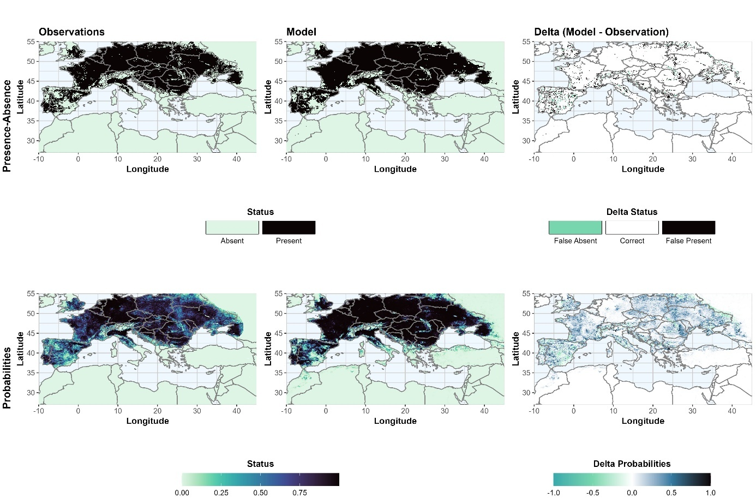
Figure S2.3.1: Observations, presence-absence and probabilities of the best model setup and the differences for the year 2010 of An. atroparvus.

S2.3.2 An. labranchiae
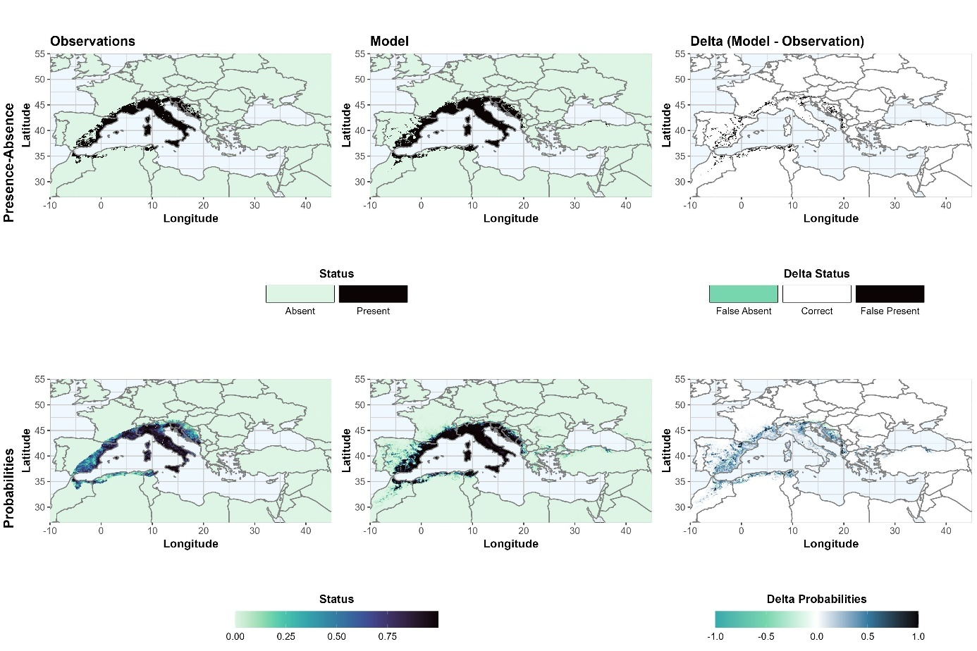
Figure S2.3.2: Observations, presence-absence and probabilities of the best model setup and the differences for the year 2010 of An. labranchiae.

S2.3.3 An. messeae
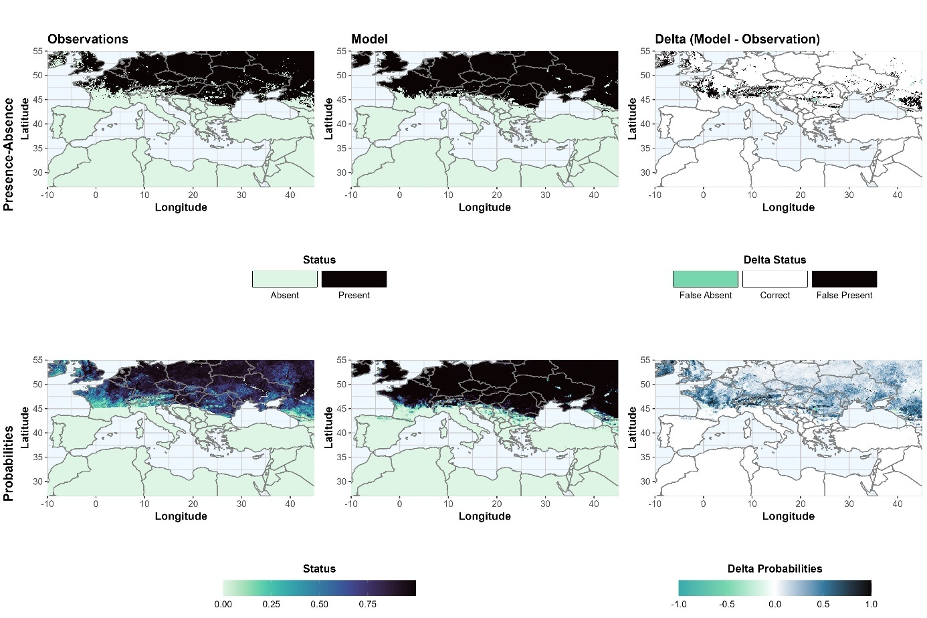
Figure S2.3.3: Observations, presence-absence and probabilities of the best model setup and the differences for the year 2010 of An. messeae.

S2.3.4 An. sacharovi
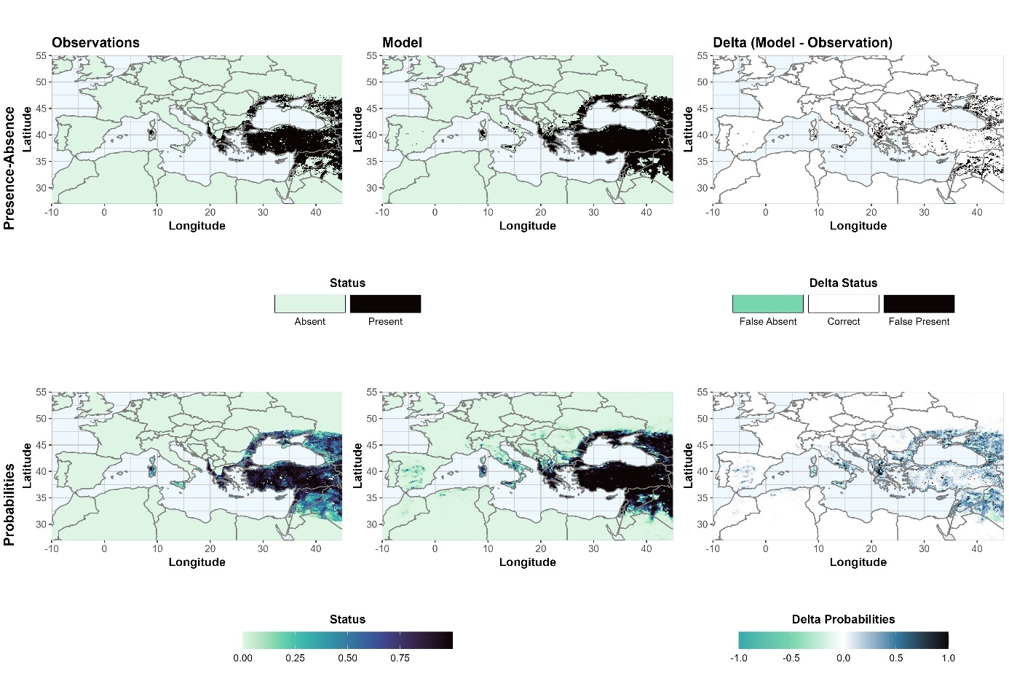
Figure S2.3.4: Observations, presence-absence and probabilities of the best model setup and the differences for the year 2010 of An. sacharovi.

S2.3.5 An. sergentii
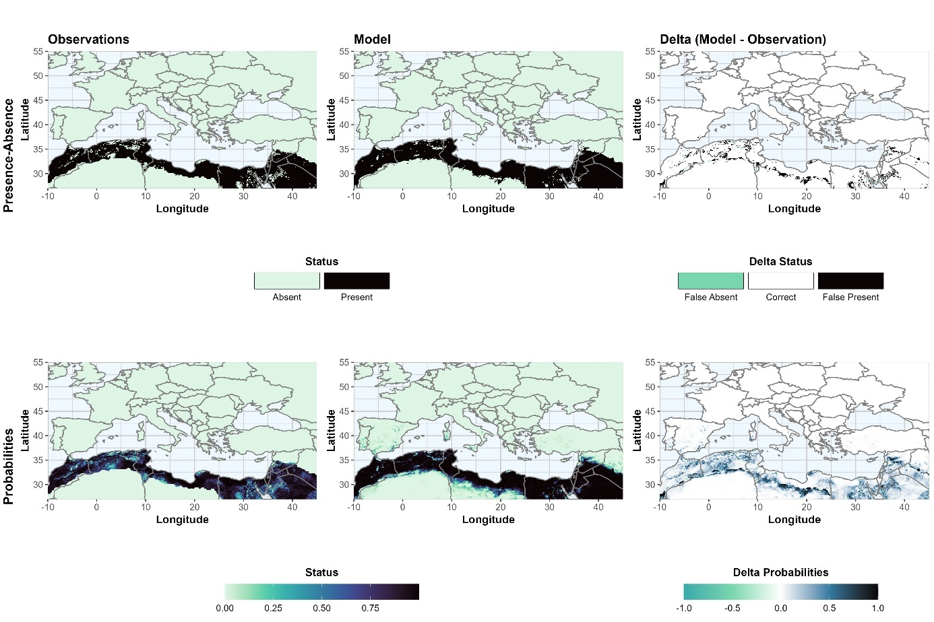
Figure S2.3.5: Observations, presence-absence and probabilities of the best model setup and the differences for the year 2010 of An. sergentii.

S2.3.6 An. superpictus
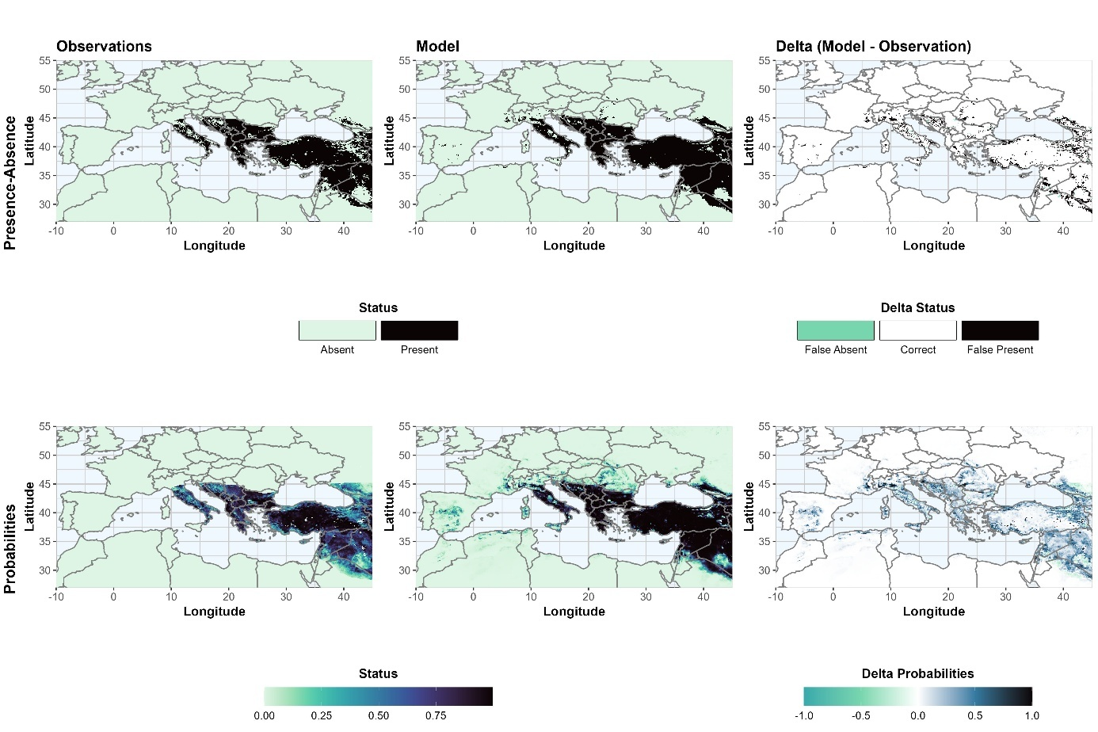
Figure S2.3.6: Observations, presence-absence and probabilities of the best model setup and the differences for the year 2010 of An. superpictus.

S3 Reasons for Change

S3.1 An. atroparvus
Table S3.1: Results per category of change for each model setup of An. atroparvus between 2000 and 2020. In addition to the categories of change, the presence area as a fraction of the land grid boxes of the study area is given for 2000 (P.2000) and 2020 (P.2020), changes as a fraction of the presence area of 2000 for the total changes (CHANGE), changes due to climate (CHANGE.CLIM) and changes due to land use (CHANGE.LU).
Species | Buffered | Sampled | Selection | P.2000 | P.2020 | CHANGE | PCC | ACC | PLUC | ALUC | RPLUC | APLUC | CHANGE.CLIM | CHANGE.LU
atroparvus |  |  | I | 35.1 | 37.1 | 5.9 | 9.8 | 3.9 | 1.3 | 1.3 | 1.0 | 0.6 | 5.9 | 0.0
atroparvus |  |  | II | 35.5 | 37.5 | 5.6 | 9.9 | 4.1 | 1.2 | 1.4 | 0.9 | 0.6 | 5.8 | -0.2
atroparvus |  |  | III | 35.5 | 37.9 | 6.7 | 10.1 | 3.5 | 1.3 | 1.2 | 0.9 | 0.7 | 6.6 | 0.1
atroparvus |  |  | IV | 34.7 | 37.1 | 7.0 | 10.6 | 3.6 | 1.5 | 1.5 | 0.9 | 0.8 | 7.0 | 0.0
atroparvus | x |  | I | 38.6 | 40.1 | 3.9 | 7.1 | 3.0 | 0.6 | 0.8 | 0.7 | 0.4 | 4.1 | -0.2
atroparvus | x |  | II | 39.3 | 40.4 | 2.8 | 6.7 | 3.6 | 0.5 | 0.8 | 0.7 | 0.3 | 3.1 | -0.3
atroparvus | x |  | III | 39.5 | 41.0 | 3.8 | 6.8 | 2.8 | 0.5 | 0.7 | 0.6 | 0.2 | 4.0 | -0.2
atroparvus | x |  | IV | 39.4 | 41.0 | 4.1 | 6.9 | 2.6 | 0.6 | 0.8 | 0.7 | 0.3 | 4.3 | -0.2
atroparvus |  | x | I | 34.9 | 37.2 | 6.6 | 10.2 | 3.8 | 1.3 | 1.1 | 0.7 | 0.6 | 6.4 | 0.2
atroparvus |  | x | II | 35.5 | 37.7 | 5.9 | 9.5 | 3.5 | 1.3 | 1.4 | 0.8 | 0.5 | 6.0 | -0.1
atroparvus |  | x | III | 35.0 | 37.1 | 6.2 | 10.4 | 4.3 | 1.4 | 1.3 | 0.8 | 0.5 | 6.1 | 0.1
atroparvus |  | x | IV | 36.2 | 37.9 | 4.8 | 8.2 | 3.1 | 1.3 | 1.6 | 0.7 | 0.6 | 5.1 | -0.3
atroparvus | x | x | I | 39.2 | 40.1 | 2.5 | 6.1 | 3.2 | 0.4 | 0.8 | 0.6 | 0.3 | 2.9 | -0.4
atroparvus | x | x | II | 40.1 | 41.0 | 2.4 | 5.4 | 2.7 | 0.4 | 0.7 | 0.5 | 0.2 | 2.7 | -0.3
atroparvus | x | x | III | 39.3 | 40.3 | 2.6 | 5.6 | 2.8 | 0.6 | 0.8 | 0.6 | 0.2 | 2.8 | -0.2
atroparvus | x | x | IV | 39.1 | 40.3 | 3.2 | 6.3 | 2.8 | 0.6 | 0.9 | 0.6 | 0.3 | 3.5 | -0.3

S3.2 An. labranchiae
Table S3.2: Results per category of change for each model setup of An. labranchiae between 2000 and 2020. In addition to the categories of change, the presence area as a fraction of the land grid boxes of the study area is given for 2000 (P.2000) and 2020 (P.2020), changes as a fraction of the presence area of 2000 for the total changes (CHANGE), changes due to climate (CHANGE.CLIM) and changes due to land use (CHANGE.LU).
Species | Buffered | Sampled | Selection | P.2000 | P.2020 | CHANGE | PCC | ACC | PLUC | ALUC | RPLUC | APLUC | CHANGE.CLIM | CHANGE.LU
labranchiae |  |  | I | 7.5 | 7.6 | 0.5 | 8.4 | 8.4 | 2.1 | 1.6 | 1.4 | 1.4 | 0.0 | 0.5
labranchiae |  |  | II | 8.1 | 8.1 | 0.5 | 8.4 | 8.3 | 2.3 | 1.9 | 1.3 | 2.0 | 0.1 | 0.4
labranchiae |  |  | III | 7.8 | 7.9 | 0.9 | 8.4 | 8.3 | 3.1 | 2.3 | 1.4 | 1.8 | 0.1 | 0.8
labranchiae |  |  | IV | 8.5 | 8.3 | -2.0 | 7.9 | 10.1 | 3.1 | 2.9 | 2.1 | 2.4 | -2.2 | 0.2
labranchiae | x |  | I | 8.0 | 7.9 | -1.2 | 6.7 | 7.9 | 1.3 | 1.3 | 1.0 | 1.2 | -1.2 | 0.0
labranchiae | x |  | II | 7.7 | 7.6 | -0.3 | 7.3 | 7.9 | 1.3 | 1.0 | 1.0 | 0.8 | -0.6 | 0.3
labranchiae | x |  | III | 8.0 | 8.0 | 0.4 | 7.5 | 7.7 | 1.6 | 1.0 | 0.8 | 0.9 | -0.2 | 0.6
labranchiae | x |  | IV | 8.4 | 8.3 | -1.3 | 7.5 | 9.1 | 1.9 | 1.6 | 1.3 | 1.3 | -1.6 | 0.3
labranchiae |  | x | I | 8.0 | 7.9 | -0.9 | 8.3 | 10.1 | 2.8 | 1.9 | 1.5 | 1.7 | -1.8 | 0.9
labranchiae |  | x | II | 8.3 | 8.1 | -2.5 | 8.0 | 10.8 | 2.2 | 1.9 | 1.4 | 2.0 | -2.8 | 0.3
labranchiae |  | x | III | 7.9 | 7.8 | -1.2 | 8.8 | 10.5 | 2.5 | 2.0 | 1.6 | 1.8 | -1.7 | 0.5
labranchiae |  | x | IV | 8.5 | 8.2 | -2.7 | 8.3 | 11.9 | 3.7 | 2.8 | 2.3 | 2.1 | -3.6 | 0.9
labranchiae | x | x | I | 8.2 | 8.2 | -0.7 | 7.1 | 8.2 | 1.5 | 1.1 | 0.9 | 1.0 | -1.1 | 0.4
labranchiae | x | x | II | 7.9 | 7.8 | -0.8 | 7.0 | 7.9 | 1.2 | 1.1 | 1.0 | 0.8 | -0.9 | 0.1
labranchiae | x | x | III | 7.9 | 7.8 | -0.7 | 7.7 | 8.3 | 1.3 | 1.4 | 0.9 | 0.8 | -0.6 | -0.1
labranchiae | x | x | IV | 8.3 | 8.1 | -2.2 | 7.0 | 9.3 | 1.6 | 1.5 | 1.5 | 1.2 | -2.3 | 0.1

S3.3 An. messeae
Table S3.3: Results per category of change for each model setup of An. messeae between 2000 and 2020. In addition to the categories of change, the presence area as a fraction of the land grid boxes of the study area is given for 2000 (P.2000) and 2020 (P.2020), changes as a fraction of the presence area of 2000 for the total changes (CHANGE), changes due to climate (CHANGE.CLIM) and changes due to land use (CHANGE.LU).
Species | Buffered | Sampled | Selection | P.2000 | P.2020 | CHANGE | PCC | ACC | PLUC | ALUC | RPLUC | APLUC | CHANGE.CLIM | CHANGE.LU
messeae |  |  | I | 36.5 | 35.5 | -2.7 | 2.9 | 5.7 | 0.6 | 0.5 | 0.7 | 0.2 | -2.8 | 0.1
messeae |  |  | II | 37.0 | 36.0 | -2.8 | 2.5 | 5.1 | 0.5 | 0.7 | 0.7 | 0.2 | -2.6 | -0.2
messeae |  |  | III | 37.1 | 35.9 | -3.4 | 2.2 | 5.4 | 0.4 | 0.6 | 0.6 | 0.2 | -3.2 | -0.2
messeae |  |  | IV | 37.2 | 36.4 | -2.2 | 2.0 | 4.2 | 0.7 | 0.7 | 0.8 | 0.3 | -2.2 | 0.0
messeae | x |  | I | 39.0 | 37.1 | -5.0 | 0.8 | 5.6 | 0.2 | 0.4 | 0.5 | 0.1 | -4.8 | -0.2
messeae | x |  | II | 39.4 | 37.3 | -5.2 | 0.8 | 5.8 | 0.2 | 0.4 | 0.5 | 0.1 | -5.0 | -0.2
messeae | x |  | III | 39.2 | 37.3 | -5.0 | 0.8 | 5.5 | 0.2 | 0.5 | 0.5 | 0.1 | -4.7 | -0.3
messeae | x |  | IV | 39.1 | 37.6 | -3.8 | 0.8 | 4.3 | 0.3 | 0.6 | 0.6 | 0.1 | -3.5 | -0.3
messeae |  | x | I | 36.6 | 35.3 | -3.4 | 2.6 | 5.9 | 0.5 | 0.6 | 0.5 | 0.3 | -3.3 | -0.1
messeae |  | x | II | 36.6 | 35.3 | -3.6 | 2.4 | 5.9 | 0.5 | 0.6 | 0.6 | 0.3 | -3.5 | -0.1
messeae |  | x | III | 37.0 | 36.1 | -2.5 | 2.5 | 5.1 | 0.6 | 0.5 | 0.4 | 0.3 | -2.6 | 0.1
messeae |  | x | IV | 37.1 | 36.1 | -2.5 | 2.0 | 4.5 | 0.6 | 0.6 | 0.7 | 0.3 | -2.5 | 0.0
messeae | x | x | I | 39.0 | 37.0 | -5.2 | 0.8 | 5.8 | 0.3 | 0.5 | 0.6 | 0.1 | -5.0 | -0.2
messeae | x | x | II | 39.2 | 37.0 | -5.4 | 0.6 | 5.7 | 0.2 | 0.5 | 0.6 | 0.1 | -5.1 | -0.3
messeae | x | x | III | 38.8 | 36.8 | -5.2 | 0.7 | 5.7 | 0.3 | 0.5 | 0.6 | 0.1 | -5.0 | -0.2
messeae | x | x | IV | 38.3 | 36.8 | -4.1 | 0.9 | 4.8 | 0.4 | 0.6 | 0.7 | 0.1 | -3.9 | -0.2

S3.4 An. sacharovi
Table S3.4: Results per category of change for each model setup of An. sacharovi between 2000 and 2020. In addition to the categories of change, the presence area as a fraction of the land grid boxes of the study area is given for 2000 (P.2000) and 2020 (P.2020), changes as a fraction of the presence area of 2000 for the total changes (CHANGE), changes due to climate (CHANGE.CLIM) and changes due to land use (CHANGE.LU).

Species | Buffered | Sampled | Selection | P.2000 | P.2020 | CHANGE | PCC | ACC | PLUC | ALUC | RPLUC | APLUC | CHANGE.CLIM | CHANGE.LU
sacharovi |  |  | I | 15.8 | 16.8 | 6.5 | 11.1 | 5.5 | 2.0 | 1.1 | 0.8 | 0.9 | 5.6 | 0.9
sacharovi |  |  | II | 16.5 | 17.9 | 8.3 | 11.6 | 4.5 | 1.9 | 0.7 | 0.7 | 0.9 | 7.1 | 1.2
sacharovi |  |  | III | 16.0 | 17.3 | 8.2 | 11.7 | 4.9 | 2.3 | 0.9 | 0.9 | 0.9 | 6.8 | 1.4
sacharovi |  |  | IV | 16.1 | 17.6 | 9.4 | 13.0 | 4.9 | 2.3 | 1.0 | 0.9 | 1.0 | 8.1 | 1.3
sacharovi | x |  | I | 17.2 | 18.1 | 5.3 | 8.4 | 4.2 | 1.6 | 0.5 | 0.7 | 0.4 | 4.2 | 1.1
sacharovi | x |  | II | 17.1 | 18.1 | 5.7 | 8.5 | 3.9 | 1.6 | 0.5 | 0.8 | 0.5 | 4.6 | 1.1
sacharovi | x |  | III | 17.0 | 18.2 | 6.9 | 8.8 | 3.1 | 1.8 | 0.6 | 0.6 | 0.6 | 5.7 | 1.2
sacharovi | x |  | IV | 17.4 | 18.4 | 5.9 | 7.1 | 3.0 | 2.5 | 0.7 | 0.7 | 0.7 | 4.1 | 1.8
sacharovi |  | x | I | 16.6 | 17.8 | 7.6 | 11.9 | 5.5 | 2.1 | 0.9 | 0.7 | 1.0 | 6.4 | 1.2
sacharovi |  | x | II | 16.3 | 17.3 | 6.6 | 11.5 | 5.6 | 1.6 | 0.9 | 0.7 | 0.8 | 5.9 | 0.7
sacharovi |  | x | III | 16.3 | 17.4 | 6.4 | 11.1 | 5.6 | 1.8 | 0.9 | 0.7 | 0.9 | 5.5 | 0.9
sacharovi |  | x | IV | 16.0 | 17.6 | 10.3 | 13.3 | 4.3 | 2.4 | 1.1 | 0.7 | 2.0 | 9.0 | 1.3
sacharovi | x | x | I | 17.4 | 18.1 | 3.7 | 7.2 | 4.2 | 1.4 | 0.7 | 0.6 | 0.5 | 3.0 | 0.7
sacharovi | x | x | II | 17.2 | 17.9 | 4.1 | 7.9 | 4.3 | 1.3 | 0.8 | 0.6 | 0.4 | 3.6 | 0.5
sacharovi | x | x | III | 17.0 | 17.8 | 4.6 | 8.1 | 3.9 | 1.0 | 0.6 | 0.5 | 0.4 | 4.2 | 0.4
sacharovi | x | x | IV | 17.3 | 18.1 | 5.2 | 8.3 | 4.0 | 1.5 | 0.6 | 0.7 | 0.6 | 4.3 | 0.9

S3.5 An. sergentii
Table S3.5: Results per category of change for each model setup of An. sergentii between 2000 and 2020. In addition to the categories of change, the presence area as a fraction of the land grid boxes of the study area is given for 2000 (P.2000) and 2020 (P.2020), changes as a fraction of the presence area of 2000 for the total changes (CHANGE), changes due to climate (CHANGE.CLIM) and changes due to land use (CHANGE.LU).
Species | Buffered | Sampled | Selection | P.2000 | P.2020 | CHANGE | PCC | ACC | PLUC | ALUC | RPLUC | APLUC | CHANGE.CLIM | CHANGE.LU
sergentii |  |  | I | 20.7 | 19.5 | -5.6 | 1.7 | 7.1 | 0.2 | 0.4 | 0.1 | 0.3 | -5.4 | -0.2
sergentii |  |  | II | 20.5 | 19.4 | -5.7 | 1.8 | 7.1 | 0.2 | 0.6 | 0.1 | 0.3 | -5.3 | -0.4
sergentii |  |  | III | 20.5 | 19.2 | -6.2 | 1.7 | 7.4 | 0.2 | 0.7 | 0.1 | 0.3 | -5.7 | -0.5
sergentii |  |  | IV | 20.0 | 19.4 | -3.0 | 2.5 | 5.1 | 0.3 | 0.7 | 0.1 | 0.3 | -2.6 | -0.4
sergentii | x |  | I | 20.7 | 19.4 | -6.0 | 1.1 | 6.8 | 0.1 | 0.4 | 0.1 | 0.2 | -5.7 | -0.3
sergentii | x |  | II | 20.5 | 19.3 | -5.7 | 1.2 | 6.6 | 0.1 | 0.4 | 0.0 | 0.1 | -5.4 | -0.3
sergentii | x |  | III | 20.6 | 19.4 | -5.9 | 1.2 | 6.8 | 0.1 | 0.4 | 0.1 | 0.1 | -5.6 | -0.3
sergentii | x |  | IV | 19.9 | 19.3 | -3.1 | 1.8 | 4.6 | 0.1 | 0.4 | 0.1 | 0.2 | -2.8 | -0.3
sergentii |  | x | I | 20.5 | 19.4 | -5.3 | 1.7 | 6.6 | 0.1 | 0.5 | 0.1 | 0.2 | -4.9 | -0.4
sergentii |  | x | II | 20.6 | 19.4 | -5.6 | 1.8 | 6.9 | 0.2 | 0.7 | 0.1 | 0.2 | -5.1 | -0.5
sergentii |  | x | III | 20.8 | 19.6 | -5.6 | 1.8 | 6.7 | 0.1 | 0.8 | 0.1 | 0.3 | -4.9 | -0.7
sergentii |  | x | IV | 20.2 | 19.4 | -3.7 | 2.4 | 5.5 | 0.2 | 0.8 | 0.1 | 0.3 | -3.1 | -0.6
sergentii | x | x | I | 21.2 | 19.8 | -6.4 | 1.5 | 7.5 | 0.1 | 0.5 | 0.0 | 0.1 | -6.0 | -0.4
sergentii | x | x | II | 20.9 | 19.7 | -5.9 | 1.6 | 7.1 | 0.0 | 0.4 | 0.0 | 0.2 | -5.5 | -0.4
sergentii | x | x | III | 21.1 | 19.7 | -6.3 | 1.2 | 7.2 | 0.1 | 0.4 | 0.0 | 0.3 | -6.0 | -0.3
sergentii | x | x | IV | 20.4 | 19.7 | -3.4 | 2.0 | 5.1 | 0.1 | 0.4 | 0.0 | 0.3 | -3.1 | -0.3

S3.6 An. superpictus
Table S3.6: Results per category of change for each model setup of An. superpictus between 2000 and 2020. In addition to the categories of change, the presence area as a fraction of the land grid boxes of the study area is given for 2000 (P.2000) and 2020 (P.2020), changes as a fraction of the presence area of 2000 for the total changes (CHANGE), changes due to climate (CHANGE.CLIM) and changes due to land use (CHANGE.LU).
Species | Buffered | Sampled | Selection | P.2000 | P.2020 | CHANGE | PCC | ACC | PLUC | ALUC | RPLUC | APLUC | CHANGE.CLIM | CHANGE.LU
superpictus |  |  | I | 18.2 | 19.0 | 4.1 | 7.1 | 3.7 | 1.1 | 0.4 | 0.2 | 0.7 | 3.4 | 0.7
superpictus |  |  | II | 17.8 | 18.6 | 4.6 | 7.4 | 3.6 | 1.2 | 0.4 | 0.2 | 0.5 | 3.8 | 0.8
superpictus |  |  | III | 17.8 | 18.6 | 4.4 | 7.2 | 3.5 | 1.1 | 0.4 | 0.3 | 0.6 | 3.7 | 0.7
superpictus |  |  | IV | 18.0 | 18.8 | 4.0 | 7.0 | 3.8 | 1.5 | 0.7 | 0.3 | 1.0 | 3.2 | 0.8
superpictus | x |  | I | 21.3 | 20.8 | -2.4 | 4.9 | 1.2 | 1.0 | 7.1 | 0.2 | 0.5 | 3.7 | -6.1
superpictus | x |  | II | 19.9 | 20.8 | 4.6 | 5.2 | 1.1 | 0.8 | 0.3 | 0.1 | 0.4 | 4.1 | 0.5
superpictus | x |  | III | 19.7 | 20.5 | 4.4 | 5.3 | 1.3 | 0.7 | 0.3 | 0.2 | 0.5 | 4.0 | 0.4
superpictus | x |  | IV | 20.6 | 20.6 | 0.0 | 5.0 | 1.5 | 1.9 | 5.4 | 0.2 | 0.8 | 3.5 | -3.5
superpictus |  | x | I | 17.6 | 18.5 | 5.3 | 8.0 | 3.5 | 1.3 | 0.5 | 0.3 | 0.7 | 4.5 | 0.8
superpictus |  | x | II | 17.5 | 18.2 | 4.2 | 7.4 | 4.1 | 1.4 | 0.5 | 0.4 | 0.6 | 3.3 | 0.9
superpictus |  | x | III | 17.6 | 18.3 | 4.1 | 6.8 | 3.8 | 1.6 | 0.5 | 0.3 | 0.6 | 3.0 | 1.1
superpictus |  | x | IV | 17.4 | 18.4 | 5.6 | 8.1 | 3.3 | 1.7 | 0.9 | 0.5 | 0.8 | 4.8 | 0.8
superpictus | x | x | I | 19.3 | 20.0 | 3.6 | 5.2 | 1.9 | 0.6 | 0.3 | 0.1 | 0.3 | 3.3 | 0.3
superpictus | x | x | II | 19.2 | 19.9 | 3.8 | 5.2 | 1.7 | 0.5 | 0.2 | 0.2 | 0.4 | 3.5 | 0.3
superpictus | x | x | III | 19.1 | 19.8 | 3.4 | 5.0 | 1.9 | 0.6 | 0.3 | 0.2 | 0.3 | 3.1 | 0.3
superpictus | x | x | IV | 19.1 | 19.7 | 2.9 | 4.5 | 1.8 | 0.6 | 0.4 | 0.3 | 0.4 | 2.7 | 0.2

S4 Most important predictors
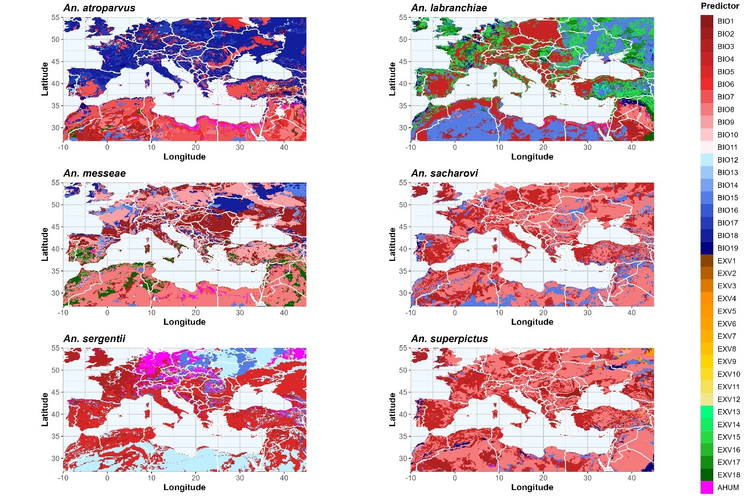
Figure S4.1: Most important climatic predictors.

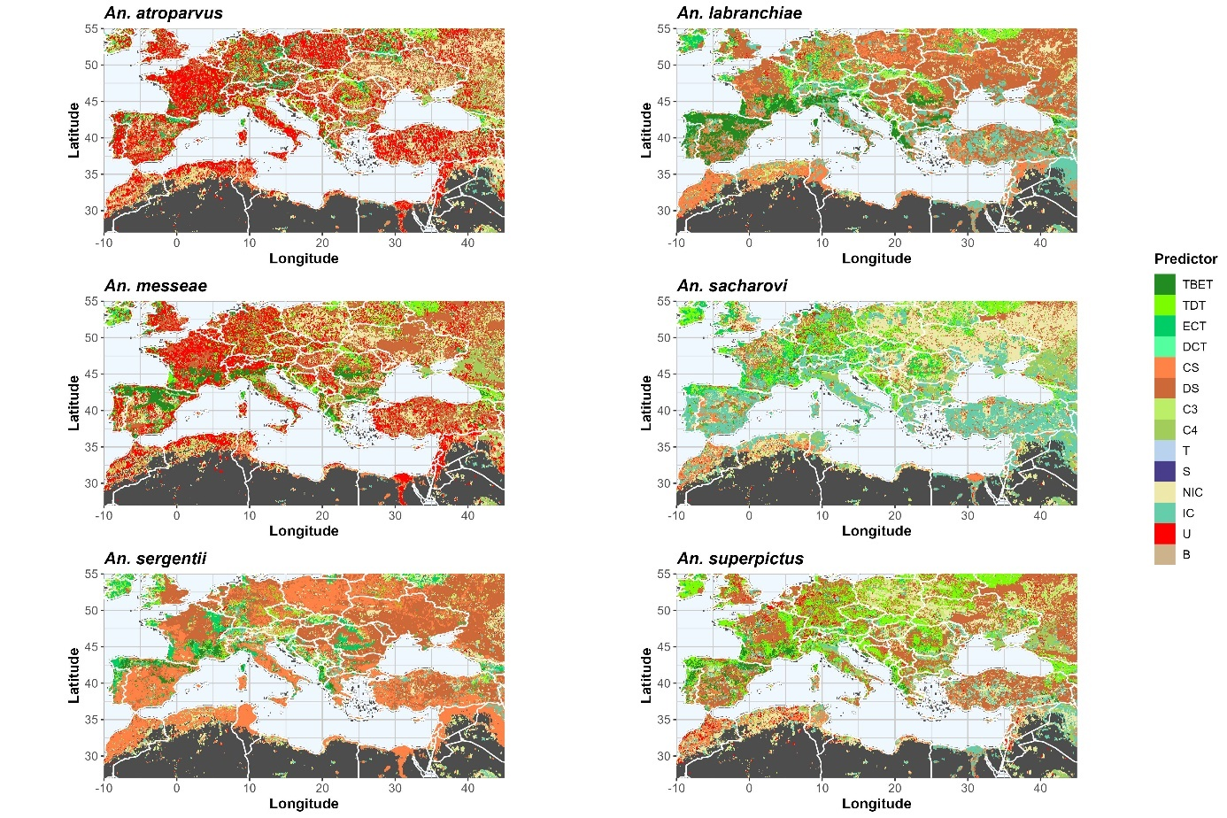
Figure S4.2: Most important land-use predictors.
S4.1 An. atroparvus
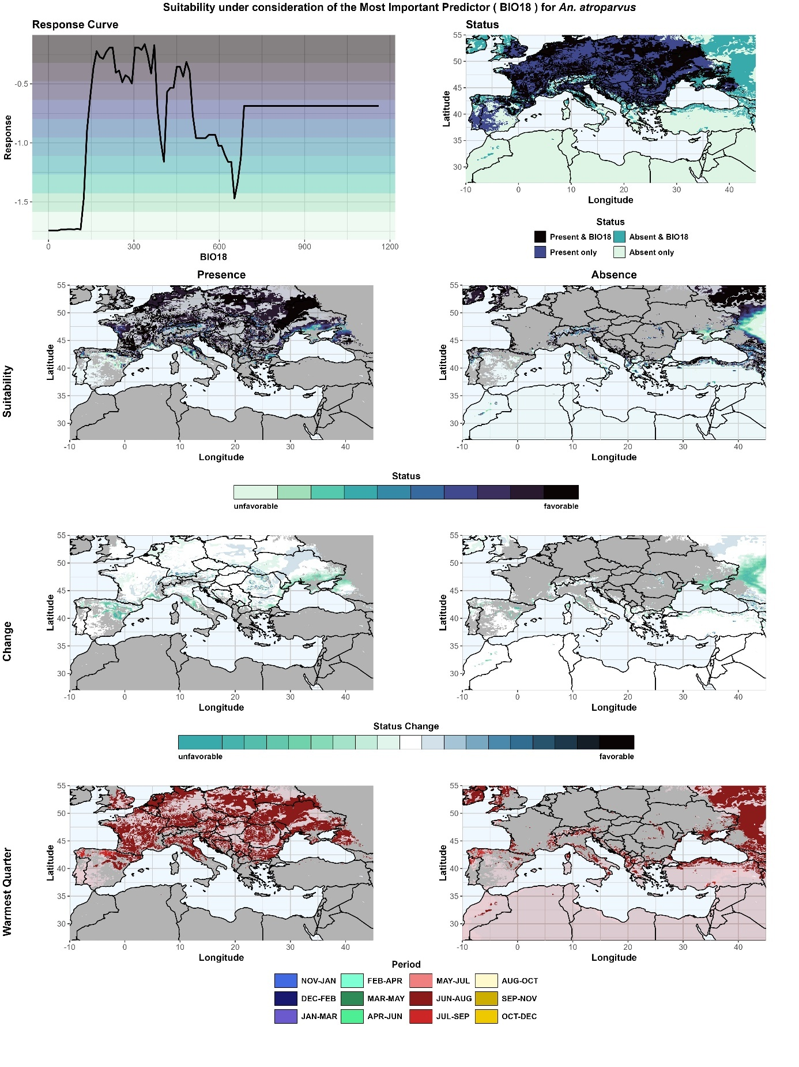
Figure S4.1.1: Suitability under consideration of the most important climatic predictor for An. atroparvus. The response curves of the MIP and the status is presented at the top. Below, suitability maps are given for the presence (left) and absence areas (right), changes in suitability (3rd row) and the reference quarter representing the warmest quarter (bottom).
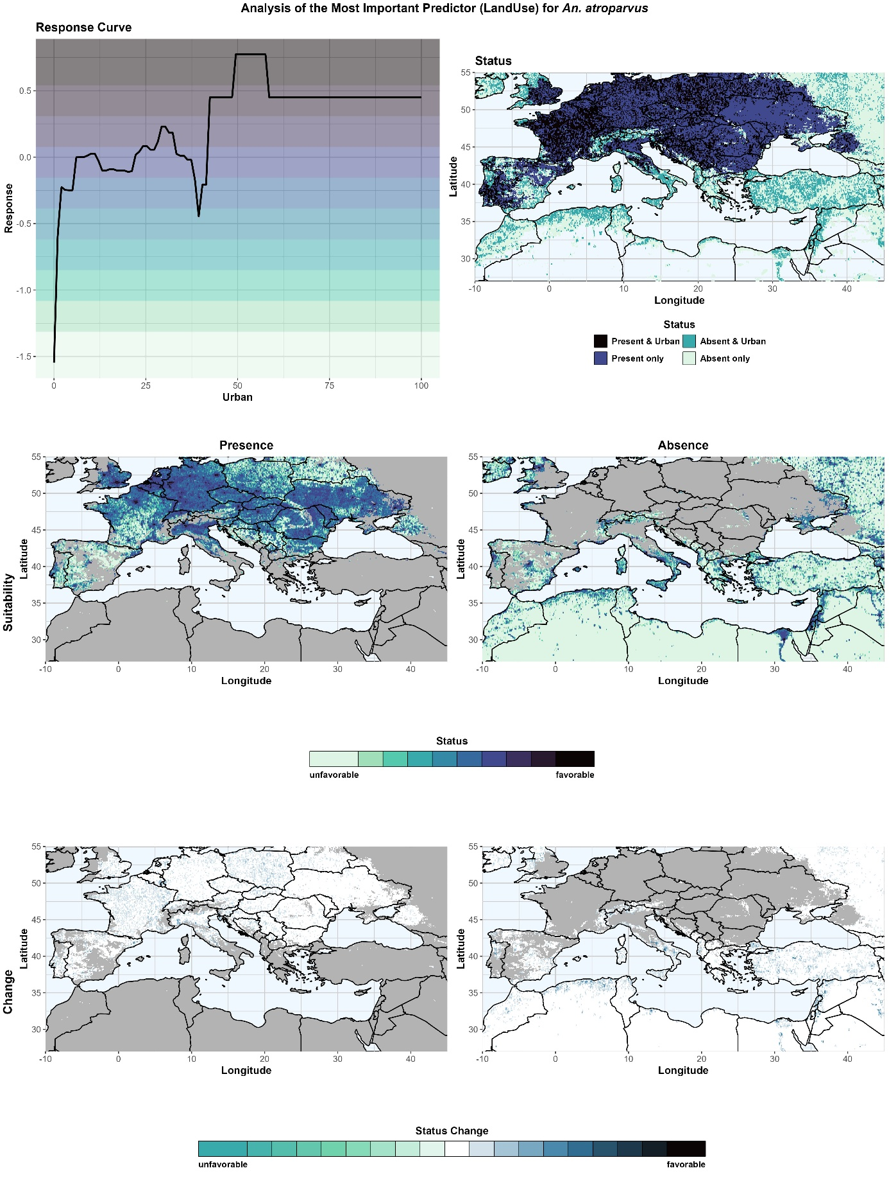
Figure S4.1.2: Suitability under consideration of the most important land-use predictor for An. atroparvus. The response curves of the MIP and the status is presented at the top. Below, suitability maps are given for the presence (left) and absence areas (right), and changes in suitability at the bottom.

S4.2 An. labranchiae
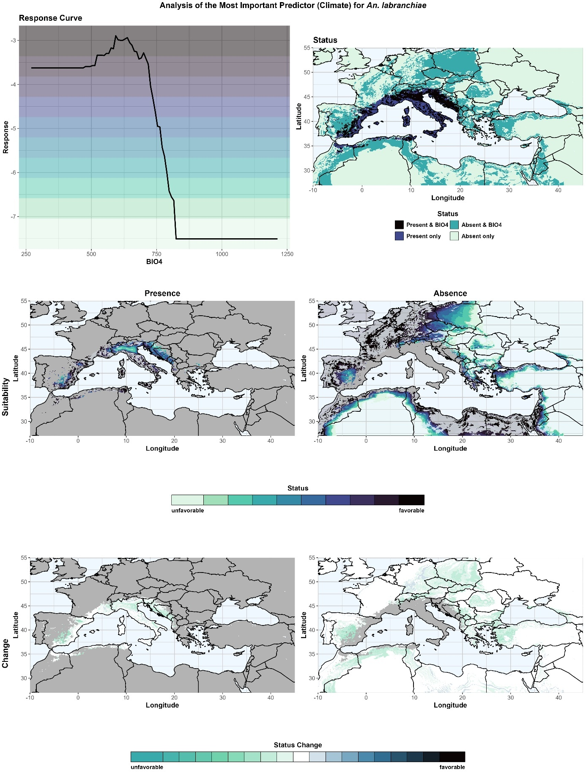
Figure S4.2.1: Suitability under consideration of the most important climatic predictor for An. labranchiae. The response curves of the MIP and the status is presented at the top. Below, suitability maps are given for the presence (left) and absence areas (right), and changes in suitability at the bottom.

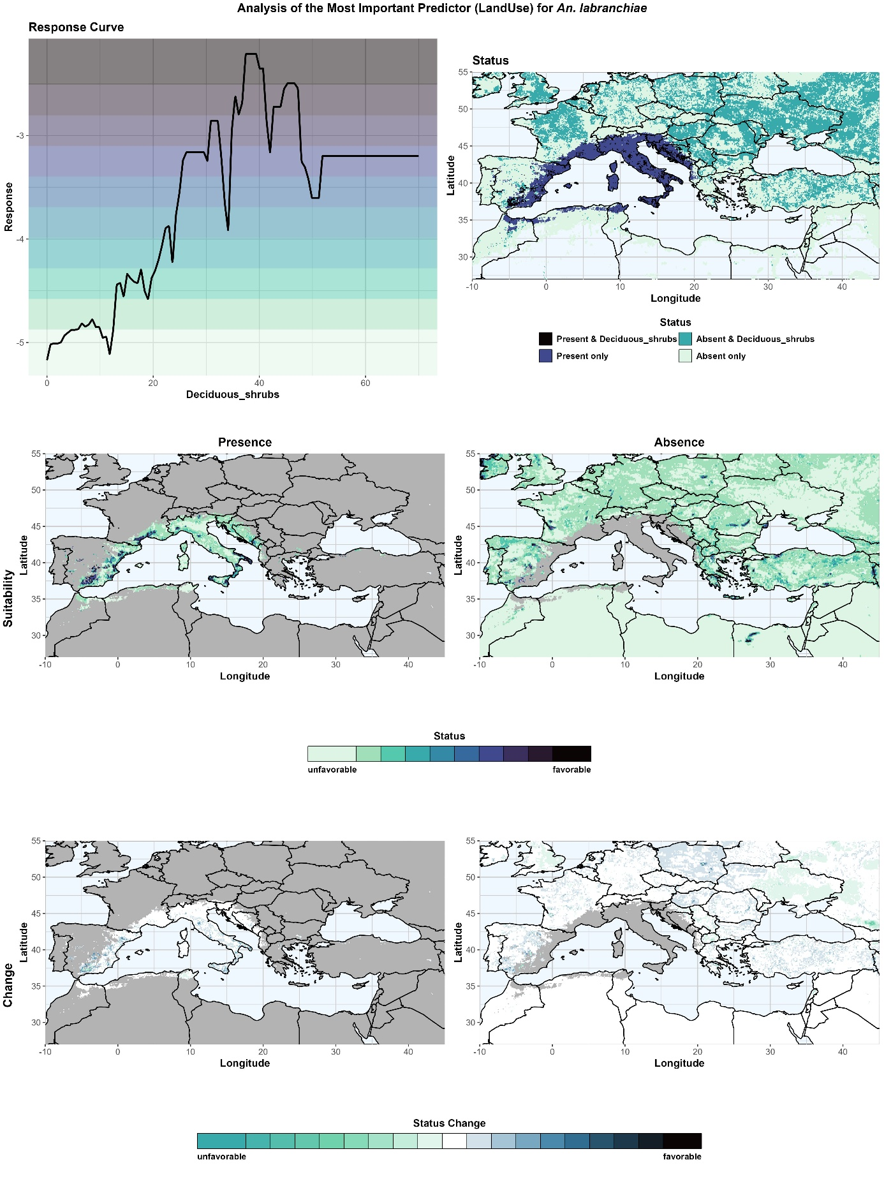
Figure S4.2.2: Suitability under consideration of the most important land-use predictor for An. labranchiae. The response curves of the MIP and the status is presented at the top. Below, suitability maps are given for the presence (left) and absence areas (right), and changes in suitability at the bottom.

S4.3 An. messeae
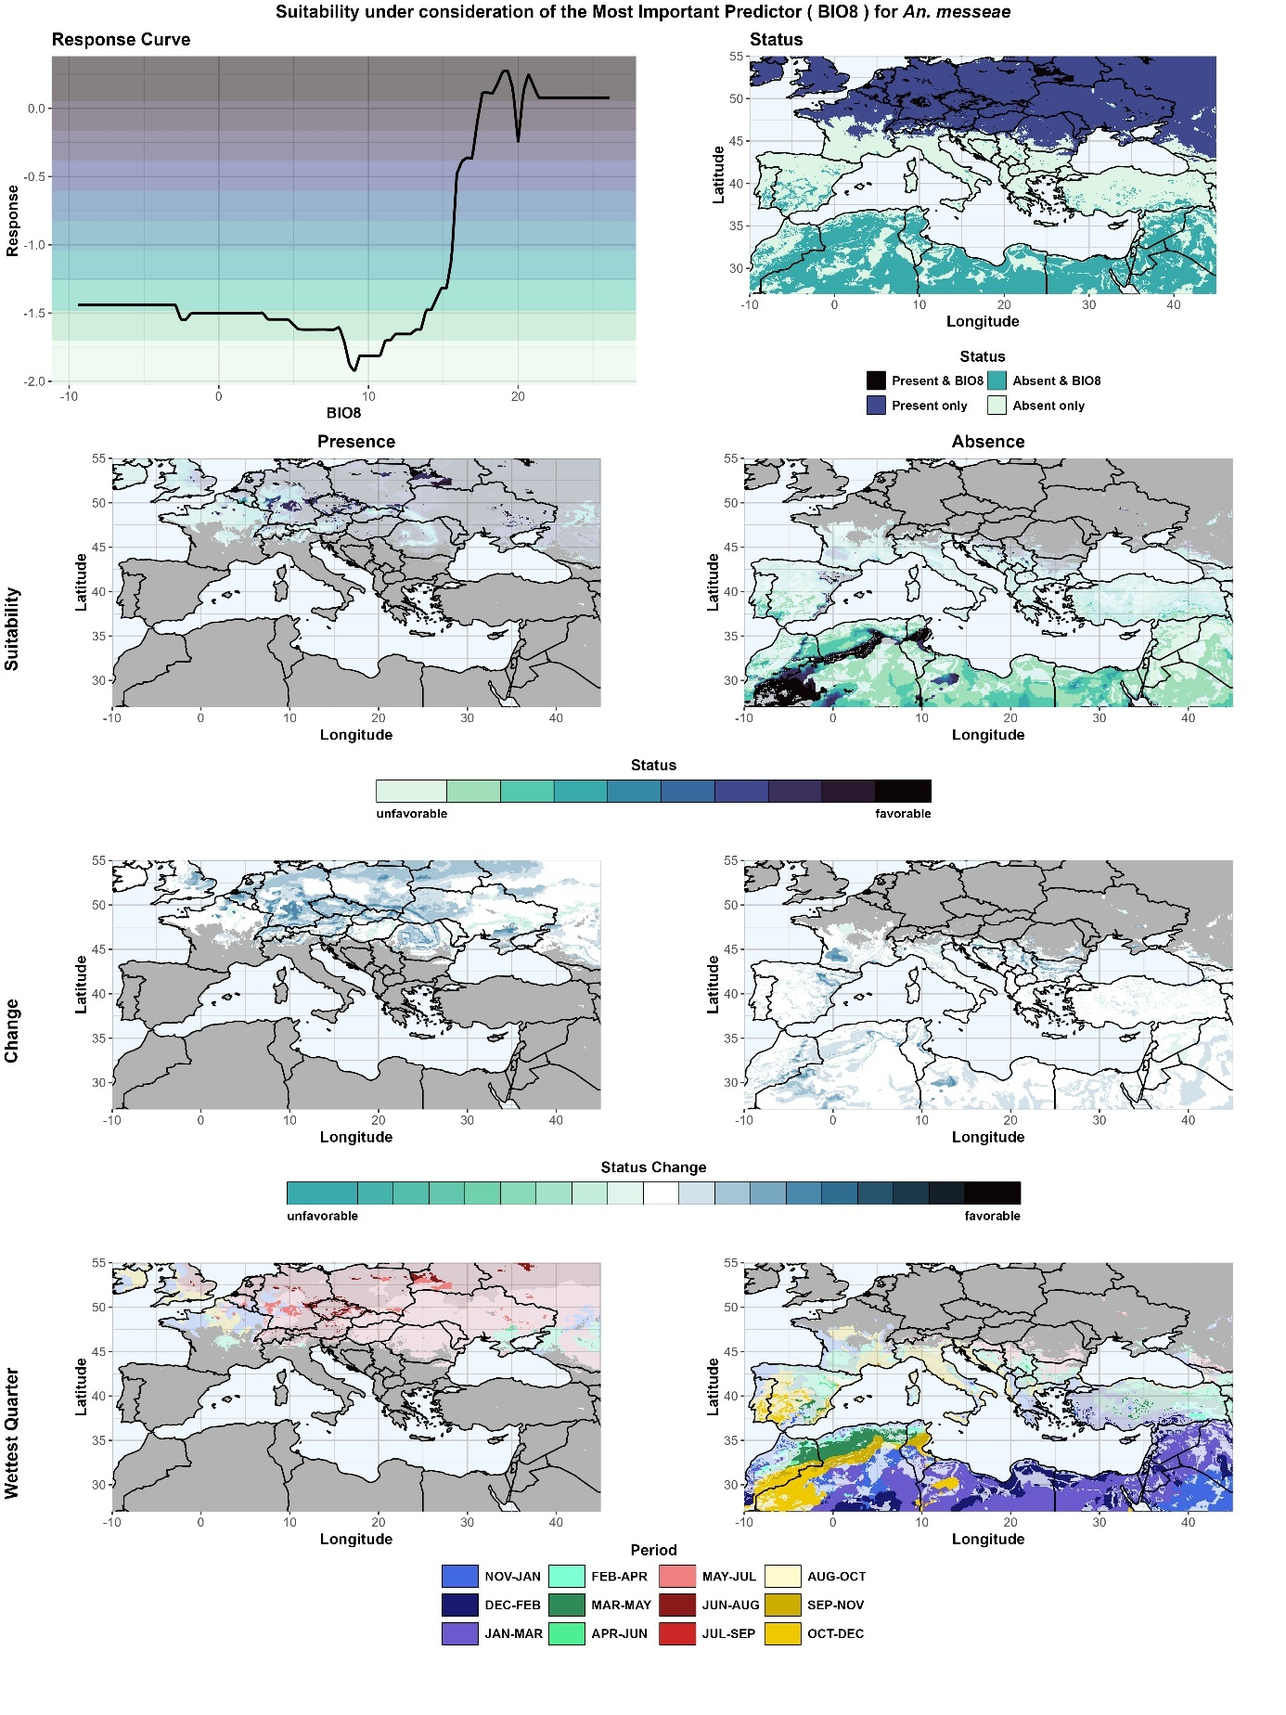
Figure S4.3.1: Suitability under consideration of the most important climatic predictor for An. messeae. The response curves of the MIP and the status is presented at the top. Below, suitability maps are given for the presence (left) and absence areas (right), changes in suitability (3rd row) and the reference quarter representing the warmest quarter (bottom).

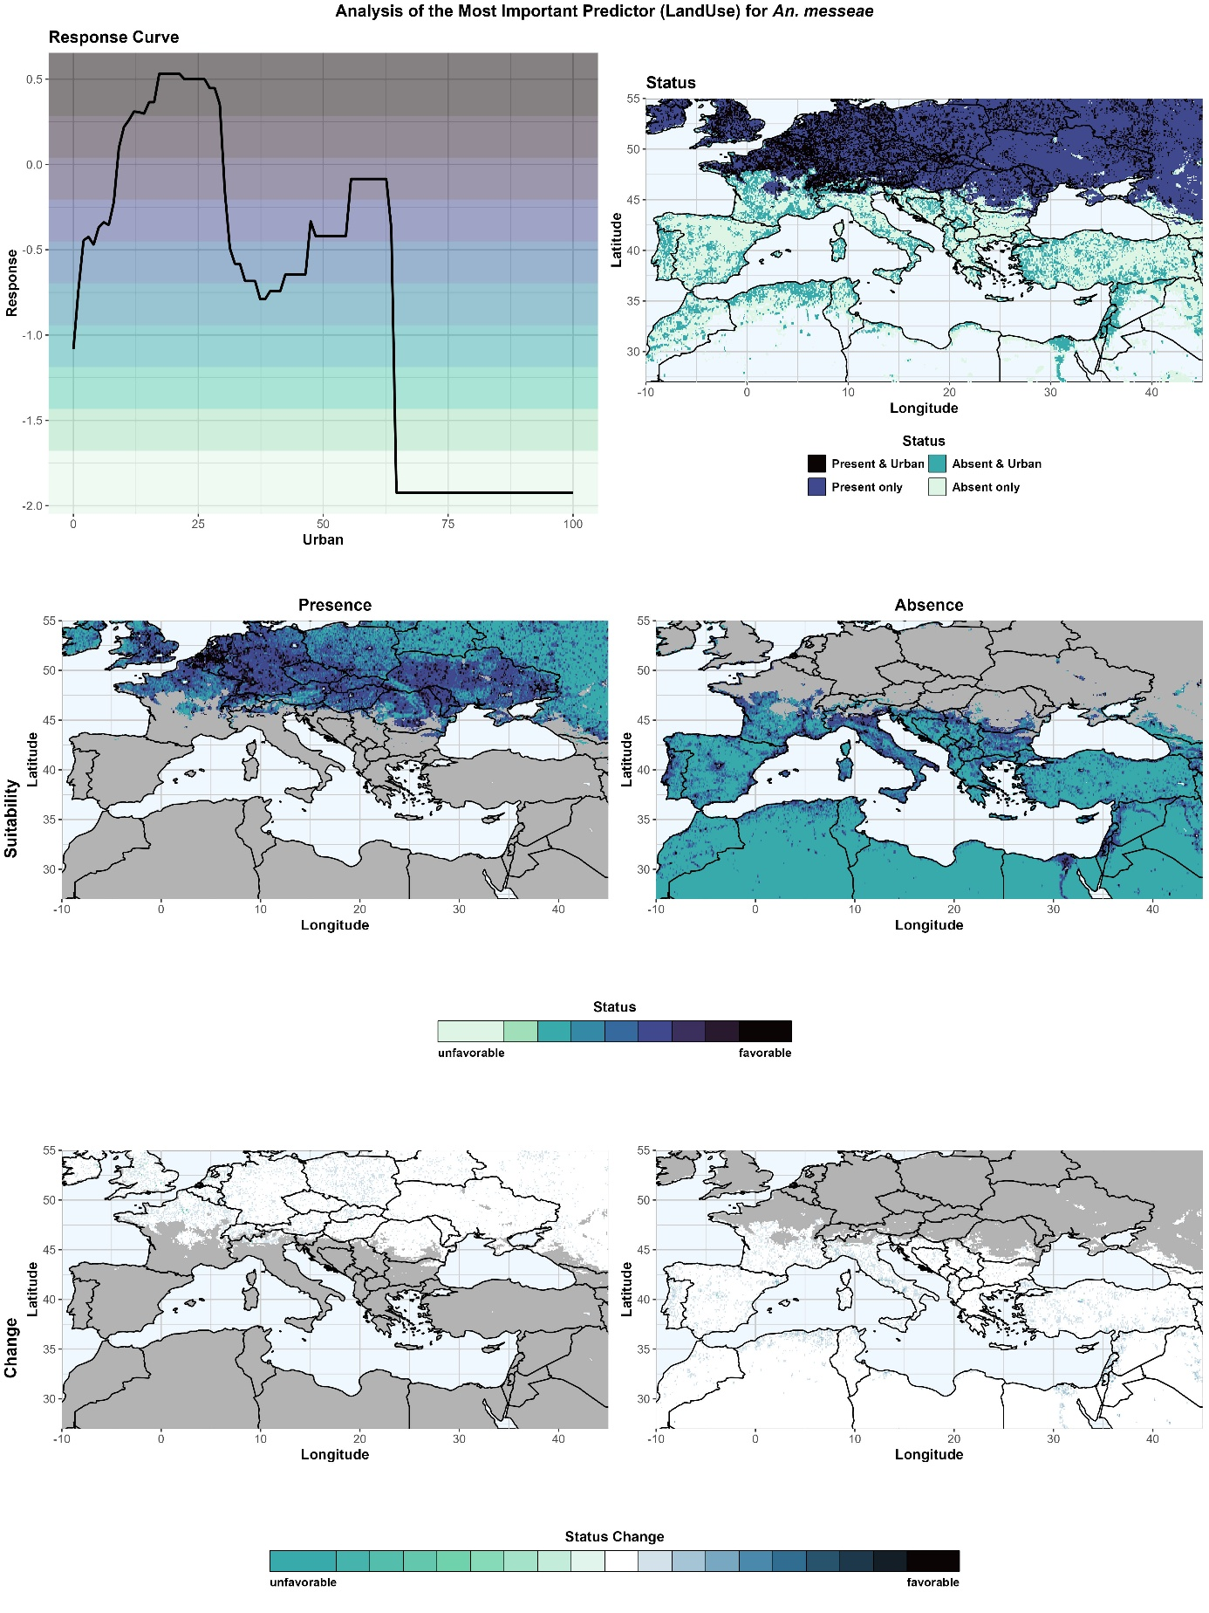
Figure S4.3.2: Suitability under consideration of the most important land-use predictor for An. messeae. The response curves of the MIP and the status is presented at the top. Below, suitability maps are given for the presence (left) and absence areas (right), and changes in suitability at the bottom.

S4.4 An. sacharovi
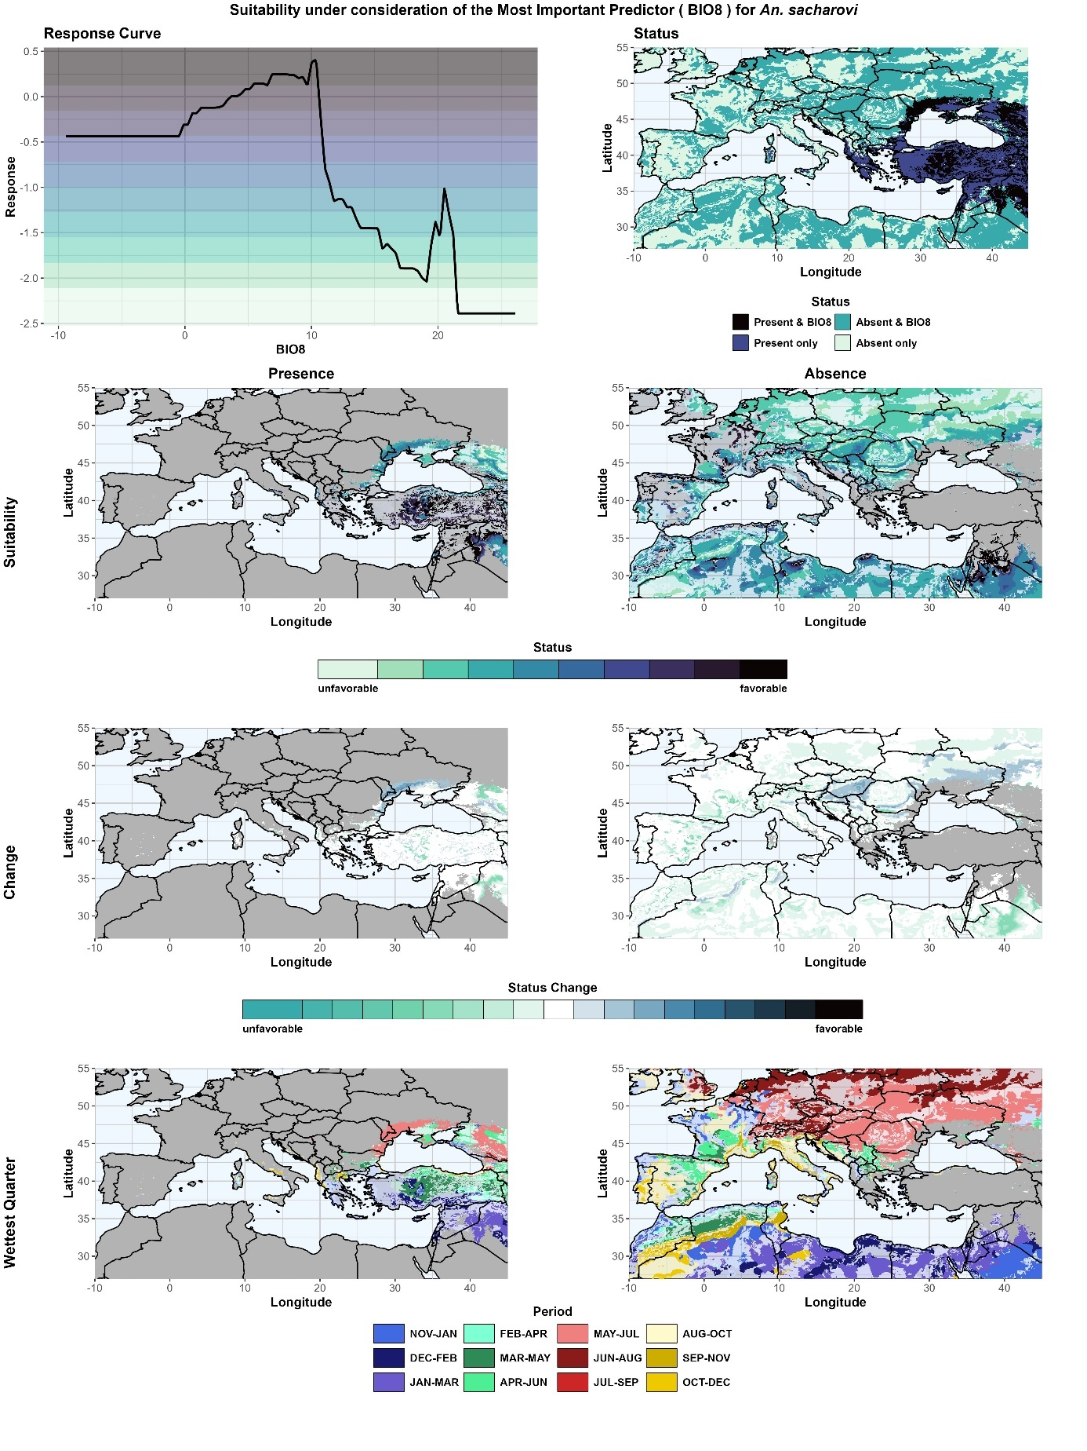
Figure S4.4.1: Suitability under consideration of the most important climatic predictor for An. sacharovi. The response curves of the MIP and the status is presented at the top. Below, suitability maps are given for the presence (left) and absence areas (right), changes in suitability (3rd row) and the reference quarter representing the warmest quarter (bottom).
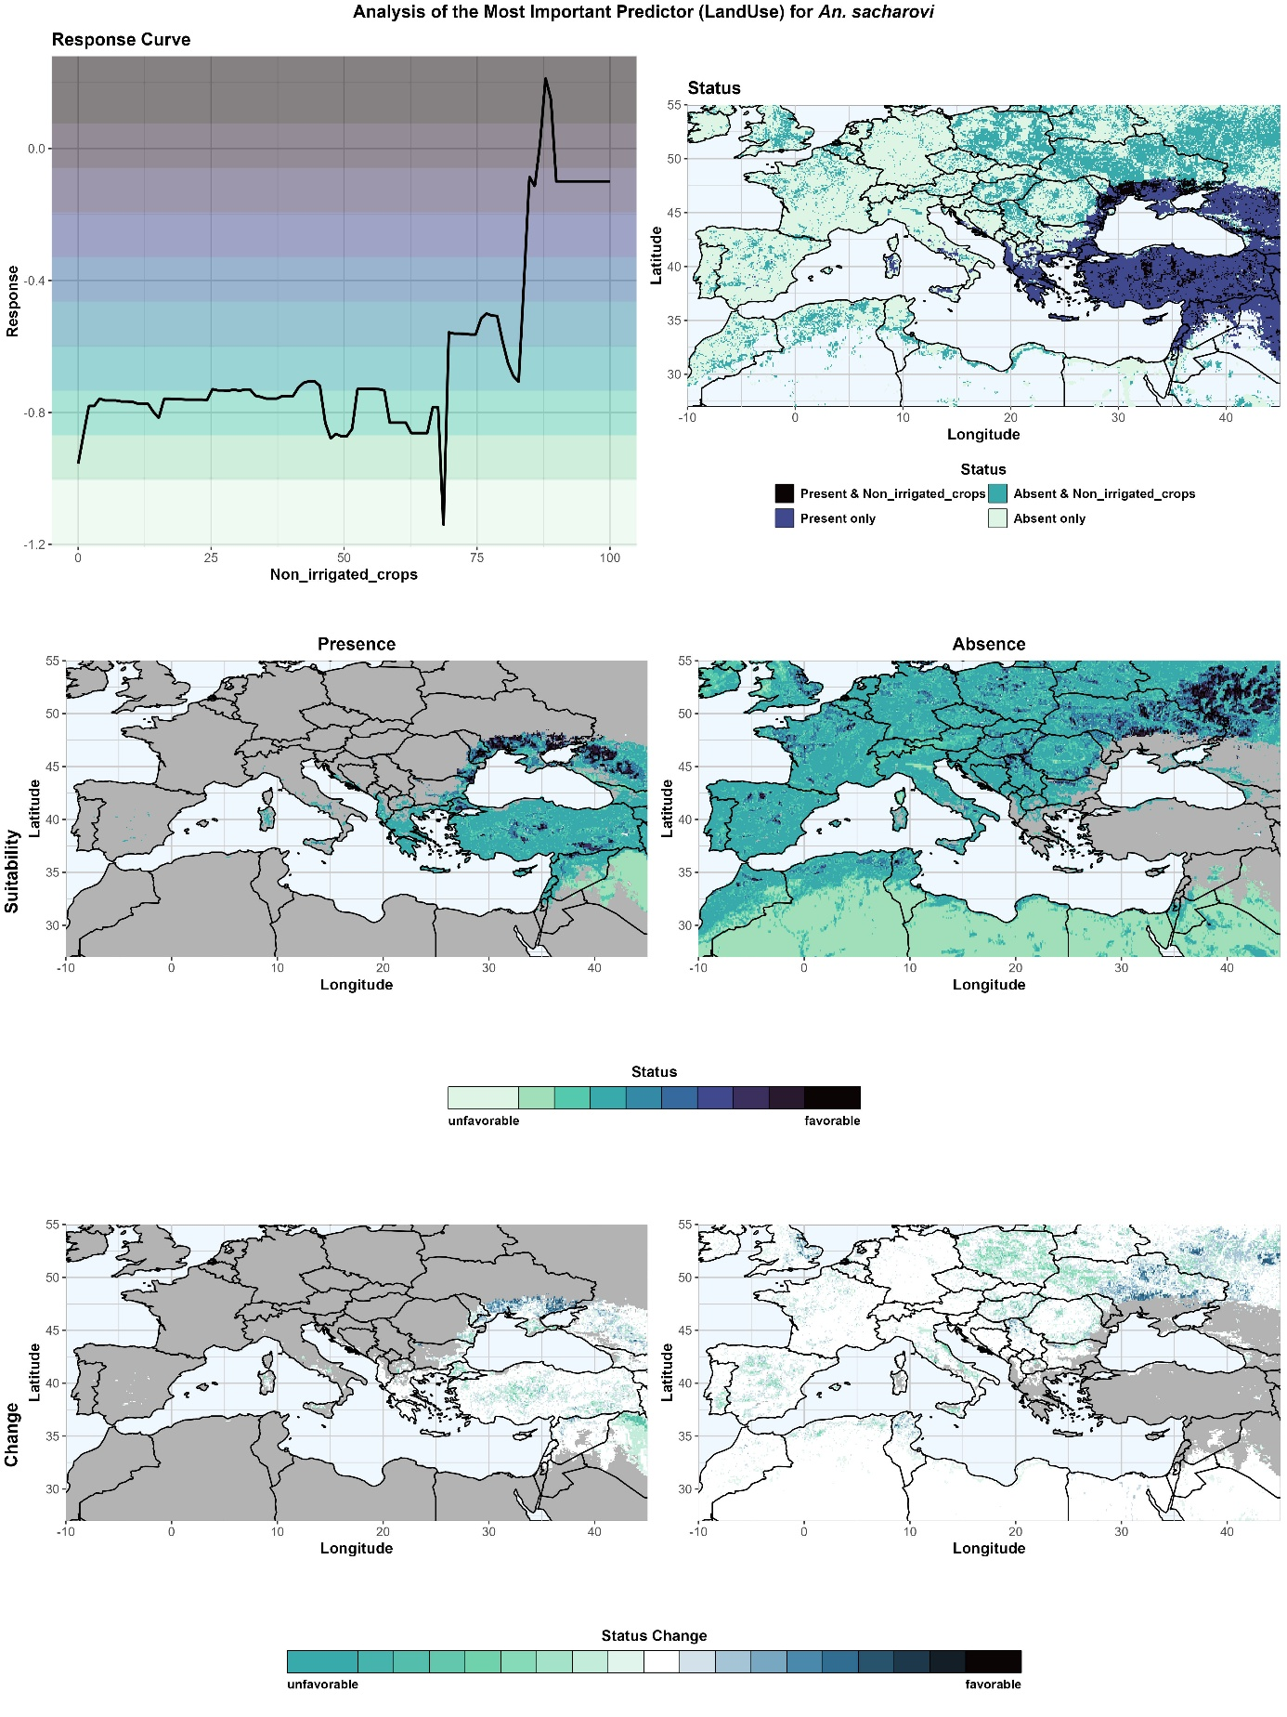
Figure S4.4.2: Suitability under consideration of the most important land-use predictor for An. sacharovi. The response curves of the MIP and the status is presented at the top. Below, suitability maps are given for the presence (left) and absence areas (right), and changes in suitability at the bottom.

S4.5 An. sergentii
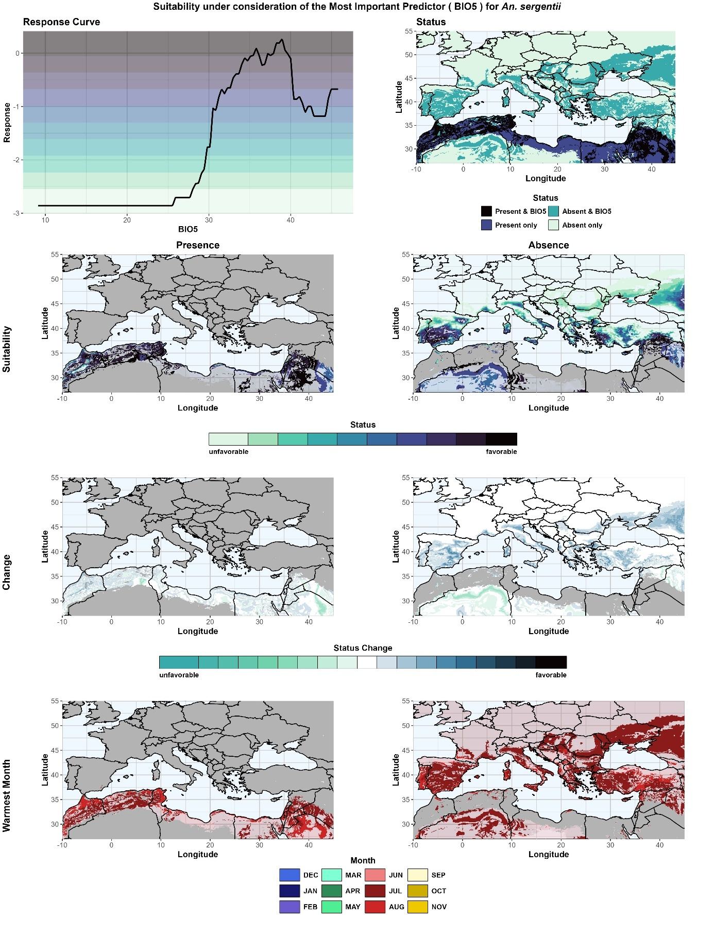
Figure S4.5.1: Suitability under consideration of the most important climatic predictor for An. sergentii. The response curves of the MIP and the status is presented at the top. Below, suitability maps are given for the presence (left) and absence areas (right), changes in suitability (3rd row) and the reference month representing the warmest month (bottom).
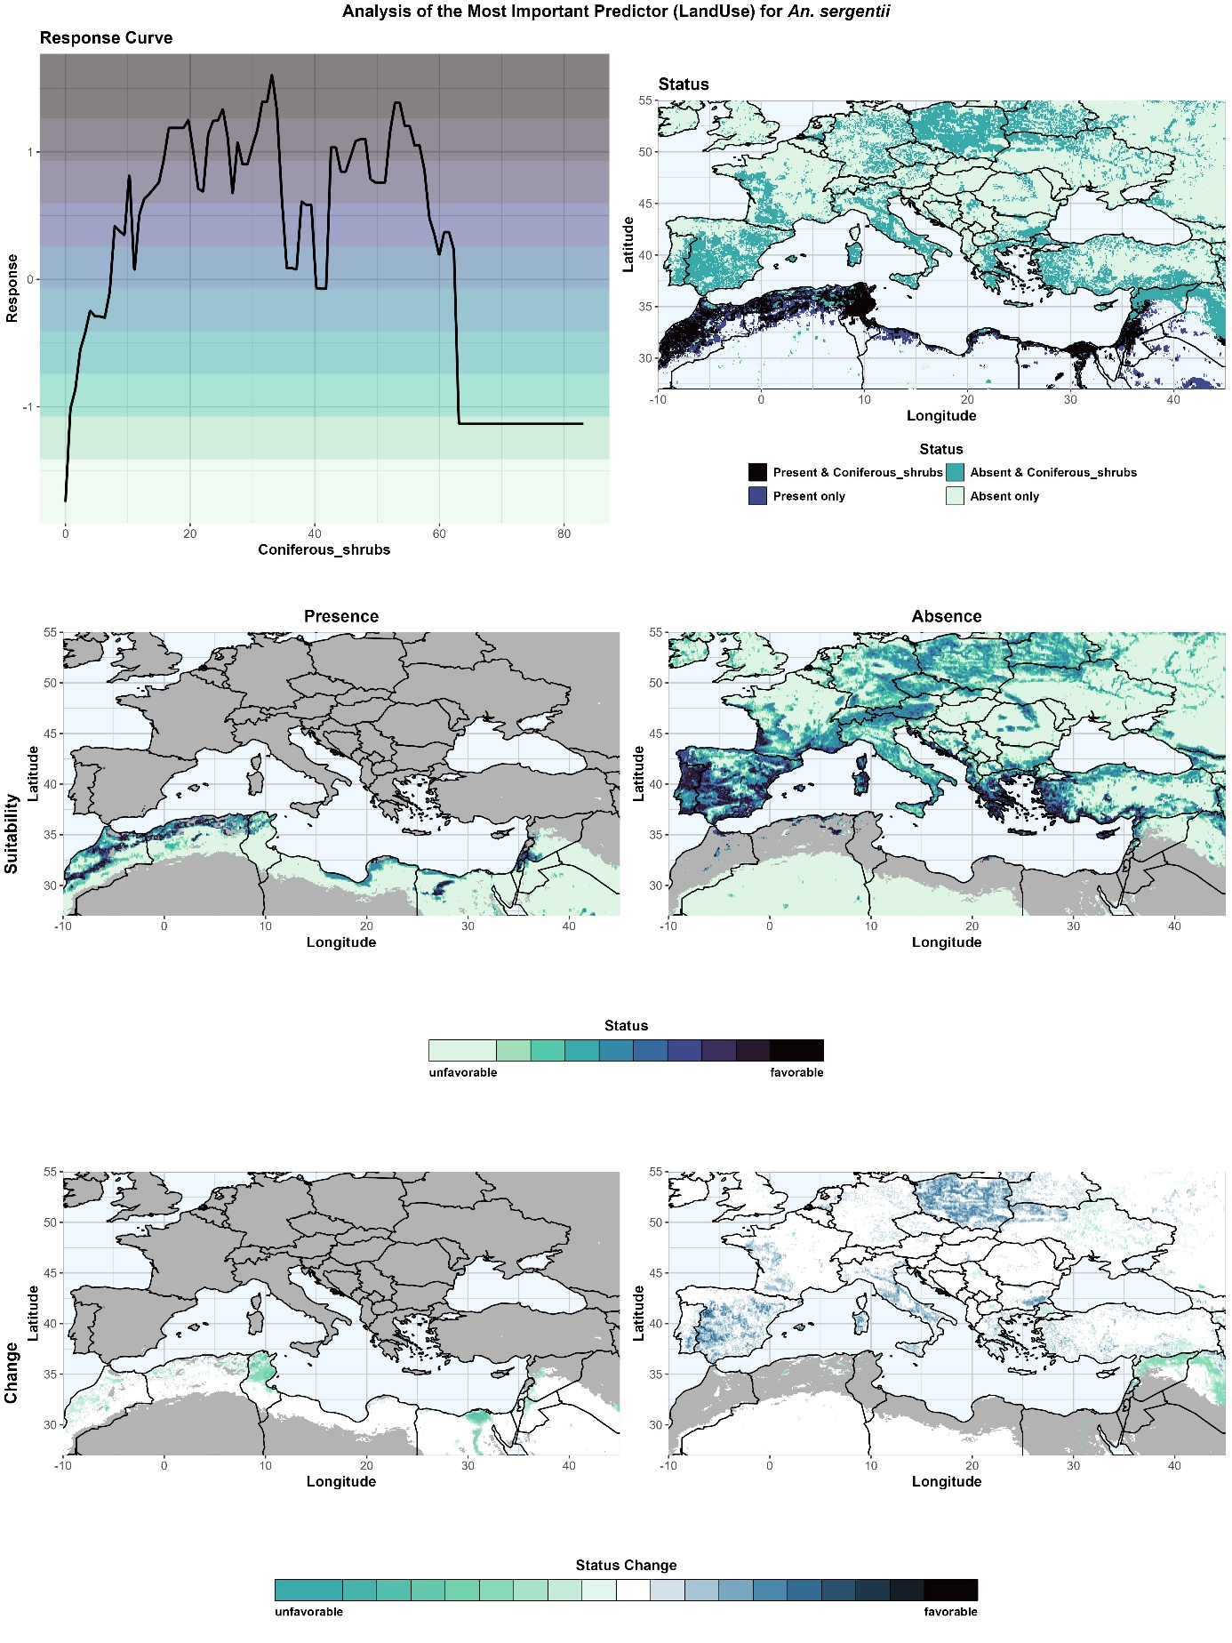
Figure S4.5.2: Suitability under consideration of the most important land-use predictor for An. sergentii. The response curves of the MIP and the status is presented at the top. Below, suitability maps are given for the presence (left) and absence areas (right), and changes in suitability at the bottom.

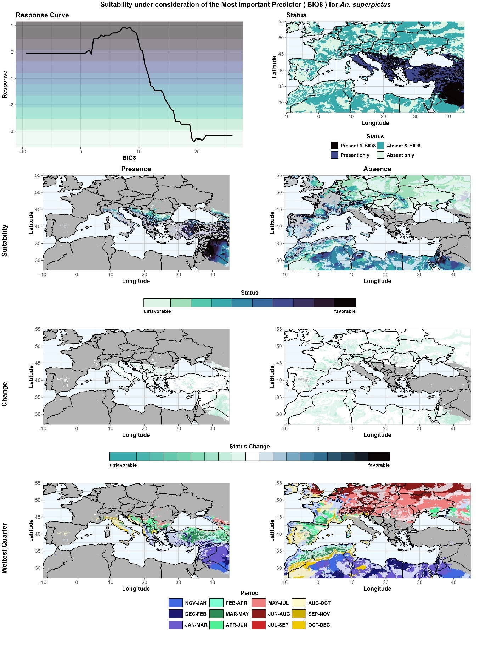
Figure S4.6.1: Suitability under consideration of the most important climatic predictor for An. superpictus. The response curves of the MIP and the status is presented at the top. Below, suitability maps are given for the presence (left) and absence areas (right), changes in suitability (3rd row) and the reference quarter representing the warmest quarter (bottom).

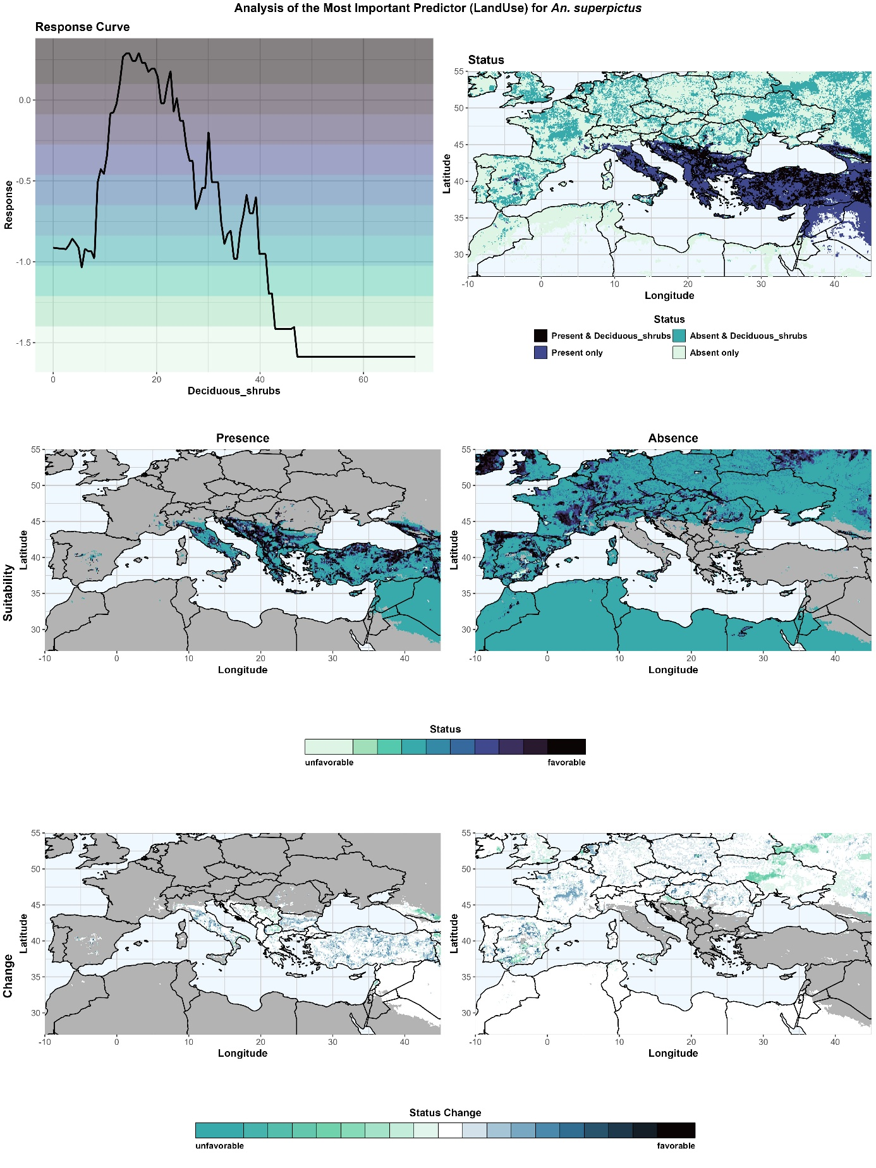
Figure S4.6.2: Suitability under consideration of the most important land-use predictor for An. superpictus. The response curves of the MIP and the status is presented at the top. Below, suitability maps are given for the presence (left) and absence areas (right), and changes in suitability at the bottom.

