Supporting Information

Title: iPSC-derived exosomes promote diabetic wound healing by attenuating inflammatory responses
Li Long^{1, 3}, Ju Qiao², Liang Wang⁴, Yue Wang¹, Yi Xu¹, Hui Chen¹, Hongzhong Jin^{2, *}, Wei He^{1, *} , Xiaohong Han^{3, *} and Jianmin Zhang^{1, 4, 5, *}

¹Department of Immunology, CAMS Key laboratory T cell and Cancer Immunotherapy, Institute of Basic Medical Sciences, Chinese Academy of Medical Sciences and School of Basic Medicine, Peking Union Medical College, State Key Laboratory of Common Mechanism Research for Major Diseases, Beijing, 100005, China.
²Department of Dermatology, State Key Laboratory of Complex Severe and Rare Diseases, Peking Union Medical College Hospital, Chinese Academy of Medical Sciences and Peking Union Medical College, National Clinical Research Center for Dermatologic and Immunologic Diseases, Beijing, China.
³Clinical Pharmacology Research Center, Peking Union Medical College Hospital, Chinese Academy of Medical Sciences & Peking Union Medical College, State Key Laboratory of Complex Severe and Rare Diseases, NMPA Key Laboratory for Clinical Research and Evaluation of Drug, Beijing Key Laboratory of Clinical PK and PD Investigation for Innovative Drugs, Beijing 100730, China
⁴Guidon Pharmaceutics Ltd. Beijing, China.
⁵Changzhou Xitaihu Institute for Frontier Technology of Cell Therapy. Changzhou, Jiangsu province, 213000, China.
* To whom correspondence may be addressed:

Dr. Hongzhong Jin at E-mail: jinhongzhong@263.net

Dr. Wei He at E-mail: heweingd@126.com

Dr. Xiaohong Han at E-mail: hanxiaohong@pumch.cn

Dr. Jianmin Zhang at E-mail: jzhang42@163.com

Supplementary Fig. 1
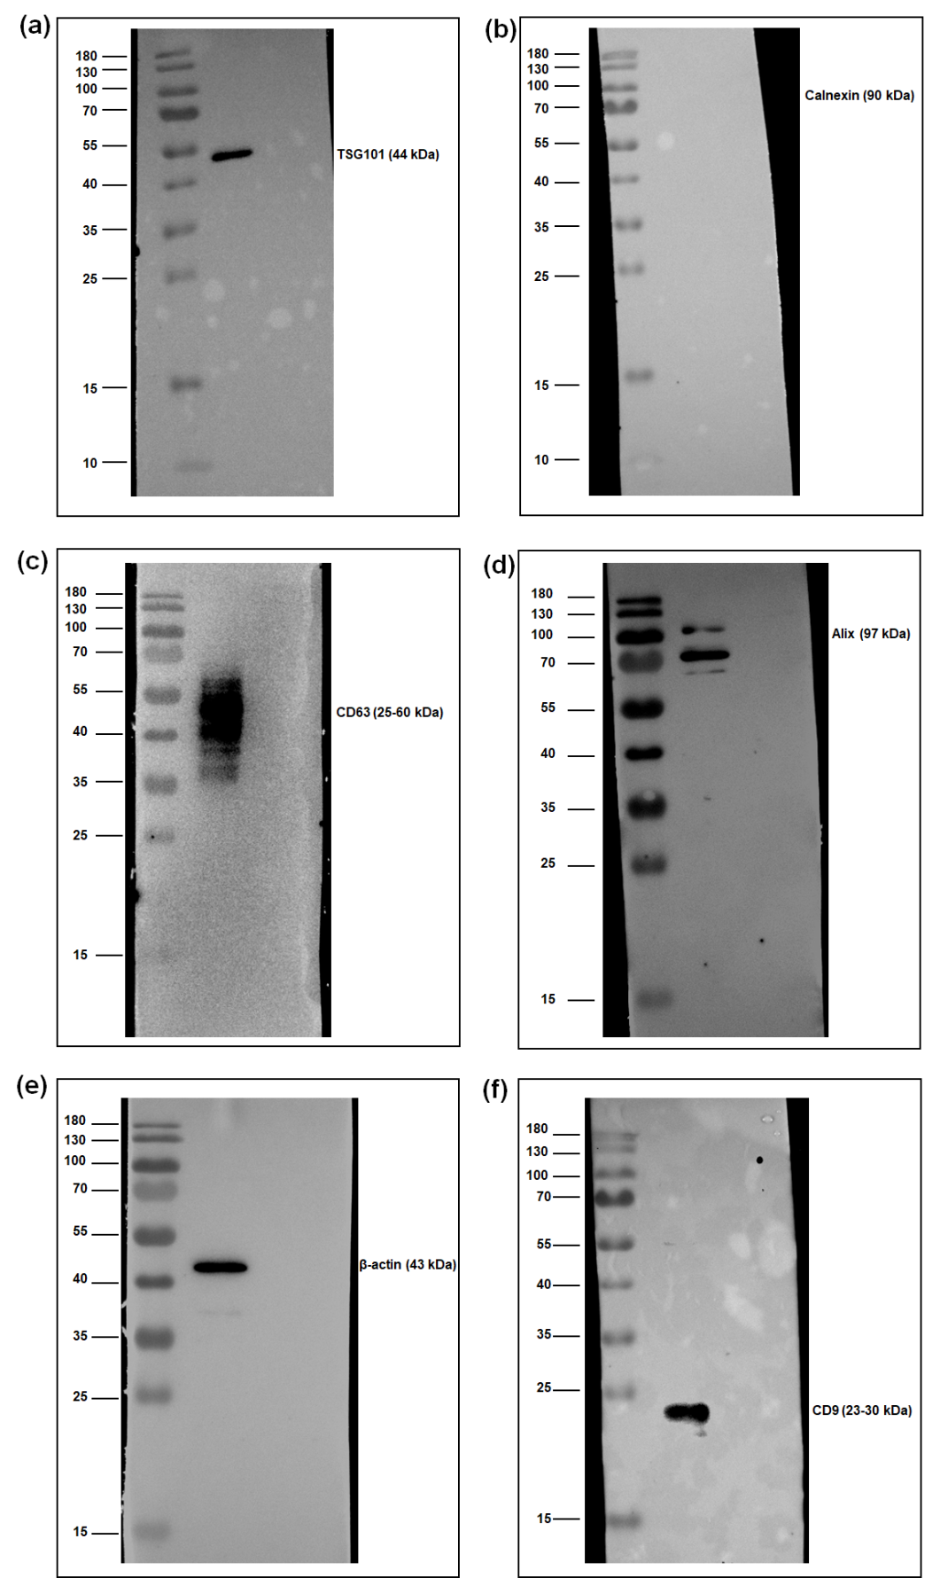

The original uncropped blots presented in the Fig. 1g. TSG101 (a), Calnexin (b), CD63 (c), Alix (d), β-actin (d), CD9 (e).

