1. Comparative Experimental Results
Since only the number of employment opportunities and average wages involve job-matching weights, we compare the results of four indicators before and after incorporating these weights: potential employment opportunity quantity, potential employment average wage, actual employment opportunity quantity accessed by residents, and actual employment average wage. The comparative results based on the main model are as follows:
 |  | Correspond variables | R² | MAE | RMSE
With job-matching weights | potential employment opportunities |  | 0.981 | 0.080 | 0.137
With job-matching weights | potential employment average salary |  | 0.967 | 0.094 | 0.181
With job-matching weights | actual employment opportunities |  | 0.726 | 0.365 | 0.524
With job-matching weights | actual employment average salary |  | 0.820 | 0.315 | 0.419
Without job-matching weights | potential employment opportunities |  | 0.938 | 0.157 | 0.248
Without job-matching weights | potential employment average salary |  | 0.537 | 0.341 | 0.683
Without job-matching weights | actual employment opportunities |  | 0.660 | 0.427 | 0.604
Without job-matching weights | actual employment average salary |  | 0.801 | 0.310 | 0.435

2. Variable Design and Description
Variable Type | Variable Name | Description
Target Variable | potential employment opportunities | Number of employment opportunities within 1 km of the residence
Target Variable | potential employment average salary | Average salary of employment opportunities within 1 km of the residence
Target Variable | potential employment accessibility | Distance from residence to city hall (as a proxy for central accessibility)
Target Variable | actual employment opportunities | Number of employment opportunities at the grid where the resident actually works
Target Variable | actual employment average salary | Average salary at the grid where the resident actually works
Target Variable | actual commute time | Average commuting time from residence to workplace
Key Variable | rent | Average housing rent in the residential area
Locational Features | distance to mall | Distance from residence to the nearest shopping mall
Locational Features | distance to school | Distance from residence to the nearest educational facility
Locational Features | distance to industrial park | Distance from residence to the nearest industrial park
Locational Features | distance to healthcare facility | Distance from residence to the nearest healthcare facility
Locational Features | distance to transit station | Distance from residence to the nearest public transit station
Environmental Features | home-work balance | Ratio of employed to residential population within the grid
Environmental Features | housing year | Construction year of the residential area
Environmental Features | floor ratio | Floor area ratio of the residential area
Environmental Features | green ratio | Green coverage ratio of the residential area
Individual Features | mobile cost | Average monthly mobile communication expense of employed residents in the grid
Individual Features | ride app time | Average usage time of ride-hailing apps among employed residents in the grid
Individual Features | finance app time | Average usage time of financial apps among employed residents in the grid
Individual Features | discount app time | Average usage time of group-buying/discount apps among employed residents in the grid
Individual Features | education app time | Average usage time of educational apps among employed residents in the grid
Individual Features | job app time | Average usage time of job-search apps among employed residents in the grid
Individual Features | male to female ratio | Ratio of male to female employed population within the grid
Individual Features | age | Average age of employed residents within the grid
Individual Features | local | Proportion of locally registered employed residents within the grid
Individual Features | work time | Average working hours of employed residents within the grid
Industrial Structure Features | top industry actual employment | Dominant industry by employment share in the actual workplace grid
Industrial Structure Features | top industry potential employment | Dominant industry by employment share in the residential grid
Transportation Features | commuting outflow | Number of residents commuting out of this grid to work elsewhere
Transportation Features | commuting inflow | Number of workers commuting into this grid from other residential areas
Transportation Features | employment congestion morning | Total number of people present in the workplace grid during morning peak (9-10 a.m.)
Transportation Features | employment congestion evening | Total number of people present in the workplace grid during evening peak (7-8 p.m.)
Transportation Features | home congestion morning | Total number of people present in the residential grid during morning peak (9–10 a.m.)
Transportation Features | home congestion evening | Total number of people present in the residential grid during evening peak (7–8 p.m.)

3.Performance comparison of SVM, XGBoost, and CatBoost models
Correspond variables | Models | R² | MAE | RMSE
potential employment opportunities | SVM | 0.928 | 0.175 | 0.266
 | XGBoost | 0.941 | 0.167 | 0.241
 | CatBoost | 0.981 | 0.080 | 0.137
potential employment average salary | SVM | 0.756 | 0.285 | 0.487
 | XGBoost | 0.934 | 0.160 | 0.255
 | CatBoost | 0.967 | 0.094 | 0.181
potential employment accessibility | SVM | 0.812 | 0.080 | 0.489
 | XGBoost | 0.966 | 0.044 | 0.207
 | CatBoost | 0.964 | 0.034 | 0.215
actual employment opportunities | SVM | 0.554 | 0.452 | 0.669
 | XGBoost | 0.708 | 0.380 | 0.541
 | CatBoost | 0.726 | 0.365 | 0.524
actual employment average salary | SVM | 0.609 | 0.472 | 0.617
 | XGBoost | 0.819 | 0.316 | 0.419
 | CatBoost | 0.820 | 0.315 | 0.419
actual commute time | SVM | 0.403 | 0.216 | 0.278
 | XGBoost | 0.463 | 0.207 | 0.264
 | CatBoost | 0.474 | 0.205 | 0.261

4. Local Dependence Plots (for features other than housing rent)
（1）Target variable：potential employment opportunities
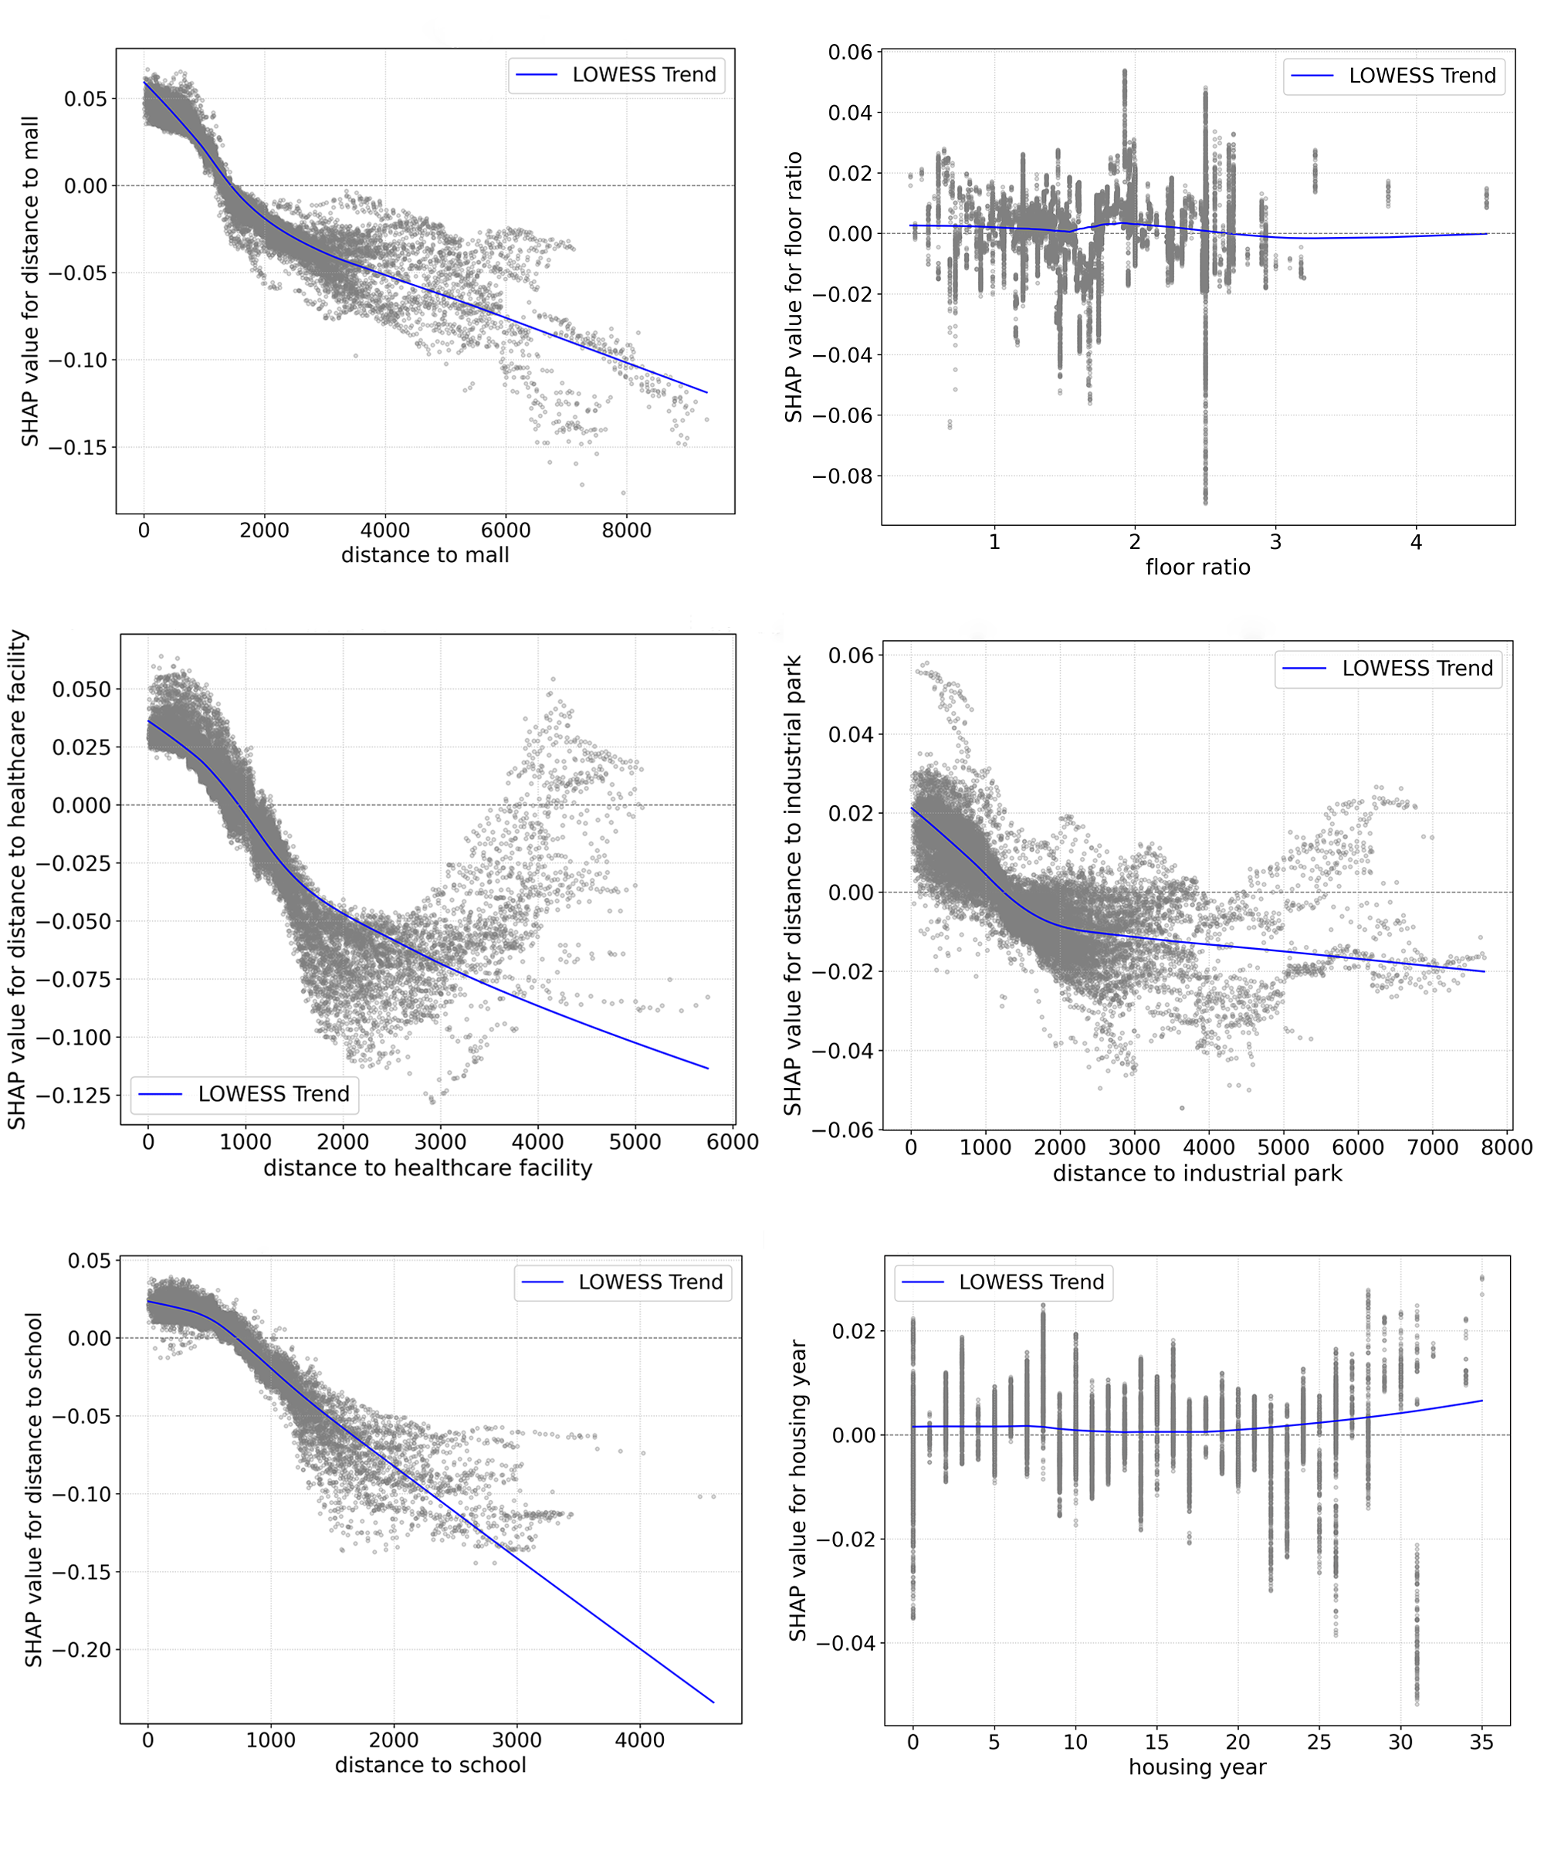
（2）Target variable：potential employment average salary
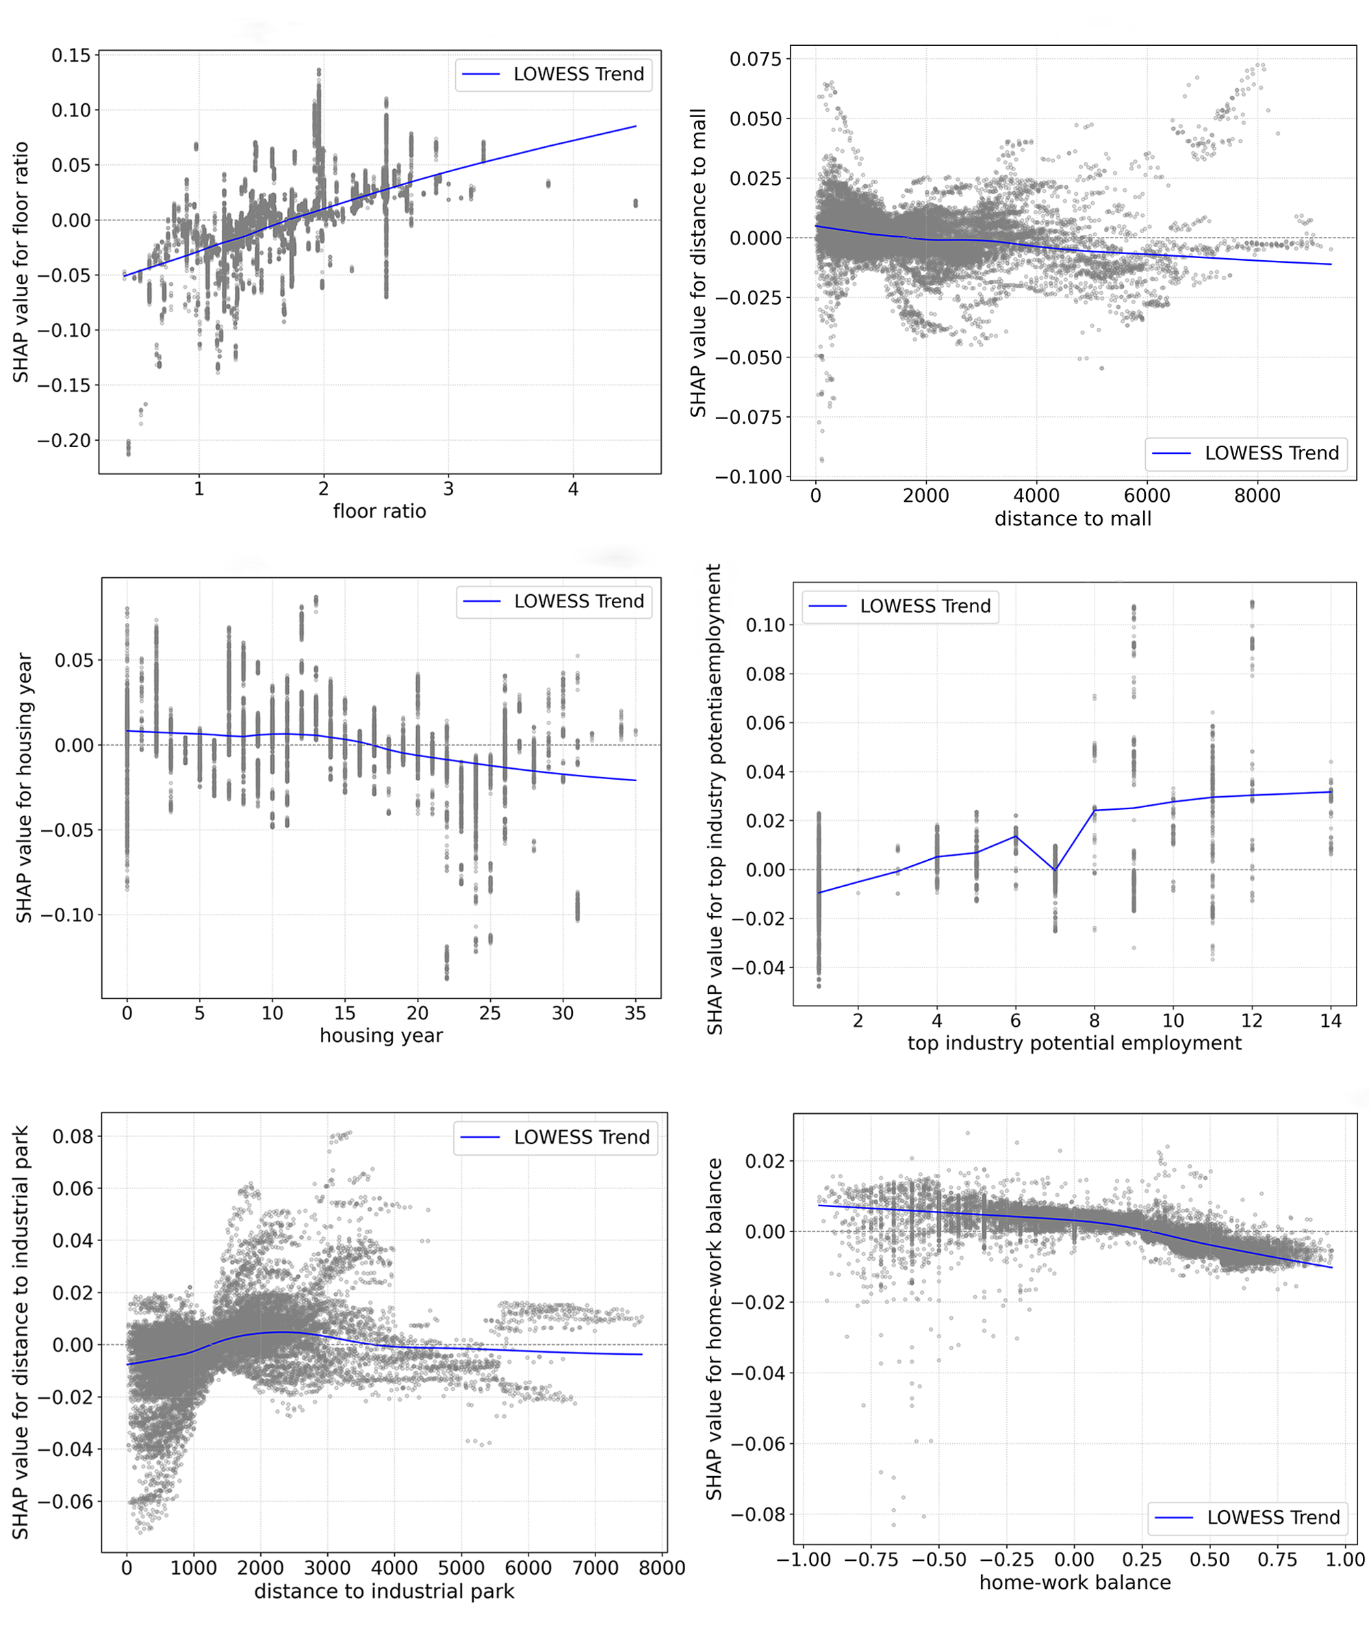
（3）Target variable: potential employment accessibility
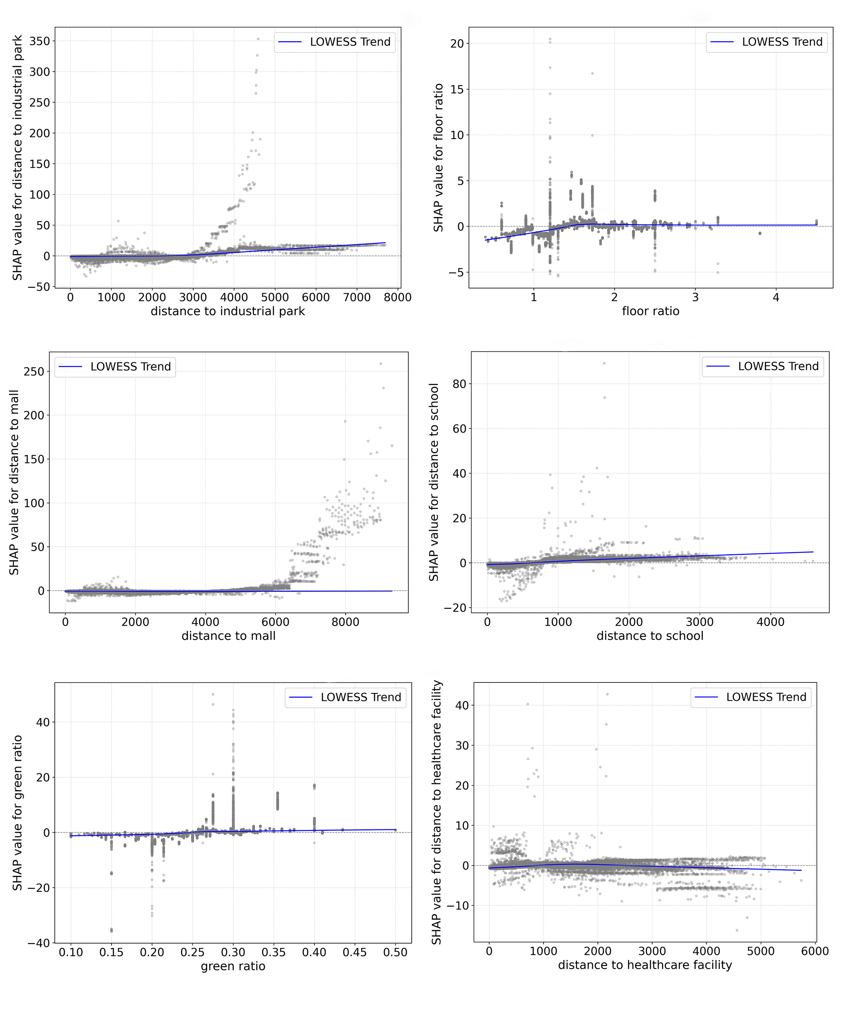

（4）Target variable: actual employment opportunities
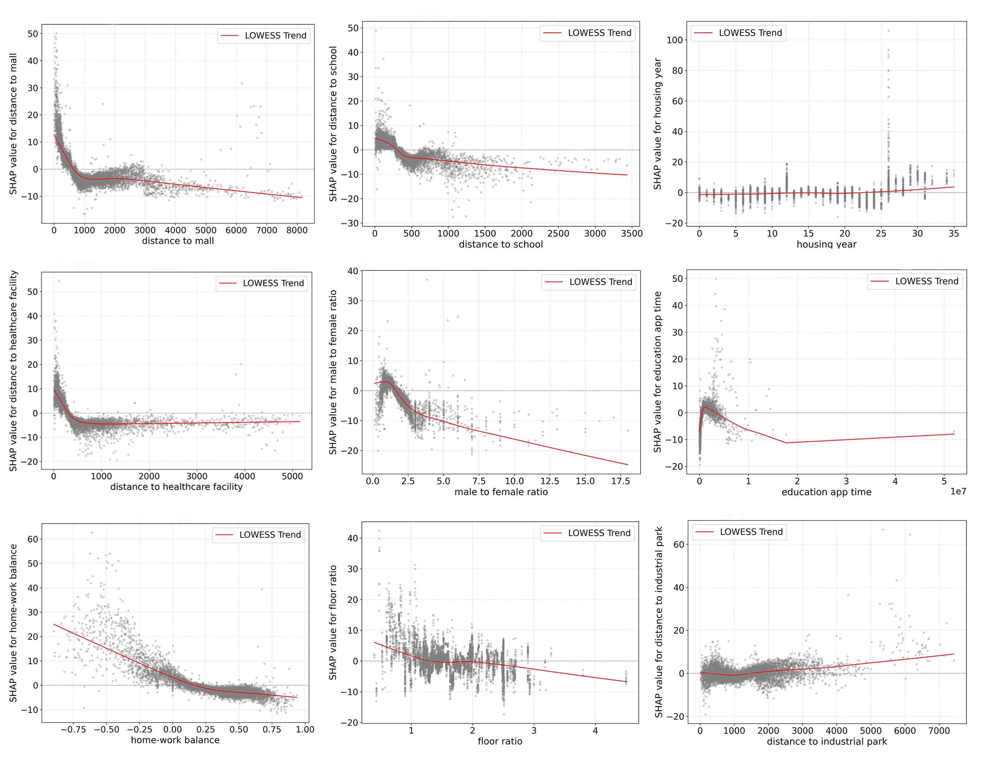
（5）Target variable: actual employment average salary
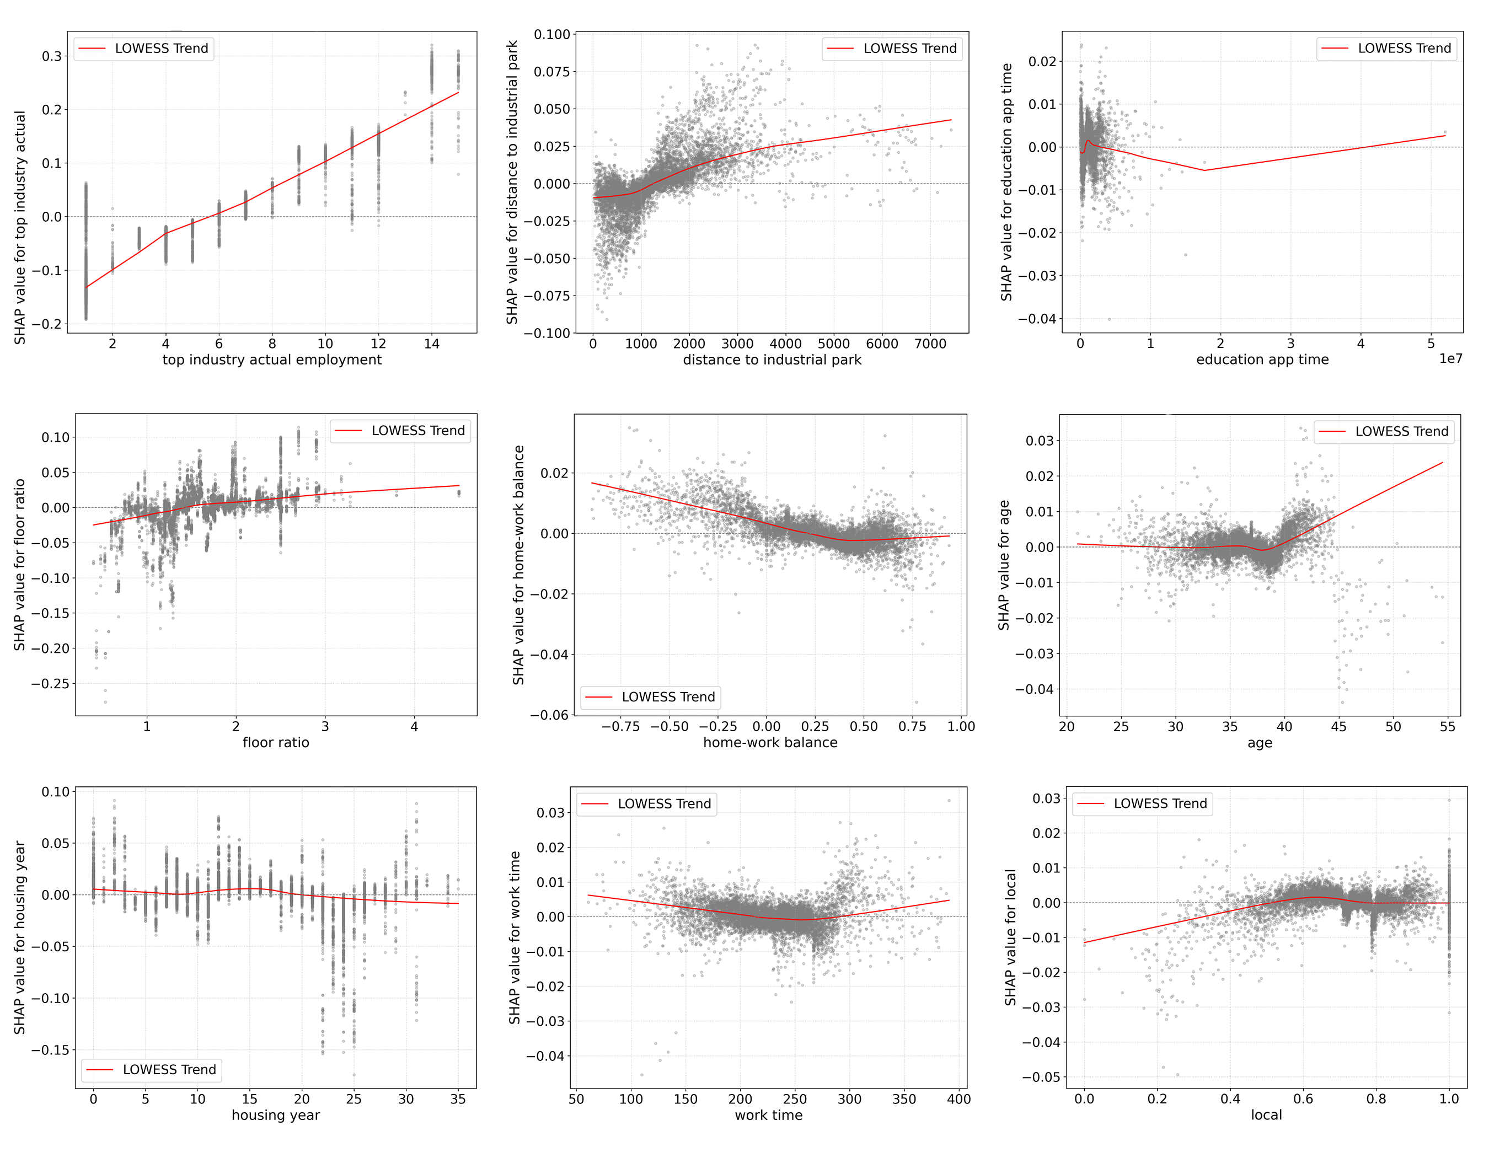
（6）Target variable: actual commute time
