a b
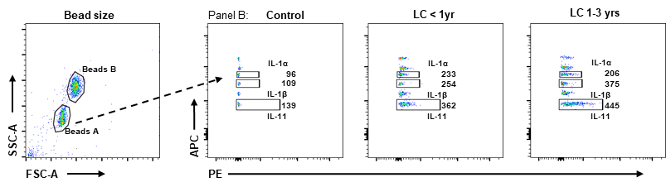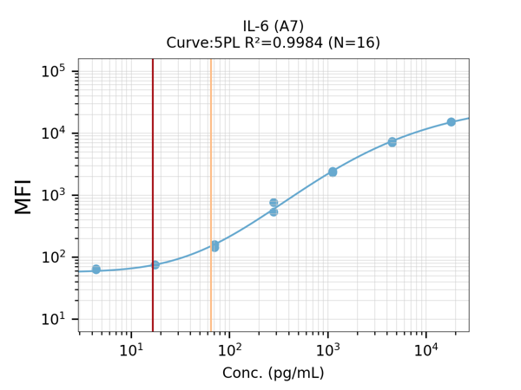
c
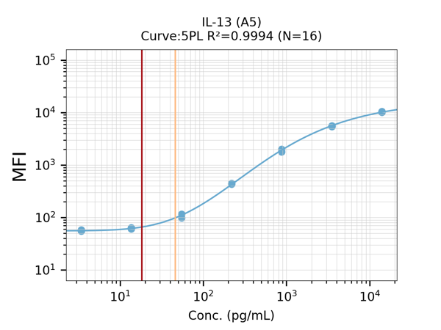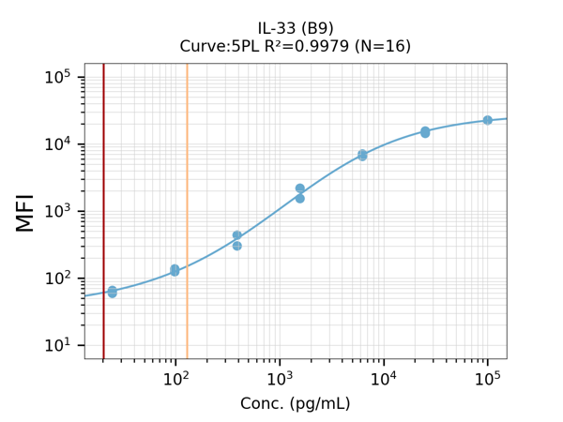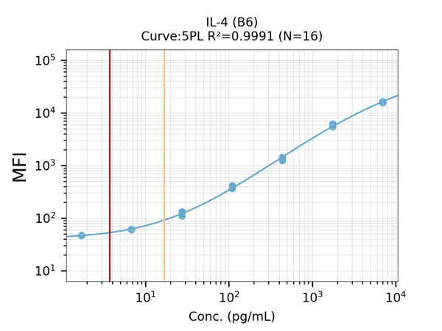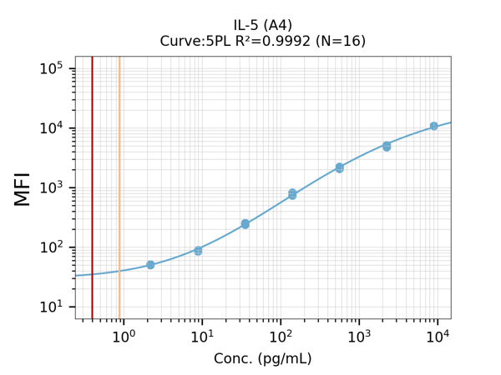
d
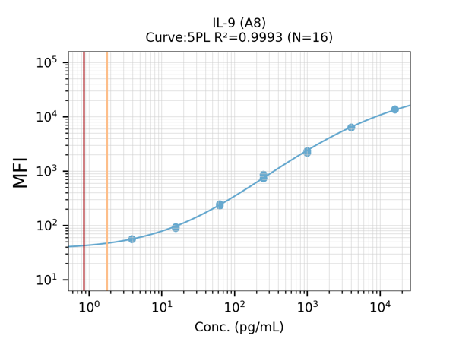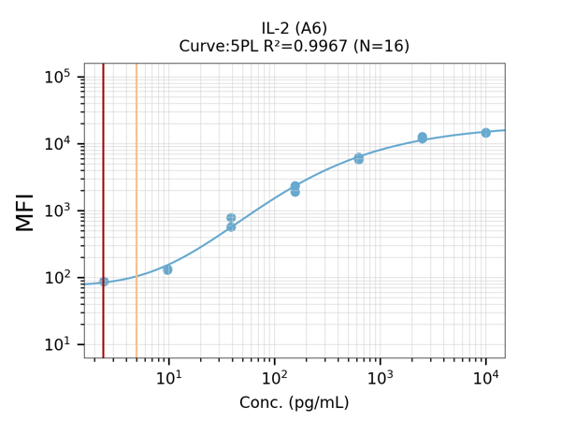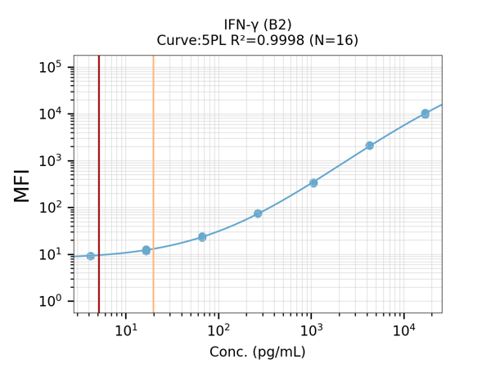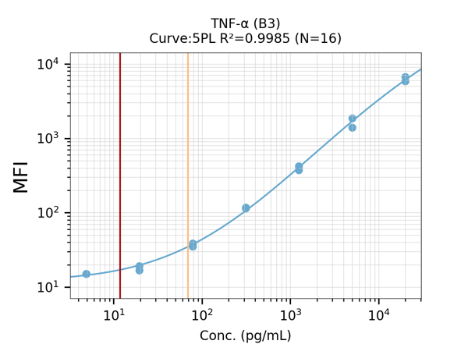
e
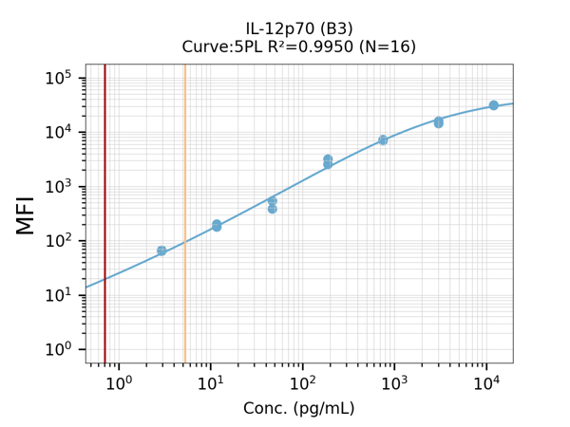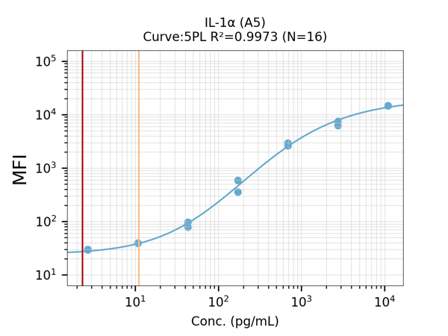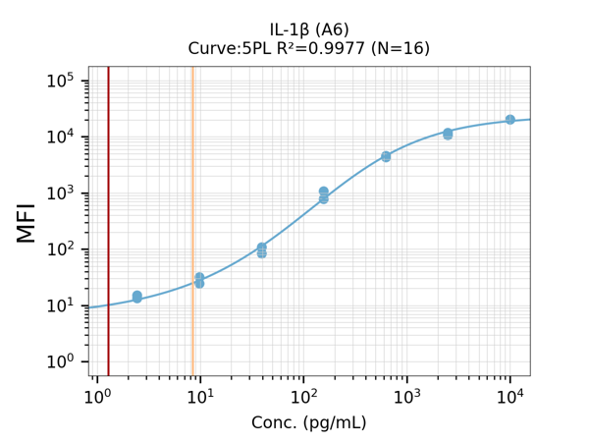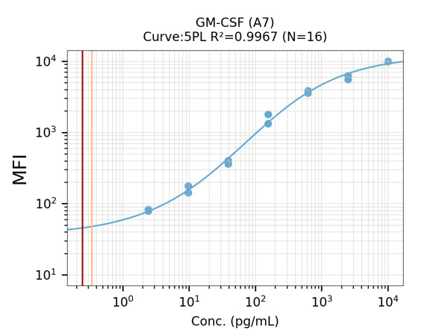
f g
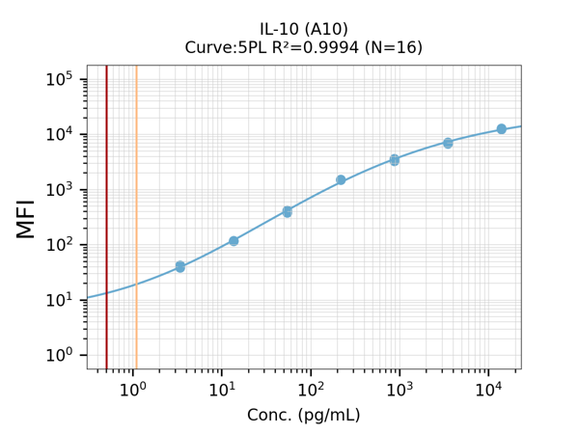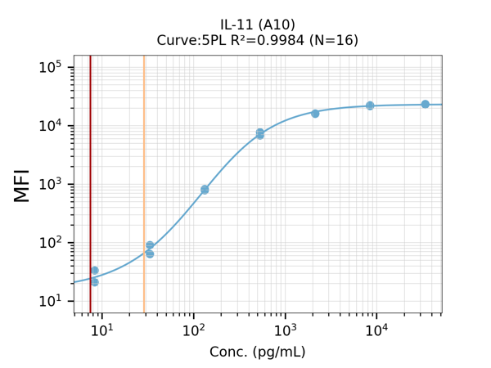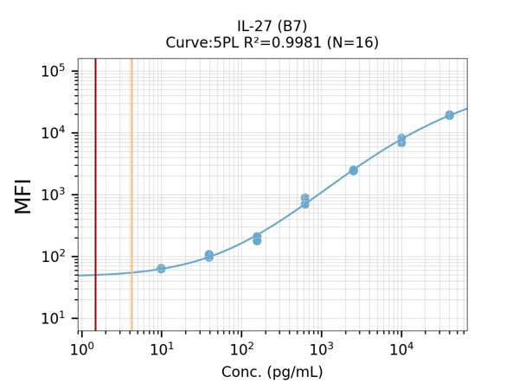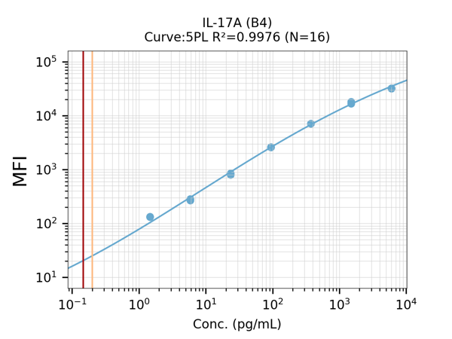
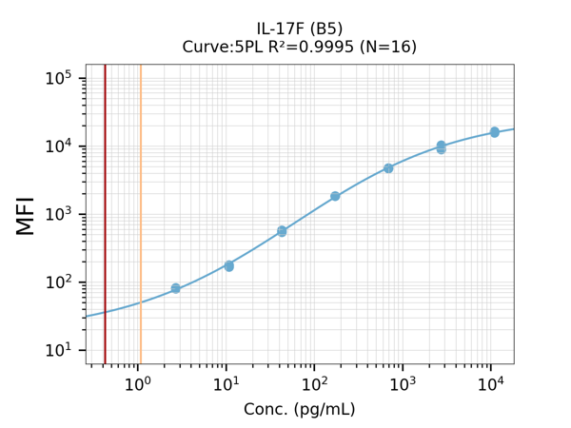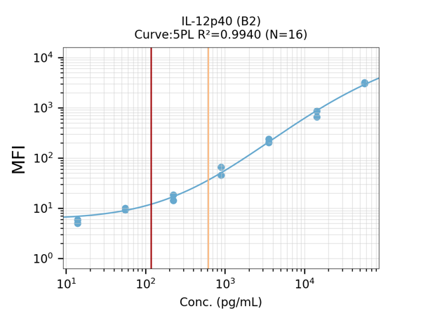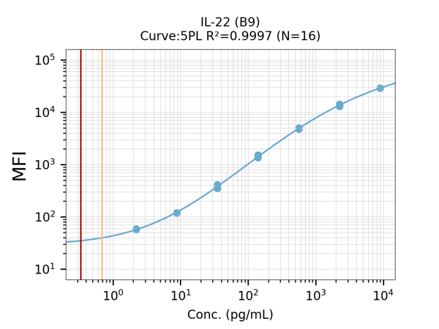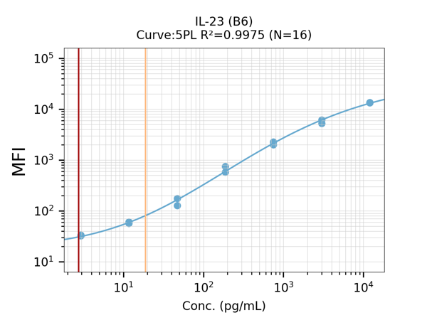

Supplementary Fig 1. Standard settings for cytokine quantification. (a) Representative dot plots of multiplex bead-based assay serum analysis from control group, LC patients within the first and second year of disease. Analysis is shown for the Human Cytokine Panel 2 cytokines IL-1α, IL-1β, and IL-11 among others. Each population represents the acquisition of a specific cytokine, the numbers represent the mean fluorescence intensity (MFI). (b-g) Standard curve concentration range measured for cytokines in the LEGENDplex Human Th Cytokine Panel or LEGENDplex Human Cytokine Panel 2 for (b) SARS-COV-2 related cytokines, (c) Th2/9 related cytokines, (d) Th1 related cytokines, (e) innate like cytokines, (f) regulatory cytokines and (g) Th17/22 related cytokines.

