Extended Data Figure and Tables
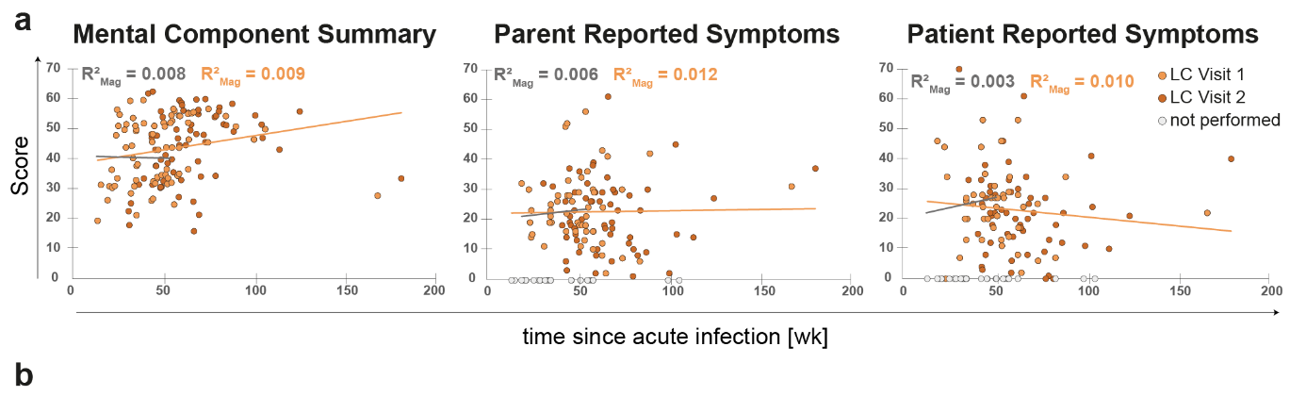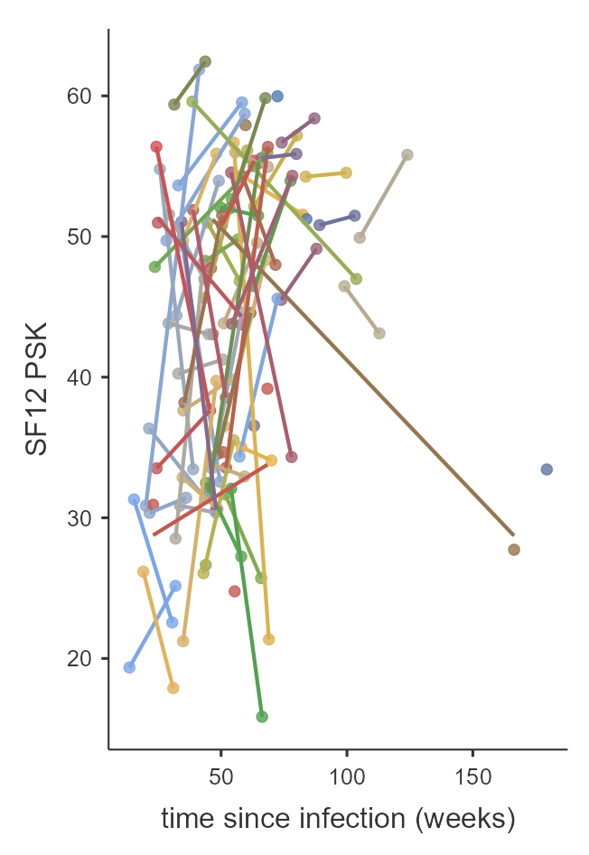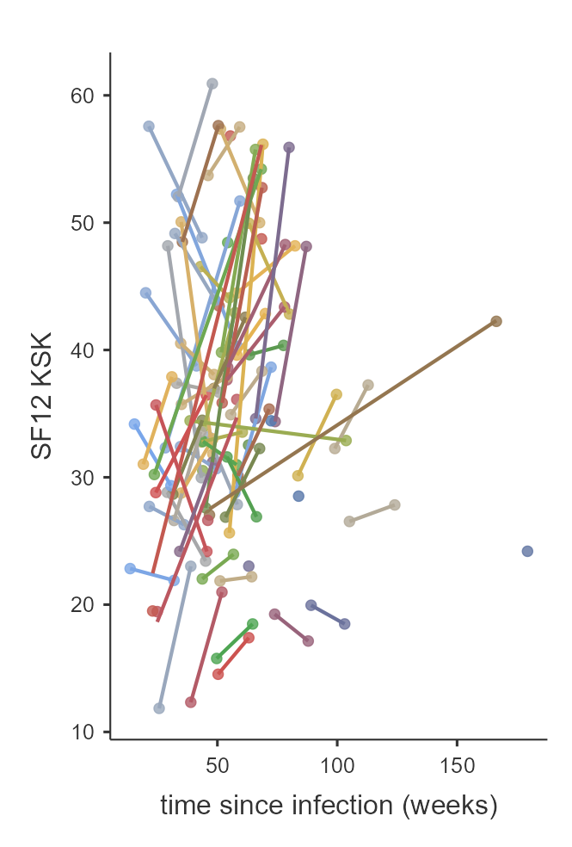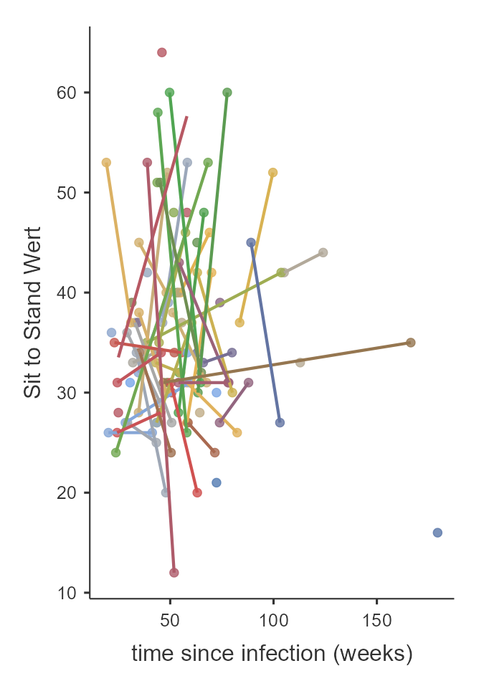
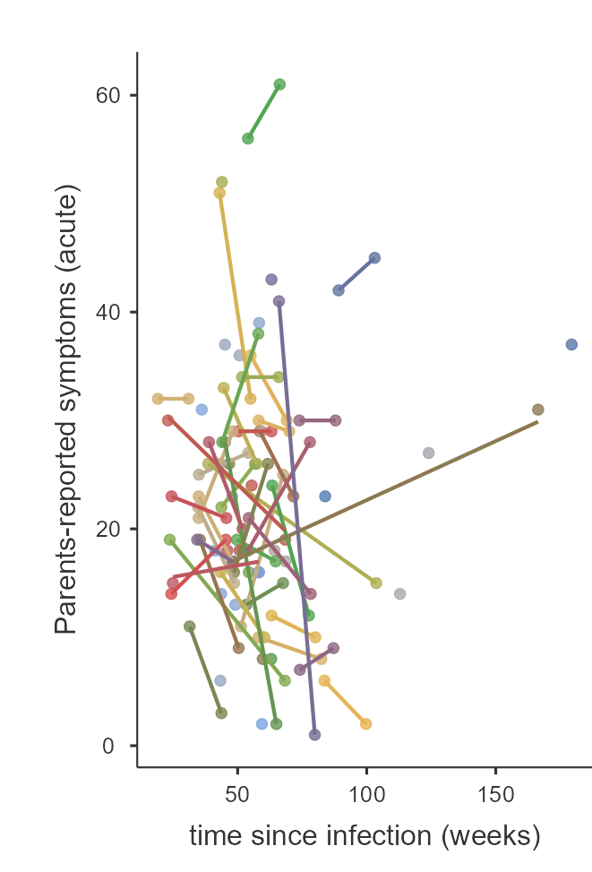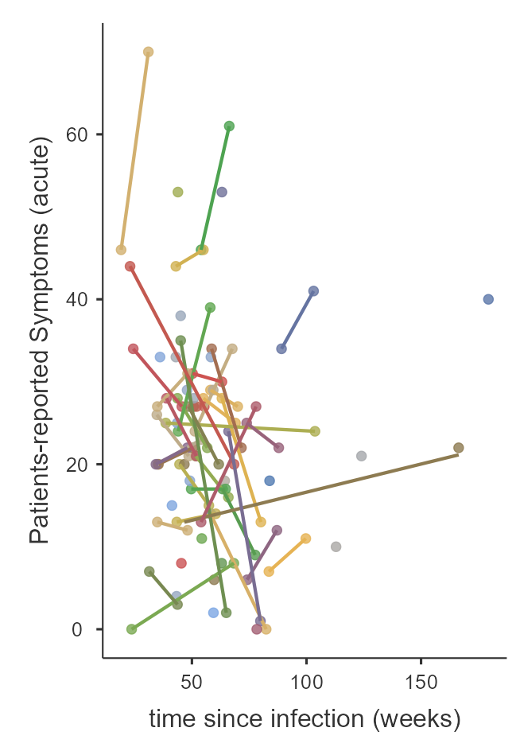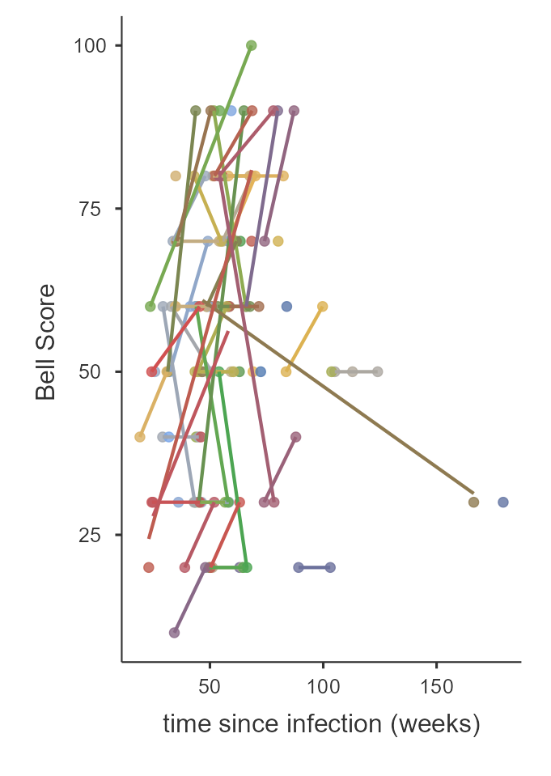

Extended Data Fig. 1 | Related to Fig. 1e. a Additional long COVID-related scores were analysed using the same linear mixed-effects model as in Fig. 1e. Marginal R² (R²_{Marg}) is shown for two time intervals: black indicates the first year post–SARS-CoV-2 infection, red the entire observational period. Each dot represents a donor at a specific visit; most donors contributed data from two visits. (LMM see Extended Data Table 2.1) Black and red lines indicate descriptive regression lines for the respective intervals. b Selected symptom scores are plotted against time since initial SARS-CoV-2 infection, with lines connecting repeated measurements from the same donor across visits.

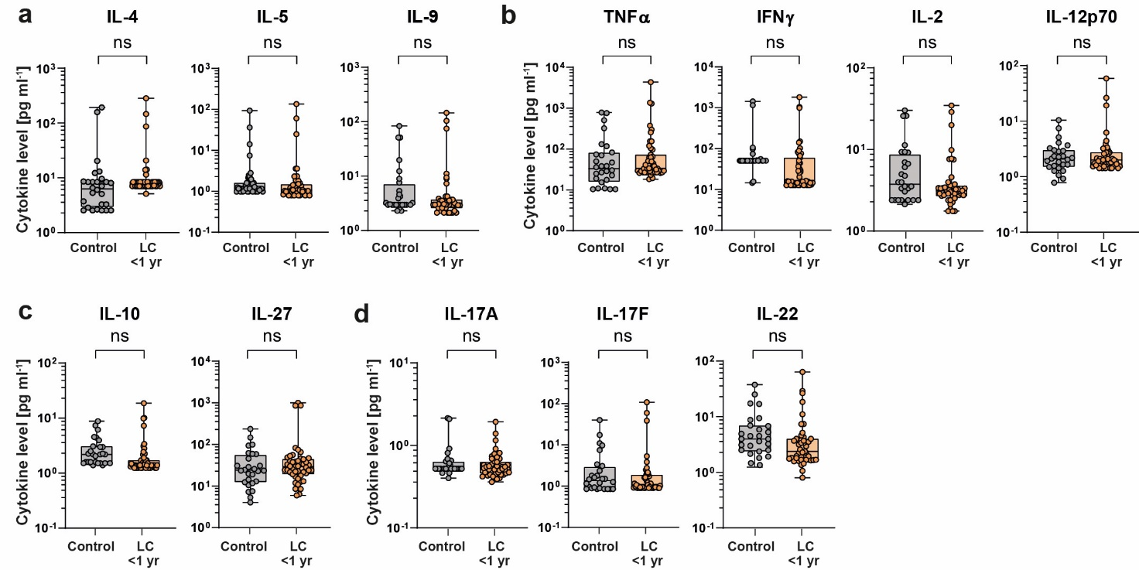
Extended Data Fig. 2 | Systemic cytokines not significantly elevated in paediatric long COVID <1 yr vs. controls (n=27). If LC patients were examined twice in the given period, the mean was taken (n=47). Each point thus shows the data of one individual. Cytokines included in the Bonferroni–Holm–corrected multiple comparison (see Fig. 2 and Extended data Table 2.1 for multiple comparison) did not show significant differences, indicating selective cytokine alterations in paediatric LC.

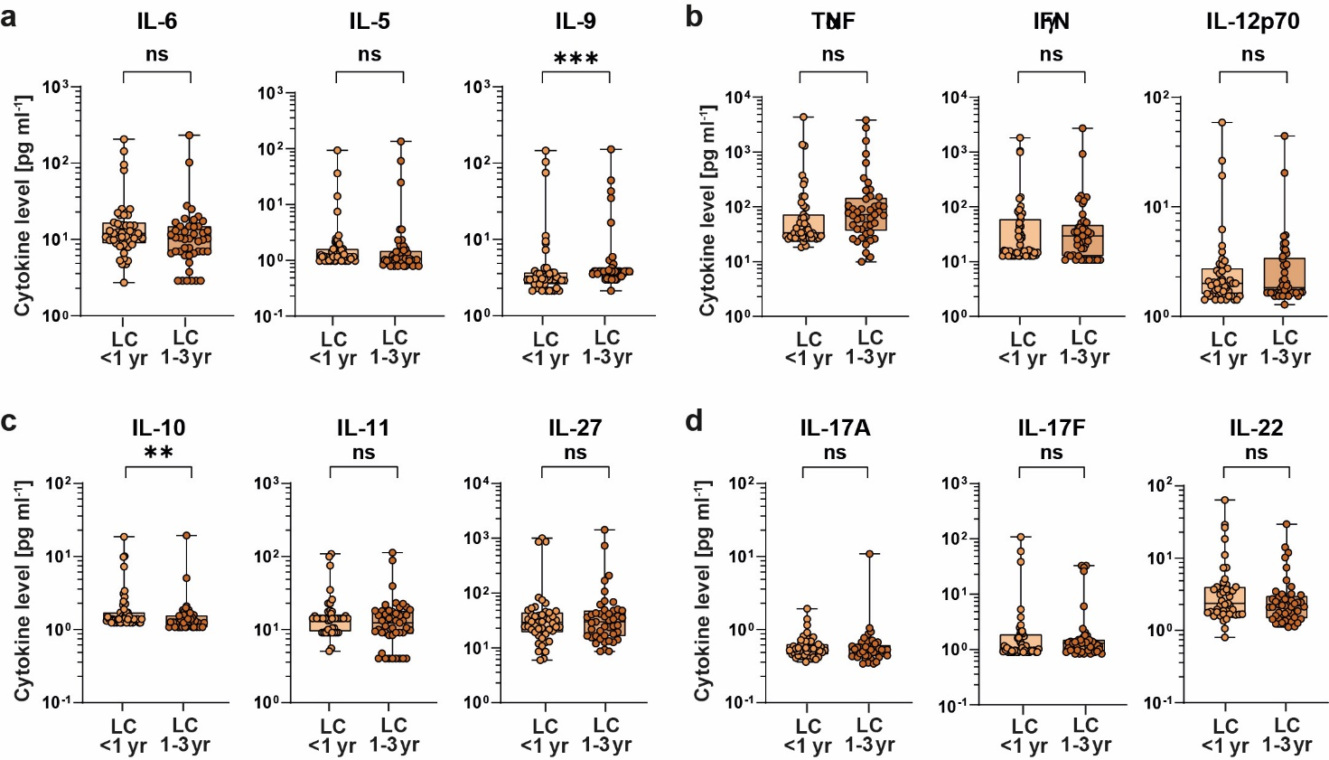

Extended Data Fig. 3.1 | Systemic cytokines not significantly elevated in paediatric long COVID <1 yr vs. 1–3 yr. Cytokines included in the Bonferroni–Holm–corrected multiple comparison (see Fig. 3 and Extended Data Table 3) showed no significant differences between LC <1 yr and LC 1–3 yr.

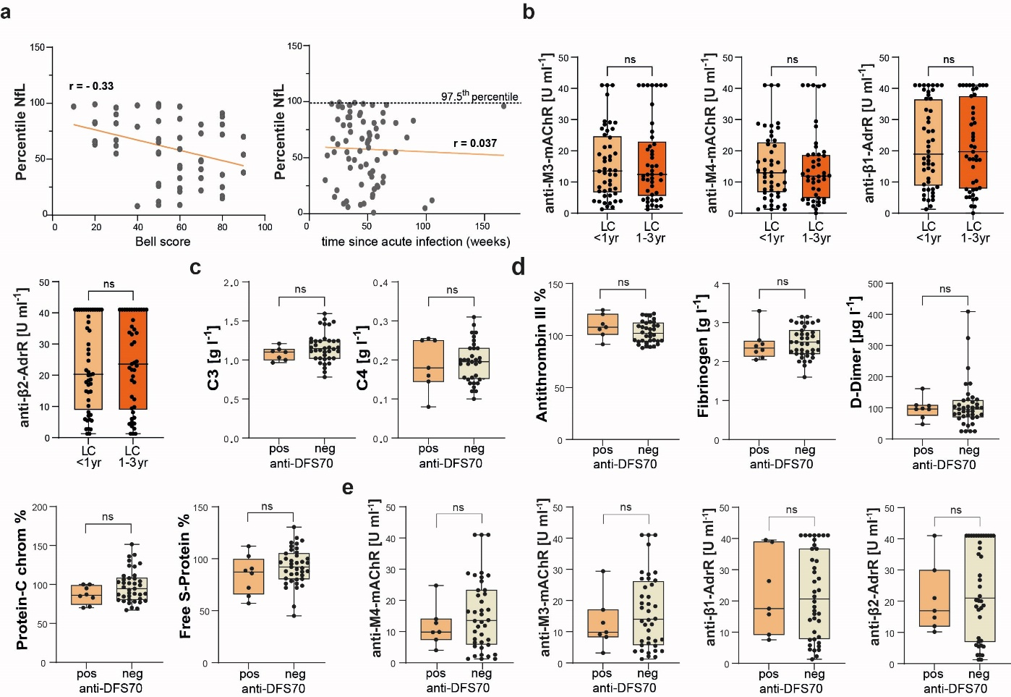

Extended Data Fig. 3.2 | NfL, autoantibodies, complement, coagulation and anti-DFS70.
a Serum NfL percentile levels in LC patients at visit 1 were plotted against Bell Score (left) or time since acute infection (wk)(right) using Pearson´s correlation. Right, the non-significant Pearson's correlation (red line) and the 97.5th percentile which is indicated as the upper Norm-value (dotted line), are shown. b Box plots compare autoantibody levels against muscarinic acetylcholine receptors (anti-M-mAChR) and β-adrenergic receptors (anti-β-AdrR). c Box plots showing coagulation factors in anti-DFS70-positive (orange) and anti-DFS70-negative patients (beige). d Levels of complement factors C3 and C4 in anti-DFS70-positive patients (orange) versus anti-DFS70-negative patients (beige). Each data point represents an individual donor; horizontal lines indicate medians. Normality was assessed using the Kolmogorov–Smirnov test. Statistical significance was determined using the Mann–Whitney U-test or an unpaired t-test.

Extended Data Table 1 | (a) Demographic and clinical characteristics of participants. (b) Lack of physical and mental health recovery in paediatric long COVID cohort over time.
a) Participant characteristics
 | LC patients | Control  group | LC to Control  p-values
General
N | 74 | 27
Age (mean/SD) | 14.1/2.5 | 10.9/5.15 | 0.07 MW-U
Sex female | 45 (59%) | 15 (56%) | 0.80 χ²Test
Percentile BMI (mean/SD) | 48.5/31.7
Visit 1 (time since infection) (wk) (mean/SD) | 47.5/23.2
Visit 2 (time since infection) (wk) (mean/SD) | 64.2/24.0
SARS-CoV-2-related
Tested for COVID-19
Anti-Nucleocapsid ab | 73/75
Anti-Spike ab | 74/75
Possible SARS-CoV-2 naive | 1 not tested | 17/27
Parents reported yes/no/not reported | 74/0/0 | 10/10/7
Pre-born (<37GA) yes/no/not reported | 7/66/4 | 0/0/27
Chronic disease prior long COVID
Attention Deficit Hyperactivity Disorder (ADHD) | 4 (5.4%)
Lactose or Fructose Malabsorption | 7 (9.5%)
Obesity | 2 (2.7%)
Dyslexia | 2 (2.7%)
Migraine (including chronic headaches) | 4 (5.4%)
Gilbert’s Syndrome | 1 (1.4%)
Fetal Alcohol Spectrum Disorder | 1 (1.4%)
Loeys-Dietz Syndrome | 1 (1.4%)
Non-Alcoholic Fatty Liver Disease | 1 (1.4%)
Scoliosis | 1 (1.4%)
Acne | 1 (1.4%)
Visual Disturbances | 1 (1.4%)
Sensory Processing Disorder | 1 (1.4%)
Bronchial Asthma | 3 (4.1%)
Coronary Fistula,  Tricuspid Functionally Bicuspid Aortic Valve,  Mild Mitral Regurgitation | 1 (1.4%)
Divergent Strabismus | 1 (1.4%)
Myofascial Pain Syndrome (Thoracolumbar) | 1 (1.4%)
Psychogenic Gait Disorder, Suspected Arterial Hypertension | 1 (1.4%)
Hashimoto’s Thyroiditis | 1 (1.4%)
Chromosome 13 Anomaly | 1 (1.4%)
Cystic Fibrosis | 0 (0%) | 13 (48%) | <0.001 χ²Test
Atopy (excluding drug allergies) yes/no/unknown | 27/50/0 | 3/16/8 | 0.148 χ²Test
No Prior Illness | 37 (50.0%) | 14 (52%) | 1.0 χ²Test
Dominant VOC in Germany’ during SARS-CoV-2 infection, Nº (%)*
Ancestral and Alpha | 5 (6.8%)
Delta | 18 (24.3%)
Omicron | 49 (66.2%)
Recomb | 2 (2.7%)
*In cases where two variants were classified as Variants of Concern (VOCs), the later-emerging variant was selected due to its higher infectiousness.` Robert-Koch Institut (2025), Berlin, Germany. www.rki.de (Accessed: 11_03_2025)

b Lack of physical and mental health recovery in paediatric long COVID patients over time. Details of linear mixed-effects model results used for Fig. 1e. Dependent variables are listed in the leftmost column. Models include time since acute SARS-CoV-2 infection as a fixed effect and donor ID as a random effect to account for intra-individual variation due to repeated measurements. 1000 bootstrap samples. Marginal R² (R²_{Marg}), reflecting variance explained by the fixed effect alone, is reported for two subgroups: Paediatric long COVID patients with visits within one year post-infection, and the entire cohort including all available visits, with time since infection modelled as a continuous covariate. Abbreviations: Generalized Anxiety Disorder 7-item scale (GAD-7), Patient Health Questionnaire 9-item (PHQ-9), Short Form-12 Physical Component Summary (SF-12 PCS), Short Form-12 Mental Component Summary (SF-12 MCS), Bell Disability Scale (Bell Score), Fatigue Severity Scale (FSS), Sit-to-Stand Test (STS), Parent-Reported Symptoms (PRS), Patient-Reported Symptoms (PtRS), KIDSCREEN Questionnaire (KIDSCREEN), Children’s Sleep Habits Questionnaire (CSHQ).

 | LC <1 yr |  | LC all time points
 | R²_{Mag} | p-value | R²_{Mag} | p-value | Corr. p-value
GAD-7 | 0.003 | 0.538 | 0.037 | 0.027 | 0.27
PHQ-9 | 0 | 0.852 | 0.071 | 0.002 | 0.022
SF12- PCS | 0 | 0.898 | 0.037 | 0.035 | 0.28
SF12 MCS | 0.008 | 0.434 | 0.009 | 0.266 | 1.0
Bell Score | 0.021 | 0.143 | 0.001 | 0.700 | 1.0
FSS | 0 | 0.9 | 0.020 | 0.124 | 0.744
Sit-To-Stand | 0.01 | 0.452 | 0 | 0.835 | 0.835
Parents-RS | 0.006 | 0.377 | 0.012 | 0.228 | 1.0
Patients-RS | 0.003 | 0.629 | 0.010 | 0.300 | 1.0
KIDCREEN | 0.001 | 0.778 | 0.038 | 0.032 | 0.288
CSHQ | 0.016 | 0.132 | 0.025 | 0.081 | 0.567

Extended Data Table 2 | Related to Fig. 2 of the main text.
Extended Data Table 2.1: LMM analysis of FEV₁ Z-scores. Information to Fig. 2d.

a The base model including IL-13 and IL-6 shows a significant fit (R²_{Marg} = 0.162), with IL-13 positively (p < 0.001) and IL-6 negatively (p = 0.003) associated with FEV₁ Z-scores. Kolmogorov-Smirnov p=0.716. 1000 bootstrap samples.

Model Fit FEV1-Z-Score
Type | R² | df | LRT X² | p
Conditional | 0.721 | 3 | 64.123 | <.001
Marginal | 0.162 | 2 | 18.938 | <.001

Parameter Estimates (Fixed coefficients) FEV1-Z-Score
Names | Estimate | SE | df | t | p
(Intercept) | -0.216 | 0.0906 | 69.6 | -2.38 | 0.020
IL-13 | 0.681 | 0.1550 | 126.6 | 4.39 | <.001
IL-6 | -0.443 | 0.1469 | 125.1 | -3.02 | 0.003

b Adding time since infections, sex, and percentile BMI did not improve model fit (ΔR² = 0.010); these covariates were not significant (p > 0.29), while IL-13 and IL-6 remained significant. Patient ID was included as a random effect in all models to account for repeated measures. Kolmogorov-Smirnov p=0.662 using 1000 bootstrap samples.

Model Fit FEV1-Z-Score
Type | R² | df | LRT X² | p
Conditional | 0.720 | 6 | 65.358 | <.001
Marginal | 0.171 | 5 | 20.107 | 0.001

Parameter Estimates (Fixed coefficients) FEV1-Z-Score
Names | Variable Type | Estimate | SE | df | t | p
(Intercept) | (Intercept) | -0.20497 | 0.09227 | 66.1 | -2.222 | 0.030
IL-13 | Metric | 0.69669 | 0.15769 | 121.4 | 4.418 | <.001
IL-6 | Metric | -0.45519 | 0.14993 | 120.9 | -3.036 | 0.003
time since infection (weeks) | Metric | 7.91e-4 | 0.00323 | 117.1 | 0.245 | 0.807
Sex (M=1, F=0) | Nominal 1 - 0 | -0.08307 | 0.18755 | 66.8 | -0.443 | 0.659
Percentile BMI | Metric | 0.00295 | 0.00280 | 91.0 | 1.052 | 0.296
c) Disease severity and G-protein-specific aAb. Spearman’s rank correlation was used to perform correlation analyses between G-protein-specific autoantibodies (aAbs) and Bell Score (n=118), time since SARS-CoV-2 infection (n=137), as well as cytokines (n=136). The dataset comprises observations, with some patients contributing data at more than one time point. Cytokines were selected due to being significantly different between the Control group and the LC group (see Fig. 2c, f–h). The correlation coefficients (Rho) and their respective p-values are shown. After Bonferroni–Holm correction for multiple testing, no statistically significant associations remained.

 | β1-adrenergic receptor aAb (U ml⁻¹) | β2-adrenergic receptor aAb (U ml⁻¹) | M3  muscarinic receptor aAb (U ml⁻¹) | M4  muscarinic receptor aAb (U ml⁻¹)
Bell Score | 0.013  0.885 | 0.040  0.667 | -0.021  0.818 | 0.002  0.986 | Rho  p-value
time since SARS-CoV-2 infection | 0.011  0.900 | 0.048  0.570 | 0.021  0.807 | -0.013  0.875 | Rho  p-value
IL-6 | -0.006  0.948 | -0.004  0,962 | 0.010  0.912 | 0.043  0.613 | Rho  p-value
IL-13 | 0.042  0.628 | 0.043  0.617 | 0.110  0.200 | 0.129  0.132 | Rho  p-value
IFN-γ | 0.062  0.473 | 0.079  0.355 | 0.093  0.280 | 0.138  0.107 | Rho  p-value
IL-1α | 0.106  0.216 | 0.118  0.169 | 0.132  0.122 | 0.156  0.067 | Rho  p-value
IL-1β | 0.127  0.140 | 0.125  0.146 | 0.078  0.364 | 0.097  0.259 | Rho  p-value
GM-CSF | -0.054  0.531 | -0.051  0.553 | -0.043  0.617 | -0.049  0.570 | Rho  p-value
IL-11 | 0.063  0.462 | 0.093  0.279 | 0.115  0.179 | 0.149  0.080 | Rho  p-value
IL-12p40 | 0.151  0.078 | 0.185  0.030 | 0.182  0.033 | 0.181  0.034 | Rho  p-value
IL-33 | 0.130  0.130 | 0.117  0.172 | 0.140  0.101 | 0.160  0.061 | Rho  p-value

Extended Data Table 2.2: Systemic cytokine analysis Control vs. LC ( <1yr). Additional information for Fig. 2c,e, f, g, h of the main text.
Serum cytokine analysis of control group versus LC patients within the first year of disease. If patients had two visits within this time frame, the values were averaged (mean scored). This table shows the p-values from the Mann-Whitney U-test for the hypothesis “Control < LC (<1 year),” along with the Bonferroni-Holm-corrected p-values (labelled corrected p-value). Bold values indicate statistical significance. Corrected p-values greater than 1.0 are reported as 1.0.

 | p-value | corrected p-value
A) SARS-COV-2-related cytokines (see Fig.2c)
IL-6 | 0.862 | 0.862
IL-13 | 0.009 | 0.027
IL-33 | 0.012 | 0.024
B) Th2/9-related cytokines (see Fig.2e; Extended Data Fig. 2a)
IL-4 | 0.021 | 0.063
IL-5 | 0.997 | 0.997
IL-9 | 0.932 | 1.0
C) Th1-related cytokines (Extended Data Fig. 2b)
IL-2 | 0.971 | 1.0
IFN-γ | 1.000 | 1.0
TNF-α | 0.161 | 0.644
IL-12p70 | 0.545 | 1.0
D) Innate-like cytokines (see Fig.2f, Extended Data Fig. 2b)
IL-1α | 0.006 | 0.018
IL-1β | 0.008 | 0.016
GM-CSF | 0.730 | 0.730
E) Regulatory cytokines (see Fig.2g, Extended Data Fig. 2c)
IL-10 | 1.000 | 1.0
IL-11 | 0.001 | 0.003
IL-27 | 0.226 | 0.452
F) Th17-associated cytokines (see Fig.2h, Extended Data Fig. 2d)
IL-17A | 0.814 | 1.0
IL-17F | 0.464 | 0.928
IL-12p40 | 0.002 | 0.01
IL-22 | 0.991 | 0.991
IL-23 | 0.024 | 0.096

Extended Data Table 2.3: Analysis of aAb from Control vs. LC ( <1yr). Additional information for Fig. 2 of the main text.
Serum aAb analysis of control group versus LC patients within the first year of disease. If patients had two visits within this time frame, the values were averaged (mean scored). This table shows the p-values from the Mann-Whitney U-test (MWU) or student´s t-test (tt) as marked, for the hypothesis “Control not LC (<1 year),” along with the Bonferroni-Holm-corrected p-values (labelled corrected p-value). Bold corrected p-values indicate statistical significance. Bold red marks indicate significantly enhanced conglutination components or Anti-EBV ab in anti-DFS70^{pos} LC (1yr) paediatric patients compared to -anti-DFS70^{neg} LC (1yr) paediatric patients. Corrected p-values greater than 1.0 are reported as 1.0 and corrected p-values <0.05 were considered significant.
 | test | p-value | corrected  p-value
A) aAb (see Fig.2i)
Anti-Cardiolipin | MWU | 0.327 | 0.327
Anti-beta-2 GPI | MWU | 0.059 | 0.236
Anti-Prothrombin | MWU | 0.067 | 0.335
Anti-MPO | MWU | 0.001 | 0.007*
Anti-PR3 | MWU | 0.007 | 0.042*
Anti-CCP | MWU | 0.869 | 1.0
Anti-TransG | MWU | 0.097 | 0.291
B) Anti-DFS70^{pos} vs. Anti-DFS70^{neg} and Coagulation factors (see Fig.2l)
vWF% | MWU | 0.0001 | <0.001
vWF Activity% | MWU | 0.0001 | <0.001
F VIII% | MWU | 0.0004 | 0.0049
Anti-PTT | MWU | 0.029 | 0.174
Antithrombin | MWU | 0.214 | 0.856
Fibrinogen | MWU | 0.642 | 1.0
D-Dimer | MWU | 0.950 | 0.950
Protein C | MWU | 0.142 | 0.710
Free S Protein | MWU | 0.237 | 0.711
C) Anti-DFS70^{pos} vs. Anti-DFS70^{neg} and EBV-status (see Fig.2m)
IgG EBV EBNA | MWU | 0.014 | 0.028
IgG EBV VCA | MWU | 0.016 | 0.016
D) Anti-DFS70^{pos} vs. Anti-DFS70^{neg} and complement system
C3 | tt | 0.266 | 0.532
C4 | tt | 0.826 | 0.826
*Reduced in LC group with low levels.

Extended Data Table 3.1 | Systemic cytokine comparison: LC <1 yr vs. LC >1 yr. Extended Data supporting Fig. 3 and Extended Data Fig.4. Serum cytokines were analysed in paediatric LC patients with visits either within the first year post-infection (LC <1 yr, n = 47) or beyond one year (LC >1 yr, n = 45). For patients with multiple visits in the respective period, values were averaged. The table reports p-values from two-sided Mann–Whitney U-tests, along with Bonferroni–Holm–corrected p-values (listed under “corrected p-value”). Bold values indicate statistical significance. Corrected p-values >1.0 are reported as 1.0. Values highlighted in red indicate cytokines significantly increased in the LC >1 yr group. Corrected p-values <0.05 are considered significant.

 | p-value |  |  | corrected p-value
A) Functional GPCR aAb
anti-M3-mAChR | 0.669 |  |  | 1.0
anti-M4-mAChR | 0.409 |  |  | 1.0
anti-beta1-AdrR | 0.989 |  |  | 0.989
anti-beta2-AdrR | 0.709 |  |  | 1.0
B) SARS-COV-2-related and
Th2/9-related cytokines (see Fig.3b)
IL-6 | 0.067 |  |  | 0.067
IL-13 |  | < .001 | < .005
IL-33 | 0.009 |  |  | 0.036
IL-4 | 0.012 |  |  | 0.036
IL-5 | 0.036 |  |  | 0.072
IL-9 |  | < .001 | < .006
C) Th1-related cytokines
IFN-γ | 0.953 |  |  | 0.953
TNFα | 0.039 |  |  | 0.117
IL-12p70 |  | 0.628 | 1.0
D) Regulatory cytokines
IL-10 | 0.004 |  |  | 0.012
IL-11 | 0.304 |  |  | 0.608
IL-27 | 0.806 |  |  | 1.0
E) Innate-like cytokines (see Fig.3c)
IL-2 | < .001 |  |  | < .004
IL-1α | 0.394 |  |  | 0.394
IL-1β | <.001 |  |  | < .003
GM-CSF | 0.037 |  |  | 0.074
F) Th17/22-related cytokines (see Fig.2d)
IL-17A | 0.645 |  |  | 1.0
IL-17F | 0.690 |  |  | 1.0
IL-12p40 | 0.002 |  |  | 0.004
IL-22 | 0.148 |  |  | 0.296
IL-23 | 0.001 |  |  | 0.005

Extended Data Table 3.2 | Details to Linear mixed-effects model to predict Bells Score from immunological and haematological parameters, see visualisation in Fig. 3f. Patient ID served as the clustering variable and was modelled as a random intercept to account for repeated measures within individuals. Bells Score was the dependent variable. Kolmogorov-Smirnov testing gives a p=0.703.
a
Model Fit Bells Score
Type | R² | df |  | LRT X² |  | p
Conditional | 0.786 | 5 |  | 64.260 |  | <.001
Marginal | 0.212 | 4 |  | 26.504 |  | <.001
Parameter Estimates (Fixed coefficients) Bells Score
Names |  |  | Estimate |  | SE |  | df |  | t | p
(Intercept) |  |  | 53.20 |  | 2.16 |  | 63.8 |  | 24.65 | <.001
MCHC mmol/l |  |  | -4.95 |  | 1.82 |  | 109.7 |  | -2.73 | 0.007
IL-12p40 |  |  | 7.31 |  | 1.78 |  | 103.1 |  | 4.11 | <.001
EBV EBNA IgG U/ml |  |  | -5.53 |  | 2.29 |  | 67.8 |  | -2.42 | 0.018
Baso. Granul (abs) Gpt/l |  |  | 3.52 |  | 1.77 |  | 109.6 |  | 1.99 | 0.049
b
Model Fit Bell score
Type | R² | df |  | LRT X² |  | p
Conditional | 0.785 | 6 |  | 64.701 |  | <.001
Marginal | 0.214 | 5 |  | 26.945 |  | <.001
Parameter Estimates (Fixed coefficients) Bell score
Names |  |  | Estimate |  | SE |  |  | df | t | p
(Intercept) |  |  | 53.73095 |  | 2.15791 |  |  | 63.2 | 24.899 | <.001
MCHC mmol/l |  |  | -8.80771 |  | 3.15664 |  |  | 108.7 | -2.790 | 0.006
IL-12p40 |  |  | 0.00510 |  | 0.00125 |  |  | 102.0 | 4.092 | <.001
EBV EBNA IgG U/ml |  |  | -0.02364 |  | 0.01014 |  |  | 67.6 | -2.332 | 0.023
Baso. Granul (abs) Gpt/l |  |  | 185.93039 |  | 93.77047 |  |  | 108.6 | 1.983 | 0.050
time since infection |  |  | -0.04937 |  | 0.07662 |  |  | 105.0 | -0.644 | 0.521

Extended Data Table 4 | EBV-experienced paediatric LC patients show elevated cytokine and autoantibody levels but no enhanced SARS-CoV-2-specific responses.
Details summarize the LMMs presented in Table 1 and Fig. 4 of the main text. LMMs were applied to assess associations between clinical scores, aAb levels, and cytokine concentrations with EBV exposure status in paediatric LC patients, accounting for repeated measurements per individual (clustered by patient ID). EBV exposure was modelled as a binary factor, distinguishing between EBV-naïve (IgG EBV EBNA < 50 U ml⁻¹) and EBV-experienced (IgG EBV EBNA > 50 U ml⁻¹) patients. Sex was included as a factor (male = 1, female = 0). Time since infection (wk), age (yr), and BMI percentile (KiGGS reference) were included as covariates. The dependent variable is indicated above each section in bold. Corrected p-values are provided in Table 1 of the main text.

Anti-SARS-response

Parameter Estimates (Fixed coefficients) Anti-SARS Spike Ab

Names | Variable Type | Estimate | SE | df | t | p
(Intercept) | (Intercept) | 1892 | 423 | 70.0 | 4.470 | <.001
time since infection | Metric | -244 | 352 | 126.2 | -0.694 | 0.489
Sex (M=1, F=0) | 2 - 1 Nominal | 115 | 841 | 69.7 | 0.137 | 0.892
Percentile BMI | Metric | 752 | 398 | 91.6 | 1.888 | 0.062
EBV 2 groups | 2 - 1 Nominal | -371 | 799 | 88.3 | -0.464 | 0.644

Parameter Estimates (Fixed coefficients) CH50

Names | Variable Type | Estimate | SE | df | t | p
(Intercept) | (Intercept) | 60.274 | 1.065 | 68.3 | 56.617 | <.001
time since infection | Metric | -1.801 | 0.849 | 124.0 | -2.121 | 0.036
Sex (M=1, F=0) | Nominal | 0.225 | 2.114 | 68.0 | 0.106 | 0.916
Percentile BMI | Metric | 3.248 | 0.994 | 97.5 | 3.268 | 0.001
EBV 2 groups | Nominal | -0.235 | 1.967 | 93.0 | -0.119 | 0.905
Anti- CoV-2 IgG (Spike) | Metric | 0.643 | 0.768 | 118.8 | 0.837 | 0.404

Parameter Estimates (Fixed coefficients) C3

Names | Variable Type | Estimate | SE | df | t | p
(Intercept) | (Intercept) | 1.16763 | 0.0167 | 65.4 | 69.816 | <.001
time since infection | Metric | -0.00409 | 0.0142 | 119.4 | -0.288 | 0.774
Sex (M=1, F=0)1 | Nominal | -0.00404 | 0.0332 | 65.4 | -0.122 | 0.904
Percentile BMI | Metric | 0.09971 | 0.0162 | 88.6 | 6.169 | <.001
EBV 2 groups | Nominal | -0.00335 | 0.0318 | 82.7 | -0.106 | 0.916
IgG CoV-2 (spike) AU/ml | Metric | 0.00998 | 0.0134 | 126.0 | 0.746 | 0.457

Parameter Estimates (Fixed coefficients) C4
Names | Variable Type | Estimate | SE | df | t | p
(Intercept) | (Intercept) | 0.18995 | 0.00511 | 67.2 | 37.1606 | <.001
time since infection | Metric | -0.00580 | 0.00376 | 124.6 | -1.5396 | 0.126
Sex (M=1, F=0) | Nominal | -0.01373 | 0.01016 | 67.0 | -1.3507 | 0.181
Percentile BMI | Metric | 0.01763 | 0.00463 | 105.1 | 3.8036 | <.001
EBV 2 groups | Nominal | 0.00206 | 0.00922 | 98.7 | 0.2239 | 0.823
IgG CoV-2 Liaison (spike) AU/ml | Metric | -1.83e−4 | 0.00342 | 113.4 | -0.0534 | 0.957

Innate-like cytokines

Parameter Estimates (Fixed coefficients) GM-CFS
Names | Variable Type | Estimate | SE | df | t | p
(Intercept) | (Intercept) | 3.063 | 0.856 | 68.5 | 3.579 | <.001
time since infection | Metric | -0.603 | 0.494 | 104.0 | -1.221 | 0.225
Sex (M=1, F=0) | Nominal 1 - 0 | 3.188 | 1.717 | 68.0 | 1.856 | 0.068
Percentile BMI | Metric | 0.455 | 0.678 | 125.4 | 0.671 | 0.504
EBV 2 groups | Nominal 2 - 1 | 2.529 | 1.388 | 123.1 | 1.823 | 0.071
Age | Metric | 0.377 | 0.340 | 70.1 | 1.108 | 0.271

Parameter Estimates (Fixed coefficients) IL-1α
Names | Variable Type | Estimate | SE | df | t | p
(Intercept) | (Intercept) | 14.806 | 1.548 | 63.5 | 9.565 | <.001
time since infection | Metric | -2.907 | 1.050 | 119.0 | -2.769 | 0.007
Sex (M=1, F=0) | Nominal 1 - 0 | 5.676 | 3.103 | 63.0 | 1.829 | 0.072
Percentile BMI | Metric | 1.646 | 1.330 | 110.3 | 1.238 | 0.218
EBV 2 groups | Nominal 2 - 1 | 6.211 | 2.705 | 106.5 | 2.296 | 0.024
Age | Metric | 0.429 | 0.617 | 65.3 | 0.695 | 0.489

Parameter Estimates (Fixed coefficients) IL-1β
Names | Variable Type | Estimate | SE | df | t | p
(Intercept) | (Intercept) | 12.084 | 2.001 | 67.5 | 6.040 | <.001
time since infection | Metric | 0.344 | 1.007 | 91.4 | 0.341 | 0.734
Sex (M=1, F=0) | Nominal 1 - 0 | 9.279 | 4.017 | 66.9 | 2.310 | 0.024
Percentile BMI | Metric | 0.525 | 1.467 | 129.0 | 0.358 | 0.721
EBV 2 groups | Nominal 2 - 1 | 5.872 | 3.013 | 128.8 | 1.949 | 0.054
Age | Metric | 0.688 | 0.793 | 68.7 | 0.867 | 0.389

Parameter Estimates (Fixed coefficients) IL-6
Names | Variable Type | Estimate | SE | df | t | p
(Intercept) | (Intercept) | 23.70 | 4.62 | 66.6 | 5.13 | <.001
time since infection | Metric | -10.74 | 2.80 | 107.6 | -3.84 | <.001
Sex (M=1, F=0) | Nominal 1 - 0 | 17.76 | 9.27 | 66.1 | 1.92 | 0.060
Percentile BMI | Metric | 5.59 | 3.75 | 122.1 | 1.49 | 0.139
EBV 2 groups | Nominal 2 - 1 | 12.26 | 7.67 | 119.2 | 1.60 | 0.113
Age | Metric | 2.07 | 1.84 | 68.3 | 1.13 | 0.264

Parameter Estimates (Fixed coefficients) IL-15
Names | Variable Type | Estimate | SE | df | t | p
(Intercept) | (Intercept) | 132.51 | 14.15 | 59.2 | 9.366 | <.001
time since infection | Metric | -38.88 | 10.20 | 124.5 | -3.811 | <.001
Sex (M=1, F=0) | Nominal 1 - 0 | 62.72 | 28.35 | 58.8 | 2.212 | 0.031
Percentile BMI | Metric | 6.98 | 12.49 | 100.6 | 0.559 | 0.578
EBV 2 groups | Nominal 2 - 1 | 62.13 | 25.35 | 96.5 | 2.451 | 0.016
Age | Metric | 4.69 | 5.65 | 61.1 | 0.830 | 0.410

Parameter Estimates (Fixed coefficients) IL-18
Names | Variable Type | Estimate | SE | df | t | p
(Intercept) | (Intercept) | 120.27 | 4.93 | 68.7 | 24.391 | <.001
time since infection | Metric | -7.25 | 4.71 | 99.9 | -1.538 | 0.127
Sex (M=1, F=0) | Nominal 1 - 0 | 13.11 | 9.87 | 68.7 | 1.328 | 0.189
Percentile BMI | Metric | -1.08 | 4.84 | 78.2 | -0.222 | 0.825
EBV 2 groups | Nominal 2 - 1 | 21.63 | 9.70 | 76.3 | 2.229 | 0.029
Age | Metric | -3.26 | 1.99 | 70.3 | -1.641 | 0.105

Parameter Estimates (Fixed coefficients) IFNα
Names | Variable Type | Estimate | SE | df | t | p
(Intercept) | (Intercept) | 19.96 | 2.62 | 56.8 | 7.61 | <.001
time since infection | Metric | -8.12 | 1.49 | 94.1 | -5.44 | <.001
Sex (M=1, F=0) | Nominal 1 - 0 | 10.16 | 5.26 | 56.2 | 1.93 | 0.059
Percentile BMI | Metric | -2.33 | 2.06 | 124.9 | -1.13 | 0.261
EBV 2 groups | Nominal 2 - 1 | 7.96 | 4.22 | 122.1 | 1.89 | 0.062
Age | Metric | 1.07 | 1.04 | 58.3 | 1.03 | 0.308

Th17/Th22-associated cytokines

Parameter Estimates (Fixed coefficients) IL-13
Names | Variable Type | Estimate | SE | df | t | p
(Intercept) | (Intercept) | 30.6915 | 5.62 | 66.5 | 5.46148 | <.001
time since infection | Metric | -17.3600 | 1.63 | 67.0 | -10.65596 | <.001
Sex (M=1, F=0) | Nominal 1 - 0 | 19.7007 | 11.31 | 66.0 | 1.74128 | 0.086
Percentile BMI | Metric | -0.0107 | 2.77 | 94.2 | -0.00385 | 0.997
EBV 2 groups | Nominal 2 - 1 | 3.9248 | 5.77 | 96.9 | 0.67997 | 0.498
Age | Metric | 8.5728 | 5.52 | 67.0 | 1.55243 | 0.125

Parameter Estimates (Fixed coefficients) IL-17A
Names | Variable Type | Estimate | SE | df | t | p
(Intercept) | (Intercept) | 0.8011 | 0.152 | 68.4 | 5.253 | <.001
time since infection | Metric | -0.0782 | 0.128 | 125.7 | -0.610 | 0.543
Sex (M=1, F=0) | Nominal 1 - 0 | 0.4202 | 0.305 | 68.2 | 1.376 | 0.173
Percentile BMI | Metric | 0.1582 | 0.143 | 90.5 | 1.105 | 0.272
EBV 2 groups | Nominal 2 - 1 | 0.3980 | 0.289 | 87.6 | 1.378 | 0.172
Age | Metric | -0.0211 | 0.152 | 70.3 | -0.139 | 0.890

Parameter Estimates (Fixed coefficients) IL-17F
Names | Variable Type | Estimate | SE | df | t | p
(Intercept) | (Intercept) | 6.32 | 1.803 | 65.4 | 3.51 | <.001
time since infection | Metric | -1.62 | 1.000 | 98.1 | -1.62 | 0.108
Sex (M=1, F=0) | Nominal 1 - 0 | 7.85 | 3.618 | 64.9 | 2.17 | 0.034
Percentile BMI | Metric | -2.45 | 1.398 | 127.0 | -1.75 | 0.083
EBV 2 groups | Nominal 2 - 1 | 5.57 | 2.863 | 125.2 | 1.95 | 0.054
Age | Metric | 1.81 | 1.780 | 66.9 | 1.02 | 0.312

Parameter Estimates (Fixed coefficients) IL-12p40
Names | Variable Type | Estimate | SE | df | t | p
(Intercept) | (Intercept) | 1445.5 | 173 | 63.0 | 8.379 | <.001
time since infection | Metric | 82.3 | 115 | 116.4 | 0.719 | 0.474
Sex (M=1, F=0) | Nominal 1 - 0 | 942.9 | 346 | 62.5 | 2.726 | 0.008
Percentile BMI | Metric | -183.4 | 147 | 112.4 | -1.250 | 0.214
EBV 2 groups | Nominal 2 - 1 | 930.6 | 299 | 108.5 | 3.115 | 0.002
Age | Metric | 59.0 | 171 | 64.8 | 0.345 | 0.731

Parameter Estimates (Fixed coefficients) IL-22
Names | Variable Type | Estimate | SE | df | t | p
(Intercept) | (Intercept) | 5.451 | 1.025 | 65.5 | 5.317 | <.001
time since infection | Metric | -2.014 | 0.670 | 115.6 | -3.005 | 0.003
Sex (M=1, F=0) | Nominal 1 - 0 | 4.616 | 2.056 | 65.0 | 2.246 | 0.028
Percentile BMI | Metric | -0.349 | 0.866 | 115.0 | -0.403 | 0.688
EBV 2 groups | Nominal 2 - 1 | 3.598 | 1.763 | 111.4 | 2.041 | 0.044
Age | Metric | 0.756 | 1.015 | 67.3 | 0.744 | 0.459

Regulatory cytokines

Parameter Estimates (Fixed coefficients) IL-10
Names | Variable Type | Estimate | SE | df | t | p
(Intercept) | (Intercept) | 2.426 | 0.365 | 67.8 | 6.647 | <.001
time since infection | Metric | -0.609 | 0.258 | 124.0 | -2.360 | 0.020
Sex (M=1, F=0) | Nominal 1 - 0 | 1.487 | 0.732 | 67.4 | 2.032 | 0.046
Percentile BMI | Metric | 0.172 | 0.320 | 108.0 | 0.537 | 0.592
EBV 2 groups | Nominal 2 - 1 | 1.476 | 0.649 | 104.5 | 2.274 | 0.025
Age | Metric | 0.369 | 0.362 | 69.7 | 1.018 | 0.312

Parameter Estimates (Fixed coefficients) IL-11
Names | Variable Type | Estimate | SE | df | t | p
(Intercept) | (Intercept) | 20.53 | 2.58 | 63.3 | 7.972 | <.001
time since infection | Metric | -6.99 | 1.48 | 100.4 | -4.709 | <.001
Sex (M=1, F=0) | Nominal 1 - 0 | 7.05 | 5.17 | 62.8 | 1.364 | 0.177
Percentile BMI | Metric | 1.44 | 2.04 | 124.8 | 0.705 | 0.482
EBV 2 groups | Nominal 2 - 1 | 9.57 | 4.17 | 122.3 | 2.295 | 0.023
Age | Metric | 3.66 | 2.55 | 64.9 | 1.436 | 0.156

Parameter Estimates (Fixed coefficients) IL-27
Names | Variable Type | Estimate | SE | df | t | p
(Intercept) | (Intercept) | 106.06 | 27.5 | 65.2 | 3.864 | <.001
time since infection | Metric | -36.59 | 12.1 | 80.7 | -3.021 | 0.003
Sex (M=1, F=0) | Nominal 1 - 0 | 104.29 | 55.2 | 64.6 | 1.891 | 0.063
Percentile BMI | Metric | -7.15 | 18.5 | 125.1 | -0.386 | 0.700
EBV 2 groups | Nominal 2 - 1 | 75.44 | 38.2 | 126.9 | 1.976 | 0.050
Age | Metric | 23.21 | 27.0 | 66.3 | 0.858 | 0.394

aAb

Parameter Estimates (Fixed coefficients) Anti-Prothrombin aAb
Names | Variable Type | Estimate | SE | df | t | p
(Intercept) | (Intercept) | 6.252 | 0.649 | 68.6 | 9.63 | <.001
time since infection | Metric | -1.677 | 0.394 | 109.0 | -4.26 | <.001
Sex (M=1, F=0) | Nominal 1 - 0 | -2.067 | 1.302 | 68.1 | -1.59 | 0.117
Percentile BMI | Metric | -0.679 | 0.528 | 122.2 | -1.29 | 0.201
EBV 2 groups | Nominal 2 - 1 | 2.297 | 1.079 | 119.5 | 2.13 | 0.035
Age | Metric | 0.671 | 0.642 | 70.2 | 1.05 | 0.299

Parameter Estimates (Fixed coefficients) Anti-TG (Transglutaminase) aAb
Names | Variable Type | Estimate | SE | df | t | p
(Intercept) | (Intercept) | 5.510 | 0.903 | 68.6 | 6.104 | <.001
time since infection | Metric | 0.433 | 0.305 | 72.8 | 1.421 | 0.159
Sex (M=1, F=0) | Nominal 1 - 0 | -0.282 | 1.816 | 68.0 | -0.156 | 0.877
Percentile BMI | Metric | -0.360 | 0.503 | 106.8 | -0.715 | 0.476
EBV 2 groups | Nominal 2 - 1 | -1.057 | 1.043 | 109.8 | -1.013 | 0.313
Age | Metric | -0.405 | 0.888 | 69.2 | -0.456 | 0.650

Parameter Estimates (Fixed coefficients) Anti-CCP aAb
Names | Variable Type | Estimate | SE | df | t | p
(Intercept) | (Intercept) | 5.579 | 0.685 | 69.5 | 8.146 | <.001
time since infection | Metric | -0.327 | 0.355 | 95.4 | -0.921 | 0.359
Sex (M=1, F=0) | Nominal 1 - 0 | -2.324 | 1.375 | 69.0 | -1.690 | 0.096
Percentile BMI | Metric | -0.369 | 0.511 | 128.9 | -0.722 | 0.471
EBV 2 groups | Nominal 2 - 1 | 0.736 | 1.049 | 128.2 | 0.702 | 0.484
Age | Metric | 0.541 | 0.676 | 70.9 | 0.800 | 0.427

Parameter Estimates (Fixed coefficients) M3-mAChr aAb
Names | Variable Type | Estimate | SE | df | t | p
(Intercept) | (Intercept) | 16.727 | 1.35 | 67.3 | 12.397 | <.001
time since infection | Metric | 0.684 | 1.13 | 126.5 | 0.607 | 0.545
Sex (M=1, F=0) | Nominal 1 - 0 | 1.561 | 2.71 | 67.1 | 0.577 | 0.566
Percentile BMI | Metric | 1.002 | 1.27 | 89.6 | 0.792 | 0.430
EBV 2 groups | Nominal 2 - 1 | 6.929 | 2.56 | 87.4 | 2.711 | 0.008
Age | Metric | 0.786 | 1.35 | 69.2 | 0.581 | 0.563

Parameter Estimates (Fixed coefficients) M4-mAChr aAb
Names | Variable Type | Estimate | SE | df | t | p
(Intercept) | (Intercept) | 15.260 | 1.271 | 67.0 | 12.006 | <.001
time since infection | Metric | -1.335 | 0.875 | 122.5 | -1.526 | 0.129
Sex (M=1, F=0) | Nominal 1 - 0 | 0.416 | 2.552 | 66.5 | 0.163 | 0.871
Percentile BMI | Metric | 1.661 | 1.101 | 110.7 | 1.509 | 0.134
EBV 2 groups | Nominal 2 - 1 | 5.438 | 2.237 | 107.8 | 2.431 | 0.017
Age | Metric | 1.057 | 1.266 | 68.8 | 0.835 | 0.407

Granulocytes

Parameter Estimates (Fixed coefficients) Neutrophils
Names | Variable Type | Estimate | SE | df | t | p
(Intercept) | (Intercept) | 3.5333 | 0.122 | 62.0 | 28.896 | <.001
time since infection | Metric | 0.0771 | 0.118 | 91.4 | 0.653 | 0.515
Sex (M=1, F=0) | Nominal 1 - 0 | 0.0763 | 0.245 | 62.2 | 0.311 | 0.757
Percentile BMI | Metric | 0.1475 | 0.121 | 71.3 | 1.219 | 0.227
EBV 2 groups | Nominal 2 - 1 | 0.5739 | 0.242 | 69.0 | 2.370 | 0.021
Age | Metric | 0.2994 | 0.124 | 64.6 | 2.411 | 0.019

Parameter Estimates (Fixed coefficients) Eosinophils
Names | Variable Type | Estimate | SE | df | t | p
(Intercept) | (Intercept) | 0.1680 | 0.0159 | 66.3 | 10.591 | <.001
time since infection | Metric | 0.0219 | 0.0141 | 115.4 | 1.545 | 0.125
Sex (M=1, F=0) | Nominal 1 - 0 | 0.0132 | 0.0318 | 66.2 | 0.414 | 0.680
Percentile BMI | Metric | 0.0191 | 0.0153 | 82.8 | 1.253 | 0.214
EBV 2 groups | Nominal 2 - 1 | -0.0134 | 0.0307 | 80.1 | -0.435 | 0.665
Age | Metric | -0.0493 | 0.0160 | 68.9 | -3.081 | 0.003

Parameter Estimates (Fixed coefficients) Basophils
Names | Variable Type | Estimate | SE | df | t | p
(Intercept) | (Intercept) | 0.03971 | 0.00215 | 67.5 | 18.459 | <.001
time since infection | Metric | 0.00121 | 0.00174 | 128.9 | 0.698 | 0.487
Sex (M=1, F=0) | Nominal 1 - 0 | -0.00198 | 0.00432 | 67.3 | -0.458 | 0.648
Percentile BMI | Metric | 7.09e-4 | 0.00199 | 94.2 | 0.356 | 0.723
EBV 2 groups | Nominal 2 - 1 | 0.00107 | 0.00403 | 90.9 | 0.265 | 0.791
Age | Metric | -7.58e−4 | 0.00216 | 70.1 | -0.351 | 0.727

Mental Health

Parameter Estimates (Fixed coefficients) PHQ-9
Names | Variable Type | Estimate | SE | df | t | p
(Intercept) | (Intercept) | 9.536 | 0.586 | 64.5 | 16.287 | <.001
time since infection | Metric | -1.605 | 0.488 | 127.3 | -3.292 | 0.001
Sex (M=1, F=0) | Nominal 1 - 0 | -0.506 | 1.174 | 64.2 | -0.431 | 0.668
Percentile BMI | Metric | -0.243 | 0.548 | 87.9 | -0.443 | 0.659
EBV 2 groups | Nominal 2 - 1 | 1.293 | 1.110 | 85.0 | 1.165 | 0.247
Age | Metric | 0.911 | 0.587 | 66.6 | 1.551 | 0.126

Parameter Estimates (Fixed coefficients) Mental Component Summary scores (SF-12 MCS)
Names | Variable Type | Estimate | SE | df | t | p
(Intercept) | (Intercept) | 43.74 | 1.14 | 67.2 | 38.33 | <.001
time since infection | Metric | 2.18 | 1.04 | 112.2 | 2.10 | 0.038
Sex (M=1, F=0) | Nominal 1 - 0 | 2.59 | 2.29 | 67.0 | 1.13 | 0.261
Percentile BMI | Metric | 2.01 | 1.10 | 81.4 | 1.83 | 0.072
EBV 2 groups | Nominal 2 - 1 | -3.27 | 2.22 | 79.2 | -1.47 | 0.145
Age | Metric | -1.44 | 1.15 | 69.3 | -1.25 | 0.215

Parameter Estimates (Fixed coefficients) GAD-7
Names | Variable Type | Estimate | SE | df | t | p
(Intercept) | (Intercept) | 5.875 | 0.511 | 64.6 | 11.492 | <.001
time since infection | Metric | -0.967 | 0.427 | 126.8 | -2.263 | 0.025
Sex (M=1, F=0) | Nominal 1 - 0 | -0.577 | 1.025 | 64.3 | -0.563 | 0.575
Percentile BMI | Metric | -0.277 | 0.479 | 87.5 | -0.579 | 0.564
EBV 2 groups | Nominal 2 - 1 | 1.658 | 0.970 | 84.7 | 1.709 | 0.091
Age | Metric | 0.316 | 0.513 | 66.8 | 0.616 | 0.540

Extended Data Table 5 | Supporting data for Fig. 4. a Linear mixed-effects model (LMM) for the Bell Score applied to the EBV EBNA-negative/low sub cohort of long COVID patients, as shown in Fig. 3f and Extended Data Table 3.2, with EBV status excluded as a covariate. 1000 bootstrap samples. Kolmogorov-Smirnov test p=0.965. b An extended version of the model including peripheral vitamin B1 levels and time since beginning of infection is also presented. 1000 bootstrap samples.

a
Model Fit Bell Score
Type | R² | df | LRT X² | p
Conditional | 0.812 | 4 | 54.117 | <.001
Marginal | 0.286 | 3 | 27.270 | <.001

Parameter Estimates (Fixed coefficients) Bell Score
Names | Estimate | SE | df | t | p
(Intercept) | 53.17 | 2.67 | 39.0 | 19.94 | <.001
MCHC mmol/l | -8.90 | 2.44 | 64.3 | -3.65 | <.001
IL-12p40 | 4.83 | 1.47 | 37.3 | 3.29 | 0.002
Baso. Granul (abs) Gpt/l | 4.72 | 2.00 | 63.0 | 2.36 | 0.021

b
Model Fit Bell Score
Type | R² | df | LRT X² | p
Conditional | 0.851 | 6 | 57.516 | <.001
Marginal | 0.314 | 5 | 33.957 | <.001

Parameter Estimates (Fixed coefficients) Bell Score
Names | Estimate | SE | df | t | p
(Intercept) | 53.5295 | 2.7063 | 38.0 | 19.780 | <.001
MCHC mmol/l | -8.4162 | 2.3941 | 61.7 | -3.515 | <.001
IL-12p40 | 3.7339 | 1.4401 | 34.9 | 2.593 | 0.014
Baso. Granul (abs) | 4.7213 | 1.9445 | 56.6 | 2.428 | 0.018
time since infection (wk) | -0.0165 | 0.1108 | 54.8 | -0.149 | 0.882
Vitamin B1 nmol/l | 0.1581 | 0.0567 | 50.8 | 2.787 | 0.007

Extended Data Table 6 | Linear mixed-effects models for 43 metabolic parameters
a,b Linear mixed-effects models (LMMs) were fitted separately for each of the 43 metabolic and biomarker parameters, with patient ID as a random intercept. Fixed effects included time since symptom onset (≤1 vs. >1 year), EBV EBNA IgG status (cut-off: 50 U ml⁻¹), anti-DFS70 aAb status (positive/negative), and all two-way and three-way interaction terms. P-values were estimated using the Satterthwaite approximation and validated via non-parametric bootstrapping (percentile method, 1,000 iterations). In some models, Q–Q plots indicated deviations from normality that were not resolved by mirroring or log₁₀ transformation. As no heteroscedasticity or V-shaped residual structure was observed, and LMMs are robust to moderate non-normality, all models were retained. Reported are both unadjusted and Holm–Bonferroni-corrected p-values; only corrected p < 0.05 was considered significant. Marginal R² values refer to variance explained by fixed effects. For further details on the significant models, refer to Extended Data Table 6b below.

Parameter | p-value | R²_{Mag} | corr.  p-value | Time (T) | EBV (E) | DFS70 (D) | Interaction  T*D | Interaction  E*D | Interaction  T*E | Interaction  T*E*D
TSH | <.001 | 0.415 | 0.043 | <.001 | <.001 | <.001 | <.001 | <.001 | <.001 | <.001
LP(a) | <.001 | 0.170 | 0.043 | <.001 | 0.074 | 0.002 | <.001 | 0.041 | <.001 | <.001
aPTT | <.001 | 0.211 | 0.043 | <.001 | 0.006 | 0.003 | <.001 | 0.078 | 0.088 | 0.048
RDW % | 0.002 | 0.140 | 0.080
IgA | 0.005 | 0.168 | 0.195
hs-CRP | 0.015 | 0.132 | 0.57
Factor VIII | 0.021 | 0.138 | 0.777
Vitamin D | 0.024 | 0.130 | 0.846
Zinc | 0.046 | 0.106 | 1.0
Selenium | 0.220 | 0.071 | 1.0
Calcium | 0.777 | 0.029 | 1.0
Chloride | 0.173 | 0.075 | 1.0
Potassium | 0.441 | 0.054 | 1.0
Blood pH | 0.627 | 0.041 | 1.0
Oxygen | 0.671 | 0.039 | 1.0
Stand.  Bicarbonate | 0.081 | 0.090 | 1.0
Glucose | 0.412 | 0.053 | 1.0
Lactate | 0.342 | 0.057 | 1.0
IgM | 0.530 | 0.035 | 1.0
IgG | 0.484 | 0.031 | 1.0
ACTH | 0.621 | 0.047 | 1.0
Fibrinogen | 0.388 | 0.058 | 1.0
D-Dimer | 0.239 | 0.062 | 1.0
Free  protein S | 0.397 | 0.053 | 1.0
Purine | 0.881 | 0.024 | 1.0
Folic acid | 0.928 | 0.014 | 1.0
Ferritin | 0.565 | 0.044 | 1.0
LDH | 0.256 | 0.063 | 1.0
CK | 0.432 | 0.053 | 1.0
Triglyceride | 0.724 | 0.034 | 1.0
Vitamin B1 | 0.983 | 0.013 | 0.983
Vitamin B6 | 0.417 | 0.061 | 1.0
Vitamin B12 | 0.203 | 0.059 | 1.0
Holotranscobalmin | 0.207 | 0.124 | 1.0
ALT | 0.878 | 0.017 | 1.0
AST | 0.645 | 0.038 | 1.0
Lipase | 0.332 | 0.038 | 1.0
Uric acid | 0.993 | 0.004 | 1.0
Creatinine | 0.274 | 0.087 | 1.0
eGFR | 0.965 | 0.014 | 1.0
Phosphate | 0.602 | 0.046 | 1.0
Hs cTNT | 0.577 | 0.045 | 1.0
CKMB | 0.643 | 0.032 | 1.0
aPTT (Activated Partial Thromboplastin Time), LP (Lipoprotein (a)), TSH (Thyroid Stimulating Hormone), hs-CRP (high-sensitivity C-Reactive Protein), ACTH (Adrenocorticotropic Hormone), RDW (Red Cell Distribution Width), AST (Aspartate Aminotransferase), LDH (Lactate Dehydrogenase), CK (Creatine Kinase), eGFR (estimated Glomerular Filtration Rate), ALT (Alanine Aminotransferase), hs-cTnT (high-sensitivity Cardiac Troponin T), CK-MB (Creatine Kinase-MB).

b) Detailed information for the significant models (LMM) in Table 2 and Extended Data Table 6a.

Model Info LP(a)
Info
Model Type |  | Mixed Model |  |  | Linear Mixed model for continuous y
Model |  | lmer |  |  | `LP(a) nmol/l)` ~ 1 + `Time window` + DSF70 + `EBV 2 groups` + `Time window`:DSF70 + `Time window`:`EBV 2 groups` + DSF70:`EBV 2 groups` + `Time window`:DSF70:`EBV 2 groups` + ( 1 | Donor ID )
Distribution |  | Gaussian |  |  | Normal distribution of residuals
Direction |  | y |  |  | Dependent variable scores
Optimizer |  | bobyqa
DF method |  | Satterthwaite
Sample size |  | 131
Converged |  | yes
Y transform |  | none
C.I. method |  | Bootstrap percent |  |  | 1000 bootstrap samples
Model Fit LP(a)
Type | R² |  | df | LRT X² |  | p
Conditional | 0.949 |  | 8 | 157.525 |  | <.001
Marginal | 0.170 |  | 7 | 25.606 |  | <.001

Parameter Estimates (Fixed coefficients) LP(a)
Names | Variable Type | Estimate | SE | df | t | p
(Intercept) | (Intercept) | 83.5 | 13.3 | 74.2 | 6.28 | <.001
Time window | 2 – 1 Nominal | -75.4 | 22.6 | 81.2 | -3.34 | 0.001
DSF70 aAb | 2 – 1 Nominal | 86.9 | 26.6 | 74.2 | 3.27 | 0.002
EBV 2 groups | 2 – 1 Nominal | 47.1 | 26.0 | 77.7 | 1.81 | 0.074
DSF70 aAb ✻ EBV 2 groups | Nominal✻Nominal | 108.1 | 52.0 | 77.7 | 2.08 | 0.041
Time window ✻ DSF70 aAb | Nominal✻Nominal | -156.1 | 45.2 | 81.2 | -3.45 | <.001
Time window ✻ EBV 2 groups | Nominal✻Nominal | -185.5 | 45.2 | 81.5 | -4.10 | <.001
Time window ✻ DSF70 aAb ✻ EBV 2 groups | Nominal✻Nominal✻ Nominal | -355.4 | 90.5 | 81.5 | -3.93 | <.001

Model Info aPTT
Info
Model Type |  | Mixed Model |  |  | Linear Mixed model for continuous y
Model |  | lmer |  |  | `aPTT` ~ 1 + `Time window` + DSF70 + `EBV 2 groups` + `Time window`:DSF70 + `Time window`:`EBV 2 groups` + DSF70:`EBV 2 groups` + `Time window`:DSF70:`EBV 2 groups` + ( 1 | Donor ID )
Distribution |  | Gaussian |  |  | Normal distribution of residuals
Direction |  | y |  |  | Dependent variable scores
Optimizer |  | bobyqa
DF method |  | Satterthwaite
Sample size |  | 138
Converged |  | yes
Y transform |  | none
C.I. method |  | Bootstrap percent |  |  | 1000 bootstrap samples
Model Fit aPTT
Type | R² |  | df | LRT X² |  | p
Conditional | 0.700 |  | 8 | 69.667 |  | <.001
Marginal | 0.211 |  | 7 | 28.961 |  | <.001

Parameter Estimates (Fixed coefficients) aPTT
Names | Variable Type | Estimate | SE | df | t | p
(Intercept) | (Intercept) | 32.39 | 0.560 | 99.7 | 57.80 | <.001
Time window | 2 – 1 Nominal | -3.43 | 1.042 | 119.7 | -3.29 | 0.001
DSF70 aAb | 2 – 1 Nominal | 3.37 | 1.121 | 99.7 | 3.01 | 0.003
EBV 2 groups | 2 – 1 Nominal | 3.15 | 1.117 | 101.3 | 2.82 | 0.006
DSF70 aAb ✻ EBV 2 groups | Nominal✻Nominal | -7.18 | 2.083 | 119.7 | -3.45 | <.001
Time window ✻ DSF70 aAb | Nominal✻Nominal | -3.59 | 2.086 | 119.4 | -1.72 | 0.088
Time window ✻ EBV 2 groups | Nominal✻Nominal | 3.98 | 2.234 | 101.3 | 1.78 | 0.078
Time window ✻ DSF70 aAb ✻ EBV 2 groups | Nominal✻Nominal✻ Nominal | -8.35 | 4.173 | 119.4 | -2.00 | 0.048

Model Info TSH
Info
Model Type |  | Mixed Model |  |  | Linear Mixed model for continuous y
Model |  | lmer |  |  | `TSH mU/l` ~ 1 + `Time window` + DSF70 + `EBV 2 groups` + `Time window`:DSF70 + `Time window`:`EBV 2 groups` + DSF70:`EBV 2 groups` + `Time window`:DSF70:`EBV 2 groups` + ( 1 | Donor ID )
Distribution |  | Gaussian |  |  | Normal distribution of residuals
Direction |  | y |  |  | Dependent variable scores
Optimizer |  | bobyqa
DF method |  | Satterthwaite
Sample size |  | 137
Converged |  | yes
Y transform |  | none
C.I. method |  | Bootstrap percent |  |  | 1000 bootstrap samples
Model Fit TSH
Type | R² |  | df | LRT X² |  | p
Conditional | 0.697 |  | 8 | 93.700 |  | <.001
Marginal | 0.415 |  | 7 | 70.399 |  | <.001

Parameter Estimates (Fixed coefficients) TSH
Names | Variable Type | Estimate | SE | df | t | p
(Intercept) | (Intercept) | 3.23 | 0.223 | 111 | 14.48 | <.001
Time window | 2 – 1 Nominal | 1.98 | 0.424 | 126 | 4.67 | <.001
DSF70 aAb | 2 – 1 Nominal | 2.66 | 0.446 | 111 | 5.96 | <.001
EBV 2 groups | 2 – 1 Nominal | 2.17 | 0.445 | 112 | 4.88 | <.001
DSF70 aAb ✻ EBV 2 groups | Nominal✻Nominal | 4.45 | 0.847 | 126 | 5.26 | <.001
Time window ✻ DSF70 aAb | Nominal✻Nominal | 4.92 | 0.849 | 125 | 5.80 | <.001
Time window ✻ EBV 2 groups | Nominal✻Nominal | 4.53 | 0.890 | 112 | 5.09 | <.001
Time window ✻ DSF70 aAb ✻ EBV 2 groups | Nominal✻Nominal✻ Nominal | 9.10 | 1.698 | 125 | 5.36 | <.001

