Supplementary Information

“Combined Inhibition of Insulin Growth Factor 1 Receptor and Autophagy impede Colorectal Cancer Metastasis”

- Eglal Mahgoub^{1,2}, Kholoud Bajbouj^{§1,2}, Samrein B. Ahmed^{§3}, Shirin Hafezi², Leen Aldohaji², Thenmozhi Venkatachalam⁴, Mahmood Hachim⁵, Tasneem Al Hamidi², Jasmin Shafarin², Wael M. Abdel-Rahman^{2,6}, Nabil Sulaiman^{1,7,8}, Rifat Hamoudi^{1,2,9,10}, Jalal Taneera^{1,2}, Ritu Lakhtakia⁵, Iman M. Talaat^{1,2,11}, Maha Saber-Ayad^{1,12}

¹College of Medicine, University of Sharjah, Sharjah 27272, United Arab Emirates
²Research Institute of Medical and Health Sciences, University of Sharjah, Sharjah 27272, United Arab Emirates
³College of Health, Wellbeing and Life Sciences, School of Biosciences and Chemistry, Biomolecular Sciences Research Centre, Sheffield Hallam University, Sheffield S1 1WB, United Kingdom.
⁴Khalifa University, Abu Dhabi, United Arab Emirates.
⁵College of Medicine, Mohammed bin Rashid University of Medicine and Health Sciences, Dubai, United Arab Emirates.
⁶Department of Medical Laboratory Sciences, College of Health Sciences, University of Sharjah, Sharjah, United Arab Emirates.
⁷Baker Heart and Diabetes Institute, Melbourne, Victoria, Australia.
⁸University of Melbourne, Melbourne, Victoria, Australia.
⁹Division of Surgery and Interventional Sciences, University College London, London, United Kingdom
¹⁰ BIMAI-Lab, Biomedically Informed Artificial Intelligence Laboratory, University of Sharjah, Sharjah P.O. Box 27272, United Arab Emirates.
¹¹Faculty of Medicine, Alexandria University, Alexandria, 21131, Egypt.
¹²Faculty of Medicine, Cairo University, Giza, Egypt.
* Correspondence:
msaber@sharjah.ac.ae
§ Equal contribution
Figure S1: Silencing of IGF-1R in HCT116, HT29, LoVo and SK-CO-1.

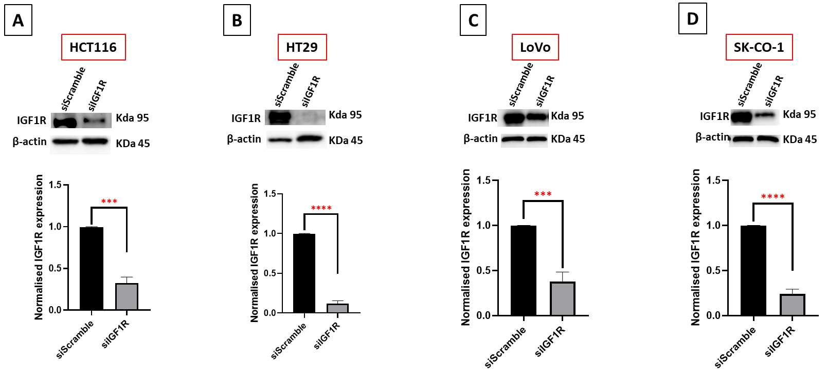

Figure S1: Protein expression analysis of IGF-1R protein expression in IGF-1R-silenced cells (upper panel) and fold changes of the immunoblot band (lower panel) in CRC cells: (A) HCT116, (B) HT29, (C) LoVo, and (D) SK-CO-1. The values were compared using independent student’s t-test between each two groups. ∗∗∗ p < 0.001 and ∗∗∗∗ p < 0.0001. Bars represent mean ± SD.

Figure S2: Full blots of Figure 1E

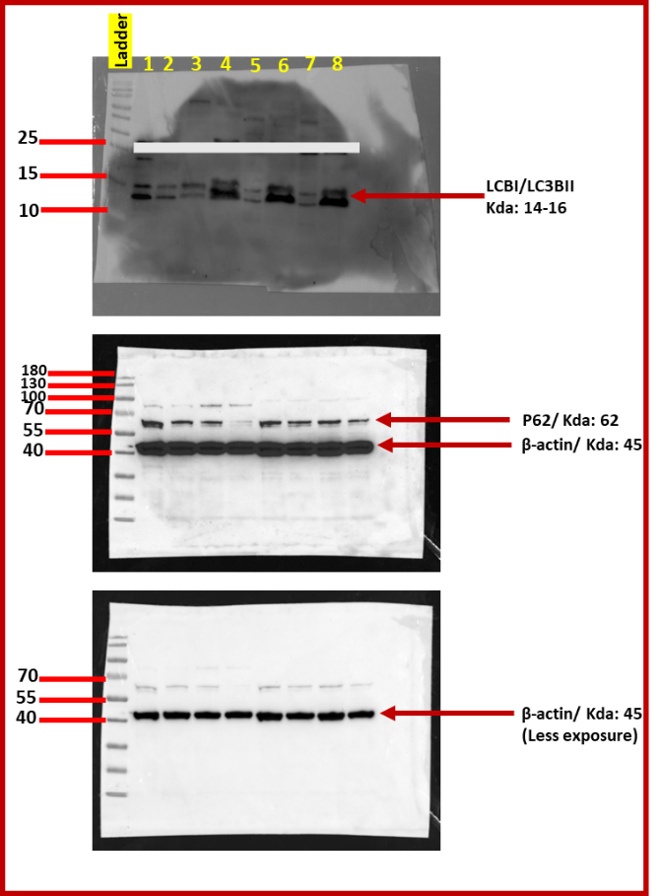
Figure S2: Original uncropped western blot of Figure 1E. The figure shows the uncropped western blot of LC3BI-LC3BII and P62, normalized to β-actin proteins bands, after treatment with IGF-1 in comparison to control untreated cells.
Lanes descriptions:
1: HCT116-control
2: HCT116-IGF-1 treated
3: HT29-control
4: HT29-IGF-1 treated
5: LoVo-control
6: LoVo-IGF-1 treated
7: SK-CO-1- control
8: SK-CO-1-IGF-1 treated

Figure S3: Full blots of Figure 1F

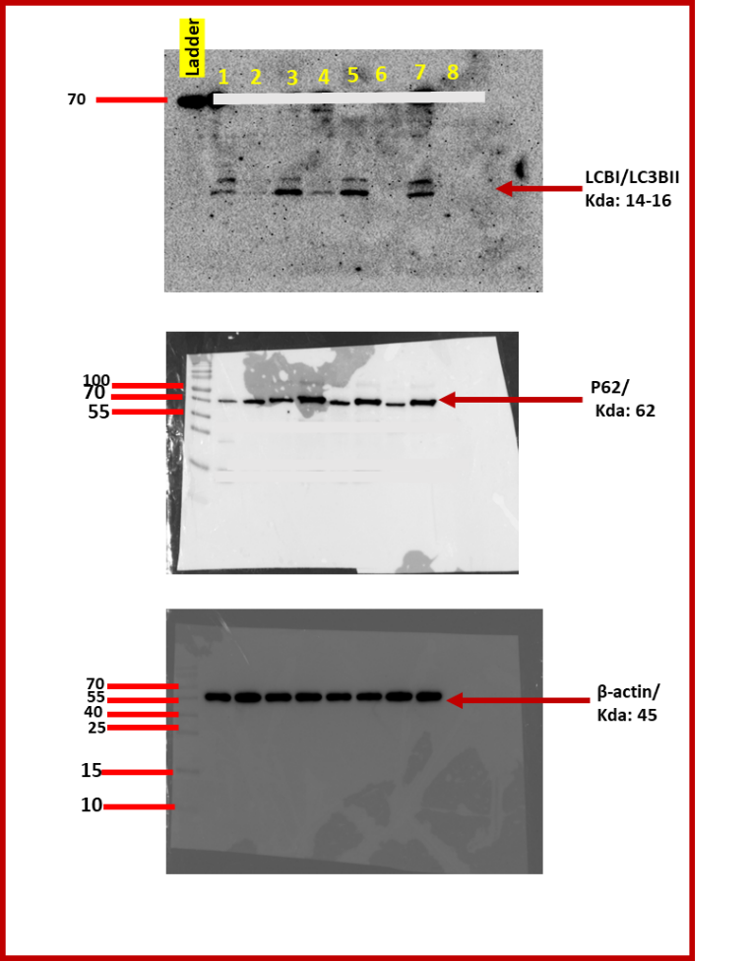
Figure S2: Original uncropped western blot of Figure 1F. The figure shows the uncropped western blot of LC3BI-LC3BII and P62, normalized to β-actin proteins bands, comparing transfected cells with siIGF-1R vs siScramble.
Lanes descriptions:
1: HCT116-siScramble
2: HCT116-siIGF-1R
3: HT29-siScramble
4: HT29-siIGF-1R
5: LoVo-siScramble
6: LoVo-siIGF-1R
7: SK-CO-1- siScramble
8: SK-CO-1-siIGF-1R

Figure S4: Target sequence of CRISPR-Cas9 gene editing of ATG5 and ATG7 genes.

ATG5
CRISPR677527_SGM
Target DNA Sequence TCCGATTGATGGCCCAAAAC
PAM Sequence TGG
Target locus Chr.6: 106248212 - 106248234 on GRCh38
Strand Forward
Application Gene Knockout

ATG7
CRISPR1032813_SGM
Target DNA Sequence CTTGAAAGACTCGAGTGTGT
PAM Sequence TGG
Target locus Chr.3: 11306996 - 11307018 on GRCh38
Strand Forward
Application Gene Knockout

Figure S4: CRISPR-Cas9 target sequences to knockout ATG5 and ATG7 genes in HCT116 cell line.

Figure S5: Full blots of Figure 2A

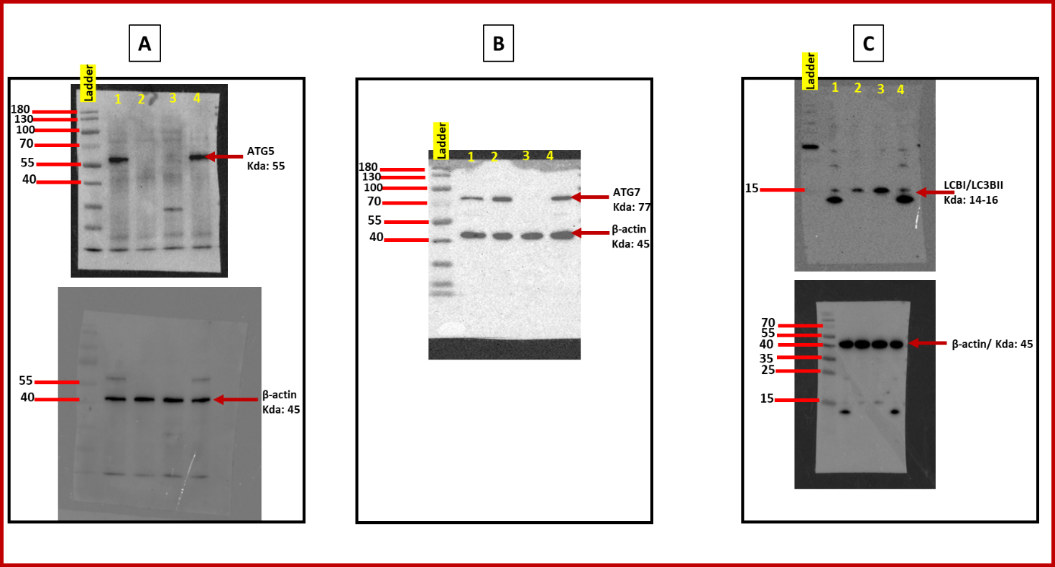

Figure S4: Original uncropped western blot of Figure 2A. The figure shows the uncropped western blot of (A) ATG5, (B) ATG7 and (C) LC3BI-LC3BII, each normalized to β-actin proteins bands, in HCT116, ATG5-/-, ATG7-/- and NC cells.
Lanes descriptions:
1: HCT116 cells
2: ATG5-/- cells
3: ATG7-/- cells
4: NC cells

