Inversion of CO Emissions in Greater Bay Area over Southern China Using a WRF-STILT-Bayesian Framework
Xingcheng Lu ^{1,*}, Yixin Luo ¹, Yiang Chen ², Jinpu Zhang ³, Lu Li ⁴, Chaoran Zhang ¹, Yuxiao Jiang ¹, Yuan Xu ¹, Bo Huang ⁵
¹ Department of Geography and Resource Management, The Chinese University of Hong Kong, Sha Tin, Hong Kong SAR, China
² Division of Environment and Sustainability, The Hong Kong University of Science and Technology, Clear Water Bay, Hong Kong SAR, China
³ Guangzhou Sub-branch of Guangdong Ecological and Environmental Monitoring Center, Guangzhou, China
⁴ Institute of Landscape and Horticulture of Bao’an District, Xin’an 2nd Road, Shenzhen, China
⁵ Department of Geography, The University of Hong Kong, Pok Fu Lam, Hong Kong SAR, China
Correspondence to: Xingcheng Lu (xingchenglu2011@gmail.com)

Table S1. Statistical matrix for the WRF model simulations. Mean_Obs: observation average, Mean_Sim: simulation average, MB: Mean bias, NMB: Normalized mean bias, RMSE: Root mean square error.

 |  | 2019 |  |  | 2020
 |  | T2 | WS10 |  | T2 | WS10
Mean_Obs |  | 18.45 | 1.88 |  | 18.22 | 1.97
Mean_Sim |  | 20.01 | 2.34 |  | 18.86 | 1.82
MB |  | 1.56 | 0.46 |  | 0.64 | -0.16
NMB |  | 0.84 | 0.24 |  | 0.035 | -0.08
RMSE |  | 3.83 | 1.77 |  | 2.27 | 1.99

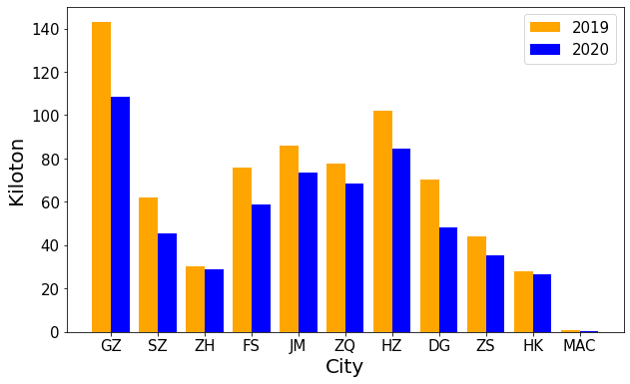
Figure S1: Comparison of CO Emissions for February Between 2019 and 2020 Across Eleven Cities in the Greater Bay Area (GBA). Abbreviations: GZ for Guangzhou, SZ for Shenzhen, ZH for Zhuhai, FS for Foshan, JM for Jiangmen, ZQ for Zhaoqing, HZ for Huizhou, DG for Dongguan, ZS for Zhongshan, HK for Hong Kong, and MAC for Macau.

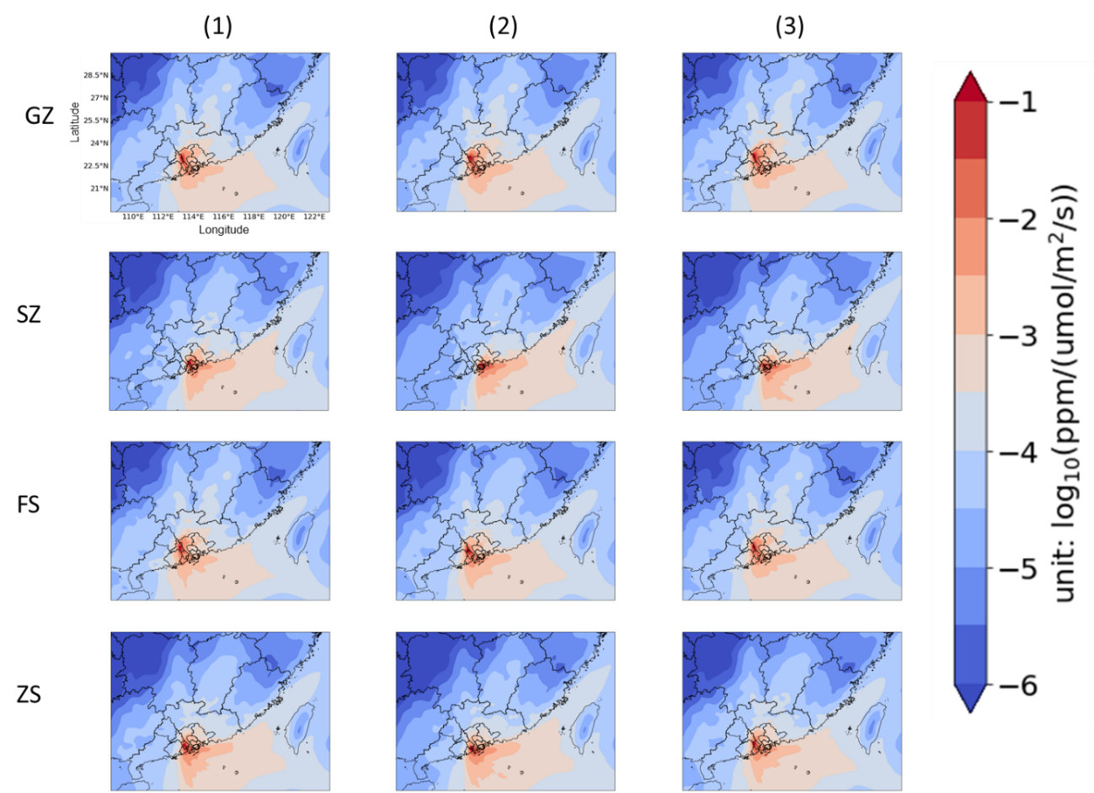
Figure S2: The Average Footprints for Selected Population-Dense Areas in Four Major Cities in the GBA in February 2019.

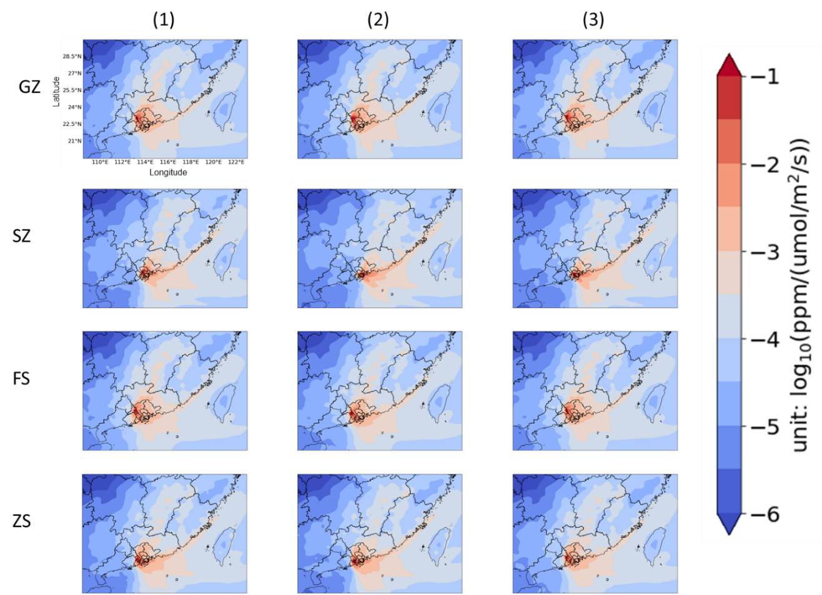
Figure S3: The Average Footprints for Selected Population-Dense Areas in Four Major Cities in the GBA in February 2020.

