Supplementary information of
High-temperature helical edge states in BiSbTeSe₂/graphene van der Waals heterostructure

- Calculation the resistance of a six-terminal quantum spin Hall bar with the disorder of contact electrodes or the elastic spin flip back scattering at between two contact electrodes.
In non-local transport measurements of quantum spin Hall insulators, it was observed that there are slight deviations in resistance from the ideal quantized value. These deviations could possibly be attributed to the effects of disorder in the electrodes used for contact and elastic spin flip back scattering on the helical edge channel at low temperatures where the inelastic spin flip back scattering is suppressed as discussed in the main text [1, 2]. To clarify these effects on the observed resistance, we calculated the resistance with various conditions. In the following calculations, we always used contact electrodes 1 and 4 as current input and output electrodes, and the voltage drop was calculated between electrodes 2 and 3, or between 1 and 4. Using these combinations of current and voltage electrodes, $R_{1423}$ and $R_{1414}$ are calculated [1].
First, we showed the effects of the disorder in the contact electrodes on the helical edge resistance. Figure S1 a, and b displayed a schematic view of a six probe Hall bar device of quantum spin Hall insulators with the disorders in the contact electrodes. In the case of Fig. S1(a), due to the potential mismatch between the helical edge and the contact electrode 2, the transmission of electrode 2 is imperfect. Therefore, the transmission and reflection rates of electrode 2, $T_{trans2}$ and $R_{2}$, were set as variable parameters under the condition $T_{trans2}+R_{2}=1$, and the transmission rates of other contact electrodes of 1,3,4,5,6 ($T_{trans i},i=1,3,4,5,6$) were set to 1. With these conditions, the conductance matrix was derived using Landauer-Büttiker formalism [3] as follows:
$$G_{ij}=-\frac{e^{2}}{h}\left(\begin{matrix}-2 & T_{trans2} & R_{2} & 0 & 0 & 1 \\ T_{trans2} & -2T_{trans2} & T_{2} & 0 & 0 & 0 \\ R_{2} & T_{2} & -2 & 1 & 0 & 0 \\ 0 & 0 & 1 & -2 & 1 & 0 \\ 0 & 0 & 0 & 1 & -2 & 1 \\ 1 & 0 & 0 & 0 & 1 & -2\end{matrix}\right) .$$
Using $V_{j}=G_{ij}^{-1}I_{i}$, the voltage drops between electrodes 2 and 3 and electrodes 1 and 4 were estimated. Finally, $R_{14;23}=\frac{V_{2}-V_{3}}{I}$ and $R_{14;14}=\frac{V_{1}-V_{4}}{I}$ were derived using $R_{2}$ as a variable parameter as shown in Fig. S1 c and d. In both cases, $R_{14;23}$ and $R_{14;14}$ decreased from the ideal values of $\frac{R_{Q}}{2}$and $\frac{3}{2}R_{Q}$ with increasing $R_{2}$. Alternatively, if the electrode 1 had a disorder effect and $0≤T_{trans1}≤1$, $R_{14;14}$ gradually increased from ideal $\frac{3}{2}R_{Q}$ with increasing $R_{2}$ while $R_{14;23}$ was constant around ideal $\frac{R_{Q}}{2}$.
In the case of Fig. S1 b, the disorders induced imperfect transmissions were assumed for electrode 1 and 2. Therefore, $T_{trans1}$ and $R_{1}$ and, $T_{trans2}$ and $R_{2}$ for electrode 1 and 2 were set as variable parameters with the condition $T_{trans1}+R_{trans1}=T_{trans2}+R_{trans2}=1$, and the transmission rate of other contact electrodes of 3,4,5,6 ($T_{transi},i=3,4,5,6$) were set to 1. The conductance matrix was set as follows:
$$G_{ij}=-\frac{e^{2}}{h}\left(\begin{matrix}-2T_{trans1} & {T_{trans1}T}_{trans2} & {T_{trans1}R}_{2} & 0 & 0 & T_{trans1} \\ {T_{trans1}T}_{trans2} & -2T_{trans2} & T_{trans2} & 0 & 0 & R_{1}T_{trans1} \\ {T_{trans1}R}_{2} & T_{trans2} & -2 & 1 & 0 & R_{1}R_{2} \\ 0 & 0 & 1 & -2 & 1 & 0 \\ 0 & 0 & 0 & 1 & -2 & 1 \\ T_{trans1} & R_{1}T_{trans2} & R_{1}R_{2} & 0 & 1 & -2\end{matrix}\right).$$
We set $R_{1}=T_{trans1}=0.5$ and $R_{2}=1-T_{trans2}$ was used variable parameters for calculations as shown in Fig. S1 e and f. $R_{14;23}$ is ~30% higher than $\frac{R_{Q}}{2}$ when $R_{2}=0$, and it gradually increased with increasing $R_{2}$ while $R_{14;14}$ was almost constant $∼\frac{2}{3}R_{Q}$ against $R_{2}$. The results of calculations represented that the disorder of the electrodes can cause the positive and negative deviation of the electrical resistance of the helical edge states from the ideal quantized resistance.
Secondly, we also represented the effects of the elastic spin flip back scattering on resistance of the helical edge states. Figure S2a, and b showed the schematic view of a six probe Hall bar device of quantum spin Hall insulators with a elastic spin flip back scattering source at the helical edge channel between electrode 1 and 2 , and 2 and 3. In the case of Fig. S2a (Fig. S2 b). Due to the elastic spin flip back scattering, the transmission of the helical edge between electrodes 1 and 2 (2 and 3) was imperfect, i.e., $T_{trans_12}$ ($T_{trans_23}$) was set in the range of $0≤T_{trans_12}≤1 (0≤T_{trans_23}≤1)$ with $T_{trans_12}+R_{12}=1 (T_{trans_23}+R_{23}=1)$condition. The conductance matrix was set for Fig. S2 a case as follows:
$$G_{ij}=-\frac{e^{2}}{h}\left(\begin{matrix}-2T_{trans_12} & 2T_{trans_12}-1 & 0 & 0 & 0 & 1 \\ 2T_{trans_12}-1 & -2T_{trans_12} & -1 & 0 & 0 & 0 \\ 0 & 1 & -2 & 1 & 0 & 0 \\ 0 & 0 & 1 & -2 & 1 & 0 \\ 0 & 0 & 0 & 1 & -2 & 1 \\ 1 & 0 & 0 & 0 & 1 & -2\end{matrix}\right).$$
For the Fig. S2 b case, the conductance matrix was set as follows:
$$G_{ij}=-\frac{e^{2}}{h}\left(\begin{matrix}-2 & 1 & 0 & 0 & 0 & 1 \\ 1 & -2T_{trans_23} & 2T_{trans_23}-1 & 0 & 0 & 0 \\ 0 & 2T_{trans_23}-1 & -2T_{trans_23} & 1 & 0 & 0 \\ 0 & 0 & 1 & -2 & 1 & 0 \\ 0 & 0 & 0 & 1 & -2 & 1 \\ 1 & 0 & 0 & 0 & 1 & -2\end{matrix}\right).$$
The$R_{12}$ dependence of $R_{14;23}$ and $R_{14;14}$ for Fig. S2 a case were shown in Fig. S2 c and d. With increasing $R_{12}$ in the range of $0≤R_{12}≤0.4$, $R_{14;23}$ gradually decreased while $R_{14;14}$ increased. For Fig. S2b case, the$R_{23}$ dependence of $R_{14;23}$ and $R_{14;14}$ were shown in Fig. S2 e and f. With increasing $R_{23}$ in the range of $0≤R_{23}≤0.4$, both $R_{14;23}$ and $R_{14;14}$ increased gradually. The calculation results showed that the elastic backscattering can also cause the positive and negative deviations in the electrical resistance of the helical edge states from the ideal quantized resistance.
- Band calculation of BiSbTeSe₂/graphene vdW heterostructure with different atomic stacking configurations.
To identify the stable configuration and maximize the Kekulé gap, we examined four different atomic stacking arrangements between graphene and two quintuple layers (QLs) of BiSbTeSe₂ with an interlayer C–Te distance of approximately 3.7 Å as illustrated in Fig. S3. The configurations considered include the following: (i) Te atoms positioned at the center of graphene hexagons (C-mid), (ii) Te atoms located directly above carbon atoms (C-top), (iii) Te atoms situated above the C–C bonds (C-bridge), and (iv) a randomly distributed arrangement. Among these, the C-mid configuration was found to be the most energetically favorable, yielding a band gap of approximately Δ ~ 6.5 meV. Notably, this magnitude of the band gap aligns well with the transport-measured Kekulé gap Δ₂ of ~ 7 meV observed for the 2 nm BiSbTeSe₂ device as shown in Fig. 3a of the main text and in Extended Data Fig. 6a.
- Evolution of the Kekulé band gap as the function of C-Te distance
We calculated the Kekulé band gap as a function of the C–Te interlayer distance in the C-mid stacking configuration with SOI, as shown in Fig. S4, for 3QL BiSbTeSe₂. As the distance d increases from 3.5 to 3.9 Å the Kekulé gap decreases from 15.6 meV to 5.4 meV.
- TEM images
From the TEM images in Figure S5, we can clearly identify the monolayer graphene and BiSbTeSe₂ layers. The gap between graphene and BiSbTeSe₂ is found to be approximately 3.89 Å while the thickness of 1 QL BiSbTeSe₂ layer is about 9.97 Å.

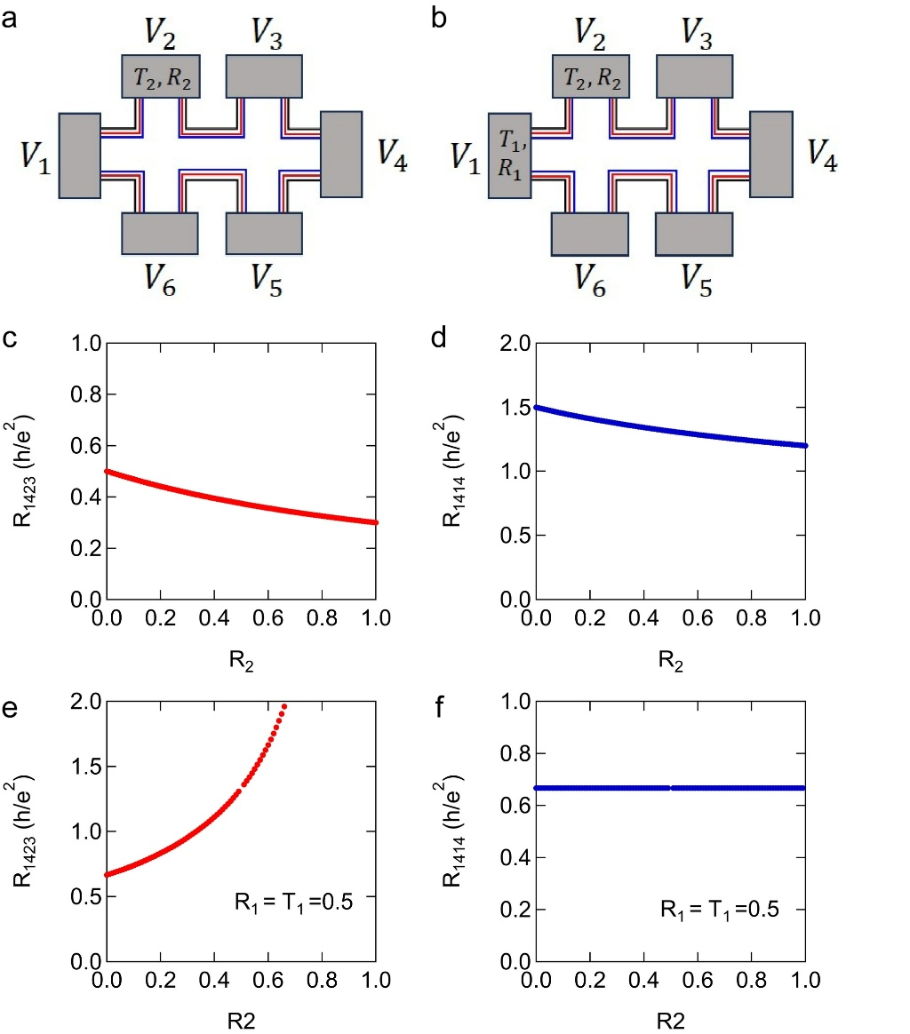
FigureS1 | Calculating the resistance of a six-terminal quantum spin Hall bar with disordered electrodes. a Electrode 2 has disorder, and the transmission and reflection of electrode 2 ($T_{trans_2}$ and $R_{2}$ ) are parameters for resistance calculation. b Both electrodes 1 and 2 have disorder, and the transmission and reflection of electrodes 1 and 2 ($T_{trans_1}$,${ R}_{1}$and $T_{trans_2}$,$R_{2}$) are parameters for resistance calculation. c,d Calculated $R_{14;23}$ and $R_{14;14}$ for case a. $R_{2}$ is a variable parameter. e,f Calculated $R_{14;23}$ and $R_{14;14}$ for case b. $T_{trans_1}=R_{1}=$0.5 and $R_{2}$ is a variable parameter.
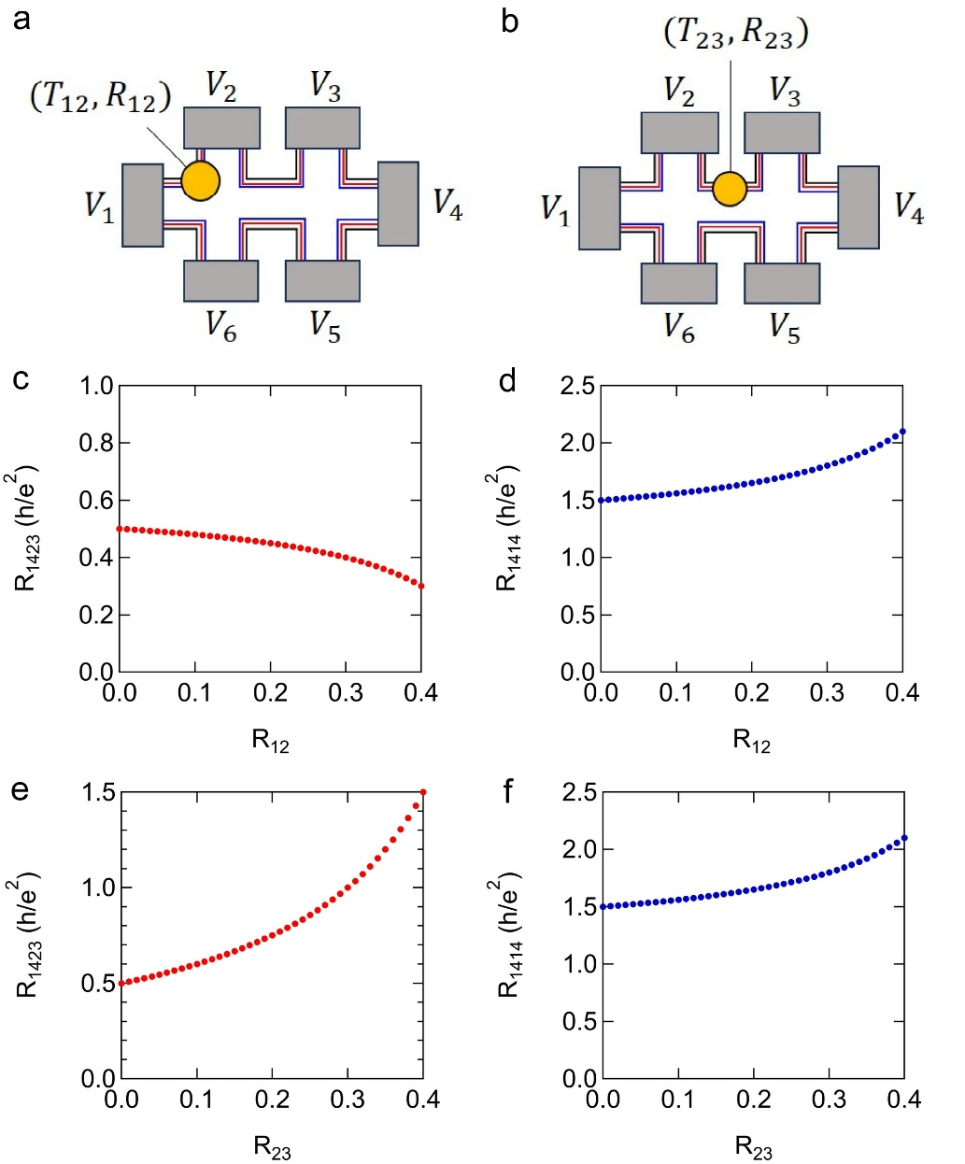
FigureS2 | Calculation of the resistance of a six-terminal quantum spin Hall bar with an elastic spin flip back scattering source. The figure shows a schematic view of a six-terminal quantum spin Hall bar with elastic spin flip back scattering source at the position between a electrode 1 and 2. b electrode 2 and 3. Transmission and reflection are $T_{trans_12}$, $R_{12}$ and $T_{trans_23},R_{23}$ with $T_{trans_12}+R_{12}=1$ and $T_{trans_23}+R_{23}=1$. c,d Calculated $R_{14;23}$ and $R_{14;14}$ for the case of a. e,f Calculated $R_{14;23}$ and $R_{14;14}$ for the case of b. $R_{12}$ and $R_{23}$ are variable parameters.
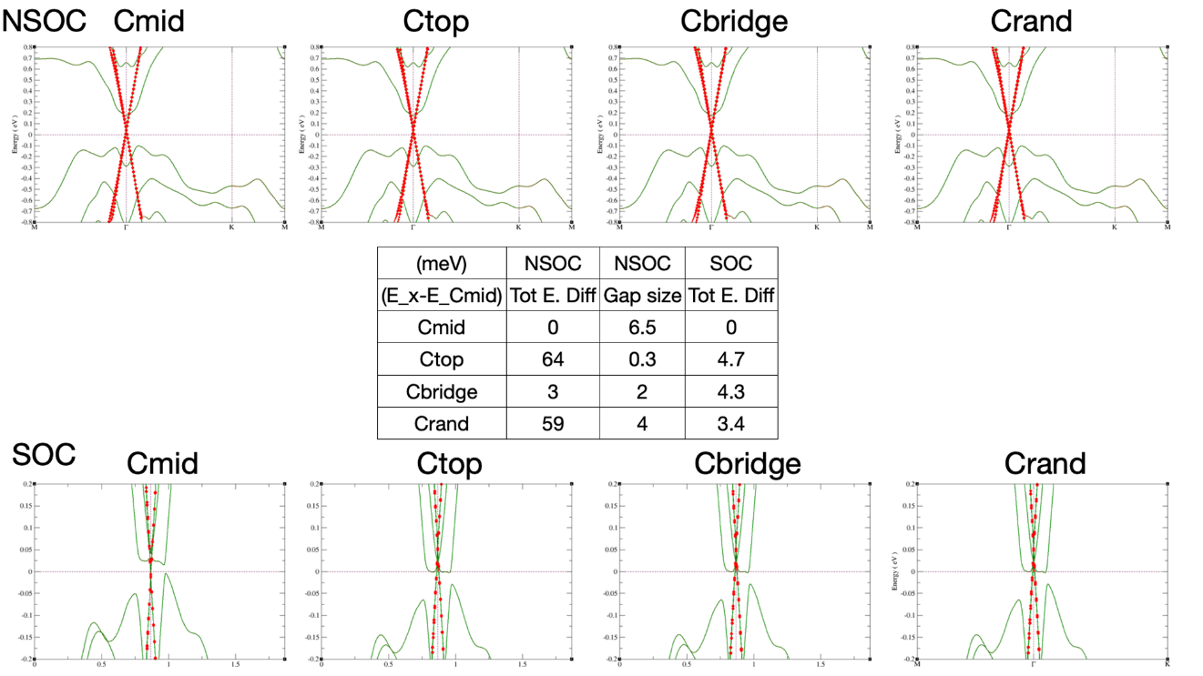
FigureS3 | Calculated Kekulé gap of 2 QL BiSbTeSe₂/ graphene using DFT without (NSOC) and with (SOC) spin – orbit – interaction for different stacking configurations.

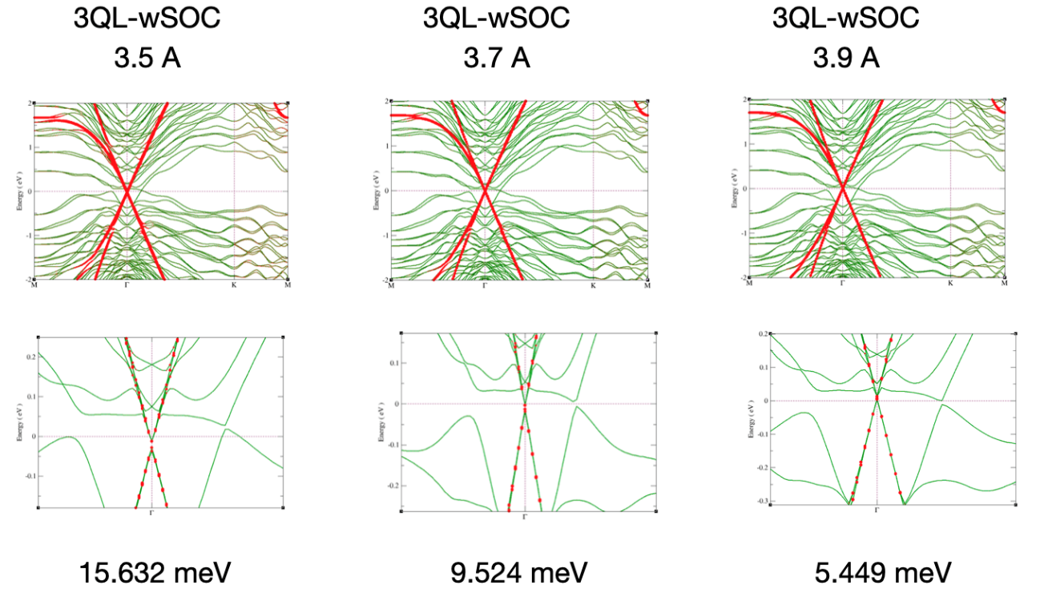
FigureS4 | Evolution of the Kekulé band gap as a function of the C-Te distance d from 3.5 to 3.9 Å.

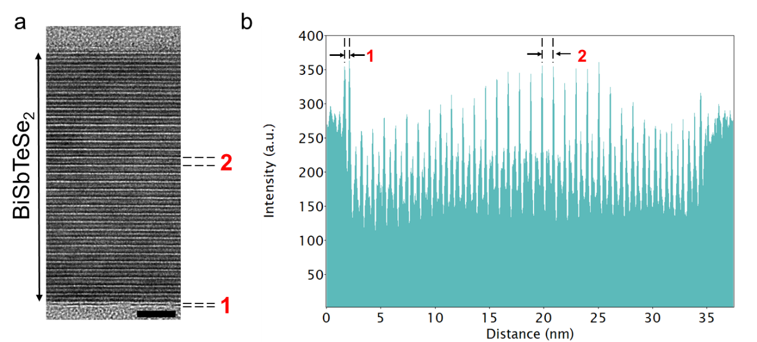

FigureS5 |TEM data of 30-nm BiSbTeSe₂/graphene vdW heterostructures a. High-resolution TEM image showing the layered BiSbTeSe₂/graphene film. Region labeled 1 indicates the interfacial gap between the graphene and the topmost BiSbTeSe₂ layer, while region 2 highlights a single quintuple layer (QL) of BiSbTeSe₂. The scale bar is 5 nm. b. Line profile measurement of the image intensity taken along the vertical axis from the bottom to the top. The measured interfacial gap between graphene and BiSbTeSe₂ is approximately 3.89 Å, and the thickness of one QL of BiSbTeSe₂ is about 9.97 Å.

Reference
[1] Arjun Mani and Colin Benjamin: J. Phys.: Condens. Matter 28 (2016) 145303.
[2] Dyakonov, M. I. & Perel, V. I. Spin relaxation of conduction electrons in noncentrosymmetric semiconductors. Soviet Physics Solid State 13, 3023–3026 (1972). / Yafet, Y. Solid State Physics (F. Seitz and D. Turnbull, 1963).
[3] M. Büttiker, Phys. Rev. Lett. 57, 1761 (1986).

