Table S1: Description of Study Instruments
Age (year) | Factors | Items | Description
≥18 | Chronic Disease | - Hypertension  - Coronary heart disease (CHD)  - Asthma  - Chronic obstructive pulmonary disease (COPD)  - Arthritis | - 5 items that measure chronic diseases.  - Answered with 2 response choices (0=No, 1=Yes)
≥18 | Accommodation | - Cold  - Damp  - Crowded  - Poor ventilation  - Poor indoor air quality  - Noisy  - Not safe and secure  - Frequent outages of power | - Describe the living conditions of Ukrainians in the cold winter and evaluate the cold winter impact.  - Accommodation condition in cold winter was measured by 8 questions.  - Answered on a 4-point Likert scale (‘Strongly Disagree’ [1 point], ‘Disagree’ [2 points], ‘Agree’ [3 points], and ‘Strongly Agree’ [4 points]).
≥18 | Access to services | - Food shop  - Public transport  - Post office  - Policlinic  - Hospital  - Family doctor  - Pharmacy  - Ambulance  - Centre for administrative services  - Humanitarian aid | - Basic services of settlements were measured with 10 questions  - Responses were ‘No access’ [0 point], ‘Don’t know ’ [0 points], ‘Limited Access’ [1 points] and ‘Consistent Access [2 points].
≥18 | Lack of Assistance | - Cash transfers or financial assistance  - Essential food and non-food assistance (clothing, hygiene items, blankets)  - Counselling and psychological support  - Legal aid  - Shelter and housing  - Housing subsidy | - 6 items ask about respondents received any of the forms of assistance since the war.  - Responses were ‘No’ [1 point], ‘Yes’ [2 points]
≥18 | Lack of Winter Preparedness | - Purchased warm clothes  - Stored food and water  - Purchased logs/wood, coal, fuel, briquettes, fuel pellets  - Metal-plastic windows installed (Installed metal-plastic windows)  - The house is insulated (Installed insulation)  - Repair works done (Performed repairs)  - Registered the (for) housing subsidy | - 7 Items  - Asked about adaptation and lack of winter preparedness.  - Answered were ‘No’ [0 point], ‘No need’ [1 point], ‘Yes’ [2 point]
≥18 | Lack of a Heating System | - Furnaces  - Boilers  - Heat pumps  - Gas-fired space heaters  - Unvented gas-fired heaters  - Electric space heaters  - Wood-burning and pellet stoves  - Fireplaces  - Radiant floor heat | - Lack of heating systems included 9 questions  - Answered were ‘Not Sure’ [0 point], ‘No’ [1 point], ‘Yes’ [2 point].
≥18 | Winter Concerns | - Not enough income/low income  - Price increase  - Size of pension  - Inflation  - Low Currency exchange rate  - Not enough food  - Not enough medicines  - It is probable the central heating and water supply system will be ruined by shelling | - 8 questions were asked about biggest concern regarding getting through the winter season  - Responses were ‘No concern [1 point], ‘Minor concern’ [2 points], and ‘Major concern ’ [3 points]

Table S2: Participants' Characteristics
Characteristics | Total n =1552
Age, years | 31.3 ± 9.1
Age group
18–30 years | 764 (49.2)
31–45 years | 669 (43.1)
46–60 years | 119 (7.67)
Gender
Male | 848 (54.6)
Female | 704 (45.4)
Living area
Urban area | 1210 (78.0)
Suburban area | 132 (8.5)
Rural area | 210 (13.5)
Education
Less than primary | 7 (0.5)
Primary | 21 (1.4)
Secondary | 121 (7.8)
Vocational School | 409 (26.4)
undergraduate degree or above | 994 (64.0)
Marital status
Single | 167 (10.8)
In a relationship or married | 1096 (70.6)
Separated, divorced, or widowed | 289 (18.6)
Current Employment Status
Employed | 962(62.0)
Un-Employed | 525 (33.8)
Disabled or Other | 65 (4.2)
Current Job Schedule
Traditional (Evening, or Morning Shifts) | 799 (51.5)
variable (Early mornings, days, and nights) | 358 (23.1)
Refused or Unspecified | 395 (25.5)
Employment Status in 2021
Employed | 1291 (83.2)
Un-Employed | 209 (13.5)
Disabled or Other | 52 (3.4)
Job Schedule in 2021
Traditional (Evening, or Morning Shifts) | 1061 (68.4)
Variable (Early mornings, days, and nights) | 305 (19.7)
Refused or Unspecified | 186 (12)

Table S3: Chronic Disease Prevalence by Age, Gender, and Vulnerable Population
 | Hypertension  n=492 (31.7%) | Coronary Heart  n=116 (7.5%) | Asthma  n=58 (3.7%) | Chronic Obstructive Pulmonary  n=119 (7.7%) | Arthritis  n=216  (13.9%)
Age
18–30 years | 159 (32.3) | 32 (27.6) | 30 (51.7) | 48 (40.3) | 50 (23.1)
31–45 years | 272 (55.3) | 60 (51.7) | 23 (39.7) | 54 (45.4) | 137 (63.4)
46–60 years | 61 (12.4) | 24 (20.7) | 5 (8.6) | 17 (14.3) | 29 (13.4)
Gender
Male | 285 (57.9) | 68 (58.6) | 33 (56.9) | 69 (58.0) | 100 (46.3)
Female | 207 (42.1) | 48 (41.4) | 25 (43.1) | 50 (42.0) | 116 (53.7)
Vulnerable Population
Children (<18) with Health Issues | 96(19.51) | 17(14.7) | 11(19.01) | 31(26.1) | 41(19)
Pregnant Women with Health Issues | 0.0 | 0.0 | 1(1.7) | 1(0.84) | 1(0.5)
Elderly (≥60) with Health Issues | 125(25.4) | 29(24.4) | 19(32.8) | 39(32.8) | 65(29.7)
n= Total positive Counts, %= Percentage

Table S4: Association Between Accommodation Status and Chronic Disease
 | Hypertension |  |  | Coronary Heart  disease |  |  | Asthma |  |  | Chronic Obstructive Pulmonary |  |  | Arthritis
Accommodation Status | Total Counts (%) | OR (95% CIs)ª | P-value^{b} | Total Counts  (%) | OR (95% CIs)ª | P-value^{b} | Total Counts (%) | OR (95% CIs)ª | P-value^{b} | Total Counts (%) | OR (95% CIs)ª | P-value^{b} | Total Counts (%) | OR (95% CIs)ª | P-value^{b}
Cold | 354 (22.8) | 1.70(1.08–2.68) | 0.022 | 77 (5) | 1.62(1.19–2.16) | 0.0008 | 41 (2.6) | 1.52(1.01–2.29) | 0.045 | 72 (4.6) | 1.45(1.11–1.91) | 0.007 | 150 (9.7) | 1.57(1.20–2.06) | 0.001
Damp | 319 (20.6) | 1.63(1.03–2.56) | 0.037 | 67 (4.3) | 1.58(1.24–1.96) | 0.0019 | 37 (2.4) | 1.81(1.22–2.31) | 0.034 | 61 (3.9) | 1.36(1.19–1.66) | 0.036 | 132 (8.5) | 1.33 (1.17–1.65) | 0.027
Crowded | 374 (24.1) | 1.90(1.21–2.95) | 0.005 | 87 (5.6) | 1.61(1.05–2.43) | 0.025 | 44 (2.8) | 1.58(1.05–2.36) | 0.025 | 88 (5.7) | 1.71(1.31–2.23) | 0.000 | 165 (10.6) | 1.31(1.01–1.70) | 0.046
Poor ventilation | 391 (25.2) | 0.60(0.31–1.14) | 0.130 | 94 (6.1) | 1.33(1.10–1.61) | 0.0414 | 47 (3) | 0.57(0.31–1.01) | 0.060 | 93 (6) | 1.49 (1.14–1.62) | 0.032 | 167 (10.8) | 1.75 (1.23–2.16) | 0.025
Poor indoor air quality | 420 (27.1) | 2.46(1.30–4.63) | 0.005 | 98 (6.3) | 2.99(1.67–5.33) | 0.000 | 51 (3.3) | 2.72(1.53–4.79) | 0.001 | 98 (6.3) | 1.95(1.33–2.87) | 0.001 | 176 (11.3) | 1.33(1.06–1.66) | 0.015
Noisy | 382 (24.6) | 0.64(0.37–1.08) | 0.106 | 86 (5.5) | 0.71(0.43–1.13) | 0.161 | 49 (3.2) | 1.47(1.19–1.19) | 0.024 | 91 (5.9) | 1.30(0.98–1.72) | 0.069 | 170 (11) | 0.90(0.68–1.18) | 0.438
Not safe and secure | 333 (21.5) | 1.81(1.34–2.04) | 0.031 | 66 (4.3) | 1.16(0.78–1.68) | 0.458 | 43 (2.8) | 1.15(0.79–1.65) | 0.464 | 72 (4.6) | 0.91(0.72–1.16) | 0.449 | 152 (9.8) | 1.32(0.90–1.94) | 0.153
Frequent outages of power | 285 (18.4) | 0.77(0.50–1.18) | 0.236 | 69 (4.4) | 0.94(0.64–1.37) | 0.754 | 36 (2.3) | 0.93(0.64–1.34) | 0.711 | 69 (4.4) | 1.06(0.84–1.34) | 0.606 | 125 (8.1) | 1.00(0.80–1.25) | 0.987
a.OR: Oddss ratio; CI: 95% confidence interval; b. p-value: level of significance. The models are multivariable logistic regression adjusted for age and gender.

Table S5: Association Between lack of access to services and chronic disease
 | Hypertension |  |  | Coronary Heart |  |  | Asthma |  |  | Chronic Obstructive Pulmonary |  |  | Arthritis
Lack of Access to Services | Total Counts (%) | ODDS Ratio (95% CIs) | p-value | Total Counts (%) | ODDS Ratio (95% CIs) | p-value | Total Counts (%) | ODDS Ratio (95% CIs) | p-value | Total Counts (%) | ODDS Ratio (95% CIs) | p-value | Total Counts (%) | ODDS Ratio (95% CIs) | p-value
Food shop | 468 (30.2) | 2.77(1.31–6.29) | 0.010 | 107 (6.9) | 0.48(0.25–0.91) | 0.026 | 56 (3.6) | 2.22(1.07–4.83) | 0.036 | 112 (7.2) | 1.31(1.12–1.52) | 0.030 | 208 (13.4) | 1.58(1.38–1.79) | 0.031
Public transport | 380 (24.5) | 1.42(1.02–1.97) | 0.038 | 91 (5.9) | 0.76(0.54–1.06) | 0.105 | 45 (2.9) | 1.41(1.01–1.96) | 0.043 | 87 (5.6) | 1.66(1.29–1.97) | 0.034 | 173 (11.1) | 1.47(1.02–2.15) | 0.045
post office | 436 (28.1) | 1.86(1.12–3.10) | 0.016 | 107 (6.9) | 2.50(1.54–4.12) | 0.000 | 57 (3.7) | 3.13(1.89–5.25) | 0.000 | 103 (6.6) | 2.39(1.16–3.63) | 0.023 | 191 (12.3) | 1.30(0.73–2.39) | 0.377
Policlinic | 387 (24.9) | 0.82(0.51–1.32) | 0.419 | 99 (6.4) | 1.10(0.69–1.76) | 0.676 | 52 (3.4) | 0.85(0.52–1.37) | 0.504 | 91 (5.9) | 2.46(0.66–9.63) | 0.190 | 173 (11.1) | 0.92(0.55–1.54) | 0.742
Hospital | 357 (23) | 2.15(1.43–3.26) | 0.000 | 94 (6.1) | 1.03(0.68–1.55) | 0.894 | 51 (3.3) | 1.69(1.10–2.57) | 0.015 | 86 (5.5) | 1.65(1.24–1.93) | 0.0371 | 158 (10.2) | 0.84(0.54–1.31) | 0.431
Family doctor | 380 (24.5) | 1.42(1.02–1.98) | 0.037 | 100 (6.4) | 1.17(0.85–1.62) | 0.337 | 48 (3.1) | 1.01(0.71–1.42) | 0.949 | 85 (5.5) | 0.53(0.18–1.61) | 0.263 | 168 (10.8) | 1.52(1.06–2.22) | 0.026
Pharmacy | 439 (28.3) | 2.27(1.33–3.92) | 0.003 | 107 (6.9) | 2.27(1.36–3.83) | 0.002 | 56 (3.6) | 2.74(1.61–4.72) | 0.000 | 103 (6.6) | 0.10(0.02–0.42) | 0.004 | 198 (12.8) | 1.76(1.29–2.23) | 0.038
Ambulance | 374 (24.1) | 1.43(1.04–1.97) | 0.027 | 94 (6.1) | 2.19(1.61–2.98) | 0.000 | 44 (2.8) | 1.57(1.14–2.17) | 0.006 | 85 (5.5) | 2.87(1.03–8.58) | 0.050 | 160 (10.3) | 1.06(0.75–1.50) | 0.745
Centre for administrative services | 351 (22.6) | 0.93(0.68–1.28) | 0.674 | 86 (5.5) | 0.76(0.55–1.03) | 0.076 | 43 (2.8) | 0.81(0.58–1.11) | 0.194 | 88 (5.7) | 2.58(0.93–7.59) | 0.075 | 162 (10.4) | 1.18(0.84–1.65) | 0.342
Humanitarian aid | 138 (8.9) | 0.92(0.71–1.19) | 0.525 | 29 (1.9) | 0.91(0.72–1.16) | 0.450 | 14 (0.9) | 0.88(0.68–1.14) | 0.341 | 30 (1.9) | 1.05(0.30–4.84) | 0.948 | 55 (3.5) | 1.17(0.91–1.50) | 0.216
a.OR: Oddss ratio; CI: 95% confidence interval; b. p-value: level of significance. The models are multivariable logistic regression adjusted for age and gender.
Table S6: Association Between lack of assistance and chronic disease
 | Hypertension |  |  | Coronary Heart |  |  | Asthma |  |  | Chronic Obstructive Pulmonary |  |  | Arthritis
Assistance | Total Counts (%) | ODDS Ratio (95% CIs) | p-value | Total Counts (%) | ODDS Ratio (95% CIs) | p-value | Total Counts (%) | ODDS Ratio (95% CIs) | p-value | Total Counts (%) | ODDS Ratio (95% CIs) | p-value | Total Counts (%) | ODDS Ratio (95% CIs) | p-value
Cash transfers or financial assistance | 184 (11.9) | 1.44(1.14–1.82) | 0.002 | 54 (3.5) | 2.36(1.84–3.04) | <0.001 | 21 (1.4) | 1.32(1.10–1.51) | 0.036 | 46 (3) | 1.43(1.13–1.82) | 0.003 | 85 (5.5) | 1.39(1.10–1.76) | 0.006
Essential food and non-food assistance (clothing, hygiene items, blankets) | 158 (10.2) | 1.45(1.13–1.86) | 0.003 | 43 (2.8) | 1.34(1.03–1.75) | 0.028 | 18 (1.2) | 1.61(1.16–2.22) | 0.004 | 42 (2.7) | 1.37(1.09–1.63) | 0.0001 | 67 (4.3) | 1.28(1.00–1.65) | 0.051
Counselling and psychological support | 39 (2.5) | 2.08(1.27–3.43) | 0.004 | 7 (0.5) | 1.02(0.61–1.72) | 0.1508 | 10 (0.6) | 0.81(0.41–1.54) | 0.540 | 11 (0.7) | 1.04(0.64–1.73) | 0.0837 | 16 (1) | 1.04(0.63–1.72) | 0.190
Legal aid | 34 (2.2) | 1.49(1.15–1.92) | 0.025 | 5 (0.3) | 0.89(0.54–1.49) | 0.6648 | 9 (0.6) | 1.25(0.66–2.26) | 0.477 | 10 (0.6) | 0.89(0.55–1.14) | 0.0746 | 19 (1.2) | 0.88(0.54–1.44) | 0.260
Shelter and housing | 45 (2.9) | 0.99(0.67–1.46) | 0.963 | 14 (0.9) | 1.23(1.074–1.42) | 0.024 | 4 (0.3) | 0.96(0.57–1.57) | 0.874 | 12 (0.8) | 1.36(1.12–1.55) | 0.0294 | 19 (1.2) | 1.22(0.82–1.84) | 0.331
Housing subsidy | 57 (3.7) | 1.00(0.71–1.41) | 0.990 | 20 (1.3) | 1.13(0.80–1.63) | 0.4878 | 7 (0.5) | 0.96(0.60–1.49) | 0.862 | 20 (1.3) | 1.17(0.84–1.66) | 0.0977 | 27 (1.7) | 1.18(0.84–1.67) | 0.348

a.OR: Oddss ratio; CI: 95% confidence interval; b. p-value: level of significance. The models are multivariable logistic regression adjusted for age and gender.

Table S7: Association Between winter preparedness and chronic disease
 | Hypertension |  |  | Coronary Heart |  |  | Asthma |  |  | Chronic Obstructive Pulmonary |  |  | Arthritis
Winter Preparedness | Total Counts (%) | ODDS Ratio (95% CIs) | p-value | Total Counts (%) | ODDS Ratio (95% CIs) | p-value | Total Counts (%) | ODDS Ratio (95% CIs) | p-value | Total Counts (%) | ODDS Ratio (95% CIs) | p-value | Total Counts (%) | ODDS Ratio (95% CIs) | p-value
Purchased warm clothes | 242 (15.6) | 1.41(1.08–1.88) | 0.016 | 52 (3.4) | 1.57(1.38–1.78) | 0.0262 | 32 (2.1) | 1.22(1.05–1.40) | 0.008 | 73 (4.7) | 1.51 (1.22–1.89) | 0.000 | 118 (7.6) | 1.32 (1.02–1.73) | 0.037
Stored food and water | 353 (22.7) | 1.55(1.09–2.31) | 0.020 | 77 (5) | 1.19(1.03–1.38) | 0.016 | 47 (3) | 1.31(1.10–1.55) | 0.002 | 93 (6) | 1.32 (1.03–1.73) | 0.036 | 162 (10.4) | 1.51 (1.09–2.19) | 0.019
Purchased logs/wood, coal, fuel, briquettes, fuel pellets | 130 (8.4) | 1.64(1.28–2.12) | 0.000 | 33 (2.1) | 0.99(0.87–1.13) | 0.114 | 23 (1.5) | 1.58(1.37–1.82) | 0.000 | 37 (2.4) | 1.43 (1.13–1.79) | 0.0398 | 66 (4.3) | 1.64 (1.29–2.09) | 0.000
Metal-plastic windows installed (Installed metal-plastic windows) | 126 (8.1) | 0.92(0.66–1.27) | 0.619 | 32 (2.1) | 1.04(0.88–1.22) | 0.191 | 21 (1.4) | 1.00(0.83–1.20) | 0.975 | 31 (2) | 1.06 (0.82–1.36) | 0.277 | 49 (3.2) | 0.93 (0.68–1.27) | 0.655
The house is insulated (Installed insulation) | 92 (5.9) | 1.42(1.19–1.73) | 0.036 | 24 (1.5) | 0.89(0.73–1.08) | 0.226 | 12 (0.8) | 0.92(0.74–1.14) | 0.448 | 20 (1.3) | 1.00 (0.73–1.34) | 0.383 | 48 (3.1) | 1.15 (0.80–1.65) | 0.440
Repair works done (Performed repairs) | 46 (3) | 1.00(0.65–1.54) | 0.982 | 15 (1) | 0.91(0.73–1.14) | 0.427 | 6 (0.4) | 0.90(0.70–1.14) | 0.379 | 18 (1.2) | 0.87 (0.62–1.23) | 0.435 | 22 (1.4) | 1.01 (0.67–1.52) | 0.972
Registered the (for) housing subsidy | 51 (3.3) | 0.70(0.42–1.13) | 0.146 | 19 (1.2) | 1.12(0.89–1.40) | 0.350 | 5 (0.3) | 1.15(0.89–1.49) | 0.281 | 20 (1.3) | 0.89 (0.61–1.28) | 0.520 | 23 (1.5) | 0.76 (0.47–1.20) | 0.246
a.OR: Oddss ratio; CI: 95% confidence interval; b. p-value: level of significance. The models are multivariable logistic regression adjusted for age and gender.
Table S8: Association Between winter concerns and chronic disease
 | Hypertension |  |  | Coronary Heart |  |  | Asthma |  |  | Chronic Obstructive Pulmonary |  |  | Arthritis
Winter concerns | Total Counts (%) | ODDS Ratio (95% CIs) | p-value | Total Counts (%) | ODDS Ratio (95% CIs) | p-value | Total Counts (%) | ODDS Ratio (95% CIs) | p-value | Total Counts (%) | ODDS Ratio (95% CIs) | p-value | Total Counts (%) | ODDS Ratio (95% CIs) | p-value
Not enough income/low income | 460 (29.6) | 1.77 (1.17–2.67) | 0.006 | 109 (7) | 2.06 (1.37–3.10) | 0.001 | 53 (3.4) | 2.13 (1.44–3.16) | 0.000 | 111 (7.2) | 2.35 (1.57–3.49) | 0.0065 | 201 (13) | 1.91 (1.22–2.95) | 0.004
Price increase | 489 (31.5) | 4.38 (1.47–15.13) | 0.012 | 115 (7.4) | 3.42 (1.20–10.88) | 0.027 | 56 (3.6) | 3.42 (1.19–11.41) | 0.030 | 113 (7.3) | 1.44 (1.16–1.74) | 0.019 | 215 (13.9) | 0.76 (0.26–2.06) | 0.602
Size of pension | 311 (20) | 1.94 (1.46–2.57) | <0.001 | 89 (5.7) | 1.85 (1.43–2.39) | <0.001 | 34 (2.2) | 1.21 (1.00–1.39) | 0.047 | 75 (4.8) | 0.95 (0.73–1.23) | 0.692 | 143 (9.2) | 0.92 (0.68–1.23) | 0.563
Inflation | 479 (30.9) | 2.33 (1.26–4.28) | 0.006 | 113 (7.3) | 1.47 (1.17–1.74) | 0.022 | 56 (3.6) | 1.93 (1.06–3.51) | 0.031 | 111 (7.2) | 2.38 (1.29–4.35) | 0.005 | 210 (13.5) | 1.37 (1.02–1.59) | 0.046
Currency exchange rate | 424 (27.3) | 1.64 (1.12–2.37) | 0.010 | 106 (6.8) | 0.80 (0.53–1.17) | 0.257 | 48 (3.1) | 2.28 (1.63–3.19) | 0.000 | 97 (6.2) | 0.82 (0.55–1.21) | 0.330 | 188 (12.1) | 0.71 (0.43–1.10) | 0.141
Not enough food | 248 (16) | 1.65 (1.13–2.40) | 0.010 | 71 (4.6) | 1.15 (0.81–1.61) | 0.432 | 30 (1.9) | 1.08 (0.78–1.49) | 0.652 | 68 (4.4) | 0.92 (0.65–1.30) | 0.648 | 119 (7.7) | 1.64 (0.34–1.95) | 0.009
Not enough medicines | 289 (18.6) | 1.67 (1.16–2.43) | 0.006 | 82 (5.3) | 1.15 (0.82–1.61) | 0.433 | 35 (2.3) | 1.10 (0.80–1.53) | 0.552 | 75 (4.8) | 1.32 (0.94–1.86) | 0.105 | 137 (8.8) | 1.69 (1.15–2.50) | 0.008
It is probable that the central heating and water supply system will be ruined by shelling | 276 (17.8) | 0.84 (0.59–1.23) | 0.367 | 109 (7) | 1.13 (0.81–1.59) | 0.469 | 35 (2.3) | 0.99 (0.73–1.35) | 0.943 | 66 (4.3) | 0.95 (0.69–1.32) | 0.760 | 127 (8.2) | 0.84 (0.59–1.21) | 0.346
Need to insulate (repair) the house | 312 (20.1) | 1.27 (0.93–1.73) | 0.127 | 89 (5.7) | 2.91 (2.19–3.88) | 0.000 | 35 (2.3) | 1.21 (0.92–1.58) | 0.169 | 83 (5.3) | 1.23 (0.93–1.63) | 0.148 | 134 (8.6) | 1.20 (0.87–1.65) | 0.268
No housing subsidy or its low level | 330 (21.3) | 1.01 (0.71–1.44) | 0.968 | 113 (7.3) | 0.96 (0.69–1.35) | 0.826 | 44 (2.8) | 1.08 (0.79–1.47) | 0.633 | 87 (5.6) | 1.53 (1.28–1.82) | 0.025 | 135 (8.7) | 0.83 (0.58–1.18) | 0.289
No support | 340 (21.9) | 1.34 (1.17–1.57) | 0.028 | 106 (6.8) | 1.83 (1.40–2.39) | 0.000 | 44 (2.8) | 1.27 (1.10–1.45) | 0.043 | 87 (5.6) | 1.38 (1.13–1.56) | 0.036 | 151 (9.7) | 1.17 (1.06–1.32) | 0.030
a.OR: Oddss ratio; CI: 95% confidence interval; b. p-value: level of significance. The models are multivariable logistic regression adjusted for age and gender
Table S9: Association Between lack of a heating system and chronic disease
 | Hypertension |  |  | Coronary Heart |  |  | Asthma |  |  | Chronic Obstructive Pulmonary |  |  | Arthritis
Heating | Total Counts (%) | ODDS Ratio (95% CIs) | p-value | Total Counts (%) | ODDS Ratio (95% CIs) | p-value | Total Counts (%) | ODDS Ratio (95% CIs) | p-value | Total Counts (%) | ODDS Ratio (95% CIs) | p-value | Total Counts (%) | ODDS Ratio (95% CIs) | p-value
Furnaces | 110 (7.1) | 1.64 (1.26–2.13) | <0.001 | 26 (1.7) | 1.06 (0.68–1.66) | 0.786 | 14 (0.9) | 1.05 (0.66–1.67) | 0.247 | 33 (2.1) | 1.00 (0.80–1.23) | 0.279 | 57 (3.7) | 1.99 (1.36–2.93) | <0.001
Boilers | 248 (16) | 1.35 (1.14–1.60) | 0.001 | 60 (3.9) | 1.52 (1.14–2.07) | 0.006 | 36 (2.3) | 1.58 (1.17–2.20) | 0.004 | 60 (3.9) | 1.14 (1.00–1.29) | 0.047 | 121 (7.8) | 1.50 (1.15–1.97) | 0.003
Heat pumps | 36 (2.3) | 0.97 (0.74–1.26) | 0.084 | 7 (0.5) | 1.09 (0.71–1.58) | 0.682 | 6 (0.4) | 1.04 (0.67–1.56) | 0.845 | 18 (1.2) | 0.94 (0.75–1.16) | 0.574 | 25 (1.6) | 1.09 (0.76–1.53) | 0.627
Gas-fired space heaters | 170 (11) | 1.37 (1.12–1.61) | 0.034 | 45 (2.9) | 1.38 (1.05–1.82) | 0.022 | 20 (1.3) | 1.45 (1.08–1.94) | 0.012 | 51 (3.3) | 1.42 (1.25–1.62) | 0.000 | 79 (5.1) | 1.40 (1.09–1.79) | 0.008
Unvented gas-fired heaters | 32 (2.1) | 1.21 (1.10–1.56) | 0.016 | 11 (0.7) | 1.08 (0.69–1.64) | 0.170 | 3 (0.2) | 1.00 (0.62–1.56) | 0.991 | 10 (0.6) | 1.20 (0.96–1.48) | 0.102 | 19 (1.2) | 0.99 (0.68–1.41) | 0.941
Electric space heaters | 331 (21.3) | 1.35 (1.13–1.63) | 0.001 | 69 (4.4) | 1.42 (1.05–2.00) | 0.030 | 40 (2.6) | 1.63 (1.16–2.42) | 0.008 | 85 (5.5) | 1.42 (1.23–1.63) | 0.000 | 148 (9.5) | 1.44 (1.10–1.95) | 0.012
Wood-burning and pellet stoves | 107 (6.9) | 1.11 (0.85–1.45) | 0.431 | 25 (1.6) | 1.42 (1.22–1.63) | 0.007 | 13 (0.8) | 1.13 (0.70–1.78) | 0.617 | 30 (1.9) | 1.16 (0.94–1.43) | 0.173 | 56 (3.6) | 1.32 (0.91–1.94) | 0.146
Fireplaces | 33 (2.1) | 0.99 (0.74–1.30) | 0.951 | 12 (0.8) | 0.93 (0.57–1.43) | 0.760 | 9 (0.6) | 0.89 (0.52–1.40) | 0.527 | 10 (0.6) | 1.18 (0.94–1.46) | 0.150 | 20 (1.3) | 1.04 (0.70–1.50) | 0.325
Radiant floor heat | 63 (4.1) | 1.14 (0.90–1.41) | 0.264 | 12 (0.8) | 1.25 (0.88–1.72) | 0.199 | 15 (1) | 1.23 (0.85–1.73) | 0.247 | 18 (1.2) | 0.91 (0.76–1.09) | 0.314 | 32 (2.1) | 1.02 (0.72–1.40) | 0.511

a.OR: Oddss ratio; CI: 95% confidence interval; b. p-value: level of significance. The models are multivariable logistic regression adjusted for age and gender.

Table S10: Multicollinearity Analysis for accommodation status.
 | Hypertension |  | Coronary Heart |  | Asthma |  | Chronic Obstructive Pulmonary |  | Arthritis
Accommodation Status | VIF | TOL | VIF | TOL | VIF | TOL | VIF | TOL | VIF | TOL
Cold | 1.344 | 0.744 | 1.345 | 0.743 | 1.349 | 0.741 | 1.298 | 0.770 | 1.296 | 0.772
Damp | 1.414 | 0.707 | 1.424 | 0.702 | 1.424 | 0.702 | 1.395 | 0.717 | 1.395 | 0.717
Crowded | 1.196 | 0.836 | 1.202 | 0.832 | 1.203 | 0.831 | 1.165 | 0.859 | 1.179 | 0.848
Poor ventilation | 2.112 | 0.473 | 2.133 | 0.469 | 2.101 | 0.476 | 1.806 | 0.554 | 1.796 | 0.557
Poor indoor air quality | 2.042 | 0.490 | 2.062 | 0.485 | 2.029 | 0.493 | 1.700 | 0.588 | 1.690 | 0.592
Noisy | 1.254 | 0.797 | 1.257 | 0.795 | 1.254 | 0.797 | 1.201 | 0.832 | 1.221 | 0.819
Not safe and secure | 1.078 | 0.927 | 1.078 | 0.928 | 1.076 | 0.929 | 1.060 | 0.943 | 1.054 | 0.949
Frequent outages of power | 1.100 | 0.909 | 1.096 | 0.912 | 1.095 | 0.913 | 1.073 | 0.932 | 1.073 | 0.932
VIF: Variance Inflation Factor; TOL: Tolerance values

Table S11: Multicollinearity Analysis for lack of access to services.
 | Hypertension |  | Coronary Heart |  | Asthma |  | Chronic Obstructive Pulmonary |  | Arthritis
Lack of Access to Services | VIF | TOL | VIF | TOL | VIF | TOL | VIF | TOL | VIF | TOL
Food shop | 1.108 | 0.902 | 1.491 | 0.671 | 1.125 | 0.889 | 1.430 | 0.700 | 1.309 | 0.764
Public transport | 1.198 | 0.835 | 1.383 | 0.723 | 1.201 | 0.833 | 1.479 | 0.676 | 1.251 | 0.800
post office | 1.333 | 0.750 | 1.658 | 0.603 | 1.298 | 0.770 | 1.668 | 0.599 | 1.528 | 0.654
Policlinic | 2.530 | 0.395 | 2.807 | 0.356 | 2.566 | 0.390 | 2.470 | 0.405 | 2.576 | 0.388
Hospital | 2.366 | 0.423 | 2.594 | 0.386 | 2.414 | 0.414 | 2.309 | 0.433 | 2.412 | 0.415
Family doctor | 1.510 | 0.662 | 1.620 | 0.617 | 1.576 | 0.635 | 1.648 | 0.607 | 1.565 | 0.639
Pharmacy | 1.346 | 0.743 | 1.734 | 0.577 | 1.352 | 0.740 | 1.598 | 0.626 | 1.552 | 0.644
Ambulance | 1.378 | 0.725 | 1.458 | 0.686 | 1.400 | 0.714 | 1.380 | 0.725 | 1.422 | 0.703
Centre for administrative services | 1.417 | 0.706 | 1.520 | 0.658 | 1.446 | 0.692 | 1.333 | 0.750 | 1.401 | 0.714
Humanitarian aid | 1.108 | 0.902 | 1.491 | 0.671 | 1.125 | 0.889 | 1.430 | 0.700 | 1.309 | 0.764
VIF: Variance Inflation Factor; TOL: Tolerance values

Table S12: Multicollinearity Analysis for lack of assistance.
 | Hypertension |  | Coronary Heart |  | Asthma |  | Chronic Obstructive  Pulmonary |  | Arthritis
Assistance | VIF | TOL | VIF | TOL | VIF | TOL | VIF | TOL | VIF | TOL
Cash transfers or financial assistance | 1.238 | 0.808 | 1.203 | 0.831 | 1.274 | 0.785 | 1.230 | 0.813 | 1.230 | 0.813
Essential food and non-food assistance | 1.278 | 0.782 | 1.247 | 0.802 | 1.312 | 0.762 | 1.274 | 0.785 | 1.273 | 0.786
Counselling and psychological support | 1.409 | 0.710 | 1.380 | 0.725 | 1.432 | 0.698 | 1.395 | 0.717 | 1.394 | 0.717
Legal aid | 1.432 | 0.699 | 1.397 | 0.716 | 1.446 | 0.691 | 1.414 | 0.707 | 1.413 | 0.708
Shelter and housing | 1.192 | 0.839 | 1.185 | 0.844 | 1.208 | 0.828 | 1.188 | 0.842 | 1.185 | 0.844
Housing subsidy | 1.030 | 0.971 | 1.024 | 0.976 | 1.032 | 0.969 | 1.027 | 0.974 | 1.027 | 0.974
VIF: Variance Inflation Factor; TOL: Tolerance values

Table S13: Multicollinearity Analysis for lack of winter preparedness.
 | Hypertension |  | Coronary Heart |  | Asthma |  | Chronic Obstructive Pulmonary |  | Arthritis
Winter Preparedness | VIF | TOL | VIF | TOL | VIF | TOL | VIF | TOL | VIF | TOL
Purchased warm clothes | 1.104 | 0.906 | 1.176 | 0.850 | 1.146 | 0.873 | 1.126 | 0.888 | 1.111 | 0.900
Stored food and water | 1.095 | 0.913 | 1.174 | 0.852 | 1.137 | 0.879 | 1.127 | 0.888 | 1.100 | 0.909
Purchased logs/wood, coal, fuel, briquettes, fuel pellets | 1.068 | 0.936 | 1.099 | 0.910 | 1.072 | 0.933 | 1.082 | 0.924 | 1.066 | 0.938
Metal-plastic windows installed (Installed metal-plastic windows) | 1.542 | 0.648 | 1.565 | 0.639 | 1.555 | 0.643 | 1.562 | 0.640 | 1.541 | 0.649
The house is insulated (Installed insulation) | 1.611 | 0.621 | 1.670 | 0.599 | 1.675 | 0.597 | 1.643 | 0.609 | 1.618 | 0.618
Repair works done (Performed repairs) | 1.479 | 0.676 | 1.555 | 0.643 | 1.529 | 0.654 | 1.522 | 0.657 | 1.480 | 0.676
Registered the (for) housing subsidy | 1.139 | 0.878 | 1.166 | 0.858 | 1.130 | 0.885 | 1.158 | 0.863 | 1.132 | 0.883
VIF: Variance Inflation Factor; TOL: Tolerance values

Table S14: Multicollinearity Analysis for winter concerns.
 | Hypertension |  | Coronary Heart |  | Asthma |  | Chronic Obstructive Pulmonary |  | Arthritis
Winter concerns | VIF | TOL | VIF | TOL | VIF | TOL | VIF | TOL | VIF | TOL
Not enough income/low income | 1.123 | 0.891 | 1.153 | 0.867 | 1.142 | 0.876 | 1.227 | 0.815 | 1.259 | 0.794
Price increase | 1.093 | 0.915 | 1.165 | 0.859 | 1.098 | 0.911 | 1.276 | 0.784 | 1.392 | 0.718
Size of pension | 1.063 | 0.940 | 1.067 | 0.937 | 1.098 | 0.911 | 1.116 | 0.896 | 1.122 | 0.891
Inflation | 1.173 | 0.853 | 1.254 | 0.797 | 1.176 | 0.850 | 1.365 | 0.733 | 1.468 | 0.681
Currency exchange rate | 1.111 | 0.900 | 1.163 | 0.860 | 1.099 | 0.910 | 1.215 | 0.823 | 1.246 | 0.802
Not enough food | 1.730 | 0.578 | 1.826 | 0.548 | 1.861 | 0.537 | 1.916 | 0.522 | 1.949 | 0.513
Not enough medicines | 1.741 | 0.574 | 1.847 | 0.541 | 1.867 | 0.536 | 1.908 | 0.524 | 1.947 | 0.514
It is probable that the central heating and water supply system will be ruined by shelling | 1.166 | 0.857 | 1.131 | 0.884 | 1.163 | 0.860 | 1.171 | 0.854 | 1.190 | 0.840
Need to insulate (repair) the house | 1.304 | 0.767 | 1.290 | 0.775 | 1.296 | 0.771 | 1.303 | 0.767 | 1.347 | 0.743
No housing subsidy or its low level | 1.337 | 0.748 | 1.333 | 0.750 | 1.333 | 0.750 | 1.338 | 0.748 | 1.391 | 0.719
No support | 1.190 | 0.840 | 1.156 | 0.865 | 1.209 | 0.827 | 1.215 | 0.823 | 1.240 | 0.806
VIF: Variance Inflation Factor; TOL: Tolerance values

Table S15: Multicollinearity Analysis for lack of heating system.
 | Hypertension |  | Coronary Heart |  | Asthma |  | Chronic Obstructive Pulmonary |  | Arthritis
Heating | VIF | TOL | VIF | TOL | VIF | TOL | VIF | TOL | VIF | TOL
Furnaces | 2.574 | 0.389 | 2.554 | 0.392 | 2.548 | 0.392 | 2.365 | 0.423 | 2.467 | 0.405
Boilers | 1.043 | 0.958 | 1.049 | 0.953 | 1.045 | 0.957 | 1.051 | 0.951 | 1.040 | 0.961
Heat pumps | 1.154 | 0.866 | 1.167 | 0.857 | 1.157 | 0.865 | 1.127 | 0.887 | 1.179 | 0.848
Gas-fired space heaters | 1.139 | 0.878 | 1.158 | 0.863 | 1.155 | 0.866 | 1.128 | 0.887 | 1.109 | 0.902
Unvented gas-fired heaters | 1.148 | 0.871 | 1.164 | 0.859 | 1.149 | 0.870 | 1.103 | 0.907 | 1.192 | 0.839
Electric space heaters | 1.020 | 0.981 | 1.019 | 0.981 | 1.017 | 0.983 | 1.023 | 0.978 | 1.018 | 0.982
Wood-burning and pellet stoves | 2.579 | 0.388 | 2.555 | 0.391 | 2.550 | 0.392 | 2.375 | 0.421 | 2.466 | 0.405
Fireplaces | 1.232 | 0.811 | 1.251 | 0.800 | 1.231 | 0.812 | 1.189 | 0.841 | 1.273 | 0.785
Radiant floor heat | 1.161 | 0.861 | 1.163 | 0.860 | 1.154 | 0.866 | 1.153 | 0.867 | 1.195 | 0.837
VIF: Variance Inflation Factor; TOL: Tolerance values

Table S16: Most Influential features from the six models for Hypertension.
Feature | Rank |  |  |  |  |  | Description
Feature | RF | LGBM | XGB | SVM | ANN | AdB | Description
Cold | 2 | 5 | 2 | 4 | 8 | 9 | exposure to low temperature
Purchased warm clothes | 3 | 7 | 8 | 6 | 7 | 6 | Lack of ability to purchased warm winter clothes
Stored food and water | 8 | 9 | 7 | 8 | NA | 8 | Insufficient reserves of food and water
Not enough income / low income | 7 | 8 | 4 | 7 | 6 | 7 | Insufficient Income for essential needs
Inflation | 5 | 6 | 3 | 5 | 3 | 4 | Poverty
Not enough medicines | 1 | 1 | 1 | 1 | 1 | 1 | Lack of access to essential medicines
Shelling Threatens Infrastructure | 10 | 10 | 5 | 10 | NA | 10 | central heating and water supply system ruined by shelling
No housing subsidy or its low level | 6 | 3 | 6 | 3 | 4 | 3 | Inadequate or absence of government housing subsidy support
No support | 4 | 2 | 8 | 2 | 2 | 5 | Lack of all forms of financial support
Humanitarian aid | 9 | 4 | 10 | 9 | 5 | 2 | Absence of humanitarian assistance and reliefs
RF: Random Forest; LGBM: Light gradient boosting; XGB: extreme gradient boosting; SVM: support vector machine; ANN: Aritifical Neural netword; Adb: Adaboost. NA: feature was not ranked in the top 10 features for that model. The list and impact of the most important variables affecting hypertension, ranked across six models

Need footnote for following tables to explain the metric for the measurements. Is there a metric?

Table S17: Most Influential features from the six models for coronary heart disease (CHD)
Features | Rank |  |  |  |  |  | Description
Features | RF | LGBM | XGB | SVM | ANN | AdB | Description
Not safe and secure | 8 | 7 | 8 | 8 | NA | 6 | Unsafe and insecure living area
Purchased warm clothes | 6 | 5 | 2 | 3 | 4 | 5 | Lack of ability to purchased warm winter clothes
Boilers | 3 | 3 | 6 | 4 | NA | 4 | Absence of heating Boiler facility at residential place
Gas-fired space heaters | 9 | 4 | 3 | 6 | NA | 2 | Absence of Gas-fired space heaters facility at residential place
Shower without hot water | 4 | 2 | 4 | 9 | 2 | 3 | Lack of access to shower with hot water
Inflation | 5 | 6 | 7 | 7 | 1 | 7 | Poverty
Not enough food | 2 | 8 | 10 | 2 | NA | 8 | Insufficient food for basic survival needs
Not enough medicines | 1 | 1 | 1 | 1 | NA | 1 | Lack of access to essential medicines
No housing subsidy or its low level | 7 | 9 | 9 | 5 | 5 | 9 | Inadequate or absence of government housing subsidy support
No support | 10 | 10 | 5 | 10 | 3 | 10 | Lack of all forms of financial support
RF: Random Forest; LGBM: Light gradient boosting; XGB: extreme gradient boosting; SVM: support vector machine; ANN: Aritifical Neural netword; Adb: Adaboost. NA: feature was not ranked in the top 10 features for that model. The list and impact of the most important variables affecting coronary heart disease, ranked across six models

Table S18: Most Influential features from the six models for Asthma
Features | Rank |  |  |  |  |  | Description
Features | RF | LGBM | XGB | SVM | ANN | AdB | Description
Pharmacy | 5 | 1 | 1 | 1 | 6 | 4 | Lack of access to essential pharmacy services
Not enough food | 8 | 4 | 6 | 9 | 2 | 8 | Insufficient food for basic survival needs
Purchased warm clothes | 4 | 8 | 4 | 5 | 4 | 3 | Lack of ability to purchased warm winter clothes
Heat pumps | 1 | 6 | 2 | 4 | 5 | 7 | Absence of access to heat pump heating systems
Poor ventilation | 7 | 10 | 8 | 8 | 1 | 10 | Inadequate ventilation at living places
Humanitarian aid | 2 | 3 | 5 | 2 | 3 | 2 | Absence of humanitarian assistance and reliefs
No support | 6 | 5 | 3 | 3 | NA | 5 | Lack of all forms of financial support
Electric space heaters | 9 | 9 | 9 | 6 | 7 | 1 | Absence of electric space heaters facility at residential place
Not enough medicines | 3 | 2 | 7 | 7 | NA | 9 | Lack of access to essential medicines
Family doctor | 10 | 7 | 10 | 10 | NA | 6 | Lack of access to electric space heaters
RF: Random Forest; LGBM: Light gradient boosting; XGB: extreme gradient boosting; SVM: support vector machine; ANN: Aritifical Neural netword; Adb: Adaboost. NA: feature was not ranked in the top 10 features for that model. The list and impact of the most important variables affecting asthma, ranked across six models

Table S19: Most Influential features from the six models for COPD
Features | Rank |  |  |  |  |  | Description
Features | RF | LGBM | XGB | SVM | ANN | AdB | Description
Poor ventilation | 6 | 5 | 6 | 5 | 7 | 5 | Inadequate ventilation at living places
Humanitarian aid | 7 | 7 | 7 | 8 | NA | 6 | Absence of humanitarian assistance and reliefs
Purchased warm clothes | 9 | 10 | 8 | 10 | NA | 9 | Lack of ability to purchased warm winter clothes
lack of Heater | 5 | 8 | 4 | 6 | 3 | 4 | Lack of facility of heaters at home
Shower without hot water | 4 | 6 | 5 | 7 | NA | 3 | Lack of access to shower with hot water
Stay warm with clothes and blankets | 8 | 9 | 10 | 9 | NA | 10 | Absence of warm clothing and blankets
Not enough food | 10 | 3 | 9 | 3 | NA | 8 | Insufficient food for basic survival needs
Need to insulate (repair) the house | 1 | 1 | 1 | 1 | 5 | 1 | need to insulate or repair current housing
No housing subsidy or its low level | 2 | 2 | 2 | 4 | NA | 2 | Inadequate or absence of government housing subsidy support
No support | 3 | 4 | 3 | 2 | 1 | 7 | Lack of all forms of financial support
RF: Random Forest; LGBM: Light gradient boosting; XGB: extreme gradient boosting; SVM: support vector machine; ANN: Aritifical Neural netword; Adb: Adaboost. NA: feature was not ranked in the top 10 features for that model. The list and impact of the most important variables affecting coronary heart disease, ranked across six models

Table S20: Most Influential features from the six models for Arthritis
Features | Rank |  |  |  |  |  | Description
Features | RF | LGBM | XGB | SVM | ANN | AdB | Description
Cold | 2 | 1 | 2 | 3 | NA | 10 | exposure to low temperature
Humanitarian aid | 5 | 7 | 9 | 10 | 3 | 3 | Absence of humanitarian assistance and reliefs
Purchased warm clothes | 4 | 4 | 3 | 6 | NA | 2 | Lack of ability to purchased warm winter clothes
Boilers | 6 | 2 | 5 | 7 | 4 | 5 | Absence of heating Boiler facility at residential place
Electric space heaters | 8 | 5 | 7 | 9 | NA | 1 | Absence of Electric space heaters facility at residential place
Inflation | 1 | 3 | 4 | 2 | NA | 4 | Poverty
Not enough medicines | 3 | 6 | 1 | 1 | NA | 7 | Lack of access to essential medicines
Ruined house/flat | 9 | 8 | 8 | 5 | NA | 8 | Severely damaged house/flat
Need to insulate (repair) the house | 7 | NA | 6 | 4 | 2 | 6 | need to insulate or repair current housing
No support | 10 | 9 | 10 | 8 | 5 | 9 | Lack of all forms of financial support
RF: Random Forest; LGBM: Light gradient boosting; XGB: extreme gradient boosting; SVM: support vector machine; ANN: Aritifical Neural netword; Adb: Adaboost. NA: feature was not ranked in the top 10 features for that model. The list and impact of the most important variables affecting coronary heart disease, ranked across six models

Figures S1: ROC curves for six machine learning models in predicting chronic diseases.
- Hypertension
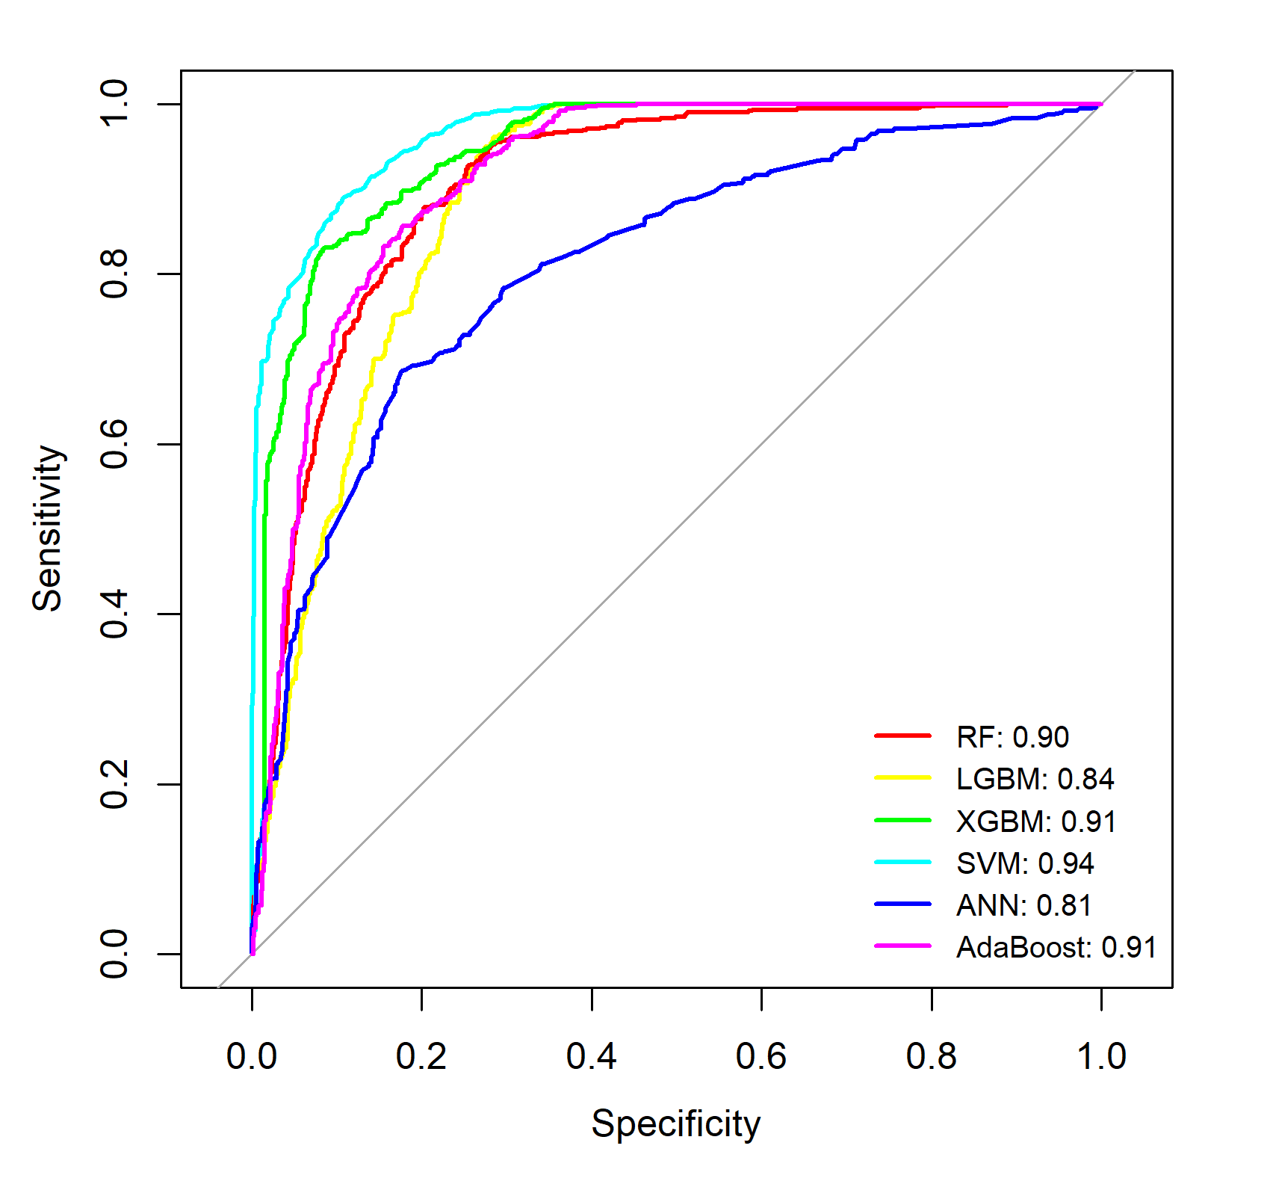

- CHD
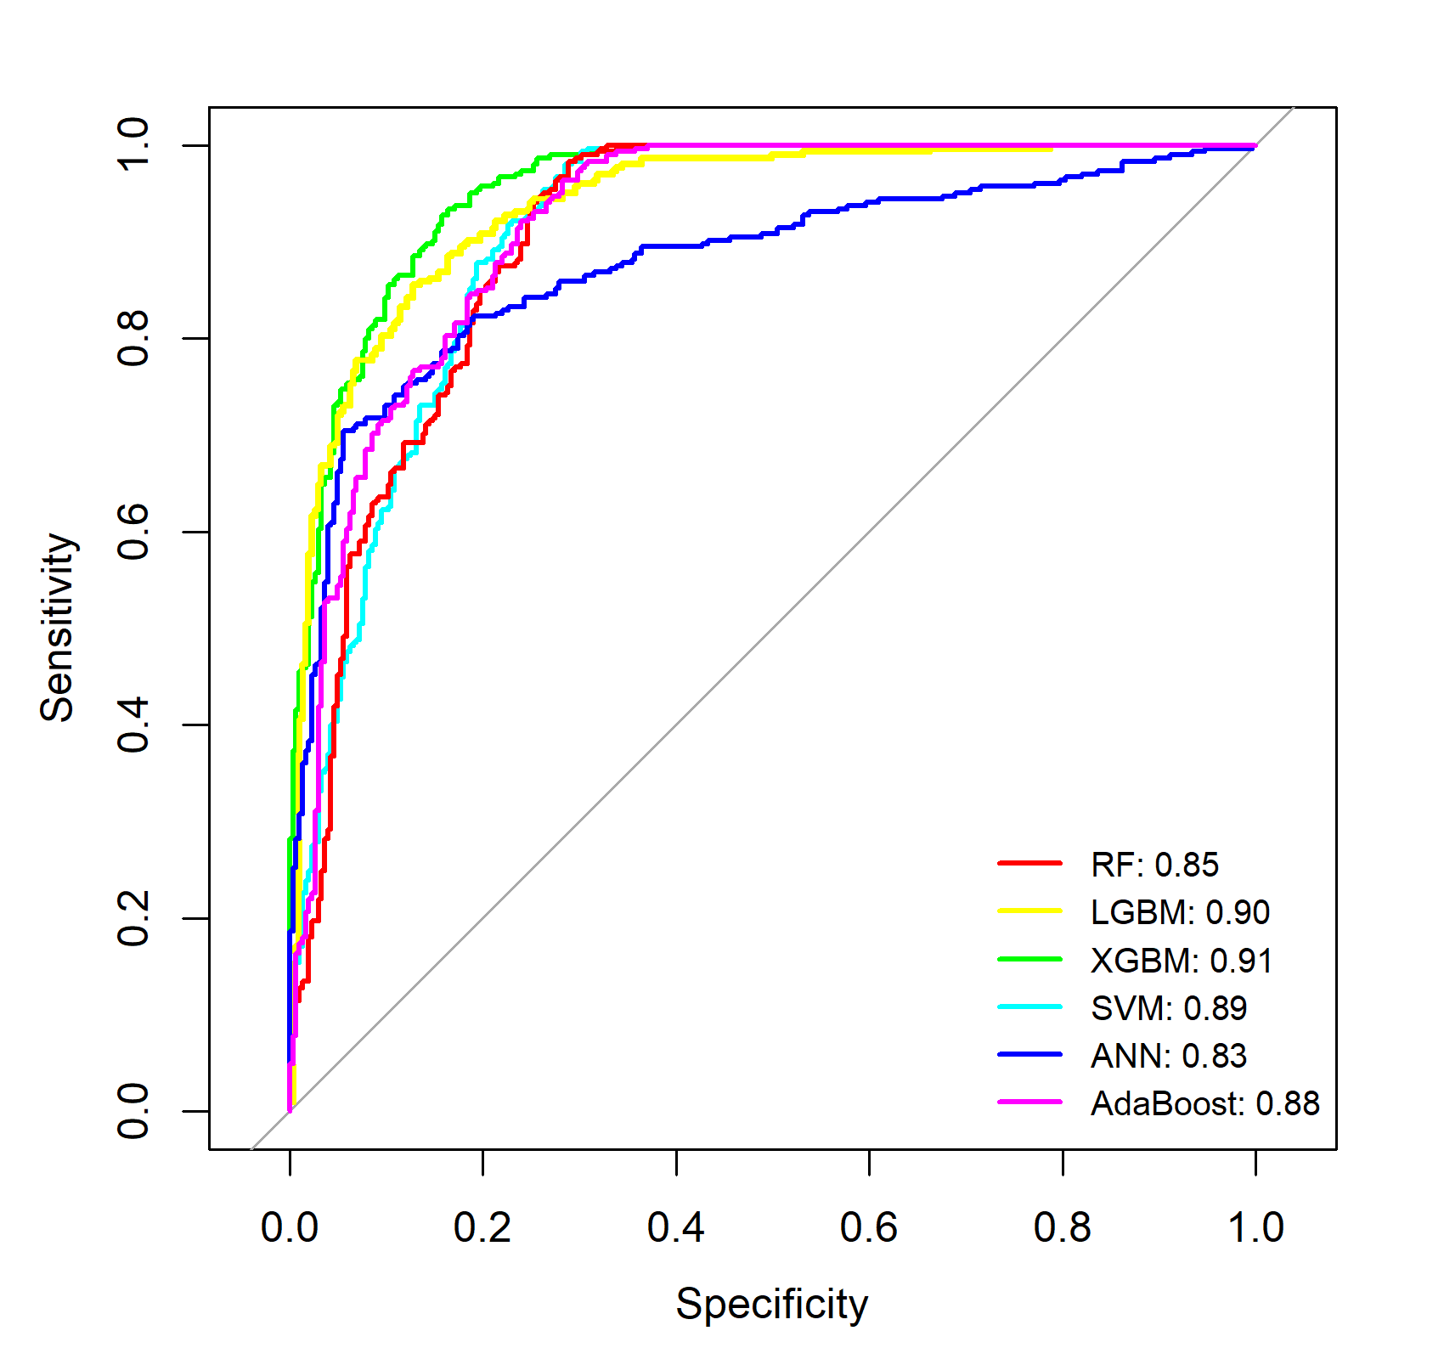

- Asthma

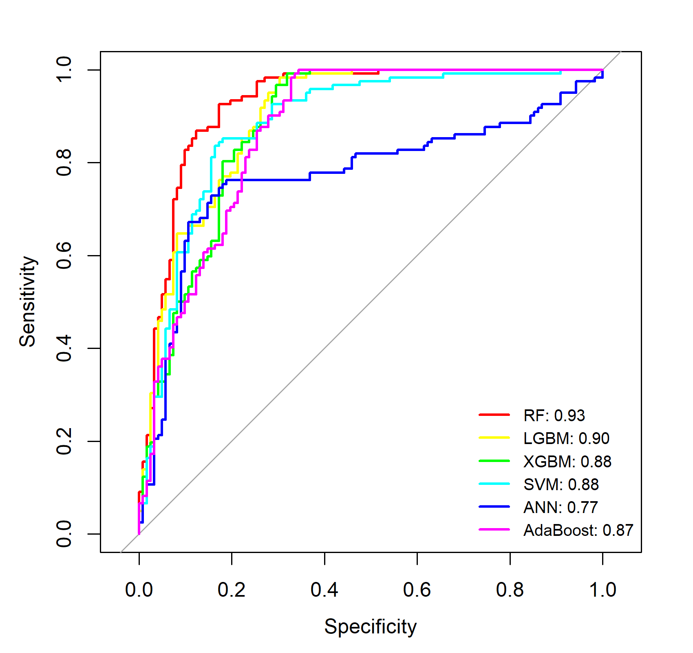

D. COPD
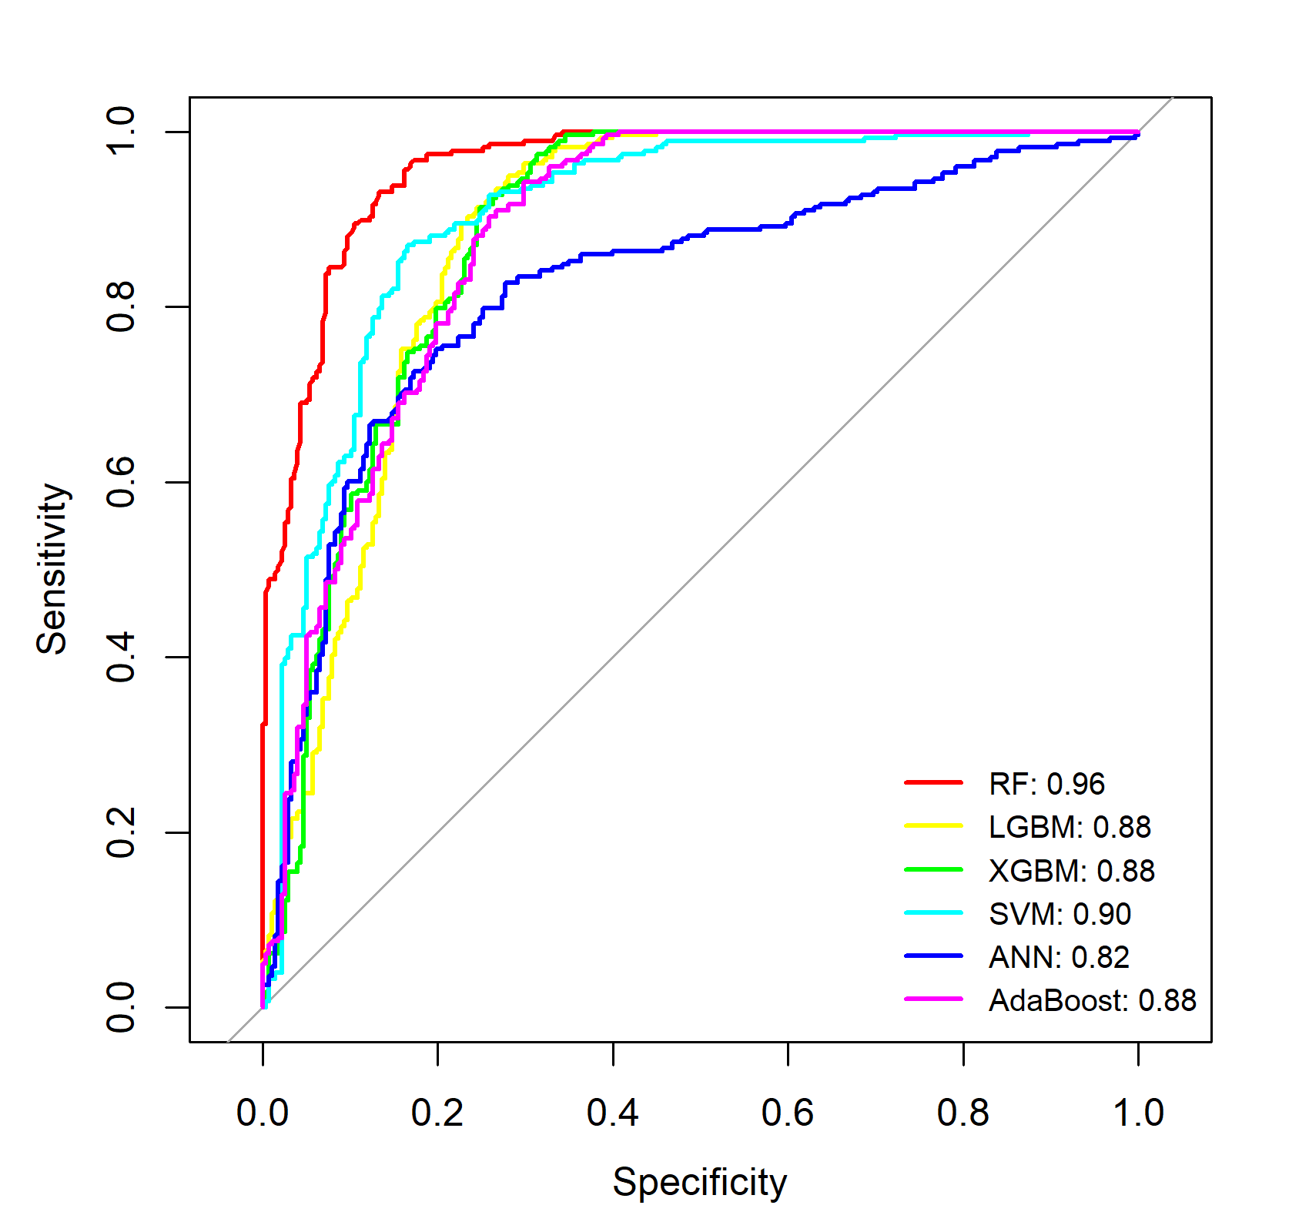

E. Arthritis
