Supplementary File

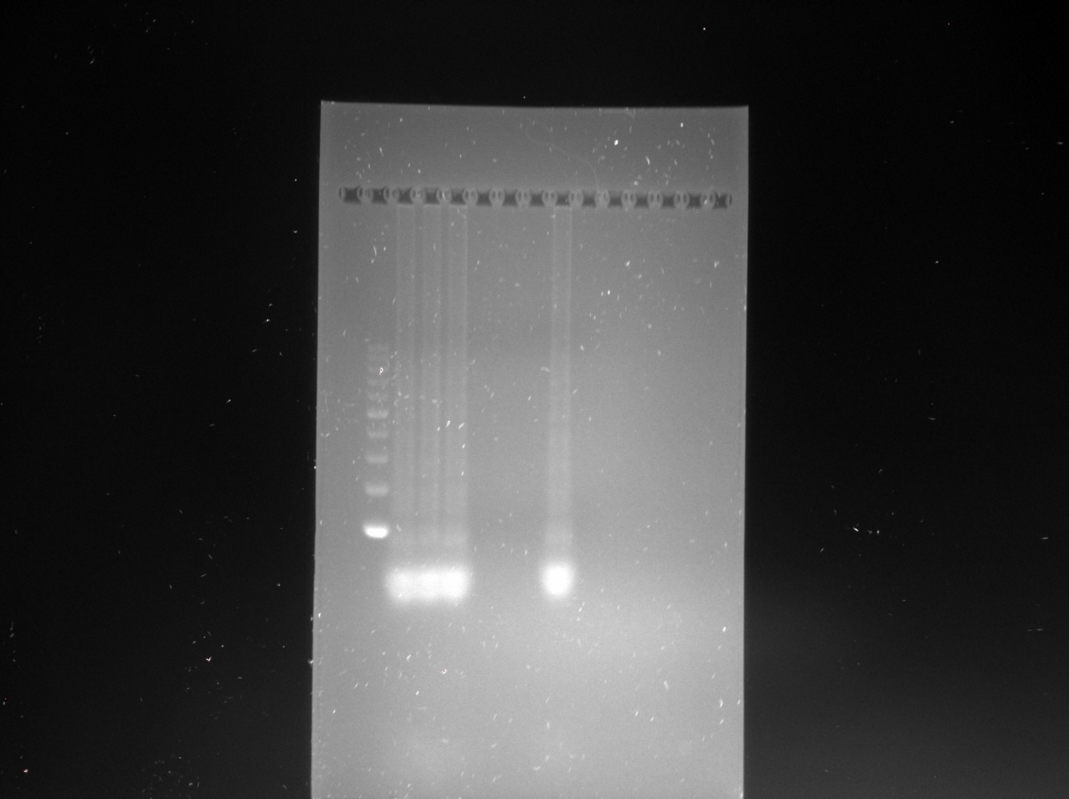
M S1 S2 S3 S4 S5 S6 C1 C2
Fig. S1 Uncropped agarose gel image showing LAMP-amplified products derived from various sample types, including raw pork, pork sausage, canned pork, raw beef, raw lamb, and raw chicken (labelled S1 to S6). A synthetic porcine oligonucleotide served as the positive control (C1), while a no template reaction was used as the negative control (C2). Each reaction used 1 µg of extracted DNA. M indicated the 100 bp molecular weight marker.

