Figure S1. Statistic particle size distribution of PAg microspheres.

Figure S2. XRD spectrum of PAg microspheres.

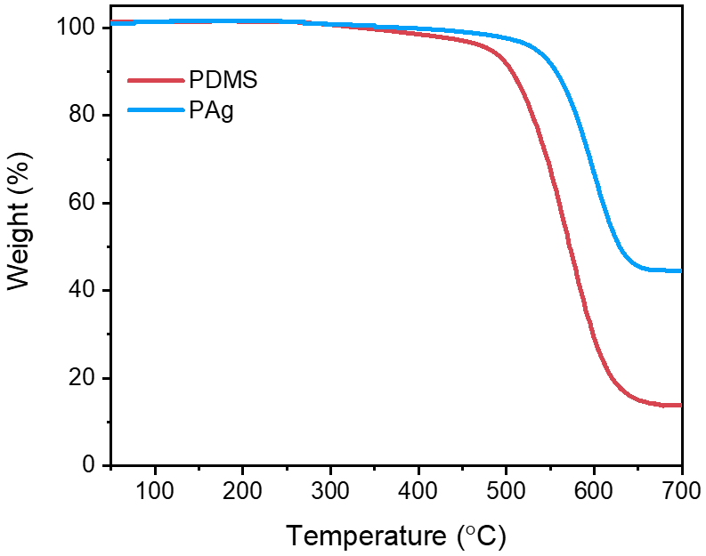
Figure S3. TGA of PAg microspheres.
Figure S4. Peak area ratios of C1s/Ag3d and O1s/Ag3d of AgFs according to XPS spectrum.
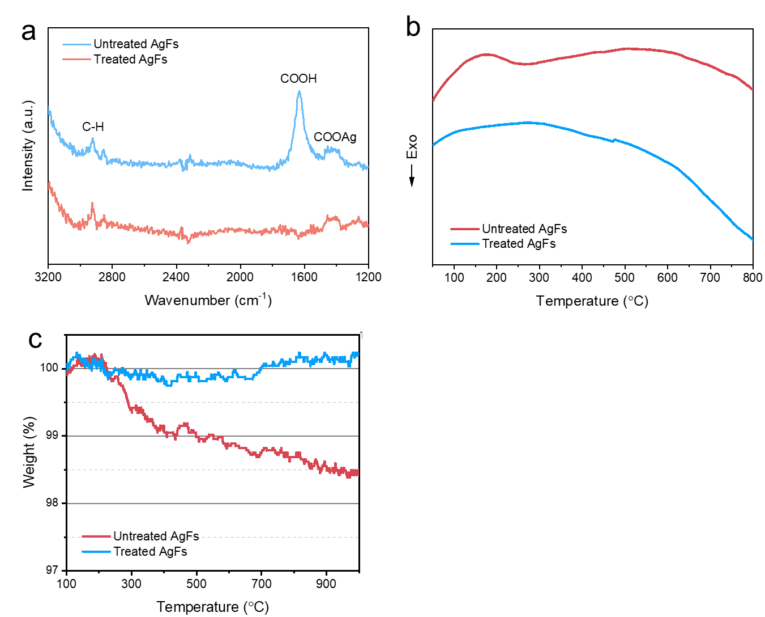
Figure S5. a) FTIR, b) TGA and c) FTIR characterizations of AgFs.
As shown in the Fourier transform infrared spectroscopy (FTIR, Figure S5a), the untreated AgFs not only exhibits the characteristic signal of carboxyl group (-COOH) at 1684 cm⁻¹^{[1]}, but also show a strong carboxylate (COO-) absorption peak at 1421 cm⁻¹^{[2, 3]}. According to previous reports, carboxyl groups form strong coordination bonds with Ag, presenting Ag⁻ form in the spectrum^{[2]}. After treatment, the -COOH peak nearly disappears, while the -COOAg peak remains, indicating that free fatty acids are almost completely removed due to their good solubility. The fatty acids bonded to AgFs (-COOAg) can be reduced to metallic Ag by reducing agent^{[4]}, which is beneficial for enhancing conductivity. The DSC curve (Figure S5b) shows that the original AgFs has a distinct exothermic peak at 257 °C, which may be related to the oxidative decomposition of fatty acids^{[2]}. The treated AgFs have no peak at 257°C, indicating that most of the lubricant was removed with boiling ethanol.
The content of fatty acids is further analyzed by TGA (Figure S5c). The initial AgFs shows weight loss of 1.6 wt% when heated to 800 °C, indicating that approximately 1.6 wt% of fatty acids are adsorbed on the surface of AgFs. After treatment, the thermal weight loss decreases to 0.2 wt%. The mass increase behavior after 400 °C originates from the oxidation phenomenon of AgFs due to the lack of protection after the removal of surfactant, resulting in a slight increase in weight.
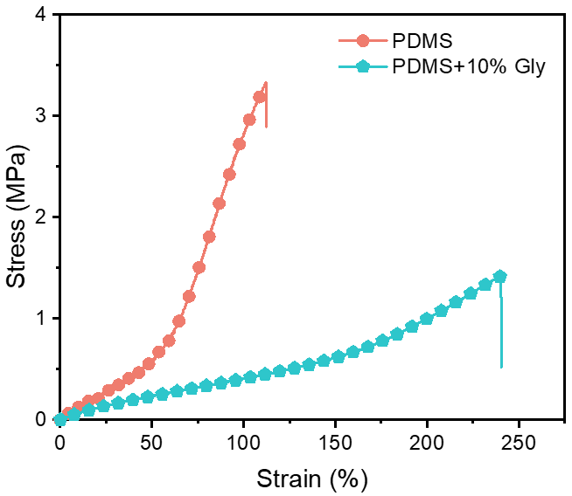
Figure S6. Stress-strain curves of PDMS elastomers with (10 wt%) and without Gly. In the presence of Gly, the elongation at break of PDMS increases significantly from 112.3% to 239.9%, while the modulus decreases from 1.48 MPa to 0.76 MPa. This adjustment in mechanical properties is beneficial for developing stretchable and soft conductor

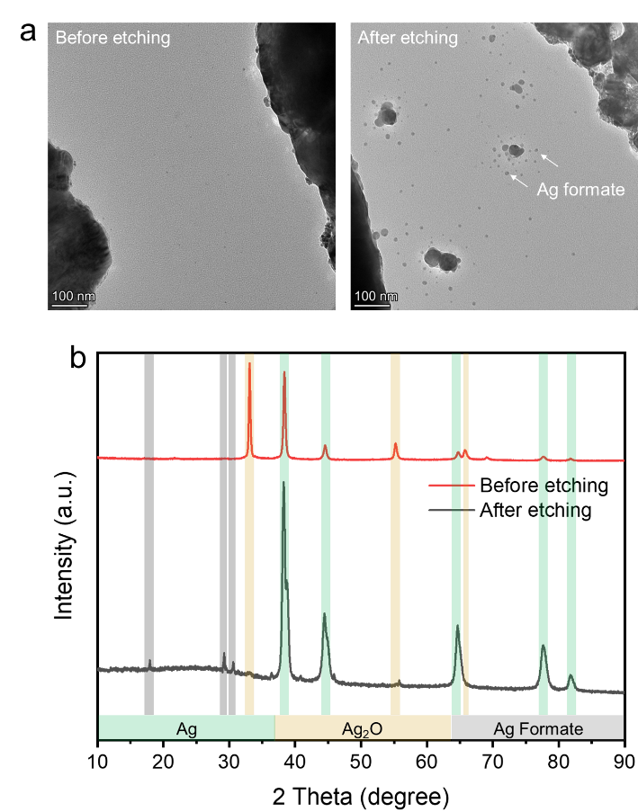
Figure S7. a) TEM images and b) XRD patterns of AgFs before and after formic acid treatment (40 μL/g, 24h).
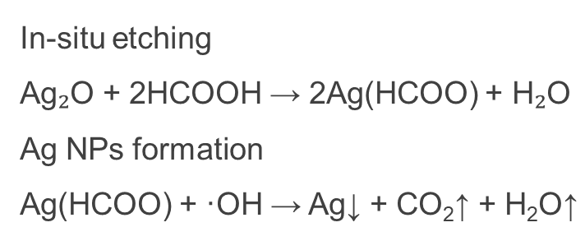
Scheme S1. The chemical process involves in-situ etching and chemical reduction leading to the formation of Ag NPs.

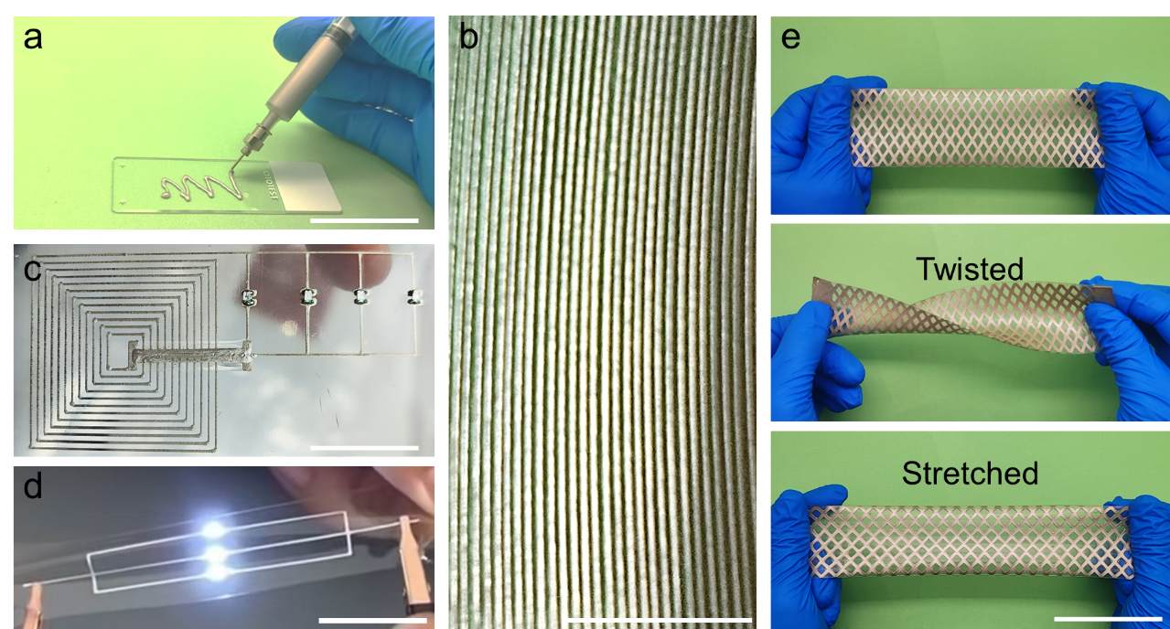
Figure S8. Various processed microstructures and devices: a) Schematic illustration of extrusion-based printing; b) Printed conductive filaments; c) Wireless power transfer system and d) stretchable LED circuit printed and integrated with electronic components on a PDMS substrate; e) Shadow-mask patterned rhombic mesh-shaped stretchable conductor. (Scale bar: 5 cm)
As demonstrated in Figures S8a and S8b, extrusion-printed conductive filament achieved feature sizes as fine as 185 μm. The customized printed circuits permitted direct integration of rigid electronic components during fabrication. Post-curing the conductive traces formed robust interfacial bonds with these components, enabling integrated soft electronic (Figure S8c). When printed on PDMS substrates, the resin matrix underwent co-crosslinking with the substrate during curing. This interfacial chemistry enabled the conductive patterns to withstand substantial tensile deformation without delamination or fracture (Figure S8d). Beyond extrusion printing, mask patterning alternatively produced conductive architectures. Figure S8e illustrates a stretchable conductor with rhombic mesh geometry, where the synergistic combination of material properties and structural design conferred exceptional mechanical compliance, maintaining functionality under severe deformation.
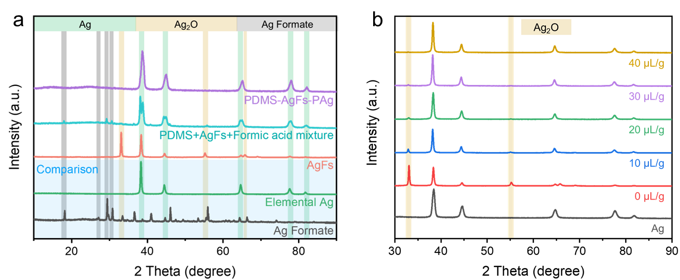
Figure S9. a) XRD analysis of the commercially obtained Ag formate (Alfa Aesar, A18569), elemental Ag (Adamas, 80528CA), AgFs (used in this work), and specimen mixture (PDMS+AgFs+formic acid), PDMS-AgFs-PAg conductor (corresponding to formic acid 40 μL/g); b) XRD spectrum of elemental Ag (Adamas, 80528CA) and PDMS-AgFs-PAg conductor with 0-40 μL/g formic acid.
Notably, in addition to the characteristic peaks of elemental Ag, AgFs exhibit strong peaks at 33.8°, 55.2° and 65.8°, corresponding to the (111), (220) and (222) crystal planes of Ag₂O (Figure S9a)^{[5]}. Chemical evidence supporting the formation of Ag formate from the etched Ag₂O is observed in the characteristic peaks of PDMS+AgFs+Formic acid mixture, where signals corresponding to Ag formate and elemental Ag appear at specific positions^{[6]}. Furthermore, the disappearance of Ag₂O characteristic peaks in the XRD spectrum confirms the complete removal of Ag₂O layer. The XRD spectrum of PDMS-AgFs-PAg composite exclusively shows characteristic peaks of elemental Ag, with no signal of Ag formate, indicating that it was entirely reduced to elemental Ag.

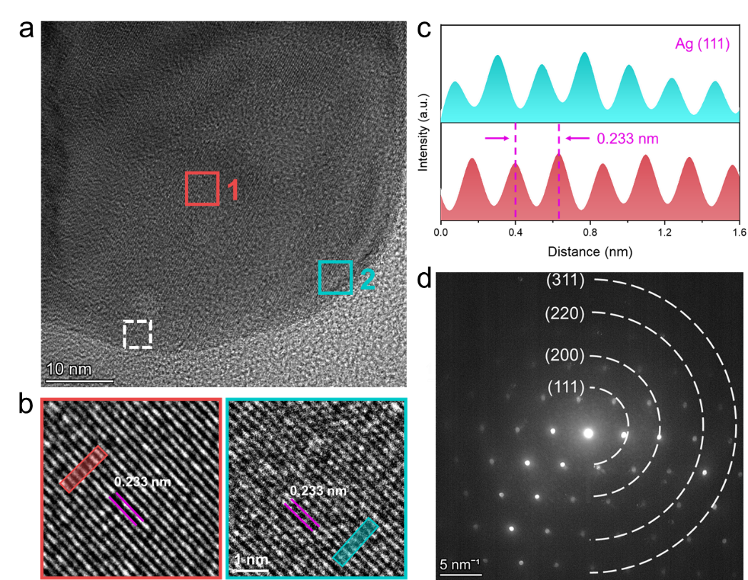
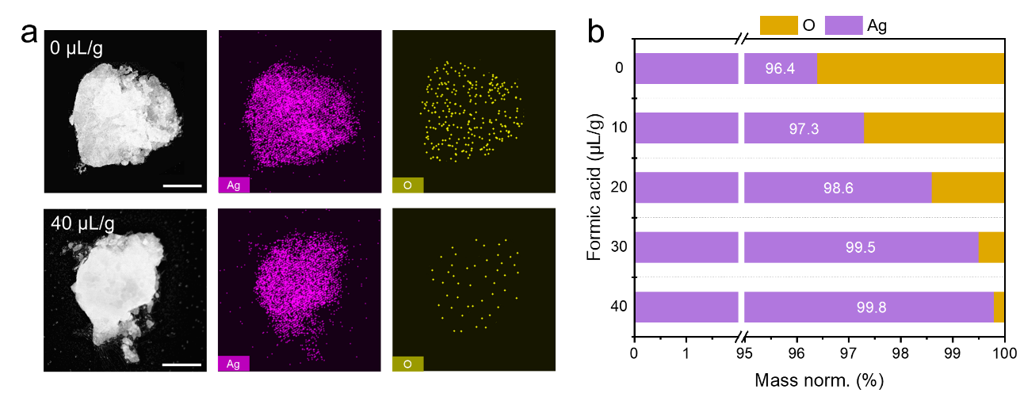
Figure S10. a) TEM images and EDS mappings of initial AgFs and AgFs etched (40 μL/g) AgFs (scale bar: 100 nm), and O/Ag signal ratio of etched AgFs derived from TEM images.
Figure S11. a) High magnification TEM image of etched AgFs; b) lattice-resolved TEM image (marked regions 1 and 2 of (a)) and c) interplanar distance profiles (marked regions of (b)); d) SAED analysis (white square marked region of (a)).
High-resolution TEM (HRTEM) scans of the edge and central regions (Regions 1 and 2) reveal consistent interplanar spacings of 0.233 nm, corresponding to the (111) crystal plane of Ag (Figure S11a, b)^{[7]}. The uniformity of interplanar spacing across the scanned area, as shown in the contour image (Figure S11c), confirming the absence of oxide layer on the etched AgFs. The selected area electron diffraction (SAED) pattern, with characteristic peaks at (111), (200), (220) and (311), further validates the complete removal of Ag₂O layer through the in-situ etching process (Figure S11d).
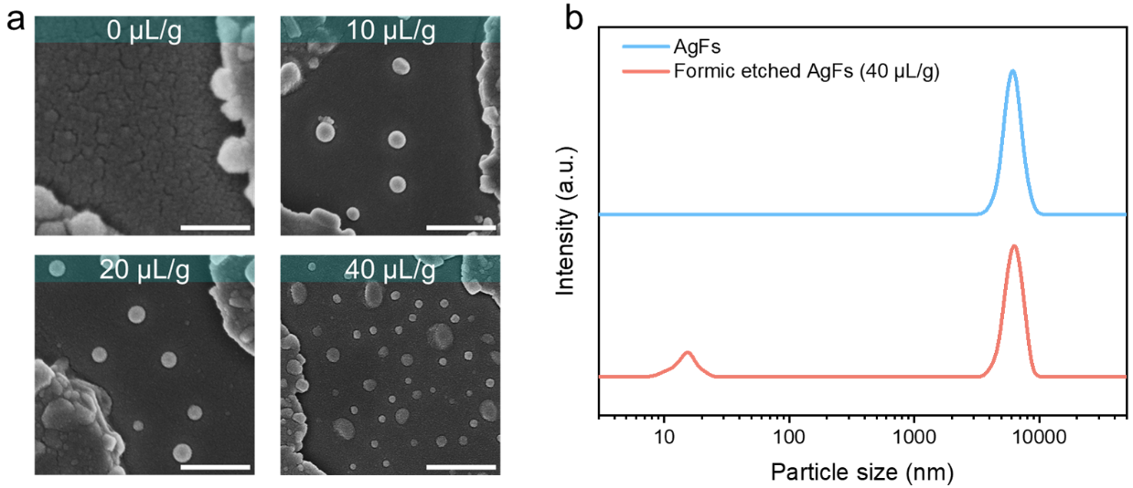
Figure S12. a) SEM images of extracted conductive fillers in PDMS-AgFs-PAg under different formic acid contents (scale bar: 100 nm); b) particle size distribution of conductive fillers (40 μL/g formic acid) obtained by dynamic light scattering (DLS).

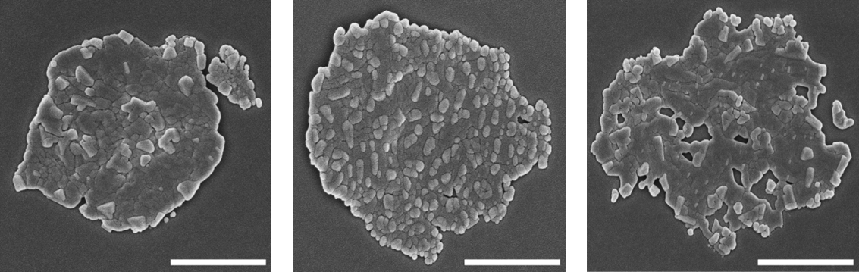
Figure S13. SEM images of formic acid etched AgFs (from left to right: 0, 40 and 50 μL/g formic acid)

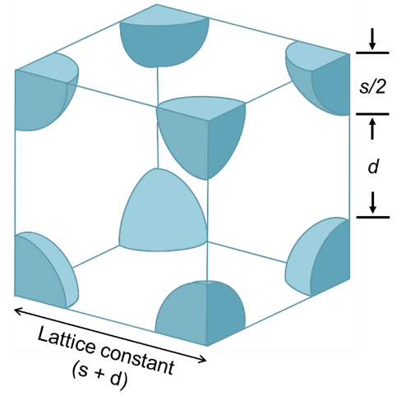
Figure S14. Schematic of the Ag NPs arrangement in a simple cubic structure. The lattice constant is the sum of the average particle size (s) and interparticle distance (d).
The volume fraction of in-situ generated Ag NPs in PDMS matrix can be estimated based on the values of s and d (Figure S14). For simplicity, assume that the Ag NPs are regular spheres with a diameter s of 9.8 nm, and the spacing between the spheres is d (19.2 nm), arranged in a simple cubic structure within polymer matrix. Based on these assumptions, the volume of a single unit cell is 24389 nm³, and the volume of Ag NPs in the unit cell is 314 nm³. Therefore, the occupied volume ratio of Ag NPs in the unit cell is 1.29 vol%, which represents the concentration of Ag NPs in PDMS matrix.

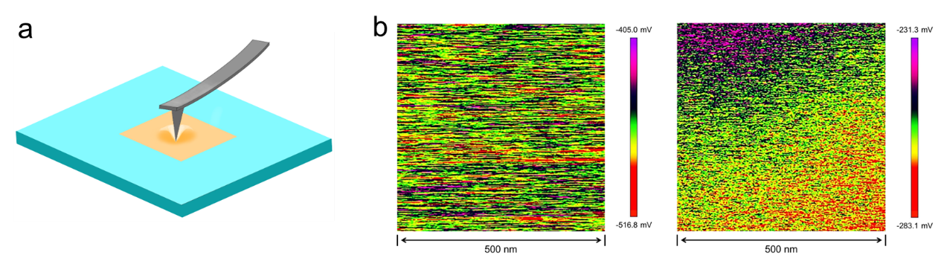
Figure S15. a) Schematic of the measurement of surface potential via KPFM technology; b) surface potential distributions of AgFs and PDMS matrix (10 wt% Gly).

The work function of AgFs was measured on a single flat nanosheet, and the electron affinity of PDMS matrix was measured on a PDMS thin film with a smooth surface prepared by spin coating (Figure S15). The electron affinity of insulating polymers can be measured by KPFM because, assuming minimal gaps between the tip and the sample, the charge transfer between them (generating a contact potential difference) will be dominated by charges in the minimum of the conduction band of insulating polymer^{[8]}. Then, λ_{B} can be directly obtained from the difference between the work function of AgFs and the electron affinity of the matrix.
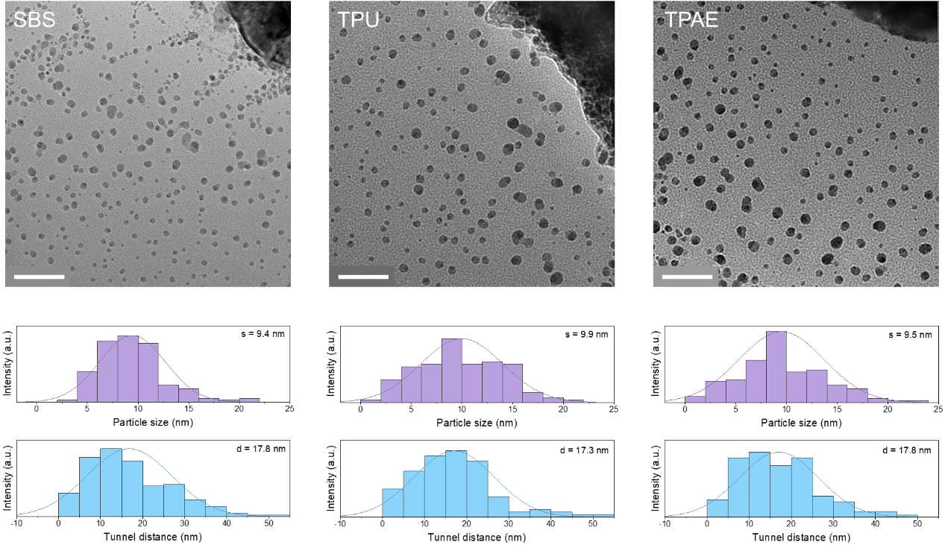
Figure S16. TEM images and corresponding statistic Ag NPs size (s) and tunneling distance (d) of composites with SBS, TPU and TPAE as matrix (scale bar: 100 nm).
Figure S16 compares the TEM morphologies of several stretchable conductors. A large number of Ag NPs is identified in these composites, indicating that the Ag NPs obtained by the proposed chemically etching-in-situ chemical reduction method do not have a dependency on the matrix. Furthermore, we statistically analyzed the particle size and its distribution of Ag NPs. The results show that the average particle size (s) of Ag NPs is 9.4 nm (SBS), 9.9 nm (TPU), and 9.5 nm (TPAE), with corresponding average tunnel distances (d) of 17.8 nm (SBS), 17.3 nm (TPU), and 17.8 nm (TPAE), respectively. Obviously, there are no significant differences in these values, proving that the differences in conductivity are caused by the differences in barrier height.
Figure S17. Electrical percolation behavior of PDMS-AgFs-PAg conductors with (cyan curve) and without (red curve) PAg, and AgFs filled PDMS without Ag NPs generation (blue curve).

Figure S18. Electrical conductivity stability of PDMS-AgFs-PAg conductor over 1000 stretching cycles at 100% strain.

Figure S19. Comparison of TCE per 1 vol% filler content of PDMS-AgFs-PAg with reported composites.

Table S1. Comparison of conductivity-filler content of PDMS-AgFs-PAg with recently reported composite conductors.
References | Filler content (wt%) | Conductivity (S/cm) | Authors
[9] | 90 | 34 | Moon et al.
[10] | 83 | 150 | Son et al.
[11] | 90.5 | 1000 | Baik et al.
[12] | 75 | 4628 | Hong et al.
[13] | 86.5 | 6168 | Someya et al.
[14] | 85 | 10000 | Xu et al.
[15] | 65 | 1000 | Yu et al.
[16] | 79.4 | 5542 | Chung et al.
[17] | 90.6 | 3400 | Faseela et al.
[18] | 86 | 4500 | Sun et al.
[19] | 80 | 900 | Kim et al.
[20] | 90 | 15700 | Gu et al.
[21] | 80 | 12000 | Jiang et al.
This work | 40 | 5847 | Tian et al.
This work | 40 | 8937 | Tian et al.
This work | 40 | 12642 | Tian et al.
This work | 40 | 19249 | Tian et al.
This work | 40 | 29429 | Tian et al.

Table S2. Comparisons of electrical retention (at 100%)-conductivity with recently reported results.
Reference | Conductivity (S/cm) | σ/σ₀ at 100% | Authors
[9] | 34 | 0.45 | Moon et al.
[15] | 1000 | 0.1 | Yu et al.
[18] | 4500 | 0.4 | Sun et al.
[16] | 5524 | 0.25 | Chung et al.
[13] | 6168 | 0.3 | Someya et al.
[20] | 15700 | 0.13 | Kim et al.
[22] | 1800 | 0.05 | Zhou et al.
[23] | 1933 | 0.23 | Jung et al.
[24] | 11000 | 0.34 | Kotov et al.
[25] | 8846 | 0.18 | Zhu et al.
[26] | 12833 | 0.12 | Lee et al.
This work | 5847 | 0.5 | Tian et al.
This work | 8937 | 0.57 | Tian et al.
This work | 12642 | 0.63 | Tian et al.
This work | 19249 | 0.69 | Tian et al.
This work | 29429 | 0.53 | Tian et al.

Table S3. Relevant parameters in the calculation of thermal conductivity of PDMS-AgFs-PAg composites at different PAg contents.
PAg content (wt%) | Out-of (In)-plane thermal diffusivity (mm²/s) | Heat capacity (J/gK) | Density (g/cm³) | Out-of (In)-plane thermal conductivity (W/m·K)
10 | 5.8 (7.3) | 0.72 | 1.83 | 7.7 (9.7)
20 | 6.6 (7.7) | 0.72 | 1.83 | 8.7 (10.2)
30 | 7.3 (9.5) | 0.72 | 1.83 | 9.6 (12.5)
40 | 8.3 (13.3) | 0.72 | 1.83 | 11 (17.6)
50 | 9 (18.4) | 0.72 | 1.83 | 11.9 (24.3)

Table S4. Comparison of thermal conductivity of our PDMS-AgFs-PAg with reported metallic filler-loaded thermal conductive composites
Composites | Thermal conductivity (W/m·K) | Filler content (vol%) | TCE  (%) | 1 vol% TCE (%)（%） | Reference
TSP/Ag MPs | 0.19 | 0 | 0 | / | [27]
TSP/Ag MPs | 0.39 | 5 | 105 | 21 | [27]
TSP/Ag MPs | 0.85 | 10 | 347 | 35 | [27]
TSP/Ag MPs | 2.28 | 20 | 1100 | 55 | [27]
TSP/Ag MPs | 3.65 | 30 | 1821 | 61 | [27]
Epoxy/Ag | 1.19 | 10.5 | 440 | 42 | [28]
Epoxy/Ag | 1.19 | 14.9 | 440 | 30 | [28]
Epoxy/Ag | 1.40 | 18.7 | 536 | 29 | [28]
Epoxy/Ag | 2.74 | 28.6 | 1145 | 40 | [28]
PVDF/Ag NWs | 0.14 | 0 | 0 | / | [29]
PVDF/Ag NWs | 0.33 | 5 | 136 | 27 | [29]
PVDF/Ag NWs | 0.81 | 10 | 479 | 48 | [29]
PVDF/Ag NWs | 1.02 | 15 | 629 | 42 | [29]
PVDF/Ag NWs | 1.36 | 20 | 871 | 44 | [29]
PVDF/Ag NWs | 1.57 | 25 | 1021 | 41 | [29]
Epoxy-PES/Ag NPs | 0.26 | 5 | 8 | 2 | [30]
Epoxy-PES/Ag NPs | 1.19 | 10 | 396 | 40 | [30]
Epoxy-PES/Ag NPs | 2.51 | 15 | 946 | 63 | [30]
Epoxy-PES/Ag NPs | 4.25 | 20 | 1671 | 84 | [30]
Epoxy-PES/Ag NPs | 7.81 | 25 | 3154 | 126 | [30]
Epoxy/Ag MPs | 0.76 | 10 | 245 | 25 | [31]
Epoxy/Ag MPs | 0.99 | 20 | 350 | 18 | [31]
Epoxy/Ag MPs | 7.41 | 30 | 3268 | 109 | [31]
Epoxy/Ag MPs | 9.83 | 40 | 4368 | 109 | [31]
Epoxy-PEI/Ag NWs | 0.22 | 0 | 0 | / | [32]
Epoxy-PEI/Ag NWs | 0.25 | 0.057 | 14 | 239 | [32]
Epoxy-PEI/Ag NWs | 0.28 | 0.12 | 27 | 227 | [32]
Epoxy-PEI/Ag NWs | 0..29 | 0.23 | 32 | 138 | [32]
Epoxy-PEI/Ag NWs | 0.30 | 0.35 | 36 | 103 | [32]
PU-PDMS/Al Fs | 0.59 | 5.4 | 228 | 42 | [33]
PU-PDMS/Al Fs | 1.17 | 11.3 | 550 | 49 | [33]
PU-PDMS/Al Fs | 1.56 | 14.1 | 767 | 54 | [33]
Epoxy/Cu MPs | 0.28 | 0 | 0 | / | [34]
Epoxy/Cu MPs | 0.34 | 1.5 | 21 | 14 | [34]
Epoxy/Cu MPs | 0.79 | 5.5 | 182 | 33 | [34]
Epoxy/Cu MPs | 0.74 | 11.9 | 164 | 14 | [34]
Epoxy/Cu MPs | 3.88 | 23.93 | 1286 | 54 | [34]
Epoxy/Cu NPs | 0.87 | 4.58 | 295 | 65 | [35]
Epoxy/Cu NPs | 1.27 | 9.44 | 477 | 51 | [35]
Epoxy/Cu NPs | 2.11 | 17.38 | 859 | 49 | [35]
Epoxy/Cu NPs | 2.85 | 23.61 | 1195 | 51 | [35]
PI/Ag MPs | 0.27 | 0 | 0 | / | [36]
PI/Ag MPs | 0.83 | 12 | 207 | 17 | [36]
PI/Ag MPs | 0.93 | 20 | 244 | 12 | [36]
PI/Ag MPs | 2.72 | 35 | 907 | 26 | [36]
PI/Ag MPs | 3.30 | 40 | 1122 | 28 | [36]
PI/Ag | 0.27 | 0 | 0 | / | [37]
PI/Ag | 0.38 | 0.52 | 41 | 78 | [37]
PI/Ag | 0.55 | 1.57 | 104 | 66 | [37]
PI/Ag | 0.90 | 2.64 | 233 | 88 | [37]
PI/Ag | 1.54 | 5.44 | 470 | 86 | [37]
PI/Ag | 2.12 | 8.41 | 685 | 81 | [37]
Epoxy/Ag MFs | 0.20 | 0 | 0 | 0 | [38]
Epoxy/Ag MFs | 1.13 | 3.92 | 463 | 118 | [38]
Epoxy/Ag MFs | 2.14 | 6.12 | 968 | 158 | [38]
Epoxy/Ag MFs | 4.38 | 9.80 | 2090 | 213 | [38]
PDMS-AgFs-PAg  (PAg: 10wt%) | 1.7 | 1.05 | 750 | 714 | This work
PDMS-AgFs-PAg  (PAg: 10wt%) | 2.7 | 2.33 | 1250 | 536 | This work
PDMS-AgFs-PAg  (PAg: 10wt%) | 4.5 | 3.92 | 2150 | 548 | This work
PDMS-AgFs-PAg  (PAg: 10wt%) | 6.6 | 5.97 | 3200 | 536 | This work
PDMS-AgFs-PAg  (PAg: 10wt%) | 9.7 | 8.70 | 4750 | 546 | This work
PDMS-AgFs-PAg  (Total Ag fraction: 50 wt%) | 10.2 | 8.70 | 5000 | 575 | This work
PDMS-AgFs-PAg  (Total Ag fraction: 50 wt%) | 12.5 | 8.70 | 6150 | 707 | This work
PDMS-AgFs-PAg  (Total Ag fraction: 50 wt%) | 17.6 | 8.70 | 8700 | 1000 | This work
PDMS-AgFs-PAg  (Total Ag fraction: 50 wt%) | 24.3 | 8.70 | 12050 | 1385 | This work

References
[1] Florio, G. M.; Zwier, T. S.; Myshakin, E. M., et al., Theoretical modeling of the OH stretch infrared spectrum of carboxylic acid dimers based on first-principles anharmonic couplings. Journal of Chemical Physics 2003, 118, 1735.
[2] Zhao, J.; Feng, J.; Jiang, Y., et al., Skin-Integrated Electrodes Based on Room-Temperature Curable, Highly Conductive Silver/Polydimethylsiloxane Composites. Small 2024, 20, 2309470.
[3] Zhang, W.; Liu, J.; Liu, H., et al., Surface Functionalization of Micrometer Silver Flakes for Fabricating High-Performance Electrically Conductive Adhesives. ACS Applied Electronic Materials 2022, 4, 5387.
[4] Zhang, R.; Moon, K.-s.; Lin, W., et al., A simple, low-cost approach to prepare flexible highly conductive polymer composites by in-situ reduction of silver carboxylate for flexible electronic applications. Composites Science and Technology 2011, 71, 528.
[5] Mou, Y.; Liu, J.; Wang, Q., et al., A novel thermal conductive Ag₂O paste for thermal management of light-emitting diode. Materials Letters 2022, 316, 132022.
[6] Puzan, A. N.; Baumer, V. N.; Mateychenko, P. V., Structure and decomposition of the silver formate Ag(HCO₂). Journal of Solid State Chemistry 2017, 246, 264.
[7] Wei, J.; Lin, Z.; Lei, Z., et al., Lightweight and Highly Compressible Expandable Polymer Microsphere/Silver Nanowire Composites for Wideband Electromagnetic Interference Shielding. ACS Applied Materials & Interfaces 2022, 14, 5940.
[8] Faseela, K. P.; Ajmal, C. M.; Cha, S., et al., In Situ Regeneration of Oxidized Copper Flakes Forming Nanosatellite Particles for Non-Oxidized Highly Conductive Copper Nanocomposites. Advanced Functional Materials 2023, 33, 2304776.
[9] Kim, I.; Woo, K.; Zhong, Z., et al., A photonic sintering derived Ag flake/nanoparticle-based highly sensitive stretchable strain sensor for human motion monitoring. Nanoscale 2018, 10, 7890.
[10] Kim, S. H.; Seo, H.; Kang, J., et al., An Ultrastretchable and Self-Healable Nanocomposite Conductor Enabled by Autonomously Percolative Electrical Pathways. ACS Nano 2019, 13, 6531.
[11] Suh, D.; Faseela, K. P.; Kim, W., et al., Electron tunneling of hierarchically structured silver nanosatellite particles for highly conductive healable nanocomposites. Nature Communications 2020, 11, 2252.
[12] Oh, Y.; Yoon, I. S.; Lee, C., et al., Selective photonic sintering of Ag flakes embedded in silicone elastomers to fabricate stretchable conductors. Journal of Materials Chemistry C 2017, 5, 11733.
[13] Matsuhisa, N.; Inoue, D.; Zalar, P., et al., Printable elastic conductors by in-situ formation of silver nanoparticles from silver flakes. Nature Materials 2017, 16, 834.
[14] Wang, T.; Liu, Q.; Liu, H., et al., Printable and Highly Stretchable Viscoelastic Conductors with Kinematically Reconstructed Conductive Pathways. Advanced Materials 2022, 34, 2202418.
[15] Zhu, H.-W.; Gao, H.-L.; Zhao, H.-Y., et al., Printable elastic silver nanowire-based conductor for washable electronic textiles. Nano Research 2020, 13, 2879.
[16] Lee, B.; Cho, H.; Moon, S., et al., Omnidirectional printing of elastic conductors for three-dimensional stretchable electronics. Nature Electronics 2023, 6, 307.
[17] Faseela, K. P.; Benny, A. P.; Kim, Y., et al., Highly Conductive Strong Healable Nanocomposites via Diels-Alder Reaction and Filler-Polymer Covalent Bifunctionalization. Small 2022, 18, 2104764.
[18] Sun, H.; Han, Z.; Willenbacher, N., Ultrastretchable Conductive Elastomers with a Low Percolation Threshold for Printed Soft Electronics. ACS Applied Materials & Interfaces 2019, 11, 38092.
[19] Ko, Y.; Oh, J.; Park, K. T., et al., Stretchable Conductive Adhesives with Superior Electrical Stability as Printable Interconnects in Washable Textile Electronics. ACS Applied Materials & Interfaces 2019, 11, 37043.
[20] Gu, M.; Song, W.-J.; Hong, J., et al., Stretchable batteries with gradient multilayer conductors. Science Advances 2019, 5, eaaw1879.
[21] Mou, L.; Qi, J.; Tang, L., et al., Highly Stretchable and Biocompatible Liquid Metal-Elastomer Conductors for Self-Healing Electronics. Small 2020, 16, 2005336.
[22] Zhong, D.; Shi, S.; Yang, X., et al., Highly Stretchable yet Degradable and Recyclable Conductive Composites with Liquid Metal Nanodroplets as Physical Crosslinks. Advanced Functional Materials 2024, 34, 2308032.
[23] Hwang, Y.; Lee, J. H.; Kim, Y. H., et al., Lubricant-Added Conductive Composite for Direct Writing of a Stretchable Electrode. ACS Applied Materials & Interfaces 2019, 11, 48459.
[24] Kim, Y.; Zhu, J.; Yeom, B., et al., Stretchable nanoparticle conductors with self-organized conductive pathways. Nature 2013, 500, 59.
[25] Kang, Y.; Wang, G.; Zhao, S., et al., High-Resolution Printable and Elastomeric Conductors from Strain-Adaptive Assemblies of Metallic Nanoparticles with Low Aspect Ratios. Small 2020, 16, 2004793.
[26] Lv, J.; Thangavel, G.; Xin, Y., et al., Printed sustainable elastomeric conductor for soft electronics. Nature Communications 2023, 14, 7132.
[27] Kim, W. J.; Taya, M.; Nguyen, M. N., Electrical and thermal conductivities of a silver flake/thermosetting polymer matrix composite. Mechanics of Materials 2009, 41, 1116.
[28] Wu, H.; Chiang, S.; Han, W., et al., Surface iodination: A simple and efficient protocol to improve the isotropically thermal conductivity of silver-epoxy pastes. Composites Science and Technology 2014, 99, 109.
[29] Zeng, H.; Wu, J.; Pei, H., et al., Highly thermally conductive yet mechanically robust composites with nacre-mimetic structure prepared by evaporation-induced self-assembly approach. Chemical Engineering Journal 2021, 405, 126865.
[30] Kishi, H.; Saruwatari, T.; Mototsuka, T., et al., Synergistic effect of phase structures and in situ sintering of silver fillers on thermal conductivity of epoxy/polyethersulphone/silver filler composites. Polymer 2021, 223, 123726.
[31] Wang, D.; Wei, H.; Lin, Y., et al., Achieving ultrahigh thermal conductivity in Ag/MXene/epoxy nanocomposites via filler-filler interface engineering. Composites Science and Technology 2021, 213, 108953.
[32] Liu, Y.; Yang, X.; Yue, L., et al., Selective dispersion of silver nanowires in epoxy/polyetherimide binary composites with enhanced electrical conductivity: a study of curing kinetics and morphology. Polymer Composites 2019, 40, 4390.
[33] Wei, B.; Chen, X.; Yang, S., Construction of a 3D aluminum flake framework with a sponge template to prepare thermally conductive polymer composites. Journal of Materials Chemistry A 2021, 9, 10979.
[34] Wang, X.; Pu, Z.; Yang, Y., et al., Ultra-high thermal conductive epoxy-based copper/graphite nanoplatelets materials for heat management application. Composites Science and Technology 2022, 224, 109454.
[35] Barani, Z.; Mohammadzadeh, A.; Geremew, A., et al., Thermal Properties of the Binary-Filler Hybrid Composites with Graphene and Copper Nanoparticles. Advanced Functional Materials 2020, 30, 1904008.
[36] Murakami, T.; Ebisawa, K.; Miyao, K., et al., Enhanced Thermal Conductivity in Polyimide/Silver Particle Composite Films Based on Spontaneous Formation of Thermal Conductive Paths. Journal of Photopolymer Science and Technology 2014, 27, 187.
[37] Guo, Y.; Yang, X.; Ruan, K., et al., Reduced Graphene Oxide Heterostructured Silver Nanoparticles Significantly Enhanced Thermal Conductivities in Hot-Pressed Electrospun Polyimide Nanocomposites. ACS Applied Materials & Interfaces 2019, 11, 25465.
[38] Guo, J.; Wang, X.; Wang, T., Thermal characterization of microscale conductive and nonconductive wires using transient electrothermal technique. Journal of Applied Physics 2007, 101, 063537.

