Table 1. Phenome-wide association studies (PheWAS) significant results of the four cognitive capacity GPSs with the cognitive/behavioral phenotypes. The table presents only the phenotypes significantly associated with all four cognitive capacity GPSs (Educational attainment (EA), Cognitive Performance (CP), Math Ability (MA), Highest Math Class (HM)). The strongest cognitive capacity GPS-phenotype associations were presented from the full PheWAS results (available in Supplementary Table 1). Positive beta (effect size) indicates that genetic contribution to cognitive capacities are positively correlated to higher scores of each measurement module.

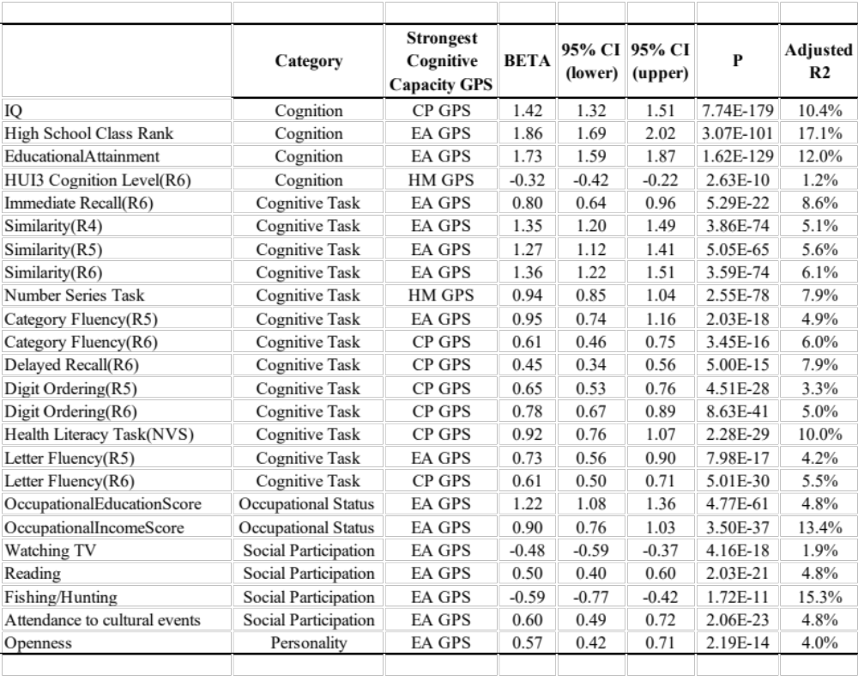

* CI = Confidence interval
* Only for HUI3 Cognition Level module, lower score indicates better cognition level.
* Bonferroni significance = 0.05 / (48 phenotypes * 4 GPSs) = 2.60E-04

Table 2. Results of the linear mixed effects model analysis explaining the temporal changes of immediate recall assessment score of the WLS participants by the GPSs of Educational attainment (EA), Cognitive Performance (CP), Math Ability (MA), Highest Math Class (HM) with age interaction effect. Effect size of each variable were presented with 95% confidence interval within the parentheses.

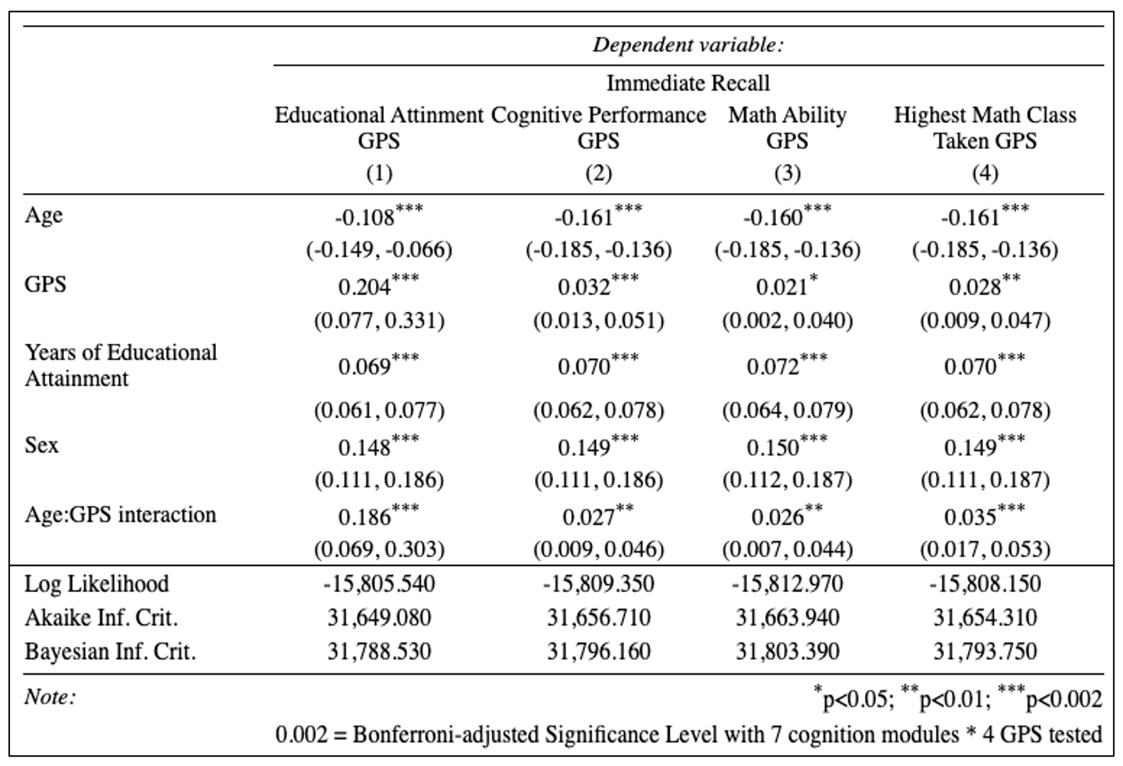

*SE=Standard Error

