Synergistic Use of Lipid-Nanocapsule and Chitosan/Iota-Carrageenan Hydrogel for Hydrophobic Antiviral Drug Delivery

Grady K. Mukubwa ^{1,3,6,8}, Justin B. Safari ^{1,5}, Zikhona N. Tetana^{7,9}, Caroline N. Jones^{6,8}, Roderick B. Walker ², and Rui W.M. Krause ^{1,4}
¹ Department of Chemistry, Faculty of Science, Rhodes University, P.O. Box 94, Grahamstown, 6140, Eastern Cape, South Africa; grady.mukubwa@utdallas.edu (G.K.M); r.krause@ru.ac.za (R.W.M.K.), safaribazibuhejustin@gmail.com (J.B.S)
² Department of Pharmaceutics, Faculty of Pharmacy, Rhodes University, P.O. Box 94, Grahamstown, 6140, Eastern Cape, South Africa; r.b.walker@ru.ac.za (R.B.W)
³ Department of Pharmaceutics, Faculty of Pharmaceutical Sciences, University of Kinshasa, P.O. Box 212, Kinshasa XI, Democratic Republic of the Congo; grady.mukubwa@utdallas.edu (G.K.M)
⁴ Center for Chemico- and Biomedical Research, Rhodes University, P.O. Box 94, Grahamstown, 6140, Eastern Cape, South Africa; r.krause@ru.ac.za (R.W.M.K.)
⁵ Department of Pharmacy, Faculty of Pharmaceutical Sciences and Public Health, Official University of Bukavu, Bukavu 570, Democratic Republic of the Congo; safaribazibuhejustin@gmail.com (J.B.S)
⁶ Department of Bioengineering, Erick Johnson School of Engineering and Computer Science, University of Texas at Dallas, Richardson, 75083, United States; grady.mukubwa@utdallas.edu (G.K.M), caroline.jones@utdallas.edu (C.N.J.)
⁷ DST/NRF Center of Excellence in Strong Materials and Molecular Sciences Institute, School of Chemistry, University of the Witwatersrand, Private bag X3, Braamfontein, Johannesburg, 2050, South Africa; zikhona.tetana@wits.ac.za (Z.N.T.)
⁸ Department of Biomedical Engineering, University of Texas Southwestern Medical School, Dallas, TX 75235, United States; grady.mukubwa@utsouthwestern.edu (G.K.M), caroline.jones@ utsouthwestern.edu (C.N.J.)
⁹ Institute for nanotechnology and water sustainability, College of Science, Engineering and Technology (CSET), University of South Africa (UNISA), Florida campus, 1709 Johannesburg, South Africa; tetanzn@unisa.ac.za (Z.N.T.)

SUPPORTING INFORMATION
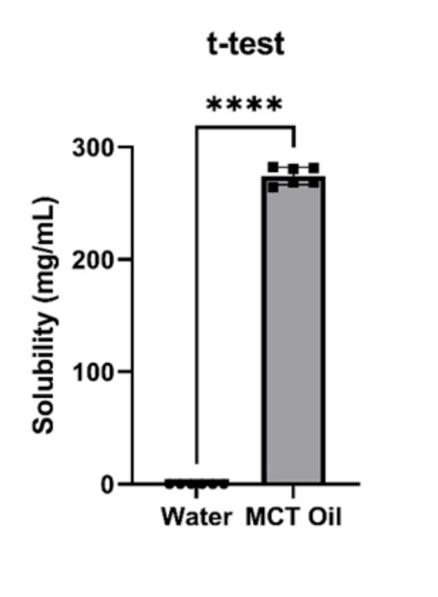
Figure S1. Solubility study. This figure shows that Efavirenz was significantly soluble in medium chain triglycerides oil (MCT oil) compared to water, supporting its high hydrophobicity property.

Table S1. Hydrogels formulations with their corresponding swelling ratio
Input variables (%) |  |  |  |  |  | Response (g/g)
Run | Iota-carrageenan | Chitosan | Acrylic acid | Acrylamide | MBA | Swelling Ratio
 | A | B | C | D | E
1.0 | 4.72 | 4.79 | 49.05 | 40.44 | 1.0 | 36.96
2.0 | 5.82 | 5.64 | 41.49 | 44.05 | 3.0 | 60.44
3.0 | 6.0 | 4.3 | 40.0 | 47.85 | 1.85 | 207.0
4.0 | 3.26 | 3.0 | 50.98 | 40.0 | 2.76 | 105.33
5.0 | 4.72 | 4.79 | 49.05 | 40.44 | 1.0 | 46.05
6.0 | 3.0 | 3.13 | 43.59 | 49.28 | 1.0 | 66.0
7.0 | 4.47 | 4.18 | 40.51 | 47.84 | 3.0 | 15.94
8.0 | 3.0 | 3.0 | 40.0 | 53.0 | 1.0 | 342.51
9.0 | 4.52 | 3.0 | 43.74 | 46.56 | 2.19 | 59.7
10.0 | 5.74 | 3.56 | 46.89 | 41.07 | 2.75 | 434.43
11.0 | 3.09 | 3.0 | 46.82 | 45.93 | 1.15 | 20.64
12.0 | 3.41 | 3.0 | 47.79 | 42.8 | 3.0 | 31.92
13.0 | 4.81 | 3.0 | 40.0 | 51.19 | 1.0 | 22.19
14.0 | 3.0 | 3.0 | 40.98 | 50.03 | 3.0 | 272.12
15.0 | 3.0 | 4.54 | 40.0 | 50.41 | 2.05 | 6.0
16.0 | 3.0 | 6.0 | 40.0 | 50.0 | 1.0 | 109.5
17.0 | 3.0 | 4.25 | 45.34 | 44.41 | 3.0 | 18.6
18.0 | 3.0 | 3.39 | 50.08 | 42.53 | 1.0 | 276.48
19.0 | 3.74 | 5.6 | 47.87 | 40.0 | 2.79 | 35.53
20.0 | 3.0 | 4.87 | 46.29 | 44.75 | 1.1 | 29.33
21.0 | 4.52 | 3.0 | 43.74 | 46.56 | 2.19 | 43.0
22.0 | 4.47 | 4.18 | 40.51 | 47.84 | 3.0 | 348.16
23.0 | 3.0 | 3.33 | 52.68 | 40.0 | 1.0 | 2.84
24.0 | 4.3 | 6.0 | 43.56 | 44.43 | 1.7 | 86.5
25.0 | 4.3 | 6.0 | 43.56 | 44.43 | 1.7 | 73.52
26.0 | 3.0 | 4.54 | 40.0 | 50.41 | 2.05 | 5.1
27.0 | 6.0 | 5.09 | 44.04 | 41.88 | 3.0 | 88.0
28.0 | 3.0 | 5.96 | 47.74 | 42.31 | 1.0 | 33.44
29.0 | 6.0 | 6.0 | 46.37 | 40.0 | 1.63 | 58.66
30.0 | 6.0 | 3.56 | 44.84 | 44.6 | 1.0 | 324.68
31.0 | 3.0 | 6.0 | 50.0 | 40.0 | 1.0 | 7.21
32.0 | 6.0 | 6.0 | 40.33 | 46.68 | 1.0 | 32.9
33.0 | 5.83 | 3.0 | 50.14 | 40.0 | 1.03 | 194.4
34.0 | 3.14 | 6.0 | 40.45 | 47.41 | 3.0 | 6.05
35.0 | 6.0 | 3.0 | 40.0 | 48.0 | 3.0 | 144.52

Table S2. Analysis of variance of fitted models.
Model | Sequential p-value | Lack of Fit p-value | Adjusted R² | Predicted R² | PRESS
Linear | 0,0451 | 0,3168 | 0,1643 | -0,0344 | 61,47 | Suggested
Quadratic | 0,7921 | 0,2329 | 0,0374 | -0,8826 | 111,88
Special Cubic | 0,4275 | 0,1962 | 0,0943 | -8,4271 | 560,25
Cubic | 0,1962 | - | 0,444 | - | * | Aliased
The sequential p-value tests whether adding terms significantly improves the model (p < 0.05 indicates improvement), while the lack of fit p-value assesses model adequacy (p > 0.05 suggests a good fit). Adjusted R² accounts for the number of predictors, and predicted R² measures the model’s ability to predict new data. PRESS (Predicted Residual Error Sum of Squares) reflects predictive performance, with lower values indicating better models. An aliased model results from insufficient data to estimate all terms reliably.
Based on the analysis of variance (Table S2), the linear model was selected as the best fit for predicting the swelling behavior. It showed a significant sequential p-value (0.0451), an acceptable lack of fit p-value (0.3168), and the lowest PRESS value (61.47) compared to higher-order models. Although the adjusted and predicted R² values were modest, they were superior to those obtained with quadratic or cubic models. Low R² values are common in swelling studies due to the inherent variability of hydrogel materials. The reliability of the model is supported by the low PRESS value, indicating good predictive performance.

Potential mechanism of formation of the hydrogel
At higher temperature, ammonium persulfate (APS) generates free radicals, which interact with either the hydroxyl or the amide groups of polysaccharides (chitosan and iota-carrageenan). This interaction results in the formation of free radical sites on the backbone of these polymers as illustrated in Figure 32. The addition of acrylamide (AAm), acrylic acid (AA), and N’N’-methylene bisacrylamide (MBA) (compounds with unsaturated carbon chains) to the activated polysaccharides result into a random reaction with their free radical sites as described in the suggested scheme of the free radical copolymerization reaction sketched in Figure 33. Since N’N’-methylene bisacrylamide is a bifunctional compound, it is likely to be responsible of the formation of polymer-polymer network, which would result in the enhancement of the viscosity of the reactional mixture. The addition of acetone at the end of the reaction allows dehydration of the produced hydrogel and remove the compounds that didn’t react in the formation of the hydrogel [1,2].
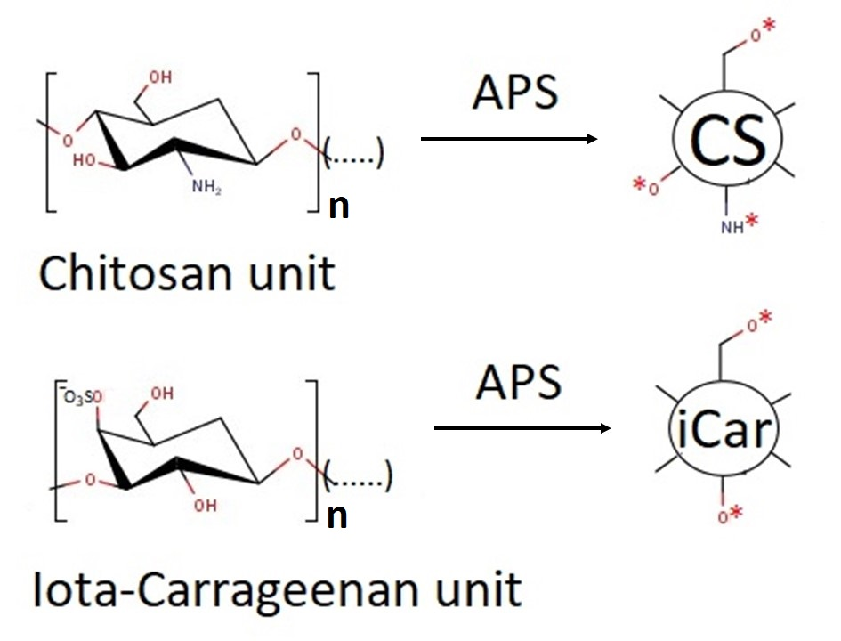
Figure S2. Formation of free radical sites on chitosan (a) and iota-carrageenan (b) backbones under ammonium persulfate (APS) initiation.
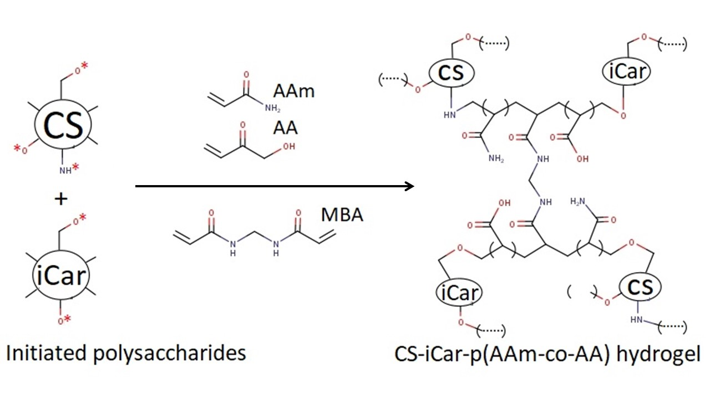Figure S3. Proposed reactional mechanism of CS-iCar-p(AAm-co-AA) hydrogel formation.

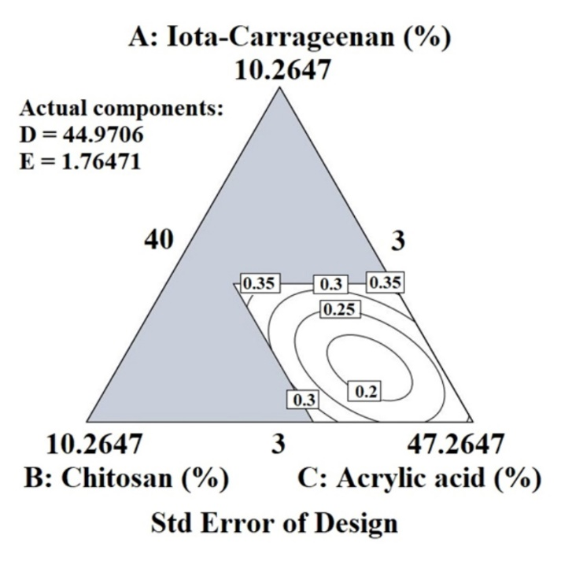
Figure S4. Standard error plot. This contour plot of the standard error at different points in the design space shows small values of the standard error that ranged from 0.2 to 0.35, which is an indication that the means of the samples are a reliable reflection of the true population means.

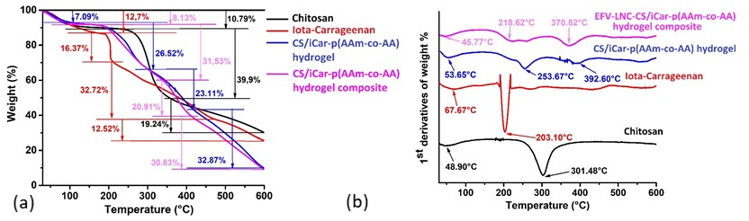
Figure S5. Thermal gravimetric analysis of hydrogels. (a) Decomposition profiles of CS/iCar-p(Aam-co-AA) hydrogel, EFV-LNCs-CS/iCar-p(Aam-co-AA) hydrogel composite, CS and iCar, showing weight loss as a function of temperature; (b) First-order derivatives of their weight loss

Table S3. Automatically generated hydrogel composition batches for model optimization and confirmation
Number | i-Car  % | CS  % | AA  % | AAm  % | MBA  % | SC  % | Desirability
1 | 6.00 | 3.00 | 40.00 | 50.00 | 1.00 | 44445.79 | 0.86 | Selected
2 | 6.00 | 3.00 | 50.00 | 40.00 | 1.00 | 35928.51 | 0.82
3 | 5.44 | 3.00 | 40.00 | 50.56 | 1.00 | 34202.18 | 0.81
4 | 5.44 | 3.00 | 50.56 | 40.00 | 1.00 | 27319.05 | 0.76
5 | 4.40 | 3.99 | 44.31 | 44.31 | 3.00 | 12553.68 | 0.61

References
[1] S. Bashir, Y.Y. Teo, S. Ramesh, K. Ramesh, Physico-chemical characterization of pH-sensitive N-Succinyl chitosan-g-poly (acrylamide-co-acrylic acid) hydrogels and in vitro drug release studies, Polym Degrad Stab. 139 (2017) 38–54. https://doi.org/10.1016/j.polymdegradstab.2017.03.014.
[2] J.B. Safari, A.M. Bapolisi, R.W.M. Krause, Development of pH-sensitive chitosan-g-poly (Acrylamide-co-acrylic acid) hydrogel for controlled drug delivery of tenofovir disoproxil fumarate, Polymers (Basel). 13 (2021). https://doi.org/10.3390/polym13203571.

