Electronic Supplementary Material

1 TESLA MRI AND MIP ANALYSIS FOR CUPRIZONE-INDUCED DEMYELINATION ASSESEMENT IN C57BL/6 MICE
Journal: Molecular Imaging and Biology

Veronika Volodina¹, Petr Zaitsev¹, Stanislav Antonov², Anastasia Maksaeva², Lyudmila Borets¹, Vadim Makarov^{1,} and Victoria. Zherdeva¹ *
¹Bach Institute of Biochemistry, Research Center of Biotechnology of the Russian Academy of Sciences, Moscow, Russian Federation; vjerdeva@inbi.ras.ru; Correspondence: vjerdeva@inbi.ras.ru (V.Zh.)
² Avtsyn Research Institute of Human Morphology of Federal state budgetary scientific institution "Petrovsky National Research Centre of Surgery", Moscow, Russian Federation.

Corresponding author:
Victoria. Zherdeva
Email: first.last@institution.org
A.N. Bach Institute of Biochemistry,
FRC of Biotechnology of the RAS,
Moscow Leninsky Avn, 33, Moscow,
119071 Russian Federation.
Tel: +7(495) 660-34-30 (*468)
E-mail: vjerdeva@inbi.ras.ru

Materials and Methods
1 Tesla MRI (M3 compact high-performance MRI system, Aspect Imaging, Shoham, Israel) was used to acquire the magneto-resonance mouse imaging. The system equipped with a 50x 150 mm inner bore allowing 440 mT/m gradients (slew rate 1750 T/m/s at 60 A).
Mice were placed at integrated heated handling system with a head RF coil (diameter 23 mm, length 25 mm, 43.3MHz frequency) and a water-based heating system. Slice thickness was 1 mm, distance between slice – 0.05 mm, TR/TE = 3000/69.1, FOV = 25x25, matrix = 168x168, ETL = 12, NEX = 10, number of slices = 13). The animal's head was fixed using the upper incisors, and the position was standardized through visual assessment. Scanning began from the same position that was checked by the initial scan. The images acquired as a 2D multi-slice stack.
Gadopentetate dimeglumine (Magnevist™, Bayer AG, Germany) was used as a contrast agent. The agent was diluted with 0.9% isotonic sodium chloride to achieve a final dose of 0.5 mmol/kg, and administered subcutaneously into the interscapular region (withers).
Axial and sagittal MRI slices were selected for analysis, as they provided the most informative views for lesion assessment. Image processing was performed using the maximum intensity projection (MIP) algorithm. MIP images were generated by stacking seven consecutive MRI slices (N = 7). To evaluate brain lesions, the MIP-derived lesion area and integral signal intensity were quantified using ImageJ/Fiji software (NIH, USA). For assessing dynamic changes in signal over the full observation period, the signal-to-noise ratio (SNR) was calculated. SNR was defined as the ratio of the average signal intensity to the Gaussian noise level in the corresponding MRI slice.

Results
C57BL/6 mice (n = 24) received 0.4% cuprizone mixed with standard chow exhibited a 90% survival rate throughout the experiment. After 30 days of cuprizone feeding, all treated mice were studied be MRI.
MRI revealed a contrast accumulation at both axial and sagittal MR slices compared to controls (Fig. S1, 2). Increased T2w MR signal was revealed in corpus callosum and caudoputamen in experimental groups.
Figure S3 demonstrated the flow of the experiment.
.

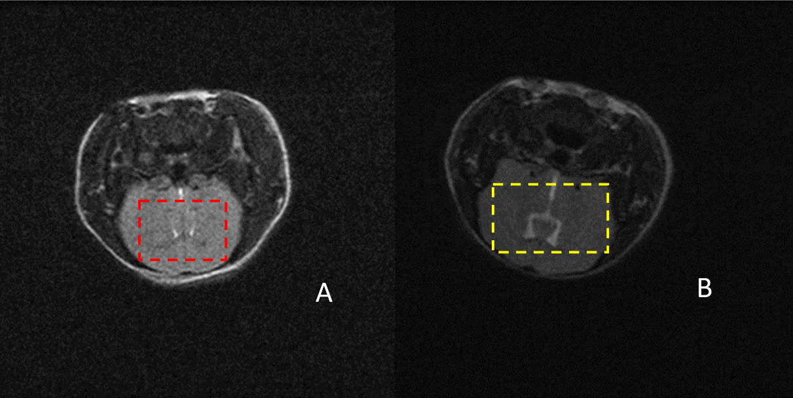
Supplementary Fig.1 MR criteria for detecting cuprizone-induced changes in cerebral ventricular system. The presented scans were obtained on day 90 to detect manifestations of toxic signs. The ventricular system of the brain is marked in red for the control group (A) and in yellow for cuprizone-induced pathological manifestations (B). The observed changes include blurred boundaries of the ventricles, referred to as the "Milky Way" effect and the initial signs of corpus callosum contrasting. T2-weighted (T2w) 1T MRI (TR/TE = 3000/69.1, FOV = 25x25, Matrix = 168x168, ETL = 12, NEX = 10, Number of slices
= 1)

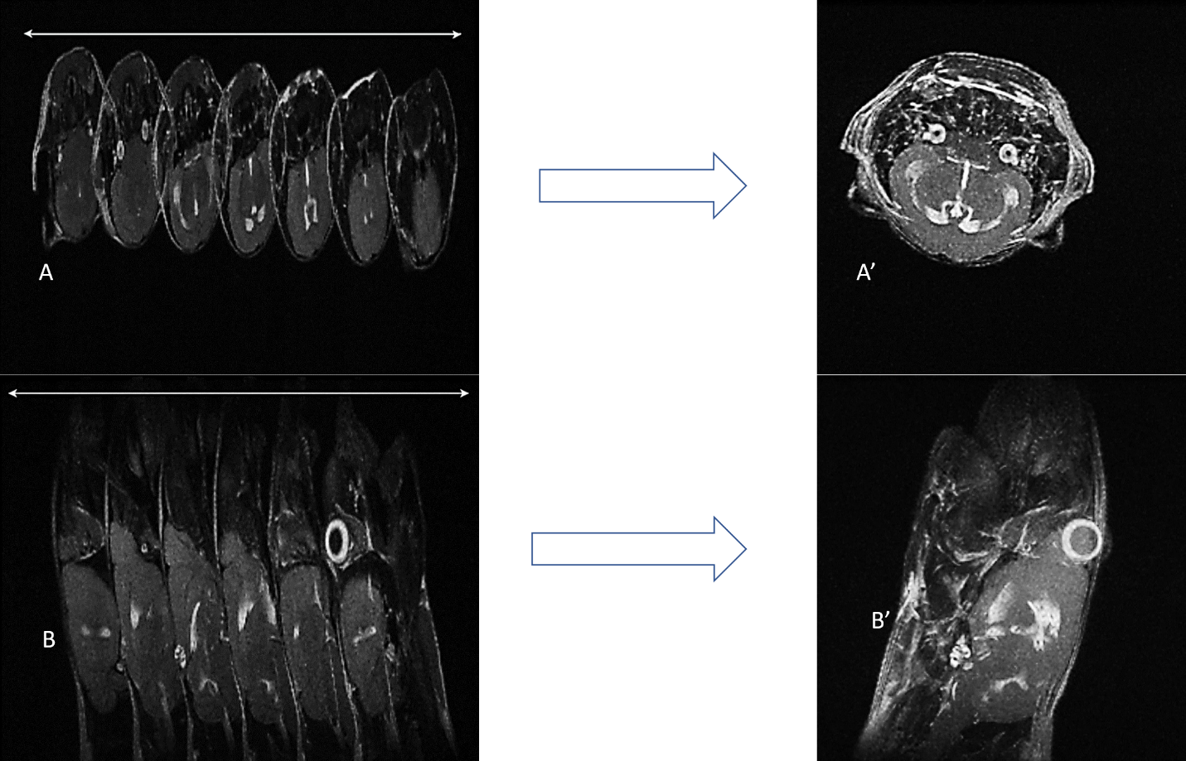
Supplementary Fig.2 MRI stacking to construct a MIP image (A’, B’) from the stack slices for axial (A) and sagittal (B) projections (N=7)

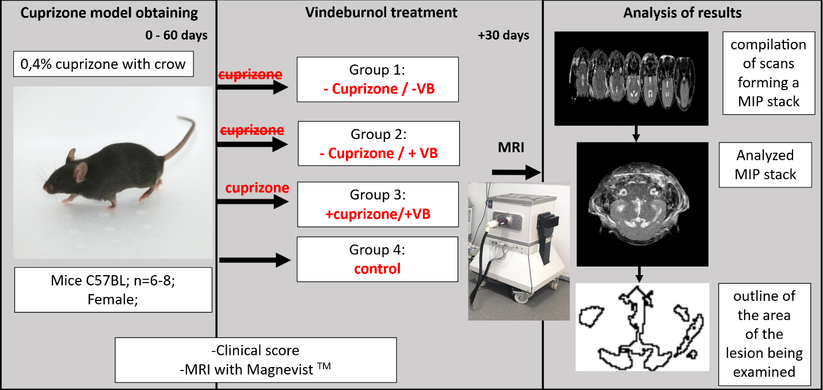
Supplementary Figure 3. The main stages of the experiment

