Supplementary Methods and Results

Supplementary Methods
Quality control of metabolomics data
Serum levels of 517 targeted metabolites were measured using liquid chromatography-mass spectrometry (LC-MS) at Biocrates Inc. The targeted metabolomics approach utilized the MxP® Quant 500 assay, which primarily focused on various lipids but also included amino acid-related metabolites and assays for eicosanoids and oxysterols. Our previous paper [1] reported the detailed pipeline for quality control of metabolomics profiles and the samples included.
Supplementary Table 1. Categories of Disease-Modifying Therapies (DMTs) Based on Efficacy Levels.
Efficacy level | Administration | DMT
Low | Injectable | Avonex (Interferon beta-1a), Betaseron (Interferon beta-1b), Copaxone (Glatiramer Acetate), Plegridy (Peginterferon beta-1a), Rebif (Interferon beta-1a)
Moderate | Oral | Aubagio (Teriflunomide), Gilenya (Fingolimod), Mayzent (Siponimod), Tecfidera (Dimethyl Fumarate)
High | Infusion | Lemtrada (Alemtuzumab), Novantrone (Mitoxantrone), Ocrevus (Ocrelizumab), Rituxan (Rituximab), Tysabri (Natalizumab)

Supplementary Figure 1. Individual metabolites associated with PST over time.
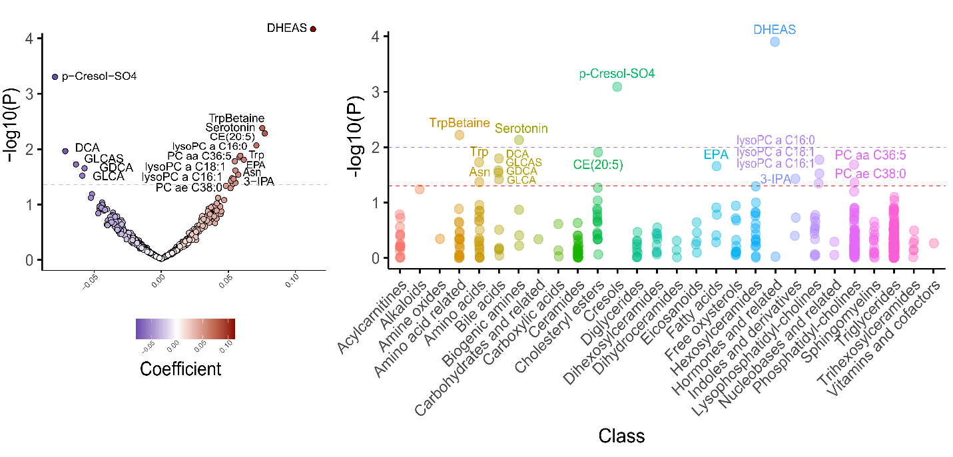

The volcano plot indicates metabolites associated with the processing speed score. Each point represents an individual metabolite; significant associations with p < 0.05 are labeled. The Manhattan Plot summarizes the analyzed metabolites and significant results. The x-axis shows the metabolite classes, which are color-coded. The y-axis displays the −log10 of p-values. The dashed blue and red horizontal lines indicate the cut-off p-values at 0.01 and 0.05, respectively.

Supplementary Table 2. Summary of metabolites exclusively associated with specific subgroups

MSPT |  | Subgroup | No. of Significant Metabolites | Main Metabolites | Notes
MDT |  | PMS | 67 | Predominantly TGs | Exclusive to PMS
WST |  | All subgroups | 2 | Sarcosine, CE 20:5 | Consistently significant across sex, disease course, and DMT class
WST |  | RRMS | 17 | Ceramides, TGs, PCs (2), DHEAS, 12S-HETE, α-aminoadipic acid, SM (OH) C24:1 | Unique to RRMS
WST |  | No DMT | 17 | Predominantly TGs | Unique to the No DMT subgroup
WST |  | High efficacy DMT | 5 | Acylcarnitines, Bile acids, Dihexosylceramides, Indoles & derivatives, Eicosanoids | Exclusive to high efficacy DMT
WST |  | Moderate efficacy DMT | 11 | Mostly TGs, also PCs, 1 Acylcarnitine, 1 Amino acid, 1 Bile acid, 1 Fatty acid | Unique to moderate efficacy DMT
WST |  | Low efficacy DMT | 11 | Cholesteryl esters, PCs, Asymmetric dimethylarginine, Cysteine, p-Cresol sulfate, Hexosylceramide | Exclusive to low efficacy DMT
PST |  | PMS | 118 | Mostly TGs, 5 DGs, PC ae C42:4, Cystine, Sarcosine, Glycine | Exclusive to PMS
PST |  | PMS, RRMS, No DMT | 1 | p-Cresol sulfate | Shared across these subgroups

Supplementary Figure 2. Selected WGCNA parameters

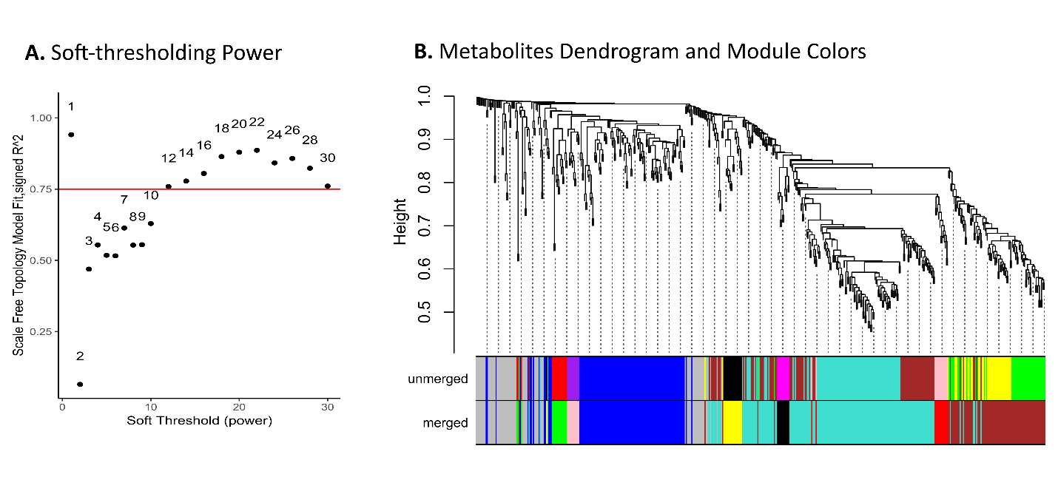

Pathways Enrichment Analysis for Individual Metabolites
In this approach, the input data was a ranked list of metabolites based on their test statistics and retrieved metabolic pathways corresponding to each metabolite’s KEGG ID obtained from the KEGG compound database [2]. If a specific ID was unavailable for an individual metabolite, the ID assigned to the broader metabolite class was used. MSEA uses an a priori-defined list of metabolic pathways for analyzed metabolites and the related ranked statistics to calculate the pathway enrichment score (ES) for metabolite sets. The ES quantifies the degree to which a metabolite set is overrepresented at the extremes of the ranked list of metabolites. To account for variability in pathway size, we computed a normalized enrichment score (NES), which adjusts for the number of metabolites within each set, enabling meaningful comparisons across pathways. The statistical significance of the association of each pathway with MSPT outcomes was determined using FDR-adjusted p-values, derived through a multiple hypothesis permutation procedure that generates an empirical null distribution of NES values[3, 4].
MSEA analyses, based on a priori-defined pathways, consistently highlighted alterations in lipid metabolism as being associated with MSPT outcomes. For example, the Glycerolipid metabolism pathway was significantly associated with MSPT outcome (FDR-adjusted p-values: MDT = 5.00E-36, WST = 4.45E-11, PST = 1.52E-34), and the leading edge for this pathway was predominantly enriched in TGs. We also noticed significant enrichment for polyunsaturated fatty acid metabolism pathways, specifically, arachidonic acid metabolism (FDR-adjusted p-values: MDT = 6.97E-11, WST = 5.41E-16, PST = 5.19E-12), linoleic acid metabolism (MDT = 1.19E-10, WST = 5.17E-15, PST = 2.94E-10), and alpha-linolenic acid metabolism (MDT = 1.01E-09, WST = 1.08E-15, PST = 1.26E-10).

Supplementary Figure 3. Metabolite Set Enrichment Analysis
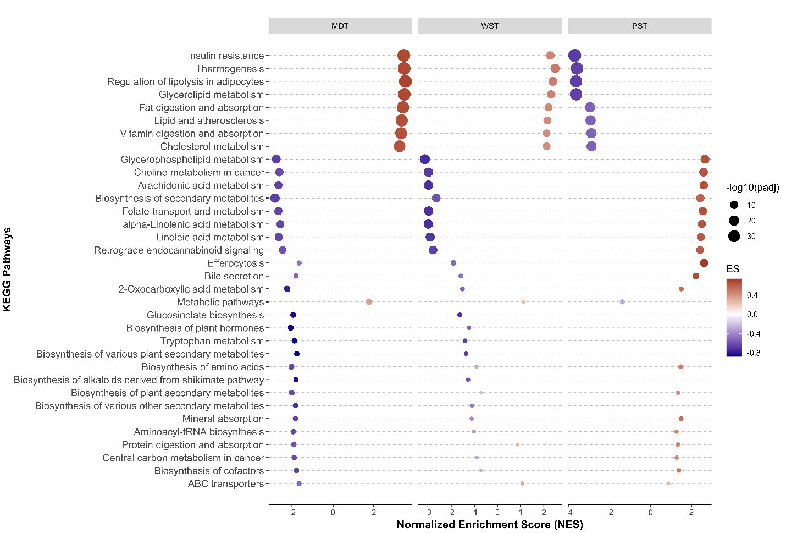
The results of the metabolite set enrichment analysis for longitudinal MSPT outcomes are illustrated in the dot plot. The y-axis displays the pathways, while the x-axis represents the normalized enrichment scores (NES), which quantify the overrepresentation of each metabolite set within the ranked list of analyzed metabolites, adjusted for set size. The dot size corresponds to the -log10 of the FDR-adjusted p-value. To improve visualization, a color gradient is applied to indicate each pathway's enrichment scores (ES) per outcome.

References

1. Noroozi, R., et al., Metabolic and lipid alterations in multiple sclerosis linked to disease severity. Multiple Sclerosis Journal, 2025: p. 13524585251325468.
2. Kanehisa, M., et al., KEGG: biological systems database as a model of the real world. Nucleic Acids Research, 2025. 53(D1): p. D672-D677.
3. Subramanian, A., et al., Gene set enrichment analysis: a knowledge-based approach for interpreting genome-wide expression profiles. Proceedings of the National Academy of Sciences, 2005. 102(43): p. 15545-15550.
4. Korotkevich, G., et al., Fast gene set enrichment analysis. biorxiv, 2016: p. 060012.

