Rhodococcus cerastii C5^{T} F(FR714842)
Rhodococcus yunnanensis YIM 70056^{T} (AY602219 )
Rhodococcus globerulus DSM 4954^{T} (X80619)
Rhodococcus jialingiae djl-6-2^{T} (DQ185597)
Rhodococcus qingshengii djl-6^{T} (DQ090961 )
Rhodococcus baikonurensis GTC1041^{T} (AB071951)
Rhodococcus sp. B2
Rhodococcus erythropolis NBRC 100887 (AP008957)
Rhodococcus erythropolis DSM 43066^{T} (X79289)
Rhodococcus maanshanensis M712^{T} (AF416566)
Rhodococcus marinonascens DSM 43752^{T} (X80617)
Rhodococcus koreensis DNP505^{T} (AF124343)
Rhodococcus jostii IFO 16295^{T} (AB046357)
Rhodococcus wratislaviensis NCIMB 13082^{T} (Z37138)
Rhodococcus imtechensis RKJ300^{T} (AY525785 )
Rhodococcus percolatus MBS1^{T} (X92114 )
Rhodococcus opacus DSM 43205^{T} (X80630)
Rhodococcus nanhaiensis SCSIO 10187^{T} (JN582175 )
Rhodococcus triatomae IMMIB RIV-085^{T} (AJ854055)
Rhodococcus artemisiae YIM 65754^{T} (GU367155)
99
93
67
96
53
72
80
78
93
57
59
97
68
95
96
98
0.005
Fig. S1. Phylogenetic tree constructed by the neighbour-joining method based on the 16S rRNA gene sequences. Rhodococcus artemisiae YIM 65754^{T} was used as the outgroup. Bootstrap values (numbers on branch nodes expressed as percentages of 1000 replications) greater than 50% are shown at branch points.

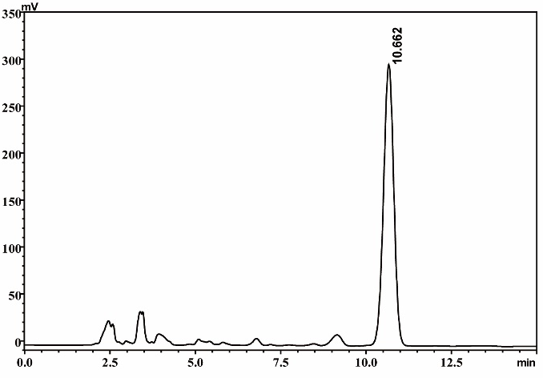
A

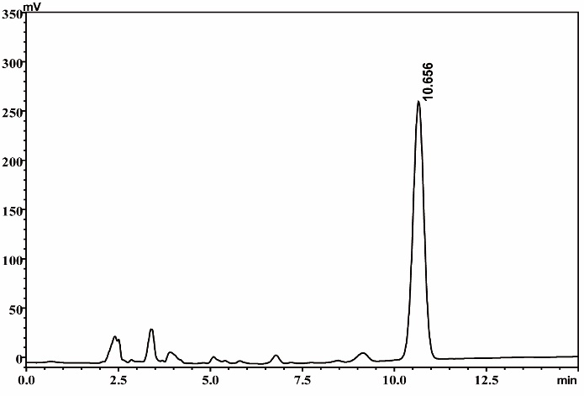
B

C
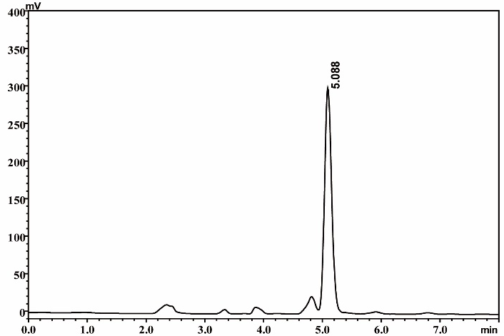

Fig. S2. HPLC analysis of pretilachlor degradation by strain TB2 and TB2(pQEth1). A, HPLC spectra of control sample; B and C, HPLC spectra of extract obtained from the culture at 48 h of TB2 and TB2(pQEth1), respectively; the medium used was MSM containing 100 mg/L pretilachlor; the peak at 10.656 min was pretilachlor.

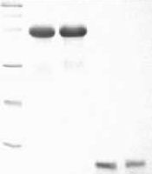
97.2

kDa M 1 2 3 4
66.4
44.3

29.0

20.1

14.3

Fig. S3. SDS-PAGE(12%) analysis of the purified His6-tagged EthA, EthB, EthC and EthD. Lane M, molecular weight markers. Lane 1, EthA; Lane 2, EthB; Lane 3, EthC; Lane 4, EthD.

A
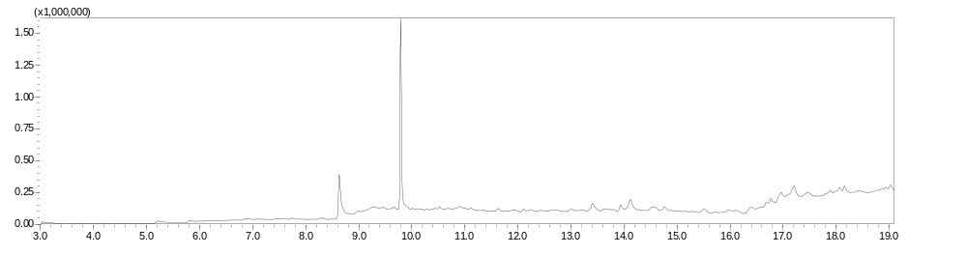
9.8
Abundance
Time (min)
8.6
metabolite

alachlor

B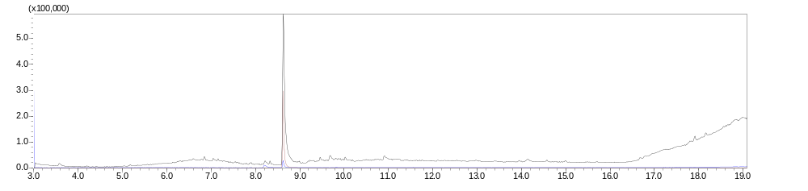
Time (min)
Abundance
standard
C
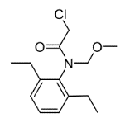
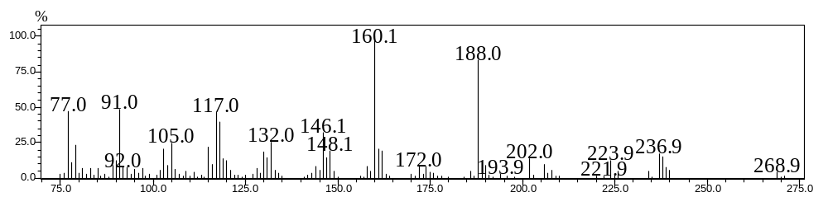
Relative Abundance
m/z
D
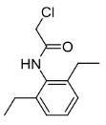
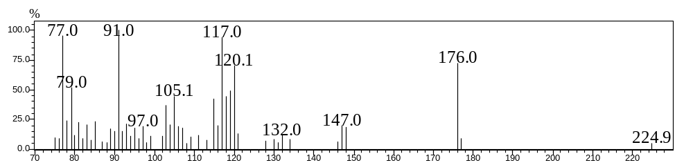
Relative Abundance
m/z
E
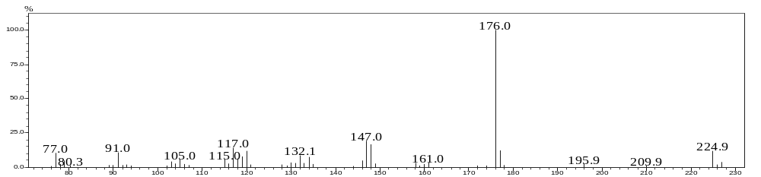
m/z
Relative Abundance
Fig. S4. GC/MS analysis of the transformation of alachlor by the EthABD_{B2}. A, GC spectra of the extract obtained from alachlor transformation for enzyme EthABD_{B2}; B, GC spectra of the standard; B and C, mass spectra for the peak with RT value of 9.8 min and 8.6 min. E, mass spectra for the standard.

A
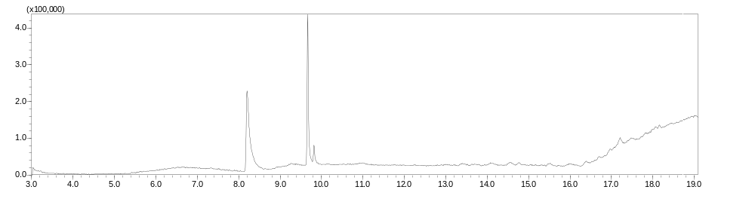
Abundance
Time (min)
acetochlor
metabolite
8.2
9.7
B
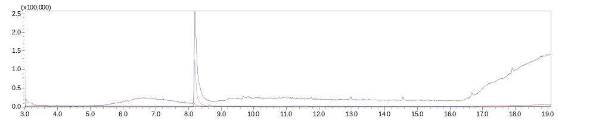
standard
Time (min)
Abundance
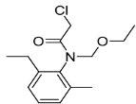
C 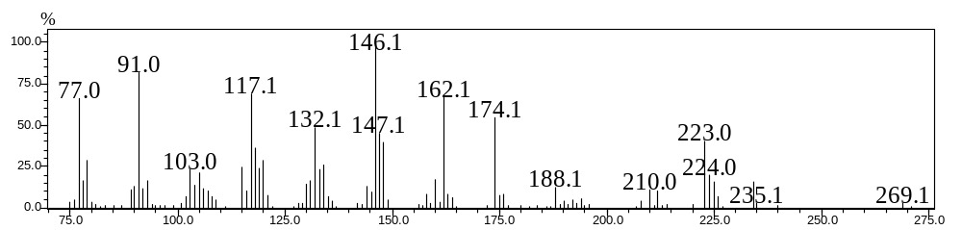
Relative Abundance
m/z
D
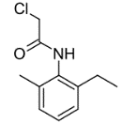
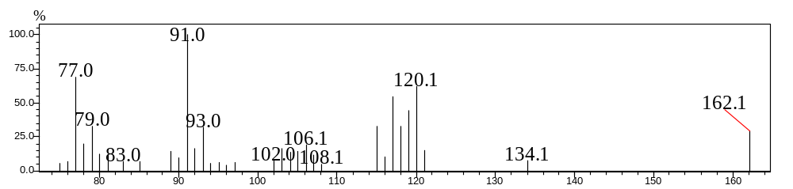
Relative Abundance
m/z
E
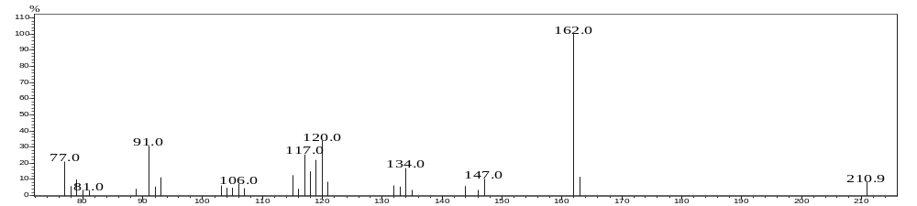
m/z
Relative Abundance
Fig. S5. GC/MS analysis of the transformation of acetochlor by the EthABD_{B2}. A, GC spectra of the extract obtained from acetochlor transformation for enzyme EthABD_{B2}; B, GC spectra of the standard; C and D, mass spectra for the peak with RT value of 9.7 min and 8.2 min; E, mass spectra for the standard.
A
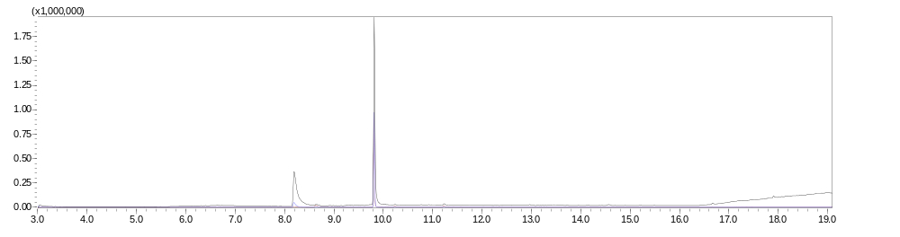
Abundance
Time (min)
8.2
9.9
metabolite

propisochlor
B
m/z
standard
Time (min)
Abundance
C
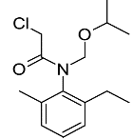
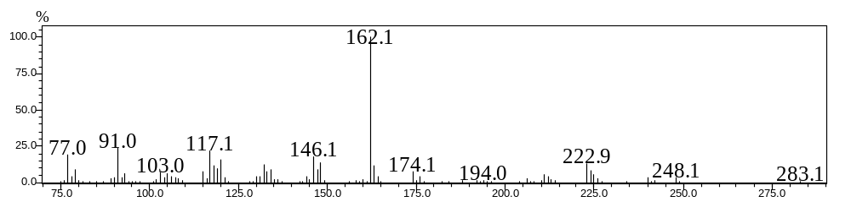
Relative Abundance
D
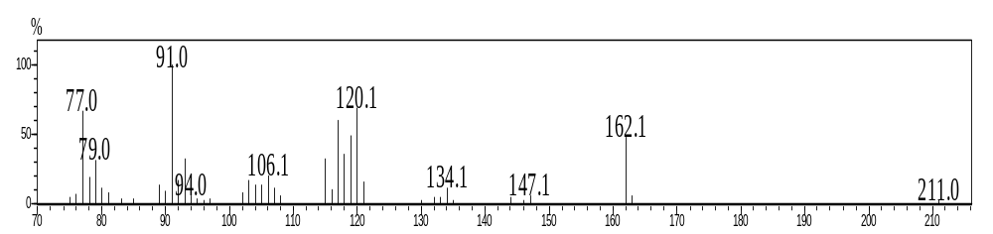
Relative Abundance
E
m/z
Relative Abundance
Fig. S6. GC/MS analysis of the transformation of propisochlor by the EthABD_{B2}. A, GC spectra of the extract obtained from propisochlor transformation for enzyme EthABD_{B2}; B, GC spectra of the standard; C and D, mass spectra for the peak with RT value of 9.9 min and 8.2 min; E, mass spectra for the standard.
A
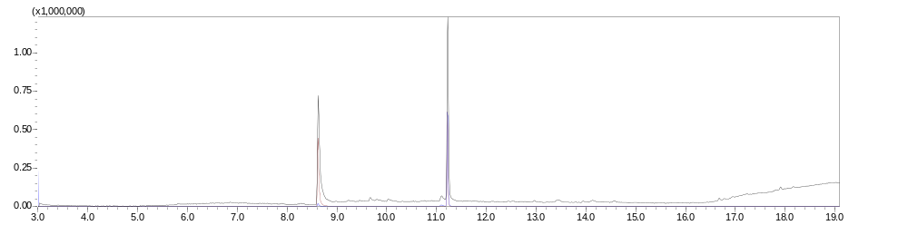B
Abundance
11.2
8.6
Time (min)
butachlor

metabolite
Abundance
Time (min)
standard
C
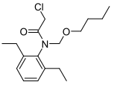
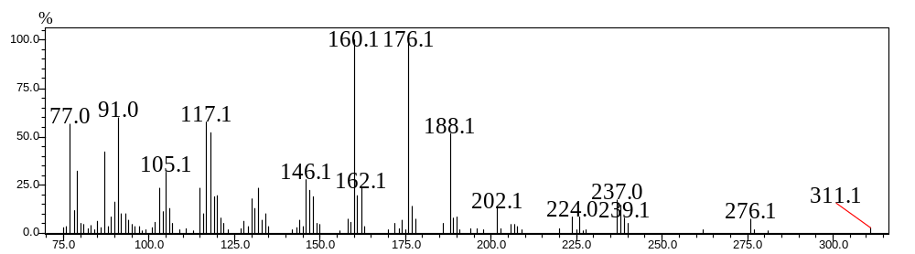
Relative Abundance
m/z
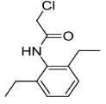
D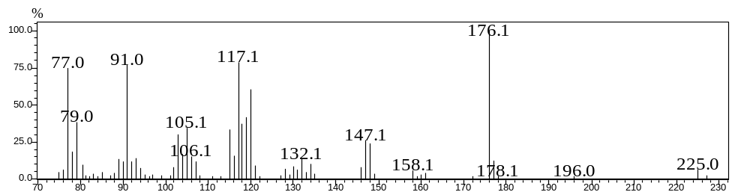
m/z
Relative Abundance
E
m/z
Relative Abundance
Fig. S7. GC/MS analysis of the transformation of butachlor by EthABD_{B2}. A , GC spectra of the extract obtained from butachlor transformation for enzyme EthABD_{B2}; B, GC spectra of the standard; C and D, mass spectra for the peak with RT value of 11.2 min and 8.6 min; E, mass spectra for the standard .
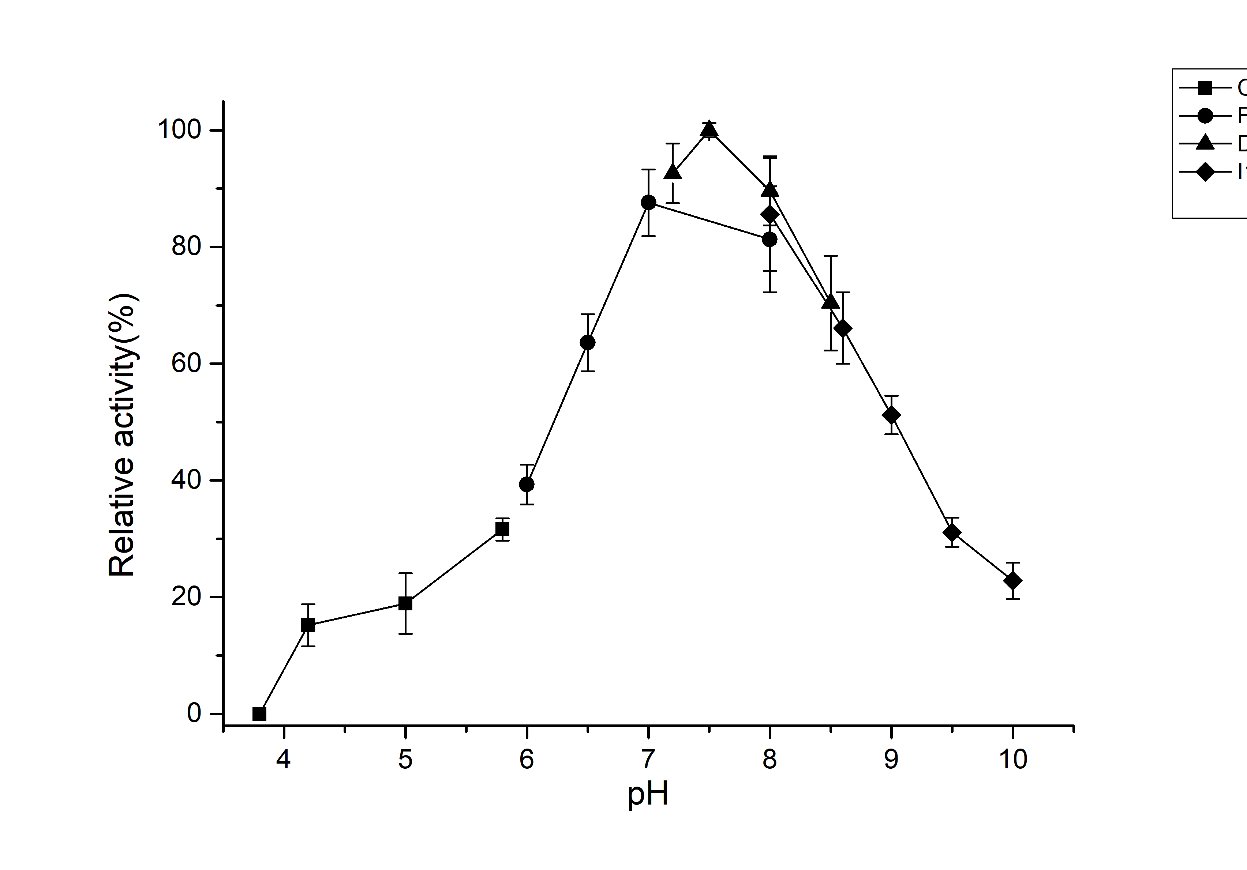
A

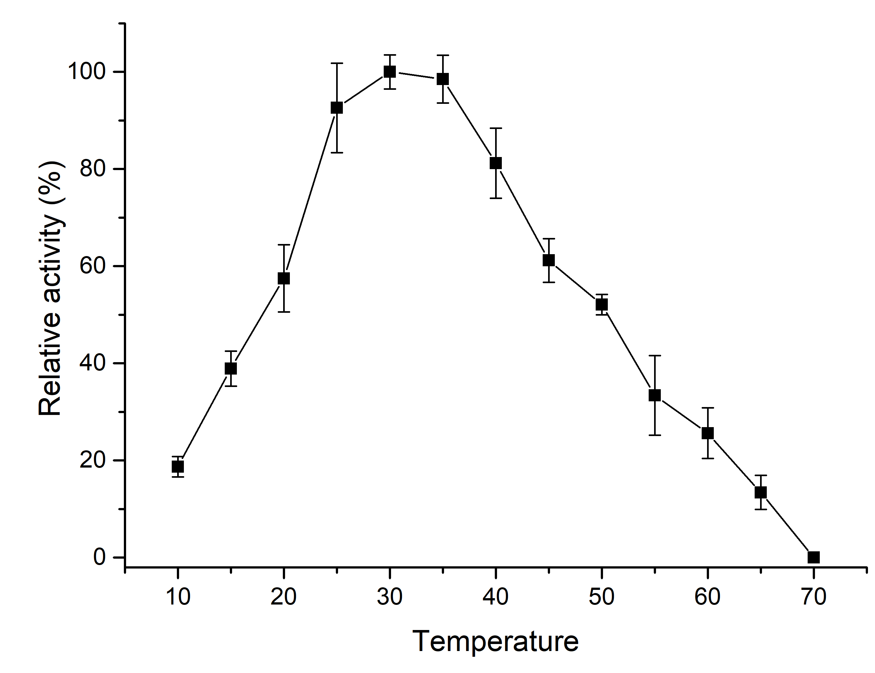
B

Fig. S8 effects of pH (A) and temperature (B) on EthABD_{B2} activity

A
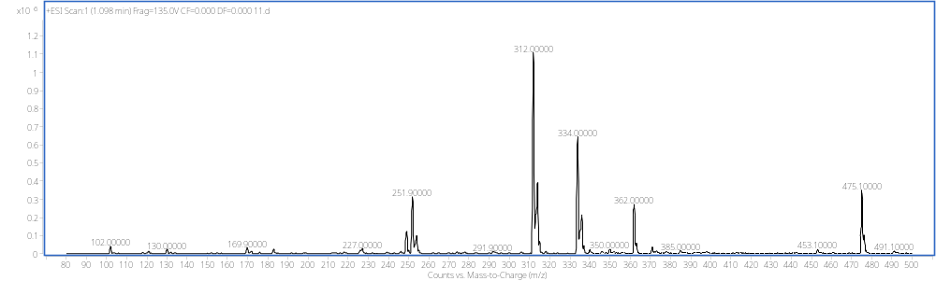
B
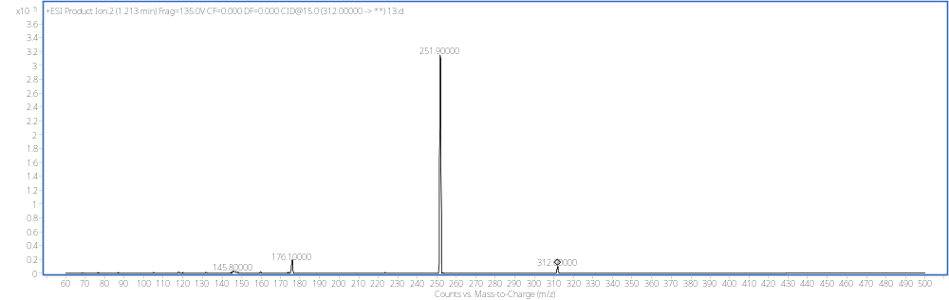
C
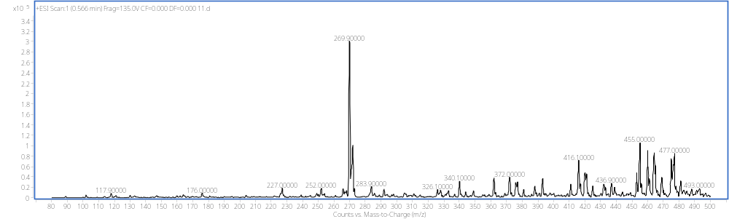
D
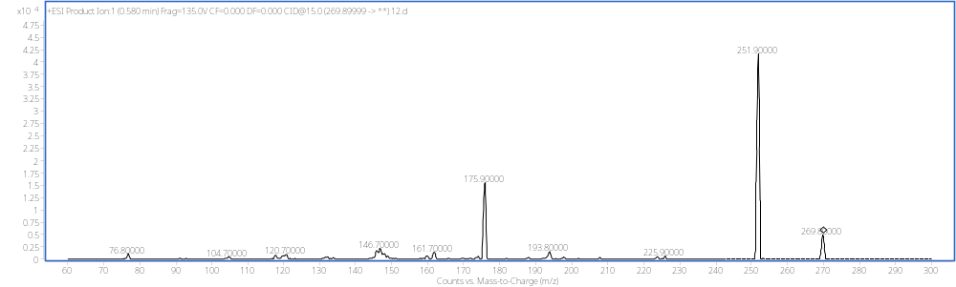
C₂H₂ClO
C₁₂H₁₇ClNO
C₁₂H₂₀NO
C₉H₉NO
C₁₀H₁₂NO
C₁₄H₁₉ClNO
C₁₂H₁₈N
C₁₄H₁₉ClNO
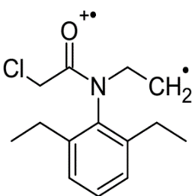
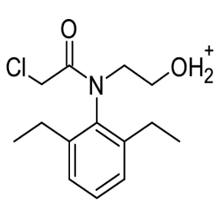
E

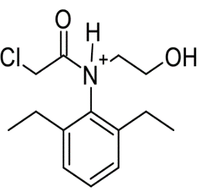
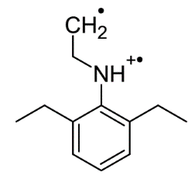
m/z 269.9 m/z 251.9

m/z 269.9 m/z 175.9
Fig. S9 HPLC-MS/MS analysis of the pretilachlor and the intermediate metabolites catalyzed by the strain B2. A, MS2-SCAN mode analysis of the pretilachlor peak (1.1 min); B, Product ion Scan mode analysis of the ion of 312 m/z; C, MS2-SCAN mode analysis of the intermediate metabolites peak (0.57 min); D, Product ion Scan mode analysis of the ion of 269.9 m/z; E, the proposed structure of characteristic fragment ions from D.

