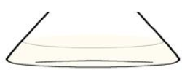
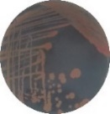
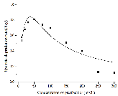
17 k
ethD ethC ethB ethA ethR
tnpA1 orf16
orf17
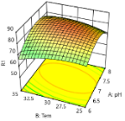
Missed fragment in strain B2
Isolation
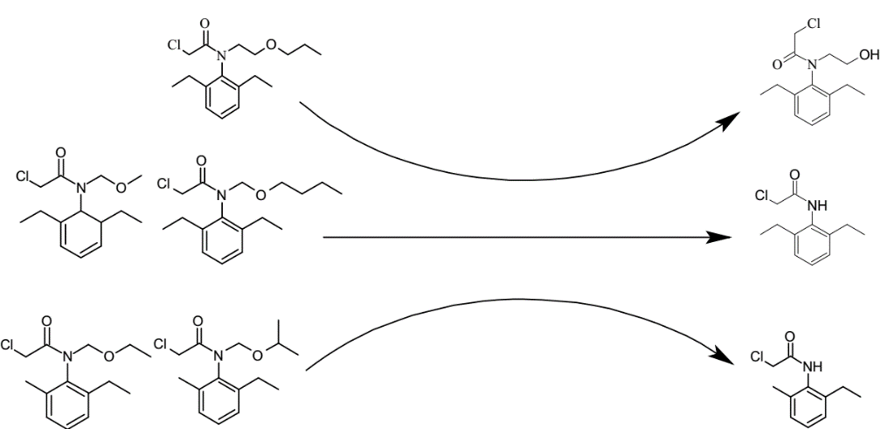

Pretilachlor
N-hydroxyethyl-2-chloro-N-(2,6-diethyl-phenyl)-acetamide

EthABD_{B2}

2-chloro-N-(2,6-diethylphenyl) acetamide
Butachlor
Alachlor

Rhodococcus sp. B2

Acetochlor
2-chloro-N-(2-methyl-6-ethylphenyl) acetamide

Propisochlor

