Supplementary Material
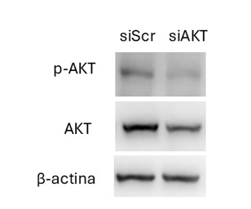

Figure S1. Validation of AKT silencing by siRNA. The levels of Akt and p-AKT expression was evaluated in 4C11+ cells knocked down for AKT with siRNA. Β-actin was used as internal controls. siScr: scrambled siRNA
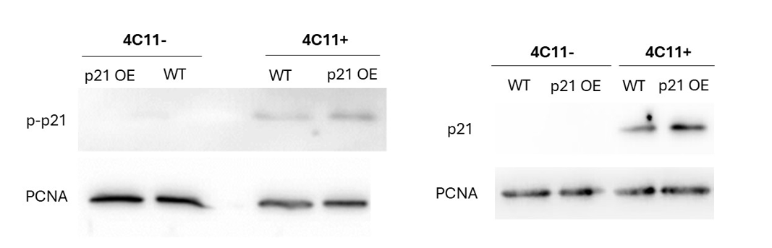
FIGURE S2. The overexpression of p21 affects p-p21 in 4C11+, but not in 4C11- cells. The levels of p21 and p-p21 (Thr145) were evaluated in 4C11- and 4C11+ cells overexpressing (p21 OE) or not (WT) p21, by western blot using specific antibody. PCNA expression was used as a loading control.

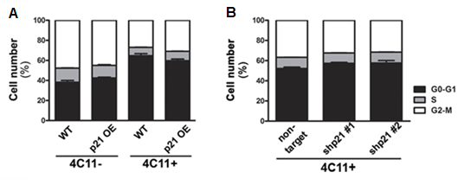

FIGURE S3. The modulation of p21 expression does not affect cell cycle in 4C11- and 4C11+ melanoma cells. The different phases of the cell cycle were evaluated by flow cytometry in the wild type (WT) and p21-overexpressing (p21 OE) 4C11- and 4C11+ cell lines (A) and non-target and p21-knocked down clones shp21 #1 and shp21 #2 (B).

