SUPPLEMENTAL TABLES
Race and Ethnicity | Avatar | TCGA
American Indian or Alaska Native | 137 (0.42%) | 27 (0.30%)
Asian | 695 (2.13%) | 650 (7.26%)
Black or African American | 1,688 (5.18%) | 868 (9.69%)
Native Hawaiian or Other Pacific Islander | 193 (0.59%) | 12 (0.13%)
White | 28,840 (88.58%) | 7,399 (82.62%)
Some Other Race | 639 (1.96%) | n/a
Unknown/Not Reported Race | 365 (1.12%) | 2,011 (18.34%)
Hispanic or Latino | 2,639 (8.11%) | 351 (4.54%)
Not Hispanic or Latino | 28,993 (89.05%) | 7,384 (95.46%)
Unknown/Not Reported Ethnicity | 925 (2.84%) | 3,232 (29.47%)
Total | 32,557 | 10,967
Supplemental Table 1. Race and Ethnicity across Avatar (v25.05). Here shown as compared to TCGA demographics.

Model/Covariates | Hazard  Ratio (HR) | P-value
Univariate Model  Signature summary score | 0.98 | 0.004
Multivariate Model  Signature Summary Score  Age at ICI start  Sex (ref:Male)  Site of Collection (ref:Primary) | 0.98  1.02  0.78  1.15 | 0.007  0.005  0.203  0.496
Supplemental Table 2. Univariate and multivariate Cox regression modeling of rwPFS in immune-checkpoint-inhibitor-treated melanoma patients. The “Signature summary score” is for the T-cell inflamed gene signature.
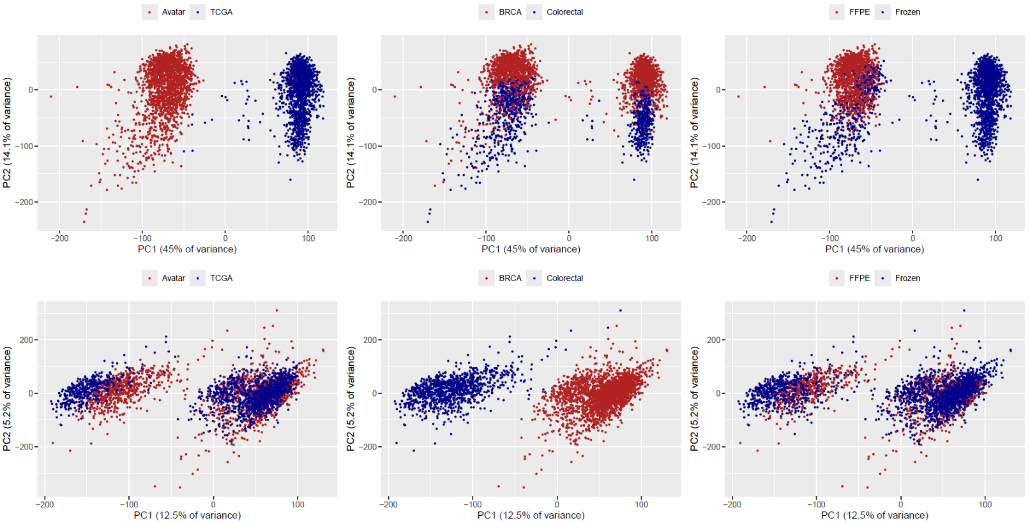
SUPPLEMENTAL FIGURES
A

B

Supplemental Figure 1. RNA-seq Normalization. A. PCA on Avatar and TCGA unnormalized RNA-seq data for breast and colorectal cancer cohorts. The left panel shows samples colored by data source, the middle panel shows samples colored by disease type, and the right panel shows samples colored by preservation method. B. Similar to the panels shown in A, using RNA-seq profiles after ComBat normalization for batch effects induced by data source or preservation method.

Supplemental Figure 2:
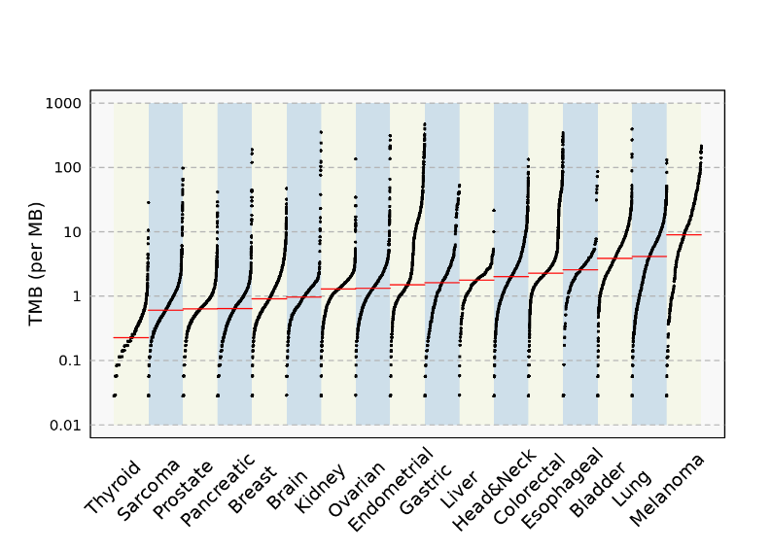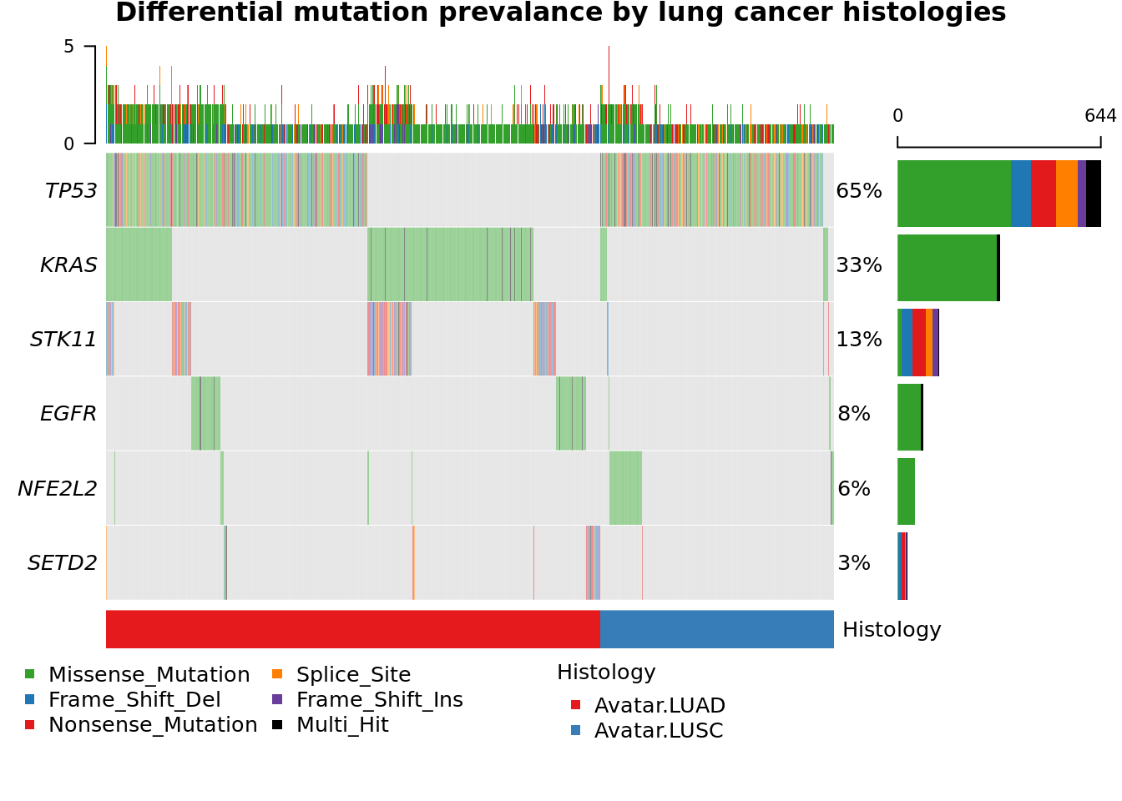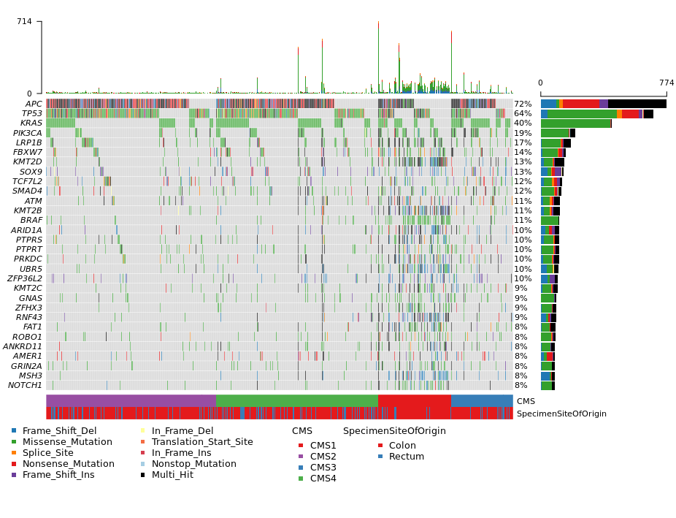

A
B
C

Supplemental Figure 2. Tumor Mutation Burden (TMB) and Histology-specific Molecular Profiles. A. Median TMB scores for the 12 top solid tumor diseases with highest number of Avatars. Notably, endometrial, and colorectal cancers are bi-phasic, with the latter profile likely due to the high TMB associated with the CMS1 subtype. B. Oncoprint showing mutational profiles for the top differentially mutated genes in lung cancer, contrasting adeno (LUAD) versus squamous cell (LUSC) lung cancer histologies. Note that only Avatars with at least one mutation in the six genes reported were included; wildtype Avatars are not shown. C. CMS subtypes predicted for the colorectal Avatar patients from RNA-seq, showing oncoprint of mutational profiles for the matched tumor/normal DNA samples in this cohort.

SUPPLEMENTAL METHODS
RNA-sequencing Normalization and Principal Component Analysis
To address any non-biological effects on RNA-seq data due to preservation method, we utilized the ComBat normalization algorithm from the `sva` R-package [version 3.34] per disease cohort and pan-cancer (with additional loess smoothing) to normalize the preservation method bias. Specifically, ComBat normalization of the Avatar/TCGA data was performed and the top 5,000 most variable protein-coding genes (variance computed on the log2-scale of TPMs across all collated samples) were used to compute principal components analysis (PCA) and tSNE (Rtsne version 0.17) to contrast sample source, disease type, and preservation method.

