Supplementary Materials

Table S1.
 | Combined Studies  N =128 | POLO  N = 74 | BRIDGE  N =54 | Group Comparisons between the POLO and BRIDGE
 | n (%ª) | n (%ª) | n (%ª) | X² | p
Group |  |  |  | 0.29 | .591
Autistic | 64 (50.0) | 39 (52.7) | 25 (46.3)
Neurotypical | 64 (50.0) | 35 (47.3) | 29 (53.7)
Sex |  |  |  | 0.98 | .322
Female | 33 (25.8) | 22 (29.7) | 11 (20.4)
Male | 95 (74.2) | 52 (70.3) | 43 (79.6)
Ethnicity |  |  |  | 0.75 | .688
Hispanic | 16 (12.5) | 9 (12.2) | 7 (13.0)
Non-Hispanic | 111 (86.7) | 64 (86.5) | 47 (87.0)
Not Answered | 1 (0.8) | 1 (1.4) | 0
Race |  |  |  | 9.58 | .088
White | 76 (59.4) | 45 (60.8) | 31 (57.4)
Black or African American | 8 (6.2) | 1 (1.4) | 7 (13.0)
Asian | 18 (14.1) | 12 (16.2) | 6 (11.1)
American Indian/Alaska Native | 2 (1.6) | 2 (2.7) | 0
More than one race | 23 (18.0) | 13 (17.6) | 10 (18.5)
Prefer not to answer or unknown | 1 (0.8) | 1 (1.4) | 0
Household Annual Income |  |  |  | 7.73 | .052
>$100,000 | 93 (72.7) | 48 (64.9) | 45 (83.3)
$40,000 - $100,000 | 25 (19.5) | 17 (23.0) | 8 (14.8)
$40,000 or less | 3 (2.3) | 2 (2.7) | 1 (1.9)
Not Answered | 7 (5.5) | 7 (9.5) | 0
Mother Education Level |  |  |  | 7.35 | .06
Graduate/Professional degree | 65 (52.3) | 44 (59.5) | 21 (38.9)
Bachelor's Degree | 44 (33.6) | 19 (25.7) | 25 (46.3)
Some college, or special training after GED | 14 (10.9) | 9 (12.2) | 5 (9.3)
High school/GED | 5 (3.1) | 2 (2.7) | 3 (5.6)
Father Education Level |  |  |  | 2.93 | .569
Graduate/Professional degree | 62 (48.4) | 40 (54.1) | 22 (40.7)
Bachelor's Degree | 35 (27.3) | 18 (24.3) | 17 (31.5)
Some college, or special training after GED | 15 (11.7) | 10 (13.5) | 5 (9.3)
High school/GED | 11 (8.6) | 4 (5.4) | 7 (13.0)
Junior High | 2 (1.6) | 1 (1.4) | 1 (1.9)
Not Answered | 3 (2.3) | 1 (1.4) | 2 (3.7)

Figure S1.
The 128-channel EGI Hydrocel Geodesic Sensor Net used in the study
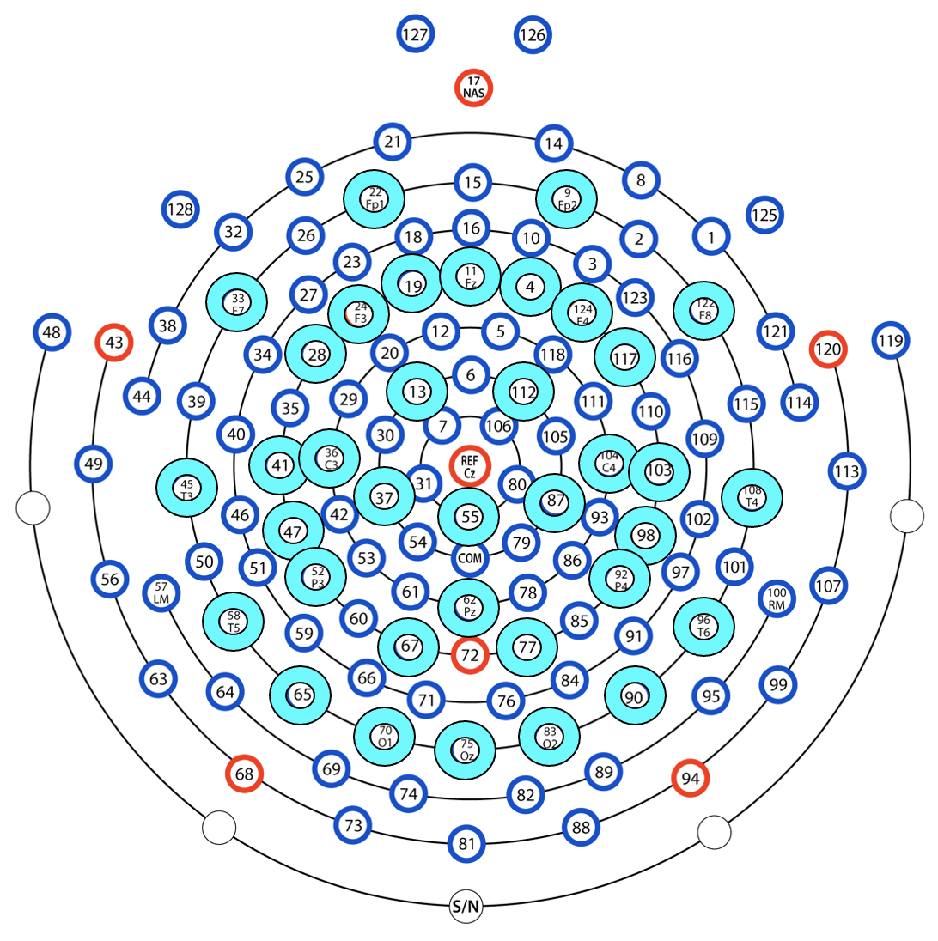

Original and Modified SpecParam Models Comparisons

The original and modified models of SpecParam (Donoghue et al., 2020) were tested for fits with the data in the present study. We found that the modified version of SpecParam demonstrated a better model fit, in which we defined the aperiodic offset as the aperiodic power at 2.5 Hz, given elevated levels of error were observed in SpecParam estimates at frequencies below 2.5 Hz. See Figure S2 for mean squared error (MSE) between original and modified versions of SpecParam models.
Figure S2.
Mean Squared Error (MSE) between original and modified versions of SpecParam models in neurotypical (N = 64) and autistic (N = 64) group.
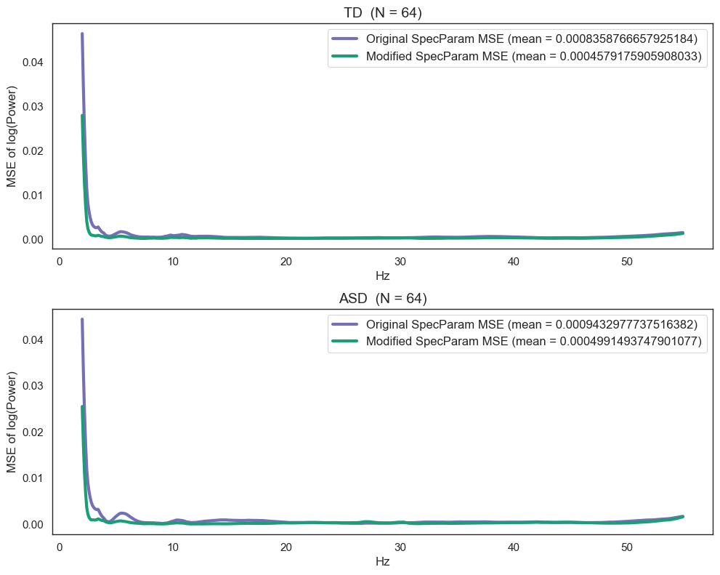
Censored Regression Models Supplementary Analyses

Given that aperiodic offset and peak alpha periodic power both significantly predicted NDW, utterance rate, and receptive language in autistic children while controlling for age, we further examined the relative predictive values of the two EEG features on each of these language variables by considering them together in the same censored regression model.
A significant censored regression model emerged when examining the predictive value of aperiodic offset and peak alpha periodic power on NDW while controlling for age, W (3) = 31.73, p < .001. Both aperiodic offset (b = -168.93, p = .014) and peak alpha periodic power (b = 302.29, p = .003) showed significant main effect. Similarly, a significant censored regression model emerged when examining the predictive value of the two EEG features on utterance rate while controlling for age, W (3) = 28.7, p < .001. Both aperiodic offset (b = -7.41, p = .009) and peak alpha periodic power (b = 14.18, p = .001) significantly predicted the number of utterances autistic children showed per minute. Last, we also found a significant censored regression model when considering both aperiodic offset and peak alpha periodic power together on receptive language, W (3) = 19.89, p < .001. Both aperiodic offset (b = -58.84, p = .004) and peak alpha periodic power (b = 116.11, p < .001) significantly predicted receptive language levels of autistic participants.

