Gut-microbial and -metabolomic signatures in the prevention of non-alcoholic fatty liver disease by Lactobacillus lactis and Pediococcus pentosaceus
Supplementary methods
Strain preparation
Lactobacillus and Bifidobacterium used for the preliminary study were isolated from various source such as sour milk, cheese, healthy Korean adult feces and new-born’s feces. L. lactis is lactic acid bacterium that was isolated from sour milk. P. pentosaceus (KCTC 18308P) is a strain of lactic acid bacterium that was isolated from finger millet (Eleusine coracana) gruel. L. lactis and P. pentosaceus were inoculated into a flask containing de Man, Rogosa, and Sharpe media (BD/Difco). The strains were incubated under anaerobic conditions at 37°C for 24 h. Stocks of each strain were prepared by mixing the culture broth with an equivalent 20% skim milk solution and then storing the mixture at -80°C.
The seed culture was grown in a flask containing MRS broth for L. lactis and P. pentosaceus. At 37°C for 24 h. Each broth was inoculated in an optimized medium in a fermenter (Bio Control & Science, MARADO-05D-PS). The fermentation was carried out with a constant pH of 5.5~6.0 by automatically adding NaOH solution (25% w/v) under the conditions of 120 rpm agitation at 37°C for 18~20 h. At the end of the fermentation, the cells were harvested by centrifugation at 6000 rpm for 10 min (Hanil, Supra R12). The lyophilization of 40X concentrated cells was accomplished in accordance with the manual (Cooling & Heating System, Lab-Mast 10). After lyophilization, the colony-forming units (CFU) per gram of each probiotics powder was measured by a serial dilution method. Strains were suspended in 0.1 M PBS and adjusted to a density of 10⁹ CFU/mL prior to use.

Animal care
All mice were individually housed in steel microisolator cages at 22 ± 2°C with 12/12-h light/dark cycle. Mice had free access to water and food throughout the experiment and were monitored daily. The experiment included an adaptation period for all groups, during which mice were fed a normal diet for one week, and groups fed a WD had a 3-day intake adaptation period. The animals received human care and all procedures were performed in accordance with the National Institutes of Health Guidelines for the Care and Use of Laboratory Animals. All procedures were approved by the Institutional Animal Care and Use Committee of the College of Medicine, Hallym University (2018-04).

STAM mouse model
Pathogen-free 14-day pregnant C57BL/6J mice were purchased from Dooyeol Biotech (Seoul, Korea). STAM-NASH model was induced in male mice by a single subcutaneous injection of 200 μg STZ (Sigma, MO, USA) at 2 days after birth and feeding with HFD32 ad libitum after 4 weeks of age. Probiotics were suspended in DPBS and oral gavage feeding at a concentration of 10⁹ CFU/g for 3 weeks (2times/week) after 6 weeks of age.

Animal sacrifice
The animals were sacrificed via inhalation anesthesia overdose (isoflurane, Aerane; Baxter, Deerfield, IL, USA) at the end of the treatment period. They were weighed, and the blood, liver, stool, and small intestine were collected. Whole blood (800 μL) samples were centrifuged (19,000 × g for 5 min) to collect serum. Liver and stool were rapidly excised and stored at 80°C.

Pathology classification
Specimens were fixed with 10% formalin and routinely embedded in paraffin, and the tissue sections were processed with hematoxylin and eosin, Masson's trichrome, and CD 68 staining. NAFLD activity score (NAS), an objective index for classifying the grade of fatty liver, was assessed [1]. All biopsy specimens were analyzed by a hepato-pathologist (S. H. H.).
Fatty liver was classified as according to NASH clinical research network scoring system for NAFLD from grades 0 to 3 (0: <5%, 1: 5%–33%, 2: 34%–66%, and 3: >66% of steatosis). Inflammation was classified from grades 0 to 3 (0: none, 1: 1–2 foci per ×20 field, 2: 2–4 foci per ×20 field, and 3: >4 foci per ×20 field). According to the guidelines based on NAS, it can help to recognize A histological scoring the system addressing the full spectrum of NAFLD.
In addition, CD 68 stain was performed by the method of immunohistochemistry also in the serial sections. Sections of formalin-fixed, paraffin wax-embedded tissue were stained in the Bond-Max automatic immunostaining device (Leica Biosystem, Newcastle, UK) using a bond polymer intensity detection kit (Leica Biosystem) for formalin-fixed, paraffin-embedded tissue sections. Using antibodies was cluster of differentiation 68 (CD 68; Leica Biosystem, Newcastle, UK, RTU). These sections were counterstained with Harris hematoxylin. From CD68 immunohistochemical stain, the findings were checked each on an average field of ⅹ200 and ⅹ400 as the area of stained cells using an imaging tool.

Analysis of endotoxin levels in fecal supernatant
The same fecal samples were used for endotoxin measurement and 16S rRNA gene sequencing. Mouse fecal samples were collected from 16-week-old controls and treated mice at 24 hours after the last oral gavage. Fecal supernatant was obtained according to a previously described protocol with some modifications.[2] Briefly, the fecal samples were suspended in sterile PBS to a concentration of 1 g per 10 mL (human) or 50 mg per 500 μL (mouse) and vortexed mildly to avoid disruption of bacterial cells. After centrifugation for 15 minutes at 3000 rpm, the supernatant was collected, sterilized by filtration through a 0.45-μm filter followed by refiltration through a 0.22-μm filter, inactivated for 15 minutes at 90°C, and stored at ‒80°C.
The fecal endotoxin levels were determined using a limulus amebocyte lysate assay (No. 50-647U; Lonza Inc) according to the manufacturer’s instructions [2]. The plasma was diluted 10-fold, and the fecal supernatant was diluted 10,000-fold in pyrogen-free water and inactivated for 15 minutes at 90°C. Endotoxin measurements were performed in pyrogenfree glass tubes, eppendorf tubes, and plates.

Trans-epithelial electrical resistance assay
Caco-2 cells were seeded onto Transwell-Clear inserts (12-well clusters, 6.5-mm inserts with polyester membrane, pore diameter 0.4 μm, Corning NY) at a density of 10⁵ cells/insert. Each insert was placed on top of a well in a 24-well plates with 1 ml in the bottom and 200 μl media in the top as described previously.[3] Caco-2 cells were grown for 5 days until confluence in Minimum Essential Medium Eagle with 20% fetal bovine serum without antibiotic-antimycotic (Gibco, Carlsdad, CA, USA) at 37°C in a humidified 5% atmosphere.
TEER measurements were performed using a Millicell Electrical resistance system (Millipore, Billerica, MA, USA). When monolayer of cells reached the confluence, Caco-2 cells were co-incubated with 200 μl of OD₆₀₀ 0.3 bacterial suspension (7 ⅹ 10⁷ CFU/ml) in MEM media for 8 hrs and the TEER was measured respectively. TEER values were compared with those of the control and expressed as the ratio of the TEER value of sample after 8 hr co-incubation to the TEER value of control after 8 hr co-incubation.

Metabolic profiling of mouse cecal samples and human stool samples
Method 1: Short chain fatty acids analysis using LC-Orbitrap MS
The supernatant (40 µl) of extraction solution Ⅰ (acetonitrile/water, 1:1, v/v) was mixed with 20 µl of 200 mM 3-nitrophenylhydrazine (3NPH)-HCL in acetonitrile (70 %) and 20 µl of a 1-ethyl-3-(3-dimethylaminopropyl) carbodiimide (EDC)-HCL (120 mM) dissolved in 6 % pyridine solution. The mixture was incubated for 30 min at 40°C and diluted with 1.92 ml of 70 % of acetonitrile [4].
The diluted derivatives were chromatographically separated with a 150×2.1 mm UPLC BEH 1.7-μm C18 column (Waters, Milford, MA, USA ) equipped with 5.0mm ×2.1mm UPLC BEH 1.7 μm C18 VanGuard Pre-Column (Waters, Milford, MA, USA ) controlled by Ultimate-3000 UPLC system (Thermo Fisher Scientific, Waltham, MA, USA). The mobile phase composed of 0.01% formic acid in water (buffer A, v/v) and 0.01% formic acid in acetonitrile (buffer B, v/v) with a flow rate of 0.3 ml/min. The gradient of LC elution was programmed follows: Equilibration in 15% buffer B for 2 min, 15-55 % buffer B gradient over 9 min, 100 % buffer B held for 1min and re-equilibration in 15 % buffer B for 3 min. Injection volume was 2 µl for both MS1 and MS/MS analysis. Mass spectra were acquisition using Q-Exactive Plus Orbitrap (Thermo Fisher Scientific, Waltham, MA, USA) equipped with an electrospray ionization (ESI) interface (HESI-II) in negative ionization, and the system was controlled using Xcalibur 4.0 and Q-Exactive Tune software.
Raw data were processed by Tracefinder software (version 4.0, Thermo Fisher Scientific, San José, CA, USA). A mass tolerance for precursor ion and retention time tolerance were set to 5 ppm and 0.5 min, respectively

Method 2: Primary metabolites profiling using GC-TOF MS
The dried metabolites were derivatized with 5 µl of 40 mg/ml methoxyamine hydrochloride (Sigma-Aldrich, St. Louis, MO, USA) dissolved in pyridine (Sigma-Aldrich, St. Louise, MO, USA) for 90 min at 30 °C. After the first derivatization step, The second derivatization step was done with 45 µl of N-methyl-N-trimethylsilyltrifluoroacetamide (MSTFA +1% TMCS; Restek, Bellefonte, PA, USA) for 1 hour for 60 min at 37°C. Internal retention time index was added which included 13 fatty acids methyl esters (C8, C9, C10, C12, C14, C16, C18, C20, C22, C24, C26, C28, and C30) [5].
The injection (5 µl) of the derivatized metabolites was programmed by and an Agilent 7693 ALS (Agilent Technologies, Wilmington, DE, USA) in splitless mode. GC-TOF MS analysis was performed using an Agilent 7890B gas chromatograph (Agilent Technologies) and Leco Pegasus HT time of flight mass spectrometer (LECO, St. Joseph, MI, USA). Oven temperature was initiated at 50°C (1 min), gradually increased at 20°C/min to 330°C, and held constant for 5 min. Transfer line and ion source temperatures were set to 280°C and 250°C, respectively. Mass spectra were collected ranging from 85 to 500 m/z at a scan rate of 20 spectra/sec with a detector voltage of 1850 V [6].
Data pre-processing was conducted using ChromaTOF software (version 4.5), which included apex mass values, full spectrum, peak purity, signal-to-noise ratio, and retention time. Generic text file (.txt) and netCDF file were produced based on ChromaTOF-specific Pegasus file (.peg) for peak identification and semi-quantification. The post-process was performed using Binbase algorithm including chromatogram validation, primary RI detection, and validation of unique mass [7, 8]. A peak height of single quant ion was generated for statistical analysis. Missing values that did not pass the primary criteria were imputed by post-matching and replacement using raw data as previously described [5]. To evaluate analytical precision, a mixture of 25 pure reference compounds were analyzed every 6 samples, which demonstrated reproducibility during analysis (supplementary figure 7).

Method 3: secondary metabolites profiling of LC-Orbitrap MS
The dried extracts were reconstituted with 50 µl of 70% acetonitrile for LC-Orbitrap MS analysis. Chromatographic separation was carried out using Ultmate-3000 UPLC system (Thermo Fisher Scientific, Waltham, MA, USA) and a 150 × 2.1 mm UPLC BEH 1.7-μm C18 column (Waters, Milford, MA, USA ) equipped with 5.0 mm × 2.1 mm UPLC BEH 1.7 μm C18 VanGuard Pre-Column (Waters, Milford, MA, USA ). Mobile phase consisted of buffer A (0.1% formic acid in water) and buffer B (0.1% formic acid in 100% acetonitrile). A flow rate was set to 0.35 ml/min and a gradient was programmed as follows : equilibration in 3% buffer B for 1 min, 3-100% buffer B gradient over 9 min, 100% buffer B held for 1 min and re-equilibration in 3% buffer B for 3 min.
Mass-spectrometric analysis was performed on a Q-Exactive plus Orbitrap (Thermo Fisher Scientific, Waltham, MA, USA) with ionization polarity-switching mode. Full MS scan was conducted on the metabolites (70-1000 m/z) with resolution of 70,000 FWHM at m/z=200 and with automatic gain control (AGC) target of 1e6 ions and maximum injection time (IT) of 100 ms. Data-dependent MS/MS analysis was performed on pooled samples by each ionization mode. Data-dependent MS/MS setting was as follows: Top10 MS1 ions; resolution, 17,500 at 200 m/z; AGC target, 1e5; maximum IT, 50 ms; isolation window, 1.0m/z; normalized collision energy (NCE), 30; intensity threshold, 2e3 ions; apex trigger, 3-6 sec; dynamic exclusion, 6 sec. M/Z values and retention times for 7 bile acids were added to the inclusion list for the application of higher collision energy (NCE, 70).
Data acquisition and pre-processing were conducted using Xcalibur software (Thermo Fisher Scientific, San José, CA, USA). The obtained RAW data files were processed using Compound Discoverer software (version 2.0, Thermo Fisher Scientific, San José, CA, USA). The data processing was done following the workflow such as Select spectra, Align Retention times, Detect Unknown Compounds, Group Unknown Compounds, Fill Gaps and Search mzCloud. Mass tolerance of MS1 on every node was set at 5 ppm. Align Retention Time node was set to 1 min to Maximum shift. Compound identification was done against mzCloud with criteria of 10 ppm (MS2 mass tolerance) and 70% of assignment threshold.

Supplymentary Figures
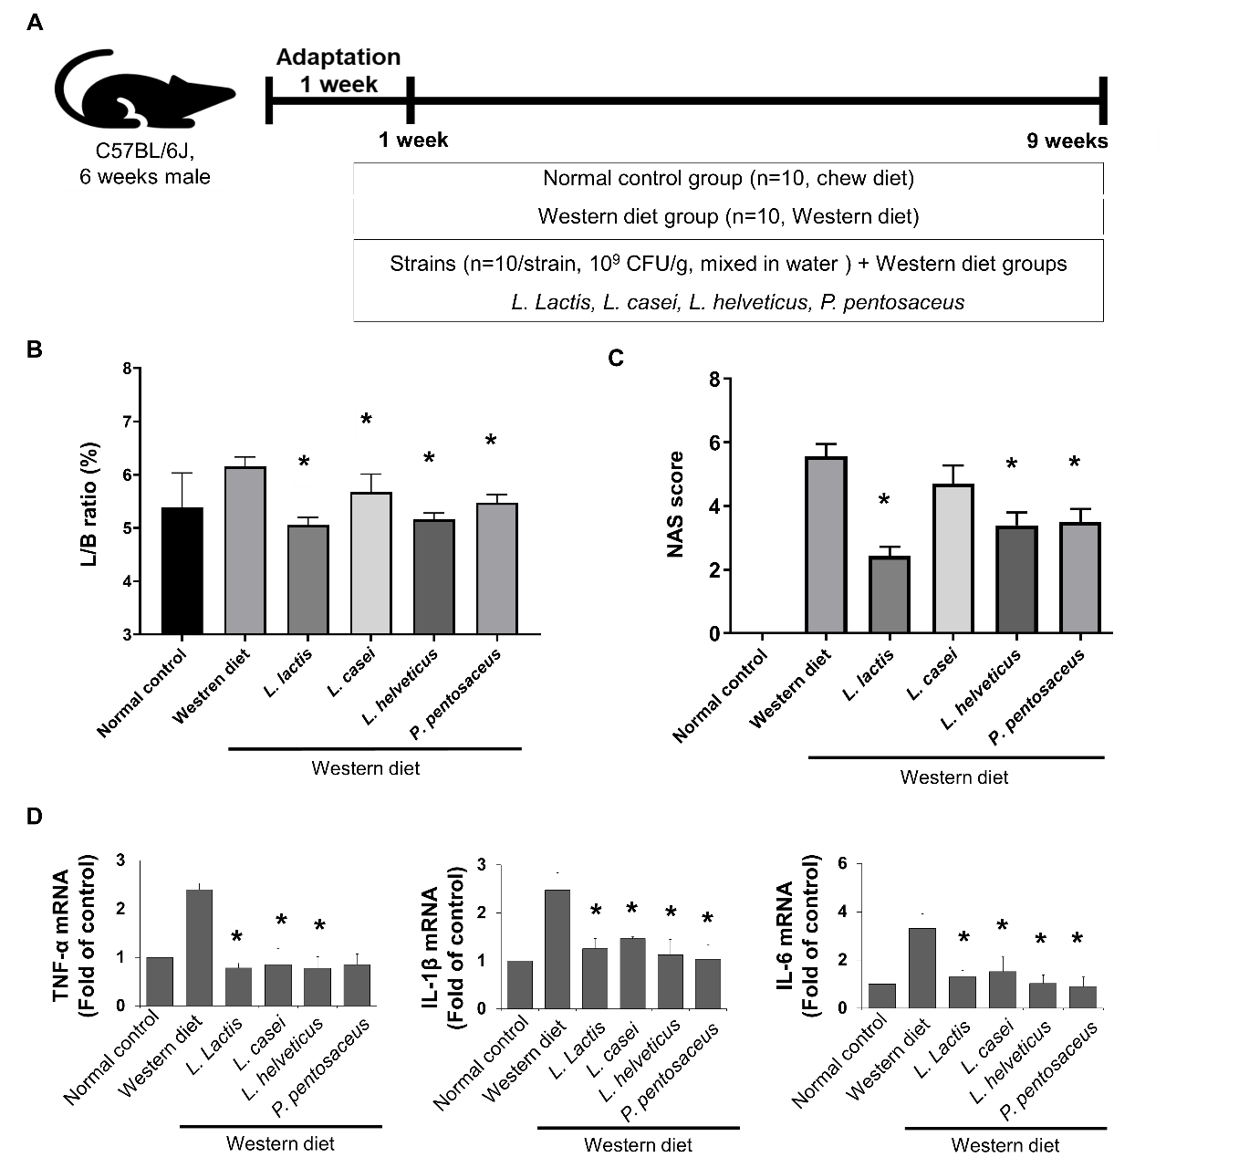
Fig. S1. Effects of probiotics in western diet-induced NAFLD mouse model. (A) Flow chart of the animal experiment. (B) Effect of dietary on liver/body weight ratio in mice. Compared with mice fed western diet. (C) NAFLD Activity Score (NAS). (D) The levels of inflammatory cytokines mRNA (TNF-α, IL-1β and IL-6) in the mouse liver. All data are shown as mean ± SEM of experiments. one-way ANOVA, the Kruskal-Wallis and Friedman tests was used for all statistical analyzes. *p<0.05 as compared with western diet.

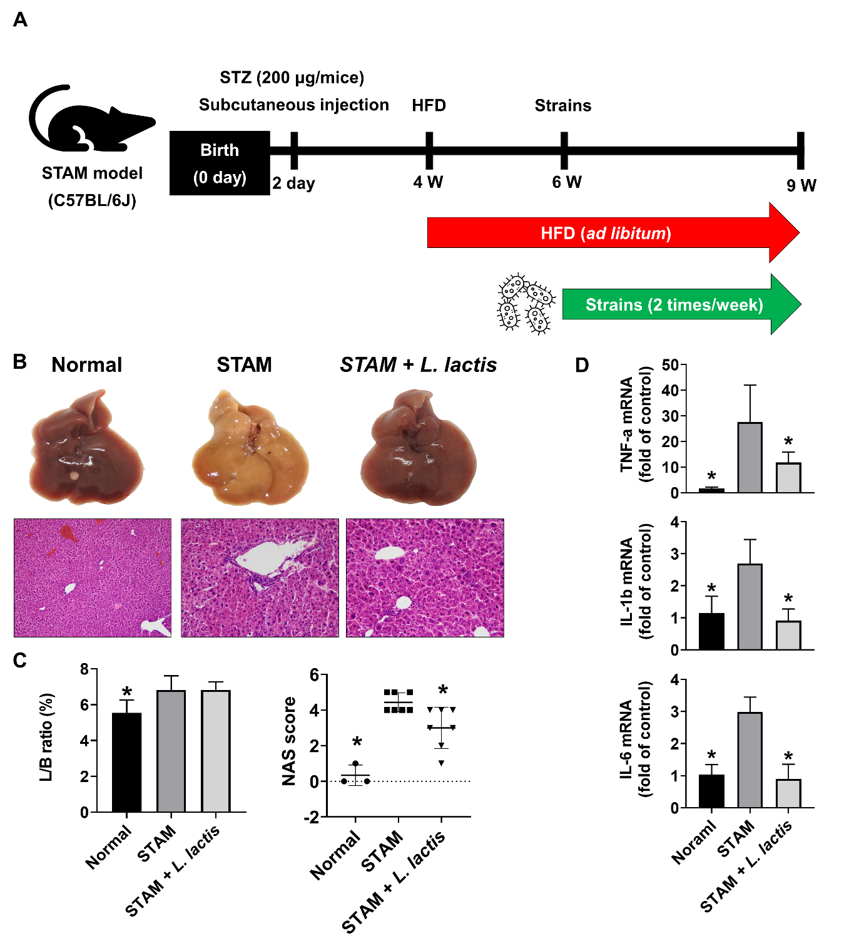
Fig. S2. Effects of L. lactis in STAM-NASH mouse model. (A) Flow chart of the animal experiment. (B) Gross specimen of mice liver. Representative photographs of liver samples were shown. (C) Effect of dietary on liver/body weight ratio and NAFLD Activity Score (NAS) in mice. (D) The levels of inflammatory cytokines mRNA (TNF-α, IL-1β and IL-6) in the mouse liver. All data are shown as mean ± SEM of experiments. one-way ANOVA, the Kruskal-Wallis and Friedman tests was used for all statistical analyzes. *p<0.05 as compared with STAM-NASH group.
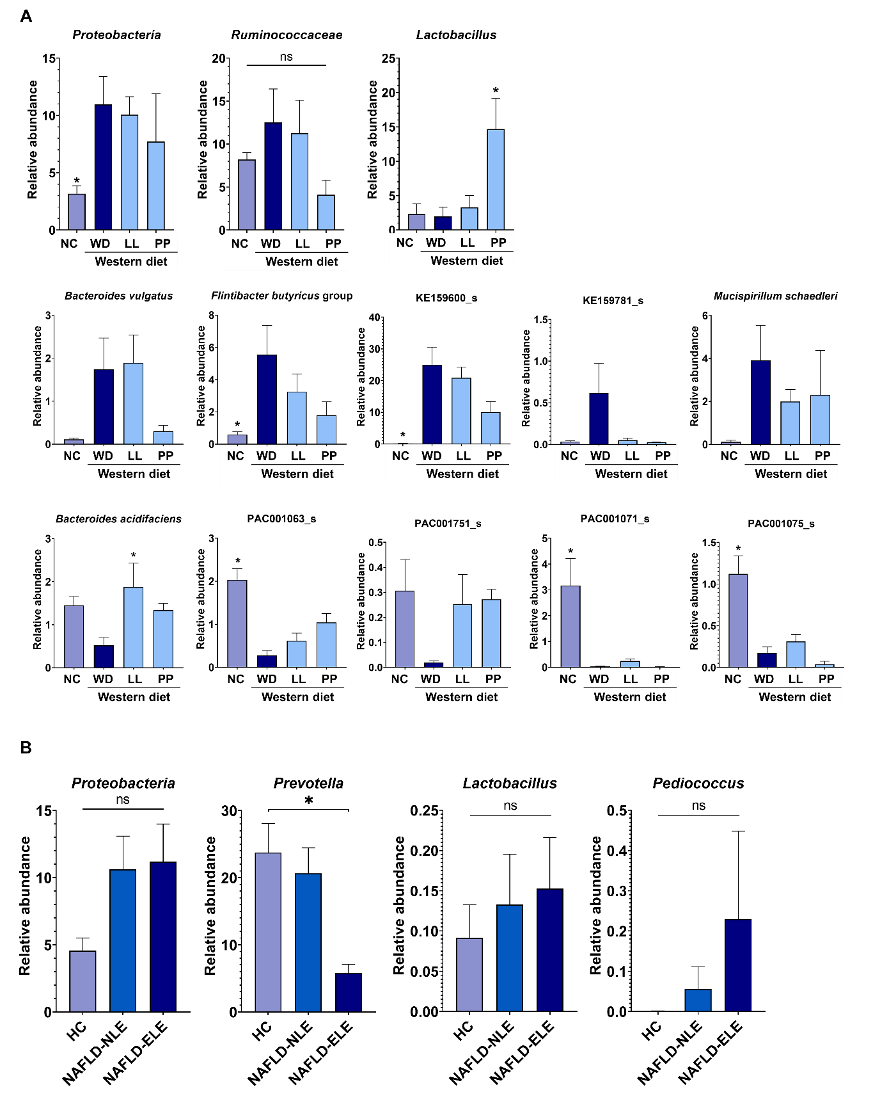
Fig. S3. Microbiome composition analysis in fecal samples. (A) Mouse microbiome was grouped into NC (n = 6), WD (n = 6), and WD with LL (n = 6) or PP (n = 3). (B) Human microbiome was grouped into healthy control (n = 30), NAFLD-NLE (n = 37) and NAFLD-ELE (n = 37). The data were analyzed using Wilcoxon rank-sum tests. *p<0.05 as compared with western diet (mouse) and healthy control (human).
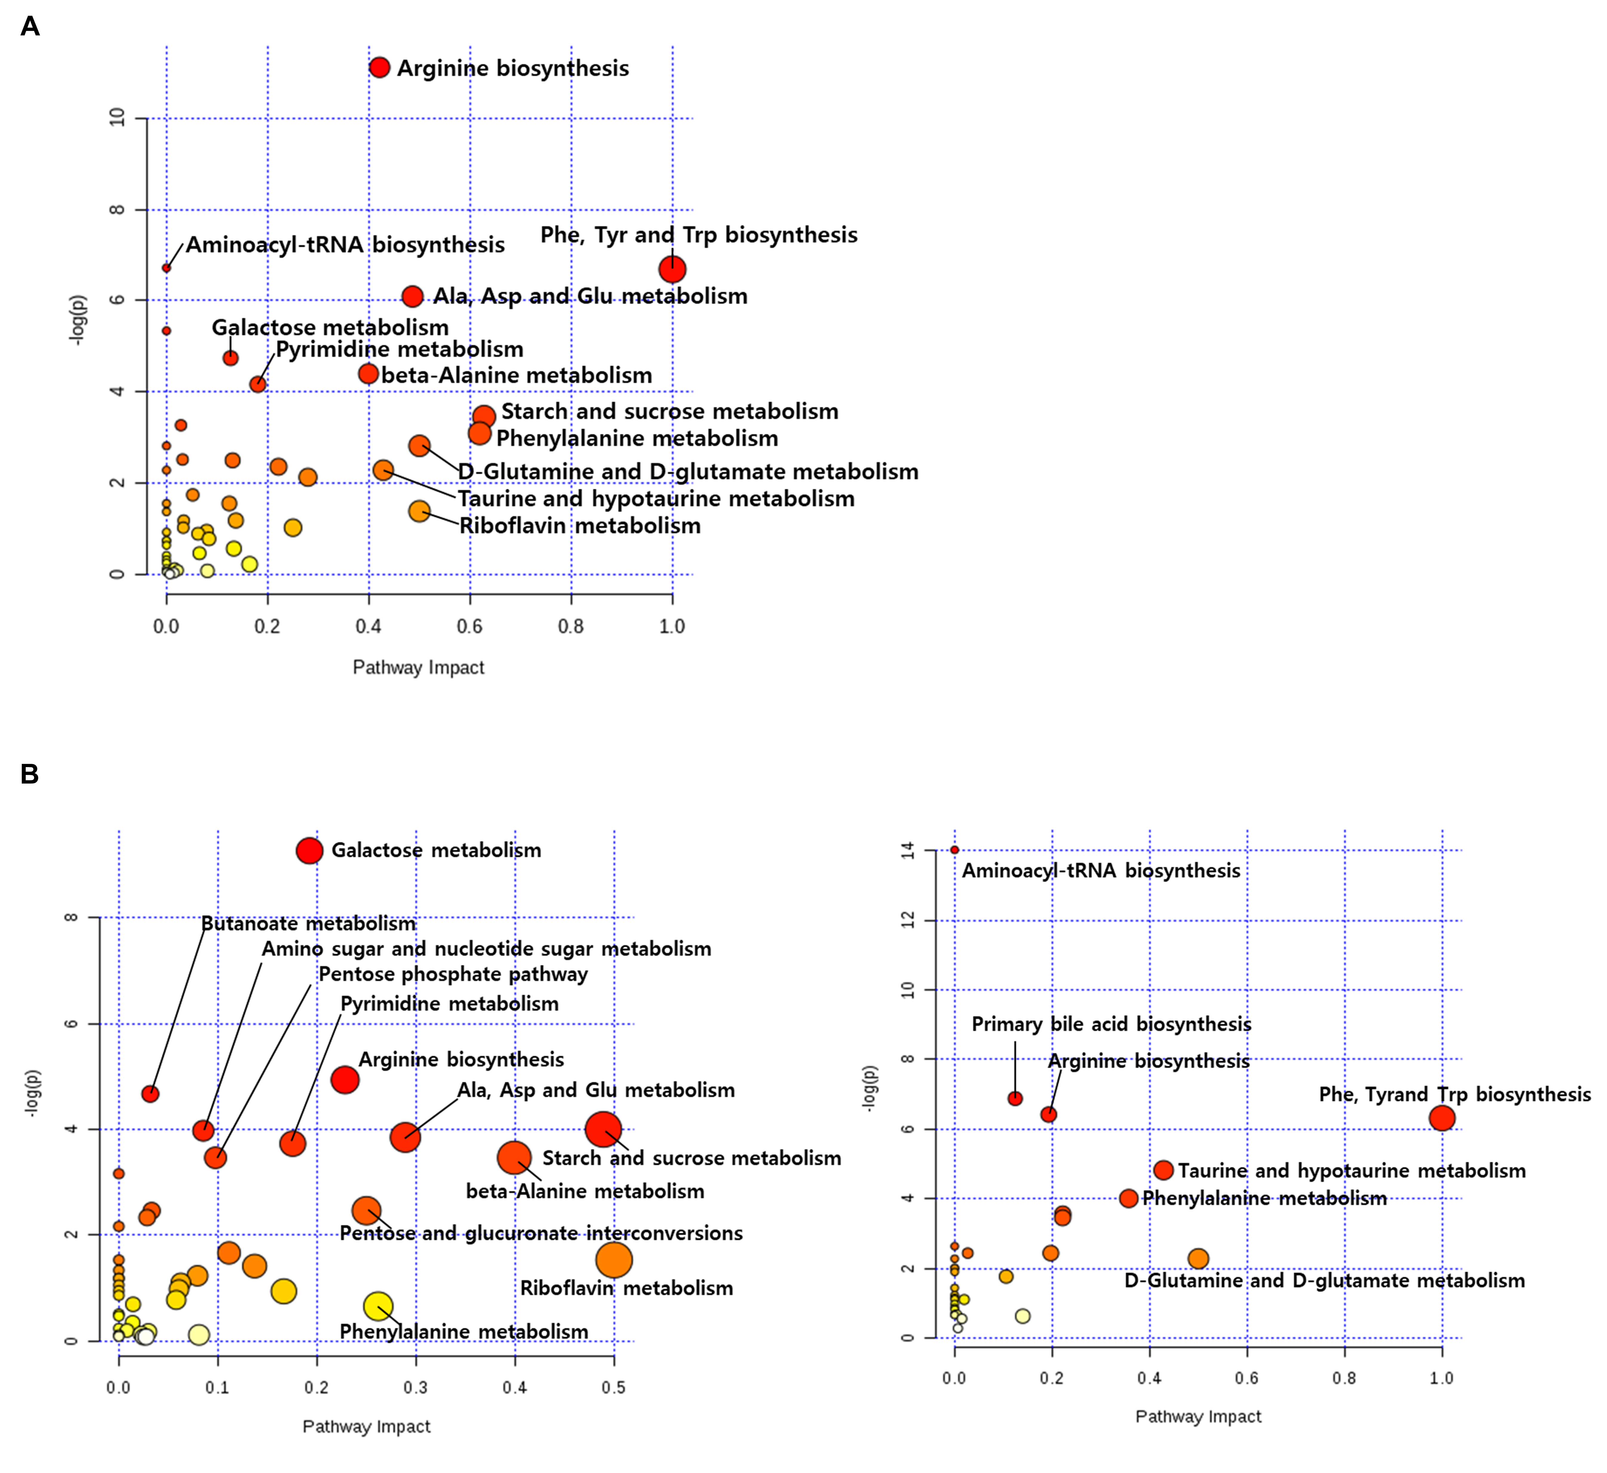
Fig. S4. Pathway over-representation anlysis of cecal metabolites. Pathway over-representation analysis was performed on list of metabolites name. X-axis means pathway impact which was calcuated in accordance with the betweenness of a node. Y-axis indicates the significance level. Node size and color are expressed in proportion to the pathway impact and statistical significance level, respectively. (A) pathway over-representation analysis of total 283 metabolites of cecal sample. (B) The list included the metabolites with statistical significance by student t test (p < 0.05). Present up-regulation metabolites in NC against WD (left panel) and down-regulation in NC against WD (right panel).

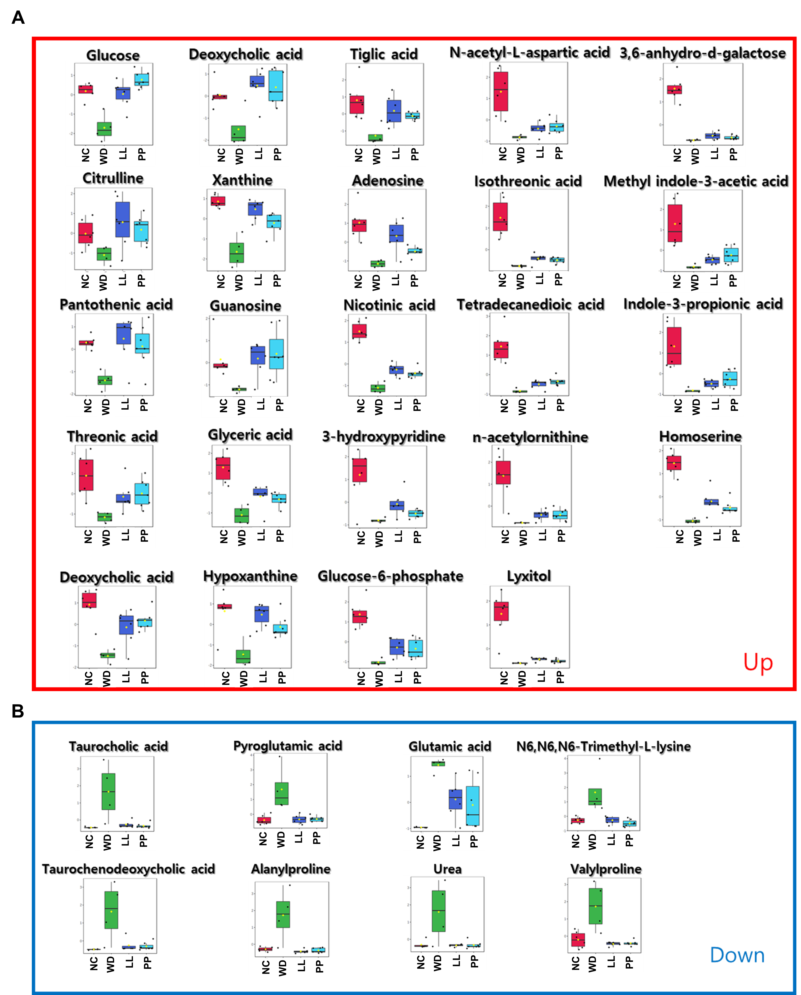
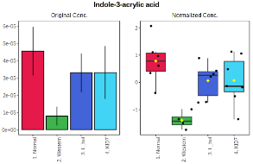


Fig. S5. Common metabolites of cecal sample according to pairwise t test. Box plot of cecal metabolites which have common abundance pattern in NC, LL and PP groups against WD. Y-axis indicates relative abundance. (A) Significantly up-regulation in NC, LL and PP groups compare to WD. (B) Significantly down-regulation in NC,LL and PP groups compare to WD.
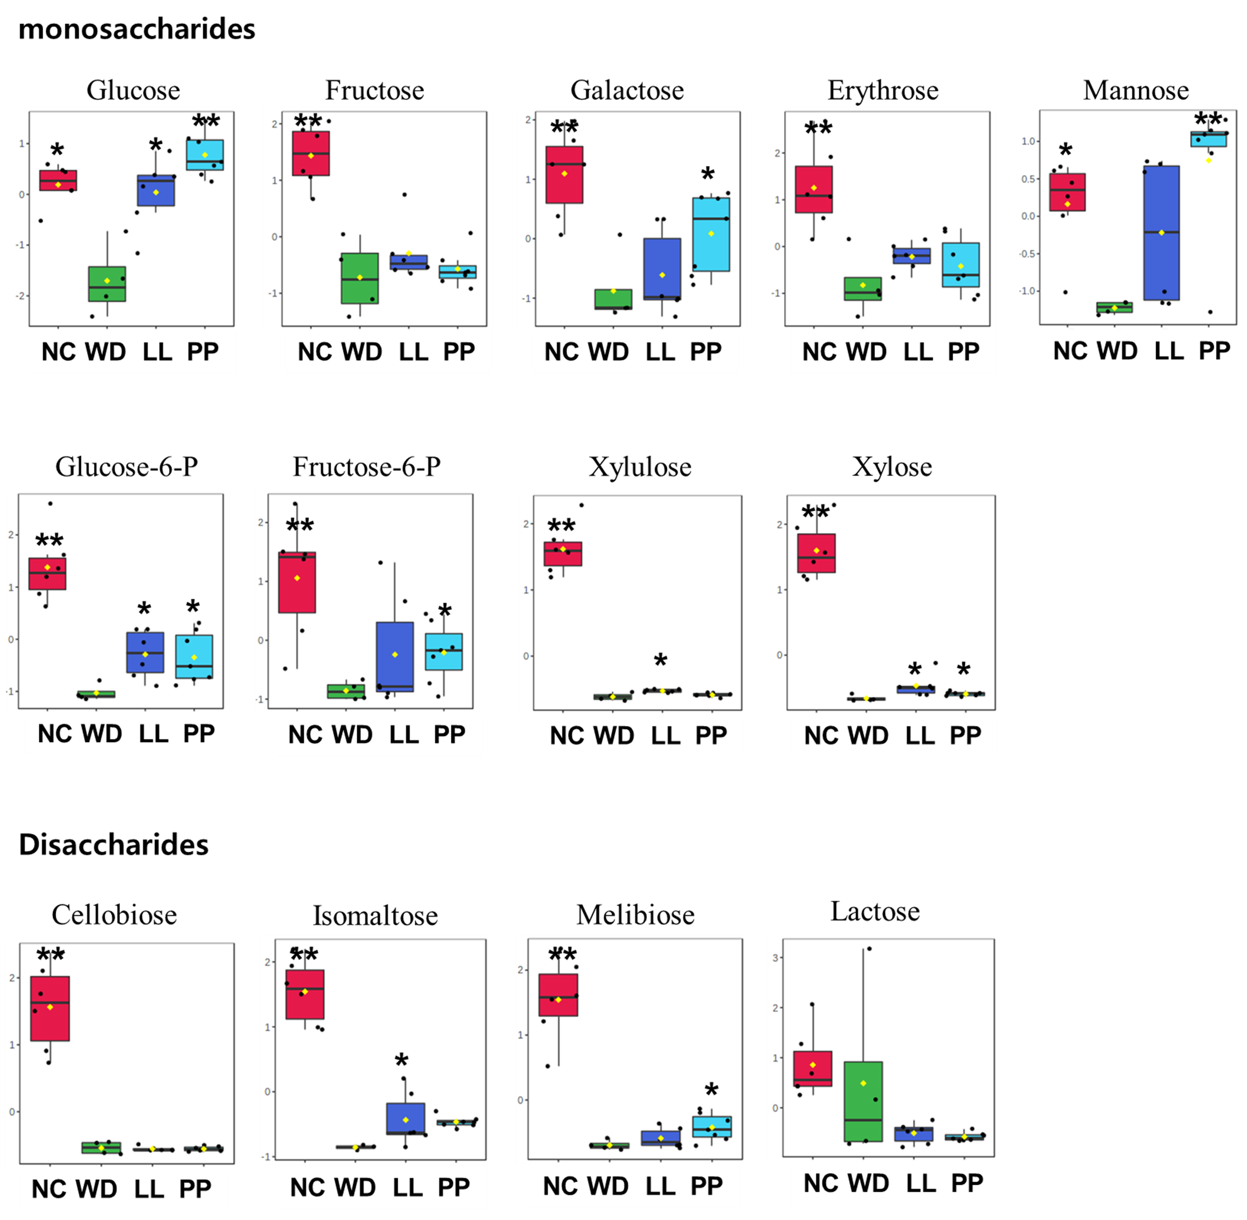
Fig. S6. Box plot of cecal carbohydrates. Box plot of 9 monosaccharides and 4 disaccharides. Y-axis indicates relative abundance. * indicates the statistical significance against WD group by Mann-Whitney U test (p <0.05). ** indicates the statistical significance against WD group by nonparametric Kruskal-Wallis test and Dunn’s test adjusted by Benjamini–Hochberg correction (p <0.05).

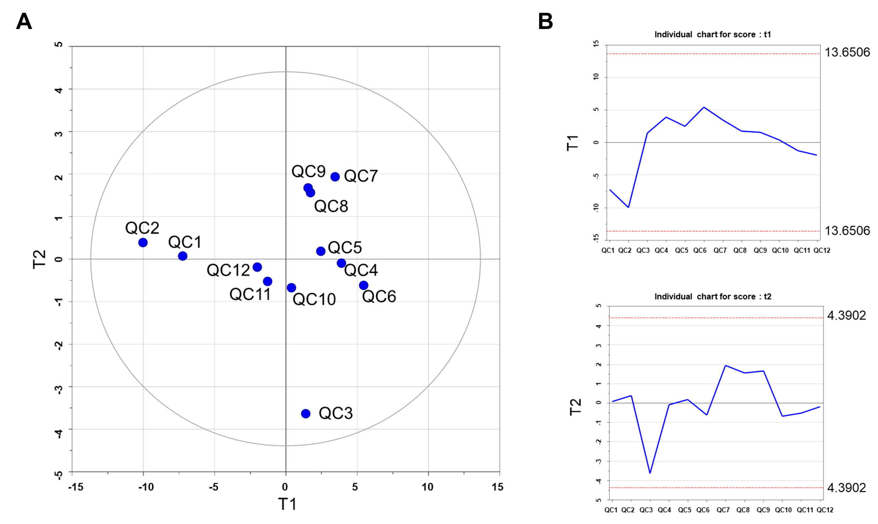
Fig. S7. Principal component analysis of quality control (QC) compounds. (A) Score scatter plot of 12 QC samples with T1 (X-axis) and T2 (Y-axis). X and Y axis indicate the most and the second moset discriminant vectors, respectively. The elipse is produced based on Hotelling’s T2 at a significant level of 0.05. (B) Line plots (Score control shart) woth T1 (upper panel) and T2 (lower panel).

Supplementary table 1. Summary of preliminary animal study
Biomarker | Group (n=10/each) | Mean ± SD | p value
Liver/body weight ratio | Western diet control | 6.2 ± 0.6 | -
Liver/body weight ratio | L. lactis | 5.1 ± 0.5 | <0.001
Liver/body weight ratio | L. helveticus | 5.2 ± 0.4 | <0.001
Liver/body weight ratio | L. acidophilus | 5.5 ± 0.4 | <0.001
Liver/body weight ratio | P. pediococcus | 5.5 ± 0.5 | 0.009
Liver/body weight ratio | L. paracasei | 5.7 ± 0.4 | 0.032
Histology score  (fatty change / inflammation) | Western diet control | 3.1 ± 0.3 / 2.0 ± 0.0 | -
Histology score  (fatty change / inflammation) | L. lactis | 0.7 ± 0.7 / 0.7 ± 0.7 | <0.001
Histology score  (fatty change / inflammation) | P. pediococcus | 1.3 ± 0.5 / 1.4 ± 0.5 | <0.001
Histology score  (fatty change / inflammation) | L. helveticus | 1.3 ± 0.5 / 1.7 ± 0.7 | <0.001
Histology score  (fatty change / inflammation) | L. acidophilus | 1.6 ± 0.7 / 1.8 ± 0.6 | <0.001
Histology score  (fatty change / inflammation) | L. casei | 1.8 ± 0.4 / 2.1 ± 0.6 | <0.001
Histology score  (fatty change / inflammation) | L. plantarum | 1.8 ± 0.6 / 2.3 ± 0.7 | 0.003
Histology score  (fatty change / inflammation) | L. paracasei | 1.6 ± 0.5 / 2.1 ± 0.9 | 0.035
Histology score  (fatty change / inflammation) | B.bifidum | 1.6 ± 0.5 / 2.5 ± 0.8 | 0.037
Histology score  (fatty change / inflammation) | L. fermentum | 1.8 ± 0.4 / 2.7 ± 0.5 | 0.042
N, number; SD, standard deviation

Supplementary table 2. The comparative abundance of microbial genes related to selected metabolic pathways and signaling pathways of mouse stool
Definition | NC | WD | LL | PP
Biosynthesis of secondary metabolites | 4.755 | 5.439 | 5.349 | 5.881
Biosynthesis of antibiotics | 3.521 | 4.009 | 3.953 | 4.373
Two-component system | 2.101 | 2.831 | 2.691 | 2.485
Carbon metabolism | 1.617 | 1.810 | 1.775 | 1.989
Biosynthesis of amino acids | 1.604 | 2.360 | 2.224 | 2.649
Purine metabolism | 1.457 | 1.593 | 1.581 | 1.791
Ribosome | 1.417 | 1.511 | 1.474 | 1.701
Quorum sensing | 1.162 | 1.486 | 1.396 | 1.530
Pyrimidine metabolism | 1.068 | 1.191 | 1.177 | 1.379
Amino sugar and nucleotide sugar metabolism | 0.993 | 1.134 | 1.141 | 1.352
Pyruvate metabolism | 0.802 | 0.840 | 0.824 | 0.908
Porphyrin and chlorophyll metabolism | 0.706 | 0.602 | 0.613 | 0.501
Sphingolipid metabolism | 0.661 | 0.404 | 0.479 | 0.329
Starch and sucrose metabolism | 0.654 | 0.820 | 0.817 | 1.145
Glycerophospholipid metabolism | 0.602 | 0.533 | 0.528 | 0.552
Glycolysis / Gluconeogenesis | 0.592 | 0.787 | 0.783 | 1.016
Base excision repair | 0.576 | 0.429 | 0.432 | 0.449
Degradation of aromatic compounds | 0.564 | 0.369 | 0.402 | 0.344
Aminoacyl-tRNA biosynthesis | 0.545 | 0.635 | 0.612 | 0.759
Cysteine and methionine metabolism | 0.545 | 0.643 | 0.628 | 0.754
Tryptophan metabolism | 0.536 | 0.359 | 0.383 | 0.240
Arginine and proline metabolism | 0.531 | 0.477 | 0.487 | 0.433
Benzoate degradation | 0.525 | 0.331 | 0.373 | 0.259
Alanine, aspartate and glutamate metabolism | 0.524 | 0.641 | 0.630 | 0.677
Methane metabolism | 0.524 | 0.633 | 0.607 | 0.651
Valine, leucine and isoleucine degradation | 0.497 | 0.394 | 0.398 | 0.300
Galactose metabolism | 0.488 | 0.614 | 0.643 | 0.786
DNA replication | 0.457 | 0.499 | 0.482 | 0.551
Nicotinate and nicotinamide metabolism | 0.455 | 0.393 | 0.402 | 0.407
Bacterial secretion system | 0.447 | 0.681 | 0.619 | 0.589
Hepatitis C | 0.443 | 0.293 | 0.309 | 0.181
Glyoxylate and dicarboxylate metabolism | 0.440 | 0.564 | 0.547 | 0.541
Homologous recombination | 0.430 | 0.524 | 0.509 | 0.641
Glycerolipid metabolism | 0.425 | 0.357 | 0.372 | 0.441
Pentose and glucuronate interconversions | 0.419 | 0.320 | 0.348 | 0.345
Glycine, serine and threonine metabolism | 0.412 | 0.493 | 0.485 | 0.570
Pentose phosphate pathway | 0.409 | 0.480 | 0.479 | 0.605
Nucleotide excision repair | 0.406 | 0.379 | 0.374 | 0.395
Pathways in cancer | 0.404 | 0.298 | 0.307 | 0.217
Mismatch repair | 0.399 | 0.505 | 0.479 | 0.586
Sphingolipid signaling pathway | 0.388 | 0.177 | 0.203 | 0.123
Human papillomavirus infection | 0.386 | 0.259 | 0.266 | 0.178
Data are determine by PICRUst and Kruskal Wallis H test in mouse cecal analysis (p<0.001).
Statistically significant top 42 markers not shown Figure 3
NC, normal control; WD, Western diet; LL, L. lactis; PP, P. pentosaceus
Supplementary table 3. The comparative relative abundance of microbial genes related to selected metabolic pathways and signaling pathways test in the human patient fecal analysis
Definition | Healthy control  (n = 30) | NAFLD
Definition | Healthy control  (n = 30) | Normal liver function  (n = 37) | Elevated liver function  (n = 37)
Metabolic pathways | 15.898 | 15.705 | 15.237
Microbial metabolism in diverse environments | 3.939 | 4.043 | 4.166
ABC transporters | 1.843 | 1.961 | 2.443
Amino sugar and nucleotide sugar metabolism | 1.401 | 1.363 | 1.197
Quorum sensing | 1.311 | 1.290 | 1.466
Starch and sucrose metabolism | 1.056 | 1.004 | 0.920
Galactose metabolism | 0.887 | 0.848 | 0.744
Pyruvate metabolism | 0.860 | 0.890 | 0.903
Oxidative phosphorylation | 0.845 | 0.835 | 0.757
Alanine, aspartate and glutamate metabolism | 0.792 | 0.768 | 0.691
Carbon fixation pathways in prokaryotes | 0.738 | 0.733 | 0.671
Homologous recombination | 0.721 | 0.677 | 0.628
Mismatch repair | 0.626 | 0.587 | 0.561
DNA replication | 0.619 | 0.578 | 0.544
beta-Lactam resistance | 0.573 | 0.540 | 0.469
Porphyrin and chlorophyll metabolism | 0.566 | 0.596 | 0.731
Other glycan degradation | 0.557 | 0.508 | 0.326
RNA degradation | 0.530 | 0.500 | 0.453
Butanoate metabolism | 0.524 | 0.579 | 0.570
Citrate cycle | 0.515 | 0.519 | 0.459
Glycerophospholipid metabolism | 0.499 | 0.510 | 0.528
Propanoate metabolism | 0.493 | 0.515 | 0.551
Sphingolipid metabolism | 0.487 | 0.459 | 0.359
Nicotinate and nicotinamide metabolism | 0.474 | 0.465 | 0.443
Cationic antimicrobial peptide resistance | 0.458 | 0.464 | 0.393
Fatty acid metabolism | 0.432 | 0.426 | 0.409
One carbon pool by folate | 0.423 | 0.398 | 0.367
Thiamine metabolism | 0.420 | 0.398 | 0.365
Arginine and proline metabolism | 0.416 | 0.430 | 0.441
Biofilm formation - Escherichia coli | 0.403 | 0.444 | 0.471
Fatty acid biosynthesis | 0.383 | 0.370 | 0.340
Drug metabolism - other enzymes | 0.377 | 0.371 | 0.352
Terpenoid backbone biosynthesis | 0.377 | 0.361 | 0.339
Streptomycin biosynthesis | 0.346 | 0.330 | 0.279
Lysosome | 0.343 | 0.324 | 0.218
Glycerolipid metabolism | 0.330 | 0.335 | 0.359
Sulfur metabolism | 0.320 | 0.340 | 0.369
Riboflavin metabolism | 0.315 | 0.307 | 0.282
Data are determine by PICRUst and Kruskal Wallis H test in mouse cecal analysis (p<0.001).
Statistically significant top 38 markers not shown Figure 3
NAFLD, non-alcoholic fatty liver disease; n, number

Supplementary table 4. Summary of statistics of short chain fatty acids
Mouse cecal sample |  |  |  | Kruskal Wallis test
 |  |  | chi squared |  | p-value | FDR
Acetic acid |  |  | 17.398 |  | < 0.001 | 0.001**
Propionic acid |  |  | 17.825 |  | < 0.001 | 0.001**
Butyric acid |  |  | 18.177 |  | < 0.001 | 0.001**
Iso-butyric acid |  |  | 15.856 |  | 0.001 | 0.002**
Valeric acid |  |  | 11.473 |  | 0.009 | 0.010*
Isovaleric acid |  |  | 12.844 |  | 0.004 | 0.006**
P-value was calculated by Kruskal-Wallis test
*FDR q value<0.05
**FDR q value<0.01

Mouse cecal sample |  |  | Post-hoc analysis
 | NC/WD |  |  | LL/WD |  | PP/WD |  | NC/LL |  | NC/PP |  | LL/PP
Acetic acid |  | < 0.001** |  |  | 0.178 |  | 0.047* |  | 0.013* | 0.054 | 0.457
Propionic acid |  | < 0.001** |  |  | 0.219 |  | 0.049* |  | 0.009** | 0.053 | 0.322
Butyric acid |  | < 0.001** |  |  | 0.251 |  | 0.041* |  | 0.007** | 0.064 | 0.248
Iso-butyric acid |  | 0.004** |  |  | 0.376 |  | 0.013* |  | 0.015* | 0.468 | 0.060
Valeric acid |  | 0.016* |  |  | 0.220 |  | 0.012* |  | 0.173 | 0.815 | 0.194
Iso-valeric acid |  | 0.023* |  |  | 0.286 |  | 0.009** |  | 0.145 | 0.627 | 0.054
Post-hoc was performed by Dunn’s test with Benjamini–Hochberg correction
*adjusted p value<0.05
**adjusted p value <0.01

Human fecal sample
 | p-value | FDR
Acetic acid | 0.012 | 0.025*
Propionic acid | 0.150 | 0.150
Butyric acid | 0.002 | 0.013*
Iso-butyric acid | 0.130 | 0.157
Valeric acid | 0.010 | 0.030*
Iso-valeric acid | 0.119 | 0.178
P-value and FDR were calculated based on Student’s t-test
*FDR q value<0.05
**FDR q value<0.01

Supplementary table 5. Summary of chemical classification of mouse cecal metabolite based on HMDB
Super class | Class | No. of metabolite
Benzenoids | Benzene and substituted derivatives | 20
Homogeneous non-metal compounds | Non-metal oxoanionic compounds  Homogeneous other non-metal compounds | 1  1
Lipids and lipid-like molecules | Fatty Acyls  Glycerolipids  Prenol lipids  Steroids and steroid derivatives | 32  1  7  14
Nucleosides, nucleotides, and analogues | 5'-deoxyribonucleosides  Purine nucleosides  Pyrimidine nucleosides  Nucleoside and nucleotide analogues | 1  8  5  1
Organic acids and derivatives | Carboximidic acids and derivatives  Carboxylic acids and derivatives  Hydroxy acids and derivatives  Keto acids and derivatives  Organic carbonic acids and derivatives  Organic phosphoric acids and derivatives  Organic sulfonic acids and derivatives  Organic sulfuric acids and derivatives | 1  60  5  1  1  1  1  1
Organic nitrogen compounds | Organonitrogen compounds | 6
Organic oxygen compounds | Organooxygen compounds | 38
Organoheterocyclic compounds | Caprolactams  Diazines  Imidazopyrimidines  Indoles and derivatives  Lactones  Pteridines and derivatives  Pyridines and derivatives  Quinolines and derivatives  Tetrahydrofurans  Azoles  Pyrrolidines  Imidazopyrimidines  Indolyl carboxylic acids and derivatives  Isoquinolines and derivatives  Tetrapyrroles and derivatives | 1  5  4  6  1  1  5  2  1  1  1  3  2  1  1
Phenylpropanoids and polyketides | Linear 1,3-diarylpropanoids  Phenylpropanoic acids  Cinnamic acids and derivatives  Flavonoids  Isoflavonoids  Phenylpropanoids and polyketides | 3  1  2  5  3  1

Supplementary table 6. Summary of univariate statistics on NC vs WD
Mouse cecal metabolite (up-regulated in WD) | p-value | FDR | Fold change
Valine  Palmitic acid  Phenylalanine  Proline  Pipecolic acid  6-chlorohexanol  Uric acid  Lactic acid  Tyrosine  (2R)-2,3-Dihydroxypropanoic acid  Stearic acid  Cytosine  Zymosterol  Creatinine  6-alpha-Prostaglandin I1  Oxoproline  Valylproline  N6,N6,N6-Trimethyl-L-lysine  Asparagine  Histidine  Alanylproline  Taurine  Beta-Leucine  Pyroglutamic acid  Arginine  Urea  Glycocholic acid  2'-Deoxycytidine  Cholesterol  Glutamic acid  Taurochenodeoxycholic acid  Taurocholic acid | 0.026  0.025  0.032  0.001  0.023  0.002  0.020  0.002  0.026  0.016  0.001  0.009  0.004  0.011  0.022  0.007  0.014  0.016  0.018  0.035  0.012  0.004  < 0.001  0.011  0.012  0.027  < 0.001  0.020  0.001  < 0.001  0.012  0.013 | 0.064  0.062  0.073  0.005  0.059  0.015  0.052  0.012  0.064  0.044  0.009  0.031  0.019  0.033  0.057  0.024  0.039  0.044  0.048  0.080  0.034  0.019  0.005  0.034  0.035  0.064  < 0.001  0.051  0.006  < 0.001  0.034  0.036 | 1.197  1.350  1.366  1.579  1.686  1.800  1.802  1.807  1.951  2.072  2.539  2.594  2.689  2.703  2.809  2.905  2.974  3.166  3.747  3.940  4.034  4.625  5.270  6.232  7.720  9.349  15.556  16.616  17.967  33.095  46.447  50.502

Mouse cecal metabolite (down-regulated in WD) | p-value | FDR | Fold change
Dehydroascorbic acid  Isoleucine  Glucose  Citrulline  Sucrose  Squalene  Glycerol-alpha-phosphate  3-phosphoglyceric acid  Fructose  Gamma-aminobutyric acid  Glycerophospho-N-palmitoyl ethanolamine  Uracil  Leucylproline  Erythrose  Oleamide  Pantothenic acid  Galactose  Fucose  Riboflavin  Thymine  Malic acid  Butyrolactam  Fumaric acid  Hexitol  2-Hydroxycaproic acid  Threonic acid  Deoxycholic acid  Xanthine  2,3-dihydroxypyridine  Inositol-4-monophosphate  Guanosine  2,5-dihydroxypyrazine  Glyceric acid  Gluconic acid  Uridine  7-Methyladenine  N-Acetyl-alpha-D-glucosamine  Hypoxanthine  Adenosine-5-monophosphate  Propane-1,3-diol  Sorbitol  Putrescine  Indole-3-acrylic acid  Imidazoleacetic acid  Tiglic acid  2-hydroxypyridine  Spermidine  Fructose-6-phosphate  8-Hydroxyquinoline  Adenosine  Erythritol  Beta alanine  Suberic acid  2-hydroxyhexanoic acid  Nicotinic acid  Shikimic acid  Kynurenic acid  Beta-hydroxybutyric acid  Mannose  Sitosterol  Xylulose  Xylitol  3-hydroxypyridine  Glucose-6-phosphate  N-acetyl-L-aspartic acid  Glutamine  2-deoxytetronic acid  Orotic acid  2-(4-hyrdroxyphenyl)ethanol  Isothreonic acid  19(R)-HETE  Phenylpyruvic acid  Indole-3-acetic acid  Tetradecanedioic acid  N8-Acetylspermidine  Delta-Gluconic acid delta-lactone  N-acetylornithine  Lyxitol  Maltotriose  3-Hydroxypicolinic acid  3-hydroxypropionic acid  3,6-anhydro-d-galactose  Cellobiose  Melibiose  Methyl indole-3-acetic acid  Lactitol  Homoserine  4-Pyridoxic acid  Indole-3-propionic acid  Succinic acid  Azelaic acid  Isomaltose  Xylose  Ethanol phosphate  Lyxose  Enolpyruvic acid  Pelargonidin  Prostaglandin A1 ethyl ester  Ferulic acid  Thiamine  Dodecanedioic acid  Isoferulic acid  5-Hydroxyindole-3-acetic acid | 0.042  0.002  0.001  0.031  0.037  0.011  0.009  0.010  < 0.001  0.002  0.004  0.009  0.001  0.005  < 0.001  0.006  0.002  0.016  0.006  0.009  0.018  0.007  0.004  0.004  0.046  < 0.001  0.008  < 0.001  0.002  0.006  0.019  0.008  < 0.001  < 0.001  0.044  0.035  0.015  0.006  0.003  0.006  < 0.001  0.010  < 0.001  0.028  0.009  < 0.001  0.004  0.007  0.004  0.002  0.033  0.002  0.001  0.012  < 0.001  0.003  0.003  0.01  0.003  < 0.001  < 0.001  < 0.001  0.012  < 0.001  0.005  0.044  0.043  0.003  0.006  0.001  0.029  0.011  0.002  0.001  0.005  0.027  0.004  0.003  0.001  0.001  0.002  < 0.001  < 0.001  < 0.001  0.007  < 0.001  < 0.001  0.003  0.005  0.001  < 0.001  < 0.001  < 0.001  0.049  < 0.001  0.026  0.036  0.015  < 0.001  0.048  < 0.001  0.004  0.004 | 0.093  0.011  0.006  0.071  0.082  0.033  0.031  0.032  0.005  0.013  0.019  0.030  0.011  0.020  0.001  0.023  0.014  0.044  0.024  0.030  0.048  0.024  0.019  0.019  0.099  0.005  0.030  0.002  0.014  0.023  0.050  0.030  0.005  0.002  0.095  0.079  0.04  0.023  0.015  0.023  < 0.001  0.032  0.008  0.067  0.030  < 0.001  0.019  0.024  0.019  0.011  0.077  0.012  0.005  0.035  < 0.001  0.017  0.018  0.033  0.015  0.005  < 0.001  0.002  0.034  0.002  0.022  0.095  0.094  0.016  0.023  0.009  0.068  0.033  0.013  0.008  0.019  0.064  0.019  0.015  0.010  0.011  0.011  0.001  0.003  0.002  0.024  0.001  < 0.001  0.015  0.020  0.006  0.003  < 0.001  < 0.001  0.104  < 0.001  0.064  0.081  0.040  0.001  0.102  0.005  0.019  0.019 | 0.686  0.539  0.519  0.511  0.508  0.505  0.491  0.459  0.434  0.429  0.417  0.406  0.402  0.371  0.365  0.336  0.331  0.329  0.321  0.321  0.314  0.296  0.286  0.285  0.271  0.267  0.265  0.265  0.264  0.256  0.248  0.230  0.225  0.217  0.215  0.209  0.207  0.197  0.196  0.196  0.188  0.182  0.176  0.166  0.155  0.153  0.148  0.144  0.143  0.138  0.137  0.126  0.124  0.12  0.116  0.113  0.109  0.108  0.101  0.100  0.099  0.098  0.094  0.094  0.089  0.088  0.081  0.080  0.068  0.067  0.065  0.061  0.061  0.06  0.057  0.056  0.055  0.053  0.052  0.051  0.05  0.046  0.046  0.044  0.038  0.037  0.037  0.036  0.032  0.028  0.028  0.026  0.016  0.015  0.012  0.010  0.007  0.007  0.006  0.005  0.004  0.003  0.002
P-value and FDR were calculated based on Student’s t-test

Supplementary table 7. Summary of statistics of indole compounds
cecum sample |  |  |  | Kruskal Wallis test
Indole metabolites |  |  | chi squared |  | p-value | FDR
Indole-3-lactic acid  Indole-3-propionic acid  Indole-3-acetic acid  Indole-3-acrylic acid  Indole-3-pyruvic acid  Indole-2-carboxylic acid  Methyl indole-3-acetate  5-Hydroxyindole-3-acetic acid  4-Hydroxyindole |  |  | 5.316  16.637  10.928  10.641  9.287  13.61  16.175  15.713  7.058 |  | 0.150  < 0.001  0.012  0.014  0.025  0.003  0.001  0.001  0.070 | 0.188  0.010*  0.027*  0.030*  0.044*  0.012*  0.010*  0.010*  0.099
Bile acids |  |  | chi.squared |  | p-value | FDR
Cholic acid  Glycocholic acid  Taurocholic acid  Deoxycholic acid  Taurodeoxycholic acid  Glycodeoxycholic acid  Taurochenodeoxycholic acid  Lithocholic acid |  |  | 13.974  14.042  13.433  7.980  3.923  2.400  13.928  3.367 |  | 0.002  0.002  0.003  0.046  0.269  0.493  0.003  0.338 | 0.012*  0.012*  0.013*  0.071  0.309  0.517  0.012*  0.375
P-value was calculated by Kruskal-Wallis test
*FDR q value<0.05
**FDR q value<0.01

cecum sample | Post-hoc analysis
Indole metabolites | NC/WD | LL/WD | PP/WD | NC/LL | NC/PP | LL/PP
Indole-3-propionic acid | 0.001** | 0.219 | 0.074 | 0.013* | 0.044* | 0.504
Indole-3-acetic acid | 0.006** | 0.132 | 0.180 | 0.122 | 0.14 | 0.791
Indole-3-acrylic acid | 0.007** | 0.304 | 0.061 | 0.260 | 0.087 | 0.786
Indole-3-pyruvic acid | 0.819 | 0.293 | 0.035* | 0.280 | 0.060 | 0.362
Indole-2-carboxylic acid | 0.007** | 0.496 | 0.594 | 0.013* | 0.014* | 0.995
Methyl indole-3-acetic acid | 0.001** | 0.184 | 0.055 | 0.019* | 0.067 | 0.484
5-Hydroxyindole-3-acetic acid | 0.001** | 0.219 | 0.139 | 0.019* | 0.026* | 0.729
Bile acids | NC/WD | LL/WD | PP/WD | NC/LL | NC/PP | LL/PP
Cholic acid | 0.954 | 0.147 | 0.010* | 0.148 | 0.007** | 0.200
Glycocholic acid | 0.002** | 0.040* | 0.245 | 0.208 | 0.034* | 0.261
Taurocholic acid | 0.003** | 0.192 | 0.035* | 0.054 | 0.265 | 0.283
Deoxycholic acid | 0.130 | 0.049* | 0.048* | 0.557 | 0.679 | 0.724
Taurochenodeoxycholic acid | 0.002** | 0.148 | 0.106 | 0.058 | 0.058 | 0.806
Post-hoc was performed by Dunn’s test with Benjamini–Hochberg correction
Post-hoc was conducted using only significantly different metabolites from Kruskal wallis test
*adjusted p value<0.05
**adjusted p value <0.01
Human fecal sample
Indole metabolites | p-value | FDR
Indole-3-propionic acid | < 0.001 | 0.001**
Indole-3-acetic acid | 0.473 | 0.473
Indole-3-acrylic acid | 0.225 | 0.225
Indole-3-lactic acid | 0.100 | 0.200
Bile acids | p-value | FDR
Cholic acid | < 0.001 | < 0.001**
Glycocholic acid | 0.104 | 0.156
Taurocholic acid | 0.050 | 0.100
Taurodeoxycholic acid | 0.189 | 0.189
Chenodeoxycholic acid | < 0.001 | < 0.001**
Taurochenodeoxycholic acid | 0.124 | 0.149
P-value and FDR were calculated based on Student’s t-test
*FDR q value<0.05
**FDR q value<0.01

Supplementary table 8. Summary of statistics of carbohydrates.
cecum sample | Kruskal Wallis test
Indole metabolites | chi squared | p-value | FDR
Glucose | 13.313 | 0.004 | 0.009**
Xylose | 17.076 | 0.001 | 0.003**
Fructose | 13.456 | 0.004 | 0.009**
Galactose | 12.949 | 0.005 | 0.009**
Mannose | 10.69 | 0.014 | 0.018*
Erythrose | 12.216 | 0.007 | 0.010*
Glucose-6-phosphate | 16.869 | 0.001 | 0.003**
Fructose-6-phosphate | 10.673 | 0.014 | 0.018*
Xylulose | 17.629 | 0.001 | 0.003**
Cellobiose | 12.811 | 0.005 | 0.009**
Isomaltose | 17.283 | 0.001 | 0.003**
Melibiose | 15.601 | 0.001 | 0.005**
Lactose | 10.505 | 0.015 | 0.018*
Maltotriose | 15.042 | 0.002 | 0.005**
P-value was calculated by Kruskal-Wallis test
*FDR q value<0.05
**FDR q value<0.01

Post-hoc
Indole metabolites | NC/WD | LL/WD | PP/WD | NC/LL | NC/PP | LL/PP
Glucose | 0.104 | 0.089 | 0.002** | 0.798 | 0.124 | 0.117
Xylose | 0.001** | 0.076 | 0.291 | 0.075 | 0.005** | 0.275
Fructose | 0.012* | 0.470 | 0.993 | 0.048* | 0.005** | 0.474
Galactose | 0.012* | 0.581 | 0.093 | 0.013* | 0.210 | 0.163
Mannose | 0.180 | 0.171 | 0.008** | 0.798 | 0.151 | 0.170
Erythrose | 0.012* | 0.512 | 0.589 | 0.034* | 0.015* | 0.743
Glucose-6-phosphate | < 0.001** | 0.093 | 0.090 | 0.034* | 0.026* | 0.875
Fructose-6-phosphate | 0.011* | 0.324 | 0.139 | 0.072 | 0.168 | 0.540
Xylulose | 0.001** | 0.100 | 0.681 | 0.106 | 0.002** | 0.105
Cellobiose | 0.017* | 1.000 | 0.920 | 0.015* | 0.009** | 1.000
Isomaltose | < 0.001** | 0.165 | 0.051 | 0.015* | 0.049* | 0.508
Melibiose | 0.002** | 0.469 | 0.149 | 0.005** | 0.049* | 0.372
Lactose | 0.135 | 0.713 | 0.674 | 0.025* | 0.018* | 0.815
Maltotriose | 0.002** | 0.381 | 0.086 | 0.009** | 0.098 | 0.314
Post-hoc was performed by Dunn’s test with Benjamini–Hochberg correction
*adjusted p value<0.05
**adjusted p value<0.01

Reference
1. Kleiner DE, Brunt EM, Van Natta M, Behling C, Contos MJ, Cummings OW, Ferrell LD, Liu YC, Torbenson MS, Unalp-Arida A, et al: Design and validation of a histological scoring system for nonalcoholic fatty liver disease. Hepatology 2005, 41:1313-1321.
2. Yoshida N, Emoto T, Yamashita T, Watanabe H, Hayashi T, Tabata T, Hoshi N, Hatano N, Ozawa G, Sasaki N, et al: Bacteroides vulgatus and Bacteroides dorei Reduce Gut Microbial Lipopolysaccharide Production and Inhibit Atherosclerosis. Circulation 2018, 138:2486-2498.
3. Anderson RC, Cookson AL, McNabb WC, Park Z, McCann MJ, Kelly WJ, Roy NC: Lactobacillus plantarum MB452 enhances the function of the intestinal barrier by increasing the expression levels of genes involved in tight junction formation. BMC microbiology 2010, 10:316.
4. Han J, Lin K, Sequeira C, Borchers CH: An isotope-labeled chemical derivatization method for the quantitation of short-chain fatty acids in human feces by liquid chromatography-tandem mass spectrometry. Anal Chim Acta 2015, 854:86-94.
5. Lee EM, Park SJ, Lee J-E, Lee BM, Shin BK, Kang DJ, Choi H-K, Kim Y-S, Lee DY: Highly geographical specificity of metabolomic traits among Korean domestic soybeans (Glycine max). Food Research International 2019, 120:12-18.
6. Park SJ, Kim JK, Kim H-H, Yoon B-A, Ji DY, Lee C-W, Kim HJ, Kim KH, Shin HY, Park SJ: Integrative metabolomics reveals unique metabolic traits in Guillain-Barré Syndrome and its variants. Scientific reports 2019, 9:1077.
7. Kind T, Wohlgemuth G, Lee DY, Lu Y, Palazoglu M, Shahbaz S, Fiehn O: FiehnLib: mass spectral and retention index libraries for metabolomics based on quadrupole and time-of-flight gas chromatography/mass spectrometry. Anal Chem 2009, 81:10038-10048.
8. Skogerson K, Wohlgemuth G, Barupal DK, Fiehn O: The volatile compound BinBase mass spectral database. BMC Bioinformatics 2011, 12:321.

