Supplementary material
Table S1. Radiometric, photometric and colorimetric parameters of the lights used in the experiments, measured with the MSC15 Spectral Light Meter, Gigahertz-Optik©, and their respective units. The values are the average of three repeated measures.
Parameter | 10 lx | 100 lx | 4315 lx
Ev (Illuminance - Photopic) / lx | 10.43 | 100.30 | 4315.33
Es (Illuminance - Scotopic) / lx | 22.90 | 225.03 | 9526.67
Es/Ev (S/P Ratio) | 2.20 | 2.24 | 2.21
Ee (Irradiance) / W/m² | 0.04 | 0.41 | 17.58
Bilirubin IEC 60601-2-50 / mW/cm² | 0.00 | 0.02 | 0.75
Bilirubin AAP 2011 / μW/(cm²nm) | 0.01 | 0.11 | 4.72
PPFD / μmol/(m²s) | 0.19 | 1.79 | 77.03
Ee,mel (Melanopic Irradiance) / W/m² | 9.27 | 90.46 | 3813.00
Ev,mel,D65 (Daylight Equivalent Melanopic Illuminance) / lx | 10.43 | 100.30 | 4315.33
x | 0.35 | 0.34 | 0.34
y | 0.33 | 0.32 | 0.32
u' | 0.23 | 0.22 | 0.22
v' | 0.47 | 0.47 | 0.47
Delta uv | 0.02 | 0.01 | 0.01
CCT / K | 4677.03 | 5171.73 | 5058.27
Dominant Wavelength / nm | 0.00 | 0.00 | 0.00
Purity | 0.00 | 0.00 | 0.00
Peak Wavelength / nm | 452.03 | 448.50 | 447.93
Centre Wavelength / nm | 454.23 | 449.80 | 449.10
Centroid Wavelength / nm | 580.23 | 571.60 | 569.80
FWHM / nm | 21.67 | 21.90 | 22.80
X | 0.02 | 0.15 | 6.66
Y | 0.02 | 0.15 | 6.32
Z | 0.02 | 0.15 | 6.53

Table S2. Spectral distribution graphs of the lights used during the light treatment trials.
Treatment Spectral distribution graphs
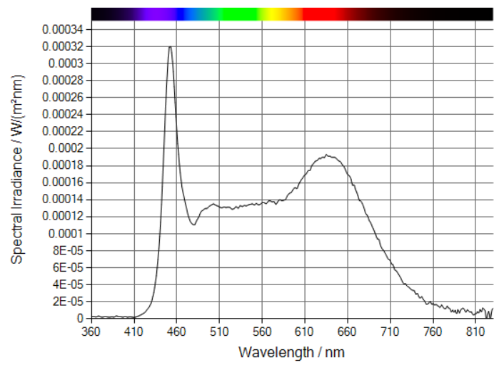

10 lx

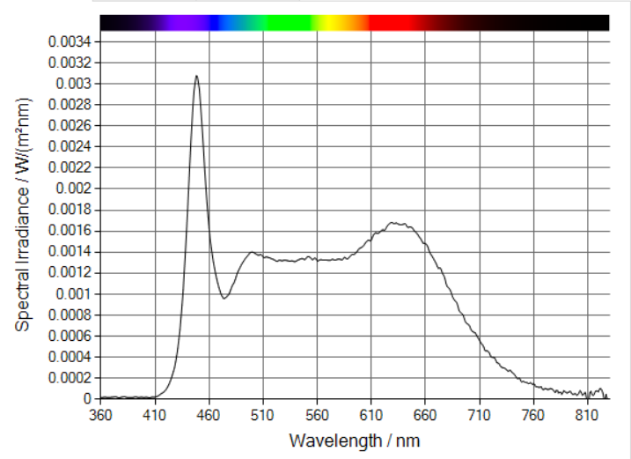

100 lx

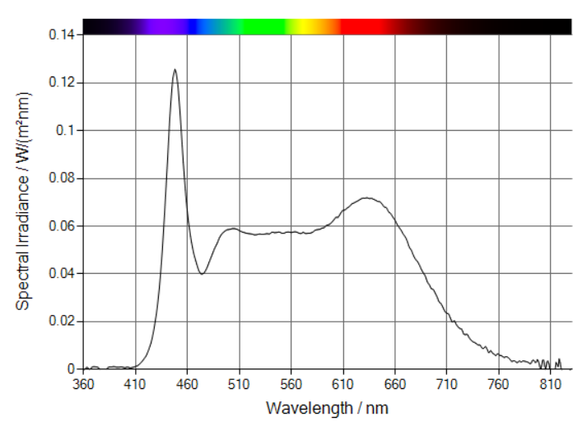

4315 lx

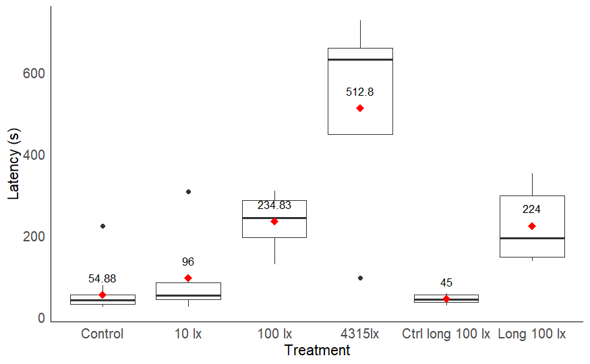

Fig. S1. Boxplot of the latency (in seconds) of males to first reach the dummy female, for each treatment. Medians are indicated by the horizontal black bars, the interquartile ranges by the boxes, the upper and lower quartiles by the whiskers and the extreme values by the black dots. The averages are numerically indicated by the red diamond shapes.

Table S3. Anova table of the linear mixed model of the mate finding success of the 2024 experiment.
Effect | df (Num, Den) | F-value | P-value
Treatment | 5, 265.02 | 20.09 | < 0.0001
Day | 1, 19.42 | 14.58 | 0.0011
Interval | 1, 470.14 | 13.52 | 0.0003
Interval² | 1, 470.14 | 1.03 | 0.311
Treatment × Interval | 5, 470.14 | 19.08 | < 0.0001
Treatment × Interval² | 5, 470.14 | 13.63 | < 0.0001

Table S4. Anova table of the generalised mixed model of mate finding success of the 2022 experiment.
Effect | χ² | df | P-value
Intercept | 15.12 | 1 | 0.0001
Treatment | 14.63 | 1 | 0.0001
Interval | 2.36 | 1 | 0.1244
Interval² | 0.01 | 1 | 0.9223
Treatment × Interval | 11.72 | 1 | 0.0006
Treatment × Interval² | 10.61 | 1 | 0.0011

Table S5. Output of the linear mixed models of the mate-finding success of the 2024 experiment.
Fixed effect | Estimate | SE | df | t-value | p-value
(Intercept) | 7.017 | 0.474 | 52.65 | 14.802 | <0.0001
100lx treatment | -2.840 | 0.650 | 211.37 | -4.370 | <0.0001
10lx treatment | -0.257 | 0.650 | 211.67 | -0.395 | 0.693
Long 100lx exposure treatment | -3.258 | 1.494 | 471.80 | -2.181 | 0.030
4315lx treatment | -6.448 | 0.699 | 211.22 | -9.226 | <0.0001
Control for long 100lx exposure | 1.010 | 1.494 | 471.80 | 0.676 | 0.499
Day | 0.114 | 0.030 | 19.42 | 3.819 | 0.001
Interval | -1.078 | 0.102 | 470.14 | -10.586 | <0.0001
Interval² | 0.0521 | 0.0076 | 470.14 | 6.830 | <0.0001
100lx × Interval | 0.854 | 0.199 | 470.14 | 4.281 | <0.0001
10lx × Interval | 0.106 | 0.199 | 470.14 | 0.532 | 0.595
Long 100lx exposure × Interval | 1.347 | 0.365 | 470.14 | 3.688 | 0.0003
4315lx × Interval | 1.890 | 0.214 | 470.14 | 8.849 | <0.0001
Control 100lx long exposure × Interval | 0.094 | 0.365 | 470.14 | 0.258 | 0.796
100lx × Interval² | -0.0550 | 0.0149 | 470.14 | -3.684 | 0.0003
10lx × Interval² | -0.0052 | 0.0149 | 470.14 | -0.349 | 0.727
Long 100lx exposure × Interval² | -0.0855 | 0.0218 | 470.14 | -3.927 | <0.0001
4315lx × Interval² | -0.116 | 0.0160 | 470.14 | -7.226 | <0.0001
Control long 100lx exposure × Interval² | -0.0129 | 0.0218 | 470.14 | -0.594 | 0.553

Table S6. Output of the estimates of the generalised mixed model of mate-finding success with Poisson distribution of the 2022 experiment.
Fixed effect | Estimate | SE | z-value | p-value
Intercept (Reference: control) | 1.360 | 0.350 | 3.888 | 0.0001
Treatment | -2.215 | 0.579 | -3.824 | 0.0001
Interval | -0.154 | 0.100 | -1.537 | 0.1244
I(Interval^2) | 0.001 | 0.008 | 0.098 | 0.9223
Treatment : Interval | 0.684 | 0.200 | 3.423 | 0.0006
Treatment : I(Interval^2) | -0.056 | 0.017 | -3.257 | 0.0011

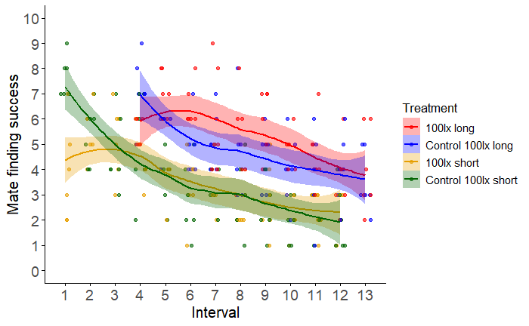
Fig. S2. Comparison of the mate-finding success after long and short exposure to 100 lx at the onset of the trials from 2024. Mate-finding success is represented by the maximum number of males simultaneously present on the dummy area during each interval.

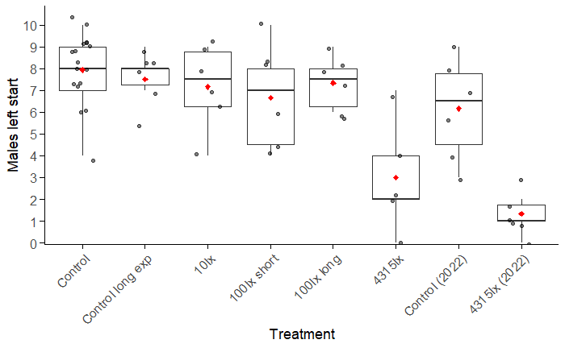
Fig. S3 . Number of males that left the starting area at the end of the first interval. The red diamonds indicate the averages. Medians are indicated by the horizontal black bars, the interquartile ranges by the boxes, the upper and lower quartiles by the whiskers and the extreme values by the black dots.

