Supplementary Information
Rethinking global hotspots of high-priority viral zoonoses to guide spillover risk monitoring
Andrea Tonelli^{1*} <andrea.tonelli@uniroma1.it>, Moreno Di Marco¹<moreno.dimarco@uniroma1.it>
Index:
Supplementary Figure 1...………………………...….……………….………………………………...2
Supplementary Figure 2...………………………...….……………….………………………………...3
Supplementary Figure 3...………………………...….……………….………………………………...4
Supplementary Figure 4...………………………...….……………….………………………………...5
Supplementary Table 1...…………………….…...….……………….………………………………...6
Supplementary Table 2....………………………...….……………….………………………………...7
Supplementary Dataset 1 and Supplementary Dataset 2 are provided as separate files.
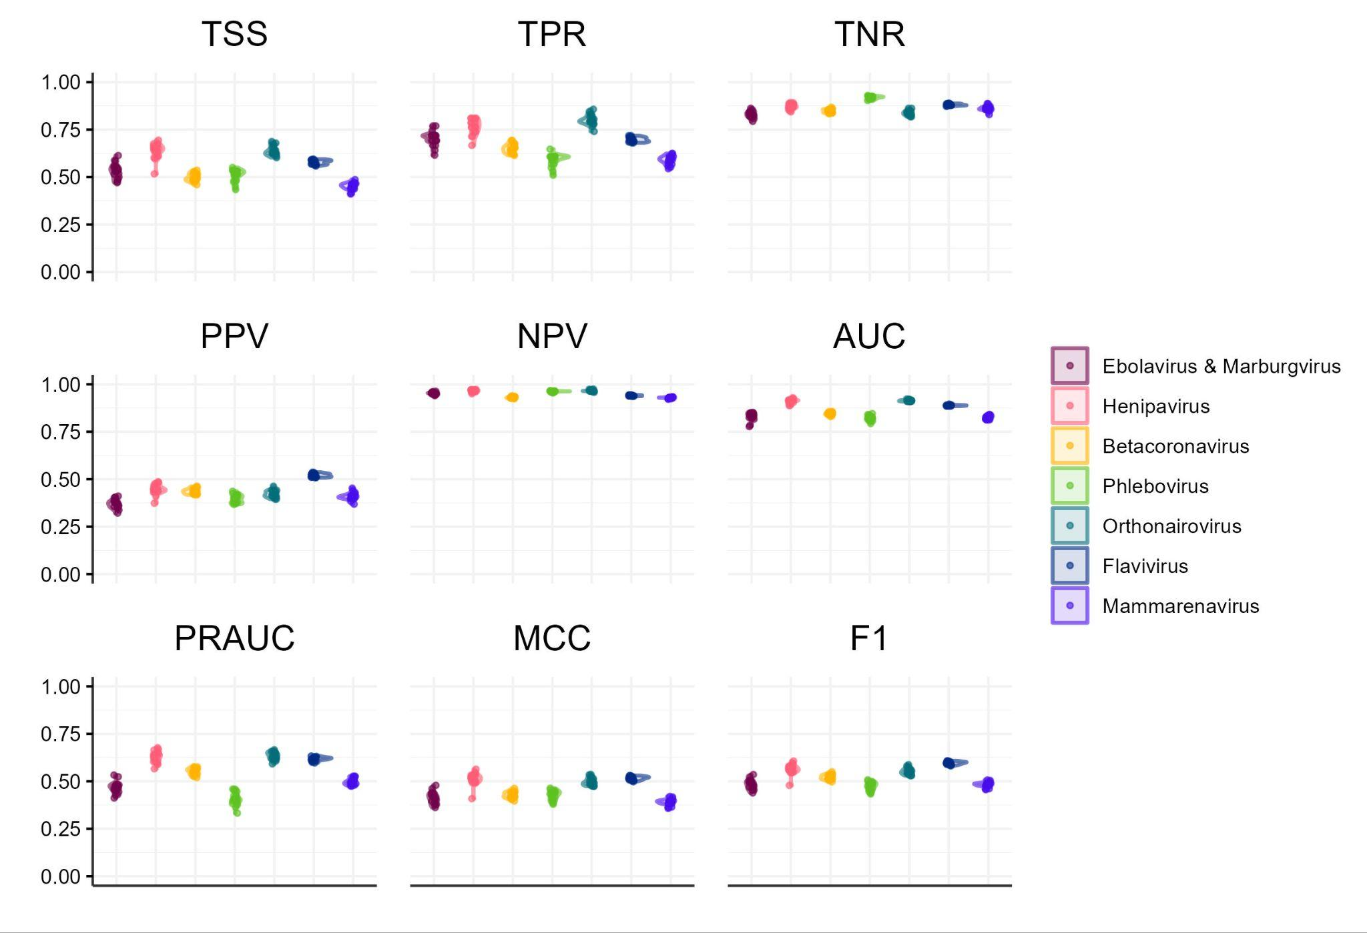

Supplementary Figure 1 Estimates of performance metrics resulting from 20 repetitions of the nested cross validation routine. TSS: True Skill Statistic; TPR: True Positive Rate (Recall); TNR: True Negative Rate; PPV: Positive Predicted Values (Precision); NPV: Negative Predicted Values; AUC: Area Under the Curve; PRAUC: Area Under the Precision Recall Curve; MCC: Matthew’s Correlation Coefficient; F1: F1 score. Performance metrics are described in Table S1.
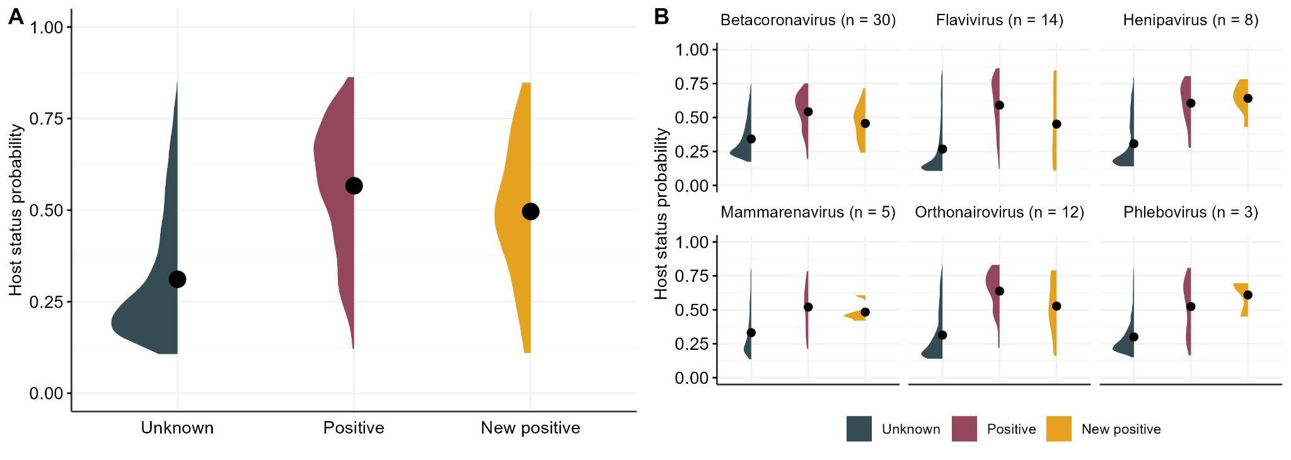
Supplementary Figure 2 Comparison of the distribution of host status probabilities for mammals with unknown status, positive status and newly-identified positives (n = 72) summarised across all viral groups (A) and separated between groups (B). No novel associations were found for Ebola & Marburgvirus. The model ensemble assigned significantly higher host probabilities to new positive species compared to a set of species with unknown status (Wilcoxon signed-rank test statistic = 14,172,169; p < 0.001).

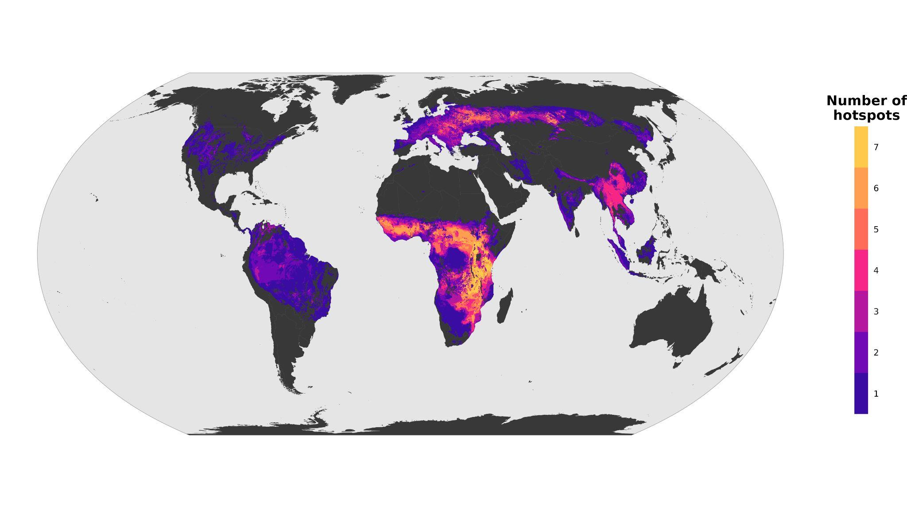
Supplementary Figure 3 Cumulative global hazard hotspots of high-priority viruses. Each grid cell in the map represents the cumulative number of overlapping zoonotic hazard hotspots, defined as 10 km×10 km cells where host richness falls within the global top 10% for a given viral group.

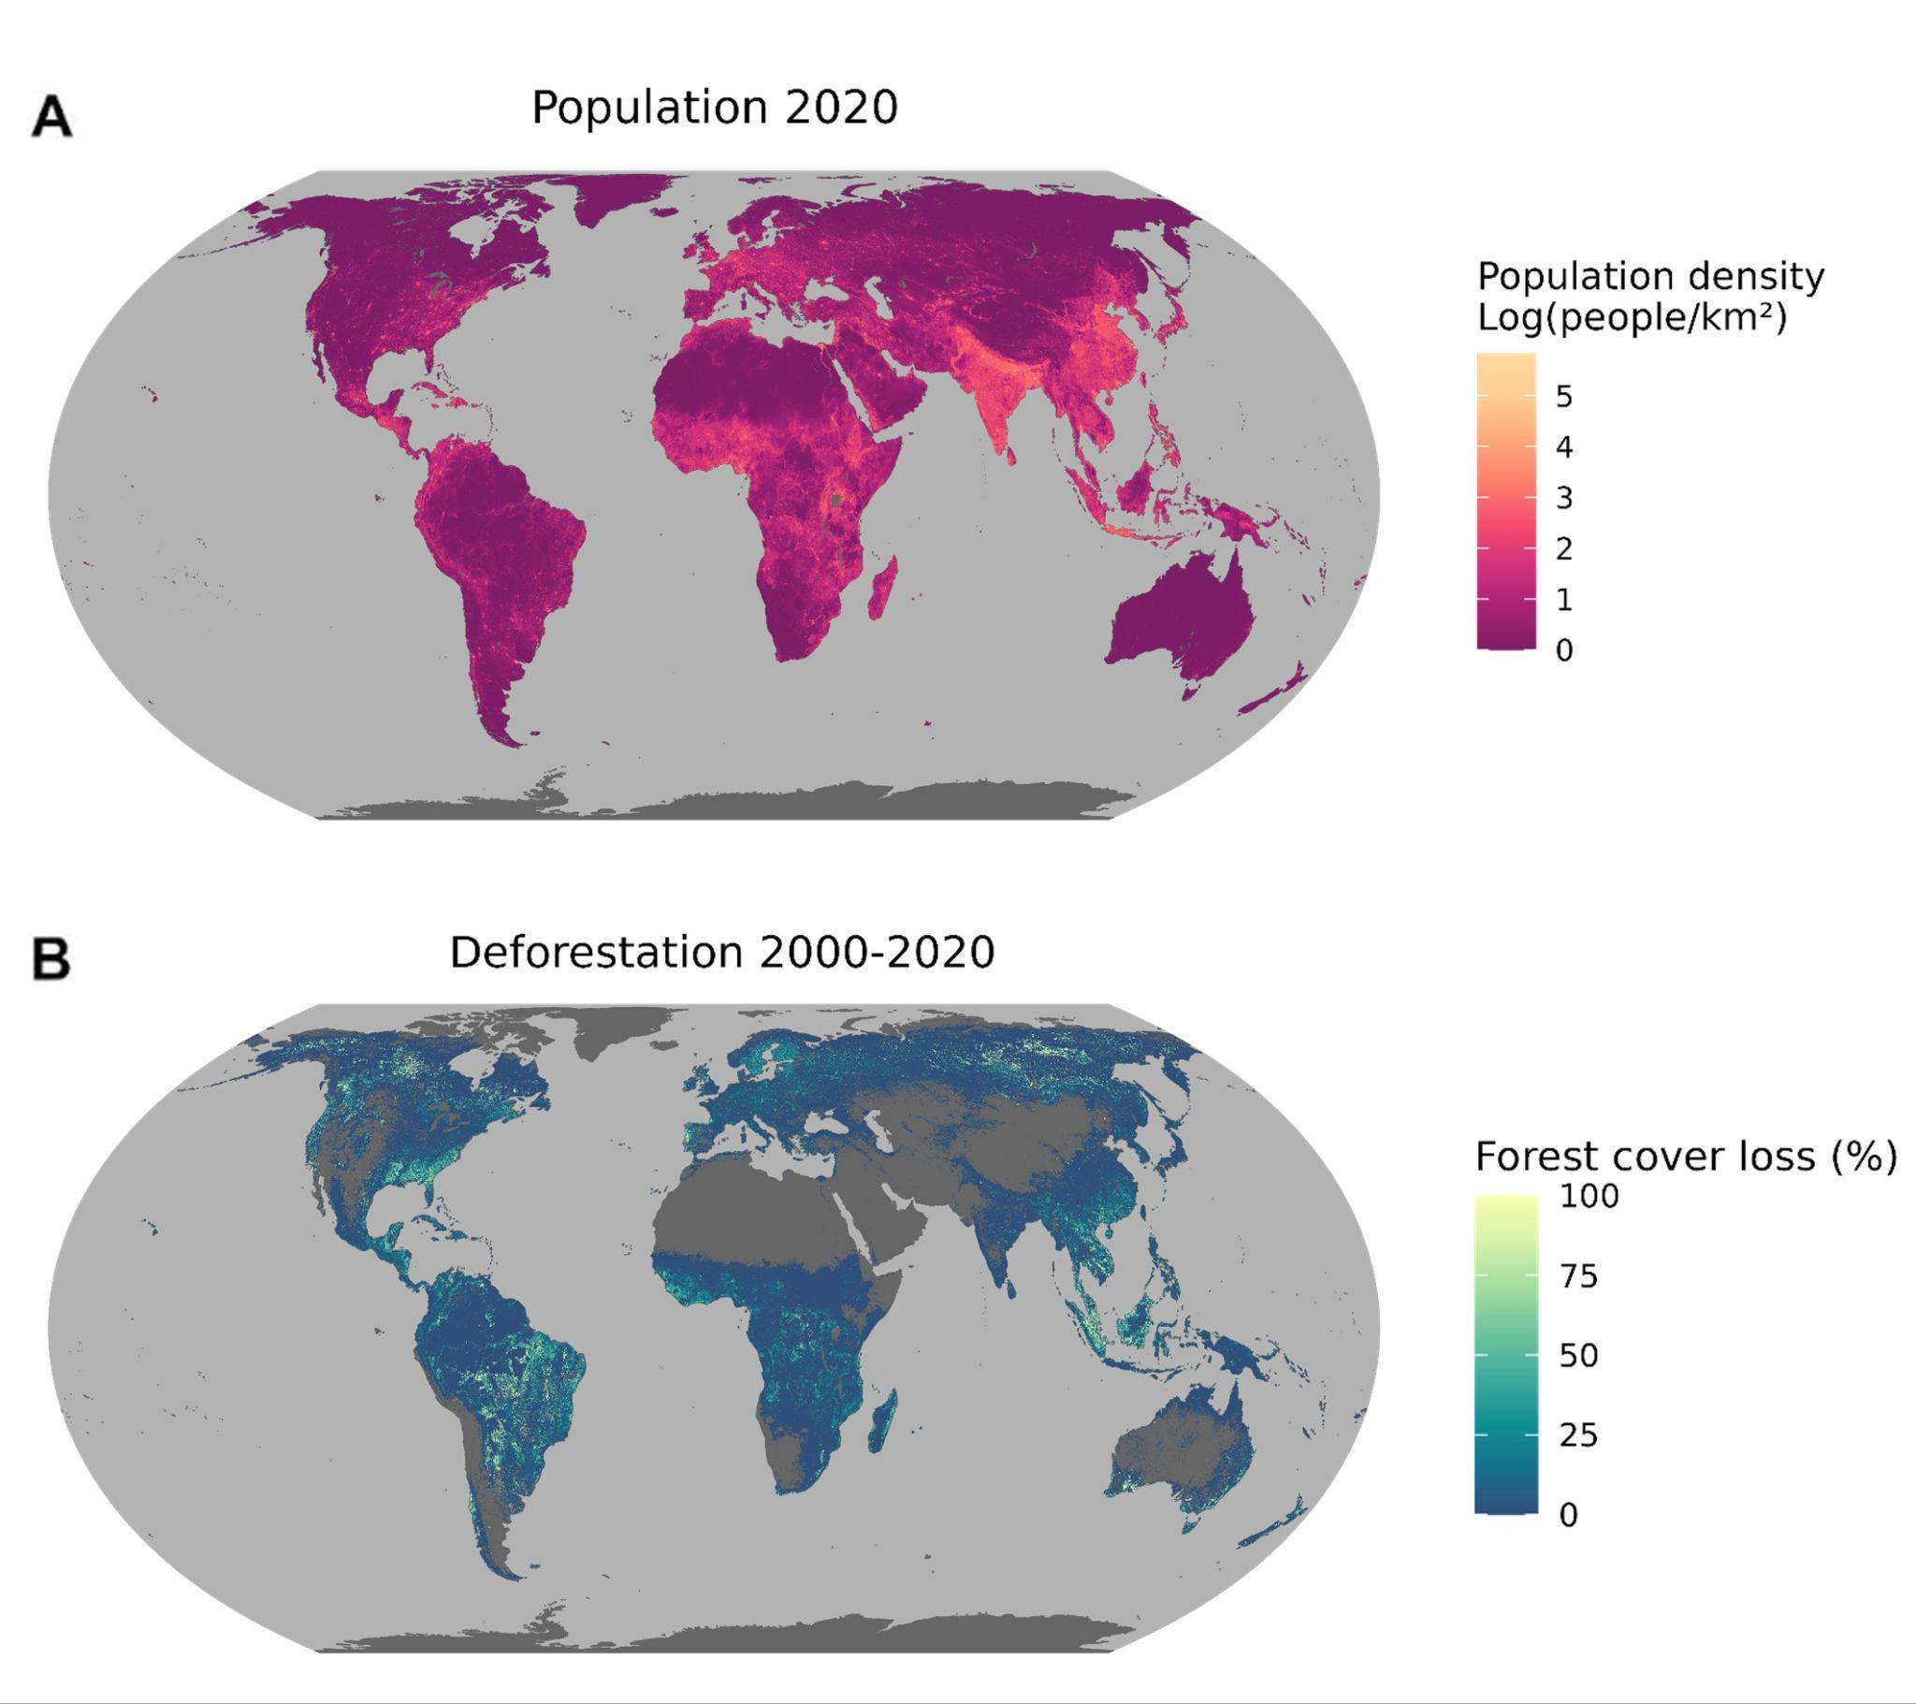

Supplementary Figure 4 Drivers of zoonotic spillover used to identify anthropogenic pressures within predicted hazard hotspots. Maps are at a spatial resolution of 1km. Population density in 2020 (A) was sourced from WorldPop and CIESIN, 2020. The pixel-level forest cover loss in the 2000-2020 period (B) was calculated from forest cover maps sourced from (1).

Supplementary Table 2 List of excluded flaviviruses for which mammals are generally considered incidental or dead-end hosts.
Flavivirus species | Primary hosts/reservoirs | Reference
Ilheus virus | Birds | (3)
Israel turkey meningoencephalomyelitis virus | Birds | (4)
Japanese encephalitis virus | Birds | (5)
Saint louis encephalitis virus | Birds | (6)
Tembusu virus | Birds | (7)
Usutu virus | Birds | (8)
West nile virus | Birds | (9)

Supplementary Table 1 Description of performance metrics used to assess the models. (TN = True negatives, TP = True positives, FN = False negatives, FP = False positives). Sourced from (2).

Metric | Formula | Description
TSS | $$TNR+TPR-1$$ | True Skill Statistic. Combines specificity and sensitivity. Ranges from -1 to 1, where 0 is the performance of a random classifier.
TNR | $$\frac{TN}{TN+FP}$$ | Proportion of negatives correctly classified. Ranges from 0 to 1, where 0.5 is the performance of a random classifier.
TPR | $$\frac{TP}{TP+FN}$$ | Proportion of positives correctly classified. Ranges from 0 to 1, where 0.5 is the performance of a random classifier.
MCC | $$\frac{TN ×TP-FN ×FP}{\sqrt{\left(TP+ FP\right)(TP+FN)(TN+FP)(TN+FN)}}$$ | Matthew’s Correlation Coefficient between true and predicted class. Ranges from -1 to 1, where 0 is the performance of a random classifier.
PPV | $$\frac{TP}{TP+FP}$$ | Proportion of true positives among predicted positives. Ranges from 0 to 1. The performance of a random classifier is equal to the proportion of positives in the data.
NPV | $$\frac{TN}{TN+FN}$$ | Proportion of true negatives among predicted negatives. Ranges from 0 to 1. The performance of a random classifier is equal to the proportion of negatives in the data.
F1 | $$2 ×\frac{PPV ×TPR}{PPV+TPR}$$ | F1 score is calculated as the harmonic mean of precision and recall. Ranges from 0 to 1 and is sensitive to class imbalance.
AUC | Area under the ROC curve | Indicates the model's ability to classify positive and negative instances and is calculated based on TPR and FPR.
PRAUC | Area under the Precision-Recall curve | Indicates the model's ability to classify positive instances and is calculated based on the TPR and PPV.
Supplementary Dataset 1 Data sources used for classifying host species in high and low- evidence hosts. Provided as a separate file.

Supplementary Dataset 2 New positive associations based on viral species-level isolation or PCR evidence extracted from Genbank (10) from January 2022 to September 2024. Provided as a separate file.

Supplementary references
1. M. C. Hansen, et al., High-resolution global maps of 21st-century forest cover change. Science (1979) 342 (2013).
2. A. Tonelli, M. S. C. Blagrove, M. Wardeh, M. Di Marco, A framework to predict zoonotic hosts under data uncertainty: A case study on betacoronaviruses. Methods Ecol Evol (2025).
3. K. S. Plante, et al., Potential of Ilhéus virus to emerge. Heliyon 10 (2024).
4. J. Fernández-Pinero, et al., Bagaza virus and Israel Turkey meningoencephalomyelitis virus are a single virus species. Journal of General Virology 95 (2014).
5. Z. A. Levesque, M. G. Walsh, C. E. Webb, R. N. Zadoks, V. J. Brookes, A scoping review of evidence of naturally occurring Japanese encephalitis infection in vertebrate animals other than humans, ardeid birds and pigs. PLoS Negl Trop Dis 18, e0012510 (2024).
6. A. Kopp, et al., Provenance and geographic spread of St. Louis encephalitis virus. mBio 4 (2013).
7. H.-J. Wang, et al., In vitro and in vivo characterization of chimeric duck Tembusu virus based on Japanese encephalitis live vaccine strain SA14-14-2. Journal of General Virology 97, 1551–1556 (2016).
8. F. Roesch, G. Moratorio, G. Moratorio, M. Vignuzzi, Usutu virus: An arbovirus on the rise. Viruses [Preprint] (2019).
9. R. A. Bowen, N. M. Nemeth, Experimental infections with West Nile virus. Curr Opin Infect Dis [Preprint] (2007).
10. D. A. Benson, et al., GenBank. Nucleic Acids Res 41 (2013).

