The effect of dopaminergic substances on resting-state EEG connectivity in healthy participants
Alina J. Preuss^{1,2*}
Renate de Bock^{3*}
Amatya J. Mackintosh⁴
Simon Schuster⁵
Philipp Sterzer³
Jonas Obleser^{2,6}
Stefan Borgwardt^{1,2}
Christina Andreou^{1,2}

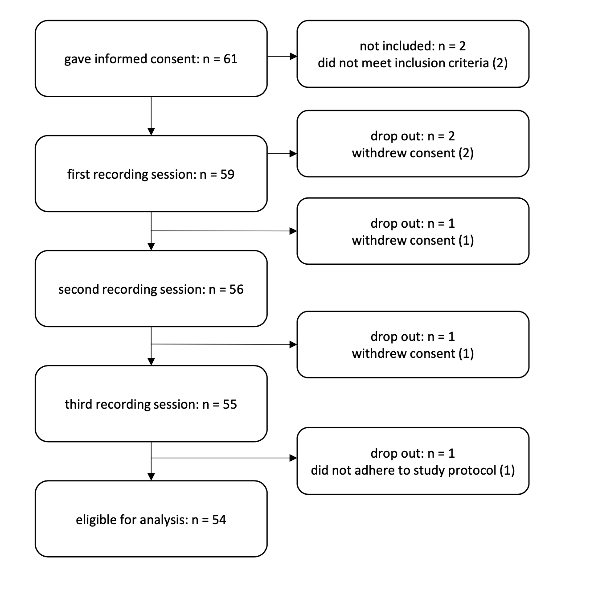
Figure S1. Flowchart of participants eligible, recruited, numbers followed up and included in analysis.

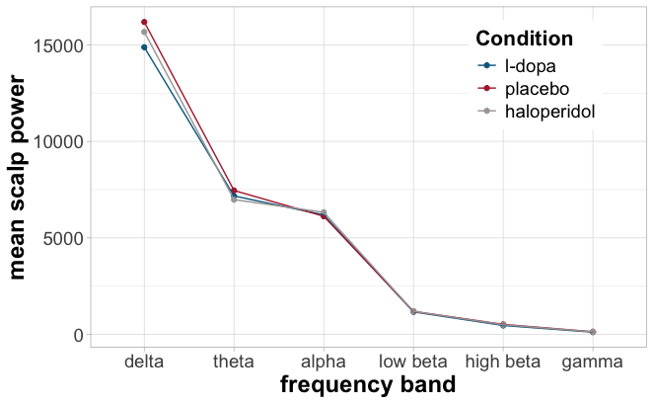
Figure S2. Mean overall scalp power at each frequency band in L-dopa, haloperidol and placebo conditions.

MIM | L-dopa | Placebo | Haloperidol
Delta (3 Hz) | 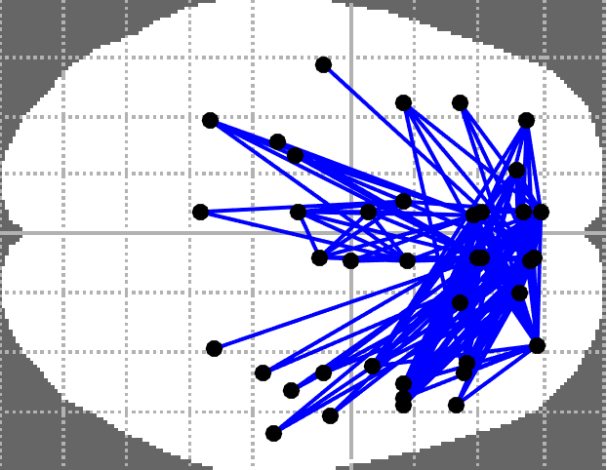 | 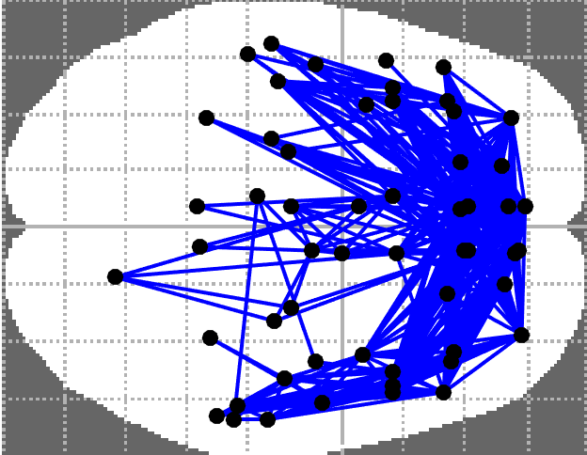 | 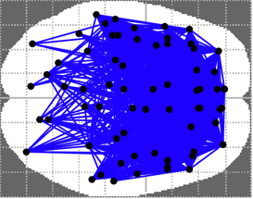
Theta (6 Hz) | 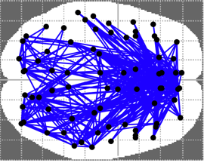 | 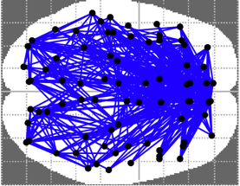 | 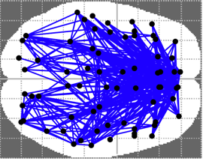
Alpha (10 Hz) | 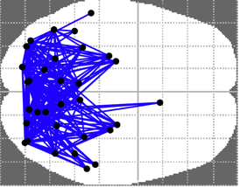 | 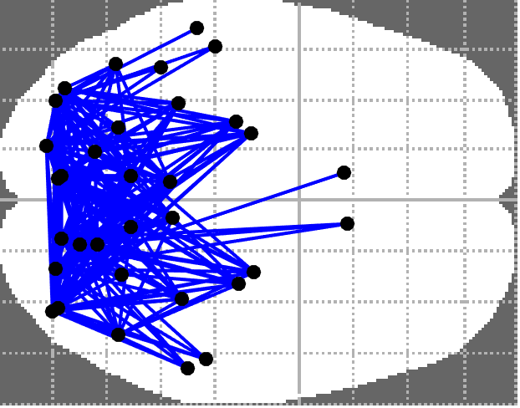 | 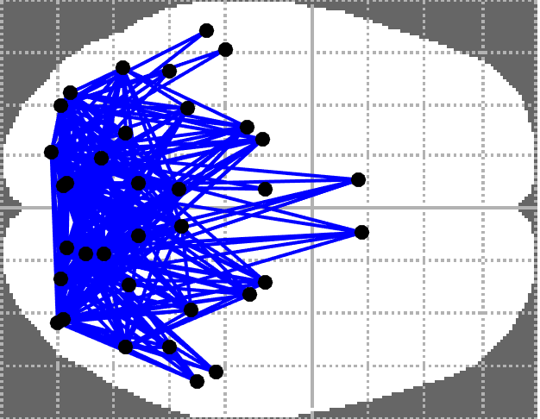
Low beta (16 Hz) | 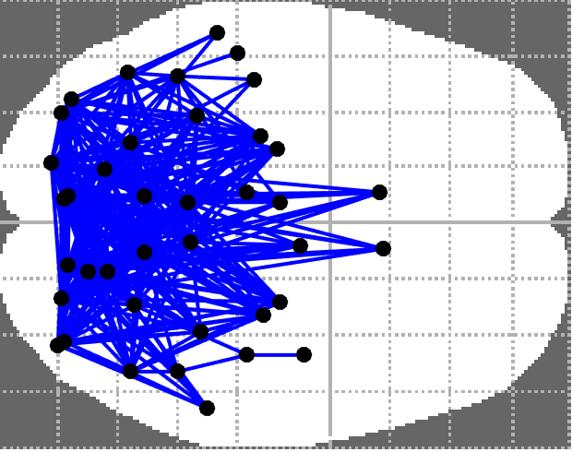 | 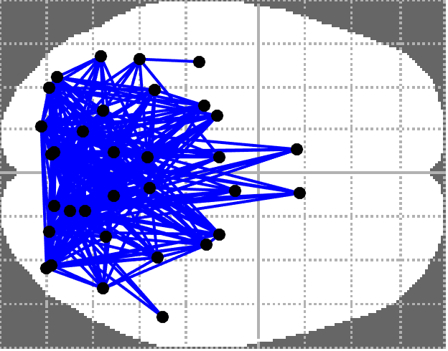 | 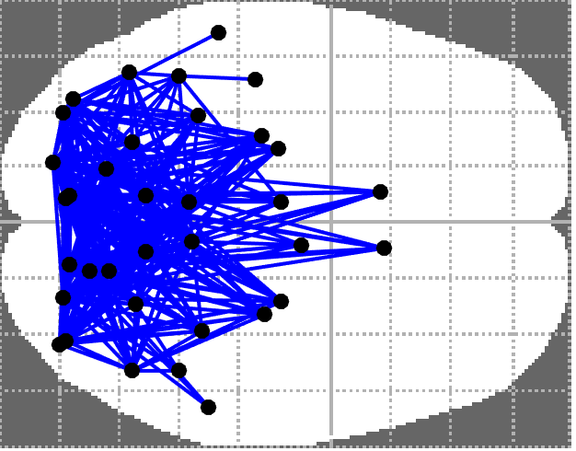
High beta (25 Hz) | 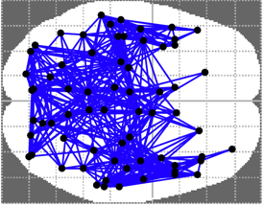 | 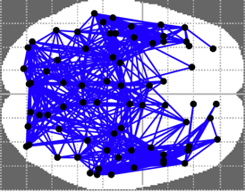 | 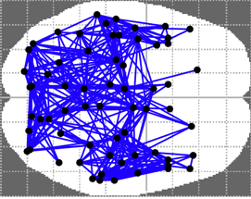
Gamma (40 Hz) | 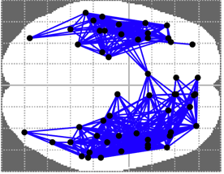 | 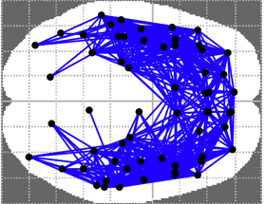 | 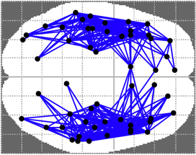
Figure S3. Multivariate interaction measure (MIM) networks (one sample NBS t-test, 1000 permutations) in each frequency range. The t-threshold was varied across frequencies to maximize network visibility, but is the same across substances for any given frequency. The left side of the brain corresponds to the left hemisphere, and the top of the brain represents the anterior direction.

ORT | L-dopa | Placebo | Haloperidol
Delta (3 Hz) | 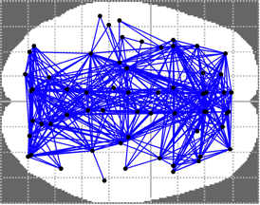 | 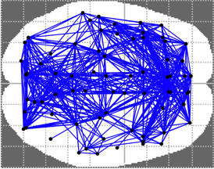 | 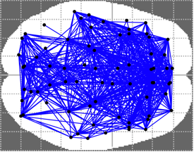
Theta (6 Hz) | 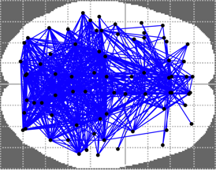 | 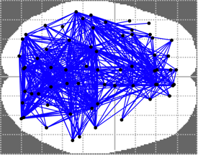 | 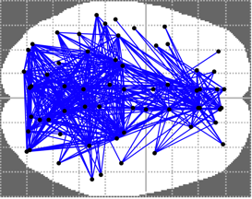
Alpha (10 Hz) | 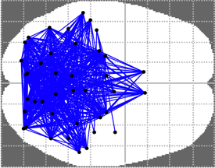 | 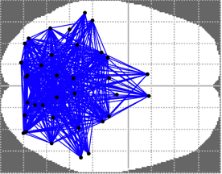 | 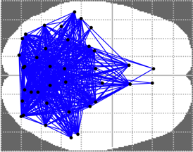
Low beta (16 Hz) | 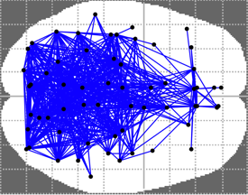 | 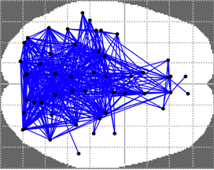 | 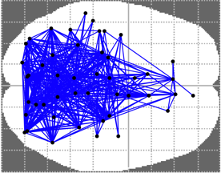
High beta (25 Hz) | 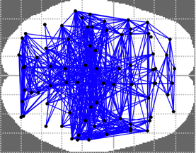 | 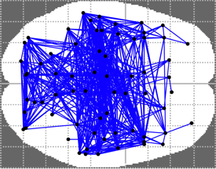 | 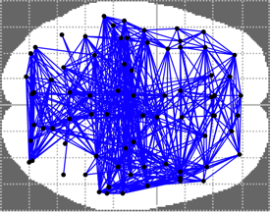
Gamma (40 Hz) | 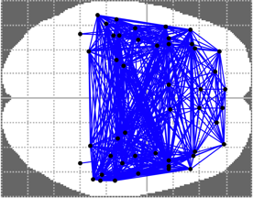 | 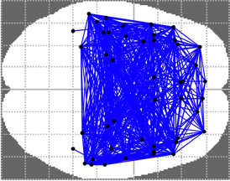 | 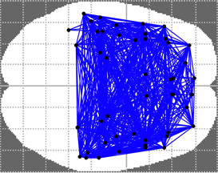
Figure S4. Orthogonalized power envelope (ORT) networks (one sample NBS t-test, 1000 permutations) in each frequency range. The t-threshold was varied across frequencies to maximize network visibility, but is the same across substances for any given frequency. The left side of the brain corresponds to the left hemisphere, and the top of the brain represents the anterior direction.

Table S1. Double-dummy design of the capsule administration
 | t0 |  | t1 (1.5h after t0) |  | t2 (2.5h after t0)
Haloperidol | Haldol® |  | Placebo |  | Onset EEG recording
L-dopa | Placebo |  | Madopar® |  | Onset EEG recording
Placebo | Placebo |  | Placebo |  | Onset EEG recording

Table S2. Brain regions included in significant networks with the number of connections within the network for delta, low-beta, and gamma for MIM.

Delta
Node-Name (according to AALA) | Number of connections
Frontal_Inf_Tri_L | 1
Frontal_Mid_L | 4
Frontal_Mid_Orb_L | 1
Frontal_Sup_L | 1
Parietal_Inf_L | 2
Postcentral_L | 3
Precentral_L | 1
SupraMarginal_R | 1

Low-Beta
Node-Name (according to AALA) | Number of connections
Cingulum_Mid_L | 1
Paracentral_Lobule_L | 1
Paracentral_Lobule_R | 1
Postcentral_L | 1
Rolandic_Oper_R | 4

Gamma
Node-Name (according to AALA) | Number of connections
Cingulum_Ant_L | 10
Cingulum_Ant_R | 3
Cingulum_Mid_R | 1
Cingulum_Post_L | 2
Frontal_Inf_Oper_L | 2
Frontal_Inf_Orb_L | 4
Frontal_Inf_Tri_L | 3
Frontal_Med_Orb_L | 6
Frontal_Med_Orb_R | 4
Frontal_Mid_L | 8
Frontal_Mid_Orb_L | 16
Frontal_Sup_L | 3
Frontal_Sup_Medial_L | 6
Frontal_Sup_Medial_R | 6
Frontal_Sup_Orb_L | 3
Fusiform_L | 3
Heschl_L | 3
Hippocampus_L | 8
Insula_L | 2
Olfactory_L | 2
Paracentral_Lobule_L | 2
Paracentral_Lobule_R | 2
Parahippocampal_L | 5
Postcentral_L | 4
Precentral_L is | 2
Rectus_L | 4
Rectus_R | 3
Rolandic_Oper_L | 3
Supp_Motor_Area_L | 1
Supp_Motor_Area_R | 1
Temp_Pole_Mid_L | 5
Temp_Pole_Sup_L | 3
Temporal_Sup_L | 1

Table S3. Brain regions included in significant networks with the number of connections within the network for alpha and low-beta for orthogonalized power envelopes.

Alpha
Node-Name (according to AALA) | Number of connections
Frontal_Inf_Oper_R | 2
Frontal_Mid_R | 1
Frontal_Sup_L | 1
Postcentral_L | 3
Precentral_L | 1
Rolandic_Oper_R | 2

Low-Beta
Node-Name (according to AALA) | Number of connections
Angular_L | 1
Cingulum_Mid_L | 8
Cingulum_Mid_R | 7
Cingulum_Post_L | 3
Cingulum_Post_R | 3
Cuneus_L | 2
Frontal_Inf_Oper_R | 15
Frontal_Inf_Orb_L | 4
Frontal_Mid_R | 11
Frontal_Sup_L | 16
Frontal_Sup_R | 3
Frontal_Sup_Medial_R | 1
Frontal_Sup_Orb_L | 1
Fusiform_L | 1
Heschl_L | 7
Heschl_R | 11
Hippocampus_L | 4
Hippocampus_R | 1
Insula_R | 13
Lingual_L | 1
Occipital_Mid_L | 2
Occipital_Sup_L | 3
Olfactory_L | 2
Olfactory_R | 2
Paracentral_Lobule_L | 6
Paracentral_Lobule_R | 4
Parahippocampal_L | 2
Parahippocampal_R | 1
Parietal_Inf_L | 6
Parietal_Inf_R | 14
Parietal_Sup_L | 6
Parietal_Sup_R | 21
Postcentral_L | 16
Postcentral_R | 11
Precentral_L | 6
Precentral_R | 16
Precuneus_L | 7
Precuneus_R | 5
Rolandic_Oper_L | 2
Rolandic_Oper_R | 17
Supp_Motor_Area_L | 11
Supp_Motor_Area_R | 6
SupraMarginal_L | 4
SupraMarginal_R | 5
Temporal_Sup_R | 2

