Supplementary Material
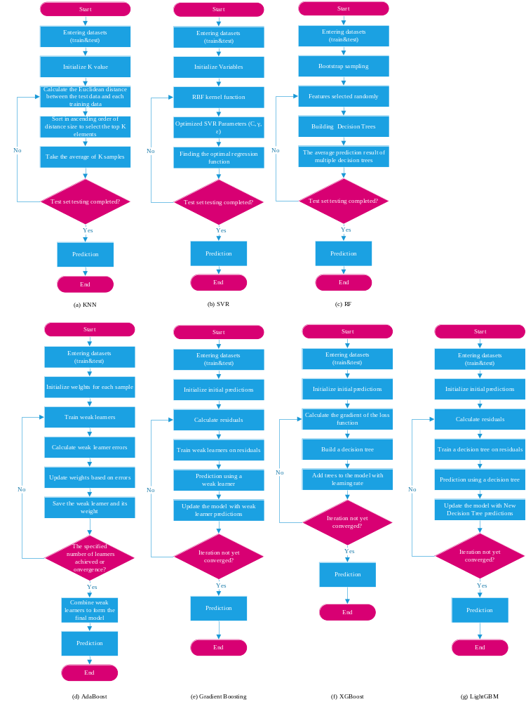
Figure S1. Flowchart of the ML models.

