Supplementary Materials
Stimulation of a ventrolateral prefrontal-amygdala circuit modulates impulsivity in Borderline Personality Disorder

Reza Tadayonnejad, M.D., Ph.D.^{ǂ,*,1,2,3}, Rani Gera, Ph.D.^{ǂ,3}, Stephanie A. Chu, B.S.^{1,2}, Hope Hawkins, B.S. ^{1,2}, Emmily Hovhannisyan, B.A.^{1,2}, Thuc Doan P. Ngo, B.A.^{1,2}, Juliana Corlier, Ph.D.^{1,2}, Andrew F. Leuchter, M.D.^{1,2}

RESULTS

Supplementary tables

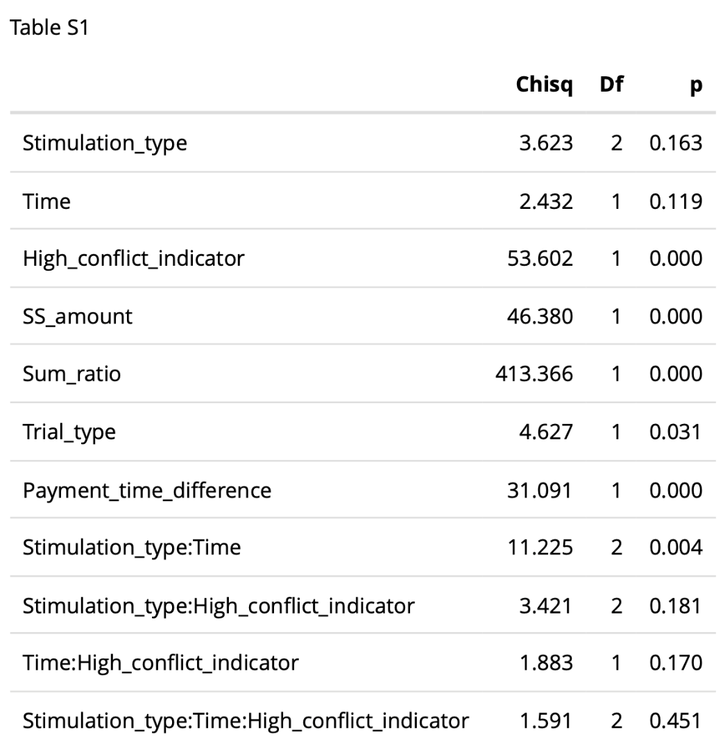
Type II Wald Chi-Square Tests for the Mixed-Effects Logistic Regression Model Predicting Intertemporal Choice Behavior.

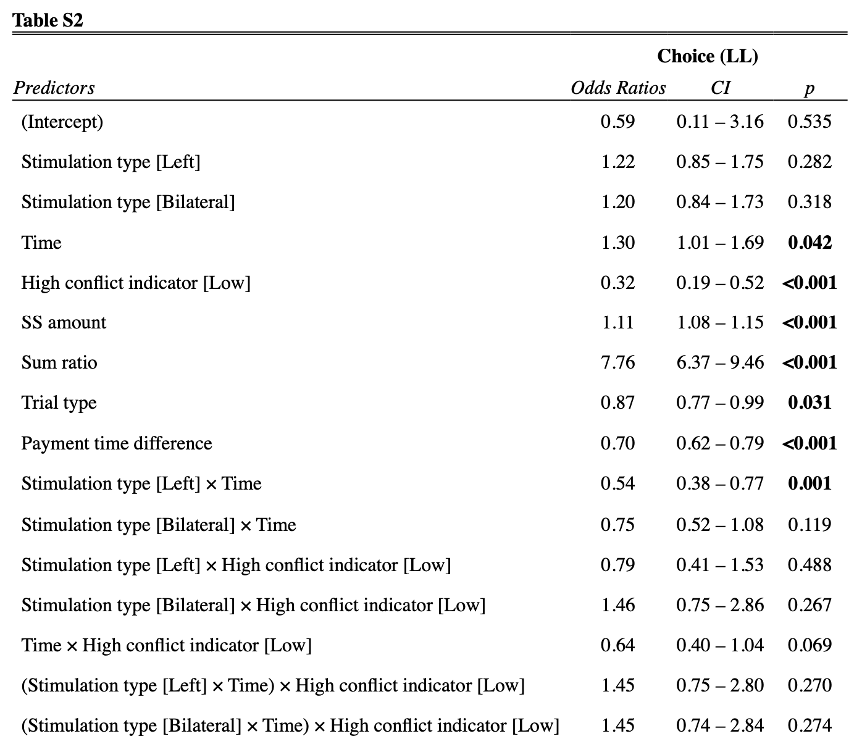
Logistic Regression Model Predicting Intertemporal Choice Behavior. Right vlPFC stimulation and High choice conflict were used as baseline levels

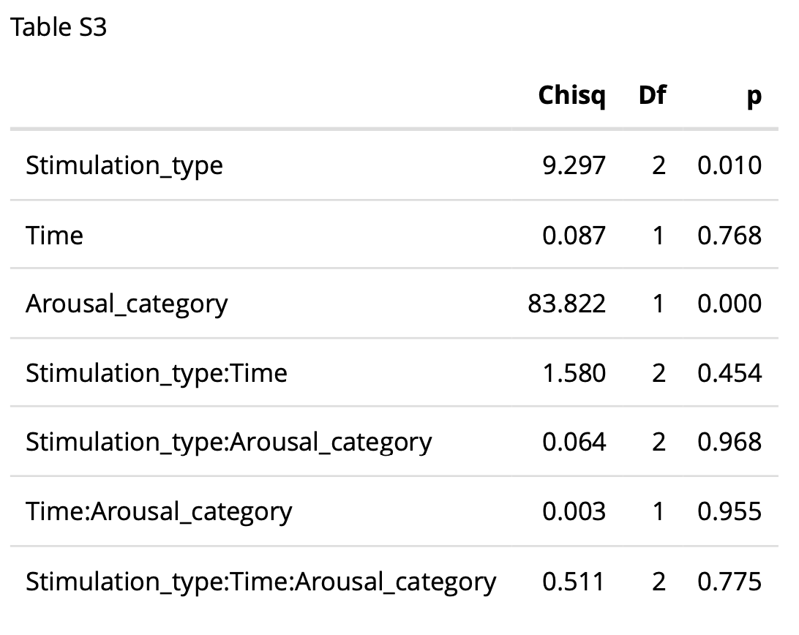
Type II Wald Chi-Square Tests for the Mixed-Effects Linear Regression Model Predicting Negativty ratings in response to social isolation images..

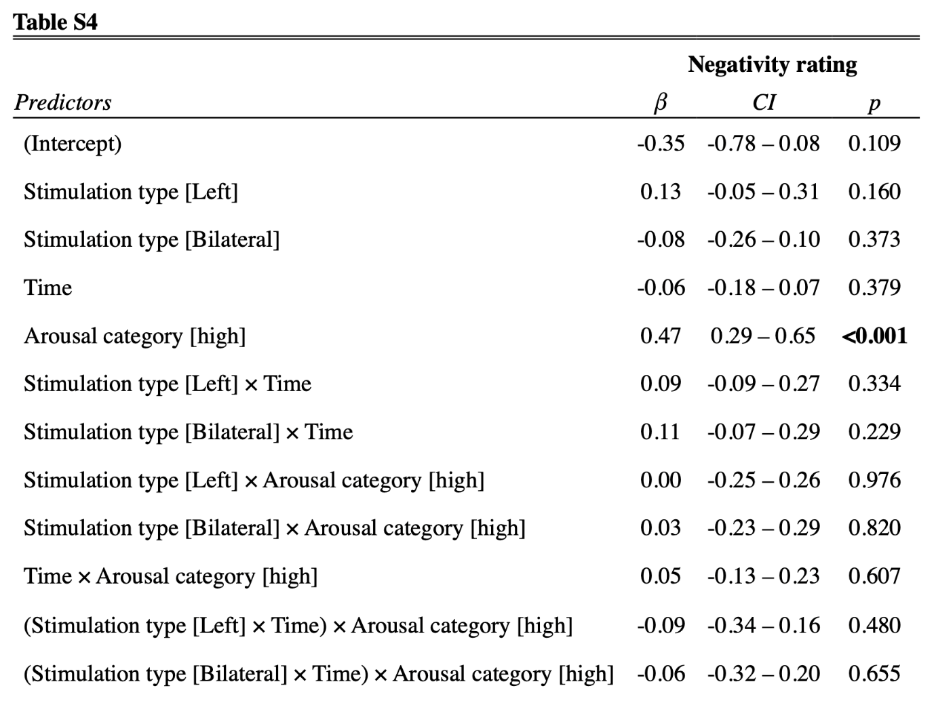
Linear Regression Model Predicting Negativty ratings in response to social isolation images. Right vlPFC stimulation and Low arousal image category used as baseline levels.

Refrence

