Supplementary Information
Interplay of oxygen vacancies and lanthanide emitters enables reversible orthogonal upconversion switching

Supplementary Table 1 | Rietveld refinement parameters for as-synthesized BiOBr:5%Er³⁺ photochromic phoshpors.
Sample | BiOBr (PDF card data) | BiOBr:Er³⁺ (Rieveld refinement data)
T | 298 K | 298 K
Space group | P4/nmm (No. 129) | P4/nmm (No. 129)
a (Å) | 3.926 | 3.921
b (Å) | 3.926 | 3.921
c (Å) | 8.103 | 8.101
V (Å³) | 124.90 | 124.55
Z | 2 | 2
R_{wp} (%) | - | 10.21
R_{p} (%) | - | 7.95
χ² | - | 2.31

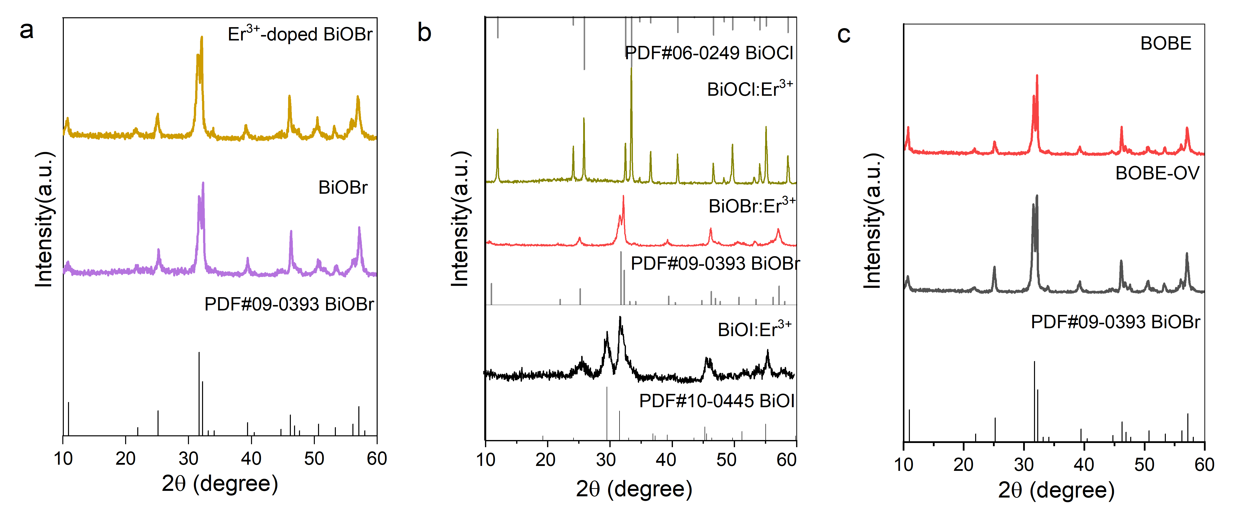
Supplementary Fig. 1 | XRD patterns of the undoped and Er³⁺-doped BiOBr samples (a), BiOX:Er³⁺ (X = Cl, Br and I) products (b), and Ovs-rich BiOBr:Er³⁺ (BOBE-OV) and Ovs-free BiOBr:Er³⁺ (BOBE) samples (c).

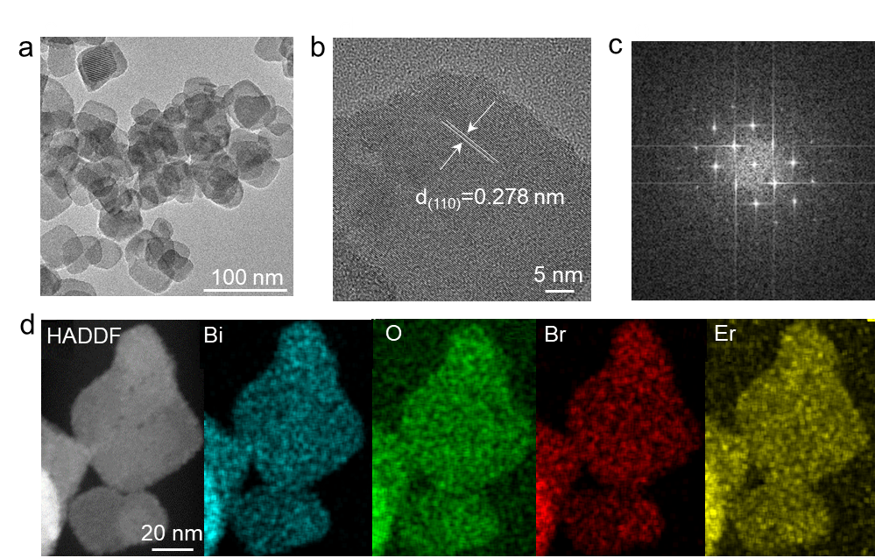
Supplementary Fig. 2 | TEM image (a), HRTEM image (b), SAED pattern (c) and EDX elemental mapping (d) of Ovs-rich BiOBr:Er³⁺ nanoparticles.

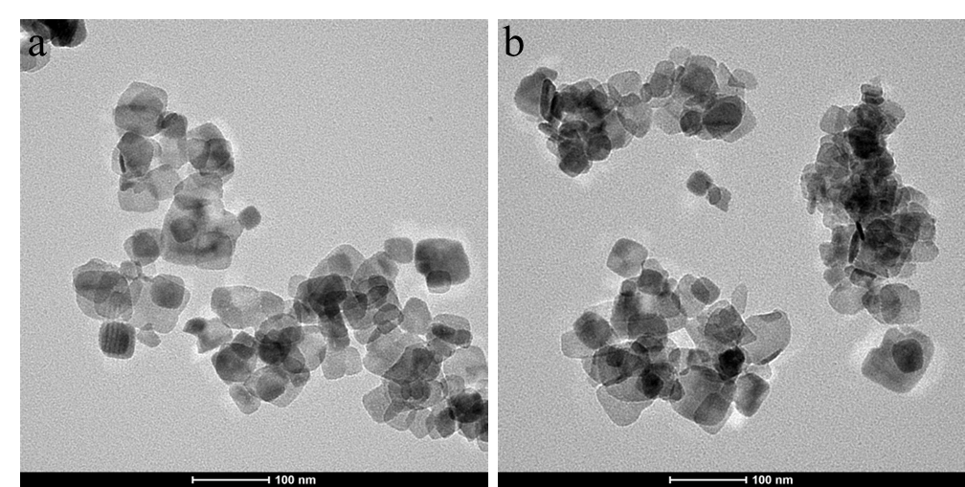
Supplementary Fig. 3 | TEM images of BiOCl:Er³⁺ (a) and BiOI:Er³⁺ (b) samples.

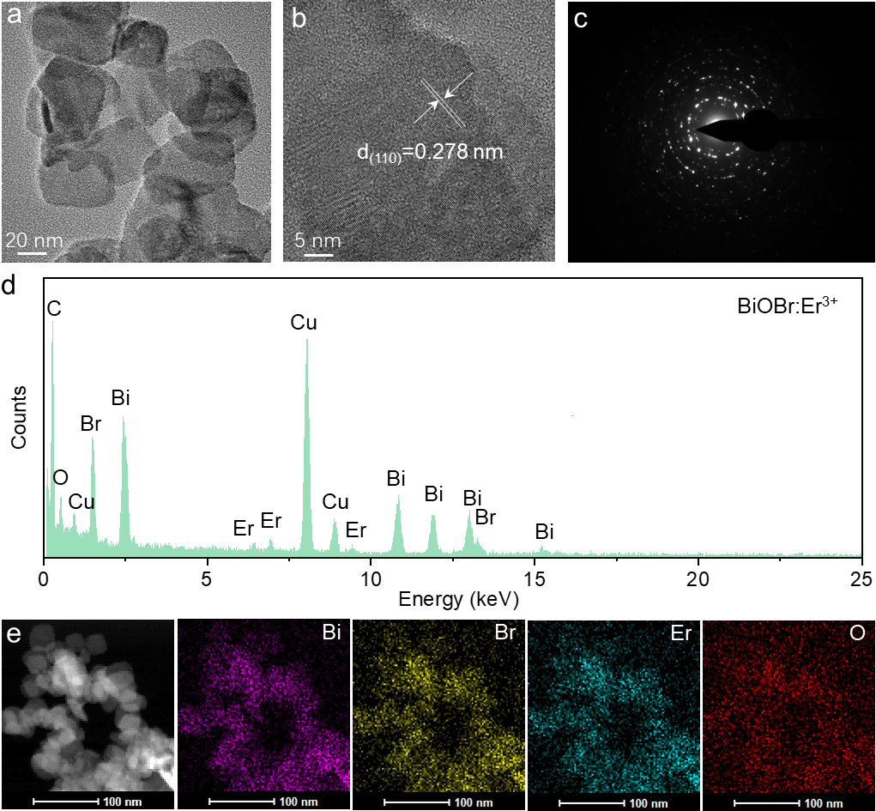
Supplementary Fig. 4 | TEM image (a), HRTEM image (b), SAED pattern (c), EDX spectrum, and elemental mapping of Er³⁺-doed BiOBr sample (without oxygen vacancies, denoted as BOBE).

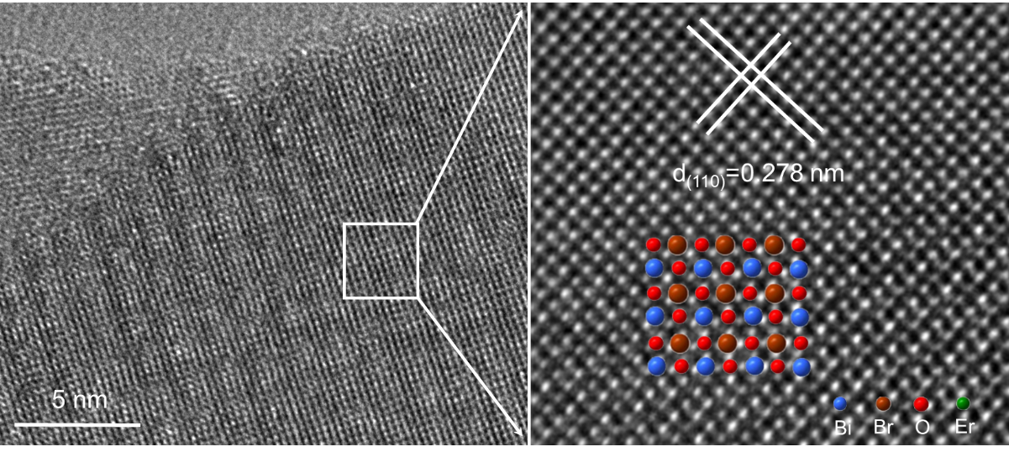
Supplementary Fig. 5 | Atomic-resolution HADDF-STEM iamge of BOBE sample.

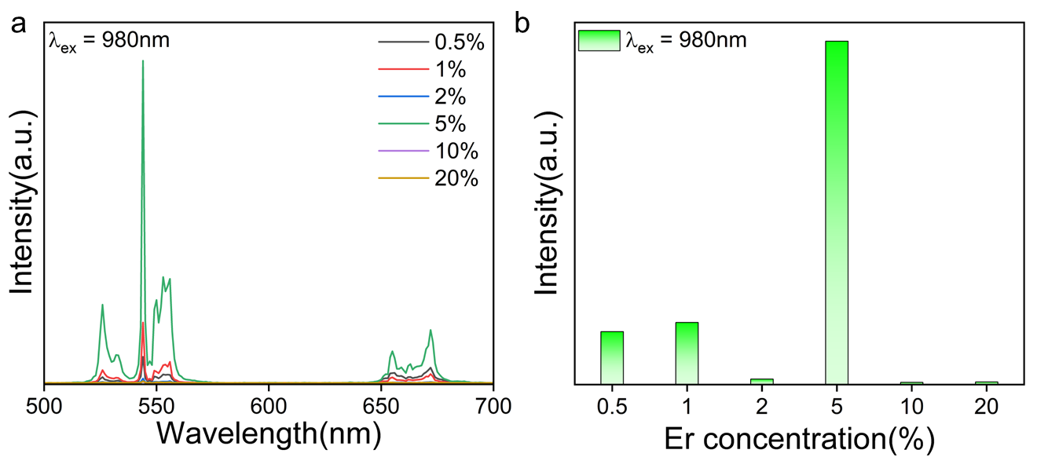
Supplementary Fig. 6 | UC emission spectra of BiOBr:x%Er³⁺ samples under the excitation of 980 nm laser (a) and the corresponding emission intensity versus Er³⁺ dopant concentration (b).

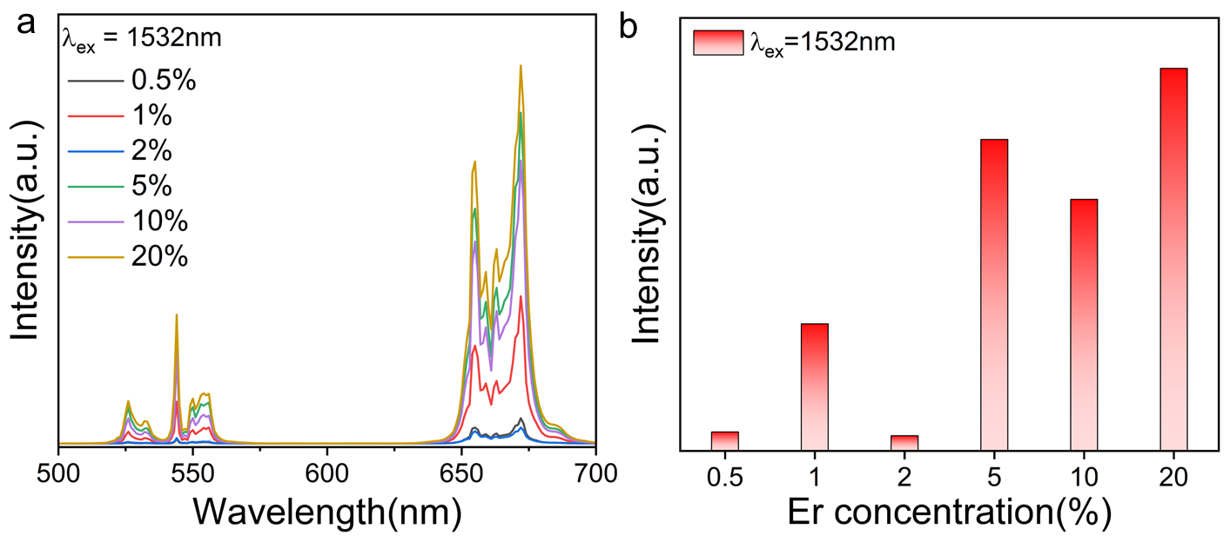
Supplementary Fig. 7 | UC emission spectra of BiOBr:x%Er³⁺ samples under the excitation of 1532 nm laser (a) and the corresponding emission intensity versus Er³⁺ dopant concentration (b).

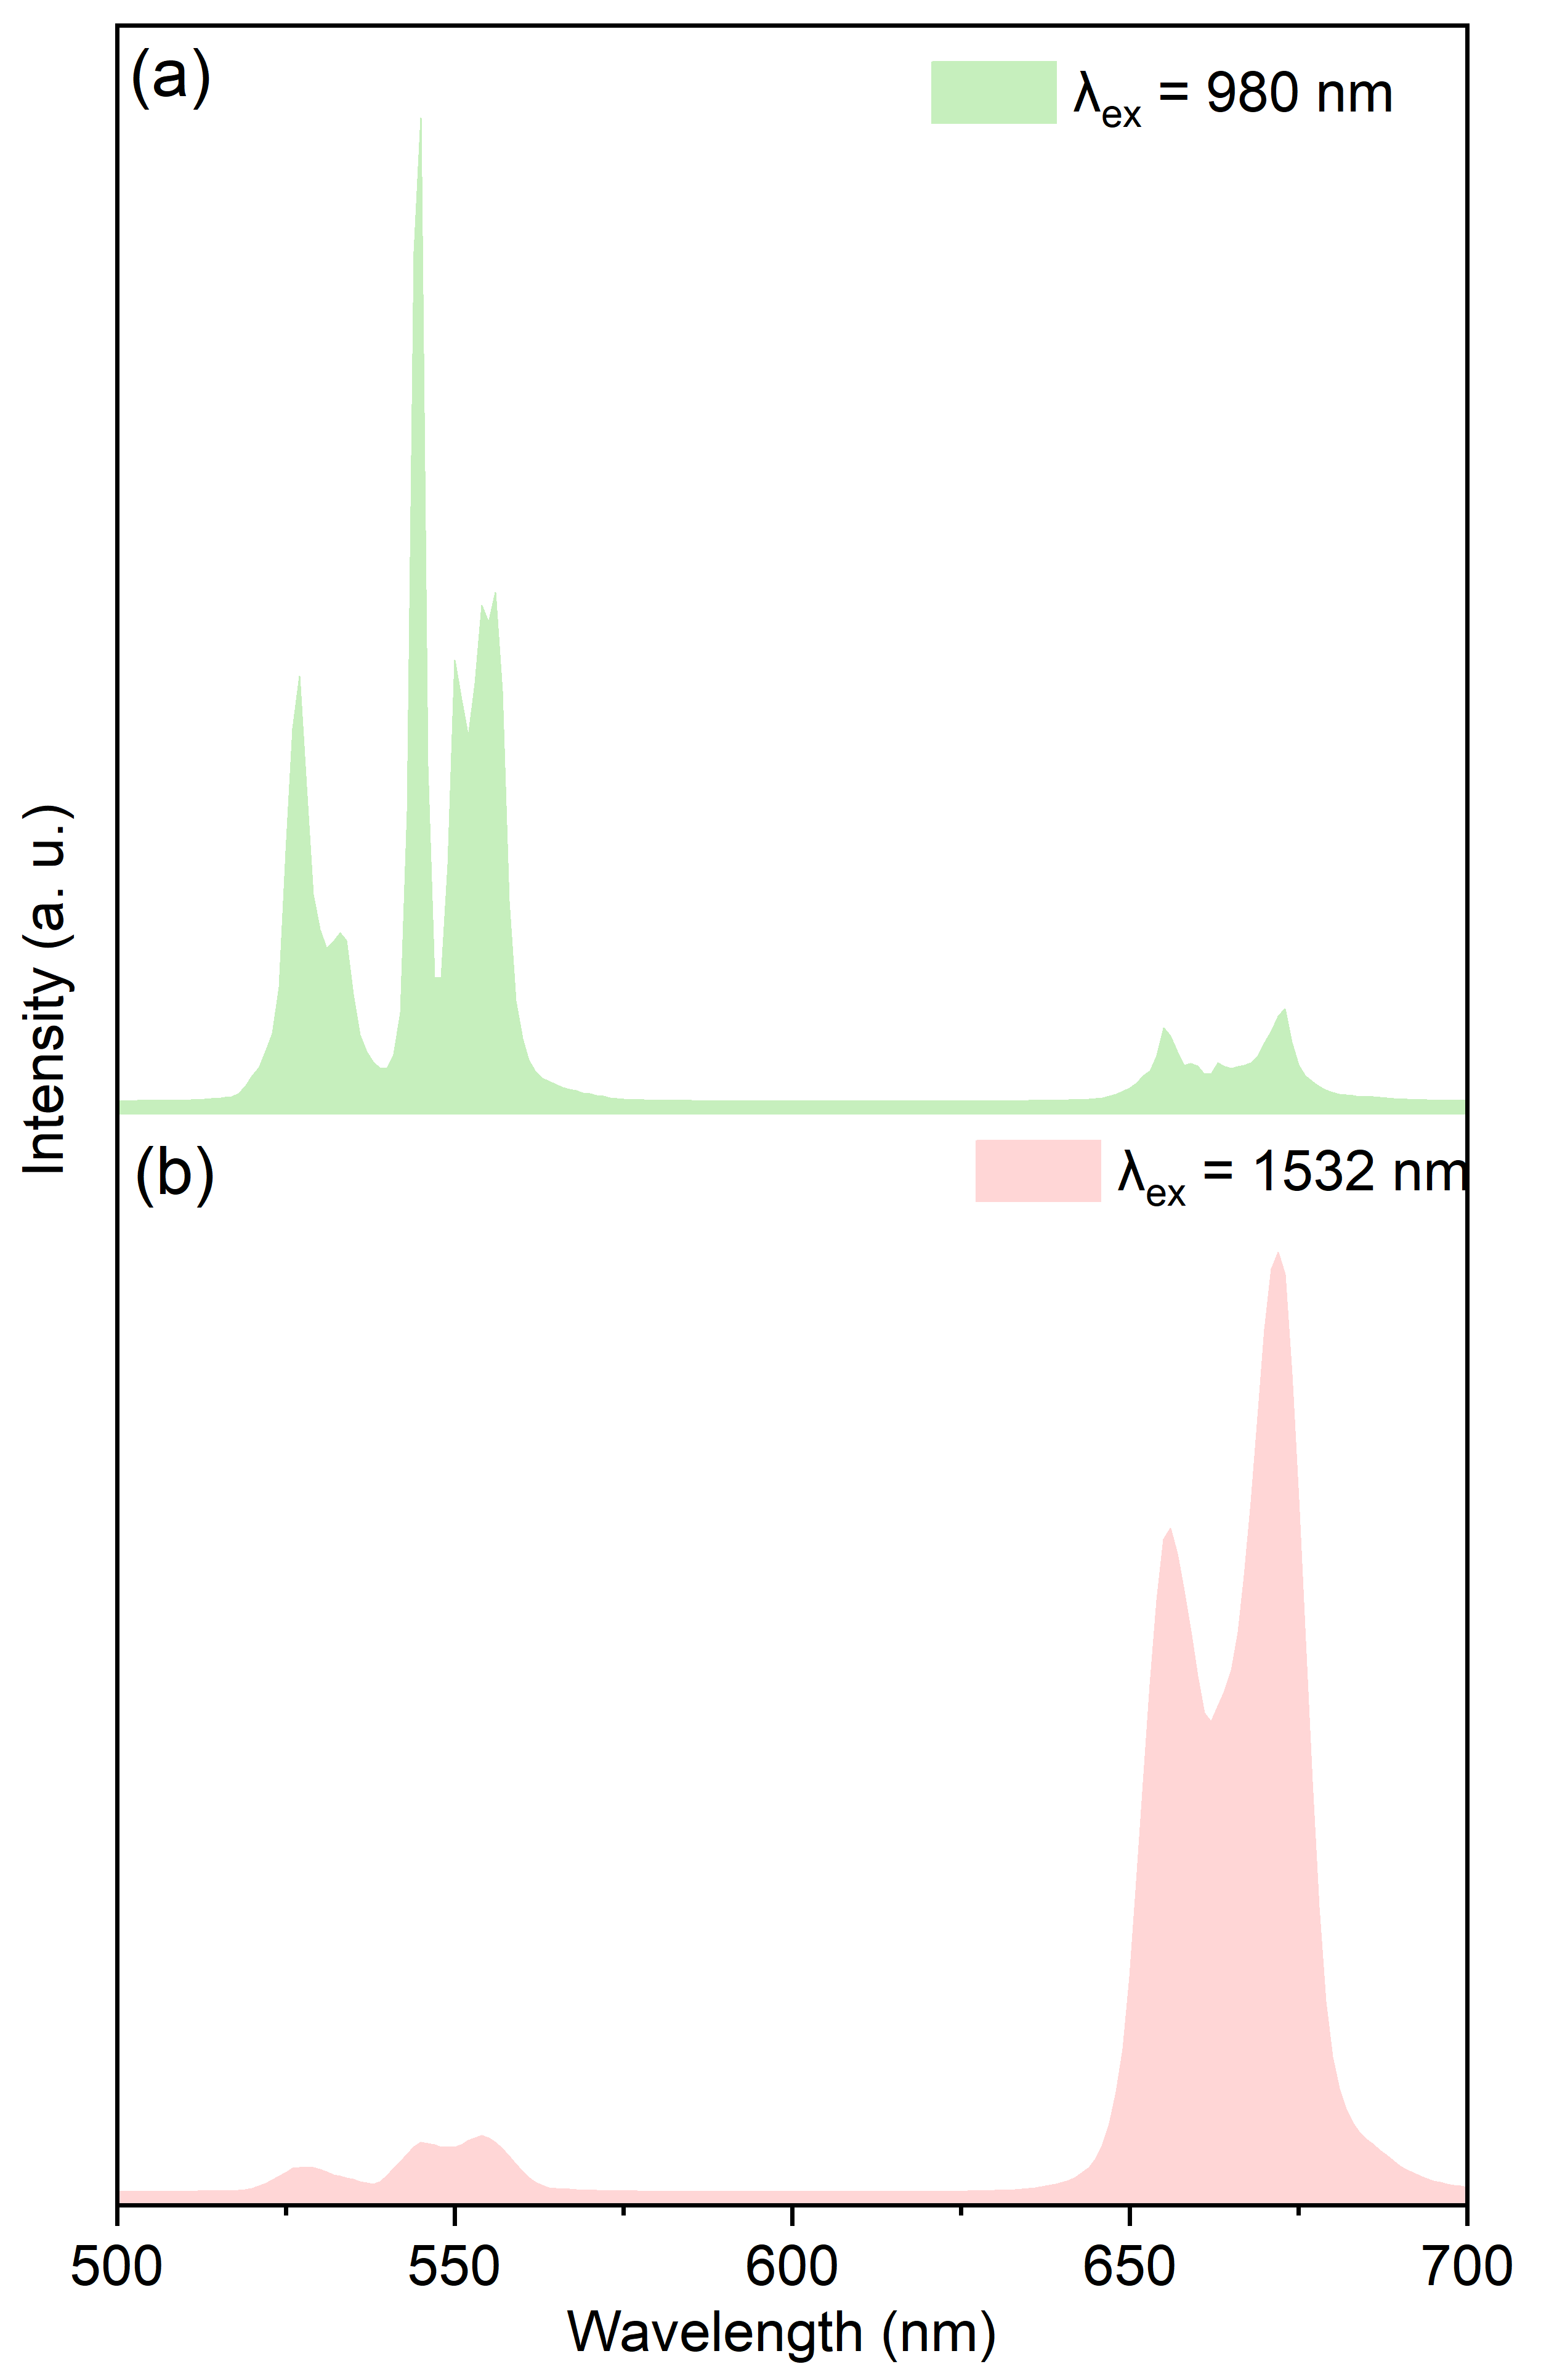
Supplementary Fig. 8 UC emission spectra of Ovs-free BOBE under the excittaion of 980 nm (a) or 1532 nm (b) NIR laser.

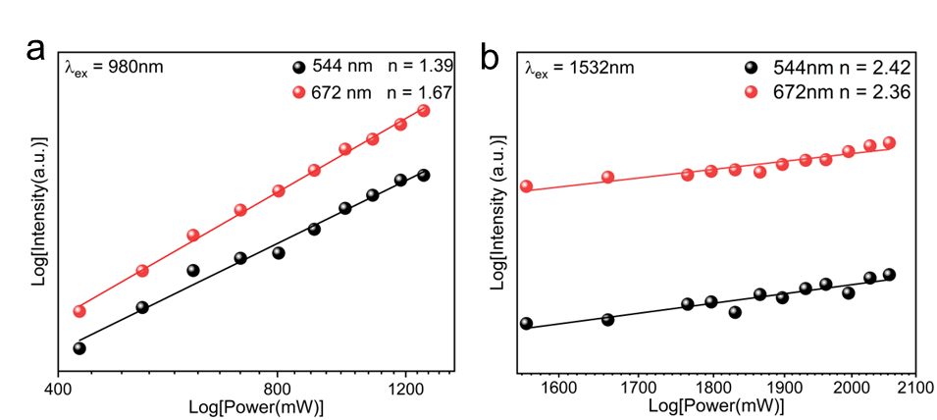
Supplementary Fig. 9 | Double logarithmic plots of green (544 nm) and red (672 nm) emission intensities verse excitation power under different excitation light: (a) 980 nm, (b) 1532 nm.

Supplementary Text S1
Modeling the UC luminescent processes excited by 980 nm or 1532 nm
To verify and make a theoretical illustration of orthogonal UC luminescence with different color outputs, we use the following steady-state rate equations based on the proposed UC processes.
- Green-emitting UC luminescence excited by 980 nm laser
As shown in Supplementary Fig. 10, the simplified rate euqations for 980 nm-excited UC luminescence are provided as follows¹⁻³.
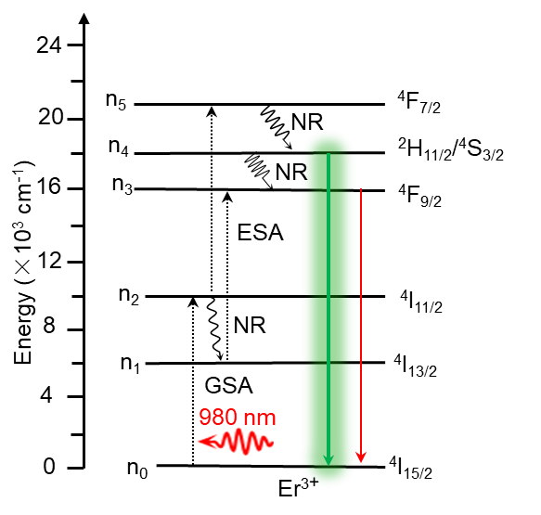
Supplementary Fig. 10 | Energy level diagrams of Er³⁺ ions as well as the proposed UC mechanism in Er³⁺-doepd system under the excitation of 980 nm laser.

Er³⁺ (⁴I_{15/2}): $\frac{dn_{0}}{dt}=ω_{4}n_{4}+ω_{3}n_{3}-ρδ_{0}n_{0}$ (1)
Er³⁺ (⁴I_{13/2}): $\frac{dn_{1}}{dt}=β_{2}n_{2}-ω_{1}n_{1}-ρδ_{1}n_{1}$ (2)
Er³⁺ (⁴I_{11/2}): $\frac{dn_{2}}{dt}=ρδ_{0}n_{0}-ω_{2}n_{2}-β_{2}n_{2}-ρδ_{2}n_{2}$ (3)
Er³⁺ (⁴F_{9/2}): $\frac{dn_{3}}{dt}=ρδ_{1}n_{1}+β_{4}n_{4}-ω_{3}n_{3}$ (4)
Er³⁺ (²H_{11/2}/⁴S_{13/2}): $\frac{dn_{4}}{dt}=β_{5}n_{5}-β_{4}n_{4}{-ω}_{4}n_{4}$ (5)
Er³⁺ (⁴F_{7/2}): $\frac{dn_{5}}{dt}=ρδ_{2}n_{2}-β_{5}n_{5}{-ω}_{5}n_{5}$ (6)
$n_{0}=n_{1}+n_{2}+n_{3}+n_{4}$ $+n_{5}$ (7)
$\frac{dn_{0}}{dt}=\frac{dn_{1}}{dt}=\frac{dn_{2}}{dt}=\frac{dn_{3}}{dt}=\frac{dn_{4}}{dt}=\frac{dn_{5}}{dt}=0$ (8)
Where ρ is the laser photon number desity, and δ_{i} denotes the absoprtion cross section for the level i under the 980 nm laser excitation. n_{i} and ω_{i} (i = 0 to 5) are the population densities and the intrinsic decay rates of the ⁴I_{15/2} (i = 0), ⁴I_{13/2} (i = 1), ⁴I_{11/2} (i = 2), ⁴F_{9/2} (i = 3), ²H_{11/2}/⁴S_{3/2} (i = 4) and ⁴F_{7/2} (i = 5) states of Er³⁺, respectively. β_{i} represents the nonradiative transition rates of the ⁴F_{7/2} (i = 5), ²H_{11/2}/⁴S_{3/2} (i = 4) and ⁴I_{11/2} (i = 2) levels. Combined with the above rate equations (eq. 1-8), the population densities of each energy state of Er³⁺ ions can be estimated according to the following equations:
n₁ = $\frac{ρδ_{0}n_{0}β_{2}}{{(ω}_{2}+β_{2}+ρδ_{2}){(ω}_{1}+ρδ_{1})}$ (9)
n₂ = $\frac{ρδ_{0}n_{0}}{ω_{2}+β_{2}+ρδ_{2}}$ (10)
n₃ = $\frac{ρδ_{0}n_{0}}{ω_{2}+β_{2}+ρδ_{2}}$ (11)
n₄ = $\frac{ρ^{2}δ_{0}{δ_{1}n}_{0}β_{5}}{{(ω}_{2}+β_{2}+ρδ_{2})(β_{5}+ω_{5})(β_{4}+ω_{4})}$ (12)
n₅ = $\frac{ρ^{2}δ_{0}{δ_{1}n}_{0}}{{(ω}_{2}+β_{2}+ρδ_{2})(β_{5}+ω_{5})}$ (13)
Based on eq (11) and (12), we can obtain the mathematical expression of R/G intensity ratio:
$\frac{I_{red}}{I_{green}}= \frac{{{ν_{red}ω}_{3}n}_{3}}{ν_{green}ω_{4}n_{4}}=\frac{\frac{{ν_{red}ω}_{3}ρδ_{0}n_{0}}{ω_{2}+β_{2}+ρδ_{2}}}{\frac{ν_{green}ω_{4}ρ^{2}δ_{0}{δ_{1}n}_{0}β_{5}}{{(ω}_{2}+β_{2}+ρδ_{2})(β_{5}+ω_{5})(β_{4}+ω_{4})} }= \frac{{ν_{red}ω}_{3}(β_{5}+ω_{5})(β_{4}+ω_{4})}{ν_{green}ω_{4}ρδ_{1}β_{5}}$ (14)
Becasue $w_{5} ≪β_{5}$, $β_{4} ≪w_{4}$, the above equation could be derived as follows:
$\frac{I_{red}}{I_{green}}= \frac{{ν_{red}ω}_{3}(1+\frac{ω_{5}}{β_{5}})(\frac{β_{4}}{w_{4}}+1)}{ν_{green}ρδ_{1}}≈\frac{{ν_{red}ω}_{3}}{ν_{green}ρδ_{1}}$ (15)
According to the eq (15), the R/G ratio is positively correlated with the value of $ω$₃. As a result, the enhanced green UC emissions is originated from the decreased decay rate of Er³⁺: ⁴F_{9/2} state.
- Red-emitting UC luminescence excited by 1532 nm laser
According to the proposed UC processes upon 1532 nm laser excitation (Supplementary Fig. 11), the corresponding rate equations are derived as follows^{4,5}:
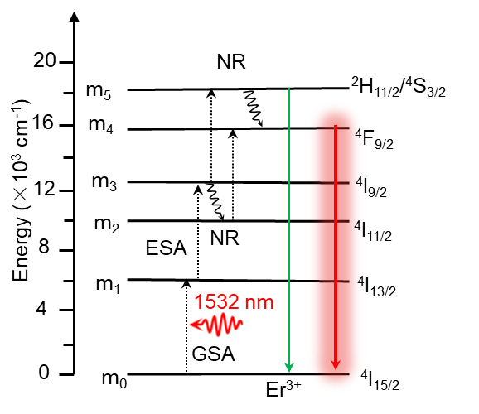
Supplementary Fig. 11 | Energy level diagrams of Er³⁺ ions as well as the proposed UC mechanism in Er³⁺-doepd system under the excitation of 1532 nm laser.

Er³⁺ (⁴I_{15/2}): $\frac{dm_{0}}{dt}=w_{4}m_{4}+w_{5}m_{5}-ρσ_{0}m_{0}$ (16)
Er³⁺ (⁴I_{13/2}): $\frac{dm_{1}}{dt}=ρσ_{0}m_{0}-w_{1}m_{1}-ρσ_{1}m_{1}$ (17)
Er³⁺ (⁴I_{11/2}): $\frac{dm_{2}}{dt}=α_{3}m_{3}-w_{2}m_{2}-ρσ_{2}m_{2}$ (18)
Er³⁺ (⁴I_{9/2}): $\frac{dm_{3}}{dt}=ρσ_{1}m_{1}-α_{3}m_{3}-ρσ_{3}m_{3}-w_{3}m_{3}$ (19)
Er³⁺ (⁴F_{9/2}): $\frac{dm_{4}}{dt}=ρδ_{2}m_{2}+α_{5}m_{5}-w_{4}m_{4}$ (20)
Er³⁺ (²H_{11/2}/⁴S_{13/2}): $\frac{dn_{4}}{dt}=ρσ_{3}m_{3}-α_{5}m_{5}{-w}_{5}m_{5}$ (21)
$n_{0}=n_{1}+n_{2}+n_{3}+n_{4}$ $+n_{5}$ (22)
$\frac{dn_{0}}{dt}=\frac{dn_{1}}{dt}=\frac{dn_{2}}{dt}=\frac{dn_{3}}{dt}=\frac{dn_{4}}{dt}=\frac{dn_{5}}{dt}=0$ (23)
Where ρ is the laser photon number density, and σ_{i} is the absorption cross section under the 1532 nm excitation. m_{i} and w_{i} (i = 0 to 5) denote the population densities and the intrinsic decay rates of the ⁴I_{15/2} (i = 0), ⁴I_{13/2} (i = 1), ⁴I_{11/2} (i = 2), ⁴I_{9/2} (i = 3), ⁴F_{9/2} (i = 4), and ²H_{11/2}/⁴S_{3/2} (i = 5) states of Er³⁺, respectively. α_{i} represents the nonradiative transition rates of the ²H_{11/2}/⁴S_{3/2} (i = 5) and ⁴I_{9/2} (i = 3) levels. Based on the above rate equations (eq. 15-22), the population densities of each energy state of Er³⁺ can be calculated as follows:
m₁ = $\frac{ρσ_{0}m_{0}}{w_{1}+ρσ_{1}}$ (24)
m₂ = $\frac{ρ^{2}σ_{1}σ_{0}m_{0}α_{3}}{{(α}_{3}+w_{3}+ρσ_{3})(w_{1}+ρσ_{1})(w_{2}+ρσ_{2})}$ (25)
m₃ = $\frac{ρ^{2}σ_{1}σ_{0}m_{0}}{{(α}_{3}+w_{3}+ρσ_{3})(w_{1}+ρσ_{1})}$ (26)
m₄ = $\frac{-w_{5}ρ^{3}σ_{1}σ_{0}σ_{3}m_{0}}{{w_{4}(α}_{3}+w_{3}+ρσ_{3})(w_{1}+ρσ_{1}){(α}_{5}+w_{5})}+\frac{ρσ_{0}m_{0}}{w_{4}}$ (27)
m₅ = $\frac{ρ^{3}σ_{1}σ_{0}σ_{3}m_{0}}{{(α}_{3}+w_{3}+ρσ_{3})(w_{1}+ρσ_{1}){(α}_{5}+w_{5})}$ (28)
According to eq (26) and (27), we can obtain the mathematical expression of R/G intensity ratio:
$\frac{I_{red}}{I_{green}}= \frac{{{ν_{red}w}_{4}m}_{4}}{ν_{green}w_{5}m_{5}}=-\frac{ν_{red}}{ν_{green} }+\frac{{ν_{red}(α}_{3}+w_{3}+ρσ_{3})(w_{1}+ρσ_{1}){(α}_{5}+w_{5})}{{ν_{green}ρ}^{2}σ_{1}σ_{3}w_{5} }≈\frac{ν_{red}α_{5}}{ν_{green}w_{5}}$ (29)
Thus, the R/G ratio in the eq (28) is mainly determined by the value of $α_{5}$/$w$₅. Consequently, the enhanced red UC luminescence in 1532 nm-excited processes can be attributed to the increase of nonraditiave rates for the ²H_{11/2}/⁴S_{3/2} → ⁴F_{9/2} transition and the suppressed decay rate of Er³⁺: ²H_{11/2}/⁴S_{3/2} levels, which is significantly different from that of 980 nm-excited UC processes.

Supplementary Text S2
To further investigate the underlying UC luminescent mechanism, the excitation-power-dependent emission behavior is investigated and shown in Supplementary Fig. 9. Generally, the relationship between laser power (P) and UC emission intensity (I_{UC}) accords with the following formula: Log(I_{uc}) = n*log(P) + constant, where n denotes the number of required photons for the realization of UC process⁷. Both green and red UC emissions are two-photon processes under the excitation of 980 nm laser, which involves three-photon processes upon 1532 nm laser excitation. These results demonstrate that the electronic transitions of Er³⁺ ions are significantly dependent on the pump wavelength. The schematic energy level diagram of Er³⁺ ions and the proposed UC mechanism are displayed in Fig. 3c and Supplementary Fig. 10-11, respectively⁸⁻¹⁰. Under the excitation of 980 nm or 1532 nm laser, Er³⁺ ions could be pumped to the first excited state (⁴I_{11/2} or ⁴I_{13/2}) via ground state absorption (GSA), then is excited to excited levels (⁴F_{7/2}, ²H_{11/2}, ⁴F_{9/2}) by continuously absorbing one or two photons (excited state absorption, ESA). Through nonradiative relaxation (NR) process, the electrons at ⁴F_{7/2}, ²H_{11/2} and ⁴S_{3/2} levels relax to green-emitting levels (²H_{11/2}/⁴S_{3/2}) and red-emitting state (⁴F_{9/2}), following by the radiative transitions (²H_{11/2}/⁴S_{3/2} → ⁴I_{15/2} and ⁴F_{9/2} → ⁴I_{15/2}). The excitation of 980 nm laser benefits the population of green-emitting states ²H_{11/2}/⁴S_{3/2}, while 1532 nm pump wavelength may be profit for the population of red-emitting level ⁴F_{9/2}, resulting in the realization of orthogonal UC emission of Er³⁺ ions in non-core-shell BiOBr host under different excitation wavelength.
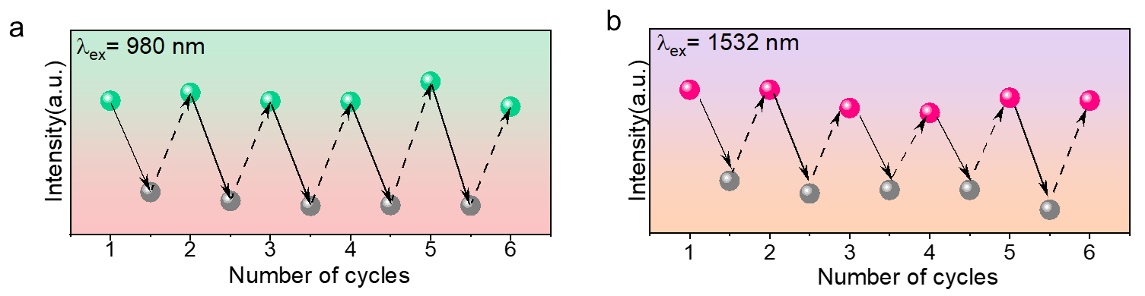
Supplementary Fig. 12 | UC luminescent intensities at 544 nm (a) and 672 nm (b) for coloration and decoloration processes as a function of cycle numbers.

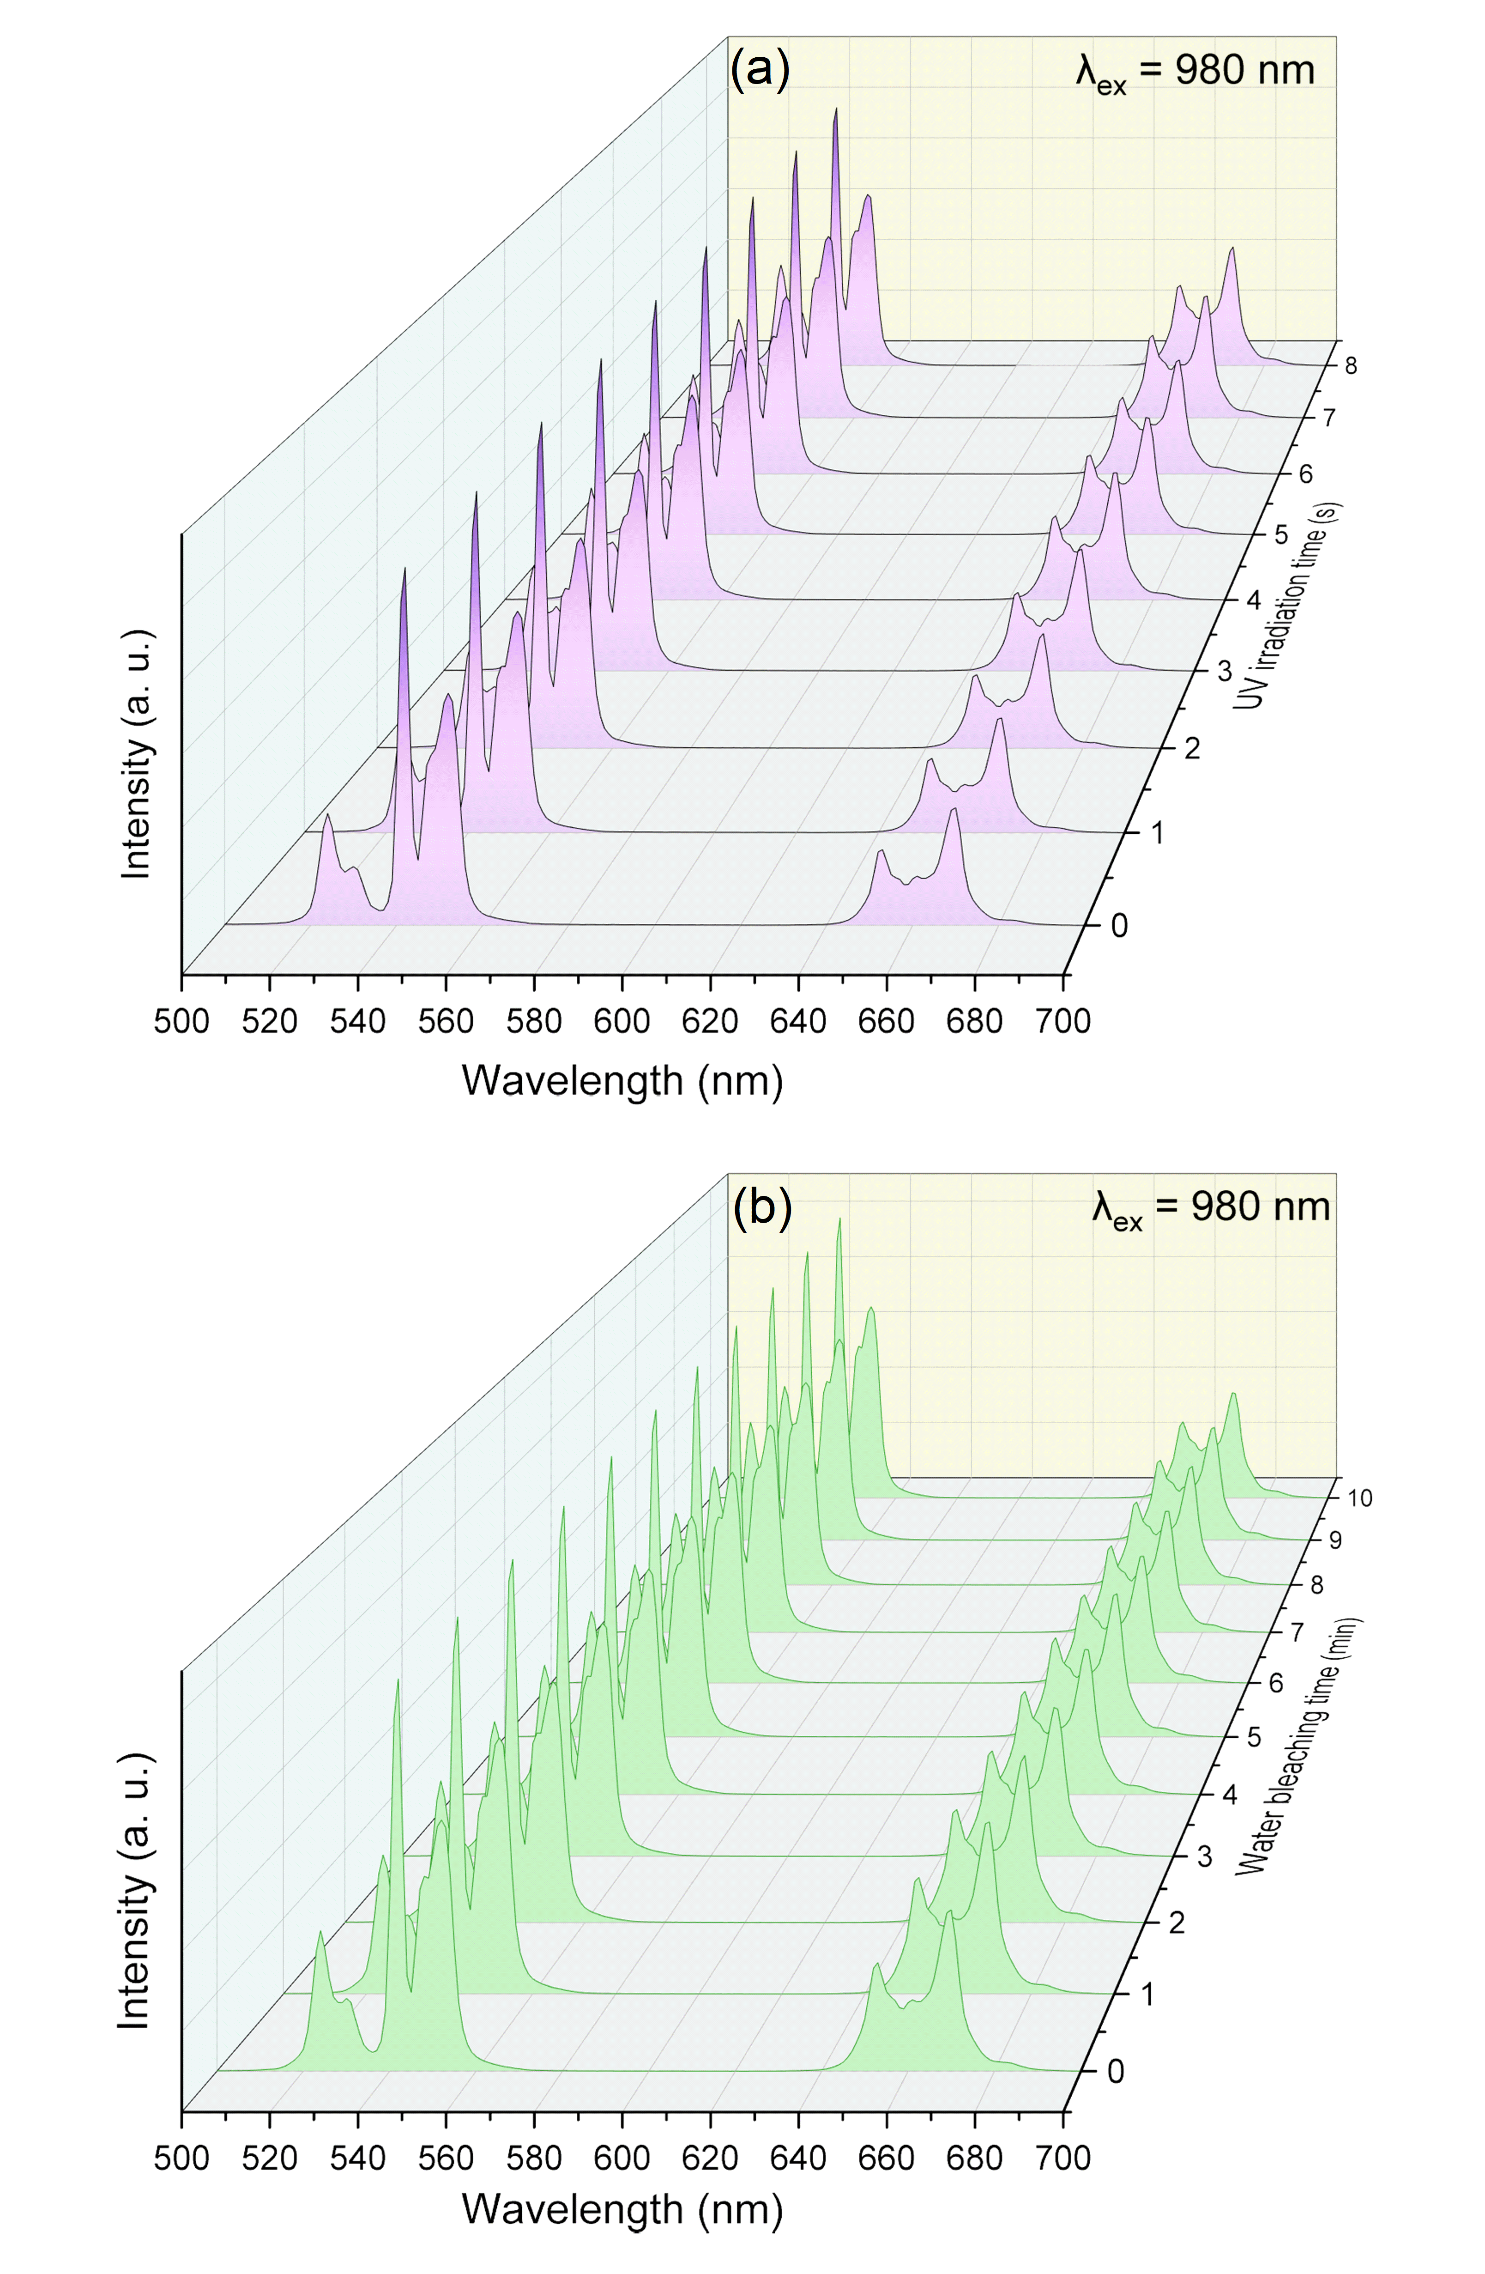
Supplementary Fig. 13 | Real-time UC modification of Ovs-free BOBE upon 980 nm laser excitation by implementing 391 nm UV irradiation of different durations (a) and water bleaching under different duration times (b).

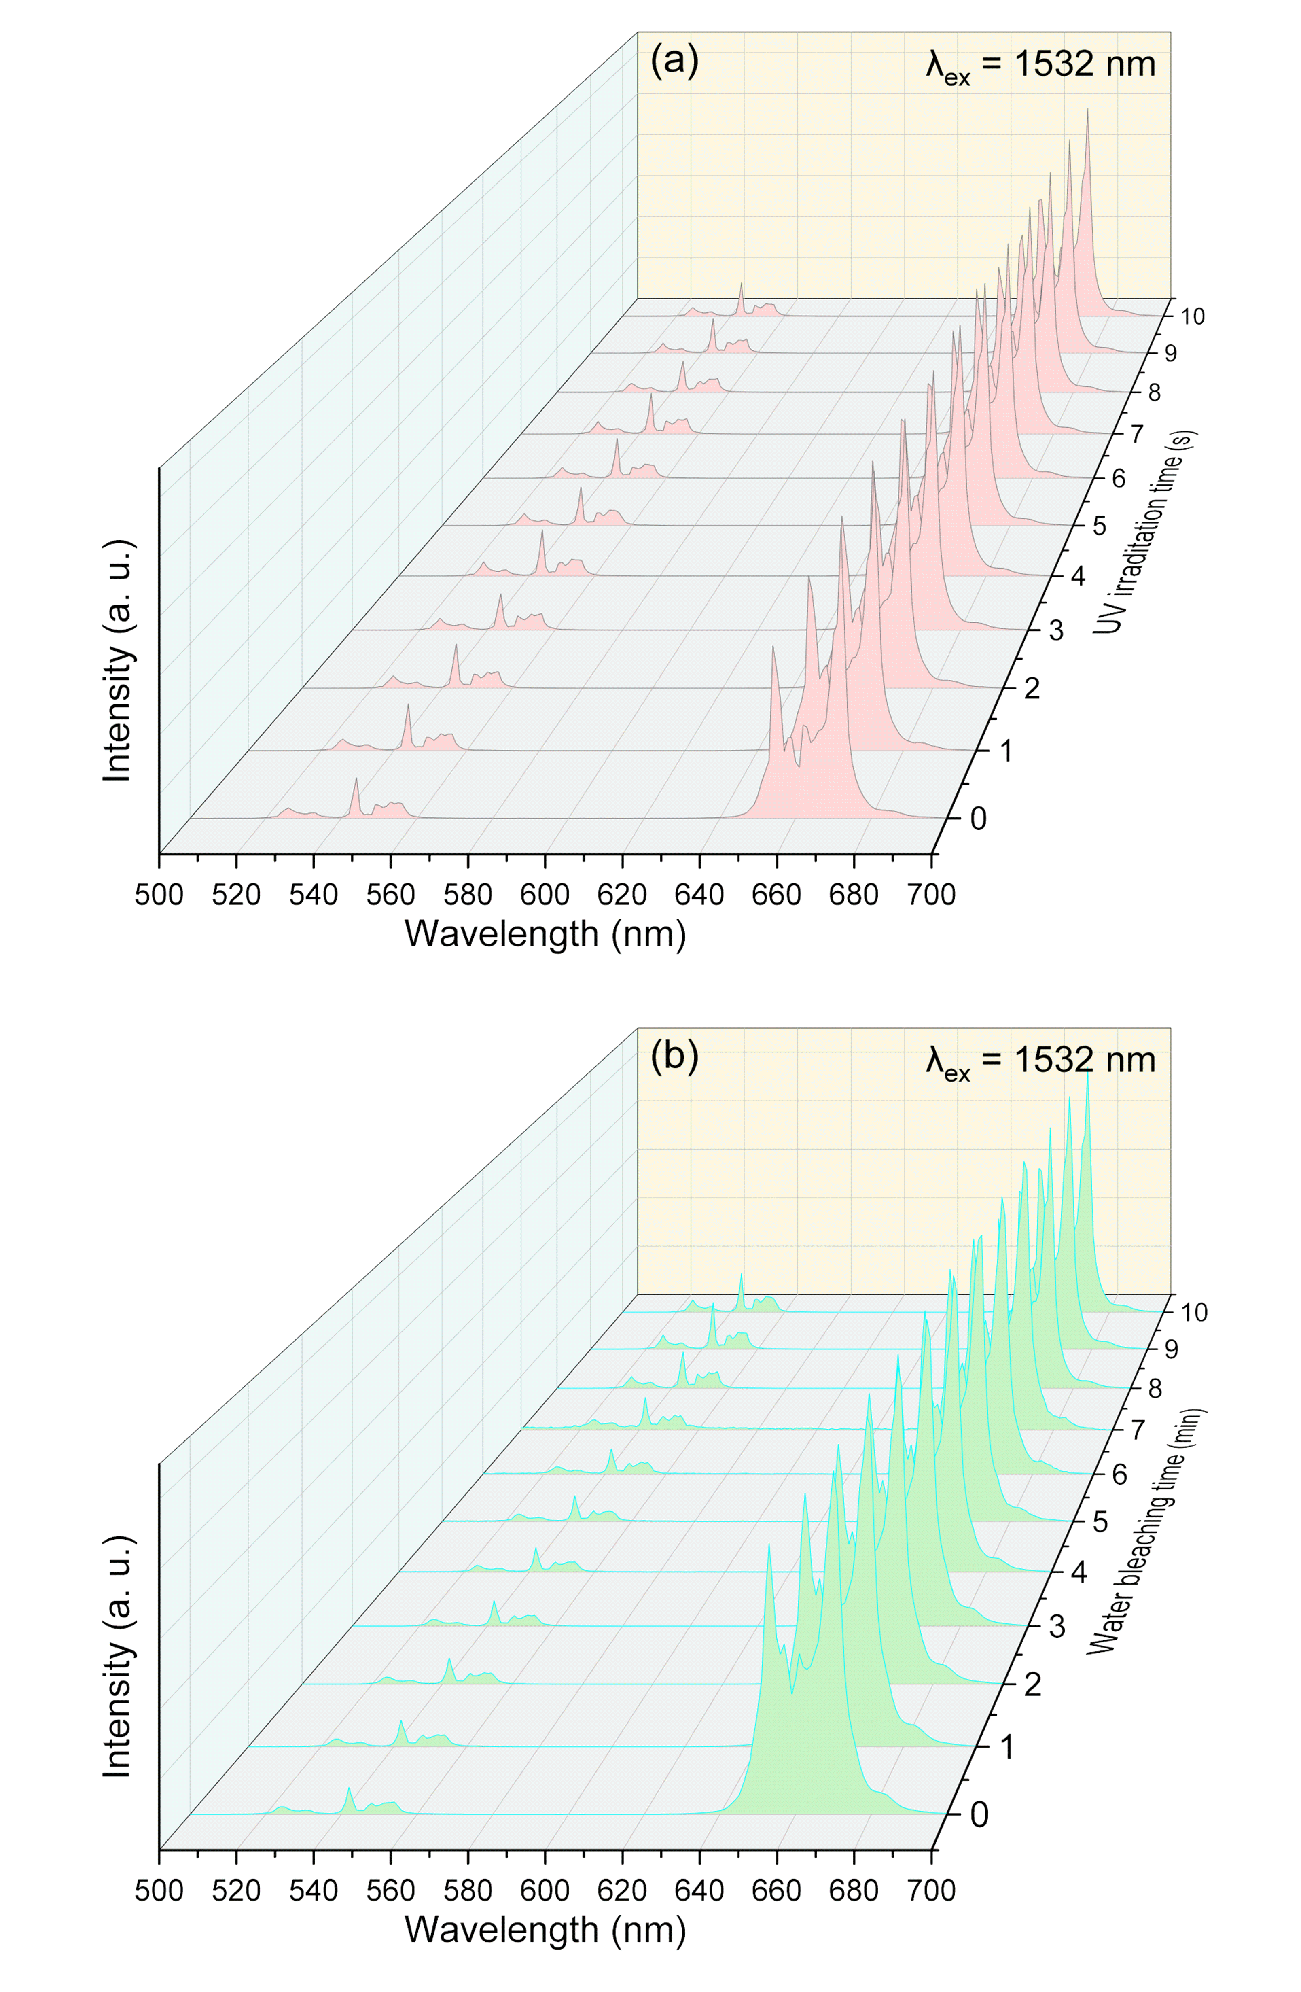
Supplementary Fig. 14 | Real-time modulation of 1532 nm-excited UC luminescence for Ovs-deficient BOBE sample under 391 nm UV illumination for different time (a) and after water bleaching with different duration times (b).

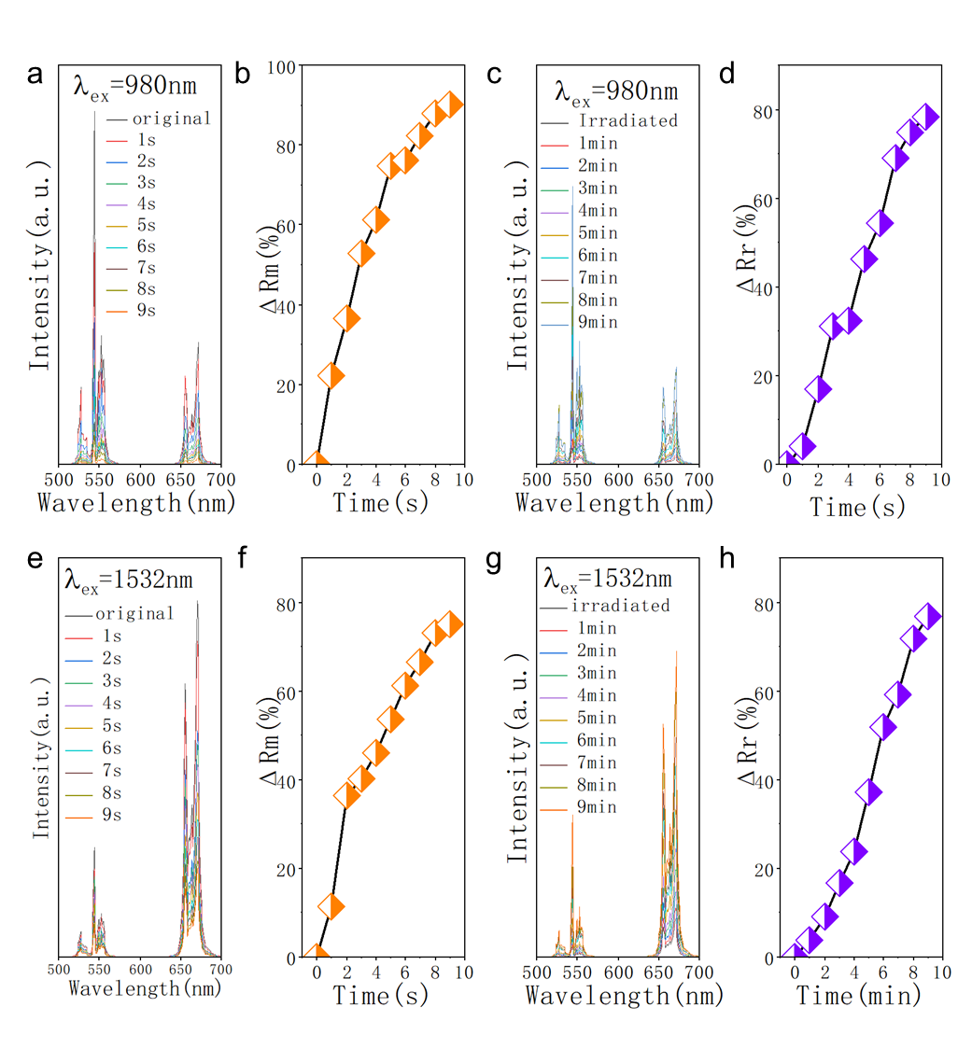
Supplementary Fig. 15 | Reversible UC emission modulation in BiOCl:Er³⁺ sample by photochromism and water bleaching. Modification of 980 nm-excited UC emission spectra (a) and the corresponding modulation degree (b) for BiOBr:Er³⁺ sample under 391 nm UV irradiation for different durations. Recovery of 980 nm-excited UC emission spectra (c) and the corresponding modulation degree (d) for BiOCl:Er³⁺ sample via water bleaching under different duration times. Modification of 1532 nm-excited UC emission spectra (e) and the corresponding modulation degree (f) for BiOCl:Er³⁺ sample under 391 nm UV irradiation for different duration times. Recovery of 1532 nm-excited UC emission spectra (g) and the corresponding modulation degree (h) for BiOCl:Er³⁺ sample through water bleaching under varying duration times.

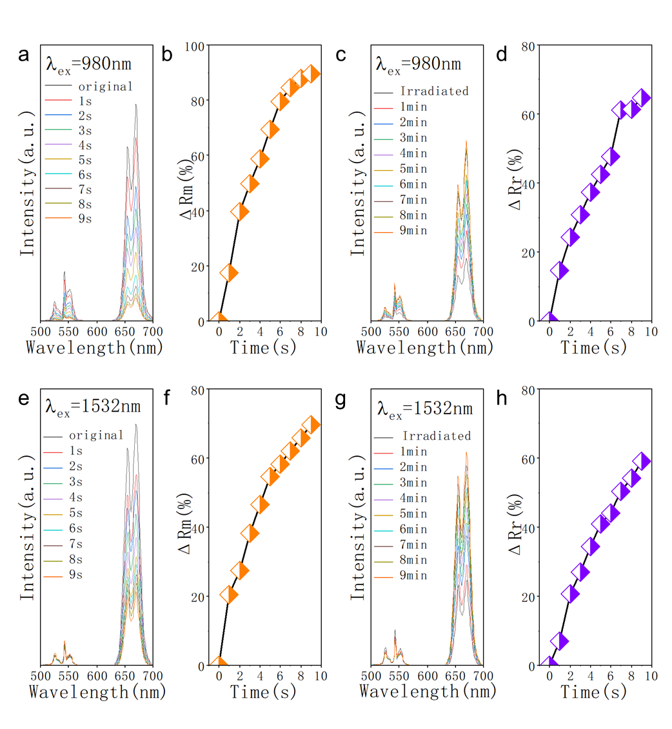
Supplementary Fig. 16 | Reversible UC emission modulation in BiOI:Er³⁺ sample by photochromism and water bleaching. Modification of 980 nm-excited UC emission spectra (a) and the corresponding modulation degree (b) for BiOI:Er³⁺ sample under 391 nm UV irradiation for different durations. Recovery of 980 nm-excited UC emission spectra (c) and the corresponding modulation degree (d) for BiOI:Er³⁺ sample via water bleaching under different duration times. Modification of 1532 nm-excited UC emission spectra (e) and the corresponding modulation degree (f) for BiOI:Er³⁺ sample under 391 nm UV irradiation for different duration times. Recovery of 1532 nm-excited UC emission spectra (g) and the corresponding modulation degree (h) for BiOI:Er³⁺ sample through water bleaching under varying duration times.

Supplementary Table 2 Luminescence modulation properties of lanthanide-doped photochromic materials.
Sample | λ_{ex} (nm) | λ_{em} (nm) | Coloration | Decoloration | ΔR_{m} (%) | ΔR_{r} (%) | Ref.
(K_{0.5}Na_{0.5}) NbO₃:Er | 980 | 550 | 407 nm light | thermal stimulus | 79.47% | — | 11
Na_{0.5}Bi_{2.5}Nb₂O₉:Yb/Er | 980 | 550 | 407 nm light | thermal stimulus | 86% | — | 12
K_{0.5}Na_{0.5}NbO₃:Yb/Er | 980 | 551 | 390 nm light | thermal stimulus | 95.10% | — | 13
K_{0.5}Na_{0.5}NbO₃:Yb/Er | 487 | 551 | 407 nm light | thermal stimulus | 75.61% | — | 13
K_{0.5}Na_{0.5}NbO₃:Yb/Ho | 980 | 549 | 405 nm light | thermal stimulus | 78.07% | — | 14
Na_{0.5}Bi_{0.5}TiO₃:Er | 980 | 553 | 405 nm light | thermal stimulus | 75.5% | — | 15
Sr₂SnO₄:Er | 980 | 550 | 290 nm light | 460 nm light | 84.9% | — | 16
BaMgSiO₄:Yb/Tb | 980 | 548 | 254 nm light | 473 nm//thermal stimulus | 75% | 99% | 17
Bi₄Ti₃O₁₂:Er | 980 | 550 | 405 nm light | thermal stimulus | 84.8% | 81% | 18
Ba_{0.7}Sr_{0.3}Nb₂O₆:Er | 980 | 552 | 405 nm light | thermal stimulus | 79.4% | 78% | 19
PbWO₄:Yb/Er | 980 | 551 | 532 nm light | 808 nm light | 80% | 92% | 20
SrBi₂Nb₂O₉:Yb/Ho/Mo | 980 | 545 | 405 nm light | thermal stimulus | 79.2% | 80% | 21
K_{0.5}Na_{0.5}NbO₃:Er/Pr | 980 | 550 | 390 nm light | thermal stimulus | 74.52% | — | 22
Er_{x}Yb_{1-x}NbO₄ | 980 | 556 | 365 nm light | 405 nm light | 99.2% | — | 23
CaWO₄: Yb/Er/Bi | 980  266 | 554  445 | 254 nm light  254 nm light | 473 nm light  473 nm light | 72%  53% | —  — | 24
Bi₇Ti₄NbO₂₁:Er | 980 | 547 | 405 nm light | 532 nm/thermal stimulus | 80.8% | — | 25
SrBi₄Ti₄O₁₅: Yb/Ho | 980 | 546 | 405 nm light | thermal stimulus | 74% | — | 26
SrHfO₃:Er | 980 | 547 | 254 nm light | thermal stimulus | 70.24% | — | 27
SrHfO₃:Er | 378 | 547 | 254 nm light | thermal stimulus | 77.21% | — | 27
SrWO₄: Yb/Er/Bi | 379 | 551 | 254 nm light | 473 nm light | 40% | 99% | 28
SrWO₄: Yb/Er/Bi | 980 | 552 | 254 nm light | 473 nm light | 70% | 99% | 28
TiO₂:Yb/Er | 980 | 664 | 405 nm light | 808 nm light | 86% | 95% | 29
YNbO₄:Er/Tm/Yb | 980 | 556 | 365 nm light | 405 nm light | 86% | — | 30
RE-Ag glass | 465 | 617 | 365 nm light | 690 nm light | 91% | 99% | 31
NaNbO₃:Eu | 538 | 612 | 365 nm light | thermal stimulus | 96.6% | — | 32
LiAlSi₂O₆:Sm | 405 | 607 | X-ray | 473 nm light | 93.1% | 99% | 33
Ba₂YTaO₆:Yb/Er/Co | 980 | 565 | 254 nm light | 473 nm light | 60.7% | 96.4% | 34
BiOCl:Er | 980 | 543 | 391 nm light | water bleaching | 90% | 78% | This work
BiOCl:Er | 1532 | 671 | 391 nm light | water bleaching | 75% | 77% | This work
BiOBr:Er | 980 | 542 | 391 nm light | water bleaching | 95% | 98% | This work
BiOBr:Er | 1532 | 668 | 391 nm light | water bleaching | 98% | 83% | This work
BiOI:Er | 980  1532 | 671  671 | 391 nm light  391 nm light | water bleaching  water bleaching | 90% | 65% | This work
 |  |  |  |  | 70% | 59% | This work

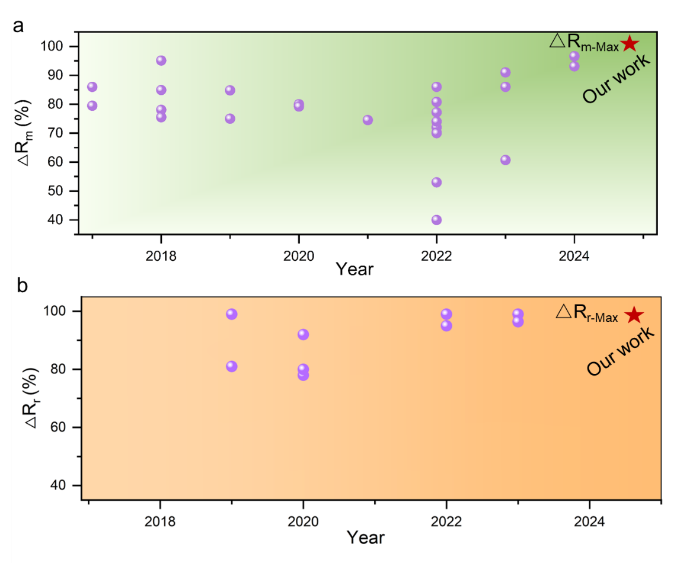
Supplementary Fig. 17 | The maximum values of ΔR_{m} (a) and ΔR_{r} (b) for the reported lanthanide-doped photochromic materials and our work in the recent years (2017-2024).

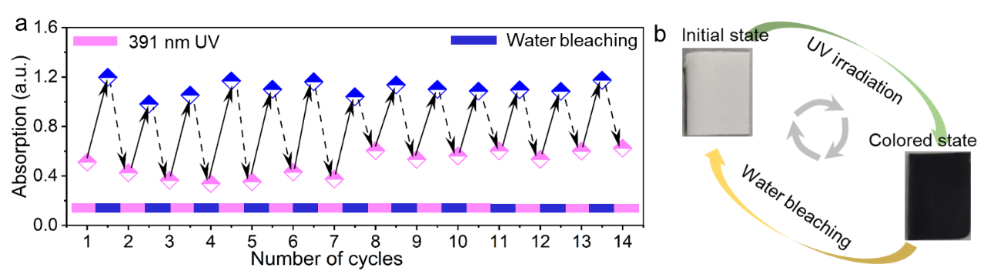
Supplementary Fig. 18 | (a) Absorption intensity at 540 nm of BiOBr:Er³⁺ sample for coloration and decoloration processes as a function of cycle numbers. (b) Digital photographs of BiOBr:Er³⁺ sample after UV irradiation for 9 s and water bleaching for 30 min, demonstrating the revisable color switching processes.

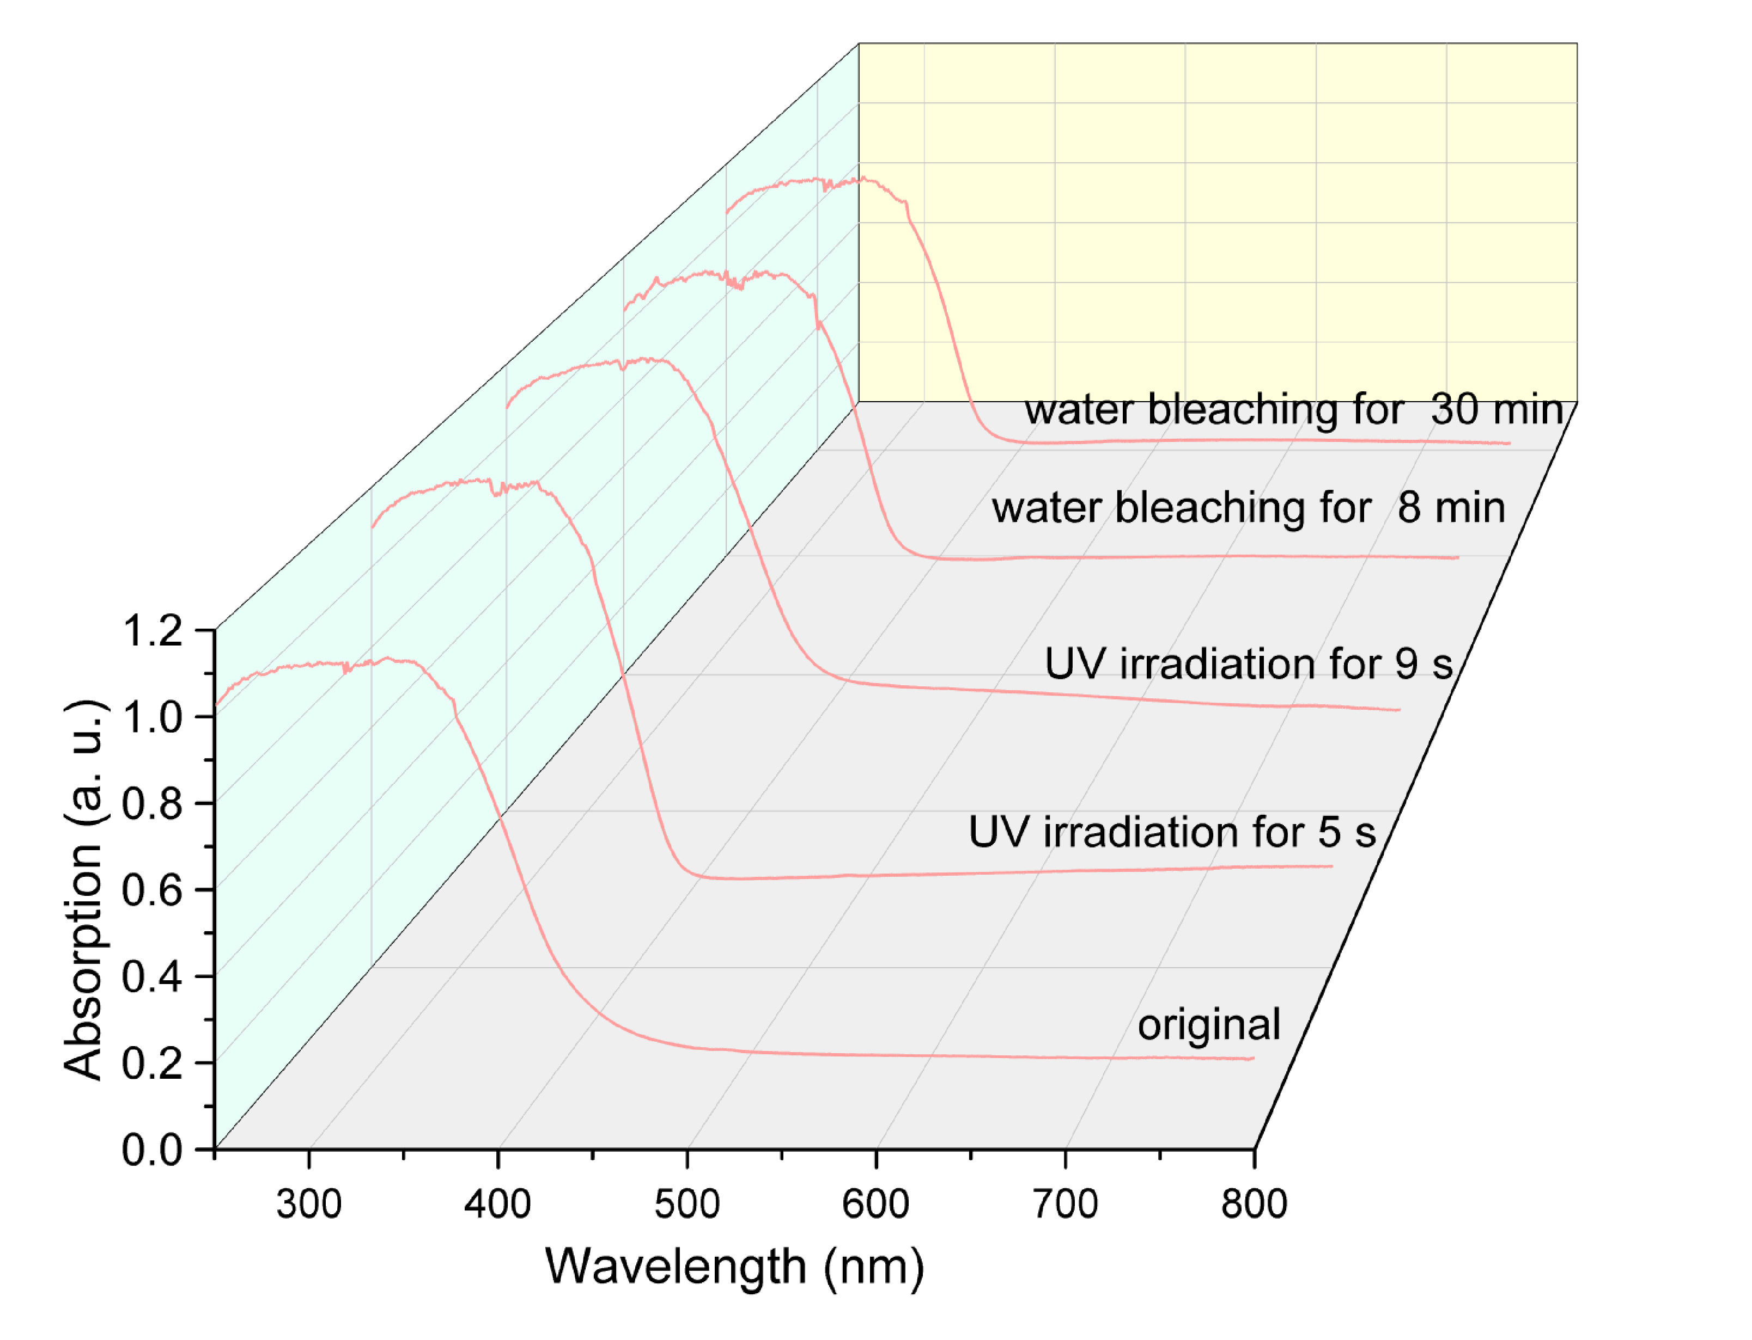
Supplementary Fig. 19 | Absoprtion spectra of OVs-free BOBE sample from the original state, upon UV illumination of different time (5 s and 9 s), and after water bleaching with different time (8 min and 30 min).

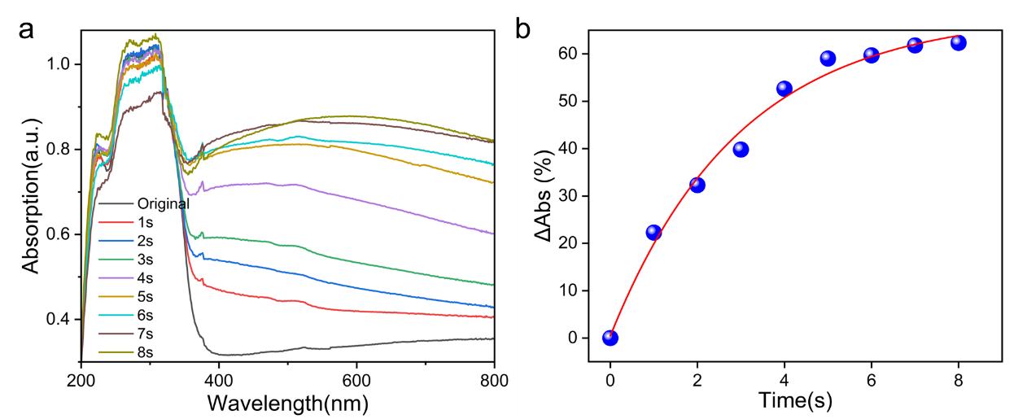
Supplementary Fig. 20 | (a) Absorption spectra of BiOCl:5%Er³⁺ illuminated by 391 nm UV light under different duration times. (b) Corresponding modulation degrees of absorption for BiOCl:5%Er³⁺ sample.

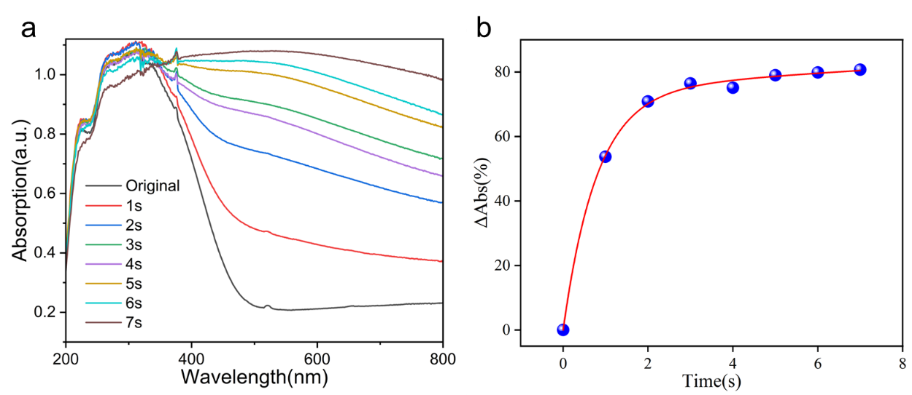
Supplementary Fig. 21 | (a) Absorption spectra of BiOI:5%Er³⁺ illuminated by 391 nm UV light under different duration times. (b) Corresponding modulation degrees of absorption for BiOI:5%Er³⁺ sample.

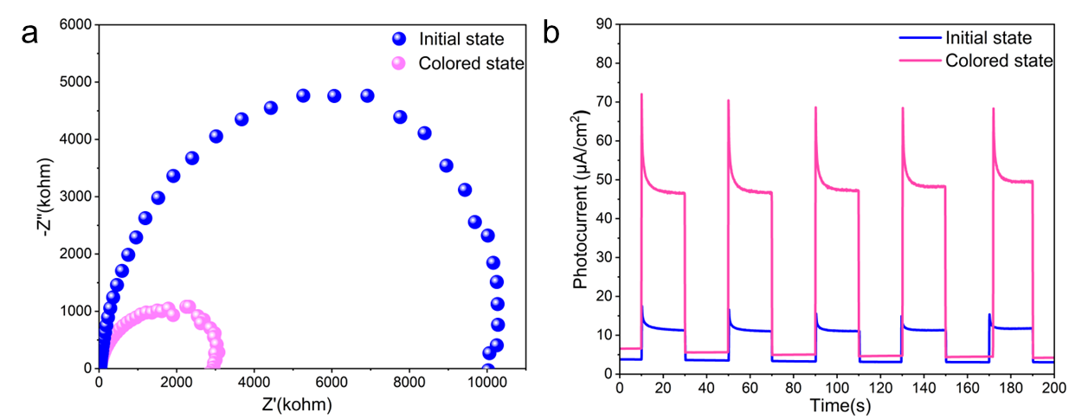
Supplementary Fig. 22 | Nyquist plots (a) and photocurrent density (b) BOBE-OV sample in initial and colored sates.

Supplementary Fig. 23 | Raman spectra of BOBE-OV sample in initial and colored sates.

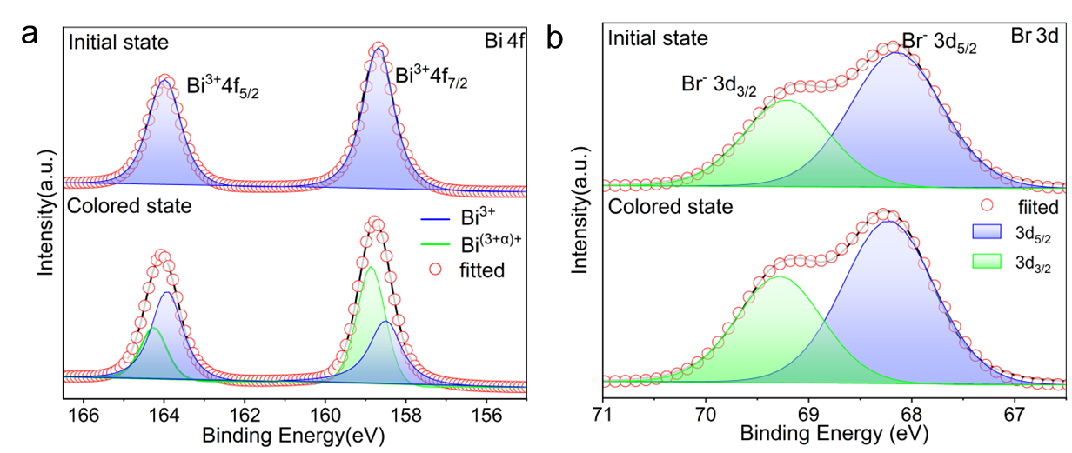
Supplementary Fig. 24 | High-resolution XPS spectra of Bi 4f (d), Br 3d (e) and O 1s (f) for BOBE-OV in initial and colored sates.

Supplementary Text S3
In order to identify the reversible photochromic and decolorization mechanism, a series of characterizations of Ovs-rich BiOBr:Er³⁺ in initial and colored states were carried out, including electrochemical impedance spectroscopy (EIS), transient photocurrent performance, Raman spectra, and X-ray photoelectron spectroscopy (XPS). Compared with the initial state, the photochromic BiOBr:Er³⁺ sample possesses the smaller arc radius of Nyquist plots (Supplementary Fig. 22a) and stronger photocurrent density (Supplementary Fig. 22b), indicating that UV illumination significantly promote the separation and transfer of photogenerated charge carriers³⁵. The peak intensity of $E_{g}^{2}$ in the Raman spectra (Supplementary Fig. 23) decrease after the photocoloration, owing to the suppressed lattice distortion caused by the displacement of oxygen atoms³⁶. The XPS spectra of BiOBr:Er³⁺ product before and after UV light irradiation are also conducted (Supplementary Fig. 24). In high-resolution XPS spectrum of Bi 4f (Supplementary Fig. 24a), both Bi ⁴f_{5/2} and Bi ⁴f_{7/2} peaks shift to high binding energy after UV illumination, implying the obvious increase in valance state of bismuth atoms. For the Br 3d spectra (Supplementary Fig. 24b), the two peaks corresponding to Bi-O band shift to high binding energy by about 0.1 eV, also representing the strengthening of Bi-O band. In the O 1s spectra of BiOBr:Er³⁺ (Fig. 4e), the subpeaks at 529.4, 530.9 and 532.1 eV are assigned to lattice oxygen (Bi-O bands), oxygen vacancies and surface-absorbed oxygen (e. g. hydroxyl groups and H₂O/O₂ molecules), respectively³⁷. After UV-induced photochromic reaction, the subpeak corresponding to the oxygen vacancies becomes weaker, suggesting that the amounts of oxygen vacancies decrease during the generation of photoinduced electrons and holes. Fig. 4f shows the ESR spetra of BOBE-OV sample in its original, photochromic and decoloration states, crucial for validating vacancy defects associated with unpaired free electrons of structure. The observed ESR signal (g = 2.002) are attributed to paramagnetic single ionized OVs that trapped a photogenerated electron ($V_{o}^{..}$ + e⁻ → $V_{o}^{.}$), key indicators of OVs during coloration and decoloration³⁸. The ESR intensity increases gradually with the increment of UV irradiation time, decreases progressively with extending time, and finally recovers to its initial state by water bleaching. According to our experimental results and previous reports, it can be inferred that the photochromic phenomenon could be attributed to oxygen vacancies in BiOBr:Er³⁺ sample.

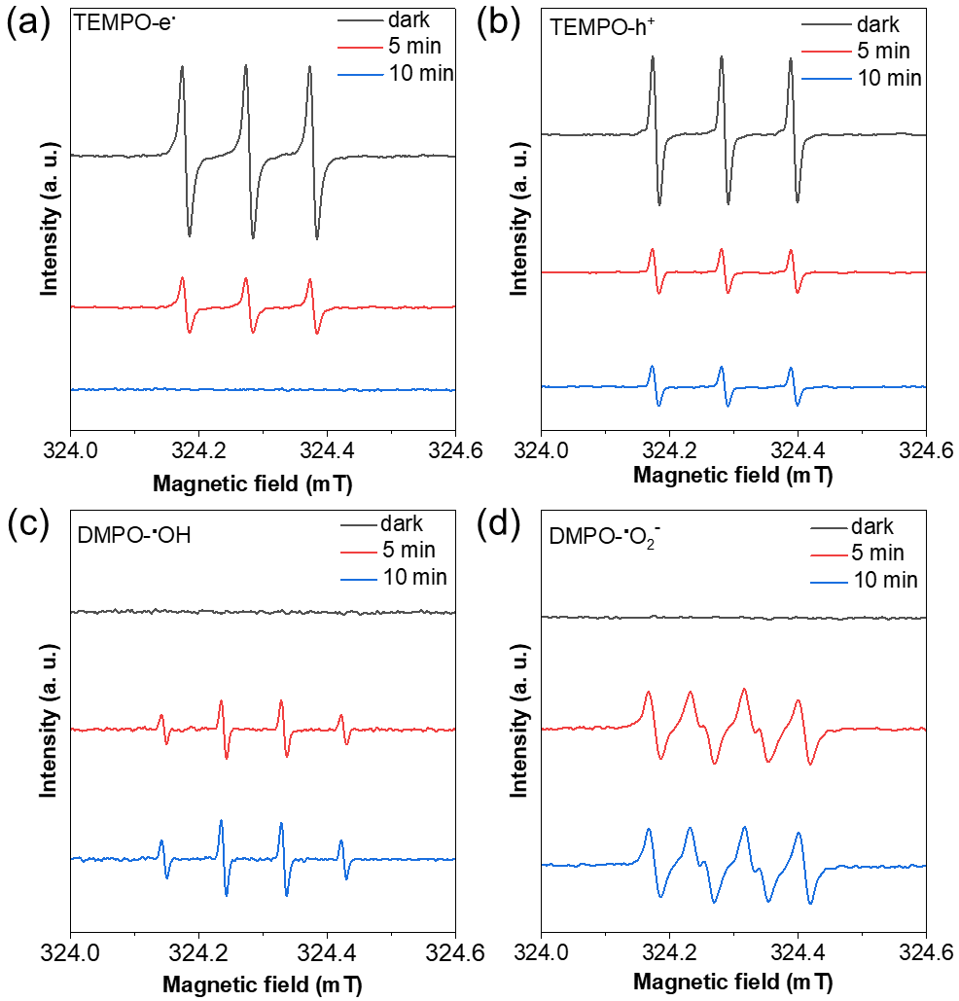
Supplementary Fig. 25 | Electron spin resonance (ESR) spectra of radical adducts signal labeled by TEMPO for electrons e⁻ (a) and holes h⁺ (b) as well as trapped by DMPO in aqueous solution for DMPO-.OH (c) and in methanol for DMPO-.O₂⁻ (d) under dark conditions or visible light irradiation with different duration time.

Supplementary Text S4
Supplementary Fig. 25 provides the ESR results of the as-obtained BOBE-OV sample under different UV irradiation times. Supplementary Fig. 25a and Fig. 25b present the generation of electrons (e⁻) and holes (h⁺) detected by spin label molecule TEMPO (2,2,6,6-tetramethylpiperidine-1-oxyl), which can combine with charge carriers (e⁻ and h⁺) to form spin adducts with a silence ESR signal³⁹. It can be observed that a triplet ESR signal with intensity of 1:1:1 was detected in dark, which comes from the ESR signal of TEMPO. After irradiation for 5 min, the ESR intensity decreases obviously, suggesting the occurrence of effective photo-induced carriers (e⁻ and h⁺). Moreover, the ESR signal intensity decreases gradually with the increment of irradiation time, indicating that the amount of photo-generated carriers increases with the lapse of UV illumination time. Differing from TEMPO, DMPO (5,5-dimethyl-1-pyrroline N-oxide) as a spin trapping molecule can be used to detected hydroxyl radicals (•OH) in aqueous solution and superoxide radicals (•O²⁻) in methanol solution. DMPO, which is unable to produce ESR signal by itself, can reacts with oxygen-containing group, thus forming a spin adducts with ESR signal. As depicted in Supplementary Fig. 25c, there is no obvious ESR signal under dark condition, suggesting that there is no production or transformation of •OH. After irradiation for 5 min, four characteristic peaks with the relative intensity of 1:2:2:1 were detected in BOBE-OV sample, which is the ESR signal of spin adduct DMPO-•OH. Moreover, this signal increases gradullay in intensity with elogating UV illumination time. In addition, the characteristic peaks in Supplementary Fig. 25d is related to the signal of spin adduct DMPO-•O₂⁻. Similarly, four characteristic peaks can be detected in BOBE-OV sample after UV irradation. With the increment of illumination time, BOBE-OV can produce or convert more •O₂⁻. According to the above results, it can be concluded that the photoexcited charge carriers can be generated from the OVs-rich BiOBr sample. In addition, these carriers can be generated or transformed into oxygen-containing groups (e. g. •OH and •O₂⁻) with redox activity, which is conducive to the photochromic reaction.

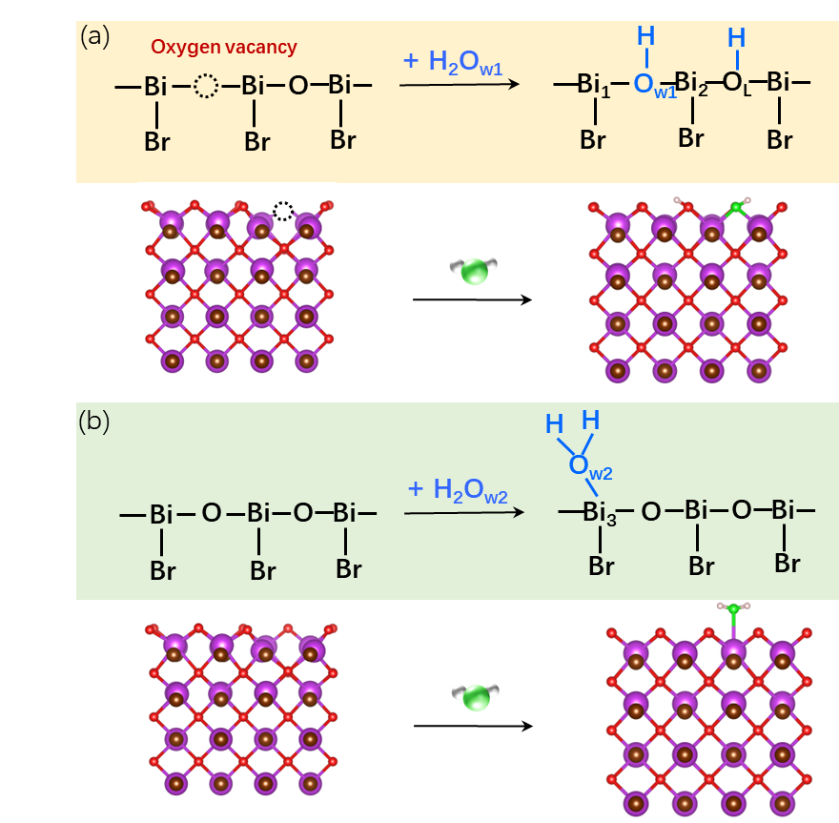
Supplementary Fig. 26 | Plausible adsorption mode of water on the BOBE-OV (a) and BOBE (b) samples.

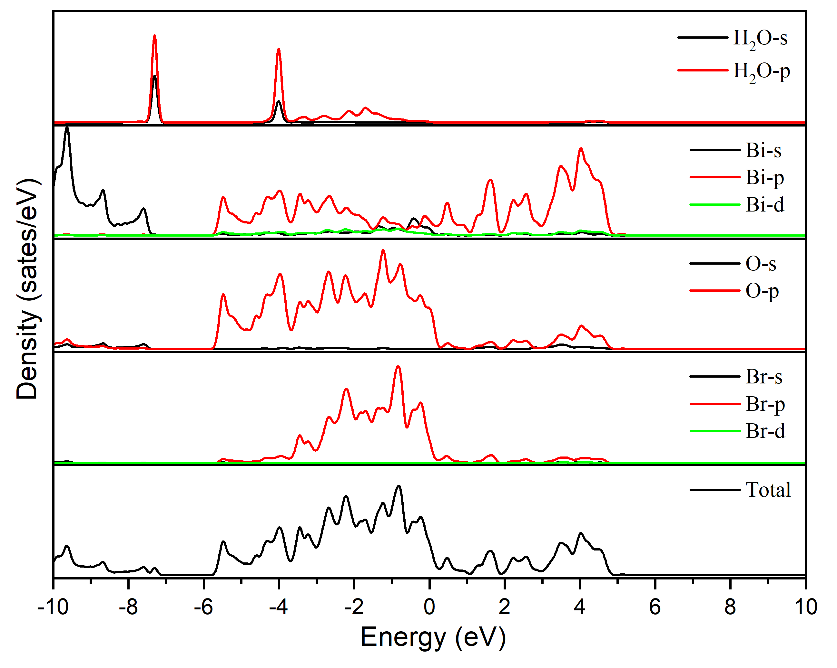
Supplementary Fig. 27 | The DOS and PDOS of water on the surface of OVs-free BiOBr:Er³⁺ (BOBE) sample.

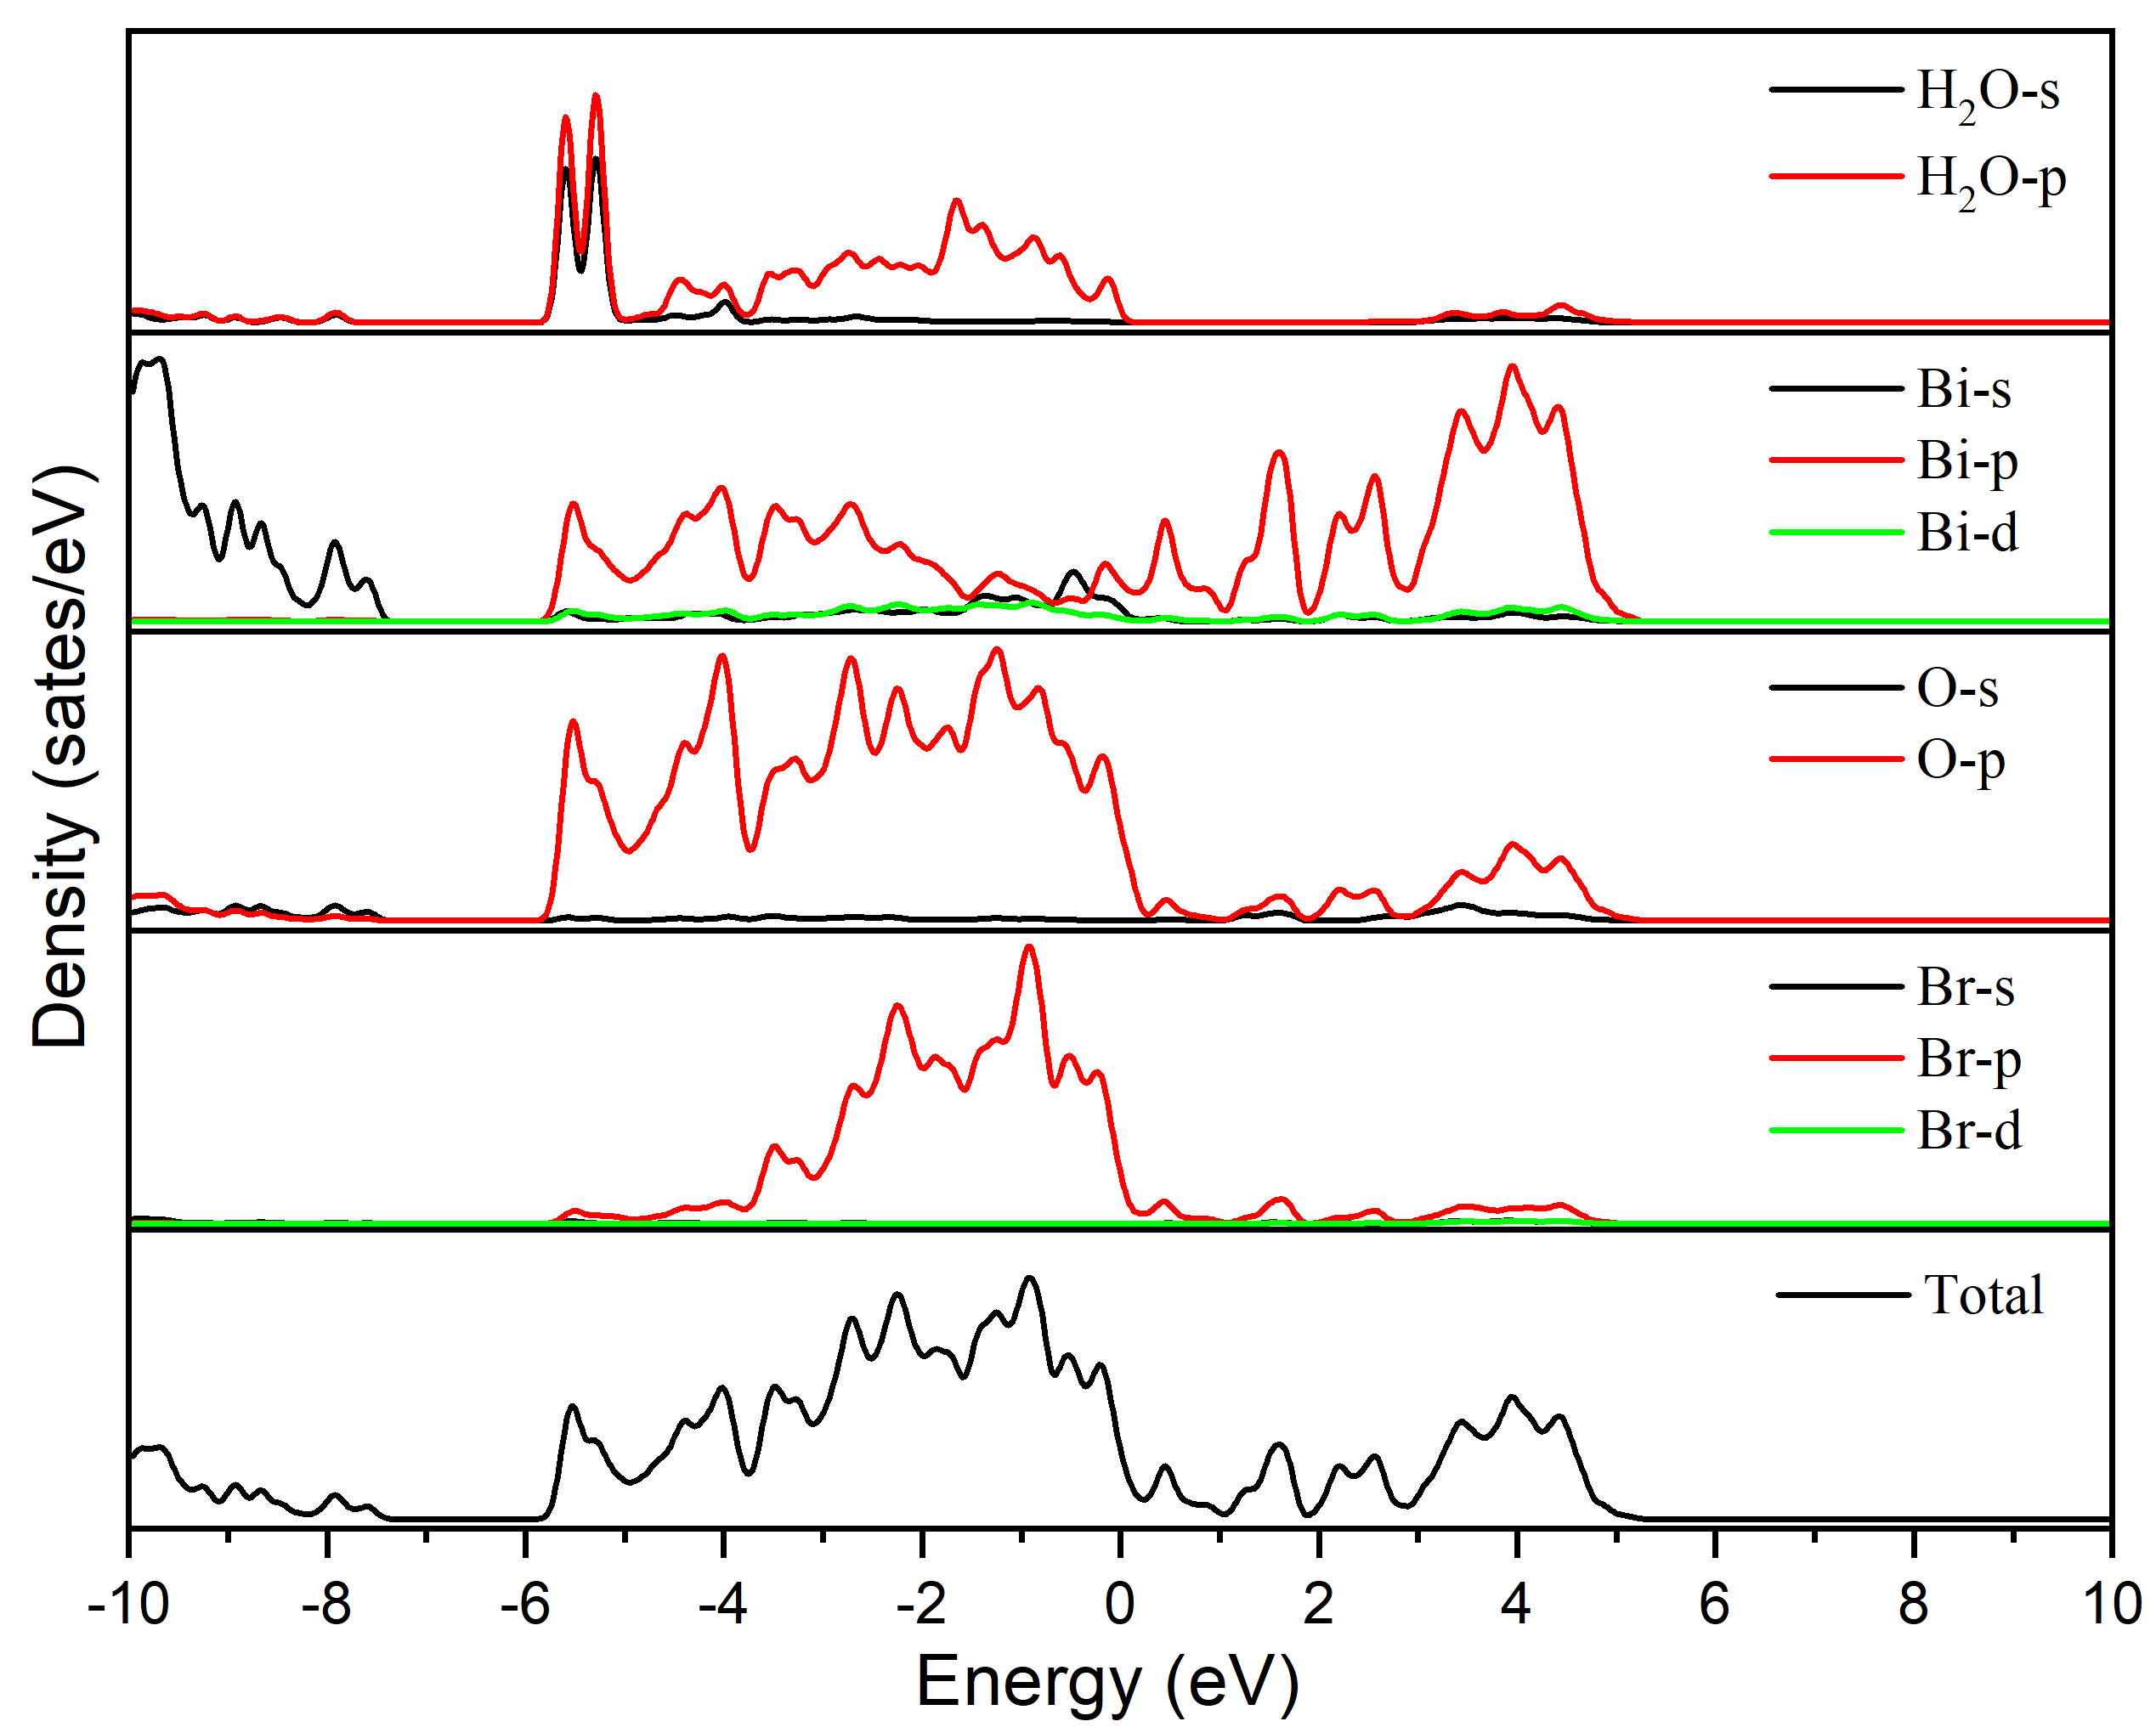
Supplementary Fig. 28 | The DOS and PDOS of water on the surface of OVs-rich BiOBr:Er³⁺ (BOBE-OV) sample.

Supplementary Table 3 The simulative energy of each part interacts with all as-prepared samples.
Samples | E(system) (eV) | Esurface (eV) | Ewater (eV)
BOBE-OV | -451.629 | -435.874 | -14.231
BOBE | -454.402 | -439.391 | -14.231

Supplementary Text S5
To further provide insightful information for water chemistry at OVs sites of BiOBr, DFT calculations were carried out, as shown in Supplementary Fig. 26-28⁴⁰. In the case of BOBE-OV, the dissociated hydroxyl group (-OH) from H2O adsorbed at the OVs sites with its oxygen atom (Ow) occupying the missing lattice oxygen (OL), and chemically bonded to the nearby Bi1 and Bi2 atoms, while the dissociated H atom directly transfers to neighboring lattice oxygen (O_{L}), forming two OH groups, i.e., OwH and OLH (Supplementary Fig. 26a). As seen clearly in Fig. 5a and 5c, bonding water could gather charge-clouds density around OVs on BOBE-OV. However, for the case of BOBE, H2O is molecularly adsorbed via Bi-O coordinate bond (Supplementary Fig. 26b). The newly formed Bi-O bond length on BOBE-OV surface (Bi1−Ow1 (2.302 Å) and Bi2−Ow1 (2.277 Å)) appears much shorter than BOBE surface (Bi3−Ow2 (2.532 Å)), suggesting stronger binding force between H2O molecules with OV-enriched surface. In addition, the different length between Bi₂−O_{w1} (2.302 Å) and Bi₂-O_{L} (2.095 Å) bond is owing to the relaxation behavior of atoms around the OVs of BOBE-OV surface. The electron density distribution away from the BOBE surface (Fig. 5b and 5d) illustrates that OVs-poor BiOBr interacts less closely with H₂O molecules than OV-enriched one.
The interaction energy of the H2O adsorbed on the BiOBr surface (∆E) was calculated and listed in Supplementary Table 3. The ∆E of the BOBE-OV surface (–1.525 eV) is much more exothermic than that of BOBE (–0.7800 eV) (Fig. 5e), confirming that the BOBE-OV surface is greatly stabilized by this type of dissociative H2O adsorption. Furthermore, the partial density of states (PDOS) shows that the top of O 2p peak (–2.76 eV) around OV shifts 1.50 eV towards lower energy compared to the perfect surface (–1.26 eV) (Supplementary Fig. 27 and Fig. 28), proving the stronger interaction between OV sites and water molecules. Also, the overlapping peaks of Bi 6p orbit and O 2p orbit in the range of 0 ~ -6 eV indicate the water molecules over BOBE-OV surface attach more tightly with Bi and O atoms. The above DFT simulation results validate that the water molecules are molecularly adsorbed on the Lewis acid Bi sites of OVs-poor BiOBr surface, while dissociatively adsorbed on the OV sites of BOBE-OV surface and generating bridged hydroxyl groups, thus improving the BiOBr surface hydrophilicity for water-induced decoloration process.

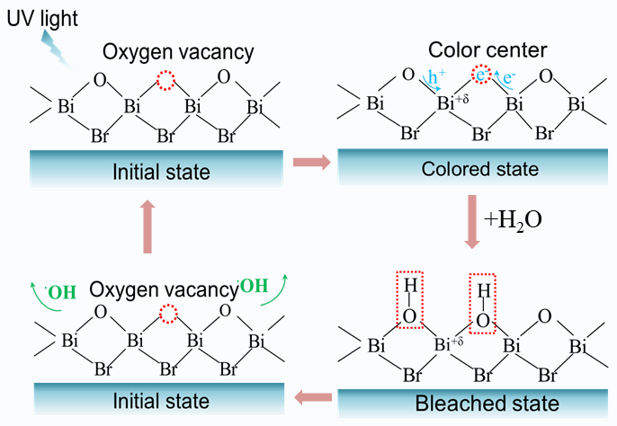
Supplementary Fig. 29 | Schematic illustration of the proposed reversible photochromic and decolorization mechanism.

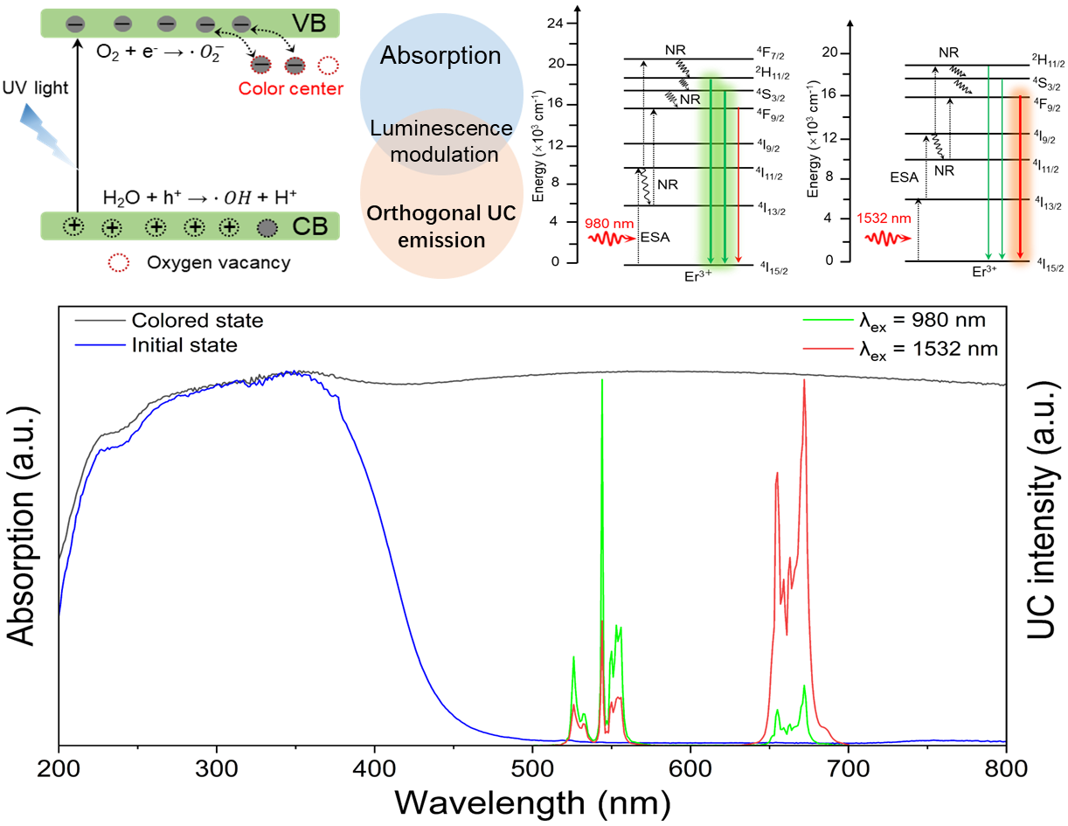
Supplementary Fig. 30 | The proposed mechanism of photochromism-induced orthogonal UC luminescence modification in Er³⁺-doped BiOBr sample.

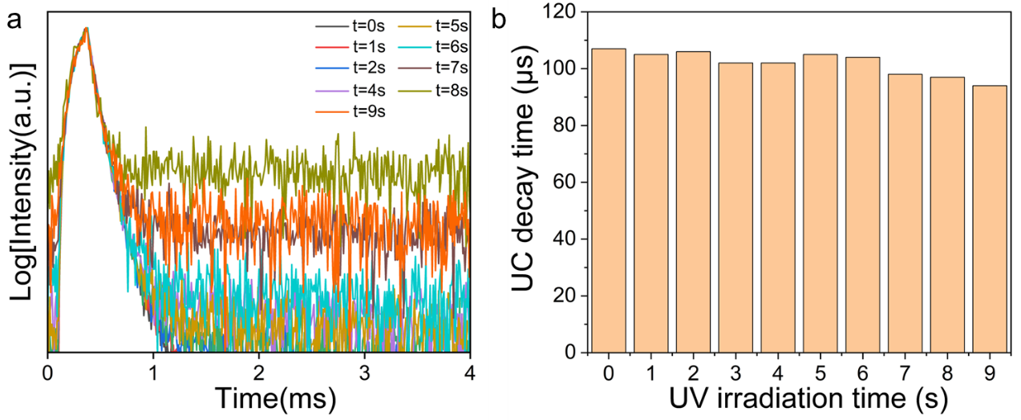
Supplementary Fig. 31 | (a) Decay curves of 542 nm UC emission (Er³⁺: ⁴S_{3/2} → ⁴I_{15/2}) for BiOBr:5%Er³⁺ upon 980 nm laser excitation with the increase of 391 nm UV irradiation time. (b) The decay time of 542 nm emission versus the 391 nm UV illumination time.

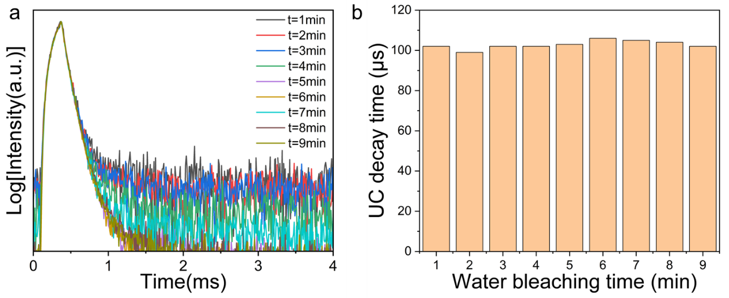
Supplementary Fig. 32 | (a) Decay curves of 542 nm UC emission (Er³⁺: ⁴S_{3/2} → ⁴I_{15/2}) for BiOBr:5%Er³⁺ upon 980 nm laser excitation with the increasing water-induced decoloration time. (b) The decay time of 542 nm emission versus water bleaching time.

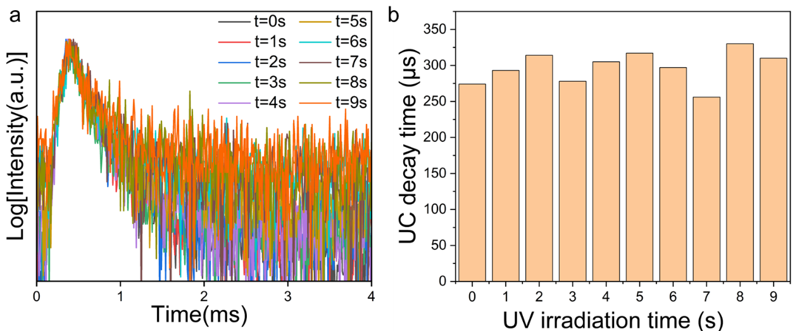
Supplementary Fig. 33 | (a) Decay curves of 668 nm UC emission (Er³⁺: ⁴F_{9/2} → ⁴I_{15/2}) for BiOBr:5%Er³⁺ upon 1532 nm laser excitation with the increase of 391 nm UV irradiation time. (b) The decay time of 668 nm emission versus the 391 nm UV illumination time.

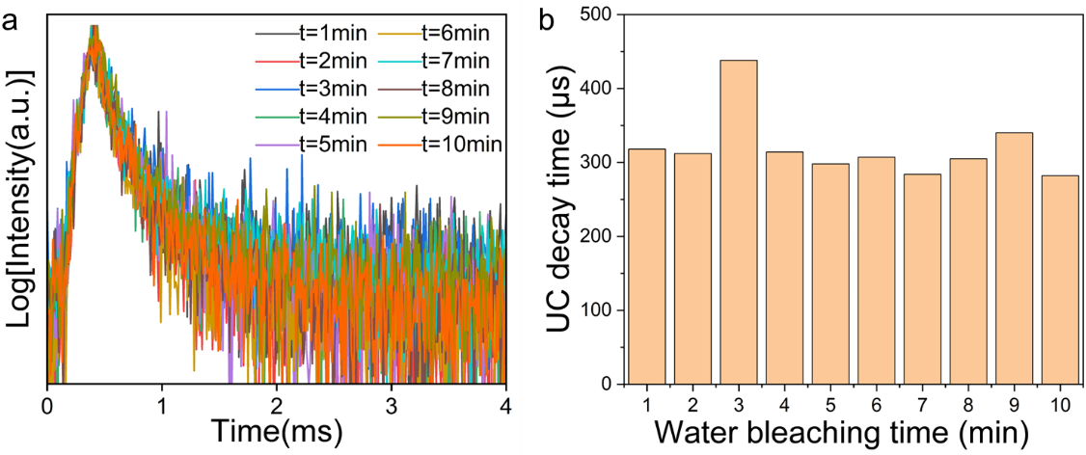
Supplementary Fig. 34 | (a) Decay curves of 668 nm UC emission (Er³⁺: ⁴F_{9/2} → ⁴I_{15/2}) for BiOBr:5%Er³⁺ upon 1532 nm laser excitation with the increasing water-induced decoloration time. (b) The decay time of 668 nm emission versus water bleaching time.

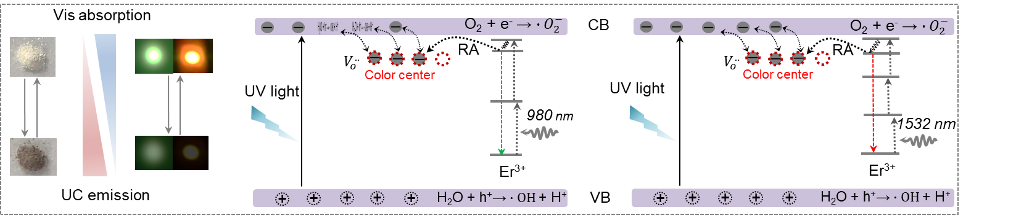
Supplementary Fig. 35 | The proposed photochromism-modulated orthogonal UC luminescence mechanism in the designed Er³⁺-doped BiOX samples.

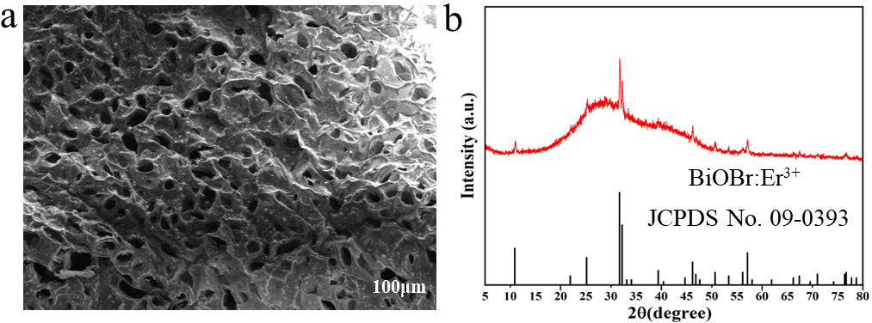
Supplementary Fig. 36 | (a) SEM image of BiOBr:Er³⁺/agarose composite film. (b) XRD pattern of BiOBr:Er³⁺/agarose composite sample.

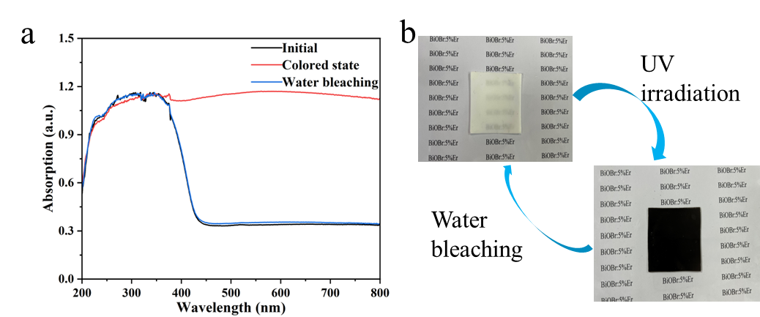
Supplementary Fig. 37 | (c) Absorption spectra of the BiOBr:Er³⁺/agarose composite film under alternating stimulation of UV light irradiation and water bleaching. (d) Digital photographs showing the reversible color switching process of composite film.

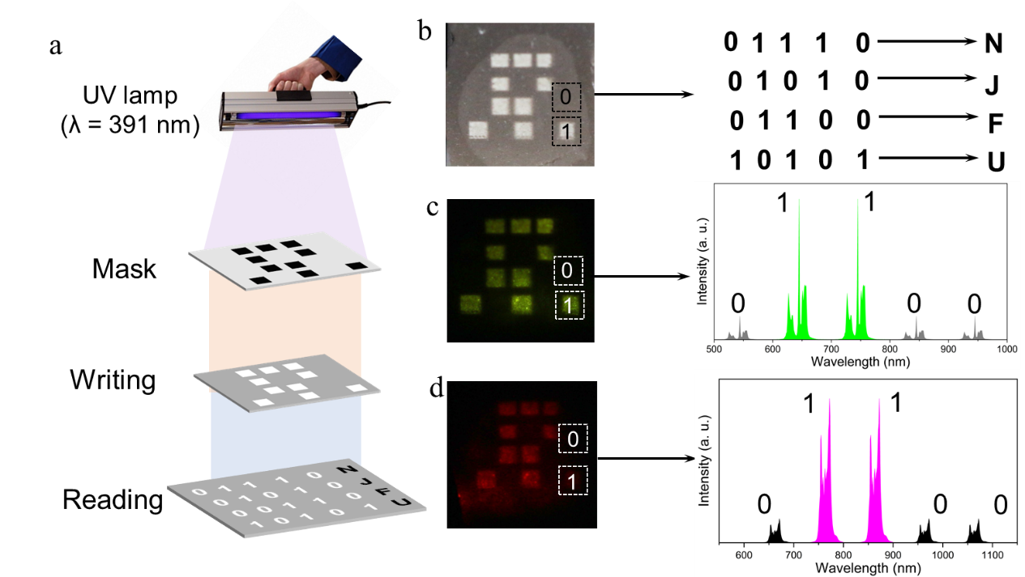
Supplementary Fig. 38 | (a) Schematic illustration of writing and reading of optical information storage. (b) The photochromic arrays and corresponding binary code at the surface of composite film. (c) Orthogonal UC luminescence photographs and emission spectra of “F” alphabet in the three-row dots.

References
[1] Li Y, Zhang J, Zhang X, et al. Near-infrared to visible upconversion in Er³⁺ and Yb³⁺ codoped Lu₂O₃ nanocrystals: enhanced red color upconversion and three-photon process in green color upconversion. The Journal of Physical Chemistry C, 2009, 113(11): 4413-4418.
[2] Liu Y, Zhou Z, Zhang S, et al. Mechanisms of upconversion luminescence of Er³⁺-doped NaYF₄ via 980 and 1530 nm excitation. Nanomaterials, 2021, 11(10): 2767.
[3] Lu D, Mao C, Cho S K, et al. Experimental demonstration of plasmon enhanced energy transfer rate in NaYF₄:Yb³⁺, Er³⁺ upconversion nanoparticles. Scientific Reports, 2016, 6(1): 18894.
[4] Anderson Robert B, Smith S J, May P S, et al. Revisiting the NIR-to-visible upconversion mechanism in β-NaYF₄:Yb³⁺, Er³⁺. The journal of physical chemistry letters, 2014, 5(1): 36-42.
[5] Fischer S, Fröhlich B, Krämer K W, et al. Relation between excitation power density and Er³⁺ doping yielding the highest absolute upconversion quantum yield. The Journal of Physical Chemistry C, 2014, 118(51): 30106-30114.
[6] Lu D, Cho S K, Ahn S, et al. Plasmon enhancement mechanism for the upconversion processes in NaYF₄:Yb³⁺, Er³⁺ nanoparticles: Maxwell versus Forster. ACS Nano, 2014, 8(8): 7780-7792.
[7] Berry Mary T, P Stanley May. Disputed mechanism for NIR-to-red upconversion luminescence in NaYF₄:Yb³⁺, Er³⁺. The Journal of Physical Chemistry A, 2015, 119(38): 9805-9811.
[8] Cheng X, Pan Y, Yuan Z, et al. Er³⁺ sensitized photon upconversion nanocrystals. Advanced Functional Materials, 2018, 28(22): 1800208.
[9] Ding M, Chen D, Yin S, et al. Simultaneous morphology manipulation and upconversion luminescence enhancement of β-NaYF₄:Yb³⁺/Er³⁺ microcrystals by simply tuning the KF dosage. Scientific Reports, 2015, 5(1): 12745.
[10] Ding M, Chen D, Ma D, et al. Highly enhanced upconversion luminescence in lanthanide-doped active-core/luminescent-shell/active-shell nanoarchitectures. Journal of Materials Chemistry C, 2016, 4(13): 2432-2437.
[11] Zhang Y, Luo L, Li K, et al. Up-conversion luminescence switching of (K_{0.5}Na_{0.5})_{0.995}Er_{0.005}NbO₃ ferroelectric ceramic based on photochromic reaction[J]. Ceramics International, 2018, 44(1): 1086-1090.
[12] Zhang Q, Yue S, Sun H, et al. Nondestructive up-conversion readout in Er/Yb co-doped Na_{0.5} Bi_{2.5}Nb₂O₉-based optical storage materials for optical data storage device applications. Journal of Materials Chemistry C, 2017, 5(15): 3838-3847.
[13] Zhang Y, Luo L, Li K, et al. Large and reversible in-situ up-conversion photoluminescence modulation based on photochromism via electric-field and thermal stimulus in ferroelectrics. Journal of the European Ceramic Society, 2018, 38(9): 3154-3161.
[14] Sun H, Zhang Y, Liu J, et al. Reversible upconversion switching for Ho/Yb codoped (K, Na)NbO₃ ceramics with excellent luminescence readout capability. Journal of the American Ceramic Society, 2018, 101(12): 5659-5674.
[15] Li K, Luo L, Zhang Y, et al. The upconversion luminescence modulation and its enhancement in Er³⁺‐doped Na_{0.5}Bi_{0.5}TiO₃ based on photochromic reaction. Journal of the American Ceramic Society, 2018, 101(12): 5640-5650.
[16] Zhang Y, Luo L, Li K, et al. Reversible up-conversion luminescence modulation based on UV-VIS light-controlled photochromism in Er³⁺ doped Sr₂SnO₄. Journal of Materials Chemistry C, 2018, 6(48): 13148-13156.
[17] Ren Y, Yang Z, Li M, et al. Reversible upconversion luminescence modification based on photochromism in BaMgSiO₄:Yb³⁺, Tb³⁺ ceramics for anti‐counterfeiting applications. Advanced Optical Materials, 2019, 7(15): 1900213.
[18] Yang F, Jia B, Wei T, et al. Reversible regulation of upconversion luminescence in new photochromic ferroelectric materials: Bi_{4-x}Er_{x}Ti₃O₁₂ ceramics. Inorganic Chemistry Frontiers, 2019, 6(10): 2756-2766.
[19] Wei T, Jia B, Shen L, et al. A new class of upconversion luminescence tuning materials based on non-photochromic reaction: Er³⁺-activated Ba_{0.7}Sr_{0.3}Nb₂O₆ ferroelectrics. Acta Materialia, 2021, 205: 116557.
[20] Bai X, Yang Z, Zhan Y, et al. Novel strategy for designing photochromic ceramic: reversible upconversion luminescence modification and optical information storage application in the PbWO₄: Yb³⁺, Er³⁺ photochromic ceramic. ACS applied materials & interfaces, 2020, 12(19): 21936-21943.
[21] Wei T, Jia B, Shen L, et al. Reversible upconversion modulation in new photochromic SrBi₂Nb₂O₉ based ceramics for optical storage and anti-counterfeiting applications. Journal of the European Ceramic Society, 2020, 40(12): 4153-4163.
[22] Zhang Q, Tang J, Du P, et al. Reversible and color controllable emissions in Er³⁺/Pr³⁺-codoped K_{0.5}Na_{0.5}NbO₃ ceramics with splendid photochromic properties for anti-counterfeiting applications. Journal of the European Ceramic Society, 2021, 41(3): 1904-1916.
[23] Zhang Z, Guo L, Sun H, et al. Rare earth orthoniobate photochromics with self-activated upconversion emissions for high-performance optical storage applications. Journal of Materials Chemistry C, 2021, 9(39): 13841-13850.
[24] Bai X, Cun Y, Xu Z, et al. Multiple Anti-Counterfeiting and optical storage of reversible dual-mode luminescence modification in photochromic CaWO₄:Yb³⁺, Er³⁺, Bi³⁺ phosphor. Chemical Engineering Journal, 2022, 429: 132333.
[25] Shen L, Wei T, Shi Y, et al. Light–heat and light–light dual-controlled upconversion luminescence and photochromic processes in Er-activated Bi₇Ti₄NbO₂₁ for optical information storage. ACS Applied Electronic Materials, 2022, 4(2): 776-786.
[26] Bi J, Wei T, Shen L, et al. Tunable upconversion luminescence in new Ho³⁺/Yb³⁺‐doped SrBi₄Ti₄O₁₅ photochromic ceramics for switching application. Journal of the American Ceramic Society, 2021, 104(4): 1785-1796.
[27] Zhang R, Jin Y, Yuan L, et al. Inorganic photochromism material SrHfO₃: Er³⁺ integrating multiple optical behaviors for multimodal anti-counterfeiting. Journal of Alloys and Compounds, 2022, 921: 166081.
[28] Bai X, Yang Z, Xu Z, et al. Optical memory and anti-counterfeiting application based on luminescence reversible modification and color contrast of photochromic phosphor. Science China Materials, 2023: 1-10.
[29] Haider A A, Cun Y, Bai X, et al. Anti-counterfeiting applications by photochromism induced modulation of reversible upconversion luminescence in TiO₂: Yb³⁺, Er³⁺ ceramic. Journal of Materials Chemistry C, 2022, 10(16): 6243-6251.
[30] Zhang Z, Li P, Xu Z, et al. Multicolor upconversion reversible modulations in YNbO₄:Er³⁺/Tm³⁺/Yb³⁺ photochromic materials. Journal of Rare Earths, 2022, https://doi.org/10.1016/j.jre.2022.11.006.
[31] Zhao H, Cun Y, Bai X, et al. Entirely reversible photochromic glass with high coloration and luminescence contrast for 3D optical storage. ACS Energy Letters, 2022, 7(6): 2060-2069.
[32] Li, X, Liu, M, Shao, J, et al. High-capacity photochromic rotary encoder for information encryption and storage. Advanced Functional Materials, 2024, 2402603.
[33] Bai X, Zan X, Zi Y, et al. Dual-functional X-Ray photochromic phosphor: high-performance detection and 3D imaging. Advanced Functional Materials, 2024: 2402452.
[34] Feng R, Bai X, Song Y, et al. Upconversion luminescence reversible modulation of photochromic Ba₂YTaO₆ double perovskite phosphors toward anticounterfeiting application. Advanced Optical Materials, 2024, 12(1): 202301293.
[35] Zhang X, Zhang Y, Feng Z, et al. Self-accelerating photocharge separation in BiOBr ultrathin nanosheets for boosting photoreversible color switching. Chemical Engineering Journal, 2022, 428: 131235.
[36] Zhang L, Xie F, Liu J, et al. Light-switchable oxygen vacancies enhanced nitrogen fixation performance on BiOBr: mechanism of formation, reconversion and function. Chemical Engineering Journal, 2022, 450: 138066.
[37] Wang H, Yong D, Chen S, et al. Oxygen-vacancy-mediated exciton dissociation in BiOBr for boosting charge-carrier-involved molecular oxygen activation. Journal of the American Chemical Society, 2018, 140(5): 1760-1766.
[38] Shen Z, Luo Z, Chen J, et al. Oxygen Vacancy‐Mediated Exciton Effect in Hierarchical BiOBr Enables Dichotomy of Energy Transfer and Electron Transfer in Photocatalysis. Advanced Functional Materials, 2023, 33(10): 2213935.
[39] Li Z, HouY, Shen Y, et al. Oxygen vacancy-dependent synergistic disinfection of antibiotic-resistant bacteria by BiOBr nanoflower induced H₂O₂ activation. Water Research, 2024, 267: 122524.
[40] Wang H, Yong D, Chen S, et al. Oxygen-vacancy-mediated exciton dissociation in BiOBr for boosting charge-carrier-involved molecular oxygen activation. Journal of the American Chemical Society, 2018, 140(5): 1760-1766.

