Supplementary material 3
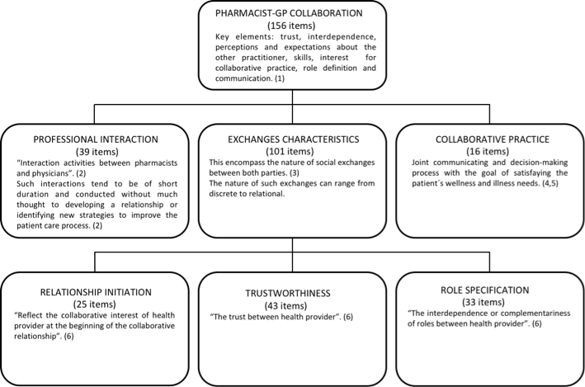
References
1. Bardet J.D, Vo T.H, Bedouch P, Allenet B. Physicians and community pharmacists collaboration in primary care: A review of specific models. Research in Social & Administrative Pharmacy. 2015;11(5):602-22.
2. McDonough R, Doucette W. Developing collaborative working relationships between pharmacists and physicians. Journal of the American Pharmaceutical Association. 2001;41(5):682-92.
3. Zillich A.J, McDonough R.P, Carter BL, Doucette W.R. Influential characteristics of physician/pharmacist collaborative relationships. Annals of Pharmacotherapy. 2004; 38(5):764-70.
4. Zillich A.J, Doucette W.R, Carter B.L, Kreiter C.D. Development and initial validation of an instrument to measure physician-pharmacist collaboration from the physician perspective. Value in Health: International Society for Pharmacoeconomics and Outcomes Research. 2005;8(1):59-66.
5. Van C, Mitchell B, Krass I. General practitioner–pharmacist interactions in professional pharmacy services. Journal of Interprofessional Care. 2011;25(5):366-72.
6. Liu Y, Doucette W.R, Farris K.B. Examining the development of pharmacist-physician collaboration over 3 months. Research in Social & Administrative Pharmacy. 2010;6(4):324-33.

