Supplementary Material

Probiotic-derived strain-specific metabolites ameliorate metabolic dysfunction-associated steatotic liver disease through modulation of the gut-liver axis
Sang Jun Yoon^{1,†}, Ji Eun Choi^{2,†}, Hee Young Kim^{1,†}, Hyun Chae Joung³, In Kyu Park¹, Jung A Eom¹, Sang Hak Han⁴, Ki Tae Suk^{1,*}, Do Yup Lee^{2,*}

* Correspondence: Ki Tae Suk, M.D., Ph.D. ktsuk@hallym.ac.kr; Do Yup Lee, Ph.D. rome73@snu.ac.kr

Supplementary Figure
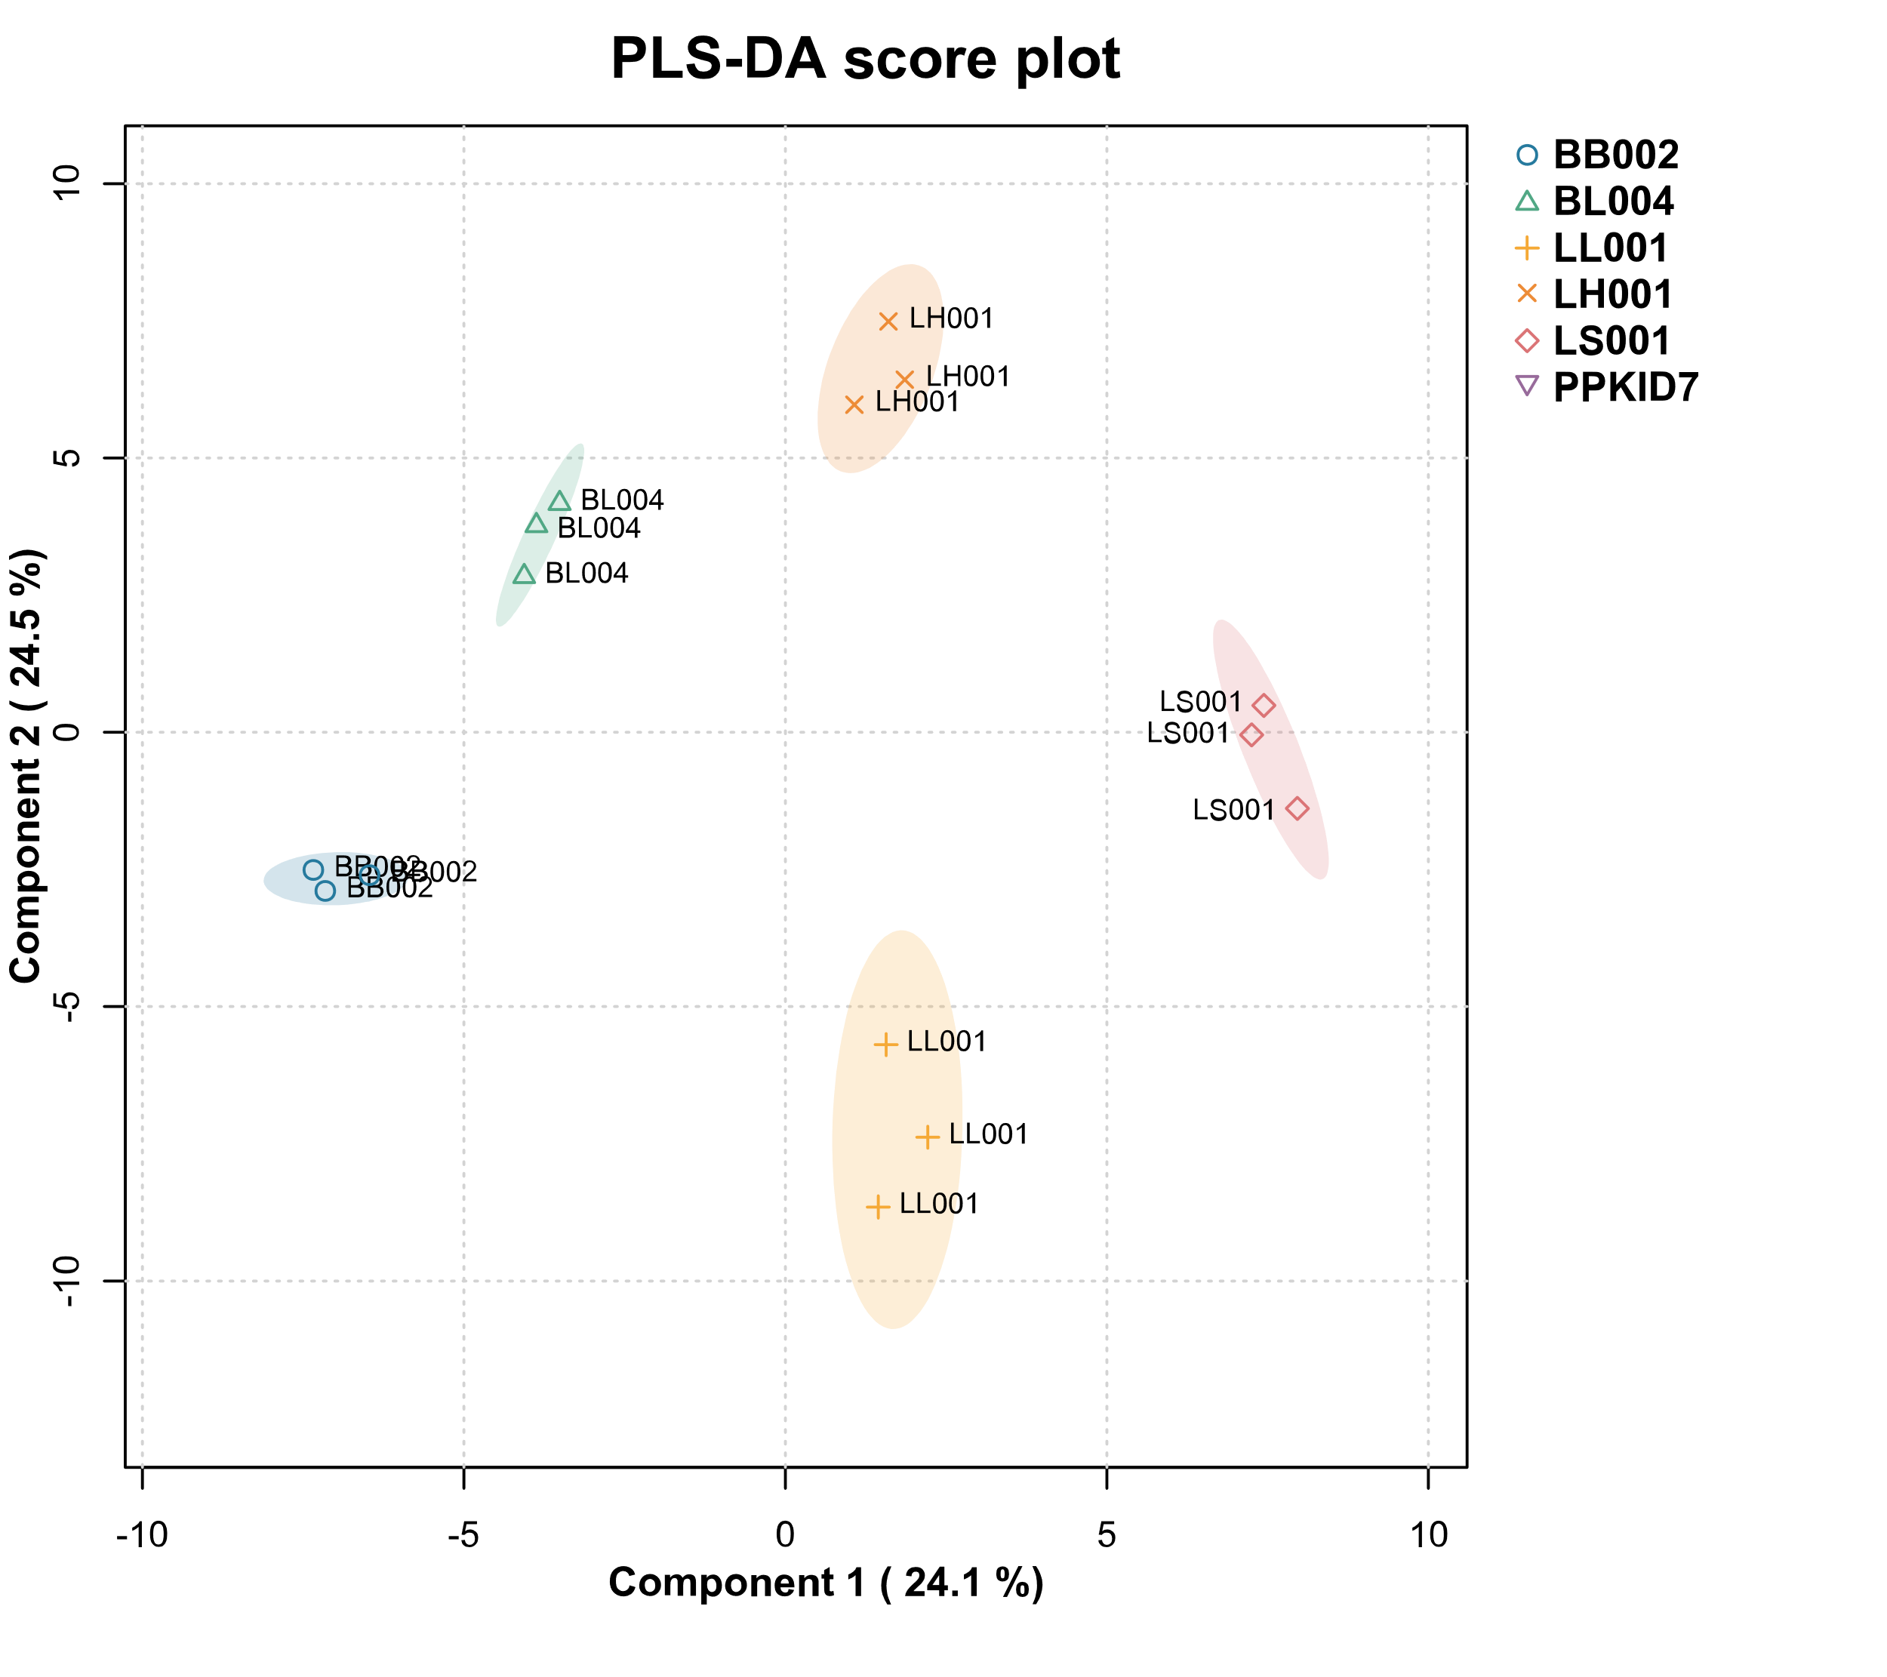
Supplementary Figure 1. PLS-DA score plot excluding PPKID7. The Bifidobacterium strains were separated from Lactobacillus strains along principal component 1, which explained 24.1% of the variance.

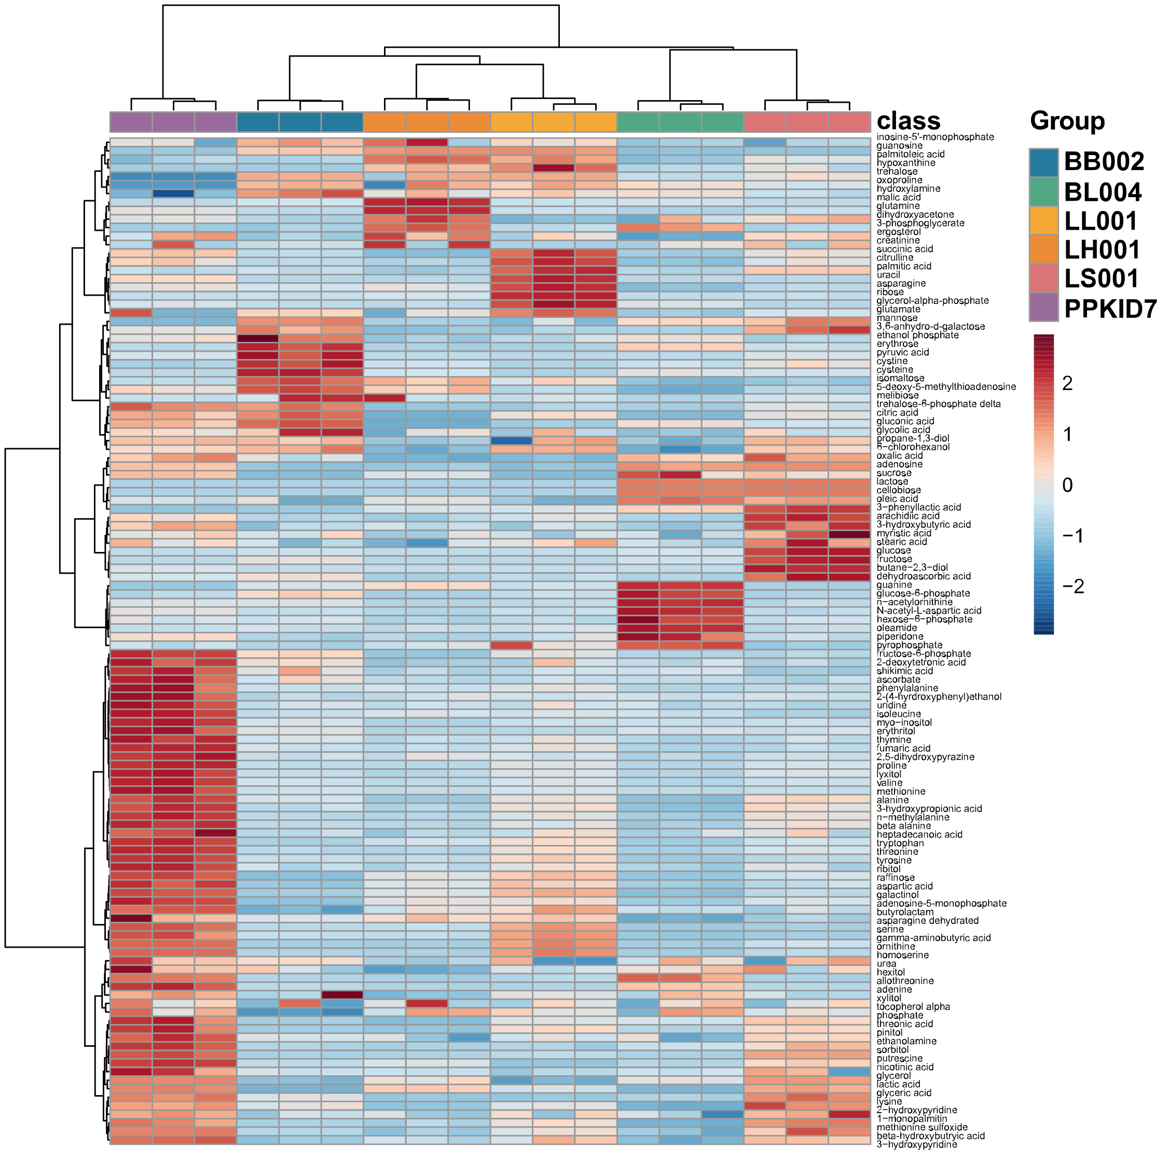
Supplementary Figure 2. Heatmap and dendrogram show hierarchical cluster analysis of probiotic metabolites. Highly abundant metabolite clusters were observed in PPKID7.

