Supplementary information
The time course of affective processing in anhedonia: insights from event-related potentials
Mologni et al.

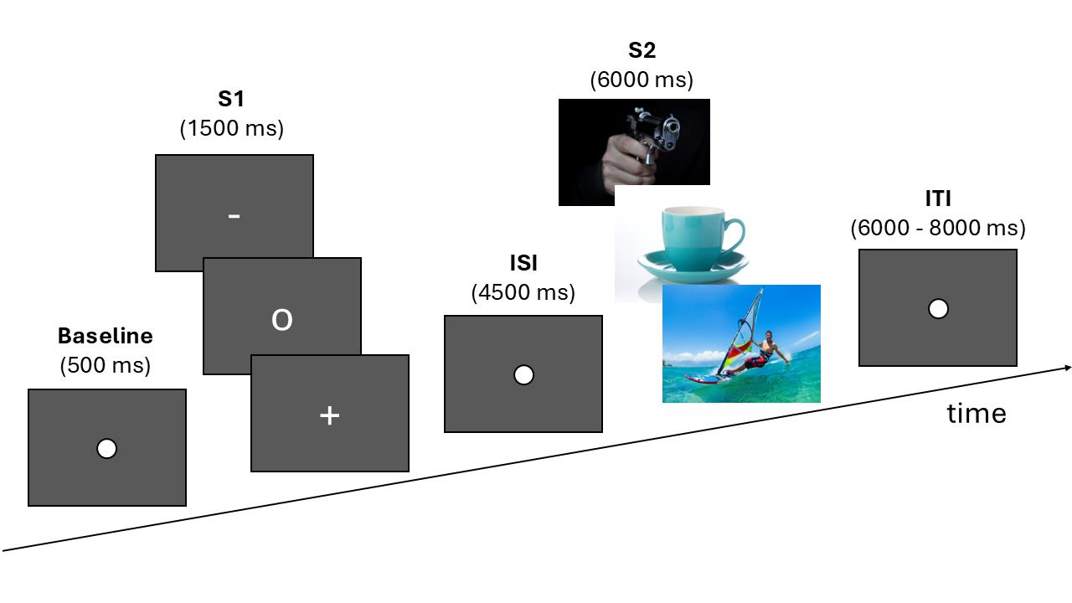
Figure S1. Schematic illustration of a trial of the emotional S1-S2 task. The S2 images are for illustrative purposes only and were sourced from an open-access online repository (https://www.istockphoto.com).
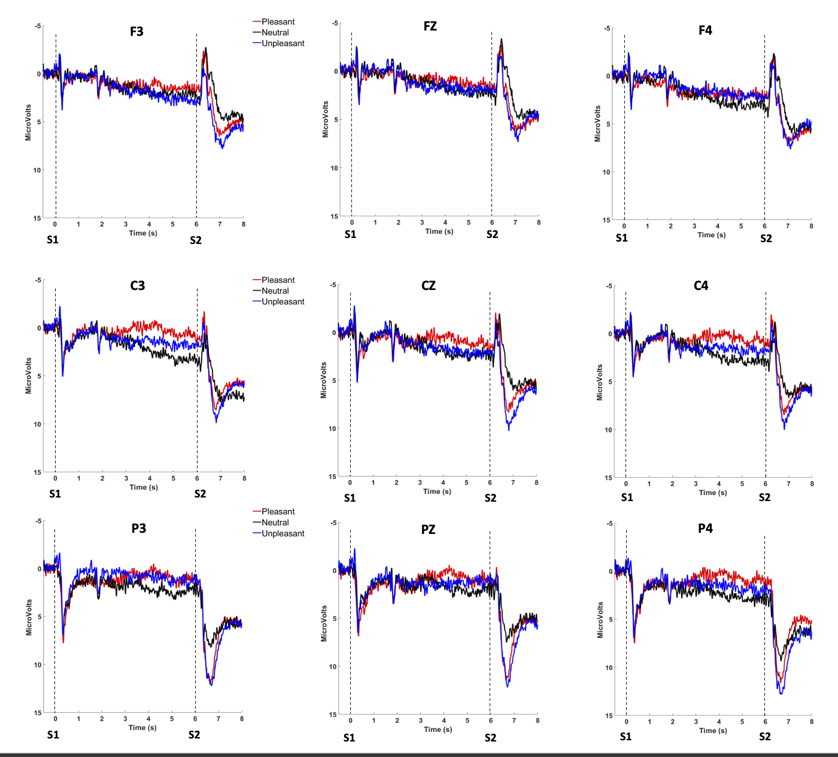
Figure S2. Grand average ERP waveforms during the S1-S2 task at parietal (P3, PZ, P4), central (C3, CZ, C4), and frontal (F3, FZ, F4) electrodes.

Table S1. Linear mixed-models predicting △ERPs amplitudes from emotional category (pleasant, unpleasant) and BDI-II non-anhedonic scores.
Predictor | b (SE) | t | p
Cue-P300 model
Category | 0.72 (0.25) | 2.87 | <.01***
BDI-II non-anhedonic | 0.50 (0.40) | 1.24 | .22
Sex | 1.09 (0.83) | 0.86 | .19
Category × BDI-II non-anhedonic | -0.19 (0.25) | -0.75 | .45
SPN model
Category | -0.83 (0.58) | -1.42 | .15
BDI-II non-anhedonic | 0.65 (0.91) | 0.70 | .48
Sex | 0.12 (1.88) | 0.06 | .94
Category × BDI-II non-anhedonic | -0.28 (0.58) | -0.48 | .63
LPP model
Category | -1.02 (0.65) | -1.56 | .12
BDI-II non-anhedonic | 0.80 (0.81) | 0.99 | .49
Sex | -1.24 (1.60) | -0.77 | .44
Category × BDI-II non-anhedonic | -0.54 (0.65) | -0.83 | .41
Notes. The reference levels are Category-unpleasant and Sex-females. Significant results are shown in bold, with asterisks indicating the level of statistical significance (*p < .05, **p < .01, ***p < .001).

