SUPPLEMENTARY INFORMATION
Supplementary Table 1. Clinical details of IM-GC and IM+GC patients used to characterise CD10 and Das1 staining
Parameters | IM-GC (n=18) | IM+GC (n=19)ª
Gender
Male | 12 | 13
Female | 6 | 6
Age (median)
Male | 69 (39-86)^{b} | 74 (60-95)^{b}
Female | 71.5 (44-79)^{b} | 67 (49-83)^{b}
Premalignant tissue
Chronic gastritis | 12 | 27
Intestinal metaplasia | 22 | 33
Matched tumour pathology
Intestinal | - | 14
Diffuse | - | 5
Matched tumour location
Antrum | - | 12
Body | - | 6
GOJ | - | 1
T stage
Tis | - | 4
T1 | - | 3
T2 | - | 3
T3 | - | 8
Unspecified | - | 1
Total n⁰ of IM glands characterised^{c}
CD10 | 96 | 119
Das1 | 81 | 142
IM-GC: patients with no evidence of gastric cancer; IM+GC: patients with concurrent gastric cancer; ªCohort included two patients with intra-mucosal gastric cancer from whom tissue was taken from multiple stomach sites and characterised across multiple time points; ^{b}Age range; ^{c}Glands were selected with the criterion that they contained the upper part of the gland near the surface (Supplementary Figure 1).

Supplementary Table 2. Subtyping of IM samples after endoscopy/gastrectomy and again prior to current study
SampleID | 1st IM subtyping  (post-endoscopy/gastrectomy) | 2nd IM subtyping  (directly prior to study)
IM-GC
N1S1ª | Complete | Complete
N1S2ª | Complete | Complete
N1S3ª | Complete | Complete
N2S1^{b} | Complete | Complete
N2S2^{b} | Complete | Incomplete
N3S1 | Complete | Complete
N4S1^{c} | Complete | Mixed
N4S2^{c} | Incomplete | Complete
N5S1 | Mixed | Incomplete
N6S1 | Complete | Complete
N7S1 | Incomplete | Incomplete
N8S1 | Complete | Complete
N9S1 | Complete | Mixed
N10S1 | Mixed | Mixed
N11S1 | Mixed | Mixed
N12S1 | Mixed | Incomplete
N13S1 | Incomplete | Incomplete
N14S1 | Mixed | Incomplete
N15S1 | Complete | Complete
N16S1 | Complete | Mixed
N17S1 | Incomplete | Incomplete
N18S1 | Complete | Complete
IM+GC
P1 | Incomplete | Mixed
P2 | Complete | Complete
P3 | Incomplete | Incomplete
P4 | Complete | Complete
P5 | Complete | Complete
P6 | Incomplete | Mixed
P7 | Mixed | Complete
P8 | Complete | Incomplete
P9 | Mixed | Mixed
P10 | Complete | Complete
P11 | Complete | Complete
P12 | Complete | Incomplete
P13 | Mixed | Complete
P14 | Incomplete | Complete
P15 | Mixed | Mixed
P16 | Incomplete | Complete
P17 | Complete | Complete
Second IM subtyping carried out on same FFPE block as before but from freshly cut sections. ªPatient N1: biopsies from 3 different endoscopies and sites (A1, A4, A5) as recommended by the updated Sydney protocol; ^{b}Patient N2: biopsies from a single endoscopy (A1, A4); ^{c}Patient N4: biopsies from 2 endoscopies (both A1). Mixed and incomplete IM considered of equal risk and pooled together for analysis purposes.

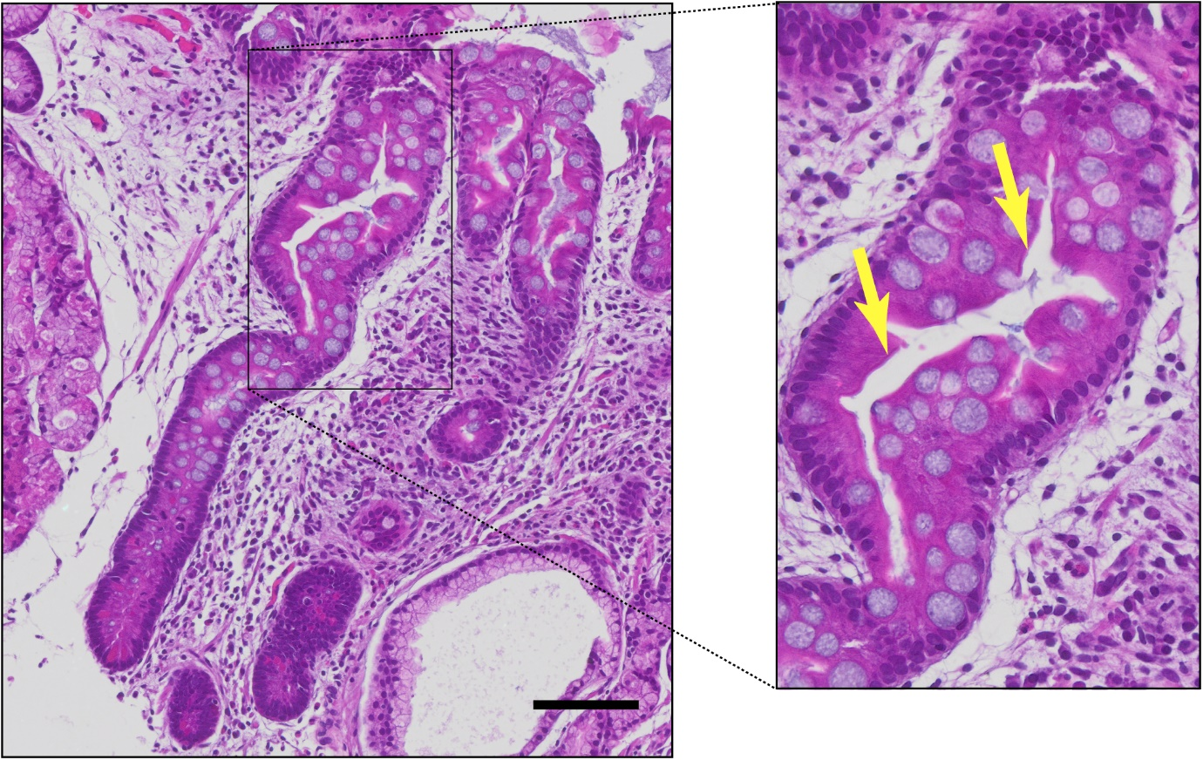
Supplementary Figure 1. Subtyping of individual intestinal metaplasia glands.
Image showing individual IM glands, with a single complete IM gland shown in inset, as defined by the presence of a brush border (yellow arrows). Individual IM glands were subtyped using the upper part of the gland and gland morphology and classified as complete (with brush border) or incomplete (absence of brush border and irregular architecture). Scale bar: 100μm.

Supplementary Table 3. Clinical details of IM-GC patients with samples used for gene expression profiling (HG-U133 Plus 2.0)
CEL file | SampleID | Gender | Age
08-0017ANTA.CELª | S1 | Male | 68
08-0021BODY2.CEL | S2 | Male | 44
08-020-02ANTB.CEL | S3 | Male | 32
09-003-01B4.CEL | S4 | Male | 67
09-020-02B1.CEL | S5 | Male | 75
09-024-02B5.CEL^{a,b} | S6 | Male | 69
09-025-01B1.CEL^{b} | S7 | Male | 84
09-032-01B3.CEL^{b} | S8 | Female | 79
09-033-03B3.CEL^{b} | S9 | Male | 59
10-038-01B1.CEL^{b} | S10 | Male | 39
10-043-01 B3.CEL | S11 | Female | 82
2006-0011ANTB.CEL | S12 | Male | 56
2006-008ANTB.CEL | S13 | Male | 70
2007-0015ANT.CEL | S14 | Male | 49
ªRNA was extracted and profiled from biopsy tissue collected from the same patient at two different hospital visits. ^{b}Biopsy tissue acquired from these patients was also used in the IHC staining part of the study. The complete Affymetrix microarray dataset can be accessed using GEO accession number: GSE160116 (https://www.ncbi.nlm.nih.gov/geo).

Supplementary Methods. Immunohistochemical staining with anti-CD10 antibody
Single stain immunohistochemistry with anti-CD10 (clone 56C6, Abcam, catalogue number: ab951) consisted of overnight incubation with the primary antibody (dilution 1:50) at 4⁰C followed by incubation with the EnVision+ System/anti-mouse HRP reagent and visualisation with DAB chromogen.
The single gland CD10 study was carried out using immunofluorescence (IF) staining with the OPAL™ reagent 650 for visualisation purposes as part of an optimised multiplex IHC panel to detect T cell subsets (part of another on-going study and mostly based on the panel described in (26)) using the OPAL™ 7-Color IHC kit (PerkinElmer, cat# NEL811001KT). Briefly 4μm FFPE sections were cyclically incubated followed by an antigen retrieval step with anti-CD4 (clone 4B12, ThermoFisher Scientific, cat# MA5-12259), anti-CD8 (clone 4B12, ThermoFisher Scientific, cat# MA1-80231), anti-FOXP3 (Bio SB, cat# BSB 6761), anti-CD3 (clone SP7, Spring Bioscience, catalogue number: M3074), anti-CD10, anti-AE1AE3 (AE1/AE3, Leica Biosystems, cat# NCL-L-AE1/AE3) and Dapi (PerkinElmer) for 30 minutes at room temperature (RT), washed and incubated with the species appropriate HRP-labelled secondary antibody (10 minutes at RT) and visualised with OPAL™ reagents diluted in 1x amplification diluent (10 minutes at RT). Slide scanning was performed on a VECTRA® automated quantitative pathology imaging system and visualisation was obtained through multi-spectral unmixing with the use of inForm® software (both PerkinElmer).
Supplementary Figure 2. Serial biopsy sections of intestinal metaplasia stained with H&E and CD10 (OPAL™ multiplex immunohistochemistry panel).
Serial FFPE sections at 4μm were used for A: H&E staining and B: OPAL™ multiplex immunohistochemistry (IHC) staining; C: inset of H&E stained section showing IM, D: matched spectrally unmixed image using inForm® software (PerkinElmer) from the multiplexed IHC scanned slide and E: pseudo-pathology view for CD10 used for single gland scoring. Scale bars: 200µm for A and B, 100µm for C, D and E.
Supplementary Figure 3. Digital quantification of Das1 staining on intestinal metaplasia glands using an overlay.
Digital quantification of Das1 staining was carried out on high resolution .vsi files using the cellSens Dimension software (Olympus). Fraction area of each region of interest (ROI) positive for Das1 staining was measured by using first the “threshold tool” with R-G-B threshold detection parameters kept constant for all images and second with the “Count and Measure on ROI” tool. All result files were exported in csv format for further analysis. Scale bar: 100μm.

Supplementary Table 4. Differentially expressed genes (DEGs) in complete and incomplete IM samples
Symbol | Name | logFC | AveExpr | adj.P.Val
High in CIMª
RBP2 | Retinol Binding Protein 2 | -5.36 | 10.73 | 1.7e-02
MME | Membrane Metalloendopeptidase | -4.08 | 7.22 | 3.9e-03
APOA4 | Apolipoprotein A4 | -3.96 | 9.34 | 4.6e-02
CCL25 | C-C Motif Chemokine Ligand 25 | -3.88 | 7.29 | 9.2e-03
SLC2A5 | Solute Carrier Family 2 Member 5 | -3.74 | 7.60 | 2.4e-02
SLC2A2 | Solute Carrier Family 2 Member 2 | -3.17 | 6.40 | 8.1e-03
XPNPEP2 | X-Prolyl Aminopeptidase 2 | -3.05 | 7.29 | 1.7e-02
MGAM | Maltase-Glucoamylase | -3.00 | 7.69 | 2.4e-02
SEMA6D | Semaphorin 6D | -2.36 | 5.89 | 1.9e-02
SLC5A1 | Solute Carrier Family 5 Member 1 | -2.16 | 8.87 | 3.7e-02
KHK | Ketohexokinase | -1.98 | 8.93 | 4.6e-02
PCK2 | Phosphoenolpyruvate Carboxykinase 2 | -1.73 | 10.09 | 4.7e-02
KLK11 | Kallikrein Related Peptidase 11 | -1.67 | 7.65 | 3.4e-02
TTTY14 | Testis-Specific Transcript, Y-Linked 14 | -1.49 | 5.55 | 4.6e-02
SFRP5 | Secreted Frizzled Related Protein 5 | -1.34 | 6.10 | 1.7e-02
SLC37A4 | Solute Carrier Family 37 Member 4 | -1.24 | 8.56 | 4.6e-02
ADRB2 | Adrenoceptor Beta 2 | -0.90 | 6.04 | 3.2e-02
NUP210 | Nucleoporin 210 | -0.85 | 7.12 | 1.7e-02
High in IIM^{b}
HOXA10 | Homeobox A10 | 3.09 | 6.60 | 2.5e-03
HOXA13 | Homeobox A13 | 2.80 | 5.74 | 1.5e-02
CXCL5 | C-X-C Motif Chemokine Ligand 5 | 2.49 | 5.48 | 1.7e-02
CLDN1 | Claudin 1 | 2.09 | 7.28 | 1.9e-02
F5 | Coagulation Factor V | 1.89 | 7.25 | 3.2e-02
CDH3 | Cadherin 3 | 1.69 | 7.62 | 5.6e-03
CTSV | Cathepsin V | 1.61 | 7.44 | 1.9e-02
MUC4 | Mucin 4 | 1.51 | 4.78 | 3.5e-02
CPD | Carboxypeptidase D | 1.26 | 8.01 | 4.5e-02
SEMG1 | Semenogelin 1 | 1.16 | 4.19 | 2.7e-02
RSPH1 | Radial Spoke Head Component 1 | 1.11 | 7.17 | 2.0e-02
FAM3D | FAM3 metabolism regulating signaling molecule D | 0.69 | 10.16 | 3.0e-02
ªcomplete IM; ^{b}incomplete IM. Differentially expressed genes were defined as log2 fold change >0.6 or <-0.6 with adjusted p<0.05 using the Benjamini-Hochberg method for multiple test correction.

Supplementary Figure 4. Unsupervised hierarchical clustering of all IM-GC samples using differentially expressed gene list.
Gene expression heatmap showing unsupervised clustering of all IM-GC samples based on previously obtained differentially expressed gene list. CIM: complete IM, IIM: incomplete IM and MIM: mixed IM. Genes with average expression level <5 removed (SEMG1 and MUC4). Pheatmap package in R used. Expression levels have been standardised (centered and scaled) within rows for visualization. Legend shows z score.

Supplementary Table 5. Significantly enriched KEGG pathways in complete IM determined using ssGSEA with IM-GC samplesª
Pathway | Adj.P.Val
Galactose Metabolism | 0.031
Glycine Serine And Threonine Metabolism | 0.031
Glycerolipid Metabolism | 0.031
Arachidonic Acid Metabolism | 0.031
Linoleic Acid Metabolism | 0.031
Retinol Metabolism | 0.031
Metabolism Of Xenobiotics By Cytochrome P450 | 0.031
Drug Metabolism Cytochrome P450 | 0.031
Drug Metabolism Other Enzymes | 0.031
Abc Transporters | 0.031
Renin Angiotensin System | 0.031
Hematopoietic Cell Lineage | 0.031
Maturity Onset Diabetes Of The Young | 0.031
Starch And Sucrose Metabolism | 0.047
Glycerophospholipid Metabolism | 0.047
Alpha Linolenic Acid Metabolism | 0.047
Leishmania Infection | 0.047
ªssGSEA carried out on complete IM (n=6) and incomplete IM (n=6) samples using the GSVA package in R. Statistical significance was calculated using the Wilcoxon rank sum test with Benjamini-Hochberg correction. KEGG pathways database (version 7.1) downloaded from the Molecular Signatures Database (www.gsea-msigdb.org/gsea/msigdb/index.jsp).

