Supporting Material

Text S1
Method for the broadband MT data analysis

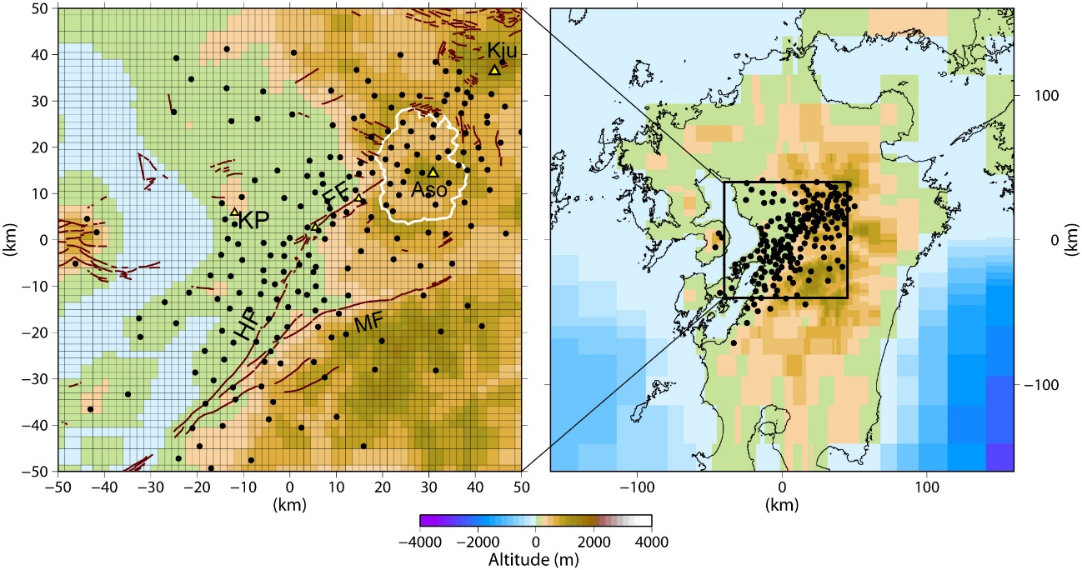
Fig. S1
Mesh used in the 3-D inversion. Solid circles show the 200 measurement sites used in the inversion. HF: Hinagu Fault, FF: Futagawa Fault, MF: Midorikawa Fault, KP: Kumamoto Plain. Other notations are the same as in Fig. 1.

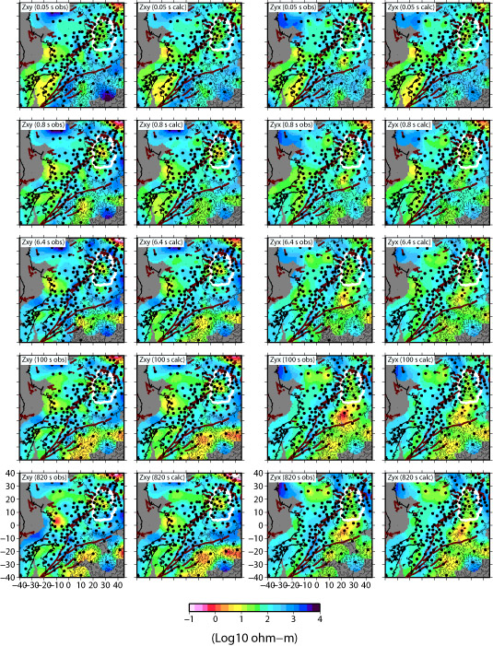
Fig. S2
Apparent resistivity maps of observed (obs.) and calculated (calc.) MT responses at various frequencies. The off-diagonal components (Zxy and Zyx) of the impedance tensor are shown. Other notations are the same as in Fig. 1.

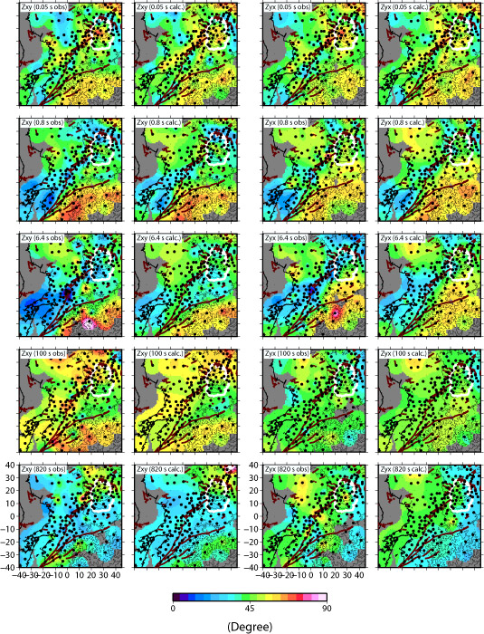
Fig. S3
Phase maps of observed (obs.) and calculated (calc.) MT responses at various frequencies. The off-diagonal components (Zxy and Zyx) of the impedance tensor are shown. Other notations are the same as in Fig. 1.

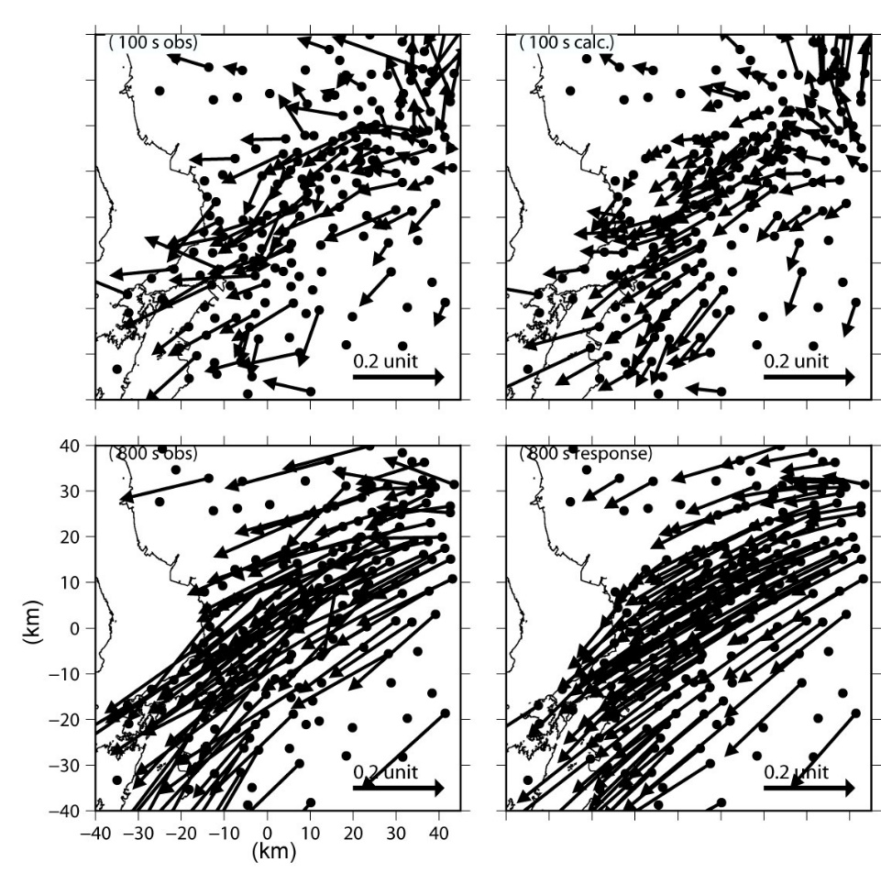
Fig. S4
Induction vector maps (Parkinson criteria) of the observed (obs.) and calculated (calc.) MT responses at 100 s (upper) and 800 s (lower). The induction vectors at the telluric only sites were not used for the inversion.

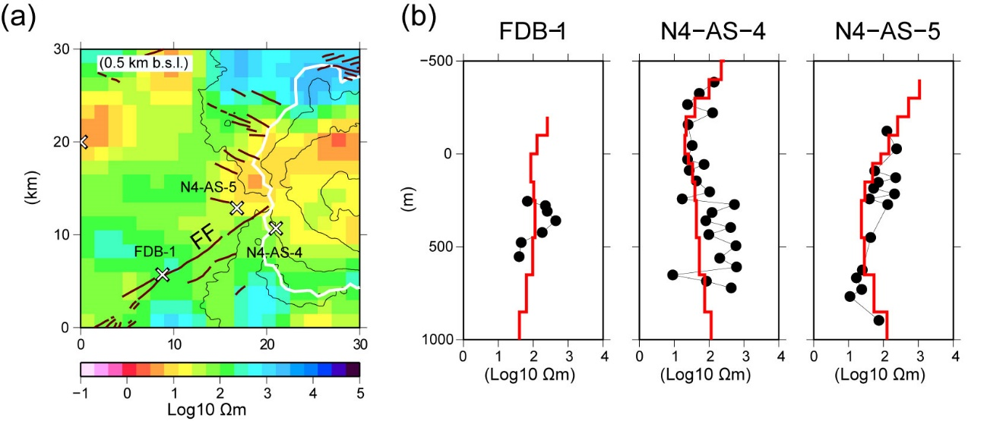

Fig. S5
Well-log data from the drill sites and inverted resistivity structure. (a) Horizontal slices of the 3-D resistivity structure at 0.5 km b.s.l around the drilling sites. White crosses indicate the drilling sites. FF is the Futagawa Fault, which ruptured during the mainshock of the 2016 Kumamoto earthquake sequence. Other notations are the same as in Fig. 1. (b) Well-log data from the drill sites. Solid circles with lines indicate the well-log resistivity data. Red lines indicate the resistivity structure beneath the drilling sites that was determined from the 3-D inversion in this study.

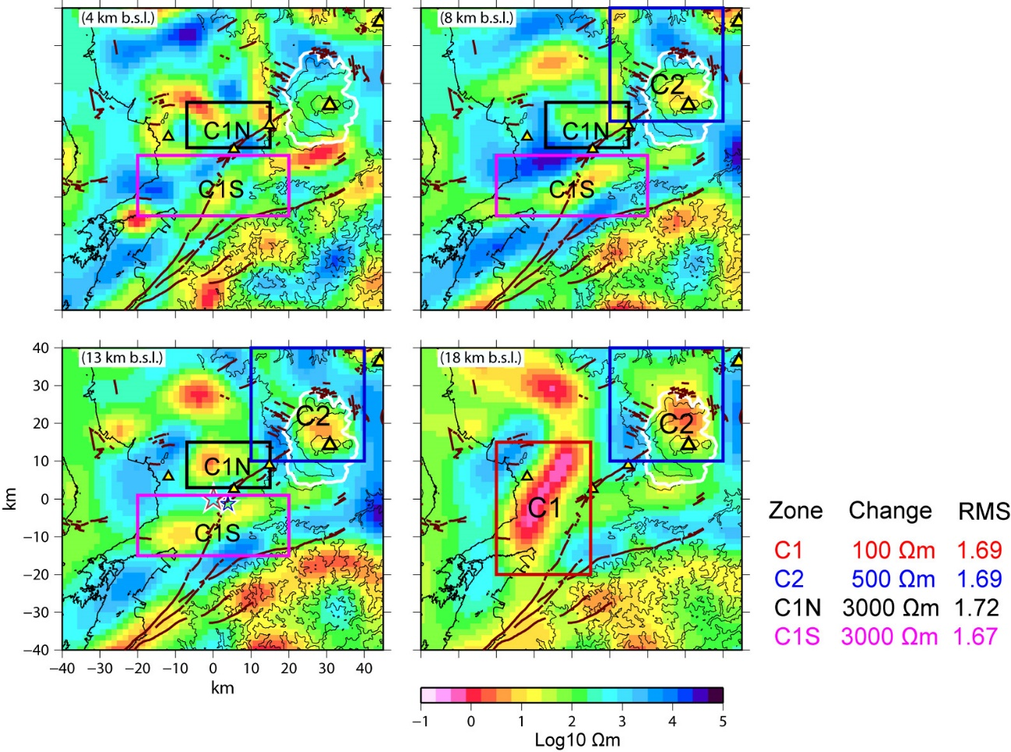
Fig. S6
Sensitivity tests. The ability to detect the four low-resistivity zones discussed in the text is verified by modifying the initial resistivity model. C1: The <100-Ωm cells in the red rectangle (14–42 km b.s.l) were all changed to 100 Ωm. This elimination of C1 resulted in an increase in the RMS misfit from 1.56 to 1.69. C2: The <500-Ωm cells in the blue rectangles (7–42 km b.s.l) were all changed to 500 Ωm. This elimination of C2 resulted in an increase in the RMS misfit from 1.56 to 1.69. C1N: The <3000-Ωm cells in the black rectangles (3–13 km b.s.l) were all changed to 3000 Ωm. This elimination of C1N resulted in an increase in the RMS misfit from 1.56 to 1.72. C1S: The <3000-Ωm cells in the magenta rectangles (3–13 km b.s.l) were all changed to 3000 Ωm. This elimination of C1N resulted in an increase in the RMS misfit from 1.56 to 1.67.

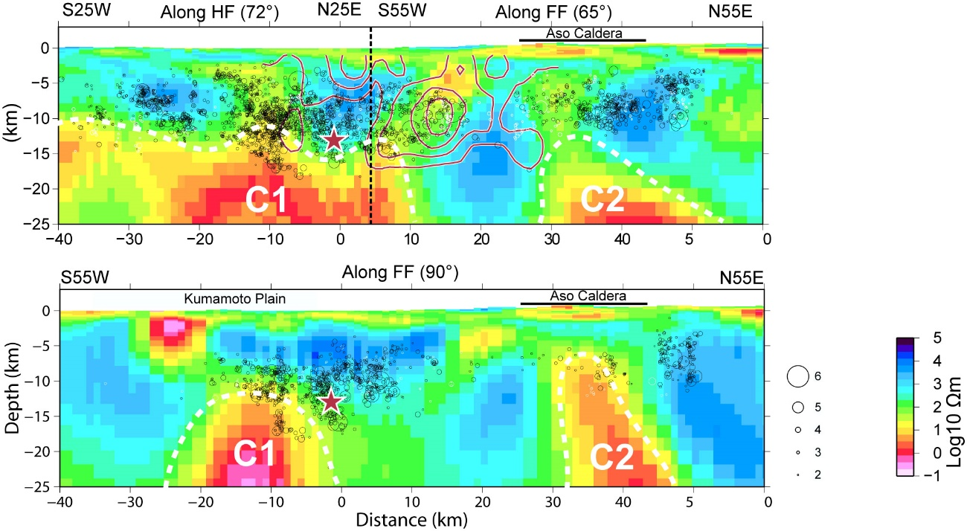

Fig. S7
Comparison of the resistivity structures and seismicity between the dipping slice along the Futugawa and Hinagu faults, where the mainshock rupture occurred (upper; Fig. 3b), and the vertical slice along the Futagawa Fault (lower). C1N is not dominant on the vertical slice beneath the Futagawa Fault, which suggests that the mainshock rupture occurred along the relatively conductive C1N. The other notations are the same as in Fig. 3.

