SUPPORTING INFORMATION

Longitudinal in vivo PET imaging of P2X7R and TSPO neuroinflammation targets and myelin load in the TgF344-AD rat model of Alzheimer’s disease.
Oscar Moreno^{1*}, Izaro Fernández², Sandra Plaza-García¹, Daniel Padro¹, Zuriñe Baz¹, Pedro Ramos-Cabrer^{1,3}, Abraham Martín^{2,3}, Jordi Llop^{1†}.
- CIC biomaGUNE, Basque Research and Technology Alliance (BRTA), Paseo Miramón 182, 20014, San Sebastián, Spain.
- Achucarro Basque Center for Neuroscience, Science Park UPV/EHU, Sede building B. Sarriena, 48940 Leioa, Spain.
- Ikerbasque Basque Foundation for Science, Bilbao, Spain.

Chemicals
Chemicals and solvents were obtained from commercial sources (i.e., AcrosOrganics, Alfa Aesar, Fluka, Merck, Sigma-Aldrich, TCI Europe) and were used without purification unless otherwise stated. Ultrapure water (resistivity > 18MΩcm) was generated using a Milli-Q system (Millipore, Bedford, MA, USA). Precursors and reference compounds for [¹⁸F]JNJ-64413739 were purchased from Chemridge (India). Precursors and reference compounds for [¹⁸F]Florbetaben were purchased from Fluidomica (Portugal). Precursors and reference compounds for [¹⁸F]DPA-714 were purchased from ABX (Germany).
Radiochemistry
Radiosynthesis of [¹⁸F]JNJ-64413739
[¹⁸F]JNJ-64413739 was prepared in a TRACERlab FX_{FN} synthesis module (GE Healthcare, Waukesha, WI, USA) following a previously described method with minor modifications (1). First, [¹⁸F]F⁻ was generated in a Cyclone 18/9 cyclotron (IBA, Belgium) by proton irradiation of ¹⁸O-enriched water via the ¹⁸O(p,n)¹⁸F nuclear reaction, and trapped on a preconditioned Sep-Pak® Accell Plus QMA Light cartridge (Waters, Milford, MA, USA). Then, [¹⁸F]F- was eluted from the cartridge with a mixture of aqueous potassium carbonate solution (3.5 mg/0.5 mL) and a solution of Kryptofix 2.2.2. (15.0 mg) in acetonitrile (1.0 mL) and transferred to the reaction vessel. The aqueous [¹⁸F]F⁻ solution was gradually dried at 60 – 120°C for 15 – 30 min under a N₂ flow to completely remove the water and acetonitrile by azeotropic drying. After complete elimination of the solvent a solution of the precursor (S)-(3-chloro-2-(trifluoromethyl)pyridin-4-yl)(6-methyl-1-(pyrimidin-2-yl)-1,4,6,7-tetrahydro-5H-[1,2,3]triazolo [4,5-c]pyridin-5-yl)methanone (4.0 mg) in anhydrous DMSO (0.7 mL) was added and the mixture was heated at 120°C for 15 min. Following ¹⁸F-fluorination, the crude of reaction was directly transferred to a stainless-steel loop and injected into a high-performance liquid chromatography (HPLC) system with a semi-preparative column (Phenomenex Luna C18 10 × 250 mm, 5 μm) as the stationary phase. A mixture of acetonitrile (ACN with 0.1% trifluoroacetic acid -TFA-)/(MQW with 0.1% TFA), (65/35) was used as a mobile phase under isocratic conditions with a 4 mL/min flow. The desired fraction (retention time = 18.5 min; [¹⁸F]JNJ-64413739 was collected into a separated vessel, diluted with a sodium ascorbate solution (3% w/v, 25 mL) and reformulated using a C-18 light cartridge (Sep-Pak® Light, Waters, Milford, MA, USA). The cartridge containing the product was eluted with pure ethanol (1.0 mL) into the final vial which was directly used for dose formulation. Injected dose was formulated as a saline solution with a maximum 10% ethanol content. Chemical and radiochemical purity were determined by radio- HPLC (Agilent 1200 Series, USA) equipped with a radio-detector (Gabi, Elysia-Raytest, Germany) and a UV-detector (Agilent, USA) connected in series. An Agilent Eclipse XBD-C18 (4.6 × 150 mm, 5 μm) was used as the stationary phase and a mixture of acetonitrile (ACN 0.1% TFA)/(MQW 0.1% TFA) was used as a mobile phase under gradient conditions (0 min [5% ACN]; 0-2 min [5% ACN]; 2-20 min [from 5% to 95% ACN, linear]; 20-24 min [95% ACN]; 24-28 min [from 95% to 5% ACN, linear]) with a 1 mL/min flow. The identity of the product was confirmed with HPLC (retention time = 12.5 min; [¹⁸F]JNJ-64413739). Radiochemical yield was 3.6 ± 0.8% (n = 6; decay-corrected to start of the synthesis) with a radiochemical purity of 99%. Total synthesis time was 70 min.
Radiosynthesis of [¹⁸F]DPA-714
[¹⁸F]DPA-714 was prepared in a TRACERlab FX_{FN} synthesis module (GE Healthcare, Waukesha, WI, USA) following a previously described method with minor modifications (2). First, [¹⁸F]F⁻ was generated in a Cyclone 18/9 cyclotron (IBA, Belgium) by proton irradiation of ¹⁸O-enriched water via the ¹⁸O(p,n)¹⁸F nuclear reaction, and trapped on a preconditioned Sep-Pak® Accell Plus QMA Light cartridge (Waters, Milford, MA, USA). Then, [¹⁸F]F⁻ was eluted from the cartridge with a mixture of aqueous potassium carbonate solution (3.5 mg/0.5 mL) and a solution of Kryptofix 2.2.2. (15.0 mg) in acetonitrile (1.0 mL) and transferred to the reaction vessel. The aqueous [¹⁸F]F⁻ solution was gradually dried at 60 – 120°C for 15 – 30 min under a N₂ flow to completely remove the water and acetonitrile by azeotropic drying. After complete elimination of the solvent a solution of the precursor 2-(4-(3-(2-(diethylamino)-2-oxoethyl)-5,7-dimethyl-1,2,3,3a-tetrahydropyrazolo[1,5-a]pyrimidin-2-yl)phenoxy)ethyl 4- methylbenzenesulfonate (4.0 mg) in anhydrous DMSO (0.7 mL) was added and the mixture was heated at 165°C for 5 min. Following ¹⁸F-fluorination, the crude of reaction was directly transferred to a stainless-steel loop and injected into a high-performance liquid chromatography (HPLC) system with a semi-preparative column (Macherey Nagel 100-7 C18 14 × 250 mm, 10 μm) as the stationary phase. A mixture of acetonitrile (ACN)/ammonium formate 0.1M (70/30) was used as a mobile phase under isocratic conditions with a 7 mL/min flow. The desired fraction (retention time = 12.8 min; [¹⁸F]DPA-714) was collected into a separated vessel, diluted with a sodium ascorbate solution (3% w/v, 25 mL) and reformulated using a C-18 light cartridge (Sep-Pak® Light, Waters, Milford, MA, USA). The cartridge containing the product was eluted with pure ethanol (1.0 mL) into the final vial which was directly used for dose formulation. Injected dose was formulated as a saline solution with a maximum 10% ethanol content. Chemical and radiochemical purity were determined by radio-HPLC (Agilent 1200 Series, USA) equipped with a radio-detector (Gabi, Elysia-Raytest, Germany) and a UV-detector (Agilent, USA) connected in series. An Agilent Eclipse XBD-C18 (4.6 × 150 mm, 5 μm) was used as the stationary phase and a mixture of ACN/ammonium formate 0.1M was used as a mobile phase under gradient conditions (0 min [10% ACN]; 0-1 min [10% ACN]; 1-10 min [from 10 to 70% ACN; linear]; 10-17 min [70% ACN]; 17-19 min [from 70 to 10% ACN; linear]; 19-22 min [10% ACN]) with a 1 mL/min flow. The identity of the product (retention time = 9.4 min; [¹⁸F]DPA-714) was confirmed with the reference standard. Radiochemical yield was 22.3 ± 2.8% (n = 3) with a radiochemical purity of 97% (decay-corrected to start of the synthesis). Total synthesis time was 60 min.
Radiosynthesis of [¹⁸F]Florbetaben
[¹⁸F]Florbetaben was prepared in a TRACERlab FX_{FN} synthesis module (GE Healthcare, Waukesha, WI, USA) following a previously described method with minor modifications (3). First, [¹⁸F]F⁻ was generated in a Cyclone 18/9 cyclotron (IBA, Belgium) by proton irradiation of ¹⁸O-enriched water via the ¹⁸O(p,n)¹⁸F nuclear reaction, and trapped on a preconditioned Sep-Pak® Accell Plus QMA Light cartridge (Waters, Milford, MA, USA). Then, [¹⁸F]F⁻ was eluted from the cartridge with a mixture of aqueous potassium carbonate solution (3.5 mg/0.5 mL) and a solution of Kryptofix 2.2.2. (15.0 mg) in acetonitrile (1.0 mL) and transferred to the reaction vessel. The aqueous [¹⁸F]F⁻ solution was gradually dried at 60 – 120°C for 15 – 30 min under a N₂ flow to completely remove the water and acetonitrile by azeotropic drying. After complete elimination of the solvent a solution of the precursor (methanesulfonic acid 2-{2-[2-(4-{2-[4-(tertbutoxycarbonyl-methyl-amino)-phenyl]-vinyl}-phenoxy)-ethoxy]-ethoxy}-ethylester) (3.0 mg) in anhydrous DMSO (0.7 mL) was added and the mixture was heated at 100°C for 10 min. Following ¹⁸F-fluorination, the reaction crude was subjected to hydrolysis under acidic conditions (HCl 3.3M, 0.25 mL) at 100°C for 10 min and subsequently quenched with a base solution (NaOH 10%, 0.33 mL). The crude of reaction was directly transferred to a stainless-steel loop and injected into a high-performance liquid chromatography (HPLC) system with a semi-preparative column (Macherey Nagel 100-7 C18, 10 × 250 mm, 5 μm) as the stationary phase. A mixture of acetonitrile (ACN)/sodium ascorbate 0.025M (60/40) was used as a mobile phase under isocratic conditions with a 5 mL/min flow. The desired fraction (retention time = 26 min; [¹⁸F]Florbetaben) was collected into a separated vessel, diluted with a sodium ascorbate solution (3% w/v, 25 mL) and reformulated using a C-18 light cartridge (Sep-Pak® Light, Waters, Milford, MA, USA). The cartridge containing the product was eluted with pure ethanol (1.5 mL) into the final vial which was directly used for dose formulation. Injected dose was formulated as a saline solution with a maximum 10% ethanol content. Chemical and radiochemical purity were determined by radio-HPLC (Agilent 1200 Series, USA) equipped with a radio-detector (Gabi, Elysia-Raytest, Germany) and a UV-detector (Agilent, USA) connected in series. An Agilent Eclipse XBD-C18 (4.6 × 150 mm, 5 μm) was used as the stationary phase and a mixture of ACN/sodium ascorbate 0.025M (60/40) was used as a mobile phase under isocratic conditions with a 1 mL/min flow. The identity of the product (retention time = 8.1 min; [¹⁸F]Florbetaben) was confirmed by coelution with the reference standard. Radiochemical yield was 23 ± 12% (n = 9) with a radiochemical purity of 96% (decay-corrected to start of the synthesis). Total synthesis time was 90 min.

Table S1. Animal distribution in the longitudinal PET study. Colored boxes represent individual PET sessions with the specified radiotracer in each animal or brain harvest.
Figure S1. Survival rates during the longitudinal PET study in AD and WT rats. Grey dotted bars indicate periods at which animals were sacrificed for ex vivo studies and therefore removed from the survival analysis (m = months). No significant difference in percent survival was observed between AD and WT rats during the study (p = 0.8940, Log-rank Mantel-Cox test).
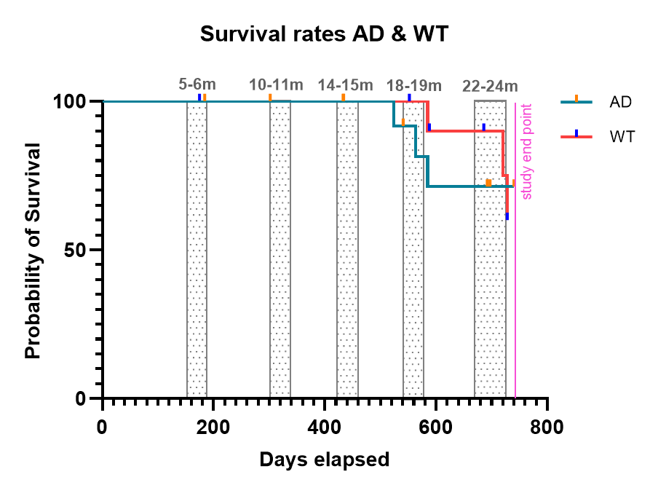

Table S2. Causes of animal mortality/sacrifice during the longitudinal PET study in AD and WT rats. Numbers indicate the animals that died from each cause. Age of death (in days) are indicated in brackets. # Indicates animals that were used for ex vivo studies after sacrifice.
Type | Humane endpoint death |  |  | Accidental death | Spontaneous death
Cause | Weak breathing | Not responding to estimlus | Subcutaneous tumour (forelimb) | Spontaneous dead after radiotracer administration | Casual death (overnight)
AD | 1 (524 days) | 1 (563 days)# | 1 (585 days)# | 2 (541, 541 days) | 0
WT | 0 | 0 | 0 | 0 | 3 (585, 720, 728)

Figure S2. Percentage of animals classified according to death causes during the longitudinal PET study in AD and WT rats.
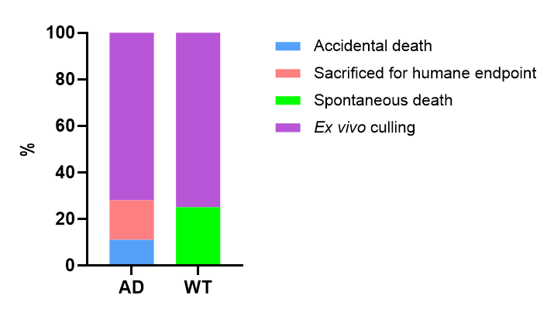

Figure S3. Weight variation in the longitudinal PET study for AD and WT rats (mean ± SD). Statistical analysis using a two-tailed unpaired t-test with Welch’s correction. Differences were concluded significant for p values < 0. 05: p < 0.05, *; p < 0.01, **, p < 0.001, ***; and p < 0.0001, ****; ns = non-significant.
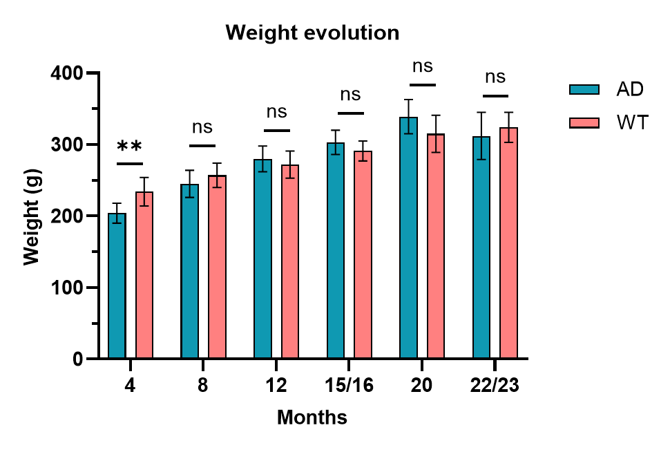
Table S3. Weight and injected doses in the longitudinal PET study with [¹⁸F]JNJ-64413739.
AD animals
8 months | Animal ID | Weight (g) | Injected dose (uCi) | Injected dose (MBq)
 | 1119_03 | 259 | 63 | 2.3
 | 1119_04 | 238 | 84 | 3.1
 | 1119_05 | 276 | 81 | 3.0
 | 1119_10 | 271 | 99 | 3.7
 | 1119_11 | 262 | 90 | 3.3
 | 1119_15 | 261 | 117 | 4.3
 | 1119_16 | 232 | 54 | 2.0
 | 1119_17 | 233 | 113 | 4.2
 | 1119_18 | 232 | 112 | 4.2
 | AVG | 252 | 90 | 3.3
 | STDV | 18 | 23 | 0.8
 | Min | 232 | 54 | 2.0
 | Max | 276 | 117 | 4.3

15 months | Animal ID | Weight (g) | Injected dose (uCi) | Injected dose (MBq)
 | 1119_01 | 297 | 82 | 3.0
 | 1119_02 | 302 | 96 | 3.6
 | 1119_04 | 273 | 84 | 3.1
 | 1119_05 | 329 | 89 | 3.3
 | 1119_08 | 293 | 80 | 3.0
 | 1119_09 | 296 | 80 | 3.0
 | 1119_10 | 314 | 75 | 2.8
 | 1119_11 | 313 | 72 | 2.7
 | 1119_15 | 310 | 75 | 2.8
 | 1119_16 | 290 | 66 | 2.4
 | AVG | 302 | 80 | 3.0
 | STDV | 16 | 9 | 0.3
 | Min | 273 | 66 | 2.4
 | Max | 329 | 96 | 3.6

22 months | Animal ID | Weight (g) | Injected dose (uCi) | Injected dose (MBq)
 | 1119_03 | 336 | 75 | 2.8
 | 1119_04 | 286 | 70 | 2.6
 | 1119_05 | 357 | 65 | 2.4
 | 1119_08 | 286 | 69 | 2.6
 | 1119_11 | 267 | 112 | 4.1
 | 1119_12 | 356 | 142 | 5.3
 | 1119_15 | 316 | 120 | 4.4
 | AVG | 315 | 93 | 3.5
 | STDV | 36 | 31 | 1.1
 | Min | 267 | 65 | 2.4
 | Max | 357 | 142 | 5.3

WT animals
8 months | Animal ID | Weight (g) | Injected dose (uCi) | Injected dose (MBq)
 | 1119_21 | 268 | 129 | 4.8
 | 1119_22 | 250 | 115 | 4.3
 | 1119_23 | 238 | 112 | 4.2
 | 1119_25 | 283 | 108 | 4.0
 | 1119_26 | 272 | 90 | 3.3
 | 1119_27 | 270 | 109 | 4.0
 | 1119_28 | 235 | 72 | 2.7
 | AVG | 259 | 105 | 3.9
 | STDV | 18 | 19 | 0.7
 | Min | 235 | 72 | 2.7
 | Max | 283 | 129 | 4.8

15 months | Animal ID | Weight (g) | Injected dose (uCi) | Injected dose (MBq)
 | 1119_21 | 296 | 96 | 3.6
 | 1119_22 | 270 | 77 | 2.8
 | 1119_23 | 269 | 56 | 2.1
 | 1119_24 | 311 | 72 | 2.7
 | 1119_25 | 320 | 84 | 3.1
 | 1119_26 | 296 | 75 | 2.8
 | 1119_27 | 295 | 73 | 2.7
 | 1119_28 | 259 | 78 | 2.9
 | AVG | 290 | 76 | 2.8
 | STDV | 22 | 11 | 0.4
 | Min | 259 | 56 | 2.1
 | Max | 320 | 96 | 3.6
22 months | Animal ID | Weight (g) | Injected dose (uCi) | Injected dose (MBq)
 | 1119_21 | 326 | 85 | 3.1
 | 1119_23 | 307 | 86 | 3.2
 | 1119_24 | 348 | 93 | 3.4
 | 1119_26 | 345 | 93 | 3.4
 | 1119_27 | 350 | 91 | 3.4
 | 1119_29 | 312 | 80 | 3.0
 | AVG | 331 | 88 | 3.3
 | STDV | 19 | 5 | 0.2
 | Min | 307 | 80 | 3.0
 | Max | 350 | 93 | 3.4

Table S4. Weight and injected doses in the PET study with [¹⁸F]DPA-714.
AD animals
22 months | Animal ID | Weight (g) | Injected dose (uCi) | Injected dose (MBq)
 | 1119_03 | 332 | 131 | 4.9
 | 1119_04 | 275 | 112 | 4.1
 | 1119_08 | 278 | 79 | 2.9
 | 1119_11 | 263 | 117 | 4.3
 | 1119_12 | 350 | 99 | 3.7
 | 1119_15 | 318 | 113 | 4.2
 | AVG | 310 | 110 | 4.1
 | STDV | 38 | 16 | 0.6
 | Min | 263 | 79 | 2.9
 | Max | 356 | 131 | 4.9

WT animals
22 months | Animal ID | Weight (g) | Injected dose (uCi) | Injected dose (MBq)
 | 1119_21 | 323 | 116 | 4.3
 | 1119_23 | 300 | 79 | 2.9
 | 1119_24 | 345 | 80 | 3.0
 | 1119_26 | 340 | 45 | 1.7
 | 1119_28 | 274 | 98 | 3.6
 | AVG | 316 | 84 | 3.1
 | STDV | 30 | 26 | 1.0
 | Min | 274 | 45 | 1.7
 | Max | 345 | 116 | 4.3

Table S5. Weight and injected doses in the longitudinal PET study with [¹⁸F]Florbetaben.
AD animals
4 months | Animal ID | Weight (g) | Injected dose (uCi) | Injected dose (MBq)
 | 1119_01 | 186 | 215 | 8.0
 | 1119_02 | 204 | 130 | 4.8
 | 1119_03 | 212 | 164 | 6.1
 | 1119_04 | 194 | 190 | 7.0
 | 1119_05 | 223 | 151 | 5.6
 | 1119_08 | 195 | 163 | 6.0
 | 1119_09 | 184 | 127 | 4.7
 | 1119_12 | 204 | 84 | 3.1
 | 1119_13 | 231 | 72 | 2.7
 | 1119_14 | 210 | 74 | 2.7
 | AVG | 204 | 137 | 5.1
 | STDV | 15 | 49 | 1.8
 | Min | 184 | 72 | 2.7
 | Max | 231 | 215 | 8.0

8 months | Animal ID | Weight (g) | Injected dose (uCi) | Injected dose (MBq)
 | 1119_01 | 216 | 109 | 4.0
 | 1119_02 | 237 | 69 | 2.5
 | 1119_03 | 255 | 69 | 2.6
 | 1119_04 | 230 | 132 | 4.9
 | 1119_05 | 276 | 76 | 2.8
 | 1119_06 | 267 | 101 | 3.7
 | 1119_07 | 206 | 150 | 5.5
 | 1119_08 | 217 | 84 | 3.1
 | 1119_09 | 236 | 127 | 4.7
 | 1119_12 | 235 | 107 | 3.9
 | AVG | 238 | 102 | 3.8
 | STDV | 23 | 28 | 1.0
 | Min | 206 | 69 | 2.5
 | Max | 276 | 150 | 5.5

12 months | Animal ID | Weight (g) | Injected dose (uCi) | Injected dose (MBq)
 | 1119_01 | 248 | 149 | 5.5
 | 1119_02 | 265 | 81 | 3.0
 | 1119_03 | 292 | 94 | 3.5
 | 1119_04 | 259 | 84 | 3.1
 | 1119_05 | 305 | 95 | 3.5
 | 1119_08 | 268 | 101 | 3.7
 | 1119_09 | 277 | 63 | 2.3
 | 1119_10 | 298 | 76 | 2.8
 | 1119_11 | 287 | 123 | 4.6
 | 1119_12 | 297 | 143 | 5.3
 | AVG | 280 | 101 | 3.7
 | STDV | 19 | 29 | 1.1
 | Min | 248 | 63 | 2.3
 | Max | 305 | 149 | 5.5

16 months | Animal ID | Weight (g) | Injected dose (uCi) | Injected dose (MBq)
 | 1119_01 | 296 | 80 | 3.0
 | 1119_02 | 296 | 110 | 4.1
 | 1119_03 | 310 | 103 | 3.8
 | 1119_04 | 269 | 93 | 3.4
 | 1119_05 | 321 | 91 | 3.4
 | 1119_08 | 288 | 114 | 4.2
 | 1119_09 | 288 | 114 | 4.2
 | 1119_10 | 318 | 107 | 4.0
 | 1119_11 | 319 | 107 | 4.0
 | 1119_12 | 331 | 116 | 4.3
 | AVG | 304 | 104 | 3.8
 | STDV | 19 | 12 | 0.4
 | Min | 269 | 80 | 3.0
 | Max | 331 | 116 | 4.3

20 months | Animal ID | Weight (g) | Injected dose (uCi) | Injected dose (MBq)
 | 1119_03 | 341 | 80 | 3.0
 | 1119_04 | 298 | 101 | 3.7
 | 1119_05 | 369 | 120 | 4.4
 | 1119_08 | 291 | 113 | 4.2
 | 1119_11 | 346 | 114 | 4.2
 | 1119_12 | 361 | 143 | 5.3
 | 1119_15 | 319 | 197 | 7.3
 | AVG | 332 | 124 | 4.6
 | STDV | 30 | 37 | 1.4
 | Min | 291 | 80 | 3.0
 | Max | 369 | 197 | 7.3

WT animals
4 months | Animal ID | Weight (g) | Injected dose (uCi) | Injected dose (MBq)
 | 1119_19 | 203 | 144 | 5.3
 | 1119_20 | 218 | 87 | 3.2
 | 1119_21 | 255 | 140 | 5.2
 | 1119_22 | 248 | 111 | 4.1
 | 1119_23 | 214 | 114 | 4.2
 | 1119_24 | 255 | 115 | 4.3
 | 1119_25 | 258 | 111 | 4.1
 | 1119_26 | 240 | 99 | 3.7
 | 1119_27 | 238 | 87 | 3.2
 | 1119_28 | 207 | 83 | 3.1
 | AVG | 234 | 109 | 4.0
 | STDV | 21 | 21 | 0.8
 | Min | 203 | 83 | 3.1
 | Max | 258 | 144 | 5.3

8 months | Animal ID | Weight (g) | Injected dose (uCi) | Injected dose (MBq)
 | 1119_20 | 255 | 54 | 2.0
 | 1119_21 | 267 | 92 | 3.4
 | 1119_22 | 250 | 126 | 4.7
 | 1119_23 | 233 | 132 | 4.9
 | 1119_24 | 274 | 162 | 6.0
 | 1119_25 | 274 | 130 | 4.8
 | 1119_26 | 268 | 114 | 4.2
 | 1119_27 | 264 | 112 | 4.1
 | 1119_28 | 225 | 97 | 3.6
 | 1119_29 | 244 | 88 | 3.3
 | AVG | 255 | 111 | 4.1
 | STDV | 17 | 30 | 1.1
 | Min | 225 | 54 | 2.0
 | Max | 274 | 162 | 6.0

12 months | Animal ID | Weight (g) | Injected dose (uCi) | Injected dose (MBq)
 | 1119_20 | 288 | 104 | 3.9
 | 1119_21 | 265 | 117 | 4.3
 | 1119_22 | 265 | 111 | 4.1
 | 1119_23 | 246 | 117 | 4.3
 | 1119_24 | 291 | 101 | 3.7
 | 1119_25 | 301 | 90 | 3.3
 | 1119_26 | 276 | 77 | 2.9
 | 1119_28 | 246 | 64 | 2.4
 | AVG | 272 | 98 | 3.6
 | STDV | 20 | 19 | 0.7
 | Min | 246 | 64 | 2.4
 | Max | 301 | 117 | 4.3

16 months | Animal ID | Weight (g) | Injected dose (uCi) | Injected dose (MBq)
 | 1119_20 | 301 | 67 | 2.5
 | 1119_21 | 292 | 85 | 3.2
 | 1119_22 | 276 | 95 | 3.5
 | 1119_23 | 260 | 70 | 2.6
 | 1119_24 | 316 | 73 | 2.7
 | 1119_25 | 331 | 67 | 2.5
 | 1119_26 | 291 | 97 | 3.6
 | 1119_27 | 295 | 91 | 3.3
 | 1119_28 | 258 | 111 | 4.1
 | 1119_29 | 311 | 77 | 2.9
 | AVG | 293 | 83 | 3.1
 | STDV | 24 | 15 | 0.5
 | Min | 258 | 67 | 2.5
 | Max | 331 | 111 | 4.1

20 months | Animal ID | Weight (g) | Injected dose (uCi) | Injected dose (MBq)
 | 1119_21 | 301 | 74 | 2.7
 | 1119_22 | 327 | 65 | 2.4
 | 1119_23 | 283 | 108 | 4.0
 | 1119_24 | 344 | 93 | 3.4
 | 1119_26 | 337 | 81 | 3.0
 | 1119_27 | 338 | 96 | 3.5
 | 1119_28 | 267 | 104 | 3.9
 | 1119_29 | 319 | 123 | 4.6
 | AVG | 315 | 93 | 3.4
 | STDV | 28 | 19 | 0.7
 | Min | 267 | 65 | 2.4
 | Max | 344 | 123 | 4.6

Figure S4. Schiffer-T2 MRI template and selected volumes of interest (VOIs) used for PET imaging quantification.
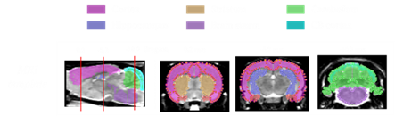

Figure S5. Averaged SUV time activity curves (TACs) in the longitudinal PET study with [¹⁸F]JNJ-64413739 for AD (left graph column) and WT (right graph column) animals at different time points and brain regions.
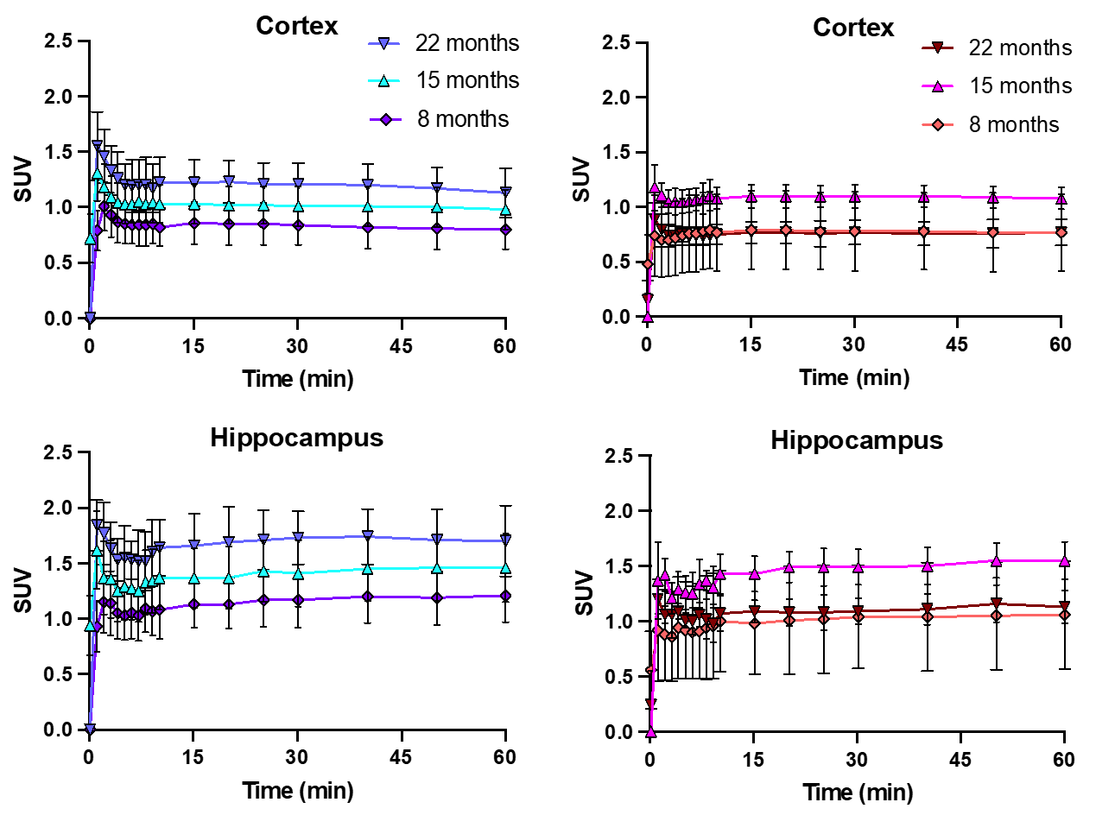

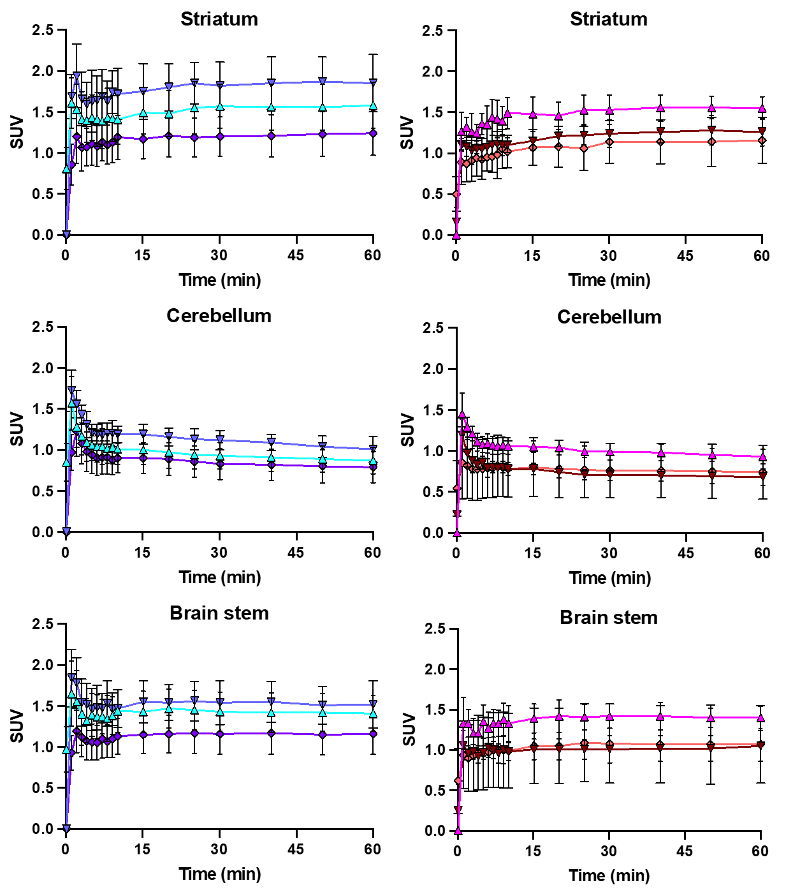

Figure S6. Averaged SUV time activity curves (TACs) in the PET study with [¹⁸F]DPA-714 for AD (left and WT animals at 22 months of age in different brain regions.
Table S5. SUV values in the longitudinal [¹⁸F]JNJ-64413739 PET study, 40 to 60 min post-injection at different ages and regions for both groups (average ± SD).
WT group | 8 months  (n = 7) |  |  | 15 months  (n = 9) |  |  | 22 months  (n = 6)
Cortex | 0,89 | ± | 0,18 | 1,09 | ± | 0,10 | 0,77 | ± | 0,12
Hippocampus | 1,20 | ± | 0,27 | 1,53 | ± | 0,16 | 1,13 | ± | 0,15
Striatum | 1,31 | ± | 0,28 | 1,56 | ± | 0,14 | 1,27 | ± | 0,16
Cerebellum | 0,86 | ± | 0,15 | 0,95 | ± | 0,09 | 0,69 | ± | 0,09
Brain stem | 1,22 | ± | 0,23 | 1,41 | ± | 0,14 | 1,03 | ± | 0,17

AD group | 8 months  (n = 8) |  |  | 15 months  (n = 9) |  |  | 22 months  (n = 7)
Cortex | 0,87 | ± | 0,11 | 1,05 | ± | 0,07 | 1,17 | ± | 0,52
Hippocampus | 1,28 | ± | 0,10 | 1,53 | ± | 0,17 | 1,72 | ± | 0,77
Striatum | 1,31 | ± | 0,12 | 1,64 | ± | 0,15 | 1,86 | ± | 0,83
Cerebellum | 0,85 | ± | 0,12 | 0,93 | ± | 0,08 | 1,05 | ± | 0,47
Brain stem | 1,23 | ± | 0,13 | 1,48 | ± | 0,15 | 1,53 | ± | 0,71

Table S6. SUVR values (cerebellum as reference) in the longitudinal [¹⁸F]JNJ-64413739 PET study, 40 to 60 min post-injection at different ages and regions for both groups (average ± SD).

WT group | 8 months  (n = 7) |  |  | 15 months  (n = 9) |  |  | 22 months  (n = 6)
Cortex | 1,04 | ± | 0,10 | 1,14 | ± | 0,06 | 1,11 | ± | 0,08
Hippocampus | 1,40 | ± | 0,20 | 1,61 | ± | 0,14 | 1,66 | ± | 0,26
Striatum | 1,54 | ± | 0,26 | 1,64 | ± | 0,16 | 1,85 | ± | 0,22
Brain stem | 1,44 | ± | 0,23 | 1,48 | ± | 0,16 | 1,50 | ± | 0,24

AD group | 8 months  (n = 8) |  |  | 15 months  (n = 9) |  |  | 22 months  (n = 7)
Cortex | 1,02 | ± | 0,05 | 1,13 | ± | 0,05 | 1,11 | ± | 0,09
Hippocampus | 1,51 | ± | 0,16 | 1,65 | ± | 0,18 | 1,64 | ± | 0,10
Striatum | 1,54 | ± | 0,14 | 1,76 | ± | 0,13 | 1,77 | ± | 0,15
Brain stem | 1,46 | ± | 0,15 | 1,58 | ± | 0,10 | 1,46 | ± | 0,13

Table S7. SUV values in the [¹⁸F]DPA-714 PET study, 45 to 60 min post-injection at 22 months of age and regions for both groups (average ± SD).

WT group | 22 months  (n = 5)
Cortex | 0,53 | ± | 0,10
Hippocampus | 0,57 | ± | 0,12
Striatum | 0,62 | ± | 0,14
Cerebellum | 0,67 | ± | 0,11
Brain stem | 0,80 | ± | 0,18

AD group | 22 months  (n = 6)
Cortex | 0,91 | ± | 0,08
Hippocampus | 0,92 | ± | 0,15
Striatum | 0,97 | ± | 0,11
Cerebellum | 1,08 | ± | 0,11
Brain stem | 1,15 | ± | 0,14

Table S8. SUV values in the longitudinal [¹⁸F]Florbetaben PET study at different ages and regions for both groups (average ± SD).

WT group | 4 months  (n = 10) |  |  | 8 months  (n = 10) |  |  | 12 months  (n = 10) |  |  | 16 months  (n = 10) |  |  | 20 months  (n = 8)
Cortex | 0,77 | ± | 0,07 | 0,84 | ± | 0,11 | 0,76 | ± | 0,14 | 0,76 | ± | 0,05 | 0,87 | ± | 0,09
Hippocampus | 1,06 | ± | 0,09 | 1,14 | ± | 0,19 | 0,97 | ± | 0,16 | 1,02 | ± | 0,10 | 1,15 | ± | 0,16
Striatum | 1,16 | ± | 0,11 | 1,21 | ± | 0,19 | 1,11 | ± | 0,14 | 1,09 | ± | 0,08 | 1,26 | ± | 0,17
Cerebellum | 1,00 | ± | 0,10 | 1,05 | ± | 0,14 | 0,89 | ± | 0,18 | 0,95 | ± | 0,07 | 1,07 | ± | 0,12
Brain stem | 1,24 | ± | 0,12 | 1,47 | ± | 0,24 | 1,24 | ± | 0,21 | 1,28 | ± | 0,11 | 1,46 | ± | 0,20

AD group | 4 months  (n = 10) |  |  | 8 months  (n = 10) |  |  | 12 months  (n =10) |  |  | 16 months  (n = 10) |  |  | 20 months  (n = 7)
Cortex | 0,75 | ± | 0,13 | 0,76 | ± | 0,14 | 0,75 | ± | 0,08 | 0,76 | ± | 0,08 | 0,75 | ± | 0,17
Hippocampus | 0,92 | ± | 0,19 | 0,95 | ± | 0,16 | 1,00 | ± | 0,09 | 1,00 | ± | 0,12 | 1,02 | ± | 0,23
Striatum | 0,95 | ± | 0,17 | 0,98 | ± | 0,18 | 1,04 | ± | 0,11 | 1,08 | ± | 0,12 | 0,99 | ± | 0,22
Cerebellum | 0,90 | ± | 0,20 | 0,93 | ± | 0,16 | 0,95 | ± | 0,10 | 0,94 | ± | 0,13 | 0,96 | ± | 0,21
Brain stem | 1,15 | ± | 0,30 | 1,20 | ± | 0,21 | 1,32 | ± | 0,12 | 1,29 | ± | 0,13 | 1,22 | ± | 0,30

Table S9. SUVR values (cerebellum as reference) in the longitudinal [¹⁸F]Florbetaben PET study at different ages and regions for both groups (average ± SD).

WT group | 4 months  (n = 10) |  |  | 8 months  (n = 10) |  |  | 12 months  (n = 10) |  |  | 16 months  (n = 10) |  |  | 20 months  (n = 8)
Cortex | 0,77 | ± | 0,04 | 0,80 | ± | 0,02 | 0,87 | ± | 0,08 | 0,81 | ± | 0,03 | 0,81 | ± | 0,03
Hippocampus | 1,06 | ± | 0,05 | 1,08 | ± | 0,08 | 1,10 | ± | 0,08 | 1,09 | ± | 0,08 | 1,08 | ± | 0,05
Striatum | 1,16 | ± | 0,09 | 1,16 | ± | 0,08 | 1,27 | ± | 0,19 | 1,16 | ± | 0,07 | 1,18 | ± | 0,06
Brain stem | 1,25 | ± | 0,12 | 1,40 | ± | 0,08 | 1,41 | ± | 0,12 | 1,37 | ± | 0,08 | 1,36 | ± | 0,10

AD group | 4 months  (n = 10) |  |  | 8 months  (n = 10) |  |  | 12 months  (n =10) |  |  | 16 months  (n = 10) |  |  | 20 months  (n = 7)
Cortex | 0,85 | ± | 0,07 | 0,82 | ± | 0,06 | 0,79 | ± | 0,02 | 0,82 | ± | 0,05 | 0,79 | ± | 0,03
Hippocampus | 1,03 | ± | 0,05 | 1,02 | ± | 0,04 | 1,06 | ± | 0,06 | 1,06 | ± | 0,07 | 1,07 | ± | 0,03
Striatum | 1,07 | ± | 0,11 | 1,06 | ± | 0,08 | 1,10 | ± | 0,06 | 1,15 | ± | 0,09 | 1,04 | ± | 0,06
Brain stem | 1,26 | ± | 0,07 | 1,29 | ± | 0,07 | 1,40 | ± | 0,08 | 1,38 | ± | 0,09 | 1,26 | ± | 0,05

Figure S7. Bar plot showing the averaged percentage of self-blocking (homologous blocking) with [¹⁸F]JNJ-64413739 per region. Dots indicate individual animals.

Figure S8. Bar plot showing the averaged percentage of self-blocking (homologous blocking) with [¹⁸F]DPA-714 per region. Dots indicate individual animals.

Figure S9. Bar plot showing the percentage of self-blocking (homologous blocking) with [¹⁸F]Florbetaben per region (n = 1).

Figure S10. Representative micrographs of microglia (Iba1) and P2X₇R in the cerebellum of AD tissue at 23 months old. Dotted lines indicate the boundries between grey matter (GM) and white matter (WM). Scale bars: 200 µm
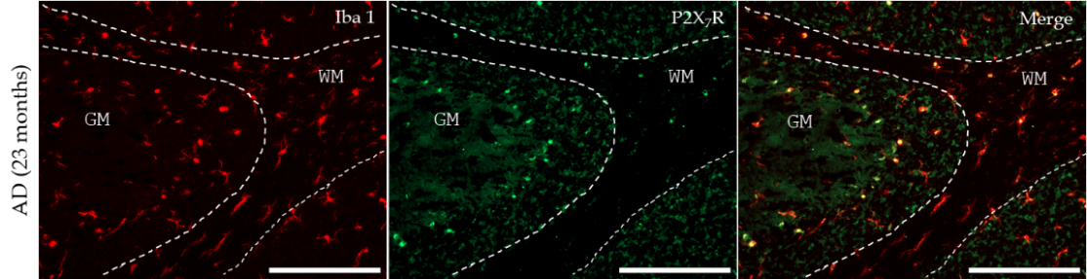

Figure S11. Fluorescent microscopy images of a 23 months-old AD rat stained with Thioflavin in the cortex (A), hippocampus (B), cerebellum (C) and the brain stem (D) with a whole slice coronal image (E) for reference (ca. -2.30 of Bregma).
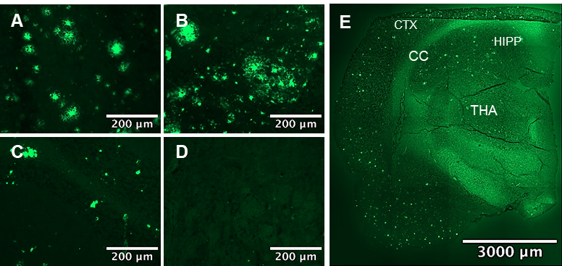

Figure S12. Fluorescent microscopy images of brain slices stained with Florbetaben in a whole slice coronal image of a 10-month-old AD rat (A) (ca. -5.20 of Bregma) and a 22-month-old WT rat (B) (ca. -2.30 of Bregma). (C) Florbetaben-stained amyloid plaques in AD tissue. (D) Coronal whole slice image of the cerebellum and brain stem of a 22-month-old WT rat (ca. -10.06 of Bregma). Staining of Aβ plaques and white matter is indicated by red and white arrows, respectively.
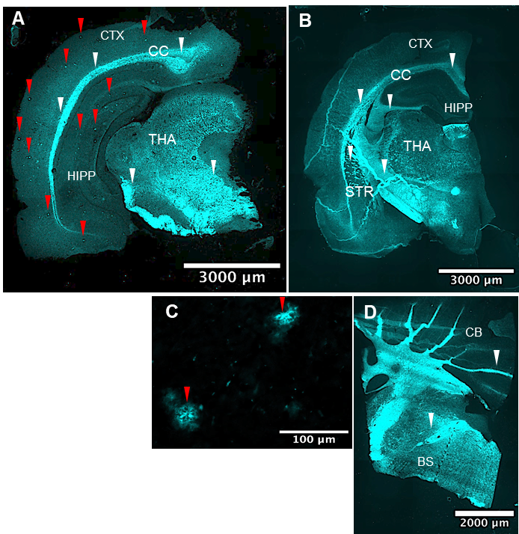

Figure S13. A) Coronal whole slice of a 19-month old AD rat (ca. -2.30 of Bregma) stained with Luxol fast blue including the corpus callosum (B), striatum (C) and cortex (D). E) Coronal whole slice of a 20-month old WT rat (ca. -2.30 of Bregma) stained with Luxol fast blue including the corpus callosum (F), striatum (G) and cortex (H). Scale bars = 350 µm unless indicated otherwise.
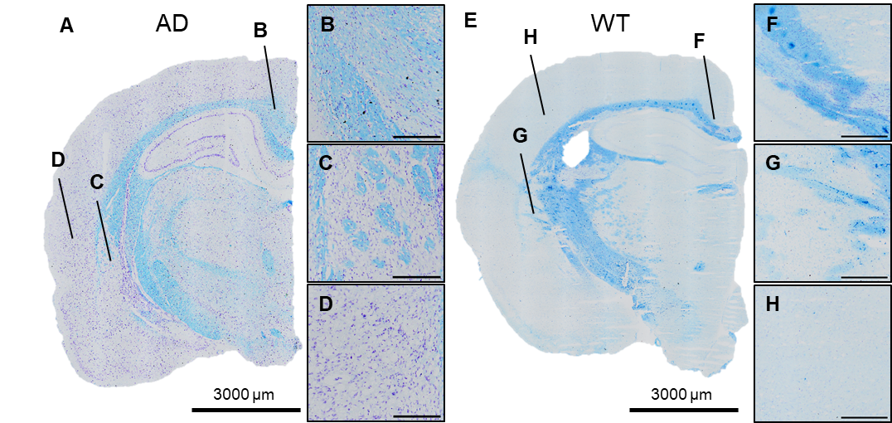

REFERENCES
1. Berdyyeva T, Xia C, Taylor N, He Y, Chen G, Huang C, et al. PET Imaging of the P2X7 Ion Channel with a Novel Tracer [18F]JNJ-64413739 in a Rat Model of Neuroinflammation. Mol Imaging Biol. 2019 Oct 1;21(5):871–8.
2. Damont A, Hinnen F, Kuhnast B, Schöllhorn-Peyronneau MA, James M, Luus C, et al. Radiosynthesis of [18F]DPA-714, a selective radioligand for imaging the translocator protein (18 kDa) with PET. J Labelled Comp Radiopharm. 2008;51(7):286–92.
3. Rejc L, Gómez-Vallejo V, Joya A, Moreno O, Egimendia A, Castellnou P, et al. Longitudinal evaluation of a novel BChE PET tracer as an early in vivo biomarker in the brain of a mouse model for Alzheimer disease. 2021;11(13):13. Available from: http://www.thno.org://creativecommons.org/licenses/by/4.0/

