Supplementary material of:

Can we quickly calculate reliable earthquake parameters from citizen testimonies?

Gianfranco Vannucci^{1*}, Remy Bossu², Matthieu Landès², Paolo Gasperini^{4,1}

¹ Istituto Nazionale di Geofisica e Vulcanologia, Sezione di Bologna, Italy
² Euro-Mediterranean Seismological Centre, Arpajon Cedex, France
³ CEA, DAM, DIF, F-91297 Arpajon, France
⁴ Dipartimento di Fisica e Astronomia, Università di Bologna, Italy

* Corresponding author

Declaration of Competing Interests:

The authors acknowledge there are no conflicts of interest recorded.

Description of the Supplemental Material

This supplementary material contains figures that provide further information and details of the main text.
Captions report image information using abbreviations and acronyms:
IDPs: individual intensity data points, i.e. the original intensities provided by citizen.
DB2-mn20: DB=method of cluster (DBSCAN, Ester et al., 1996); 2= 2km of radius (otherwise 1 km, 0.5 km), mn20=trimmed mean 20%, i.e. IDPs sorted in intensity, excluding the 20% of the tails of the distribution of IDPs.
MDPs: Macroseismic data Points, i.e. intensity at the scale of a locality after clustering the original IDPs (eg. DB method with radius 2 km) and deriving the corresponding intensity by central tendency estimators (eg. trimmed mean 20%).
W, EU, US, SA, AO, AF: macro-areas acronyms for worldwide (W), Europe (EU), North America (US), South America (SA), Asia and Oceania (AO), Africa(AF), according to Vannucci et al. (2023).
BOXER-0: method 0 of BOXER code (Gasperini et al., 2010): Barycentre of the sites with the most severe effects, comparable to a centroid of the area of deformation or maximum slip.
BOXER-1: method 0 of BOXER code (Gasperini et al., 2010): centre of the entire intensity distribution by minimizing the squared residuals of an attenuation function e.g. Pasolini et al. (2008).
Minstr or Mw: instrumental magnitude provide by EMSC.
Mm: macroseismic magnitude computed in this work.
dM: difference of Magnitude (macroseismic magnitude vs instrumental one).
30s, 2m, 1d (and similar): time intervals in seconds (s), minutes (m) or days (d) with respect to the origin time of eartquakes (T0).

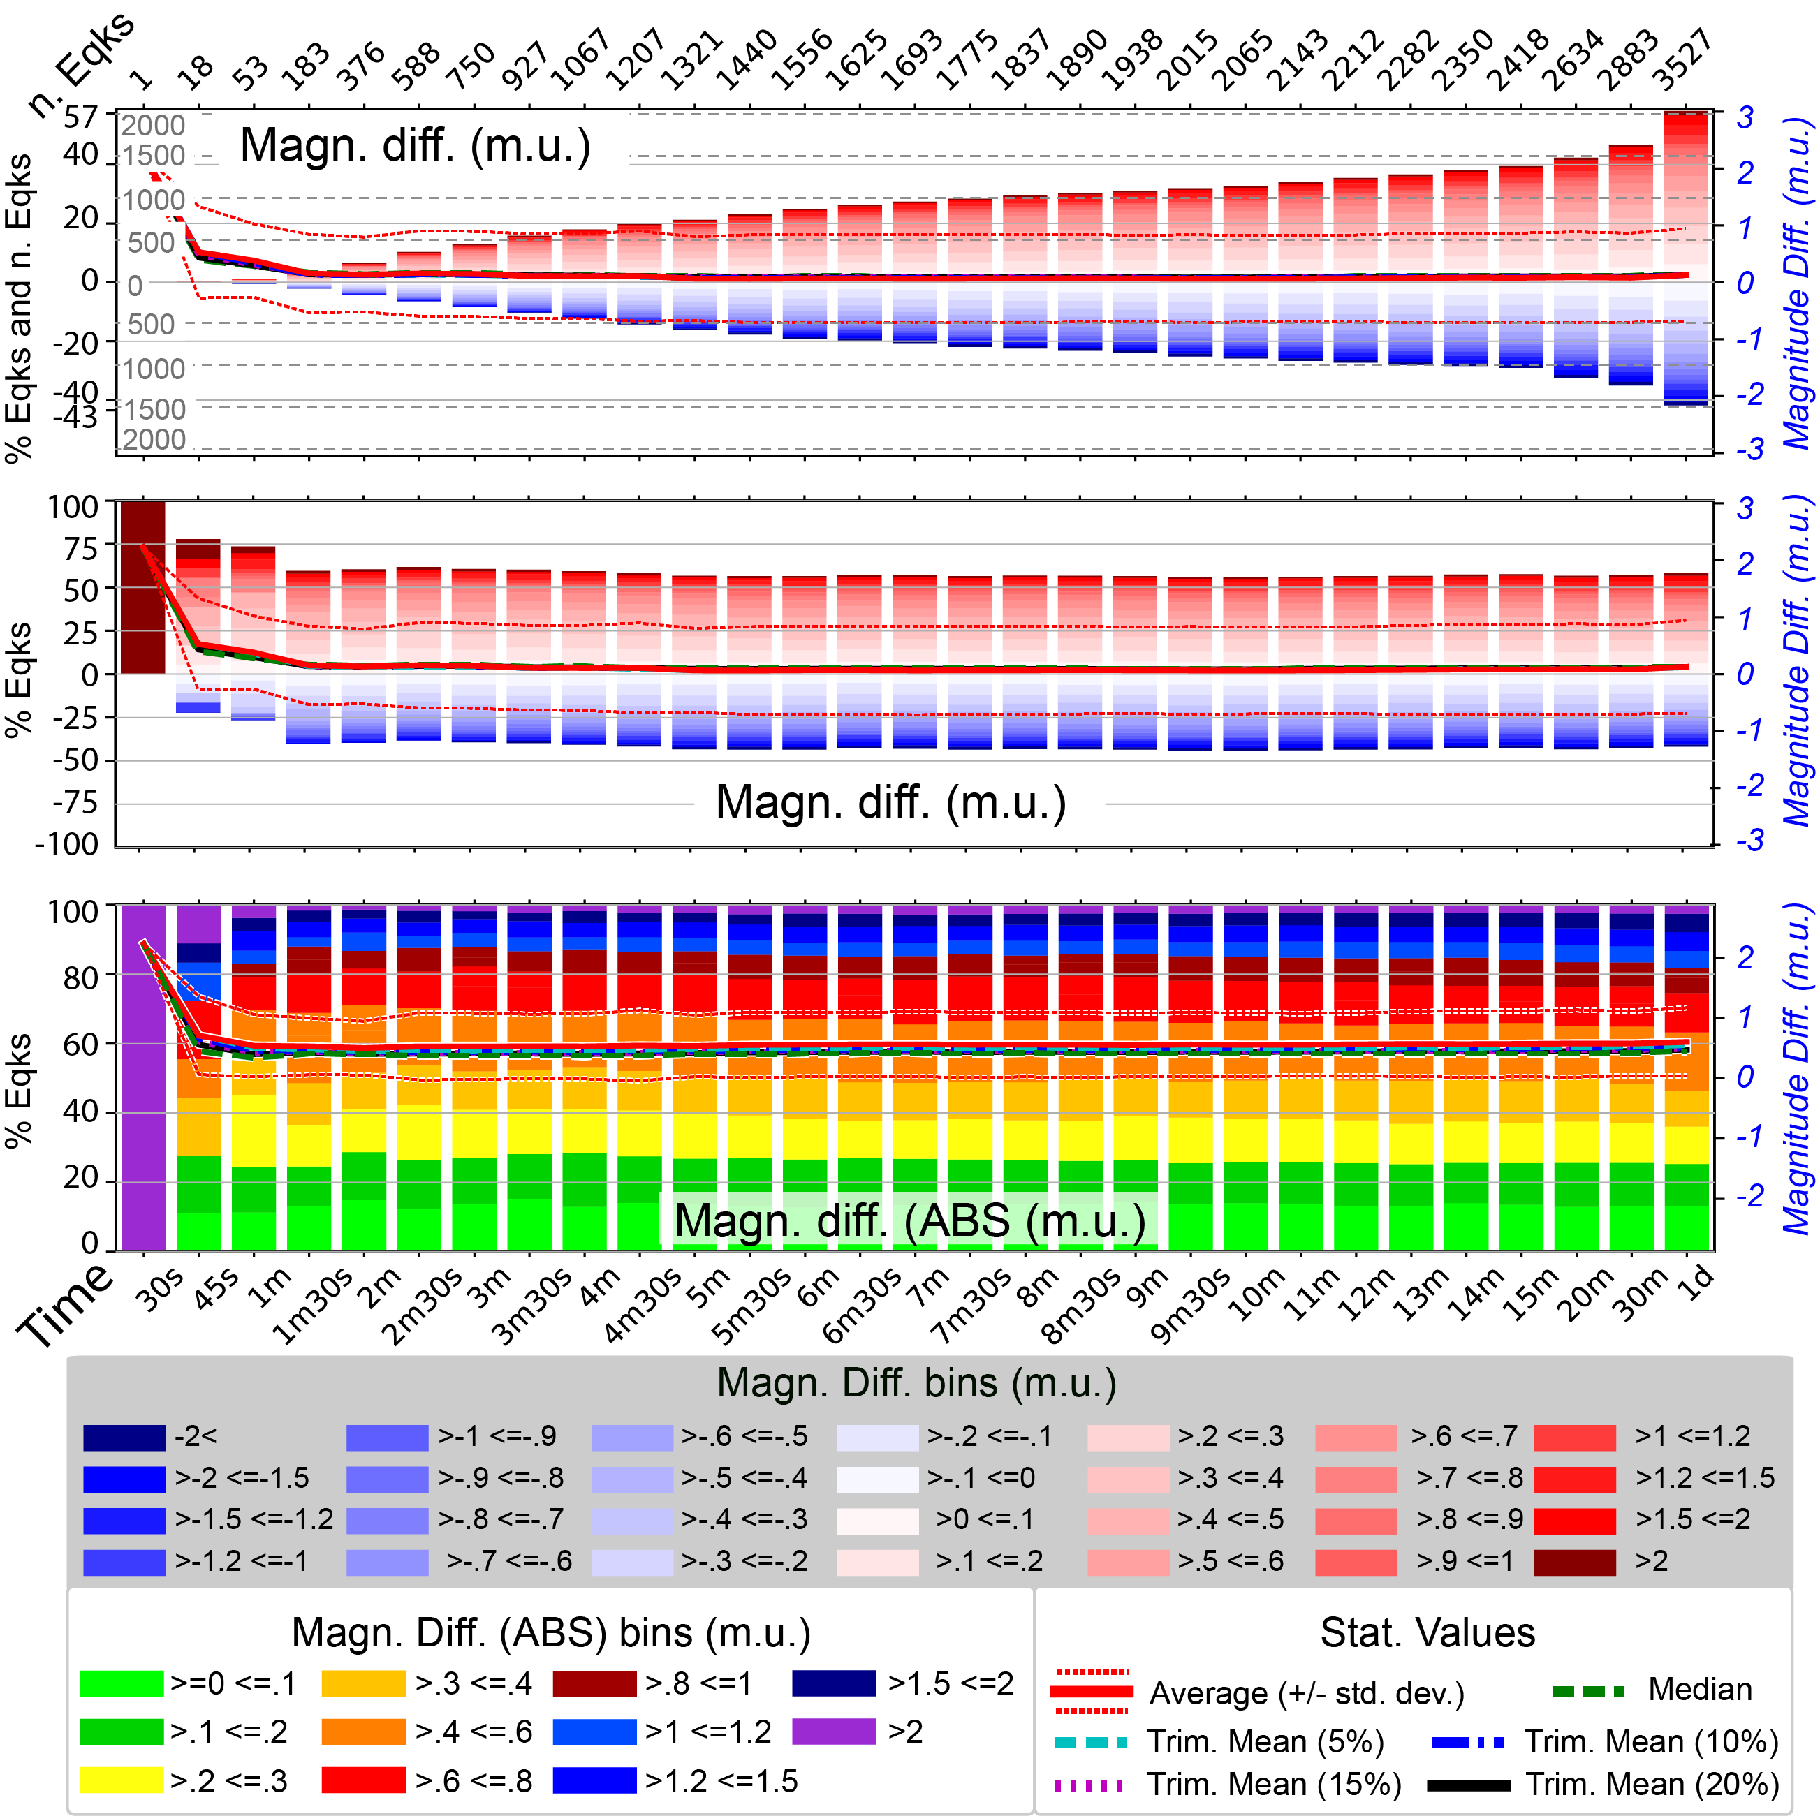
Figure S1: as in Fig. 2 of the text for BOXER-1. Numerical Values in Tables S10-S12

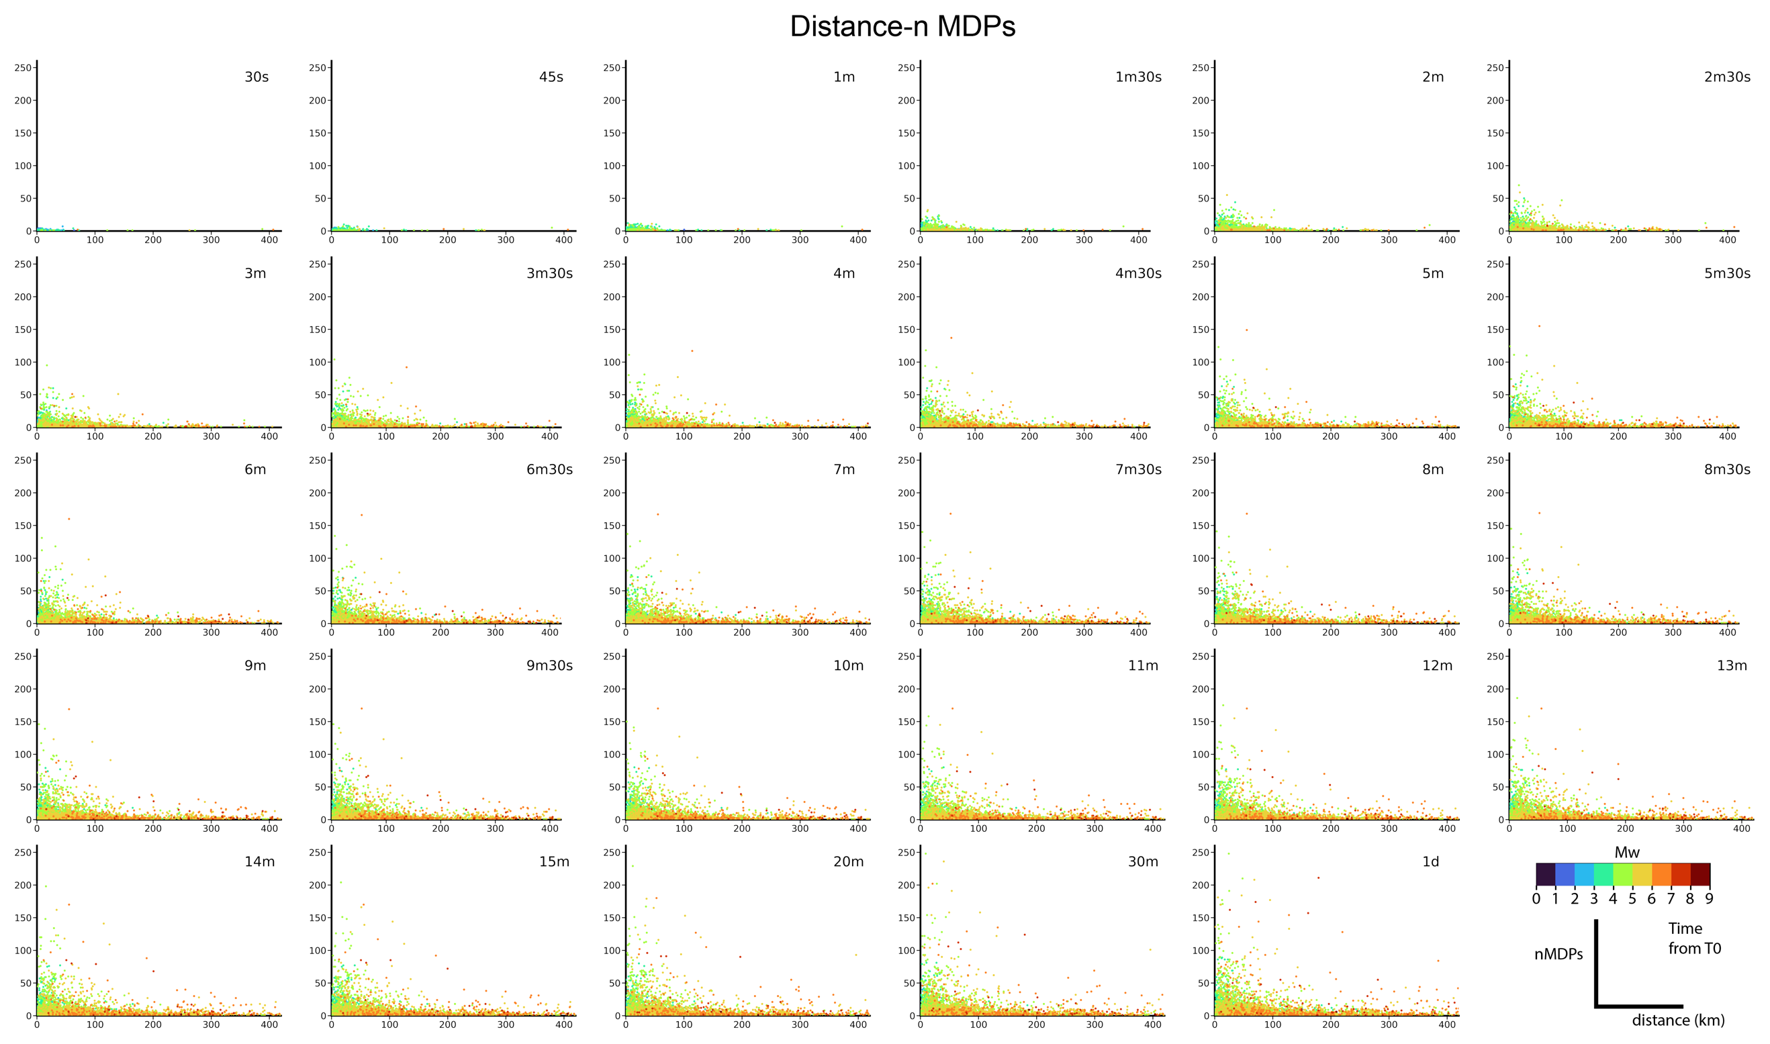Figure S2: Relationship between distance (in X-axis, limited to 400 km) from macroseismic and instrumental epicentres, and number of MDPs available (Y-axis) for global events at various time intervals for events. Colours according to the instrumental magnitude available for each event. Macroseismic epicentres by BOXER-0 on MDPs by the DB2-mn20 combination.

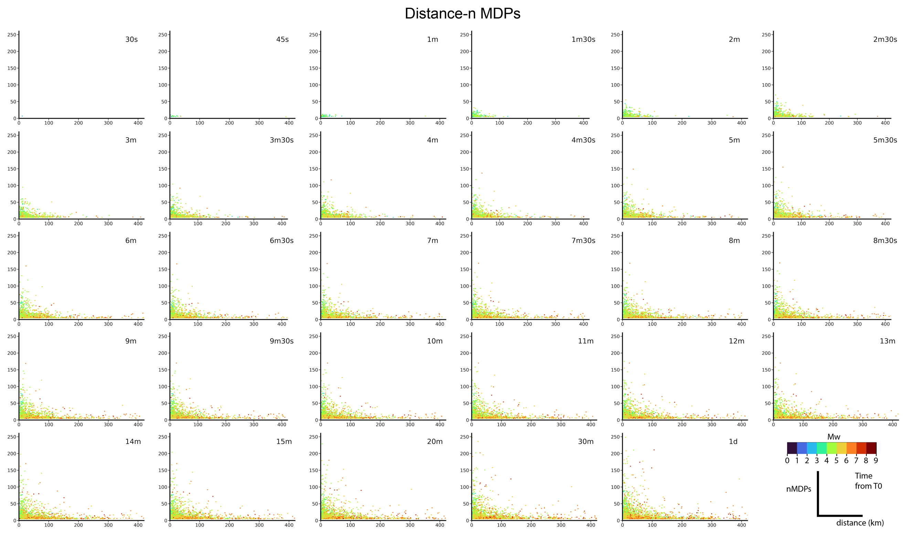
Figure S3: come in Fig. S2 per BOXER-1
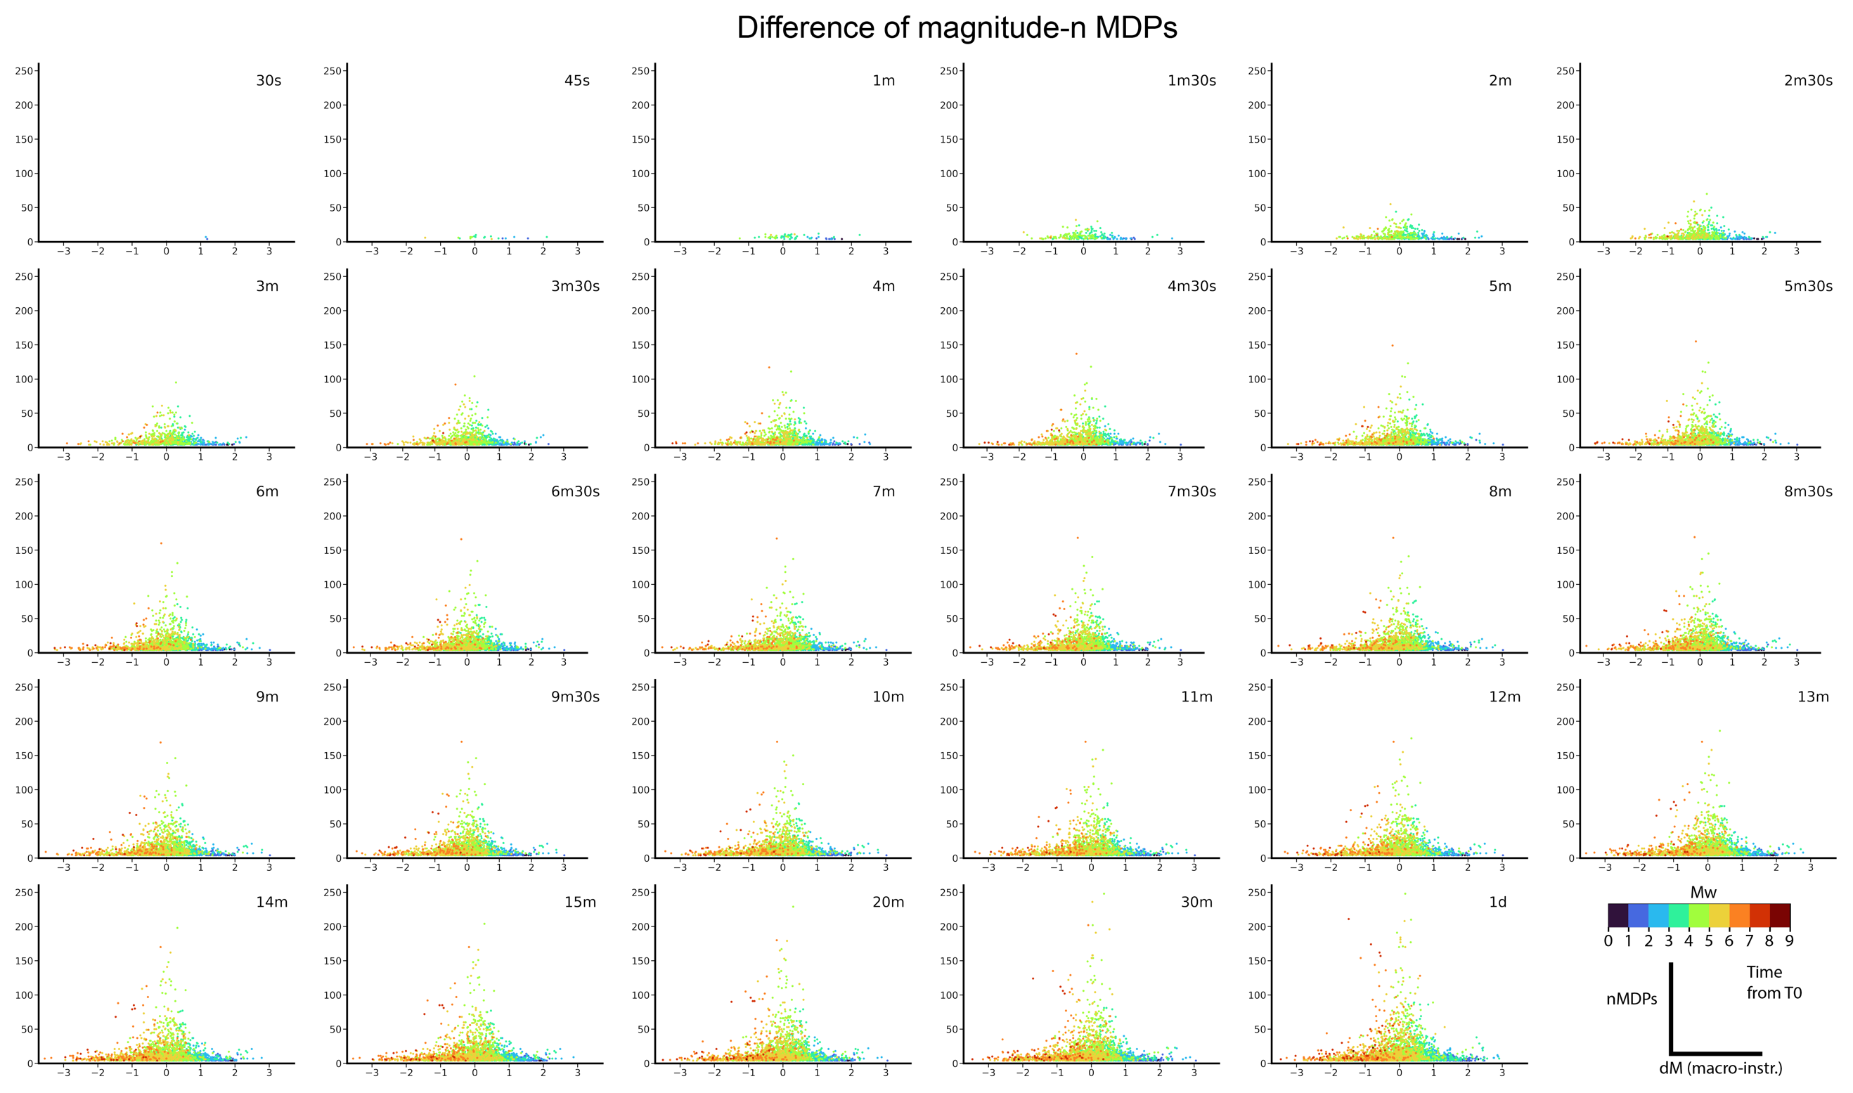Figure S4: Distribution of the magnitude differences (dM, X-axis) of earthquakes computed at the global scale with BOXER-0 in different time intervals, as a function of the number of MDPs (n MDPs, Y-axis) and instrumental magnitude (Mw, palette).

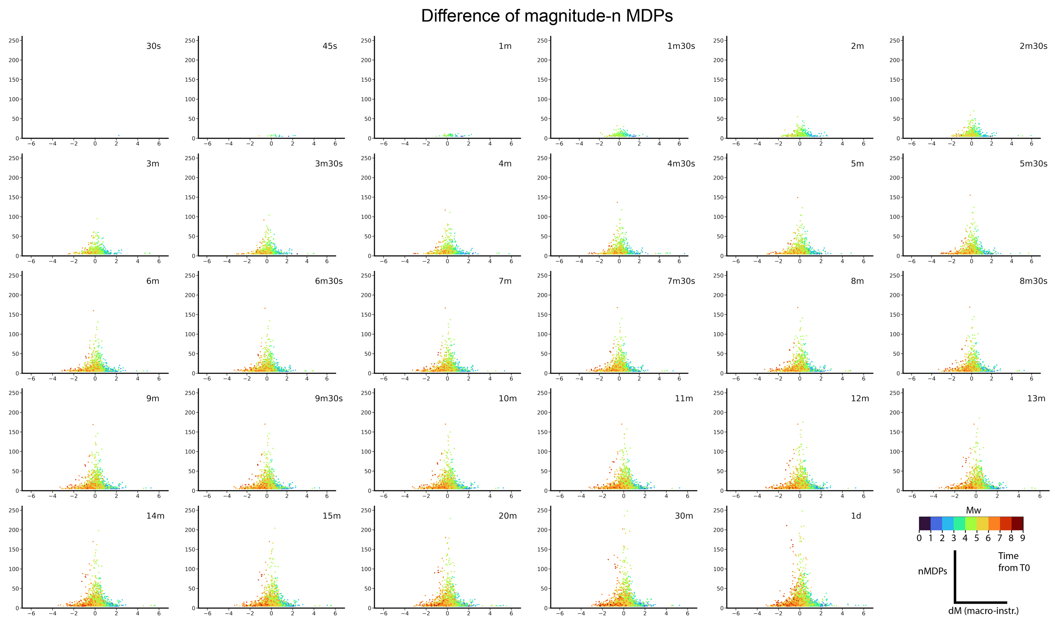
Figure S5: As in Fig. S4 for BOXER-1
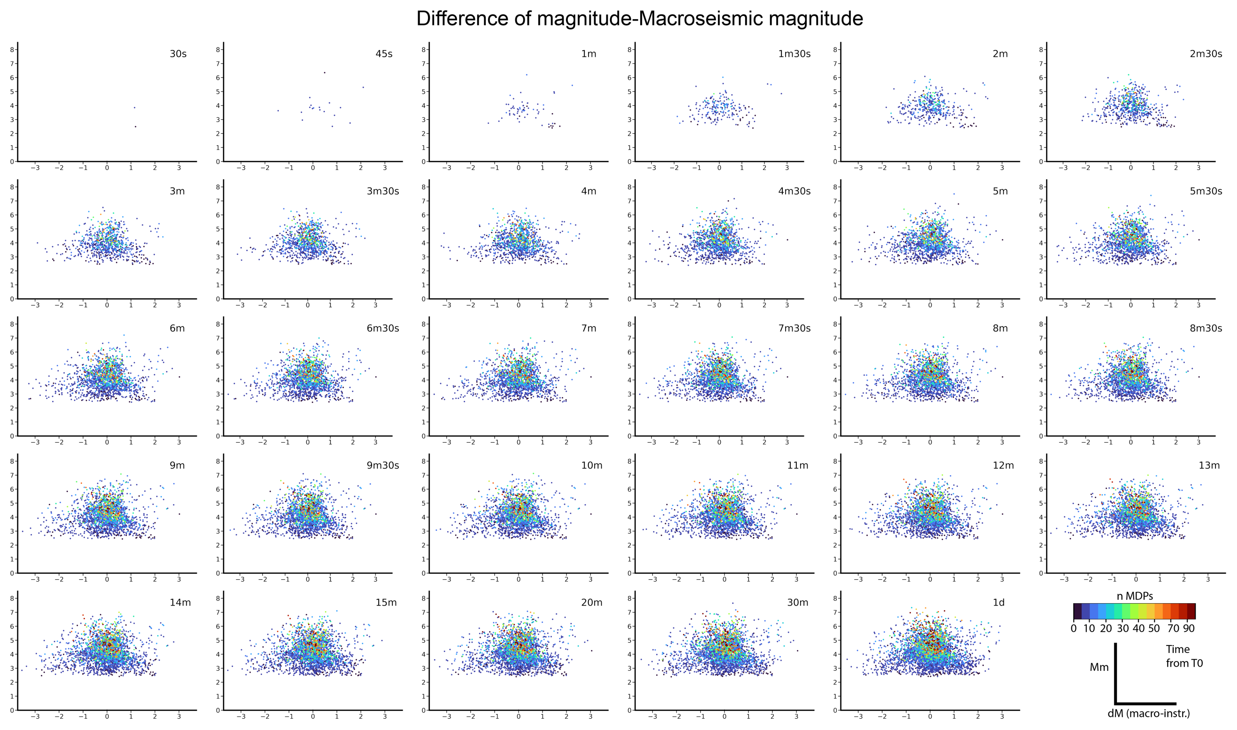
Figure S6: Magnitude differences (dM, X-axis) of earthquakes computed at the global scale with BOXER-0 in different time intervals, as a function of the macroseismic magnitude (Mm, Y-axis) and of the number of MDPs (n MDPs, palette).
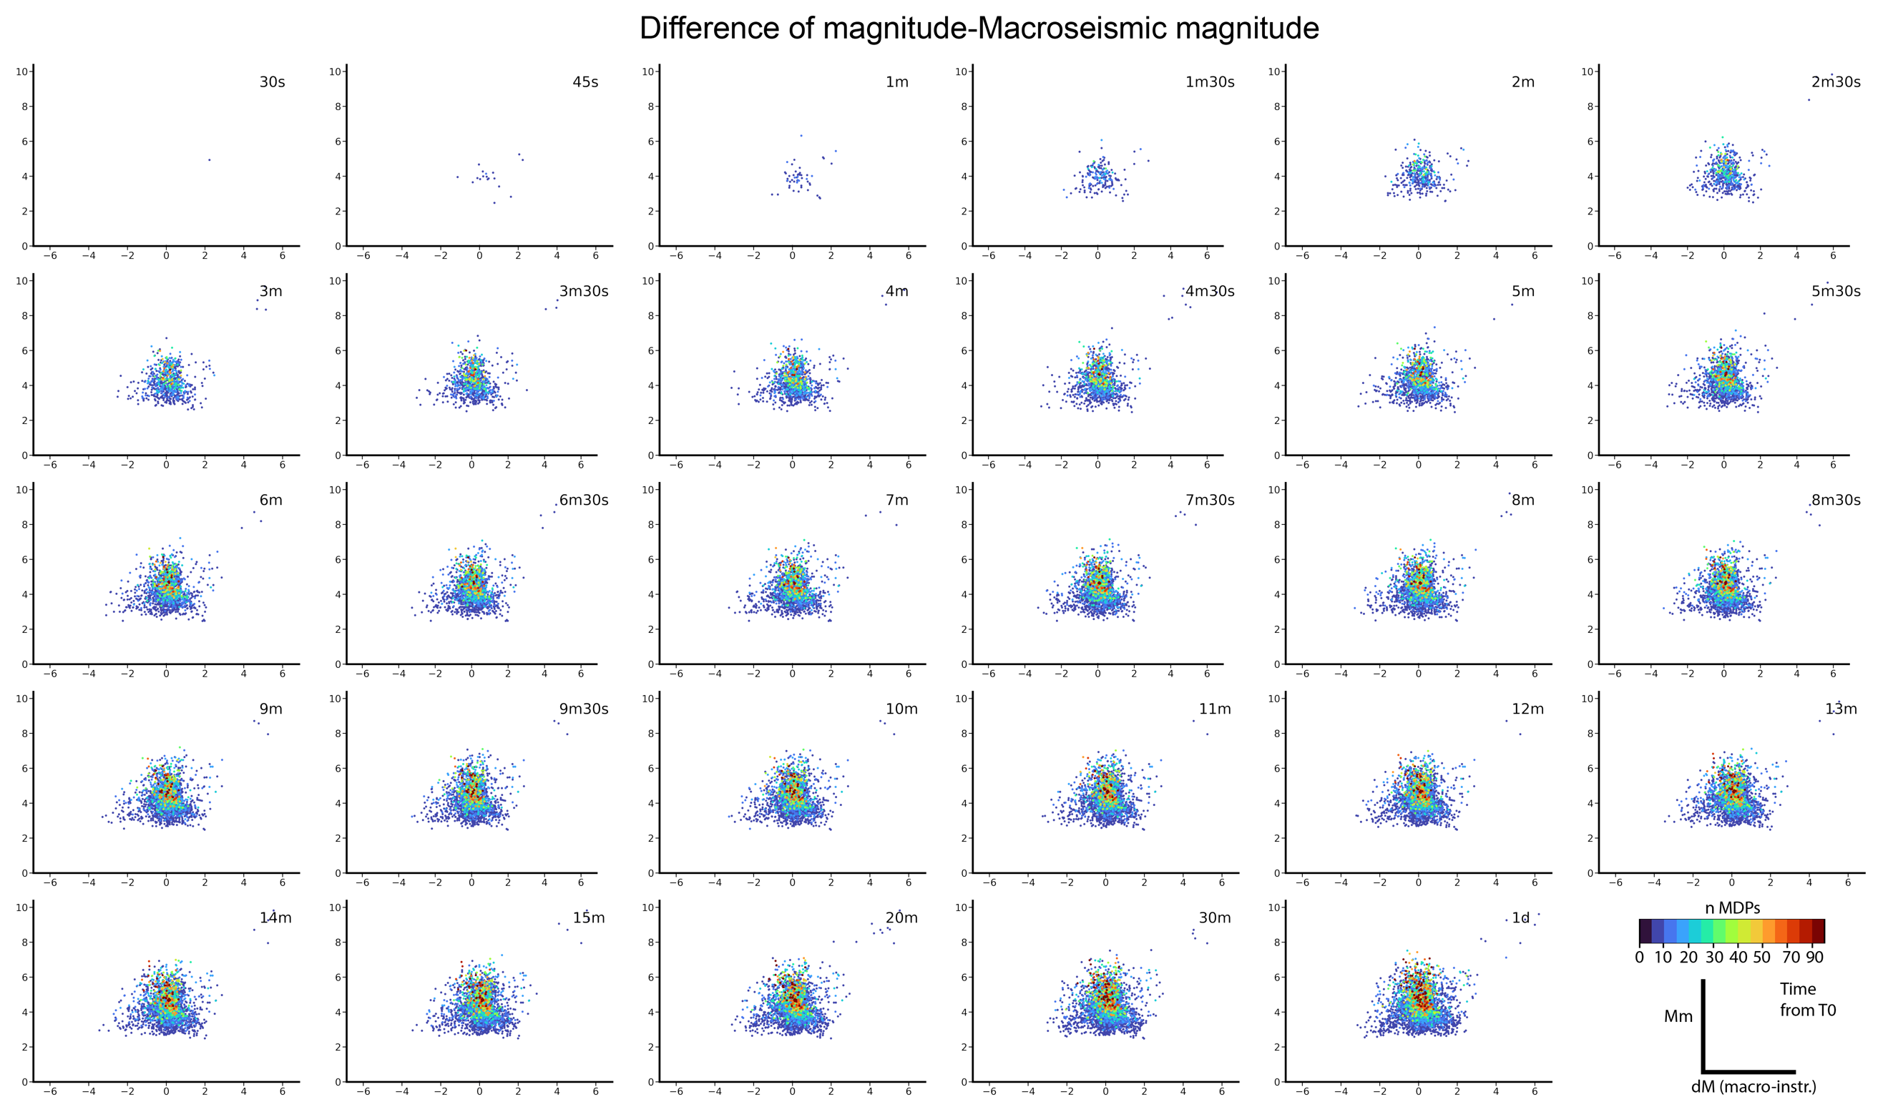
Figure S7: As in Fig. S6 for BOXER-1

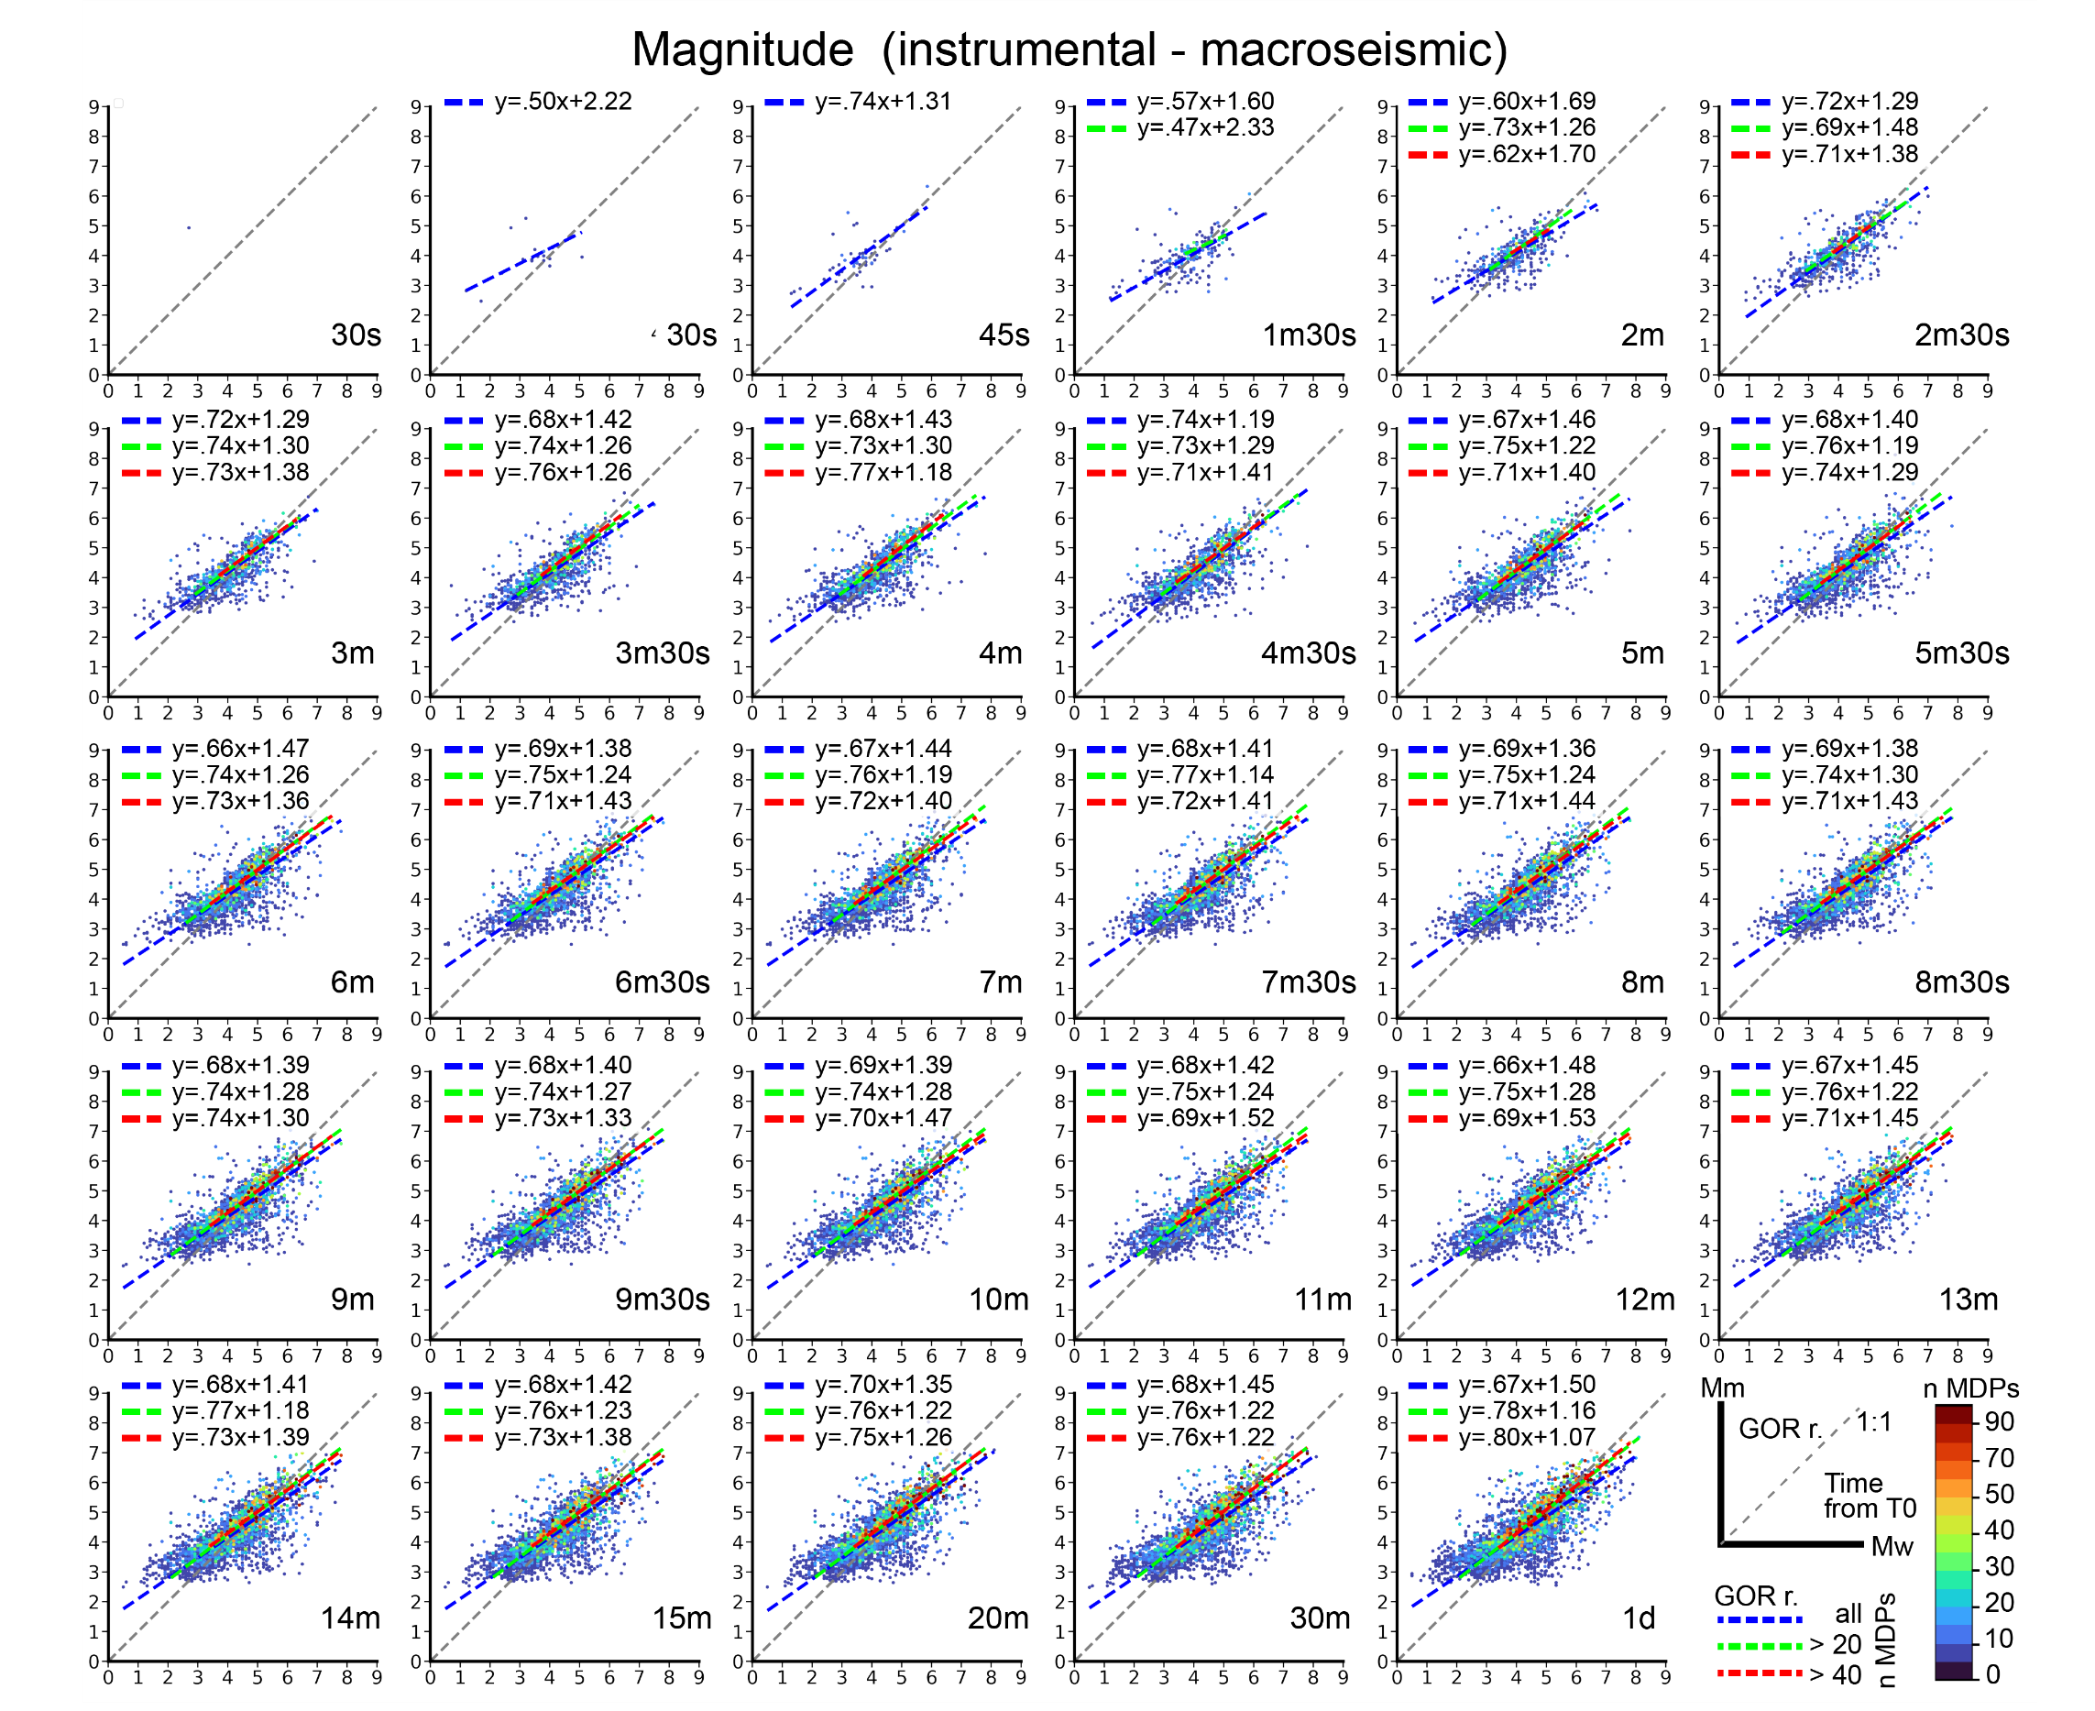
Figure S8: as in Fig. 4 for BOXER-1

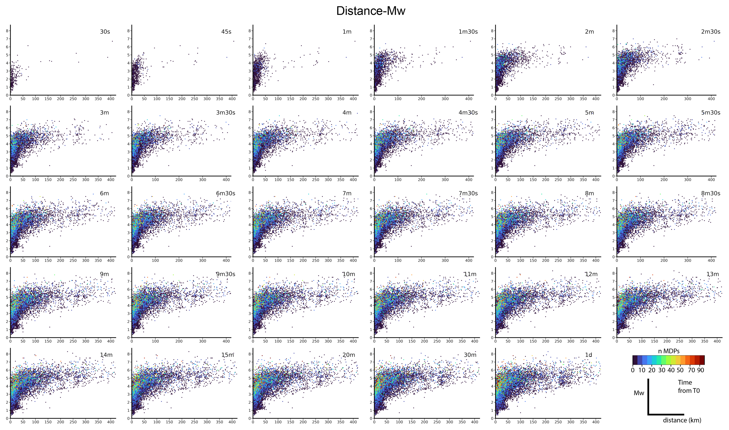
Figure S9: Relationship between distance (D2, in X-axis, limited to 400 km) from macroseismic and instrumental epicentres, and instrumental magnitude Mw (Y-axis) for global events at various time intervals for events. Colours according to the number of MDPs available for each event. Macroseismic epicentres by BOXER-0 on MDPs by the DB2-mn20 combination.
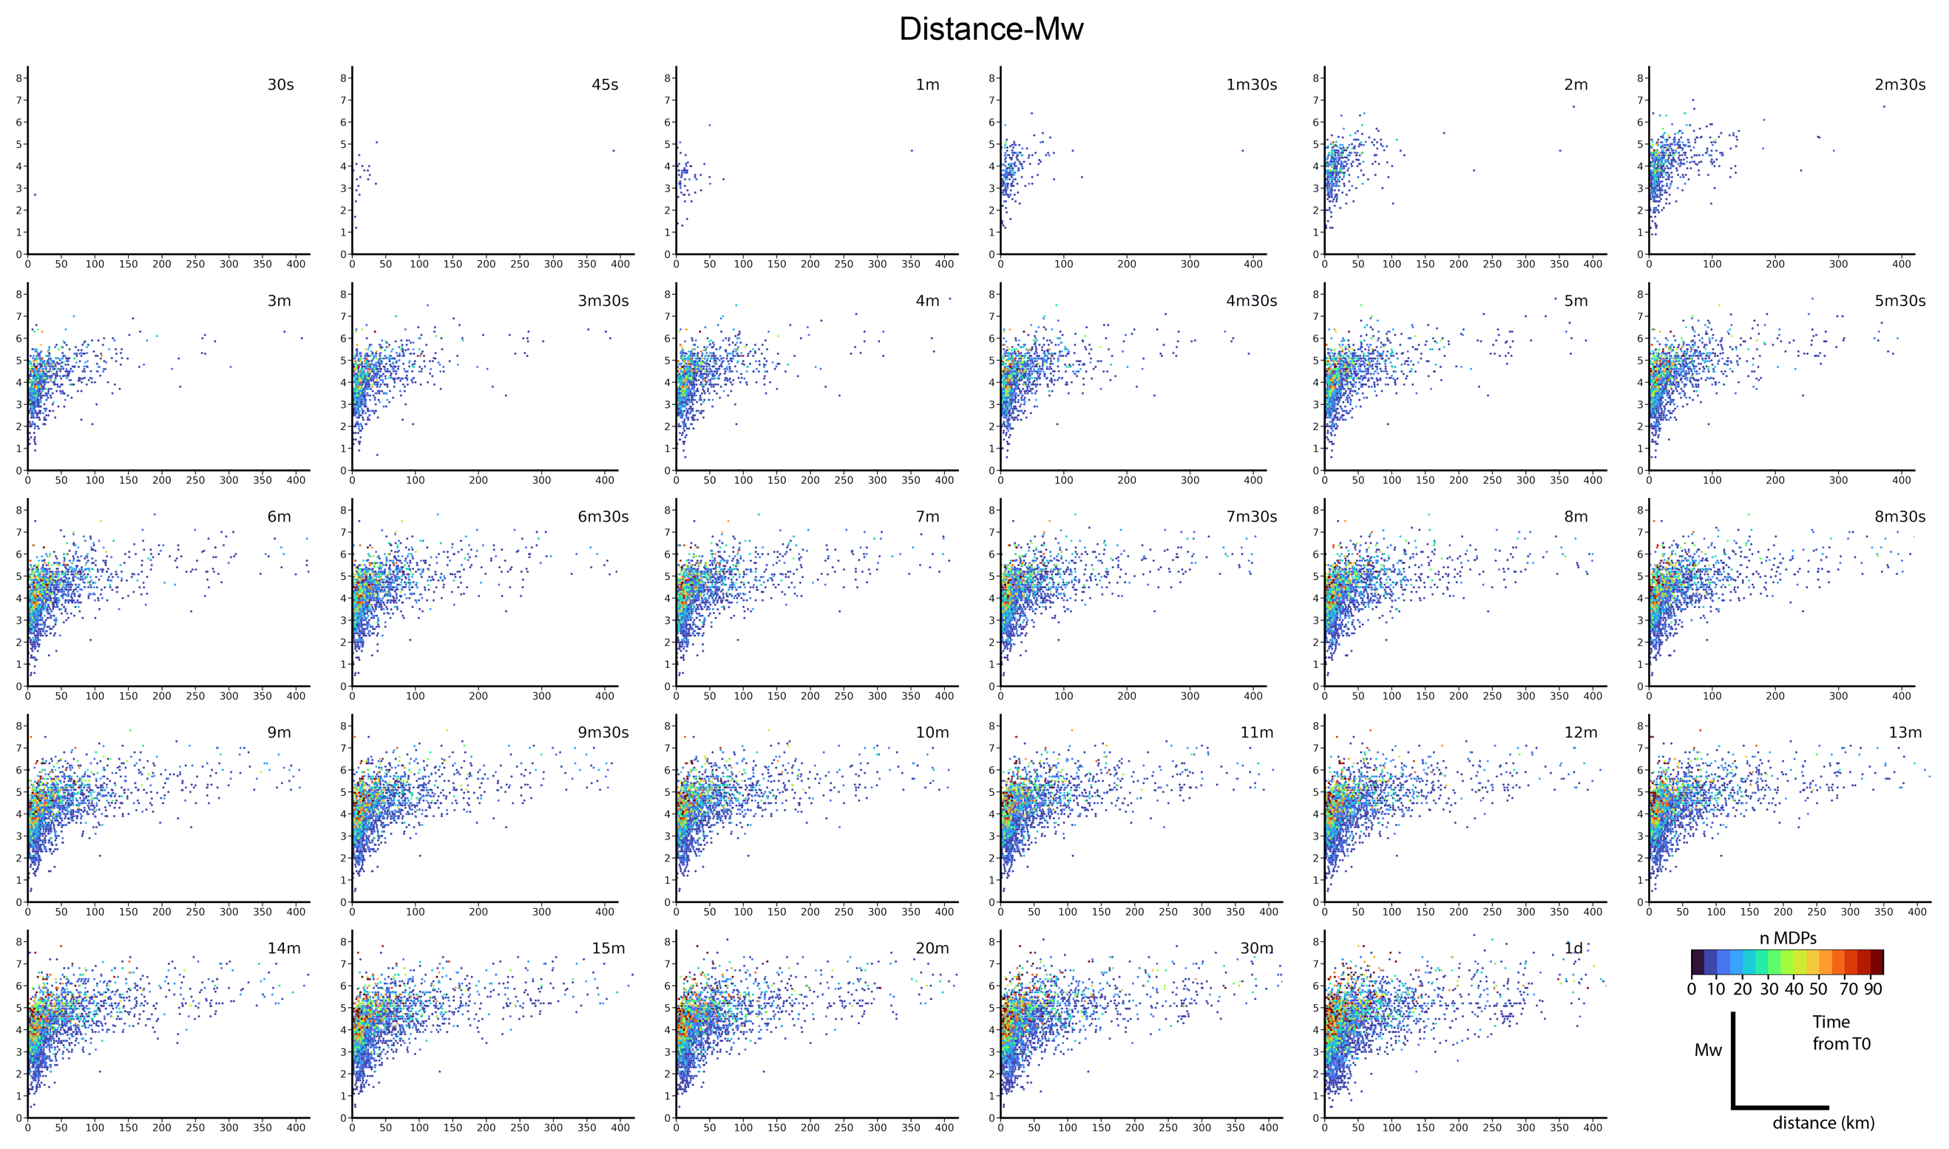
Figure S10: come in Fig. S9 per BOXER-1

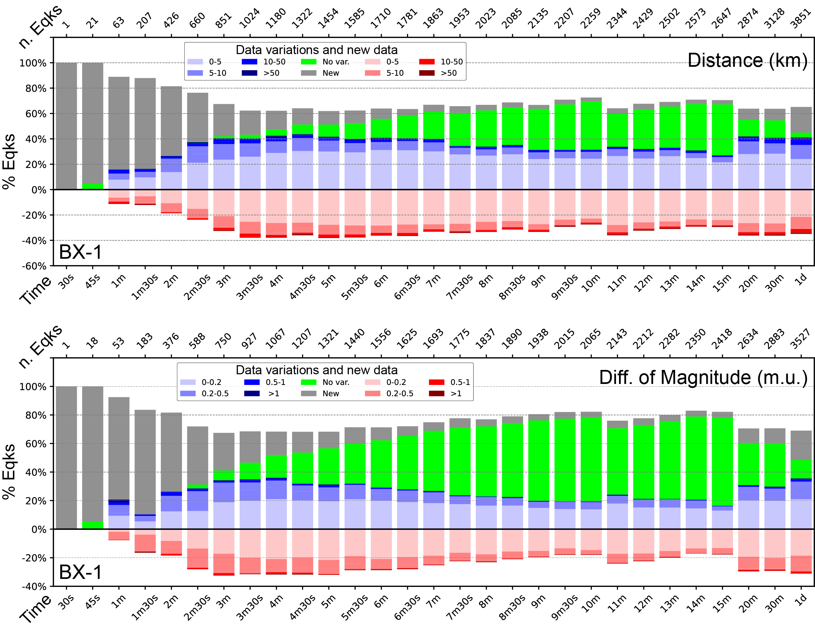
Figure S11: As in Fig. 4 of the main text for BOXER method 1.

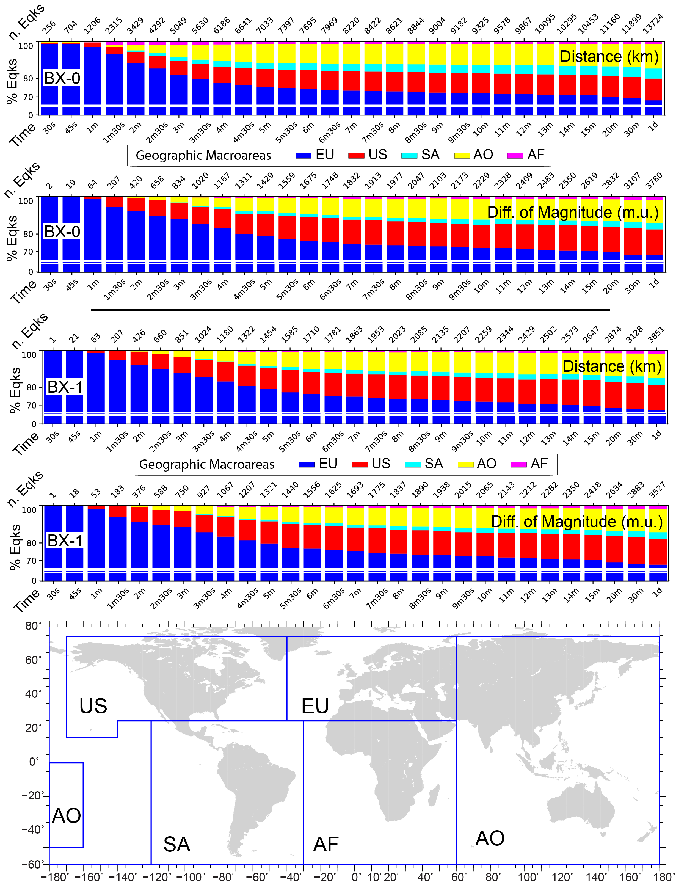
Figure S12: Relative percentage occurrence for geographic macroareas: Europe (EU), North America (US), South America (SA), Asia and Oceania (AO) and Africa, according to Vannucci et al. (2024) and bottom map. N. of earthquakes (upper X axis) over time for distance and difference of magnitude and for BOXER methods 0 and 1 (top and bottom panels, respectively).

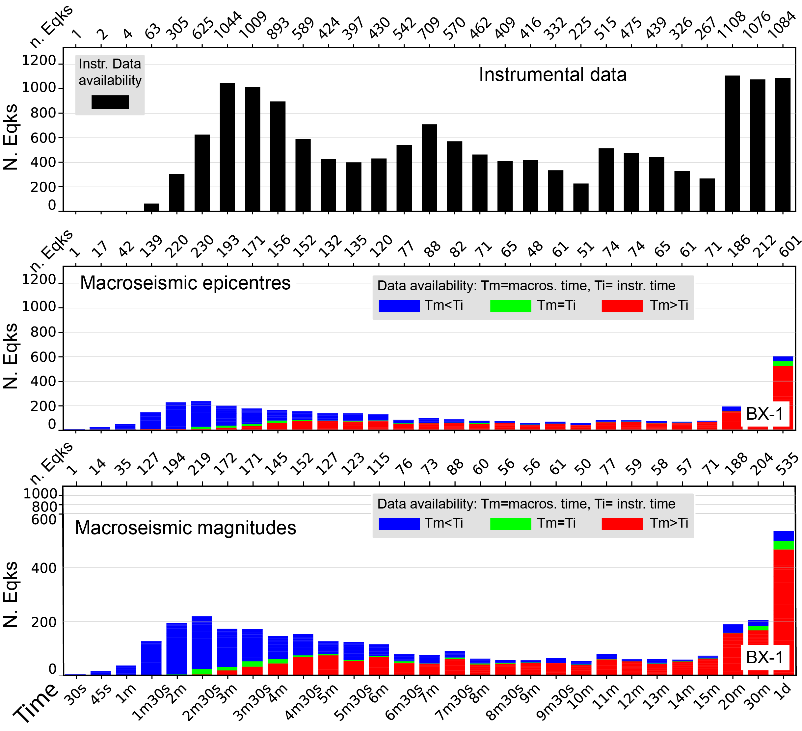

Figure S13: As in Fig. 5 of the main text for BOXER-1.Numerical values in Tables S15 and S16.

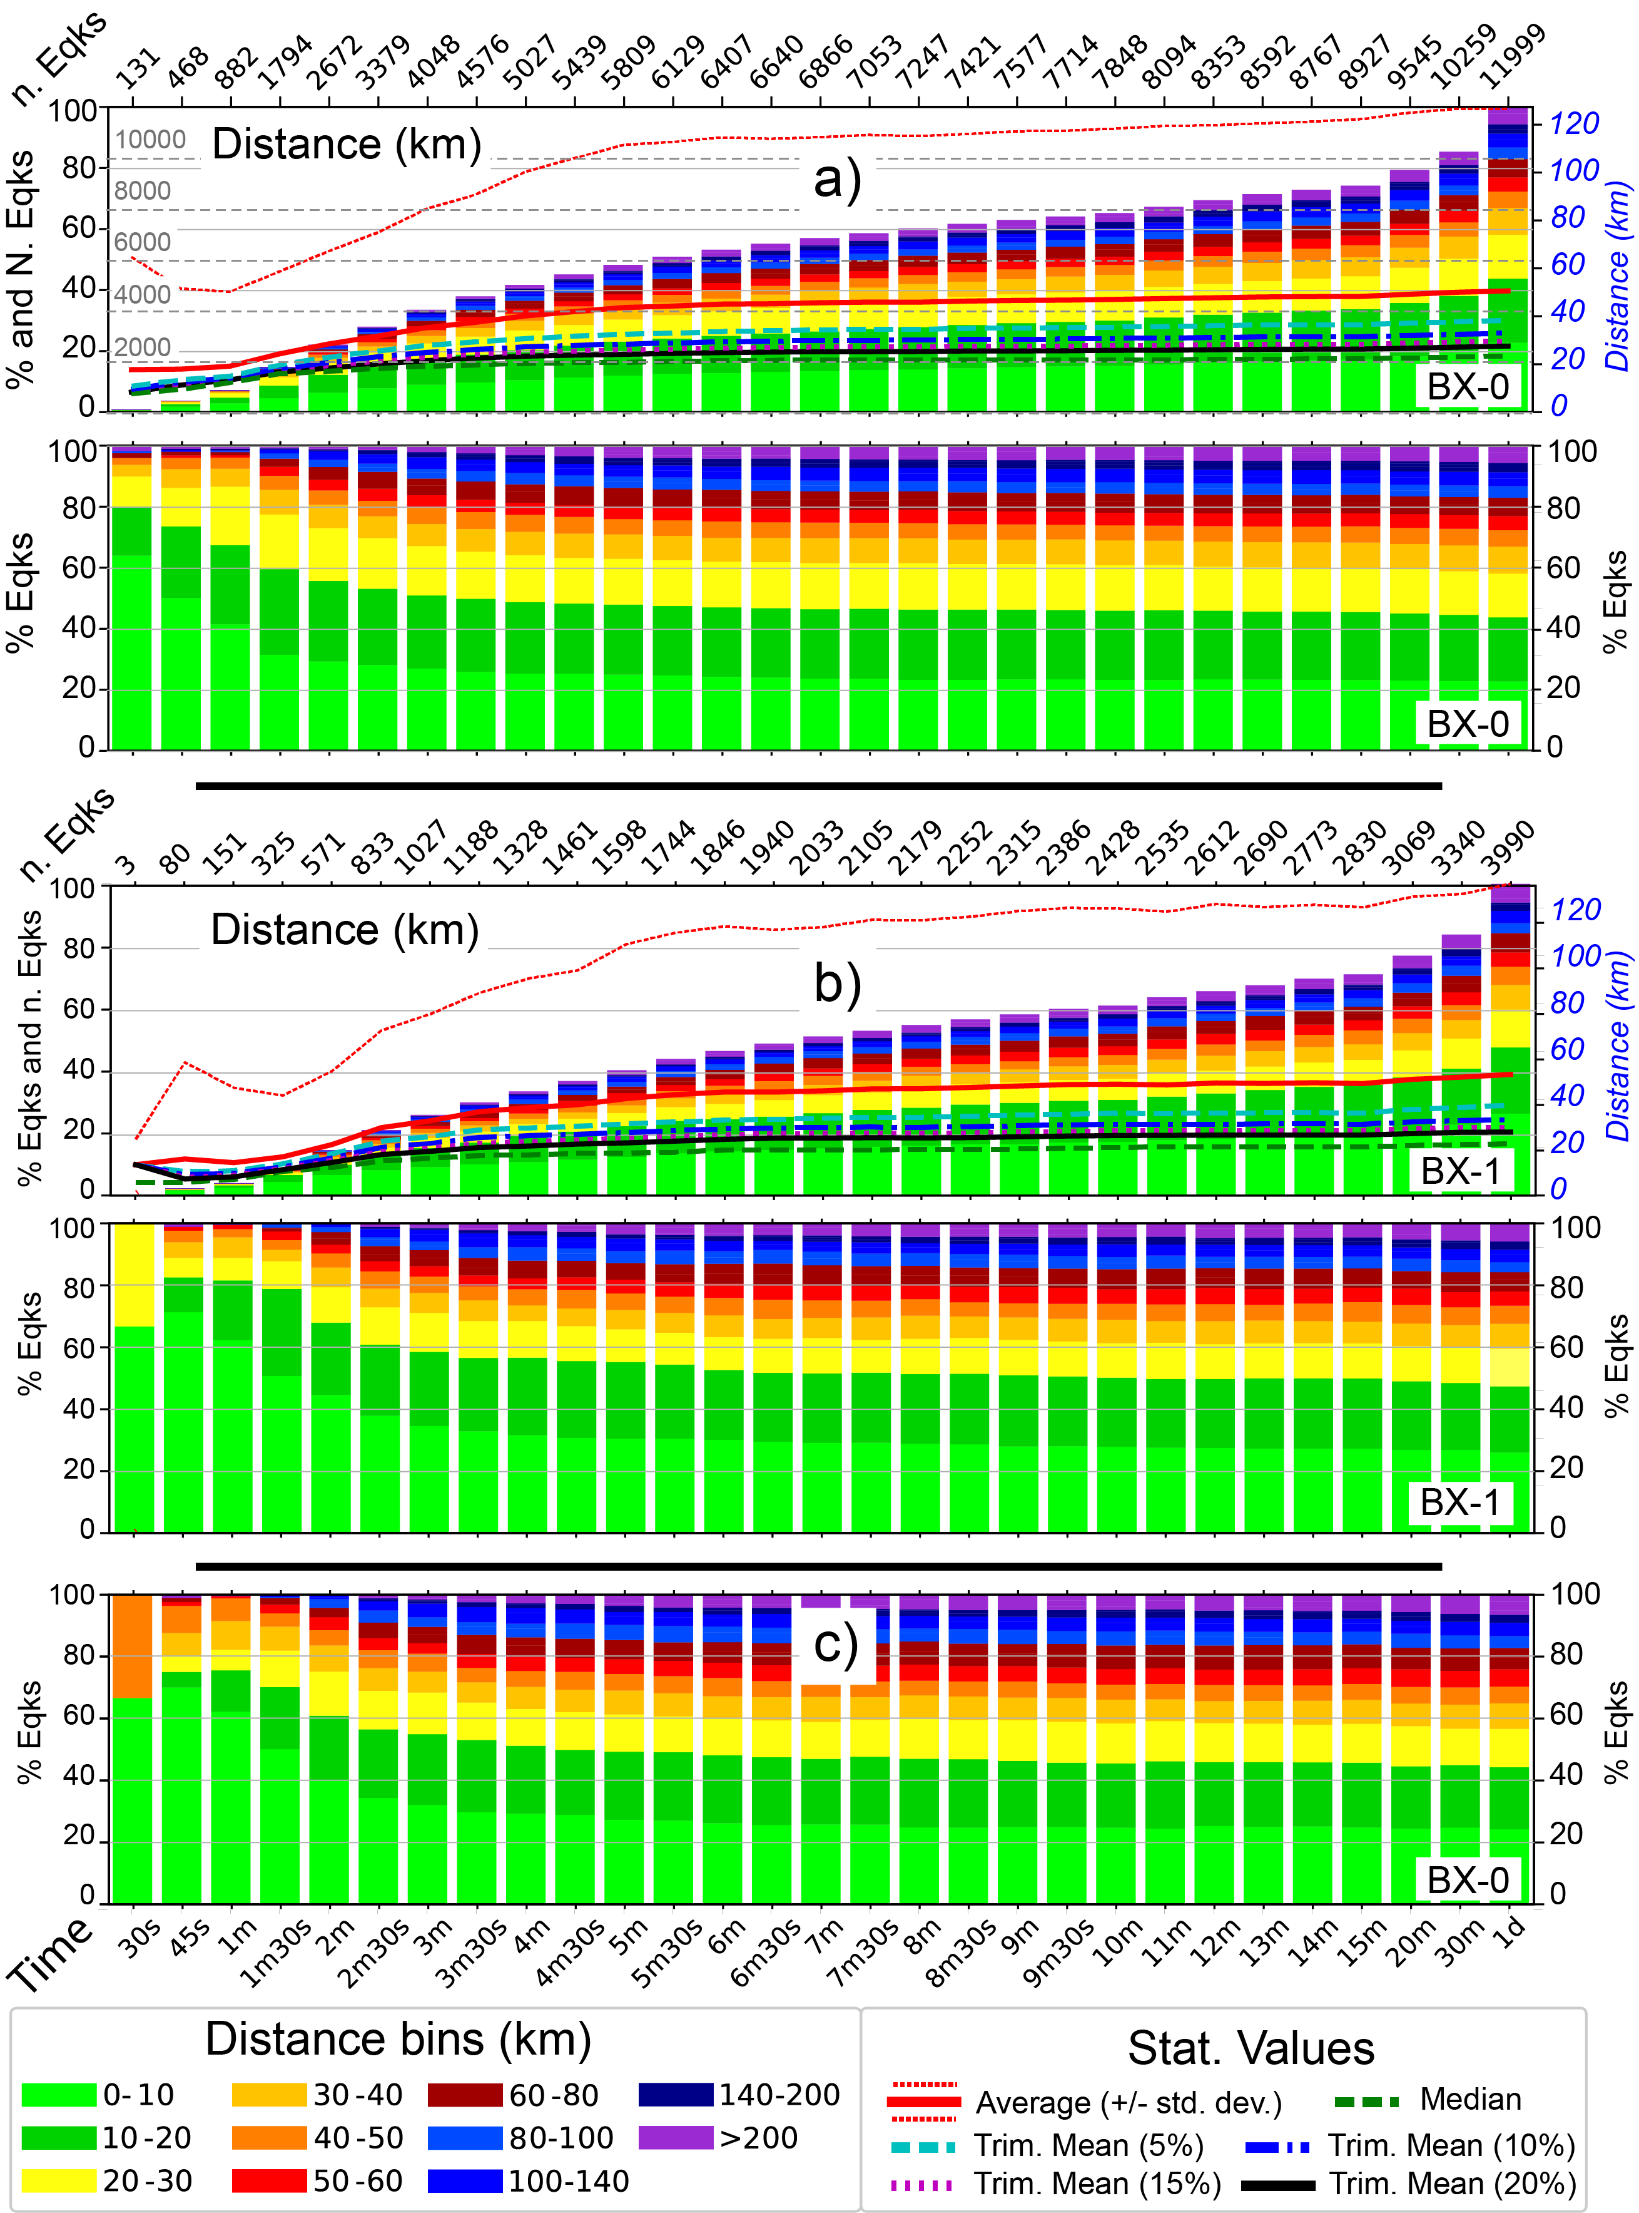
Figure S14: As in Fig. 1 of the main text on MDPs from DB with radius of 1 km
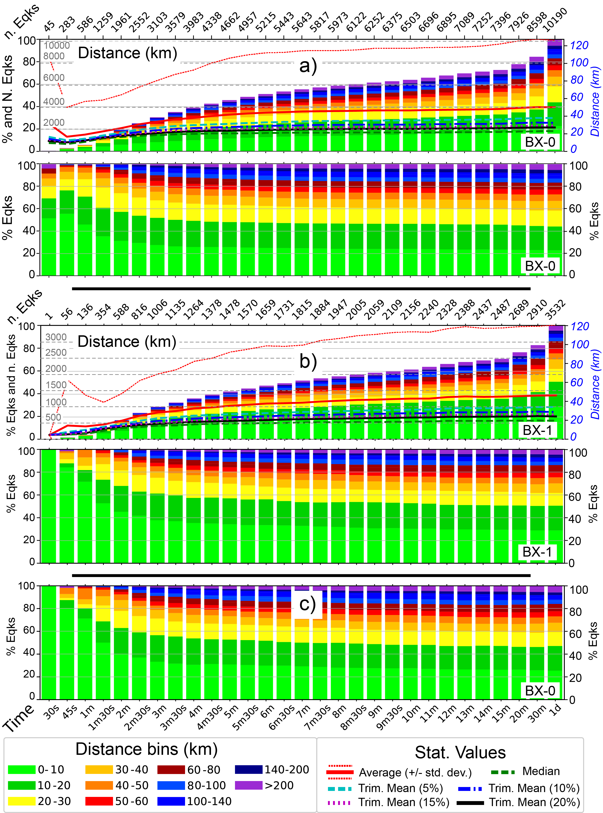
Figure S15: As in Fig. 1 of the main text on MDPs from DB with radius of half a km
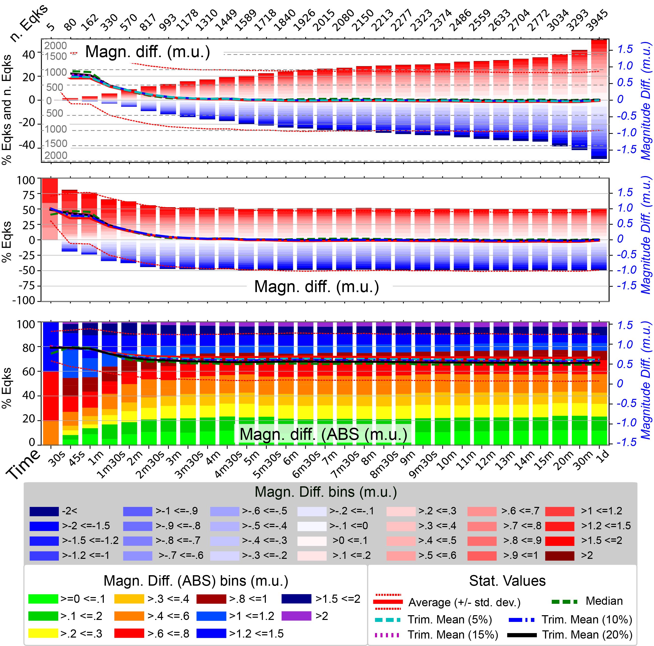
Figure S16: As in Fig. 2 of the main text by BOXER-0 on MDPs from DB with radius of 1 km

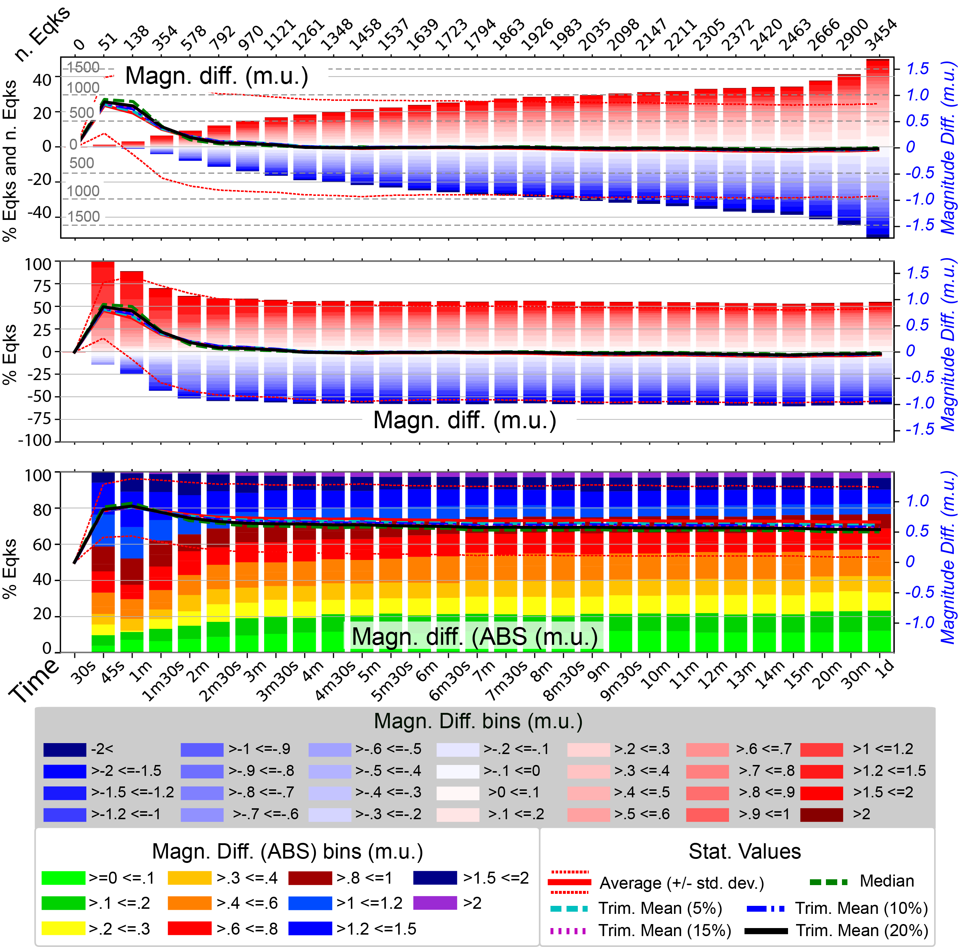
Figure S17: As in Fig. 2 of the main text by BOXER-0 on MDPs from DB with radius of half a km

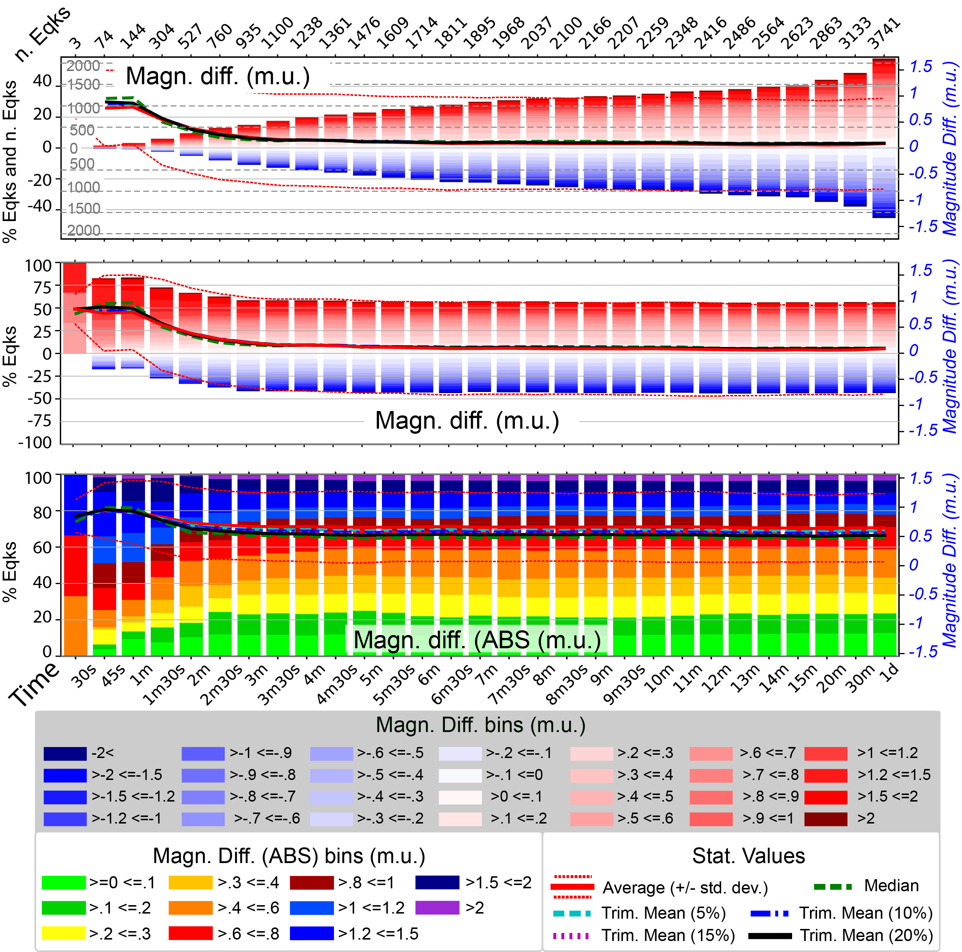
Figure S18: As in Fig. S1 of the main text by BOXER-1 on MDPs from DB with radius of 1 km

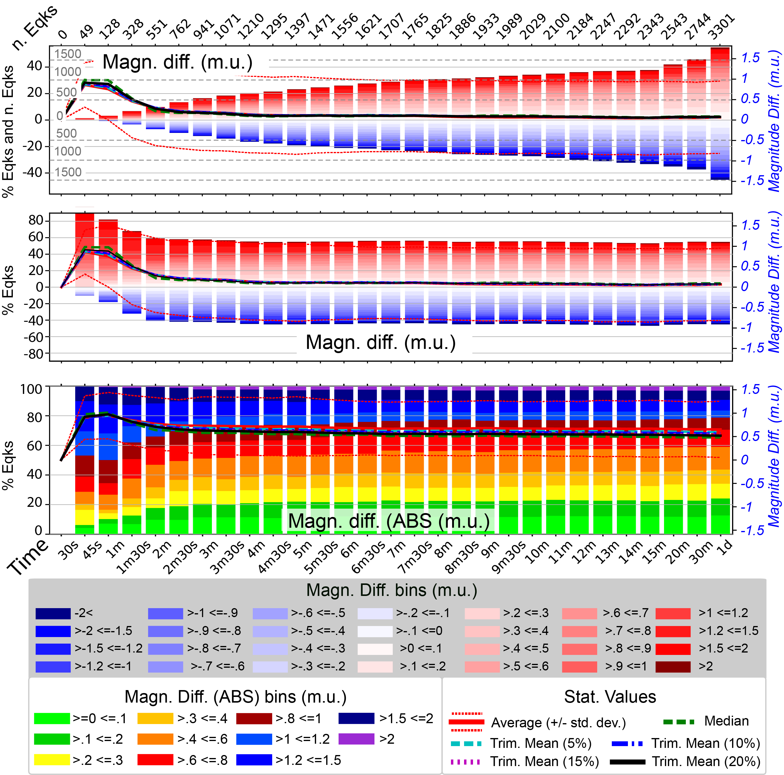
Figure S19: As in Fig. S1 of the main text by BOXER-1 on MDPs from DB with radius of half a km

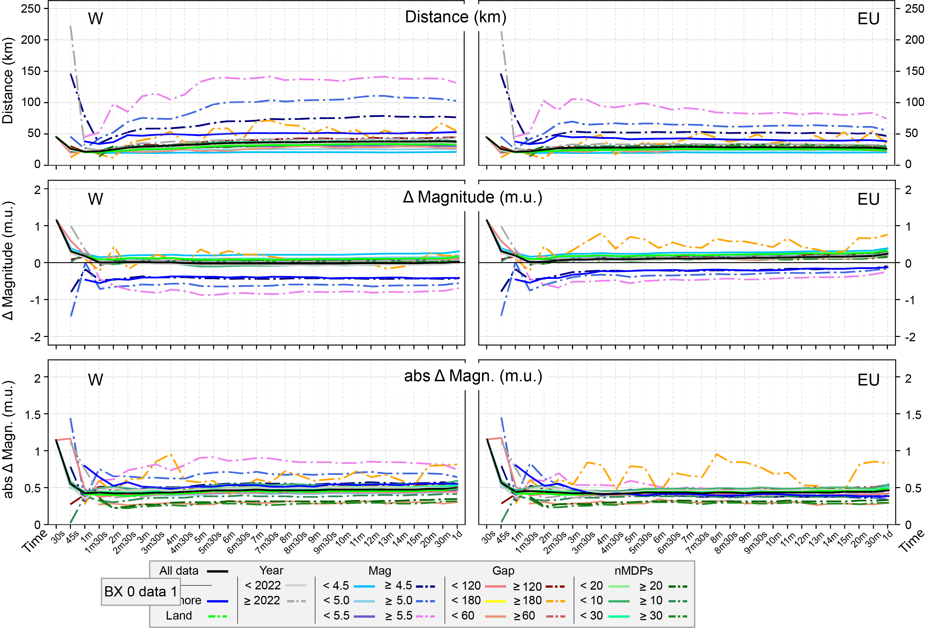
Figure S20: As in Fig. 7 by comparing BOXER-0 results on the same data of BOXER-1

Dist.  (Km) | Time from T0
Dist.  (Km) | 30s | 45s | 1m | 1m  30s | 2m | 2m  30s | 3m | 3m  30s | 4m | 4m  30s | 5m | 5m  30s | 6m | 6m  30s | 7m | 7m  30s | 8m | 8m  30s | 9m | 9m  30s | 10m | 11m | 12m | 13m | 14m | 15m | 20m | 30m | 1d
0-10 | 159 | 320 | 455 | 702 | 978 | 1132 | 1303 | 1419 | 1528 | 1613 | 1697 | 1777 | 1812 | 1839 | 1882 | 1934 | 1965 | 2016 | 2057 | 2093 | 2108 | 2174 | 2230 | 2254 | 2280 | 2307 | 2454 | 2589 | 3000
10-20 | 43 | 174 | 323 | 644 | 897 | 1101 | 1239 | 1357 | 1464 | 1537 | 1627 | 1676 | 1760 | 1827 | 1887 | 1918 | 1970 | 2009 | 2053 | 2101 | 2131 | 2171 | 2229 | 2271 | 2310 | 2331 | 2469 | 2594 | 2915
20-30 | 28 | 125 | 239 | 428 | 600 | 705 | 801 | 875 | 921 | 992 | 1035 | 1120 | 1159 | 1196 | 1232 | 1252 | 1299 | 1315 | 1330 | 1338 | 1372 | 1408 | 1445 | 1489 | 1519 | 1548 | 1632 | 1741 | 1960
30-40 | 10 | 37 | 79 | 175 | 243 | 314 | 370 | 411 | 477 | 536 | 587 | 606 | 621 | 655 | 666 | 690 | 700 | 708 | 714 | 732 | 740 | 755 | 804 | 837 | 857 | 872 | 951 | 1017 | 1214
40-50 | 4 | 19 | 44 | 114 | 157 | 224 | 259 | 316 | 349 | 353 | 361 | 385 | 413 | 439 | 461 | 475 | 469 | 478 | 479 | 492 | 498 | 513 | 533 | 530 | 542 | 564 | 598 | 645 | 764
50-60 | 0 | 5 | 21 | 66 | 126 | 169 | 204 | 246 | 262 | 306 | 317 | 334 | 346 | 346 | 370 | 370 | 384 | 403 | 411 | 415 | 427 | 429 | 433 | 451 | 465 | 470 | 499 | 549 | 633
60-70 | 2 | 5 | 9 | 39 | 96 | 151 | 189 | 193 | 221 | 240 | 258 | 261 | 269 | 276 | 275 | 279 | 289 | 299 | 299 | 306 | 314 | 330 | 344 | 343 | 359 | 367 | 402 | 419 | 484
70-80 | 3 | 2 | 4 | 34 | 68 | 91 | 111 | 139 | 149 | 154 | 152 | 177 | 177 | 194 | 196 | 197 | 204 | 219 | 221 | 221 | 234 | 240 | 242 | 263 | 263 | 271 | 264 | 282 | 326
80-90 | 0 | 0 | 3 | 24 | 57 | 85 | 117 | 131 | 135 | 143 | 158 | 161 | 177 | 170 | 184 | 185 | 182 | 187 | 186 | 191 | 184 | 190 | 197 | 195 | 204 | 207 | 234 | 247 | 293
90-100 | 0 | 1 | 2 | 17 | 33 | 67 | 73 | 68 | 88 | 101 | 115 | 122 | 125 | 138 | 139 | 143 | 143 | 155 | 168 | 177 | 185 | 174 | 186 | 188 | 187 | 190 | 197 | 218 | 261
100-120 | 0 | 0 | 1 | 23 | 69 | 70 | 100 | 109 | 147 | 150 | 153 | 174 | 189 | 190 | 198 | 216 | 220 | 223 | 242 | 237 | 244 | 256 | 262 | 267 | 266 | 267 | 296 | 325 | 374
120-140 | 1 | 3 | 4 | 15 | 36 | 57 | 75 | 89 | 93 | 98 | 116 | 112 | 129 | 143 | 148 | 158 | 161 | 165 | 160 | 173 | 174 | 179 | 168 | 181 | 188 | 193 | 216 | 239 | 285
140-160 | 1 | 2 | 2 | 6 | 14 | 33 | 50 | 73 | 75 | 82 | 84 | 90 | 87 | 97 | 99 | 109 | 121 | 131 | 133 | 137 | 132 | 147 | 154 | 161 | 166 | 167 | 182 | 185 | 225
160-180 | 1 | 1 | 2 | 3 | 11 | 18 | 30 | 37 | 47 | 59 | 50 | 61 | 66 | 66 | 71 | 73 | 73 | 73 | 76 | 84 | 86 | 89 | 88 | 94 | 98 | 101 | 119 | 130 | 141
180-200 | 0 | 1 | 3 | 4 | 6 | 11 | 22 | 22 | 27 | 35 | 42 | 42 | 48 | 52 | 59 | 59 | 63 | 68 | 75 | 80 | 81 | 77 | 84 | 82 | 92 | 93 | 100 | 104 | 115
200-250 | 0 | 2 | 4 | 5 | 9 | 16 | 22 | 37 | 54 | 61 | 79 | 84 | 89 | 99 | 101 | 101 | 108 | 111 | 113 | 112 | 108 | 123 | 128 | 143 | 139 | 141 | 152 | 169 | 189
250-300 | 2 | 5 | 7 | 11 | 23 | 38 | 58 | 67 | 83 | 91 | 99 | 102 | 107 | 108 | 112 | 117 | 127 | 133 | 131 | 131 | 141 | 150 | 166 | 165 | 173 | 173 | 194 | 227 | 278
>300 | 2 | 2 | 4 | 5 | 6 | 10 | 26 | 41 | 66 | 90 | 103 | 113 | 121 | 134 | 140 | 146 | 143 | 151 | 156 | 162 | 166 | 173 | 174 | 181 | 187 | 191 | 201 | 219 | 267

Table S1: Number of earthquakes at the global scale over different time intervals from T0 for different bins (in km) of the distance between macroseismic and instrumental epicentres. Parameters computed by BOXER-0 on MDPs from DB2-mn20 approach. Table supporting Fig. 1 of the main text.

Dist.  (Km) | Time from T0
Dist.  (Km) | 30s | 45s | 1m | 1m  30s | 2m | 2m  30s | 3m | 3m  30s | 4m | 4m  30s | 5m | 5m  30s | 6m | 6m  30s | 7m | 7m  30s | 8m | 8m  30s | 9m | 9m  30s | 10m | 11m | 12m | 13m | 14m | 15m | 20m | 30m | 1d
0-10 | 1.2 | 2.3 | 3.3 | 5.1 | 7.1 | 8.2 | 9.5 | 10.3 | 11.1 | 11.8 | 12.4 | 12.9 | 13.2 | 13.4 | 13.7 | 14.1 | 14.3 | 14.7 | 15.0 | 15.3 | 15.4 | 15.8 | 16.2 | 16.4 | 16.6 | 16.8 | 17.9 | 18.9 | 21.9
10-20 | 0.3 | 1.3 | 2.4 | 4.7 | 6.5 | 8.0 | 9.0 | 9.9 | 10.7 | 11.2 | 11.9 | 12.2 | 12.8 | 13.3 | 13.7 | 14.0 | 14.4 | 14.6 | 15.0 | 15.3 | 15.5 | 15.8 | 16.2 | 16.5 | 16.8 | 17.0 | 18.0 | 18.9 | 21.2
20-30 | 0.2 | 0.9 | 1.7 | 3.1 | 4.4 | 5.1 | 5.8 | 6.4 | 6.7 | 7.2 | 7.5 | 8.2 | 8.4 | 8.7 | 9.0 | 9.1 | 9.5 | 9.6 | 9.7 | 9.7 | 10.0 | 10.3 | 10.5 | 10.8 | 11.1 | 11.3 | 11.9 | 12.7 | 14.3
30-40 | 0.1 | 0.3 | 0.6 | 1.3 | 1.8 | 2.3 | 2.7 | 3.0 | 3.5 | 3.9 | 4.3 | 4.4 | 4.5 | 4.8 | 4.9 | 5.0 | 5.1 | 5.2 | 5.2 | 5.3 | 5.4 | 5.5 | 5.9 | 6.1 | 6.2 | 6.4 | 6.9 | 7.4 | 8.8
40-50 | 0.0 | 0.1 | 0.3 | 0.8 | 1.1 | 1.6 | 1.9 | 2.3 | 2.5 | 2.6 | 2.6 | 2.8 | 3.0 | 3.2 | 3.4 | 3.5 | 3.4 | 3.5 | 3.5 | 3.6 | 3.6 | 3.7 | 3.9 | 3.9 | 3.9 | 4.1 | 4.4 | 4.7 | 5.6
50-60 | 0.0 | 0.0 | 0.2 | 0.5 | 0.9 | 1.2 | 1.5 | 1.8 | 1.9 | 2.2 | 2.3 | 2.4 | 2.5 | 2.5 | 2.7 | 2.7 | 2.8 | 2.9 | 3.0 | 3.0 | 3.1 | 3.1 | 3.2 | 3.3 | 3.4 | 3.4 | 3.6 | 4.0 | 4.6
60-70 | 0.0 | 0.0 | 0.1 | 0.3 | 0.7 | 1.1 | 1.4 | 1.4 | 1.6 | 1.7 | 1.9 | 1.9 | 2.0 | 2.0 | 2.0 | 2.0 | 2.1 | 2.2 | 2.2 | 2.2 | 2.3 | 2.4 | 2.5 | 2.5 | 2.6 | 2.7 | 2.9 | 3.1 | 3.5
70-80 | 0.0 | 0.0 | 0.0 | 0.2 | 0.5 | 0.7 | 0.8 | 1.0 | 1.1 | 1.1 | 1.1 | 1.3 | 1.3 | 1.4 | 1.4 | 1.4 | 1.5 | 1.6 | 1.6 | 1.6 | 1.7 | 1.7 | 1.8 | 1.9 | 1.9 | 2.0 | 1.9 | 2.1 | 2.4
80-90 | 0.0 | 0.0 | 0.0 | 0.2 | 0.4 | 0.6 | 0.9 | 1.0 | 1.0 | 1.0 | 1.2 | 1.2 | 1.3 | 1.2 | 1.3 | 1.3 | 1.3 | 1.4 | 1.4 | 1.4 | 1.3 | 1.4 | 1.4 | 1.4 | 1.5 | 1.5 | 1.7 | 1.8 | 2.1
90-100 | 0.0 | 0.0 | 0.0 | 0.1 | 0.2 | 0.5 | 0.5 | 0.5 | 0.6 | 0.7 | 0.8 | 0.9 | 0.9 | 1.0 | 1.0 | 1.0 | 1.0 | 1.1 | 1.2 | 1.3 | 1.3 | 1.3 | 1.4 | 1.4 | 1.4 | 1.4 | 1.4 | 1.6 | 1.9
100-120 | 0.0 | 0.0 | 0.0 | 0.2 | 0.5 | 0.5 | 0.7 | 0.8 | 1.1 | 1.1 | 1.1 | 1.3 | 1.4 | 1.4 | 1.4 | 1.6 | 1.6 | 1.6 | 1.8 | 1.7 | 1.8 | 1.9 | 1.9 | 1.9 | 1.9 | 1.9 | 2.2 | 2.4 | 2.7
120-140 | 0.0 | 0.0 | 0.0 | 0.1 | 0.3 | 0.4 | 0.5 | 0.6 | 0.7 | 0.7 | 0.8 | 0.8 | 0.9 | 1.0 | 1.1 | 1.2 | 1.2 | 1.2 | 1.2 | 1.3 | 1.3 | 1.3 | 1.2 | 1.3 | 1.4 | 1.4 | 1.6 | 1.7 | 2.1
140-160 | 0.0 | 0.0 | 0.0 | 0.0 | 0.1 | 0.2 | 0.4 | 0.5 | 0.5 | 0.6 | 0.6 | 0.7 | 0.6 | 0.7 | 0.7 | 0.8 | 0.9 | 1.0 | 1.0 | 1.0 | 1.0 | 1.1 | 1.1 | 1.2 | 1.2 | 1.2 | 1.3 | 1.3 | 1.6
160-180 | 0.0 | 0.0 | 0.0 | 0.0 | 0.1 | 0.1 | 0.2 | 0.3 | 0.3 | 0.4 | 0.4 | 0.4 | 0.5 | 0.5 | 0.5 | 0.5 | 0.5 | 0.5 | 0.6 | 0.6 | 0.6 | 0.6 | 0.6 | 0.7 | 0.7 | 0.7 | 0.9 | 0.9 | 1.0
180-200 | 0.0 | 0.0 | 0.0 | 0.0 | 0.0 | 0.1 | 0.2 | 0.2 | 0.2 | 0.3 | 0.3 | 0.3 | 0.3 | 0.4 | 0.4 | 0.4 | 0.5 | 0.5 | 0.5 | 0.6 | 0.6 | 0.6 | 0.6 | 0.6 | 0.7 | 0.7 | 0.7 | 0.8 | 0.8
200-250 | 0.0 | 0.0 | 0.0 | 0.0 | 0.1 | 0.1 | 0.2 | 0.3 | 0.4 | 0.4 | 0.6 | 0.6 | 0.6 | 0.7 | 0.7 | 0.7 | 0.8 | 0.8 | 0.8 | 0.8 | 0.8 | 0.9 | 0.9 | 1.0 | 1.0 | 1.0 | 1.1 | 1.2 | 1.4
250-300 | 0.0 | 0.0 | 0.1 | 0.1 | 0.2 | 0.3 | 0.4 | 0.5 | 0.6 | 0.7 | 0.7 | 0.7 | 0.8 | 0.8 | 0.8 | 0.9 | 0.9 | 1.0 | 1.0 | 1.0 | 1.0 | 1.1 | 1.2 | 1.2 | 1.3 | 1.3 | 1.4 | 1.7 | 2.0
>300 | 0.0 | 0.0 | 0.0 | 0.0 | 0.0 | 0.1 | 0.2 | 0.3 | 0.5 | 0.7 | 0.8 | 0.8 | 0.9 | 1.0 | 1.0 | 1.1 | 1.0 | 1.1 | 1.1 | 1.2 | 1.2 | 1.3 | 1.3 | 1.3 | 1.4 | 1.4 | 1.5 | 1.6 | 1.9

Table S2: Percentage of earthquakes with respect to the total number of earthquakes after 1 day in various bins of distance. Values in Table S1. Table supporting Fig. 1 of the main text.

Dist.  (Km) | Time from T0
Dist.  (Km) | 30s | 45s | 1m | 1m  30s | 2m | 2m  30s | 3m | 3m  30s | 4m | 4m  30s | 5m | 5m  30s | 6m | 6m  30s | 7m | 7m  30s | 8m | 8m  30s | 9m | 9m  30s | 10m | 11m | 12m | 13m | 14m | 15m | 20m | 30m | 1d
0-10 | 62.1 | 45.5 | 37.7 | 30.3 | 28.5 | 26.4 | 25.8 | 25.2 | 24.7 | 24.3 | 24.1 | 24.0 | 23.5 | 23.1 | 22.9 | 23.0 | 22.8 | 22.8 | 22.8 | 22.8 | 22.6 | 22.7 | 22.6 | 22.3 | 22.1 | 22.1 | 22.0 | 21.8 | 21.9
10-20 | 16.8 | 24.7 | 26.8 | 27.8 | 26.2 | 25.7 | 24.5 | 24.1 | 23.7 | 23.1 | 23.1 | 22.7 | 22.9 | 22.9 | 23.0 | 22.8 | 22.9 | 22.7 | 22.8 | 22.9 | 22.9 | 22.7 | 22.6 | 22.5 | 22.4 | 22.3 | 22.1 | 21.8 | 21.2
20-30 | 10.9 | 17.8 | 19.8 | 18.5 | 17.5 | 16.4 | 15.9 | 15.5 | 14.9 | 14.9 | 14.7 | 15.1 | 15.1 | 15.0 | 15.0 | 14.9 | 15.1 | 14.9 | 14.8 | 14.6 | 14.7 | 14.7 | 14.6 | 14.7 | 14.8 | 14.8 | 14.6 | 14.6 | 14.3
30-40 | 3.9 | 5.3 | 6.6 | 7.6 | 7.1 | 7.3 | 7.3 | 7.3 | 7.7 | 8.1 | 8.3 | 8.2 | 8.1 | 8.2 | 8.1 | 8.2 | 8.1 | 8.0 | 7.9 | 8.0 | 7.9 | 7.9 | 8.1 | 8.3 | 8.3 | 8.3 | 8.5 | 8.5 | 8.8
40-50 | 1.6 | 2.7 | 3.6 | 4.9 | 4.6 | 5.2 | 5.1 | 5.6 | 5.6 | 5.3 | 5.1 | 5.2 | 5.4 | 5.5 | 5.6 | 5.6 | 5.4 | 5.4 | 5.3 | 5.4 | 5.3 | 5.4 | 5.4 | 5.3 | 5.3 | 5.4 | 5.4 | 5.4 | 5.6
50-60 | 0.0 | 0.7 | 1.7 | 2.9 | 3.7 | 3.9 | 4.0 | 4.4 | 4.2 | 4.6 | 4.5 | 4.5 | 4.5 | 4.3 | 4.5 | 4.4 | 4.5 | 4.6 | 4.6 | 4.5 | 4.6 | 4.5 | 4.4 | 4.5 | 4.5 | 4.5 | 4.5 | 4.6 | 4.6
60-70 | 0.8 | 0.7 | 0.7 | 1.7 | 2.8 | 3.5 | 3.7 | 3.4 | 3.6 | 3.6 | 3.7 | 3.5 | 3.5 | 3.5 | 3.3 | 3.3 | 3.4 | 3.4 | 3.3 | 3.3 | 3.4 | 3.4 | 3.5 | 3.4 | 3.5 | 3.5 | 3.6 | 3.5 | 3.5
70-80 | 1.2 | 0.3 | 0.3 | 1.5 | 2.0 | 2.1 | 2.2 | 2.5 | 2.4 | 2.3 | 2.2 | 2.4 | 2.3 | 2.4 | 2.4 | 2.3 | 2.4 | 2.5 | 2.5 | 2.4 | 2.5 | 2.5 | 2.5 | 2.6 | 2.6 | 2.6 | 2.4 | 2.4 | 2.4
80-90 | 0.0 | 0.0 | 0.2 | 1.0 | 1.7 | 2.0 | 2.3 | 2.3 | 2.2 | 2.2 | 2.2 | 2.2 | 2.3 | 2.1 | 2.2 | 2.2 | 2.1 | 2.1 | 2.1 | 2.1 | 2.0 | 2.0 | 2.0 | 1.9 | 2.0 | 2.0 | 2.1 | 2.1 | 2.1
90-100 | 0.0 | 0.1 | 0.2 | 0.7 | 1.0 | 1.6 | 1.4 | 1.2 | 1.4 | 1.5 | 1.6 | 1.6 | 1.6 | 1.7 | 1.7 | 1.7 | 1.7 | 1.8 | 1.9 | 1.9 | 2.0 | 1.8 | 1.9 | 1.9 | 1.8 | 1.8 | 1.8 | 1.8 | 1.9
100-120 | 0.0 | 0.0 | 0.1 | 1.0 | 2.0 | 1.6 | 2.0 | 1.9 | 2.4 | 2.3 | 2.2 | 2.4 | 2.5 | 2.4 | 2.4 | 2.6 | 2.6 | 2.5 | 2.7 | 2.6 | 2.6 | 2.7 | 2.7 | 2.6 | 2.6 | 2.6 | 2.7 | 2.7 | 2.7
120-140 | 0.4 | 0.4 | 0.3 | 0.6 | 1.0 | 1.3 | 1.5 | 1.6 | 1.5 | 1.5 | 1.6 | 1.5 | 1.7 | 1.8 | 1.8 | 1.9 | 1.9 | 1.9 | 1.8 | 1.9 | 1.9 | 1.9 | 1.7 | 1.8 | 1.8 | 1.8 | 1.9 | 2.0 | 2.1
140-160 | 0.4 | 0.3 | 0.2 | 0.3 | 0.4 | 0.8 | 1.0 | 1.3 | 1.2 | 1.2 | 1.2 | 1.2 | 1.1 | 1.2 | 1.2 | 1.3 | 1.4 | 1.5 | 1.5 | 1.5 | 1.4 | 1.5 | 1.6 | 1.6 | 1.6 | 1.6 | 1.6 | 1.6 | 1.6
160-180 | 0.4 | 0.1 | 0.2 | 0.1 | 0.3 | 0.4 | 0.6 | 0.7 | 0.8 | 0.9 | 0.7 | 0.8 | 0.9 | 0.8 | 0.9 | 0.9 | 0.8 | 0.8 | 0.8 | 0.9 | 0.9 | 0.9 | 0.9 | 0.9 | 1.0 | 1.0 | 1.1 | 1.1 | 1.0
180-200 | 0.0 | 0.1 | 0.2 | 0.2 | 0.2 | 0.3 | 0.4 | 0.4 | 0.4 | 0.5 | 0.6 | 0.6 | 0.6 | 0.7 | 0.7 | 0.7 | 0.7 | 0.8 | 0.8 | 0.9 | 0.9 | 0.8 | 0.9 | 0.8 | 0.9 | 0.9 | 0.9 | 0.9 | 0.8
200-250 | 0.0 | 0.3 | 0.3 | 0.2 | 0.3 | 0.4 | 0.4 | 0.7 | 0.9 | 0.9 | 1.1 | 1.1 | 1.2 | 1.2 | 1.2 | 1.2 | 1.3 | 1.3 | 1.3 | 1.2 | 1.2 | 1.3 | 1.3 | 1.4 | 1.4 | 1.3 | 1.4 | 1.4 | 1.4
250-300 | 0.8 | 0.7 | 0.6 | 0.5 | 0.7 | 0.9 | 1.1 | 1.2 | 1.3 | 1.4 | 1.4 | 1.4 | 1.4 | 1.4 | 1.4 | 1.4 | 1.5 | 1.5 | 1.5 | 1.4 | 1.5 | 1.6 | 1.7 | 1.6 | 1.7 | 1.7 | 1.7 | 1.9 | 2.0
>300 | 0.8 | 0.3 | 0.3 | 0.2 | 0.2 | 0.2 | 0.5 | 0.7 | 1.1 | 1.4 | 1.5 | 1.5 | 1.6 | 1.7 | 1.7 | 1.7 | 1.7 | 1.7 | 1.7 | 1.8 | 1.8 | 1.8 | 1.8 | 1.8 | 1.8 | 1.8 | 1.8 | 1.8 | 1.9

Table S3: As in Fig. S2, with respect to the total number of earthquakes in different time intervals. Values in Table SS1. Table supporting Fig. 1 of the main text.

ist.  (Km) | Time from T0
ist.  (Km) | 30s | 45s | 1m | 1m  30s | 2m | 2m  30s | 3m | 3m  30s | 4m | 4m  30s | 5m | 5m  30s | 6m | 6m  30s | 7m | 7m  30s | 8m | 8m  30s | 9m | 9m  30s | 10m | 11m | 12m | 13m | 14m | 15m | 20m | 30m | 1d
0-10 | 0 | 8 | 25 | 67 | 111 | 179 | 223 | 268 | 272 | 318 | 350 | 364 | 394 | 411 | 441 | 444 | 452 | 464 | 475 | 483 | 499 | 515 | 544 | 558 | 578 | 583 | 627 | 711 | 848
10-20 | 1 | 5 | 22 | 66 | 134 | 182 | 241 | 256 | 322 | 343 | 358 | 392 | 401 | 405 | 422 | 456 | 482 | 488 | 503 | 532 | 536 | 535 | 539 | 560 | 584 | 596 | 643 | 666 | 860
20-30 | 0 | 5 | 6 | 34 | 71 | 89 | 106 | 140 | 163 | 171 | 179 | 198 | 234 | 230 | 228 | 232 | 235 | 252 | 254 | 255 | 272 | 304 | 320 | 345 | 345 | 348 | 377 | 408 | 508
30-40 | 0 | 2 | 4 | 13 | 26 | 55 | 67 | 82 | 92 | 111 | 137 | 141 | 135 | 141 | 166 | 178 | 172 | 178 | 177 | 182 | 178 | 189 | 187 | 175 | 182 | 205 | 219 | 261 | 310
40-50 | 0 | 0 | 2 | 7 | 24 | 38 | 42 | 57 | 69 | 79 | 78 | 81 | 90 | 122 | 100 | 119 | 135 | 133 | 138 | 147 | 142 | 145 | 138 | 141 | 147 | 153 | 197 | 201 | 244
50-60 | 0 | 0 | 2 | 5 | 23 | 27 | 39 | 43 | 59 | 61 | 71 | 88 | 94 | 87 | 95 | 94 | 86 | 90 | 89 | 85 | 97 | 110 | 114 | 127 | 132 | 131 | 128 | 139 | 187
60-70 | 0 | 0 | 0 | 6 | 3 | 15 | 27 | 38 | 33 | 49 | 51 | 57 | 70 | 72 | 83 | 85 | 91 | 96 | 97 | 92 | 92 | 87 | 98 | 90 | 98 | 112 | 120 | 121 | 150
70-80 | 0 | 0 | 1 | 4 | 12 | 16 | 20 | 26 | 36 | 37 | 49 | 49 | 57 | 64 | 52 | 53 | 65 | 65 | 60 | 71 | 75 | 69 | 83 | 85 | 72 | 72 | 93 | 99 | 91
80-90 | 0 | 0 | 0 | 2 | 9 | 6 | 21 | 27 | 30 | 25 | 27 | 30 | 37 | 40 | 49 | 44 | 48 | 46 | 47 | 54 | 50 | 61 | 57 | 54 | 66 | 65 | 57 | 68 | 80
90-100 | 0 | 0 | 0 | 0 | 3 | 16 | 10 | 21 | 24 | 25 | 28 | 33 | 35 | 31 | 31 | 37 | 33 | 43 | 41 | 35 | 39 | 37 | 43 | 41 | 45 | 47 | 44 | 53 | 67
100-120 | 0 | 0 | 0 | 1 | 5 | 17 | 21 | 21 | 24 | 27 | 29 | 39 | 38 | 38 | 47 | 54 | 54 | 52 | 65 | 67 | 66 | 65 | 69 | 74 | 70 | 67 | 75 | 77 | 101
120-140 | 0 | 0 | 0 | 1 | 0 | 11 | 13 | 15 | 21 | 21 | 26 | 25 | 23 | 25 | 23 | 24 | 27 | 33 | 32 | 38 | 42 | 43 | 42 | 46 | 52 | 64 | 60 | 71 | 74
140-160 | 0 | 0 | 0 | 0 | 0 | 1 | 4 | 6 | 8 | 13 | 11 | 10 | 13 | 19 | 23 | 22 | 27 | 29 | 27 | 26 | 33 | 37 | 39 | 40 | 40 | 32 | 45 | 42 | 55
160-180 | 0 | 0 | 0 | 0 | 1 | 0 | 4 | 6 | 4 | 9 | 15 | 18 | 17 | 20 | 24 | 22 | 18 | 15 | 23 | 26 | 27 | 30 | 28 | 34 | 30 | 31 | 30 | 31 | 37
180-200 | 0 | 0 | 0 | 0 | 0 | 2 | 1 | 1 | 4 | 4 | 3 | 5 | 10 | 11 | 13 | 16 | 18 | 16 | 17 | 22 | 21 | 17 | 12 | 18 | 15 | 15 | 22 | 20 | 29
200-250 | 0 | 0 | 0 | 0 | 1 | 1 | 3 | 5 | 5 | 8 | 11 | 13 | 15 | 19 | 17 | 16 | 23 | 27 | 31 | 29 | 24 | 24 | 35 | 32 | 37 | 40 | 36 | 40 | 58
250-300 | 0 | 0 | 0 | 0 | 0 | 3 | 5 | 7 | 6 | 9 | 17 | 22 | 22 | 23 | 23 | 24 | 24 | 23 | 22 | 24 | 27 | 36 | 35 | 33 | 34 | 40 | 46 | 57 | 83
>300 | 0 | 1 | 1 | 1 | 3 | 2 | 4 | 5 | 8 | 12 | 14 | 20 | 25 | 23 | 26 | 33 | 33 | 35 | 37 | 39 | 39 | 40 | 46 | 49 | 46 | 46 | 55 | 63 | 69

Table S4: As for Table S1 by BOXER-1. Table supporting Fig. 1 of the main text.

Dist.  (Km) | Time from T0
Dist.  (Km) | 30s | 45s | 1m | 1m  30s | 2m | 2m  30s | 3m | 3m  30s | 4m | 4m  30s | 5m | 5m  30s | 6m | 6m  30s | 7m | 7m  30s | 8m | 8m  30s | 9m | 9m  30s | 10m | 11m | 12m | 13m | 14m | 15m | 20m | 30m | 1d
0-10 | 0.0 | 0.2 | 0.6 | 1.7 | 2.9 | 4.6 | 5.8 | 7.0 | 7.1 | 8.3 | 9.1 | 9.5 | 10.2 | 10.7 | 11.5 | 11.5 | 11.7 | 12.0 | 12.3 | 12.5 | 13.0 | 13.4 | 14.1 | 14.5 | 15.0 | 15.1 | 16.3 | 18.5 | 22.0
10-20 | 0.0 | 0.1 | 0.6 | 1.7 | 3.5 | 4.7 | 6.3 | 6.6 | 8.4 | 8.9 | 9.3 | 10.2 | 10.4 | 10.5 | 11.0 | 11.8 | 12.5 | 12.7 | 13.1 | 13.8 | 13.9 | 13.9 | 14.0 | 14.5 | 15.2 | 15.5 | 16.7 | 17.3 | 22.3
20-30 | 0.0 | 0.1 | 0.2 | 0.9 | 1.8 | 2.3 | 2.8 | 3.6 | 4.2 | 4.4 | 4.6 | 5.1 | 6.1 | 6.0 | 5.9 | 6.0 | 6.1 | 6.5 | 6.6 | 6.6 | 7.1 | 7.9 | 8.3 | 9.0 | 9.0 | 9.0 | 9.8 | 10.6 | 13.2
30-40 | 0.0 | 0.1 | 0.1 | 0.3 | 0.7 | 1.4 | 1.7 | 2.1 | 2.4 | 2.9 | 3.6 | 3.7 | 3.5 | 3.7 | 4.3 | 4.6 | 4.5 | 4.6 | 4.6 | 4.7 | 4.6 | 4.9 | 4.9 | 4.5 | 4.7 | 5.3 | 5.7 | 6.8 | 8.0
40-50 | 0.0 | 0.0 | 0.1 | 0.2 | 0.6 | 1.0 | 1.1 | 1.5 | 1.8 | 2.1 | 2.0 | 2.1 | 2.3 | 3.2 | 2.6 | 3.1 | 3.5 | 3.5 | 3.6 | 3.8 | 3.7 | 3.8 | 3.6 | 3.7 | 3.8 | 4.0 | 5.1 | 5.2 | 6.3
50-60 | 0.0 | 0.0 | 0.1 | 0.1 | 0.6 | 0.7 | 1.0 | 1.1 | 1.5 | 1.6 | 1.8 | 2.3 | 2.4 | 2.3 | 2.5 | 2.4 | 2.2 | 2.3 | 2.3 | 2.2 | 2.5 | 2.9 | 3.0 | 3.3 | 3.4 | 3.4 | 3.3 | 3.6 | 4.9
60-70 | 0.0 | 0.0 | 0.0 | 0.2 | 0.1 | 0.4 | 0.7 | 1.0 | 0.9 | 1.3 | 1.3 | 1.5 | 1.8 | 1.9 | 2.2 | 2.2 | 2.4 | 2.5 | 2.5 | 2.4 | 2.4 | 2.3 | 2.5 | 2.3 | 2.5 | 2.9 | 3.1 | 3.1 | 3.9
70-80 | 0.0 | 0.0 | 0.0 | 0.1 | 0.3 | 0.4 | 0.5 | 0.7 | 0.9 | 1.0 | 1.3 | 1.3 | 1.5 | 1.7 | 1.4 | 1.4 | 1.7 | 1.7 | 1.6 | 1.8 | 1.9 | 1.8 | 2.2 | 2.2 | 1.9 | 1.9 | 2.4 | 2.6 | 2.4
80-90 | 0.0 | 0.0 | 0.0 | 0.1 | 0.2 | 0.2 | 0.5 | 0.7 | 0.8 | 0.6 | 0.7 | 0.8 | 1.0 | 1.0 | 1.3 | 1.1 | 1.2 | 1.2 | 1.2 | 1.4 | 1.3 | 1.6 | 1.5 | 1.4 | 1.7 | 1.7 | 1.5 | 1.8 | 2.1
90-100 | 0.0 | 0.0 | 0.0 | 0.0 | 0.1 | 0.4 | 0.3 | 0.5 | 0.6 | 0.6 | 0.7 | 0.9 | 0.9 | 0.8 | 0.8 | 1.0 | 0.9 | 1.1 | 1.1 | 0.9 | 1.0 | 1.0 | 1.1 | 1.1 | 1.2 | 1.2 | 1.1 | 1.4 | 1.7
100-120 | 0.0 | 0.0 | 0.0 | 0.0 | 0.1 | 0.4 | 0.5 | 0.5 | 0.6 | 0.7 | 0.8 | 1.0 | 1.0 | 1.0 | 1.2 | 1.4 | 1.4 | 1.4 | 1.7 | 1.7 | 1.7 | 1.7 | 1.8 | 1.9 | 1.8 | 1.7 | 1.9 | 2.0 | 2.6
120-140 | 0.0 | 0.0 | 0.0 | 0.0 | 0.0 | 0.3 | 0.3 | 0.4 | 0.5 | 0.5 | 0.7 | 0.6 | 0.6 | 0.6 | 0.6 | 0.6 | 0.7 | 0.9 | 0.8 | 1.0 | 1.1 | 1.1 | 1.1 | 1.2 | 1.4 | 1.7 | 1.6 | 1.8 | 1.9
140-160 | 0.0 | 0.0 | 0.0 | 0.0 | 0.0 | 0.0 | 0.1 | 0.2 | 0.2 | 0.3 | 0.3 | 0.3 | 0.3 | 0.5 | 0.6 | 0.6 | 0.7 | 0.8 | 0.7 | 0.7 | 0.9 | 1.0 | 1.0 | 1.0 | 1.0 | 0.8 | 1.2 | 1.1 | 1.4
160-180 | 0.0 | 0.0 | 0.0 | 0.0 | 0.0 | 0.0 | 0.1 | 0.2 | 0.1 | 0.2 | 0.4 | 0.5 | 0.4 | 0.5 | 0.6 | 0.6 | 0.5 | 0.4 | 0.6 | 0.7 | 0.7 | 0.8 | 0.7 | 0.9 | 0.8 | 0.8 | 0.8 | 0.8 | 1.0
180-200 | 0.0 | 0.0 | 0.0 | 0.0 | 0.0 | 0.1 | 0.0 | 0.0 | 0.1 | 0.1 | 0.1 | 0.1 | 0.3 | 0.3 | 0.3 | 0.4 | 0.5 | 0.4 | 0.4 | 0.6 | 0.5 | 0.4 | 0.3 | 0.5 | 0.4 | 0.4 | 0.6 | 0.5 | 0.8
200-250 | 0.0 | 0.0 | 0.0 | 0.0 | 0.0 | 0.0 | 0.1 | 0.1 | 0.1 | 0.2 | 0.3 | 0.3 | 0.4 | 0.5 | 0.4 | 0.4 | 0.6 | 0.7 | 0.8 | 0.8 | 0.6 | 0.6 | 0.9 | 0.8 | 1.0 | 1.0 | 0.9 | 1.0 | 1.5
250-300 | 0.0 | 0.0 | 0.0 | 0.0 | 0.0 | 0.1 | 0.1 | 0.2 | 0.2 | 0.2 | 0.4 | 0.6 | 0.6 | 0.6 | 0.6 | 0.6 | 0.6 | 0.6 | 0.6 | 0.6 | 0.7 | 0.9 | 0.9 | 0.9 | 0.9 | 1.0 | 1.2 | 1.5 | 2.2
>300 | 0.0 | 0.0 | 0.0 | 0.0 | 0.1 | 0.1 | 0.1 | 0.1 | 0.2 | 0.3 | 0.4 | 0.5 | 0.6 | 0.6 | 0.7 | 0.9 | 0.9 | 0.9 | 1.0 | 1.0 | 1.0 | 1.0 | 1.2 | 1.3 | 1.2 | 1.2 | 1.4 | 1.6 | 1.8

Table S5: As for Table S2 for BOXER-1. Values in Table S4. Table supporting Fig. 1 of the main text.

Dist.  (Km) | Time from T0
Dist.  (Km) | 30s | 45s | 1m | 1m  30s | 2m | 2m  30s | 3m | 3m  30s | 4m | 4m  30s | 5m | 5m  30s | 6m | 6m  30s | 7m | 7m  30s | 8m | 8m  30s | 9m | 9m  30s | 10m | 11m | 12m | 13m | 14m | 15m | 20m | 30m | 1d
0-10 | 0.0 | 38.1 | 39.7 | 32.4 | 26.1 | 27.1 | 26.2 | 26.2 | 23.1 | 24.1 | 24.1 | 23.0 | 23.0 | 23.1 | 23.7 | 22.7 | 22.3 | 22.3 | 22.2 | 21.9 | 22.1 | 22.0 | 22.4 | 22.3 | 22.5 | 22.0 | 21.8 | 22.7 | 22.0
10-20 | 100.0 | 23.8 | 34.9 | 31.9 | 31.5 | 27.6 | 28.3 | 25.0 | 27.3 | 25.9 | 24.6 | 24.7 | 23.5 | 22.7 | 22.7 | 23.3 | 23.8 | 23.4 | 23.6 | 24.1 | 23.7 | 22.8 | 22.2 | 22.4 | 22.7 | 22.5 | 22.4 | 21.3 | 22.3
20-30 | 0.0 | 23.8 | 9.5 | 16.4 | 16.7 | 13.5 | 12.5 | 13.7 | 13.8 | 12.9 | 12.3 | 12.5 | 13.7 | 12.9 | 12.2 | 11.9 | 11.6 | 12.1 | 11.9 | 11.6 | 12.0 | 13.0 | 13.2 | 13.8 | 13.4 | 13.1 | 13.1 | 13.0 | 13.2
30-40 | 0.0 | 9.5 | 6.3 | 6.3 | 6.1 | 8.3 | 7.9 | 8.0 | 7.8 | 8.4 | 9.4 | 8.9 | 7.9 | 7.9 | 8.9 | 9.1 | 8.5 | 8.5 | 8.3 | 8.2 | 7.9 | 8.1 | 7.7 | 7.0 | 7.1 | 7.7 | 7.6 | 8.3 | 8.0
40-50 | 0.0 | 0.0 | 3.2 | 3.4 | 5.6 | 5.8 | 4.9 | 5.6 | 5.8 | 6.0 | 5.4 | 5.1 | 5.3 | 6.9 | 5.4 | 6.1 | 6.7 | 6.4 | 6.5 | 6.7 | 6.3 | 6.2 | 5.7 | 5.6 | 5.7 | 5.8 | 6.9 | 6.4 | 6.3
50-60 | 0.0 | 0.0 | 3.2 | 2.4 | 5.4 | 4.1 | 4.6 | 4.2 | 5.0 | 4.6 | 4.9 | 5.6 | 5.5 | 4.9 | 5.1 | 4.8 | 4.3 | 4.3 | 4.2 | 3.9 | 4.3 | 4.7 | 4.7 | 5.1 | 5.1 | 4.9 | 4.5 | 4.4 | 4.9
60-70 | 0.0 | 0.0 | 0.0 | 2.9 | 0.7 | 2.3 | 3.2 | 3.7 | 2.8 | 3.7 | 3.5 | 3.6 | 4.1 | 4.0 | 4.5 | 4.4 | 4.5 | 4.6 | 4.5 | 4.2 | 4.1 | 3.7 | 4.0 | 3.6 | 3.8 | 4.2 | 4.2 | 3.9 | 3.9
70-80 | 0.0 | 0.0 | 1.6 | 1.9 | 2.8 | 2.4 | 2.4 | 2.5 | 3.1 | 2.8 | 3.4 | 3.1 | 3.3 | 3.6 | 2.8 | 2.7 | 3.2 | 3.1 | 2.8 | 3.2 | 3.3 | 2.9 | 3.4 | 3.4 | 2.8 | 2.7 | 3.2 | 3.2 | 2.4
80-90 | 0.0 | 0.0 | 0.0 | 1.0 | 2.1 | 0.9 | 2.5 | 2.6 | 2.5 | 1.9 | 1.9 | 1.9 | 2.2 | 2.2 | 2.6 | 2.3 | 2.4 | 2.2 | 2.2 | 2.4 | 2.2 | 2.6 | 2.3 | 2.2 | 2.6 | 2.5 | 2.0 | 2.2 | 2.1
90-100 | 0.0 | 0.0 | 0.0 | 0.0 | 0.7 | 2.4 | 1.2 | 2.1 | 2.0 | 1.9 | 1.9 | 2.1 | 2.0 | 1.7 | 1.7 | 1.9 | 1.6 | 2.1 | 1.9 | 1.6 | 1.7 | 1.6 | 1.8 | 1.6 | 1.7 | 1.8 | 1.5 | 1.7 | 1.7
100-120 | 0.0 | 0.0 | 0.0 | 0.5 | 1.2 | 2.6 | 2.5 | 2.1 | 2.0 | 2.0 | 2.0 | 2.5 | 2.2 | 2.1 | 2.5 | 2.8 | 2.7 | 2.5 | 3.0 | 3.0 | 2.9 | 2.8 | 2.8 | 3.0 | 2.7 | 2.5 | 2.6 | 2.5 | 2.6
120-140 | 0.0 | 0.0 | 0.0 | 0.5 | 0.0 | 1.7 | 1.5 | 1.5 | 1.8 | 1.6 | 1.8 | 1.6 | 1.3 | 1.4 | 1.2 | 1.2 | 1.3 | 1.6 | 1.5 | 1.7 | 1.9 | 1.8 | 1.7 | 1.8 | 2.0 | 2.4 | 2.1 | 2.3 | 1.9
140-160 | 0.0 | 0.0 | 0.0 | 0.0 | 0.0 | 0.2 | 0.5 | 0.6 | 0.7 | 1.0 | 0.8 | 0.6 | 0.8 | 1.1 | 1.2 | 1.1 | 1.3 | 1.4 | 1.3 | 1.2 | 1.5 | 1.6 | 1.6 | 1.6 | 1.6 | 1.2 | 1.6 | 1.3 | 1.4
160-180 | 0.0 | 0.0 | 0.0 | 0.0 | 0.2 | 0.0 | 0.5 | 0.6 | 0.3 | 0.7 | 1.0 | 1.1 | 1.0 | 1.1 | 1.3 | 1.1 | 0.9 | 0.7 | 1.1 | 1.2 | 1.2 | 1.3 | 1.2 | 1.4 | 1.2 | 1.2 | 1.0 | 1.0 | 1.0
180-200 | 0.0 | 0.0 | 0.0 | 0.0 | 0.0 | 0.3 | 0.1 | 0.1 | 0.3 | 0.3 | 0.2 | 0.3 | 0.6 | 0.6 | 0.7 | 0.8 | 0.9 | 0.8 | 0.8 | 1.0 | 0.9 | 0.7 | 0.5 | 0.7 | 0.6 | 0.6 | 0.8 | 0.6 | 0.8
200-250 | 0.0 | 0.0 | 0.0 | 0.0 | 0.2 | 0.2 | 0.4 | 0.5 | 0.4 | 0.6 | 0.8 | 0.8 | 0.9 | 1.1 | 0.9 | 0.8 | 1.1 | 1.3 | 1.5 | 1.3 | 1.1 | 1.0 | 1.4 | 1.3 | 1.4 | 1.5 | 1.3 | 1.3 | 1.5
250-300 | 0.0 | 0.0 | 0.0 | 0.0 | 0.0 | 0.5 | 0.6 | 0.7 | 0.5 | 0.7 | 1.2 | 1.4 | 1.3 | 1.3 | 1.2 | 1.2 | 1.2 | 1.1 | 1.0 | 1.1 | 1.2 | 1.5 | 1.4 | 1.3 | 1.3 | 1.5 | 1.6 | 1.8 | 2.2
>300 | 0.0 | 4.8 | 1.6 | 0.5 | 0.7 | 0.3 | 0.5 | 0.5 | 0.7 | 0.9 | 1.0 | 1.3 | 1.5 | 1.3 | 1.4 | 1.7 | 1.6 | 1.7 | 1.7 | 1.8 | 1.7 | 1.7 | 1.9 | 2.0 | 1.8 | 1.7 | 1.9 | 2.0 | 1.8

Table S6: As for Table S3 for BOXER-1. Values in Table S4. Table supporting Fig. 1 of the main text.

Mag.  diff.  (m.u.) | Time from T0
Mag.  diff.  (m.u.) | 30s | 45s | 1m | 1m  30s | 2m | 2m  30s | 3m | 3m  30s | 4m | 4m  30s | 5m | 5m  30s | 6m | 6m  30s | 7m | 7m  30s | 8m | 8m  30s | 9m | 9m  30s | 10m | 11m | 12m | 13m | 14m | 15m | 20m | 30m | 1d
-2< | 0 | 0 | 0 | 0 | 0 | 4 | 9 | 12 | 11 | 22 | 27 | 31 | 35 | 38 | 44 | 44 | 44 | 44 | 46 | 51 | 51 | 51 | 54 | 62 | 56 | 56 | 63 | 78 | 67
>-2 <=-1.5 | 0 | 0 | 0 | 3 | 8 | 13 | 17 | 20 | 31 | 27 | 31 | 37 | 39 | 36 | 36 | 38 | 46 | 46 | 49 | 54 | 62 | 61 | 66 | 62 | 65 | 72 | 79 | 79 | 100
>-1.5 <=-1.2 | 0 | 1 | 1 | 4 | 8 | 11 | 15 | 21 | 21 | 33 | 41 | 38 | 45 | 40 | 47 | 45 | 46 | 42 | 48 | 52 | 56 | 63 | 68 | 65 | 70 | 71 | 72 | 82 | 103
>-1.2 <=-1.0 | 0 | 0 | 0 | 7 | 15 | 21 | 26 | 29 | 25 | 35 | 43 | 38 | 44 | 47 | 47 | 47 | 54 | 51 | 48 | 50 | 51 | 50 | 57 | 61 | 70 | 66 | 72 | 81 | 94
>-1 <=-.9 | 0 | 0 | 0 | 4 | 6 | 12 | 13 | 17 | 22 | 31 | 27 | 23 | 21 | 32 | 32 | 33 | 29 | 31 | 31 | 28 | 34 | 39 | 34 | 44 | 42 | 41 | 47 | 53 | 63
>-.9 <=-.8 | 0 | 0 | 1 | 2 | 9 | 8 | 16 | 24 | 30 | 32 | 41 | 39 | 44 | 42 | 39 | 46 | 47 | 53 | 53 | 51 | 47 | 49 | 48 | 41 | 45 | 52 | 57 | 53 | 80
>-.8 <=-.7 | 0 | 0 | 1 | 4 | 9 | 17 | 17 | 30 | 37 | 34 | 28 | 36 | 42 | 48 | 57 | 55 | 55 | 53 | 56 | 58 | 57 | 54 | 58 | 61 | 62 | 66 | 76 | 93 | 83
>-.7 <=-.6 | 0 | 0 | 0 | 5 | 13 | 19 | 22 | 22 | 31 | 34 | 41 | 50 | 54 | 53 | 58 | 59 | 72 | 66 | 71 | 77 | 77 | 83 | 69 | 75 | 78 | 78 | 80 | 87 | 102
>-.6 <=-.5 | 0 | 0 | 2 | 13 | 7 | 18 | 28 | 32 | 37 | 42 | 45 | 64 | 57 | 59 | 62 | 67 | 72 | 84 | 85 | 87 | 86 | 70 | 89 | 89 | 83 | 88 | 87 | 92 | 120
>-.5 <=-.4 | 0 | 2 | 1 | 7 | 20 | 18 | 34 | 37 | 37 | 46 | 58 | 57 | 68 | 64 | 72 | 80 | 74 | 82 | 83 | 86 | 89 | 100 | 102 | 107 | 106 | 99 | 118 | 126 | 154
>-.4 <=-.3 | 0 | 0 | 5 | 10 | 17 | 39 | 41 | 49 | 55 | 66 | 70 | 78 | 85 | 96 | 83 | 85 | 79 | 96 | 104 | 107 | 114 | 120 | 120 | 122 | 111 | 135 | 146 | 155 | 175
>-.3 <=-.2 | 0 | 0 | 4 | 17 | 27 | 31 | 47 | 58 | 70 | 86 | 78 | 93 | 100 | 96 | 102 | 114 | 109 | 99 | 110 | 122 | 114 | 125 | 127 | 124 | 135 | 131 | 135 | 164 | 180
>-.2 <=-.1 | 0 | 2 | 2 | 16 | 23 | 47 | 46 | 63 | 66 | 78 | 97 | 100 | 89 | 95 | 105 | 116 | 136 | 132 | 130 | 117 | 121 | 127 | 133 | 135 | 140 | 142 | 165 | 161 | 212
>-.1 <=0 | 0 | 2 | 5 | 10 | 34 | 45 | 56 | 67 | 61 | 80 | 87 | 96 | 112 | 121 | 124 | 136 | 128 | 139 | 144 | 145 | 146 | 152 | 158 | 161 | 163 | 163 | 172 | 195 | 237
>0 <=.1 | 0 | 2 | 5 | 11 | 28 | 41 | 60 | 64 | 98 | 81 | 97 | 112 | 120 | 132 | 132 | 124 | 130 | 136 | 132 | 141 | 136 | 141 | 149 | 161 | 182 | 184 | 184 | 208 | 244
>.1 <=.2 | 0 | 0 | 5 | 10 | 28 | 54 | 62 | 79 | 105 | 107 | 97 | 90 | 104 | 93 | 115 | 121 | 117 | 125 | 142 | 151 | 164 | 167 | 159 | 171 | 166 | 173 | 194 | 218 | 227
>.2 <=.3 | 0 | 2 | 5 | 15 | 25 | 57 | 57 | 82 | 77 | 92 | 94 | 104 | 101 | 114 | 102 | 113 | 126 | 127 | 129 | 128 | 131 | 142 | 158 | 164 | 172 | 166 | 176 | 203 | 243
>.3 <=.4 | 0 | 0 | 5 | 14 | 33 | 27 | 51 | 62 | 79 | 90 | 88 | 92 | 104 | 125 | 129 | 126 | 123 | 136 | 122 | 134 | 142 | 141 | 139 | 146 | 161 | 156 | 164 | 169 | 218
>.4 <=.5 | 0 | 2 | 1 | 4 | 21 | 32 | 38 | 52 | 46 | 55 | 84 | 83 | 85 | 81 | 85 | 93 | 96 | 91 | 91 | 92 | 94 | 106 | 113 | 126 | 119 | 128 | 129 | 148 | 196
>.5 <=.6 | 0 | 0 | 0 | 11 | 18 | 31 | 37 | 38 | 36 | 46 | 53 | 64 | 70 | 62 | 74 | 80 | 85 | 84 | 92 | 88 | 91 | 91 | 100 | 97 | 102 | 109 | 127 | 131 | 161
>.6 <=.7 | 0 | 1 | 1 | 7 | 10 | 25 | 30 | 31 | 50 | 47 | 42 | 50 | 46 | 50 | 56 | 56 | 68 | 71 | 73 | 71 | 72 | 81 | 79 | 78 | 77 | 76 | 99 | 105 | 115
>.7 <=.8 | 0 | 0 | 3 | 3 | 11 | 17 | 17 | 23 | 25 | 27 | 26 | 34 | 41 | 46 | 48 | 52 | 55 | 58 | 56 | 58 | 61 | 68 | 74 | 66 | 69 | 78 | 75 | 80 | 99
>.8 <=.9 | 0 | 2 | 2 | 6 | 2 | 10 | 17 | 18 | 26 | 24 | 28 | 27 | 24 | 30 | 36 | 34 | 29 | 32 | 31 | 35 | 44 | 50 | 45 | 43 | 44 | 45 | 43 | 56 | 67
>.9 <=1 | 0 | 0 | 1 | 5 | 8 | 4 | 12 | 8 | 10 | 15 | 20 | 24 | 30 | 33 | 25 | 25 | 28 | 33 | 35 | 38 | 38 | 38 | 36 | 39 | 42 | 40 | 50 | 41 | 65
>1 <=1.2 | 2 | 1 | 2 | 4 | 6 | 12 | 16 | 29 | 28 | 25 | 26 | 33 | 34 | 29 | 34 | 33 | 34 | 37 | 43 | 49 | 46 | 54 | 58 | 64 | 61 | 68 | 69 | 74 | 109
>1.2 <=1.5 | 0 | 0 | 9 | 10 | 19 | 26 | 27 | 29 | 26 | 28 | 28 | 32 | 41 | 44 | 45 | 43 | 45 | 48 | 47 | 48 | 48 | 46 | 48 | 49 | 54 | 61 | 70 | 77 | 113
>1.5 <=2 | 0 | 1 | 2 | 2 | 11 | 15 | 17 | 18 | 20 | 21 | 23 | 24 | 28 | 30 | 31 | 36 | 37 | 38 | 39 | 40 | 42 | 41 | 50 | 53 | 59 | 58 | 64 | 74 | 113
>2 | 0 | 1 | 1 | 3 | 4 | 4 | 6 | 6 | 7 | 7 | 9 | 10 | 12 | 12 | 12 | 12 | 13 | 13 | 13 | 15 | 15 | 18 | 18 | 17 | 16 | 17 | 19 | 24 | 40

Table S7: Number of earthquakes at the global scale over time intervals from T0 for different bins (in magnitude units, m.u.) of the difference between macroseismic and instrumental magnitudes. Parameters computed by BOXER-0 on MDPs from DB2-mn20 approach. Table supporting Fig. 2 of the main text.

Mag.  diff.  (m.u.) | Time from T0
Mag.  diff.  (m.u.) | 30s | 45s | 1m | 1m  30s | 2m | 2m  30s | 3m | 3m  30s | 4m | 4m  30s | 5m | 5m  30s | 6m | 6m  30s | 7m | 7m  30s | 8m | 8m  30s | 9m | 9m  30s | 10m | 11m | 12m | 13m | 14m | 15m | 20m | 30m | 1d
-2< | 0.0 | 0.0 | 0.0 | 0.0 | 0.0 | 0.1 | 0.2 | 0.3 | 0.3 | 0.6 | 0.7 | 0.8 | 0.9 | 1.0 | 1.2 | 1.2 | 1.2 | 1.2 | 1.2 | 1.3 | 1.3 | 1.3 | 1.4 | 1.6 | 1.5 | 1.5 | 1.7 | 2.1 | 1.8
>-2 <=-1.5 | 0.0 | 0.0 | 0.0 | 0.1 | 0.2 | 0.3 | 0.4 | 0.5 | 0.8 | 0.7 | 0.8 | 1.0 | 1.0 | 1.0 | 1.0 | 1.0 | 1.2 | 1.2 | 1.3 | 1.4 | 1.6 | 1.6 | 1.7 | 1.6 | 1.7 | 1.9 | 2.1 | 2.1 | 2.6
>-1.5 <=-1.2 | 0.0 | 0.0 | 0.0 | 0.1 | 0.2 | 0.3 | 0.4 | 0.6 | 0.6 | 0.9 | 1.1 | 1.0 | 1.2 | 1.1 | 1.2 | 1.2 | 1.2 | 1.1 | 1.3 | 1.4 | 1.5 | 1.7 | 1.8 | 1.7 | 1.9 | 1.9 | 1.9 | 2.2 | 2.7
>-1.2 <=-1.0 | 0.0 | 0.0 | 0.0 | 0.2 | 0.4 | 0.6 | 0.7 | 0.8 | 0.7 | 0.9 | 1.1 | 1.0 | 1.2 | 1.2 | 1.2 | 1.2 | 1.4 | 1.3 | 1.3 | 1.3 | 1.3 | 1.3 | 1.5 | 1.6 | 1.9 | 1.7 | 1.9 | 2.1 | 2.5
>-1 <=-.9 | 0.0 | 0.0 | 0.0 | 0.1 | 0.2 | 0.3 | 0.3 | 0.4 | 0.6 | 0.8 | 0.7 | 0.6 | 0.6 | 0.8 | 0.8 | 0.9 | 0.8 | 0.8 | 0.8 | 0.7 | 0.9 | 1.0 | 0.9 | 1.2 | 1.1 | 1.1 | 1.2 | 1.4 | 1.7
>-.9 <=-.8 | 0.0 | 0.0 | 0.0 | 0.1 | 0.2 | 0.2 | 0.4 | 0.6 | 0.8 | 0.8 | 1.1 | 1.0 | 1.2 | 1.1 | 1.0 | 1.2 | 1.2 | 1.4 | 1.4 | 1.3 | 1.2 | 1.3 | 1.3 | 1.1 | 1.2 | 1.4 | 1.5 | 1.4 | 2.1
>-.8 <=-.7 | 0.0 | 0.0 | 0.0 | 0.1 | 0.2 | 0.4 | 0.4 | 0.8 | 1.0 | 0.9 | 0.7 | 1.0 | 1.1 | 1.3 | 1.5 | 1.5 | 1.5 | 1.4 | 1.5 | 1.5 | 1.5 | 1.4 | 1.5 | 1.6 | 1.6 | 1.7 | 2.0 | 2.5 | 2.2
>-.7 <=-.6 | 0.0 | 0.0 | 0.0 | 0.1 | 0.3 | 0.5 | 0.6 | 0.6 | 0.8 | 0.9 | 1.1 | 1.3 | 1.4 | 1.4 | 1.5 | 1.6 | 1.9 | 1.7 | 1.9 | 2.0 | 2.0 | 2.2 | 1.8 | 2.0 | 2.1 | 2.1 | 2.1 | 2.3 | 2.7
>-.6 <=-.5 | 0.0 | 0.0 | 0.1 | 0.3 | 0.2 | 0.5 | 0.7 | 0.8 | 1.0 | 1.1 | 1.2 | 1.7 | 1.5 | 1.6 | 1.6 | 1.8 | 1.9 | 2.2 | 2.2 | 2.3 | 2.3 | 1.9 | 2.4 | 2.4 | 2.2 | 2.3 | 2.3 | 2.4 | 3.2
>-.5 <=-.4 | 0.0 | 0.1 | 0.0 | 0.2 | 0.5 | 0.5 | 0.9 | 1.0 | 1.0 | 1.2 | 1.5 | 1.5 | 1.8 | 1.7 | 1.9 | 2.1 | 2.0 | 2.2 | 2.2 | 2.3 | 2.4 | 2.6 | 2.7 | 2.8 | 2.8 | 2.6 | 3.1 | 3.3 | 4.1
>-.4 <=-.3 | 0.0 | 0.0 | 0.1 | 0.3 | 0.4 | 1.0 | 1.1 | 1.3 | 1.5 | 1.7 | 1.9 | 2.1 | 2.2 | 2.5 | 2.2 | 2.2 | 2.1 | 2.5 | 2.8 | 2.8 | 3.0 | 3.2 | 3.2 | 3.2 | 2.9 | 3.6 | 3.9 | 4.1 | 4.6
>-.3 <=-.2 | 0.0 | 0.0 | 0.1 | 0.4 | 0.7 | 0.8 | 1.2 | 1.5 | 1.9 | 2.3 | 2.1 | 2.5 | 2.6 | 2.5 | 2.7 | 3.0 | 2.9 | 2.6 | 2.9 | 3.2 | 3.0 | 3.3 | 3.4 | 3.3 | 3.6 | 3.5 | 3.6 | 4.3 | 4.8
>-.2 <=-.1 | 0.0 | 0.1 | 0.1 | 0.4 | 0.6 | 1.2 | 1.2 | 1.7 | 1.7 | 2.1 | 2.6 | 2.6 | 2.4 | 2.5 | 2.8 | 3.1 | 3.6 | 3.5 | 3.4 | 3.1 | 3.2 | 3.4 | 3.5 | 3.6 | 3.7 | 3.8 | 4.4 | 4.3 | 5.6
>-.1 <=0 | 0.0 | 0.1 | 0.1 | 0.3 | 0.9 | 1.2 | 1.5 | 1.8 | 1.6 | 2.1 | 2.3 | 2.5 | 3.0 | 3.2 | 3.3 | 3.6 | 3.4 | 3.7 | 3.8 | 3.8 | 3.9 | 4.0 | 4.2 | 4.3 | 4.3 | 4.3 | 4.6 | 5.2 | 6.3
>0 <=.1 | 0.0 | 0.1 | 0.1 | 0.3 | 0.7 | 1.1 | 1.6 | 1.7 | 2.6 | 2.1 | 2.6 | 3.0 | 3.2 | 3.5 | 3.5 | 3.3 | 3.4 | 3.6 | 3.5 | 3.7 | 3.6 | 3.7 | 3.9 | 4.3 | 4.8 | 4.9 | 4.9 | 5.5 | 6.5
>.1 <=.2 | 0.0 | 0.0 | 0.1 | 0.3 | 0.7 | 1.4 | 1.6 | 2.1 | 2.8 | 2.8 | 2.6 | 2.4 | 2.8 | 2.5 | 3.0 | 3.2 | 3.1 | 3.3 | 3.8 | 4.0 | 4.3 | 4.4 | 4.2 | 4.5 | 4.4 | 4.6 | 5.1 | 5.8 | 6.0
>.2 <=.3 | 0.0 | 0.1 | 0.1 | 0.4 | 0.7 | 1.5 | 1.5 | 2.2 | 2.0 | 2.4 | 2.5 | 2.8 | 2.7 | 3.0 | 2.7 | 3.0 | 3.3 | 3.4 | 3.4 | 3.4 | 3.5 | 3.8 | 4.2 | 4.3 | 4.6 | 4.4 | 4.7 | 5.4 | 6.4
>.3 <=.4 | 0.0 | 0.0 | 0.1 | 0.4 | 0.9 | 0.7 | 1.3 | 1.6 | 2.1 | 2.4 | 2.3 | 2.4 | 2.8 | 3.3 | 3.4 | 3.3 | 3.3 | 3.6 | 3.2 | 3.5 | 3.8 | 3.7 | 3.7 | 3.9 | 4.3 | 4.1 | 4.3 | 4.5 | 5.8
>.4 <=.5 | 0.0 | 0.1 | 0.0 | 0.1 | 0.6 | 0.8 | 1.0 | 1.4 | 1.2 | 1.5 | 2.2 | 2.2 | 2.2 | 2.1 | 2.2 | 2.5 | 2.5 | 2.4 | 2.4 | 2.4 | 2.5 | 2.8 | 3.0 | 3.3 | 3.1 | 3.4 | 3.4 | 3.9 | 5.2
>.5 <=.6 | 0.0 | 0.0 | 0.0 | 0.3 | 0.5 | 0.8 | 1.0 | 1.0 | 1.0 | 1.2 | 1.4 | 1.7 | 1.9 | 1.6 | 2.0 | 2.1 | 2.2 | 2.2 | 2.4 | 2.3 | 2.4 | 2.4 | 2.6 | 2.6 | 2.7 | 2.9 | 3.4 | 3.5 | 4.3
>.6 <=.7 | 0.0 | 0.0 | 0.0 | 0.2 | 0.3 | 0.7 | 0.8 | 0.8 | 1.3 | 1.2 | 1.1 | 1.3 | 1.2 | 1.3 | 1.5 | 1.5 | 1.8 | 1.9 | 1.9 | 1.9 | 1.9 | 2.1 | 2.1 | 2.1 | 2.0 | 2.0 | 2.6 | 2.8 | 3.0
>.7 <=.8 | 0.0 | 0.0 | 0.1 | 0.1 | 0.3 | 0.4 | 0.4 | 0.6 | 0.7 | 0.7 | 0.7 | 0.9 | 1.1 | 1.2 | 1.3 | 1.4 | 1.5 | 1.5 | 1.5 | 1.5 | 1.6 | 1.8 | 2.0 | 1.7 | 1.8 | 2.1 | 2.0 | 2.1 | 2.6
>.8 <=.9 | 0.0 | 0.1 | 0.1 | 0.2 | 0.1 | 0.3 | 0.4 | 0.5 | 0.7 | 0.6 | 0.7 | 0.7 | 0.6 | 0.8 | 1.0 | 0.9 | 0.8 | 0.8 | 0.8 | 0.9 | 1.2 | 1.3 | 1.2 | 1.1 | 1.2 | 1.2 | 1.1 | 1.5 | 1.8
>.9 <=1 | 0.0 | 0.0 | 0.0 | 0.1 | 0.2 | 0.1 | 0.3 | 0.2 | 0.3 | 0.4 | 0.5 | 0.6 | 0.8 | 0.9 | 0.7 | 0.7 | 0.7 | 0.9 | 0.9 | 1.0 | 1.0 | 1.0 | 1.0 | 1.0 | 1.1 | 1.1 | 1.3 | 1.1 | 1.7
>1 <=1.2 | 0.1 | 0.0 | 0.1 | 0.1 | 0.2 | 0.3 | 0.4 | 0.8 | 0.7 | 0.7 | 0.7 | 0.9 | 0.9 | 0.8 | 0.9 | 0.9 | 0.9 | 1.0 | 1.1 | 1.3 | 1.2 | 1.4 | 1.5 | 1.7 | 1.6 | 1.8 | 1.8 | 2.0 | 2.9
>1.2 <=1.5 | 0.0 | 0.0 | 0.2 | 0.3 | 0.5 | 0.7 | 0.7 | 0.8 | 0.7 | 0.7 | 0.7 | 0.8 | 1.1 | 1.2 | 1.2 | 1.1 | 1.2 | 1.3 | 1.2 | 1.3 | 1.3 | 1.2 | 1.3 | 1.3 | 1.4 | 1.6 | 1.9 | 2.0 | 3.0
>1.5 <=2 | 0.0 | 0.0 | 0.1 | 0.1 | 0.3 | 0.4 | 0.4 | 0.5 | 0.5 | 0.6 | 0.6 | 0.6 | 0.7 | 0.8 | 0.8 | 1.0 | 1.0 | 1.0 | 1.0 | 1.1 | 1.1 | 1.1 | 1.3 | 1.4 | 1.6 | 1.5 | 1.7 | 2.0 | 3.0
>2 | 0.0 | 0.0 | 0.0 | 0.1 | 0.1 | 0.1 | 0.2 | 0.2 | 0.2 | 0.2 | 0.2 | 0.3 | 0.3 | 0.3 | 0.3 | 0.3 | 0.3 | 0.3 | 0.3 | 0.4 | 0.4 | 0.5 | 0.5 | 0.4 | 0.4 | 0.4 | 0.5 | 0.6 | 1.1

Table S8: Percentage of earthquakes with respect to the total number of earthquakes after 1 day in various bins of the difference of magnitude. Values in Table S7. Table supporting Fig. 2 of the main text.

Mag.  diff.  (m.u.) | Time from T0
Mag.  diff.  (m.u.) | 30s | 45s | 1m | 1m  30s | 2m | 2m  30s | 3m | 3m  30s | 4m | 4m  30s | 5m | 5m  30s | 6m | 6m  30s | 7m | 7m  30s | 8m | 8m  30s | 9m | 9m  30s | 10m | 11m | 12m | 13m | 14m | 15m | 20m | 30m | 1d
-2< | 0.0 | 0.0 | 0.0 | 0.0 | 0.0 | 0.6 | 1.1 | 1.2 | 0.9 | 1.7 | 1.9 | 2.0 | 2.1 | 2.2 | 2.4 | 2.3 | 2.2 | 2.1 | 2.2 | 2.3 | 2.3 | 2.2 | 2.2 | 2.5 | 2.2 | 2.1 | 2.2 | 2.5 | 1.8
>-2 <=-1.5 | 0.0 | 0.0 | 0.0 | 1.4 | 1.9 | 2.0 | 2.0 | 2.0 | 2.7 | 2.1 | 2.2 | 2.4 | 2.3 | 2.1 | 2.0 | 2.0 | 2.3 | 2.2 | 2.3 | 2.5 | 2.8 | 2.6 | 2.7 | 2.5 | 2.5 | 2.7 | 2.8 | 2.5 | 2.6
>-1.5 <=-1.2 | 0.0 | 5.3 | 1.6 | 1.9 | 1.9 | 1.7 | 1.8 | 2.1 | 1.8 | 2.5 | 2.9 | 2.4 | 2.7 | 2.3 | 2.6 | 2.4 | 2.3 | 2.1 | 2.3 | 2.4 | 2.5 | 2.7 | 2.8 | 2.6 | 2.7 | 2.7 | 2.5 | 2.6 | 2.7
>-1.2 <=-1.0 | 0.0 | 0.0 | 0.0 | 3.4 | 3.6 | 3.2 | 3.1 | 2.8 | 2.1 | 2.7 | 3.0 | 2.4 | 2.6 | 2.7 | 2.6 | 2.5 | 2.7 | 2.5 | 2.3 | 2.3 | 2.3 | 2.1 | 2.4 | 2.5 | 2.7 | 2.5 | 2.5 | 2.6 | 2.5
>-1 <=-.9 | 0.0 | 0.0 | 0.0 | 1.9 | 1.4 | 1.8 | 1.6 | 1.7 | 1.9 | 2.4 | 1.9 | 1.5 | 1.3 | 1.8 | 1.7 | 1.7 | 1.5 | 1.5 | 1.5 | 1.3 | 1.5 | 1.7 | 1.4 | 1.8 | 1.6 | 1.6 | 1.7 | 1.7 | 1.7
>-.9 <=-.8 | 0.0 | 0.0 | 1.6 | 1.0 | 2.1 | 1.2 | 1.9 | 2.4 | 2.6 | 2.4 | 2.9 | 2.5 | 2.6 | 2.4 | 2.1 | 2.4 | 2.4 | 2.6 | 2.5 | 2.3 | 2.1 | 2.1 | 2.0 | 1.7 | 1.8 | 2.0 | 2.0 | 1.7 | 2.1
>-.8 <=-.7 | 0.0 | 0.0 | 1.6 | 1.9 | 2.1 | 2.6 | 2.0 | 2.9 | 3.2 | 2.6 | 2.0 | 2.3 | 2.5 | 2.7 | 3.1 | 2.9 | 2.8 | 2.6 | 2.7 | 2.7 | 2.6 | 2.3 | 2.4 | 2.5 | 2.4 | 2.5 | 2.7 | 3.0 | 2.2
>-.7 <=-.6 | 0.0 | 0.0 | 0.0 | 2.4 | 3.1 | 2.9 | 2.6 | 2.2 | 2.7 | 2.6 | 2.9 | 3.2 | 3.2 | 3.0 | 3.2 | 3.1 | 3.6 | 3.2 | 3.4 | 3.5 | 3.5 | 3.6 | 2.9 | 3.0 | 3.1 | 3.0 | 2.8 | 2.8 | 2.7
>-.6 <=-.5 | 0.0 | 0.0 | 3.1 | 6.3 | 1.7 | 2.7 | 3.4 | 3.1 | 3.2 | 3.2 | 3.1 | 4.1 | 3.4 | 3.4 | 3.4 | 3.5 | 3.6 | 4.1 | 4.0 | 4.0 | 3.9 | 3.0 | 3.7 | 3.6 | 3.3 | 3.4 | 3.1 | 3.0 | 3.2
>-.5 <=-.4 | 0.0 | 10.5 | 1.6 | 3.4 | 4.8 | 2.7 | 4.1 | 3.6 | 3.2 | 3.5 | 4.1 | 3.7 | 4.1 | 3.7 | 3.9 | 4.2 | 3.7 | 4.0 | 3.9 | 4.0 | 4.0 | 4.3 | 4.2 | 4.3 | 4.2 | 3.8 | 4.2 | 4.1 | 4.1
>-.4 <=-.3 | 0.0 | 0.0 | 7.8 | 4.8 | 4.0 | 5.9 | 4.9 | 4.8 | 4.7 | 5.0 | 4.9 | 5.0 | 5.1 | 5.5 | 4.5 | 4.4 | 4.0 | 4.7 | 4.9 | 4.9 | 5.1 | 5.2 | 5.0 | 4.9 | 4.4 | 5.2 | 5.2 | 5.0 | 4.6
>-.3 <=-.2 | 0.0 | 0.0 | 6.3 | 8.2 | 6.4 | 4.7 | 5.6 | 5.7 | 6.0 | 6.6 | 5.5 | 6.0 | 6.0 | 5.5 | 5.6 | 6.0 | 5.5 | 4.8 | 5.2 | 5.6 | 5.1 | 5.4 | 5.3 | 5.0 | 5.3 | 5.0 | 4.8 | 5.3 | 4.8
>-.2 <=-.1 | 0.0 | 10.5 | 3.1 | 7.7 | 5.5 | 7.1 | 5.5 | 6.2 | 5.7 | 5.9 | 6.8 | 6.4 | 5.3 | 5.4 | 5.7 | 6.1 | 6.9 | 6.4 | 6.2 | 5.4 | 5.4 | 5.5 | 5.5 | 5.4 | 5.5 | 5.4 | 5.8 | 5.2 | 5.6
>-.1 <=0 | 0.0 | 10.5 | 7.8 | 4.8 | 8.1 | 6.8 | 6.7 | 6.6 | 5.2 | 6.1 | 6.1 | 6.2 | 6.7 | 6.9 | 6.8 | 7.1 | 6.5 | 6.8 | 6.8 | 6.7 | 6.6 | 6.5 | 6.6 | 6.5 | 6.4 | 6.2 | 6.1 | 6.3 | 6.3
>0 <=.1 | 0.0 | 10.5 | 7.8 | 5.3 | 6.7 | 6.2 | 7.2 | 6.3 | 8.4 | 6.2 | 6.8 | 7.2 | 7.2 | 7.6 | 7.2 | 6.5 | 6.6 | 6.6 | 6.3 | 6.5 | 6.1 | 6.1 | 6.2 | 6.5 | 7.1 | 7.0 | 6.5 | 6.7 | 6.5
>.1 <=.2 | 0.0 | 0.0 | 7.8 | 4.8 | 6.7 | 8.2 | 7.4 | 7.7 | 9.0 | 8.2 | 6.8 | 5.8 | 6.2 | 5.3 | 6.3 | 6.3 | 5.9 | 6.1 | 6.8 | 6.9 | 7.4 | 7.2 | 6.6 | 6.9 | 6.5 | 6.6 | 6.9 | 7.0 | 6.0
>.2 <=.3 | 0.0 | 10.5 | 7.8 | 7.2 | 6.0 | 8.7 | 6.8 | 8.0 | 6.6 | 7.0 | 6.6 | 6.7 | 6.0 | 6.5 | 5.6 | 5.9 | 6.4 | 6.2 | 6.1 | 5.9 | 5.9 | 6.1 | 6.6 | 6.6 | 6.7 | 6.3 | 6.2 | 6.5 | 6.4
>.3 <=.4 | 0.0 | 0.0 | 7.8 | 6.8 | 7.9 | 4.1 | 6.1 | 6.1 | 6.8 | 6.9 | 6.2 | 5.9 | 6.2 | 7.2 | 7.0 | 6.6 | 6.2 | 6.6 | 5.8 | 6.2 | 6.4 | 6.1 | 5.8 | 5.9 | 6.3 | 6.0 | 5.8 | 5.4 | 5.8
>.4 <=.5 | 0.0 | 10.5 | 1.6 | 1.9 | 5.0 | 4.9 | 4.6 | 5.1 | 3.9 | 4.2 | 5.9 | 5.3 | 5.1 | 4.6 | 4.6 | 4.9 | 4.9 | 4.4 | 4.3 | 4.2 | 4.2 | 4.6 | 4.7 | 5.1 | 4.7 | 4.9 | 4.6 | 4.8 | 5.2
>.5 <=.6 | 0.0 | 0.0 | 0.0 | 5.3 | 4.3 | 4.7 | 4.4 | 3.7 | 3.1 | 3.5 | 3.7 | 4.1 | 4.2 | 3.5 | 4.0 | 4.2 | 4.3 | 4.1 | 4.4 | 4.0 | 4.1 | 3.9 | 4.2 | 3.9 | 4.0 | 4.2 | 4.5 | 4.2 | 4.3
>.6 <=.7 | 0.0 | 5.3 | 1.6 | 3.4 | 2.4 | 3.8 | 3.6 | 3.0 | 4.3 | 3.6 | 2.9 | 3.2 | 2.7 | 2.9 | 3.1 | 2.9 | 3.4 | 3.5 | 3.5 | 3.3 | 3.2 | 3.5 | 3.3 | 3.1 | 3.0 | 2.9 | 3.5 | 3.4 | 3.0
>.7 <=.8 | 0.0 | 0.0 | 4.7 | 1.4 | 2.6 | 2.6 | 2.0 | 2.3 | 2.1 | 2.1 | 1.8 | 2.2 | 2.4 | 2.6 | 2.6 | 2.7 | 2.8 | 2.8 | 2.7 | 2.7 | 2.7 | 2.9 | 3.1 | 2.7 | 2.7 | 3.0 | 2.6 | 2.6 | 2.6
>.8 <=.9 | 0.0 | 10.5 | 3.1 | 2.9 | 0.5 | 1.5 | 2.0 | 1.8 | 2.2 | 1.8 | 2.0 | 1.7 | 1.4 | 1.7 | 2.0 | 1.8 | 1.5 | 1.6 | 1.5 | 1.6 | 2.0 | 2.1 | 1.9 | 1.7 | 1.7 | 1.7 | 1.5 | 1.8 | 1.8
>.9 <=1 | 0.0 | 0.0 | 1.6 | 2.4 | 1.9 | 0.6 | 1.4 | 0.8 | 0.9 | 1.1 | 1.4 | 1.5 | 1.8 | 1.9 | 1.4 | 1.3 | 1.4 | 1.6 | 1.7 | 1.7 | 1.7 | 1.6 | 1.5 | 1.6 | 1.6 | 1.5 | 1.8 | 1.3 | 1.7
>1 <=1.2 | 100.0 | 5.3 | 3.1 | 1.9 | 1.4 | 1.8 | 1.9 | 2.8 | 2.4 | 1.9 | 1.8 | 2.1 | 2.0 | 1.7 | 1.9 | 1.7 | 1.7 | 1.8 | 2.0 | 2.3 | 2.1 | 2.3 | 2.4 | 2.6 | 2.4 | 2.6 | 2.4 | 2.4 | 2.9
>1.2 <=1.5 | 0.0 | 0.0 | 14.1 | 4.8 | 4.5 | 4.0 | 3.2 | 2.8 | 2.2 | 2.1 | 2.0 | 2.1 | 2.4 | 2.5 | 2.5 | 2.2 | 2.3 | 2.3 | 2.2 | 2.2 | 2.2 | 2.0 | 2.0 | 2.0 | 2.1 | 2.3 | 2.5 | 2.5 | 3.0
>1.5 <=2 | 0.0 | 5.3 | 3.1 | 1.0 | 2.6 | 2.3 | 2.0 | 1.8 | 1.7 | 1.6 | 1.6 | 1.5 | 1.7 | 1.7 | 1.7 | 1.9 | 1.9 | 1.9 | 1.9 | 1.8 | 1.9 | 1.8 | 2.1 | 2.1 | 2.3 | 2.2 | 2.3 | 2.4 | 3.0
>2 | 0.0 | 5.3 | 1.6 | 1.4 | 1.0 | 0.6 | 0.7 | 0.6 | 0.6 | 0.5 | 0.6 | 0.6 | 0.7 | 0.7 | 0.7 | 0.6 | 0.7 | 0.6 | 0.6 | 0.7 | 0.7 | 0.8 | 0.7 | 0.7 | 0.6 | 0.6 | 0.7 | 0.8 | 1.1

Table S9: As in Fig. S8 with respect to the total number of earthquakes in different time intervals. Values in Table S7. Table supporting Fig. 2 of the main text.

Mag.  diff.  (m.u.) | Time from T0
Mag.  diff.  (m.u.) | 30s | 45s | 1m | 1m  30s | 2m | 2m  30s | 3m | 3m  30s | 4m | 4m  30s | 5m | 5m  30s | 6m | 6m  30s | 7m | 7m  30s | 8m | 8m  30s | 9m | 9m  30s | 10m | 11m | 12m | 13m | 14m | 15m | 20m | 30m | 1d
-2< | 0 | 0 | 0 | 0 | 0 | 0 | 4 | 9 | 7 | 12 | 17 | 23 | 24 | 25 | 32 | 30 | 29 | 28 | 27 | 32 | 26 | 29 | 31 | 31 | 30 | 32 | 31 | 43 | 39
>-2 <=-1.5 | 0 | 0 | 0 | 2 | 3 | 9 | 8 | 10 | 20 | 12 | 18 | 24 | 29 | 32 | 26 | 28 | 26 | 29 | 32 | 34 | 39 | 43 | 45 | 43 | 46 | 50 | 59 | 65 | 73
>-1.5 <=-1.2 | 0 | 0 | 0 | 3 | 7 | 8 | 10 | 15 | 15 | 23 | 29 | 29 | 30 | 31 | 34 | 35 | 36 | 36 | 34 | 39 | 46 | 42 | 45 | 47 | 46 | 50 | 57 | 56 | 72
>-1.2 <=-1.0 | 0 | 1 | 1 | 3 | 10 | 14 | 13 | 18 | 17 | 25 | 27 | 30 | 26 | 35 | 33 | 30 | 45 | 28 | 33 | 33 | 39 | 50 | 47 | 47 | 48 | 51 | 53 | 60 | 72
>-1 <=-.9 | 0 | 0 | 0 | 2 | 1 | 8 | 13 | 15 | 19 | 20 | 19 | 18 | 20 | 16 | 20 | 23 | 19 | 24 | 26 | 27 | 24 | 25 | 31 | 42 | 40 | 39 | 44 | 36 | 51
>-.9 <=-.8 | 0 | 0 | 0 | 5 | 9 | 9 | 6 | 18 | 17 | 17 | 21 | 23 | 32 | 26 | 34 | 31 | 29 | 39 | 35 | 39 | 36 | 33 | 31 | 36 | 47 | 41 | 42 | 54 | 63
>-.8 <=-.7 | 0 | 0 | 1 | 3 | 6 | 8 | 16 | 17 | 15 | 19 | 26 | 26 | 23 | 30 | 32 | 35 | 37 | 40 | 44 | 40 | 40 | 43 | 45 | 34 | 33 | 32 | 48 | 54 | 73
>-.7 <=-.6 | 0 | 0 | 0 | 2 | 6 | 10 | 20 | 22 | 27 | 27 | 28 | 41 | 45 | 47 | 53 | 56 | 53 | 56 | 50 | 53 | 48 | 55 | 62 | 61 | 65 | 58 | 60 | 78 | 84
>-.6 <=-.5 | 0 | 0 | 0 | 5 | 10 | 21 | 21 | 28 | 34 | 37 | 43 | 42 | 48 | 58 | 56 | 55 | 68 | 68 | 71 | 75 | 79 | 63 | 56 | 61 | 58 | 71 | 64 | 61 | 90
>-.5 <=-.4 | 0 | 0 | 0 | 12 | 17 | 15 | 27 | 28 | 24 | 42 | 49 | 48 | 58 | 53 | 51 | 62 | 62 | 62 | 70 | 74 | 80 | 78 | 83 | 92 | 81 | 90 | 96 | 109 | 129
>-.4 <=-.3 | 0 | 1 | 2 | 6 | 12 | 30 | 24 | 33 | 48 | 48 | 54 | 62 | 64 | 66 | 67 | 75 | 76 | 98 | 91 | 79 | 93 | 103 | 104 | 115 | 104 | 109 | 124 | 140 | 146
>-.3 <=-.2 | 0 | 0 | 4 | 8 | 20 | 28 | 39 | 39 | 58 | 77 | 77 | 80 | 83 | 90 | 90 | 98 | 89 | 87 | 98 | 122 | 106 | 109 | 114 | 112 | 126 | 129 | 141 | 150 | 170
>-.2 <=-.1 | 0 | 1 | 4 | 10 | 24 | 33 | 48 | 53 | 64 | 72 | 82 | 98 | 105 | 104 | 103 | 109 | 118 | 105 | 109 | 116 | 121 | 134 | 140 | 131 | 127 | 134 | 158 | 151 | 191
>-.1 <=0 | 0 | 1 | 2 | 13 | 24 | 32 | 46 | 64 | 69 | 72 | 82 | 82 | 90 | 83 | 97 | 106 | 106 | 119 | 124 | 125 | 135 | 133 | 128 | 138 | 151 | 139 | 164 | 178 | 221
>0 <=.1 | 0 | 1 | 4 | 11 | 31 | 38 | 54 | 71 | 64 | 88 | 87 | 100 | 100 | 115 | 120 | 119 | 131 | 131 | 143 | 142 | 142 | 141 | 142 | 149 | 162 | 170 | 157 | 183 | 217
>.1 <=.2 | 0 | 2 | 3 | 10 | 27 | 50 | 51 | 72 | 96 | 88 | 95 | 99 | 113 | 125 | 121 | 121 | 123 | 126 | 121 | 118 | 124 | 134 | 143 | 143 | 150 | 156 | 177 | 205 | 247
>.2 <=.3 | 0 | 0 | 7 | 15 | 28 | 62 | 68 | 75 | 87 | 91 | 104 | 99 | 96 | 85 | 100 | 113 | 119 | 131 | 149 | 148 | 150 | 160 | 157 | 157 | 155 | 158 | 181 | 187 | 214
>.3 <=.4 | 0 | 2 | 6 | 15 | 27 | 43 | 55 | 74 | 78 | 88 | 79 | 106 | 120 | 120 | 121 | 124 | 132 | 135 | 123 | 135 | 145 | 144 | 153 | 165 | 183 | 185 | 194 | 192 | 215
>.4 <=.5 | 0 | 2 | 5 | 14 | 30 | 23 | 41 | 54 | 66 | 70 | 89 | 67 | 80 | 95 | 99 | 106 | 99 | 98 | 91 | 101 | 105 | 113 | 120 | 126 | 133 | 136 | 127 | 166 | 195
>.5 <=.6 | 0 | 0 | 0 | 7 | 17 | 35 | 43 | 42 | 51 | 62 | 68 | 77 | 79 | 95 | 82 | 89 | 94 | 93 | 91 | 87 | 88 | 92 | 97 | 101 | 108 | 112 | 124 | 141 | 187
>.6 <=.7 | 0 | 1 | 0 | 8 | 19 | 25 | 37 | 49 | 51 | 53 | 55 | 66 | 71 | 63 | 82 | 73 | 86 | 88 | 103 | 106 | 100 | 98 | 103 | 95 | 90 | 92 | 110 | 116 | 139
>.7 <=.8 | 0 | 2 | 4 | 8 | 6 | 21 | 26 | 25 | 23 | 29 | 35 | 38 | 45 | 47 | 47 | 61 | 58 | 59 | 51 | 49 | 54 | 65 | 69 | 70 | 73 | 81 | 82 | 92 | 108
>.8 <=.9 | 0 | 0 | 1 | 2 | 7 | 14 | 13 | 13 | 19 | 27 | 24 | 32 | 29 | 30 | 37 | 40 | 36 | 38 | 48 | 46 | 50 | 55 | 54 | 55 | 58 | 52 | 58 | 62 | 87
>.9 <=1 | 0 | 0 | 1 | 3 | 5 | 9 | 10 | 10 | 20 | 16 | 26 | 29 | 27 | 32 | 27 | 25 | 30 | 21 | 24 | 34 | 33 | 34 | 37 | 45 | 46 | 48 | 46 | 48 | 50
>1 <=1.2 | 0 | 1 | 1 | 4 | 10 | 7 | 17 | 20 | 19 | 27 | 25 | 30 | 33 | 34 | 36 | 40 | 38 | 46 | 48 | 48 | 51 | 52 | 55 | 60 | 57 | 66 | 77 | 74 | 106
>1.2 <=1.5 | 0 | 0 | 3 | 5 | 8 | 15 | 21 | 28 | 29 | 29 | 29 | 34 | 40 | 41 | 46 | 41 | 47 | 49 | 49 | 55 | 54 | 59 | 57 | 57 | 61 | 64 | 72 | 83 | 121
>1.5 <=2 | 0 | 1 | 2 | 4 | 7 | 11 | 8 | 13 | 18 | 19 | 21 | 21 | 30 | 30 | 30 | 31 | 32 | 37 | 35 | 38 | 37 | 35 | 41 | 46 | 48 | 50 | 58 | 69 | 115
>2 | 1 | 2 | 2 | 3 | 5 | 10 | 11 | 12 | 12 | 17 | 12 | 16 | 16 | 17 | 17 | 19 | 19 | 19 | 18 | 20 | 20 | 21 | 22 | 23 | 24 | 23 | 30 | 30 | 52

Table S10: As for Table S7 by BOXER-1. Table supporting Fig. S1 of the supplementary material.

Mag.  diff.  (m.u.) | Time from T0
Mag.  diff.  (m.u.) | 30s | 45s | 1m | 1m  30s | 2m | 2m  30s | 3m | 3m  30s | 4m | 4m  30s | 5m | 5m  30s | 6m | 6m  30s | 7m | 7m  30s | 8m | 8m  30s | 9m | 9m  30s | 10m | 11m | 12m | 13m | 14m | 15m | 20m | 30m | 1d
-2< | 0.0 | 0.0 | 0.0 | 0.0 | 0.0 | 0.0 | 0.1 | 0.3 | 0.2 | 0.3 | 0.5 | 0.7 | 0.7 | 0.7 | 0.9 | 0.9 | 0.8 | 0.8 | 0.8 | 0.9 | 0.7 | 0.8 | 0.9 | 0.9 | 0.9 | 0.9 | 0.9 | 1.2 | 1.1
>-2 <=-1.5 | 0.0 | 0.0 | 0.0 | 0.1 | 0.1 | 0.3 | 0.2 | 0.3 | 0.6 | 0.3 | 0.5 | 0.7 | 0.8 | 0.9 | 0.7 | 0.8 | 0.7 | 0.8 | 0.9 | 1.0 | 1.1 | 1.2 | 1.3 | 1.2 | 1.3 | 1.4 | 1.7 | 1.8 | 2.1
>-1.5 <=-1.2 | 0.0 | 0.0 | 0.0 | 0.1 | 0.2 | 0.2 | 0.3 | 0.4 | 0.4 | 0.7 | 0.8 | 0.8 | 0.9 | 0.9 | 1.0 | 1.0 | 1.0 | 1.0 | 1.0 | 1.1 | 1.3 | 1.2 | 1.3 | 1.3 | 1.3 | 1.4 | 1.6 | 1.6 | 2.0
>-1.2 <=-1.0 | 0.0 | 0.0 | 0.0 | 0.1 | 0.3 | 0.4 | 0.4 | 0.5 | 0.5 | 0.7 | 0.8 | 0.9 | 0.7 | 1.0 | 0.9 | 0.9 | 1.3 | 0.8 | 0.9 | 0.9 | 1.1 | 1.4 | 1.3 | 1.3 | 1.4 | 1.4 | 1.5 | 1.7 | 2.0
>-1 <=-.9 | 0.0 | 0.0 | 0.0 | 0.1 | 0.0 | 0.2 | 0.4 | 0.4 | 0.5 | 0.6 | 0.5 | 0.5 | 0.6 | 0.5 | 0.6 | 0.7 | 0.5 | 0.7 | 0.7 | 0.8 | 0.7 | 0.7 | 0.9 | 1.2 | 1.1 | 1.1 | 1.2 | 1.0 | 1.4
>-.9 <=-.8 | 0.0 | 0.0 | 0.0 | 0.1 | 0.3 | 0.3 | 0.2 | 0.5 | 0.5 | 0.5 | 0.6 | 0.7 | 0.9 | 0.7 | 1.0 | 0.9 | 0.8 | 1.1 | 1.0 | 1.1 | 1.0 | 0.9 | 0.9 | 1.0 | 1.3 | 1.2 | 1.2 | 1.5 | 1.8
>-.8 <=-.7 | 0.0 | 0.0 | 0.0 | 0.1 | 0.2 | 0.2 | 0.5 | 0.5 | 0.4 | 0.5 | 0.7 | 0.7 | 0.7 | 0.9 | 0.9 | 1.0 | 1.0 | 1.1 | 1.2 | 1.1 | 1.1 | 1.2 | 1.3 | 1.0 | 0.9 | 0.9 | 1.4 | 1.5 | 2.1
>-.7 <=-.6 | 0.0 | 0.0 | 0.0 | 0.1 | 0.2 | 0.3 | 0.6 | 0.6 | 0.8 | 0.8 | 0.8 | 1.2 | 1.3 | 1.3 | 1.5 | 1.6 | 1.5 | 1.6 | 1.4 | 1.5 | 1.4 | 1.6 | 1.8 | 1.7 | 1.8 | 1.6 | 1.7 | 2.2 | 2.4
>-.6 <=-.5 | 0.0 | 0.0 | 0.0 | 0.1 | 0.3 | 0.6 | 0.6 | 0.8 | 1.0 | 1.0 | 1.2 | 1.2 | 1.4 | 1.6 | 1.6 | 1.6 | 1.9 | 1.9 | 2.0 | 2.1 | 2.2 | 1.8 | 1.6 | 1.7 | 1.6 | 2.0 | 1.8 | 1.7 | 2.6
>-.5 <=-.4 | 0.0 | 0.0 | 0.0 | 0.3 | 0.5 | 0.4 | 0.8 | 0.8 | 0.7 | 1.2 | 1.4 | 1.4 | 1.6 | 1.5 | 1.4 | 1.8 | 1.8 | 1.8 | 2.0 | 2.1 | 2.3 | 2.2 | 2.4 | 2.6 | 2.3 | 2.6 | 2.7 | 3.1 | 3.7
>-.4 <=-.3 | 0.0 | 0.0 | 0.1 | 0.2 | 0.3 | 0.9 | 0.7 | 0.9 | 1.4 | 1.4 | 1.5 | 1.8 | 1.8 | 1.9 | 1.9 | 2.1 | 2.2 | 2.8 | 2.6 | 2.2 | 2.6 | 2.9 | 2.9 | 3.3 | 2.9 | 3.1 | 3.5 | 4.0 | 4.1
>-.3 <=-.2 | 0.0 | 0.0 | 0.1 | 0.2 | 0.6 | 0.8 | 1.1 | 1.1 | 1.6 | 2.2 | 2.2 | 2.3 | 2.4 | 2.6 | 2.6 | 2.8 | 2.5 | 2.5 | 2.8 | 3.5 | 3.0 | 3.1 | 3.2 | 3.2 | 3.6 | 3.7 | 4.0 | 4.3 | 4.8
>-.2 <=-.1 | 0.0 | 0.0 | 0.1 | 0.3 | 0.7 | 0.9 | 1.4 | 1.5 | 1.8 | 2.0 | 2.3 | 2.8 | 3.0 | 2.9 | 2.9 | 3.1 | 3.3 | 3.0 | 3.1 | 3.3 | 3.4 | 3.8 | 4.0 | 3.7 | 3.6 | 3.8 | 4.5 | 4.3 | 5.4
>-.1 <=0 | 0.0 | 0.0 | 0.1 | 0.4 | 0.7 | 0.9 | 1.3 | 1.8 | 2.0 | 2.0 | 2.3 | 2.3 | 2.6 | 2.4 | 2.8 | 3.0 | 3.0 | 3.4 | 3.5 | 3.5 | 3.8 | 3.8 | 3.6 | 3.9 | 4.3 | 3.9 | 4.6 | 5.0 | 6.3
>0 <=.1 | 0.0 | 0.0 | 0.1 | 0.3 | 0.9 | 1.1 | 1.5 | 2.0 | 1.8 | 2.5 | 2.5 | 2.8 | 2.8 | 3.3 | 3.4 | 3.4 | 3.7 | 3.7 | 4.1 | 4.0 | 4.0 | 4.0 | 4.0 | 4.2 | 4.6 | 4.8 | 4.5 | 5.2 | 6.2
>.1 <=.2 | 0.0 | 0.1 | 0.1 | 0.3 | 0.8 | 1.4 | 1.4 | 2.0 | 2.7 | 2.5 | 2.7 | 2.8 | 3.2 | 3.5 | 3.4 | 3.4 | 3.5 | 3.6 | 3.4 | 3.3 | 3.5 | 3.8 | 4.1 | 4.1 | 4.3 | 4.4 | 5.0 | 5.8 | 7.0
>.2 <=.3 | 0.0 | 0.0 | 0.2 | 0.4 | 0.8 | 1.8 | 1.9 | 2.1 | 2.5 | 2.6 | 2.9 | 2.8 | 2.7 | 2.4 | 2.8 | 3.2 | 3.4 | 3.7 | 4.2 | 4.2 | 4.3 | 4.5 | 4.5 | 4.5 | 4.4 | 4.5 | 5.1 | 5.3 | 6.1
>.3 <=.4 | 0.0 | 0.1 | 0.2 | 0.4 | 0.8 | 1.2 | 1.6 | 2.1 | 2.2 | 2.5 | 2.2 | 3.0 | 3.4 | 3.4 | 3.4 | 3.5 | 3.7 | 3.8 | 3.5 | 3.8 | 4.1 | 4.1 | 4.3 | 4.7 | 5.2 | 5.2 | 5.5 | 5.4 | 6.1
>.4 <=.5 | 0.0 | 0.1 | 0.1 | 0.4 | 0.9 | 0.7 | 1.2 | 1.5 | 1.9 | 2.0 | 2.5 | 1.9 | 2.3 | 2.7 | 2.8 | 3.0 | 2.8 | 2.8 | 2.6 | 2.9 | 3.0 | 3.2 | 3.4 | 3.6 | 3.8 | 3.9 | 3.6 | 4.7 | 5.5
>.5 <=.6 | 0.0 | 0.0 | 0.0 | 0.2 | 0.5 | 1.0 | 1.2 | 1.2 | 1.4 | 1.8 | 1.9 | 2.2 | 2.2 | 2.7 | 2.3 | 2.5 | 2.7 | 2.6 | 2.6 | 2.5 | 2.5 | 2.6 | 2.8 | 2.9 | 3.1 | 3.2 | 3.5 | 4.0 | 5.3
>.6 <=.7 | 0.0 | 0.0 | 0.0 | 0.2 | 0.5 | 0.7 | 1.0 | 1.4 | 1.4 | 1.5 | 1.6 | 1.9 | 2.0 | 1.8 | 2.3 | 2.1 | 2.4 | 2.5 | 2.9 | 3.0 | 2.8 | 2.8 | 2.9 | 2.7 | 2.6 | 2.6 | 3.1 | 3.3 | 3.9
>.7 <=.8 | 0.0 | 0.1 | 0.1 | 0.2 | 0.2 | 0.6 | 0.7 | 0.7 | 0.7 | 0.8 | 1.0 | 1.1 | 1.3 | 1.3 | 1.3 | 1.7 | 1.6 | 1.7 | 1.4 | 1.4 | 1.5 | 1.8 | 2.0 | 2.0 | 2.1 | 2.3 | 2.3 | 2.6 | 3.1
>.8 <=.9 | 0.0 | 0.0 | 0.0 | 0.1 | 0.2 | 0.4 | 0.4 | 0.4 | 0.5 | 0.8 | 0.7 | 0.9 | 0.8 | 0.9 | 1.0 | 1.1 | 1.0 | 1.1 | 1.4 | 1.3 | 1.4 | 1.6 | 1.5 | 1.6 | 1.6 | 1.5 | 1.6 | 1.8 | 2.5
>.9 <=1 | 0.0 | 0.0 | 0.0 | 0.1 | 0.1 | 0.3 | 0.3 | 0.3 | 0.6 | 0.5 | 0.7 | 0.8 | 0.8 | 0.9 | 0.8 | 0.7 | 0.9 | 0.6 | 0.7 | 1.0 | 0.9 | 1.0 | 1.0 | 1.3 | 1.3 | 1.4 | 1.3 | 1.4 | 1.4
>1 <=1.2 | 0.0 | 0.0 | 0.0 | 0.1 | 0.3 | 0.2 | 0.5 | 0.6 | 0.5 | 0.8 | 0.7 | 0.9 | 0.9 | 1.0 | 1.0 | 1.1 | 1.1 | 1.3 | 1.4 | 1.4 | 1.4 | 1.5 | 1.6 | 1.7 | 1.6 | 1.9 | 2.2 | 2.1 | 3.0
>1.2 <=1.5 | 0.0 | 0.0 | 0.1 | 0.1 | 0.2 | 0.4 | 0.6 | 0.8 | 0.8 | 0.8 | 0.8 | 1.0 | 1.1 | 1.2 | 1.3 | 1.2 | 1.3 | 1.4 | 1.4 | 1.6 | 1.5 | 1.7 | 1.6 | 1.6 | 1.7 | 1.8 | 2.0 | 2.4 | 3.4
>1.5 <=2 | 0.0 | 0.0 | 0.1 | 0.1 | 0.2 | 0.3 | 0.2 | 0.4 | 0.5 | 0.5 | 0.6 | 0.6 | 0.9 | 0.9 | 0.9 | 0.9 | 0.9 | 1.0 | 1.0 | 1.1 | 1.0 | 1.0 | 1.2 | 1.3 | 1.4 | 1.4 | 1.6 | 2.0 | 3.3
>2 | 0.0 | 0.1 | 0.1 | 0.1 | 0.1 | 0.3 | 0.3 | 0.3 | 0.3 | 0.5 | 0.3 | 0.5 | 0.5 | 0.5 | 0.5 | 0.5 | 0.5 | 0.5 | 0.5 | 0.6 | 0.6 | 0.6 | 0.6 | 0.7 | 0.7 | 0.7 | 0.9 | 0.9 | 1.5

Table S11: As for Table S8 for BOXER-1. Values in Table S10. Table supporting Fig. S1 of the supplementary material.

Mag.  diff.  (m.u.) | Time from T0
Mag.  diff.  (m.u.) | 30s | 45s | 1m | 1m  30s | 2m | 2m  30s | 3m | 3m  30s | 4m | 4m  30s | 5m | 5m  30s | 6m | 6m  30s | 7m | 7m  30s | 8m | 8m  30s | 9m | 9m  30s | 10m | 11m | 12m | 13m | 14m | 15m | 20m | 30m | 1d
-2< | 0.0 | 0.0 | 0.0 | 0.0 | 0.0 | 0.0 | 0.5 | 1.0 | 0.7 | 1.0 | 1.3 | 1.6 | 1.5 | 1.5 | 1.9 | 1.7 | 1.6 | 1.5 | 1.4 | 1.6 | 1.3 | 1.4 | 1.4 | 1.4 | 1.3 | 1.3 | 1.2 | 1.5 | 1.1
>-2 <=-1.5 | 0.0 | 0.0 | 0.0 | 1.1 | 0.8 | 1.5 | 1.1 | 1.1 | 1.9 | 1.0 | 1.4 | 1.7 | 1.9 | 2.0 | 1.5 | 1.6 | 1.4 | 1.5 | 1.7 | 1.7 | 1.9 | 2.0 | 2.0 | 1.9 | 2.0 | 2.1 | 2.2 | 2.3 | 2.1
>-1.5 <=-1.2 | 0.0 | 0.0 | 0.0 | 1.6 | 1.9 | 1.4 | 1.3 | 1.6 | 1.4 | 1.9 | 2.2 | 2.0 | 1.9 | 1.9 | 2.0 | 2.0 | 2.0 | 1.9 | 1.8 | 1.9 | 2.2 | 2.0 | 2.0 | 2.1 | 2.0 | 2.1 | 2.2 | 1.9 | 2.0
>-1.2 <=-1.0 | 0.0 | 5.6 | 1.9 | 1.6 | 2.7 | 2.4 | 1.7 | 1.9 | 1.6 | 2.1 | 2.0 | 2.1 | 1.7 | 2.2 | 1.9 | 1.7 | 2.4 | 1.5 | 1.7 | 1.6 | 1.9 | 2.3 | 2.1 | 2.1 | 2.0 | 2.1 | 2.0 | 2.1 | 2.0
>-1 <=-.9 | 0.0 | 0.0 | 0.0 | 1.1 | 0.3 | 1.4 | 1.7 | 1.6 | 1.8 | 1.7 | 1.4 | 1.3 | 1.3 | 1.0 | 1.2 | 1.3 | 1.0 | 1.3 | 1.3 | 1.3 | 1.2 | 1.2 | 1.4 | 1.8 | 1.7 | 1.6 | 1.7 | 1.2 | 1.4
>-.9 <=-.8 | 0.0 | 0.0 | 0.0 | 2.7 | 2.4 | 1.5 | 0.8 | 1.9 | 1.6 | 1.4 | 1.6 | 1.6 | 2.1 | 1.6 | 2.0 | 1.7 | 1.6 | 2.1 | 1.8 | 1.9 | 1.7 | 1.5 | 1.4 | 1.6 | 2.0 | 1.7 | 1.6 | 1.9 | 1.8
>-.8 <=-.7 | 0.0 | 0.0 | 1.9 | 1.6 | 1.6 | 1.4 | 2.1 | 1.8 | 1.4 | 1.6 | 2.0 | 1.8 | 1.5 | 1.8 | 1.9 | 2.0 | 2.0 | 2.1 | 2.3 | 2.0 | 1.9 | 2.0 | 2.0 | 1.5 | 1.4 | 1.3 | 1.8 | 1.9 | 2.1
>-.7 <=-.6 | 0.0 | 0.0 | 0.0 | 1.1 | 1.6 | 1.7 | 2.7 | 2.4 | 2.5 | 2.2 | 2.1 | 2.8 | 2.9 | 2.9 | 3.1 | 3.2 | 2.9 | 3.0 | 2.6 | 2.6 | 2.3 | 2.6 | 2.8 | 2.7 | 2.8 | 2.4 | 2.3 | 2.7 | 2.4
>-.6 <=-.5 | 0.0 | 0.0 | 0.0 | 2.7 | 2.7 | 3.6 | 2.8 | 3.0 | 3.2 | 3.1 | 3.3 | 2.9 | 3.1 | 3.6 | 3.3 | 3.1 | 3.7 | 3.6 | 3.7 | 3.7 | 3.8 | 2.9 | 2.5 | 2.7 | 2.5 | 2.9 | 2.4 | 2.1 | 2.6
>-.5 <=-.4 | 0.0 | 0.0 | 0.0 | 6.6 | 4.5 | 2.6 | 3.6 | 3.0 | 2.2 | 3.5 | 3.7 | 3.3 | 3.7 | 3.3 | 3.0 | 3.5 | 3.4 | 3.3 | 3.6 | 3.7 | 3.9 | 3.6 | 3.8 | 4.0 | 3.4 | 3.7 | 3.6 | 3.8 | 3.7
>-.4 <=-.3 | 0.0 | 5.6 | 3.8 | 3.3 | 3.2 | 5.1 | 3.2 | 3.6 | 4.5 | 4.0 | 4.1 | 4.3 | 4.1 | 4.1 | 4.0 | 4.2 | 4.1 | 5.2 | 4.7 | 3.9 | 4.5 | 4.8 | 4.7 | 5.0 | 4.4 | 4.5 | 4.7 | 4.9 | 4.1
>-.3 <=-.2 | 0.0 | 0.0 | 7.5 | 4.4 | 5.3 | 4.8 | 5.2 | 4.2 | 5.4 | 6.4 | 5.8 | 5.6 | 5.3 | 5.5 | 5.3 | 5.5 | 4.8 | 4.6 | 5.1 | 6.1 | 5.1 | 5.1 | 5.2 | 4.9 | 5.4 | 5.3 | 5.4 | 5.2 | 4.8
>-.2 <=-.1 | 0.0 | 5.6 | 7.5 | 5.5 | 6.4 | 5.6 | 6.4 | 5.7 | 6.0 | 6.0 | 6.2 | 6.8 | 6.7 | 6.4 | 6.1 | 6.1 | 6.4 | 5.6 | 5.6 | 5.8 | 5.9 | 6.3 | 6.3 | 5.7 | 5.4 | 5.5 | 6.0 | 5.2 | 5.4
>-.1 <=0 | 0.0 | 5.6 | 3.8 | 7.1 | 6.4 | 5.4 | 6.1 | 6.9 | 6.5 | 6.0 | 6.2 | 5.7 | 5.8 | 5.1 | 5.7 | 6.0 | 5.8 | 6.3 | 6.4 | 6.2 | 6.5 | 6.2 | 5.8 | 6.0 | 6.4 | 5.7 | 6.2 | 6.2 | 6.3
>0 <=.1 | 0.0 | 5.6 | 7.5 | 6.0 | 8.2 | 6.5 | 7.2 | 7.7 | 6.0 | 7.3 | 6.6 | 6.9 | 6.4 | 7.1 | 7.1 | 6.7 | 7.1 | 6.9 | 7.4 | 7.0 | 6.9 | 6.6 | 6.4 | 6.5 | 6.9 | 7.0 | 6.0 | 6.3 | 6.2
>.1 <=.2 | 0.0 | 11.1 | 5.7 | 5.5 | 7.2 | 8.5 | 6.8 | 7.8 | 9.0 | 7.3 | 7.2 | 6.9 | 7.3 | 7.7 | 7.1 | 6.8 | 6.7 | 6.7 | 6.2 | 5.9 | 6.0 | 6.3 | 6.5 | 6.3 | 6.4 | 6.5 | 6.7 | 7.1 | 7.0
>.2 <=.3 | 0.0 | 0.0 | 13.2 | 8.2 | 7.4 | 10.5 | 9.1 | 8.1 | 8.2 | 7.5 | 7.9 | 6.9 | 6.2 | 5.2 | 5.9 | 6.4 | 6.5 | 6.9 | 7.7 | 7.3 | 7.3 | 7.5 | 7.1 | 6.9 | 6.6 | 6.5 | 6.9 | 6.5 | 6.1
>.3 <=.4 | 0.0 | 11.1 | 11.3 | 8.2 | 7.2 | 7.3 | 7.3 | 8.0 | 7.3 | 7.3 | 6.0 | 7.4 | 7.7 | 7.4 | 7.1 | 7.0 | 7.2 | 7.1 | 6.3 | 6.7 | 7.0 | 6.7 | 6.9 | 7.2 | 7.8 | 7.7 | 7.4 | 6.7 | 6.1
>.4 <=.5 | 0.0 | 11.1 | 9.4 | 7.7 | 8.0 | 3.9 | 5.5 | 5.8 | 6.2 | 5.8 | 6.7 | 4.7 | 5.1 | 5.8 | 5.8 | 6.0 | 5.4 | 5.2 | 4.7 | 5.0 | 5.1 | 5.3 | 5.4 | 5.5 | 5.7 | 5.6 | 4.8 | 5.8 | 5.5
>.5 <=.6 | 0.0 | 0.0 | 0.0 | 3.8 | 4.5 | 6.0 | 5.7 | 4.5 | 4.8 | 5.1 | 5.1 | 5.3 | 5.1 | 5.8 | 4.8 | 5.0 | 5.1 | 4.9 | 4.7 | 4.3 | 4.3 | 4.3 | 4.4 | 4.4 | 4.6 | 4.6 | 4.7 | 4.9 | 5.3
>.6 <=.7 | 0.0 | 5.6 | 0.0 | 4.4 | 5.1 | 4.3 | 4.9 | 5.3 | 4.8 | 4.4 | 4.2 | 4.6 | 4.6 | 3.9 | 4.8 | 4.1 | 4.7 | 4.7 | 5.3 | 5.3 | 4.8 | 4.6 | 4.7 | 4.2 | 3.8 | 3.8 | 4.2 | 4.0 | 3.9
>.7 <=.8 | 0.0 | 11.1 | 7.5 | 4.4 | 1.6 | 3.6 | 3.5 | 2.7 | 2.2 | 2.4 | 2.6 | 2.6 | 2.9 | 2.9 | 2.8 | 3.4 | 3.2 | 3.1 | 2.6 | 2.4 | 2.6 | 3.0 | 3.1 | 3.1 | 3.1 | 3.3 | 3.1 | 3.2 | 3.1
>.8 <=.9 | 0.0 | 0.0 | 1.9 | 1.1 | 1.9 | 2.4 | 1.7 | 1.4 | 1.8 | 2.2 | 1.8 | 2.2 | 1.9 | 1.8 | 2.2 | 2.3 | 2.0 | 2.0 | 2.5 | 2.3 | 2.4 | 2.6 | 2.4 | 2.4 | 2.5 | 2.2 | 2.2 | 2.2 | 2.5
>.9 <=1 | 0.0 | 0.0 | 1.9 | 1.6 | 1.3 | 1.5 | 1.3 | 1.1 | 1.9 | 1.3 | 2.0 | 2.0 | 1.7 | 2.0 | 1.6 | 1.4 | 1.6 | 1.1 | 1.2 | 1.7 | 1.6 | 1.6 | 1.7 | 2.0 | 2.0 | 2.0 | 1.7 | 1.7 | 1.4
>1 <=1.2 | 0.0 | 5.6 | 1.9 | 2.2 | 2.7 | 1.2 | 2.3 | 2.2 | 1.8 | 2.2 | 1.9 | 2.1 | 2.1 | 2.1 | 2.1 | 2.3 | 2.1 | 2.4 | 2.5 | 2.4 | 2.5 | 2.4 | 2.5 | 2.6 | 2.4 | 2.7 | 2.9 | 2.6 | 3.0
>1.2 <=1.5 | 0.0 | 0.0 | 5.7 | 2.7 | 2.1 | 2.6 | 2.8 | 3.0 | 2.7 | 2.4 | 2.2 | 2.4 | 2.6 | 2.5 | 2.7 | 2.3 | 2.6 | 2.6 | 2.5 | 2.7 | 2.6 | 2.8 | 2.6 | 2.5 | 2.6 | 2.6 | 2.7 | 2.9 | 3.4
>1.5 <=2 | 0.0 | 5.6 | 3.8 | 2.2 | 1.9 | 1.9 | 1.1 | 1.4 | 1.7 | 1.6 | 1.6 | 1.5 | 1.9 | 1.8 | 1.8 | 1.7 | 1.7 | 2.0 | 1.8 | 1.9 | 1.8 | 1.6 | 1.9 | 2.0 | 2.0 | 2.1 | 2.2 | 2.4 | 3.3
>2 | 100.0 | 11.1 | 3.8 | 1.6 | 1.3 | 1.7 | 1.5 | 1.3 | 1.1 | 1.4 | 0.9 | 1.1 | 1.0 | 1.0 | 1.0 | 1.1 | 1.0 | 1.0 | 0.9 | 1.0 | 1.0 | 1.0 | 1.0 | 1.0 | 1.0 | 1.0 | 1.1 | 1.0 | 1.5

Table S12: As for Table S9 for BOXER-1. Values in Table S10. Table supporting Fig. S1 of the supplementary material.

Eqk  location  BX-0 | Time from T0
Eqk  location  BX-0 | 30s | 45s | 1m | 1m  30s | 2m | 2m  30s | 3m | 3m  30s | 4m | 4m  30s | 5m | 5m  30s | 6m | 6m  30s | 7m | 7m  30s | 8m | 8m  30s | 9m | 9m  30s | 10m | 11m | 12m | 13m | 14m | 15m | 20m | 30m | 1d
N. data | 198 | 380 | 452 | 998 | 1010 | 784 | 674 | 509 | 497 | 399 | 347 | 318 | 248 | 241 | 213 | 179 | 169 | 202 | 145 | 155 | 121 | 216 | 251 | 194 | 169 | 137 | 586 | 593 | 1338
Tm>Ti | 0 | 0 | 0 | 1 | 2 | 9 | 16 | 54 | 88 | 119 | 114 | 118 | 103 | 101 | 86 | 73 | 81 | 118 | 86 | 107 | 79 | 141 | 149 | 124 | 104 | 88 | 361 | 317 | 786
Tm=Ti | 0 | 0 | 0 | 0 | 11 | 27 | 49 | 60 | 40 | 38 | 16 | 15 | 8 | 12 | 9 | 23 | 11 | 13 | 11 | 4 | 3 | 13 | 33 | 18 | 18 | 12 | 33 | 91 | 218
Tm<Ti | 198 | 380 | 452 | 997 | 997 | 748 | 609 | 395 | 369 | 242 | 217 | 185 | 137 | 128 | 118 | 83 | 77 | 71 | 48 | 44 | 39 | 62 | 69 | 52 | 47 | 37 | 192 | 185 | 334
Tm<Ti CN | 198 | 578 | 1030 | 2027 | 3024 | 3772 | 4381 | 4776 | 5145 | 5387 | 5604 | 5789 | 5926 | 6054 | 6172 | 6255 | 6332 | 6403 | 6451 | 6495 | 6534 | 6596 | 6665 | 6717 | 6764 | 6801 | 6993 | 7178 | 7512
Tm<Ti C% | 1.7 | 4.9 | 8.8 | 17.3 | 25.8 | 32.2 | 37.4 | 40.7 | 43.9 | 46.0 | 47.8 | 49.4 | 50.6 | 51.6 | 52.6 | 53.4 | 54.0 | 54.6 | 55.0 | 55.4 | 55.7 | 56.3 | 56.9 | 57.3 | 57.7 | 58.0 | 59.7 | 61.2 | 64.1

Table S13: Number of earthquakes since 2016 located in different time intervals by BOXER-0. The table reports the total number of available earthquakes (N. data, 11723 events) and of earthquakes for which the macroseismic location is subsequent (Tm > Ti, 3425 events), simultaneous (Tm = Ti, 786 events) or before (Tm < Ti, 7542 events) the instrumental one. For the latter the cumulative number of events over time (Tm < Ti CN) is also reported, with the percentage (Tm < Ti C%) relative to the total number of events analysed. Data plot in Fig. 5 of the main text.

Eqk  magnitude  BX-0 | Time from T0
Eqk  magnitude  BX-0 | 30s | 45s | 1m | 1m  30s | 2m | 2m  30s | 3m | 3m  30s | 4m | 4m  30s | 5m | 5m  30s | 6m | 6m  30s | 7m | 7m  30s | 8m | 8m  30s | 9m | 9m  30s | 10m | 11m | 12m | 13m | 14m | 15m | 20m | 30m | 1d
N. data | 2 | 15 | 41 | 143 | 212 | 247 | 189 | 187 | 160 | 164 | 138 | 140 | 125 | 83 | 91 | 86 | 64 | 68 | 66 | 62 | 50 | 92 | 73 | 66 | 57 | 75 | 201 | 219 | 560
Tm>Ti | 0 | 0 | 0 | 1 | 1 | 4 | 17 | 37 | 47 | 66 | 78 | 65 | 70 | 52 | 49 | 52 | 39 | 48 | 50 | 45 | 39 | 75 | 68 | 48 | 48 | 65 | 161 | 173 | 487
Tm=Ti | 0 | 0 | 0 | 1 | 1 | 24 | 17 | 27 | 19 | 7 | 6 | 4 | 6 | 5 | 3 | 10 | 3 | 4 | 2 | 0 | 1 | 1 | 1 | 3 | 4 | 1 | 4 | 20 | 31
Tm<Ti | 2 | 15 | 41 | 141 | 210 | 219 | 155 | 123 | 94 | 91 | 54 | 71 | 49 | 26 | 39 | 24 | 22 | 16 | 14 | 17 | 10 | 16 | 4 | 15 | 5 | 9 | 36 | 26 | 42
Tm<Ti CN | 2 | 17 | 58 | 199 | 409 | 628 | 783 | 906 | 1000 | 1091 | 1145 | 1216 | 1265 | 1291 | 1330 | 1354 | 1376 | 1392 | 1406 | 1423 | 1433 | 1449 | 1453 | 1468 | 1473 | 1482 | 1518 | 1544 | 1586
Tm<Ti C% | 0.1 | 0.5 | 1.6 | 5.4 | 11.1 | 17.1 | 21.3 | 24.6 | 27.2 | 29.7 | 31.1 | 33.1 | 34.4 | 35.1 | 36.2 | 36.8 | 37.4 | 37.9 | 38.2 | 38.7 | 39.0 | 39.4 | 39.5 | 39.9 | 40.1 | 40.3 | 41.3 | 42.0 | 43.1

Table S14: as for Table S13 for sized earthquakes (magnitude)

Eqk  location  BX-1 | Time from T0
Eqk  location  BX-1 | 30s | 45s | 1m | 1m  30s | 2m | 2m  30s | 3m | 3m  30s | 4m | 4m  30s | 5m | 5m  30s | 6m | 6m  30s | 7m | 7m  30s | 8m | 8m  30s | 9m | 9m  30s | 10m | 11m | 12m | 13m | 14m | 15m | 20m | 30m | 1d
N. data | 1 | 17 | 42 | 139 | 220 | 230 | 193 | 171 | 156 | 152 | 132 | 135 | 120 | 77 | 88 | 82 | 71 | 65 | 48 | 61 | 51 | 74 | 74 | 65 | 61 | 71 | 186 | 212 | 601
Tm>Ti | 0 | 0 | 0 | 1 | 1 | 3 | 13 | 26 | 52 | 67 | 69 | 64 | 70 | 45 | 49 | 50 | 44 | 51 | 36 | 46 | 36 | 57 | 59 | 49 | 53 | 61 | 147 | 177 | 519
Tm=Ti | 0 | 0 | 0 | 0 | 1 | 18 | 17 | 17 | 20 | 9 | 3 | 3 | 3 | 4 | 2 | 5 | 6 | 3 | 3 | 1 | 0 | 1 | 5 | 3 | 2 | 0 | 2 | 15 | 41
Tm<Ti | 1 | 17 | 42 | 138 | 218 | 209 | 163 | 128 | 84 | 76 | 60 | 68 | 47 | 28 | 37 | 27 | 21 | 11 | 9 | 14 | 15 | 16 | 10 | 13 | 6 | 10 | 37 | 20 | 41
Tm<Ti CN | 1 | 18 | 60 | 198 | 416 | 625 | 788 | 916 | 1000 | 1076 | 1136 | 1204 | 1251 | 1279 | 1316 | 1343 | 1364 | 1375 | 1384 | 1398 | 1413 | 1429 | 1439 | 1452 | 1458 | 1468 | 1505 | 1525 | 1566
Tm<Ti C% | 0.0 | 0.5 | 1.7 | 5.5 | 11.6 | 17.4 | 21.9 | 25.5 | 27.8 | 29.9 | 31.6 | 33.5 | 34.8 | 35.6 | 36.6 | 37.4 | 37.9 | 38.2 | 38.5 | 38.9 | 39.3 | 39.7 | 40.0 | 40.4 | 40.6 | 40.8 | 41.9 | 42.4 | 43.6

Table S15: As in Table S13 for BOXER-1. Data plot in Fig. of the supplementary material.

Eqk  magnitude  BX-1 | Time from T0
Eqk  magnitude  BX-1 | 30s | 45s | 1m | 1m  30s | 2m | 2m  30s | 3m | 3m  30s | 4m | 4m  30s | 5m | 5m  30s | 6m | 6m  30s | 7m | 7m  30s | 8m | 8m  30s | 9m | 9m  30s | 10m | 11m | 12m | 13m | 14m | 15m | 20m | 30m | 1d
N. data | 1 | 14 | 35 | 127 | 194 | 219 | 172 | 171 | 145 | 152 | 127 | 123 | 115 | 76 | 73 | 88 | 60 | 56 | 56 | 61 | 50 | 77 | 59 | 58 | 57 | 71 | 188 | 204 | 535
Tm>Ti | 0 | 0 | 0 | 1 | 1 | 2 | 17 | 31 | 43 | 66 | 73 | 52 | 66 | 45 | 42 | 59 | 39 | 42 | 44 | 44 | 37 | 58 | 51 | 41 | 50 | 61 | 155 | 166 | 467
Tm=Ti | 0 | 0 | 0 | 0 | 1 | 20 | 13 | 20 | 17 | 7 | 5 | 3 | 5 | 6 | 1 | 6 | 4 | 2 | 3 | 0 | 2 | 2 | 0 | 2 | 1 | 1 | 2 | 17 | 32
Tm<Ti | 1 | 14 | 35 | 126 | 192 | 197 | 142 | 120 | 85 | 79 | 49 | 68 | 44 | 25 | 30 | 23 | 17 | 12 | 9 | 17 | 11 | 17 | 8 | 15 | 6 | 9 | 31 | 21 | 36
Tm<Ti CN | 1 | 15 | 50 | 176 | 368 | 565 | 707 | 827 | 912 | 991 | 1040 | 1108 | 1152 | 1177 | 1207 | 1230 | 1247 | 1259 | 1268 | 1285 | 1296 | 1313 | 1321 | 1336 | 1342 | 1351 | 1382 | 1403 | 1439
Tm<Ti C% | 0.0 | 0.4 | 1.5 | 5.2 | 10.9 | 16.8 | 21.0 | 24.6 | 27.1 | 29.5 | 30.9 | 32.9 | 34.2 | 35.0 | 35.9 | 36.6 | 37.1 | 37.4 | 37.7 | 38.2 | 38.5 | 39.0 | 39.3 | 39.7 | 39.9 | 40.2 | 41.1 | 41.7 | 42.8

Table S16: as in Table S14 for BOXER-1. Data plot in Fig. of the supplementary material.

 |  |  | Florence eqk, 2022, May 12th 21:12, Mw 3.7
 | DB  rad | Mt | 1m  30s | 2m | 2m  30s | 3m | 3m  30s | 4m | 4m  30s | 5m | 5m  30s | 6m | 6m  30s | 7m | 7m  30s | 8m | 8m  30s | 9m | 9m  30s | 10m | 11m | 12m | 13m | 14m | 15m | 20m | 30m | 1d
n  MDPs | 2 |  | 2 | 1 | 1 | 1 | 1 | 1 | 2 | 2 | 3 | 4 | 4 | 5 | 5 | 5 | 5 | 6 | 6 | 5 | 5 | 6 | 7 | 7 | 8 | 9 | 11 | 11
n  MDPs | 1 |  |  | 3 | 3 | 3 | 3 | 4 | 5 | 5 | 5 | 6 | 6 | 6 | 5 | 5 | 6 | 6 | 6 | 6 | 6 | 7 | 7 | 9 | 10 | 15 | 17 | 17
n  MDPs | .5 |  |  | 2 | 3 | 3 | 5 | 7 | 7 | 8 | 10 | 12 | 12 | 13 | 13 | 11 | 13 | 14 | 14 | 14 | 12 | 12 | 13 | 14 | 14 | 16 | 16 | 18
Di  (km) | 2 | 0 | 12.8 | 12.8 | 12.9 | 12.7 | 12.9 | 12.9 | 19.5 | 19.5 | 20.7 | 20.7 | 20.7 | 19.1 | 19.2 | 19.2 | 19.0 | 19.2 | 19.1 | 20.9 | 20.9 | 19.7 | 21.2 | 20.7 | 9.8 | 3.0 | 9.9 | 12.3
Di  (km) | 2 | 1 |  |  |  |  |  |  |  |  |  |  |  | 13.8 | 13.8 | 13.8 | 12.3 | 14.4 | 13.3 | 19.1 | 19.1 | 19.4 | 22.0 | 22.8 | 18.1 | 10.3 | 9.2 | 6.3
Di  (km) | 1 | 0 |  | 12.1 | 12.1 | 12.1 | 12.1 | 10.9 | 11.3 | 11.3 | 11.2 | 11.9 | 11.4 | 9.2 | 9.2 | 9.2 | 10.3 | 10.3 | 10.3 | 10.3 | 10.3 | 9.5 | 11.5 | 9.5 | 8.7 | 8.7 | 10.2 | 12.5
Di  (km) | 1 | 1 |  |  |  |  |  |  | 8.0 | 7.7 | 7.7 | 7.8 | 7.6 | 9.1 | 8.7 | 8.7 | 9.8 | 9.8 | 9.8 | 9.8 | 9.8 | 11.2 | 13.1 | 8.7 | 6.0 | 6.6 | 7.0 | 8.4
Di  (km) | .5 | 0 |  | 12.7 | 13.0 | 13.0 | 13.7 | 12.3 | 12.3 | 12.3 | 13.1 | 13.5 | 13.4 | 11.0 | 11.0 | 11.0 | 11.6 | 13.0 | 13.0 | 13.0 | 13.0 | 10.9 | 12.4 | 10.9 | 10.9 | 9.7 | 10.5 | 11.0
Di  (km) | .5 | 1 |  |  |  |  | 14.3 | 8.5 | 8.9 | 9.2 | 11.3 | 12.0 | 16.1 | 12.1 | 12.1 | 12.1 | 12.9 | 13.7 | 13.7 | 13.7 | 13.7 | 13.2 | 15.6 | 12.9 | 12.9 | 8.3 | 8.4 | 9.7
dM  (m.u) | 2 | 0 |  |  |  |  |  |  |  |  |  |  |  | 0.7 | 0.7 | 0.7 |  | 0.6 | 0.5 | 0.1 | 0.1 | 0.5 | 0.7 | 0.4 | 0.6 | 1.0 | 0.7 | 0.5
dM  (m.u) | 2 | 1 |  |  |  |  |  |  |  |  |  |  |  | 0.7 | 0.7 | 0.7 |  | 0.7 | 0.6 | 0.3 | 0.3 | 0.7 | 0.8 | 0.6 | 0.9 | 1.1 | 0.9 | 0.6
dM  (m.u) | 1 | 0 |  |  |  |  |  | 0.4 | 0.5 | 0.5 | 0.3 | 0.6 | 0.3 | 0.3 |  |  | 0.7 | 0.7 | 0.7 | 0.7 | 0.7 | 0.7 | 0.8 | 0.5 | 0.6 | 0.4 | 0.4 | 0.5
dM  (m.u) | 1 | 1 |  |  |  |  |  |  | 0.5 | 0.5 | 0.3 | 0.6 | 0.3 | 0.4 |  |  | 0.7 | 0.7 | 0.7 | 0.7 | 0.7 | 0.9 | 0.9 | 0.6 | 0.7 | 0.4 | 0.5 | 0.5
dM  (m.u) | .5 | 0 |  |  |  |  |  | 0.2 | 0.2 | 0.2 | 0.0 | 0.4 | 0.1 | 0.3 | 0.3 | 0.3 | 0.4 | 0.4 | 0.4 | 0.4 | 0.4 | 0.5 | 0.5 | 0.5 | 0.5 | 0.4 | 0.3 | 0.3
dM  (m.u) | .5 | 1 |  |  |  |  |  | 0.4 | 0.4 | 0.4 | 0.2 | 0.5 | 0.2 | 0.4 | 0.4 | 0.4 | 0.5 | 0.5 | 0.5 | 0.5 | 0.5 | 0.6 | 0.6 | 0.5 | 0.5 | 0.5 | 0.4 | 0.4
 |  |  | Turkey eqk, 2023, Feb. 6th 1:17, Mw 7.8
 | DB  rad | Mt | 1m  30s | 2m | 2m  30s | 3m | 3m  30s | 4m | 4m  30s | 5m | 5m  30s | 6m | 6m  30s | 7m | 7m  30s | 8m | 8m  30s | 9m | 9m  30s | 10m | 11m | 12m | 13m | 14m | 15m | 20m | 30m | 1d
n  MDPs | 2 |  |  |  |  |  | 4 | 6 | 7 | 9 | 12 | 14 | 19 | 24 | 27 | 29 | 30 | 34 | 37 | 41 | 54 | 65 | 72 | 79 | 85 | 96 | 112 | 174
n  MDPs | 1 |  |  |  |  |  | 1 | 6 | 11 | 12 | 16 | 20 | 21 | 31 | 35 | 33 | 35 | 44 | 47 | 48 | 51 | 62 | 68 | 76 | 84 | 99 | 126 | 215
n  MDPs | .5 |  |  |  |  |  |  | 3 | 13 | 18 | 28 | 30 | 35 | 38 | 43 | 43 | 47 | 54 | 58 | 64 | 70 | 77 | 80 | 88 | 98 | 118 | 136 | 268
Di  (km) | 2 | 0 |  |  |  |  | 428.5 | 416.4 | 410.0 | 386.1 | 367.3 | 330.5 | 222.0 | 222.0 | 222.0 | 184.3 | 184.3 | 176.0 | 176.0 | 165.4 | 149.5 | 99.5 | 142.9 | 101.6 | 101.6 | 36.9 | 65.2 | 70.4
Di  (km) | 2 | 1 |  |  |  |  |  | 408.4 | 400.4 | 344.3 | 258.9 | 189.2 | 135.6 | 123.1 | 118.3 | 155.6 | 157.6 | 152.9 | 150.4 | 137.8 | 106.6 | 68.2 | 76.6 | 49.7 | 45.6 | 31.5 | 28.9 | 58.2
Di  (km) | 1 | 0 |  |  |  |  | 456.6 | 431.0 | 451.1 | 454.4 | 419.4 | 418.0 | 403.1 | 399.0 | 391.2 | 393.5 | 388.3 | 380.3 | 370.1 | 345.2 | 151.1 | 151.1 | 151.1 | 151.1 | 151.1 | 88.7 | 68.9 | 47.5
Di  (km) | 1 | 1 |  |  |  |  |  | 405.2 | 438.9 | 443.2 | 379.2 | 347.5 | 353.2 | 339.6 | 327.0 | 327.1 | 320.5 | 307.3 | 304.5 | 281.4 | 145.4 | 155.2 | 169.8 | 160.9 | 159.6 | 111.4 | 29.6 | 41.4
Di  (km) | .5 | 0 |  |  |  |  |  | 437.7 | 436.7 | 428.7 | 413.4 | 413.3 | 385.6 | 386.5 | 379.0 | 381.9 | 393.5 | 396.8 | 395.1 | 399.5 | 151.1 | 151.1 | 151.1 | 151.1 | 151.1 | 151.1 | 151.1 | 110.1
Di  (km) | .5 | 1 |  |  |  |  |  |  | 431.3 | 426.5 | 416.8 | 418.7 | 355.9 | 364.8 | 325.1 | 330.2 | 350.7 | 347.1 | 348.6 | 345.7 | 146.4 | 156.0 | 155.1 | 155.3 | 158.3 | 158.0 | 168.2 | 79.7
dM  (m.u) | 2 | 0 |  |  |  |  |  | -3.1 | -3.0 | -2.6 | -2.4 | -1.6 | -1.2 | -1.2 | -1.1 | -1.3 | -1.2 | -1.3 | -1.2 | -1.2 | -1.3 | -1.1 | -1.1 | -1.0 | -1.0 | -0.9 | -0.9 | -0.8
dM  (m.u) | 2 | 1 |  |  |  |  |  | -3.0 | -2.8 | -2.2 | -2.1 | -1.5 | -1.2 | -1.2 | -1.2 | -1.2 | -1.1 | -1.2 | -1.1 | -1.2 | -1.2 | -1.0 | -1.0 | -0.9 | -0.9 | -0.9 | -0.8 | -0.8
dM  (m.u) | 1 | 0 |  |  |  |  |  | -3.2 | -2.9 | -3.0 | -2.6 | -2.5 | -2.5 | -2.4 | -2.2 | -2.2 | -2.2 | -2.2 | -2.1 | -2.1 | -0.8 | -0.8 | -0.5 | -0.8 | -0.8 | -0.9 | -1.0 | -0.8
dM  (m.u) | 1 | 1 |  |  |  |  |  | -2.9 | -3.0 | -3.1 | -2.5 | -2.3 | -2.0 | -2.3 | -2.1 | -2.1 | -2.1 | -2.1 | -2.0 | -1.8 | -0.8 | -0.8 | -0.5 | -0.8 | -0.8 | -0.8 | -0.9 | -0.8
dM  (m.u) | .5 | 0 |  |  |  |  |  |  | -3.0 | -3.0 | -3.2 | -3.0 | -2.8 | -2.9 | -2.7 | -2.6 | -2.8 | -2.6 | -2.5 | -2.7 | -0.7 | -0.7 | -0.7 | -0.7 | -0.7 | -0.6 | -0.6 | -0.9
dM  (m.u) | .5 | 1 |  |  |  |  |  |  | -2.9 | -3.0 | -3.0 | -2.9 | -2.6 | -2.6 | -2.4 | -2.4 | -2.5 | -2.4 | -2.4 | -2.4 | -0.8 | -0.7 | -0.7 | -0.7 | -0.7 | -0.6 | -0.6 | -0.8
 |  |  | New Jersey eqk, 2024, April, 5th 14:23, Mw 4.8
 | DB  rad | Mt | 1m  30s | 2m | 2m  30s | 3m | 3m  30s | 4m | 4m  30s | 5m | 5m  30s | 6m | 6m  30s | 7m | 7m  30s | 8m | 8m  30s | 9m | 9m  30s | 10m | 11m | 12m | 13m | 14m | 15m | 20m | 30m | 1d
n  MDPs | 2 |  |  |  | 1 | 2 | 3 | 4 | 4 | 7 | 8 | 9 | 12 | 16 | 20 | 28 | 45 | 51 | 61 | 71 | 96 | 110 | 124 | 134 | 148 | 167 | 202 | 248
n  MDPs | 1 |  |  |  |  | 1 | 2 | 2 | 2 | 5 | 6 | 6 | 8 | 10 | 11 | 12 | 23 | 30 | 40 | 42 | 65 | 75 | 86 | 103 | 120 | 161 | 195 | 251
n  MDPs | .5 |  |  |  |  |  |  |  |  |  |  |  | 2 | 3 | 4 | 7 | 10 | 14 | 20 | 23 | 40 | 46 | 54 | 70 | 82 | 114 | 140 | 184
Di  (km) | 2 | 0 |  |  | 65.1 | 65.6 | 65.9 | 60.4 | 60.5 | 60.6 | 60.6 | 63.3 | 59.0 | 53.5 | 49.5 | 36.5 | 31.0 | 27.9 | 26.4 | 28.2 | 24.5 | 34.1 | 27.8 | 29.3 | 26.2 | 34.7 | 28.2 | 24.3
Di  (km) | 2 | 1 |  |  |  |  |  |  |  | 53.3 | 54.9 | 53.9 | 33.2 | 33.1 | 47.1 | 30.2 | 24.9 | 22.4 | 20.2 | 22.9 | 16.8 | 12.4 | 9.8 | 8.0 | 9.4 | 11.3 | 13.8 | 10.5
Di  (km) | 1 | 0 |  |  |  | 64.7 | 65.8 | 65.8 | 65.8 | 65.2 | 65.0 | 65.0 | 65.5 | 65.5 | 58.0 | 56.2 | 39.1 | 34.4 | 37.9 | 40.1 | 27.4 | 25.4 | 28.5 | 35.7 | 37.7 | 36.0 | 36.4 | 32.2
Di  (km) | 1 | 1 |  |  |  |  |  |  |  | 64.2 | 61.1 | 61.1 | 64.8 | 65.4 | 61.7 | 35.1 | 32.6 | 33.5 | 35.3 | 36.4 | 21.0 | 19.7 | 15.1 | 49.5 | 24.5 | 17.1 | 17.2 | 11.5
Di  (km) | .5 | 0 |  |  |  |  |  |  |  |  |  |  | 40.1 | 38.1 | 38.3 | 57.3 | 62.2 | 63.3 | 61.3 | 61.8 | 40.0 | 40.1 | 39.7 | 38.3 | 46.5 | 50.9 | 43.0 | 40.6
Di  (km) | .5 | 1 |  |  |  |  |  |  |  |  |  |  |  |  |  | 47.2 | 49.6 | 59.9 | 49.8 | 52.9 | 31.5 | 28.8 | 28.5 | 27.9 | 41.6 | 42.6 | 32.6 | 31.7
dM  (m.u) | 2 | 0 |  |  |  |  |  |  |  | -1.8 | -1.2 | -1.1 | -0.7 | -0.8 | -0.8 | -0.4 | -0.4 | -0.4 | -0.2 | -0.2 | -0.1 | -0.1 | -0.1 | -0.1 | -0.1 | 0.0 | 0.0 | 0.2
dM  (m.u) | 2 | 1 |  |  |  |  |  |  |  | -1.4 | -1.1 | -0.9 | -0.3 | -0.4 | -0.6 | -0.3 | -0.3 | -0.3 | -0.2 | -0.1 | 0.0 | 0.0 | 0.0 | 0.0 | 0.0 | 0.0 | 0.1 | 0.2
dM  (m.u) | 1 | 0 |  |  |  |  |  |  |  |  | -1.5 | -1.5 | -0.9 | -0.9 | -1.0 | -0.7 | -0.3 | -0.3 | -0.3 | -0.2 | -0.1 | -0.2 | -0.2 | -0.3 | -0.3 | -0.2 | 0.0 | 0.0
dM  (m.u) | 1 | 1 |  |  |  |  |  |  |  |  | -1.4 | -1.4 | -0.8 | -0.8 | -0.8 | -0.2 | -0.2 | -0.2 | -0.1 | -0.1 | -0.1 | -0.1 | -0.1 | -0.3 | -0.2 | -0.1 | 0.1 | 0.1
dM  (m.u) | .5 | 0 |  |  |  |  |  |  |  |  |  |  |  |  |  | -0.9 | -1.7 | -1.7 | -0.9 | -0.2 | -0.6 | -0.5 | -0.6 | -0.5 | -0.6 | -0.6 | -0.4 | -0.3
dM  (m.u) | .5 | 1 |  |  |  |  |  |  |  |  |  |  |  |  |  | -0.6 | -1.3 | -1.4 | -0.6 | -0.1 | -0.4 | -0.3 | -0.3 | -0.3 | -0.5 | -0.4 | -0.2 | -0.2

Table S17: Numerical values of the distance (Di, in km) and difference of magnitude (dM, in m.u.) between macroseismic and instrumental data over time intervals in minutes (m), seconds (s) and days (d) for DBSCAN method and radius (DB rad) of 2 km (plotted in Fig. 6 of the main text) ,1 km and 0.5 km. Values for different elaborations of BOXER code methods (0, 1 in column Mt) are indicated. The number of MDPs (n MDPs) available in different time intervals is reported. Gray cells highlight the best values for Di and dM separately comparing the different radii and BOXER methods

