Applied Microbiology and Biotechnology Express

Novel method to achieve crystallinity of calcite by Bacillus subtilis in coupled and non-coupled calcium-carbon sources

Ferral-Pérez H.^{ab}, Galicia-García M.^{b}, Alvarado-Tenorio B.^{c}, Izaguirre-Pompa A^{d}, Aguirre-Ramírez M.ª*

ª Laboratorio de Biología Celular y Molecular. ^{b} Laboratorio de Electroquímica. ^{c} Laboratorio de Bioquímica Funcional y Proteómica del Estrés. Departamento de Ciencias Químico-Biológicas, Instituto de Ciencias Biomédicas, Universidad Autónoma de Ciudad Juárez, Cd. Juárez, Chih., 32310. México.
^{d} Laboratorio de Geología. Departamento de Ingeniería Civil y Ambiental, Instituto de Ingeniería y Tecnología, Universidad Autónoma de Ciudad Juárez, Cd. Juárez, Chih.

* Corresponding author: Marisela Aguirre-Ramírez, marisela.aguirre@uacj.mx

Supplementary material:

Fig S1. pH values of B. subtilis cultures grown in Nutrient Broth supplemented conditions. Data represents the average of three independent experiments ± standard deviation.

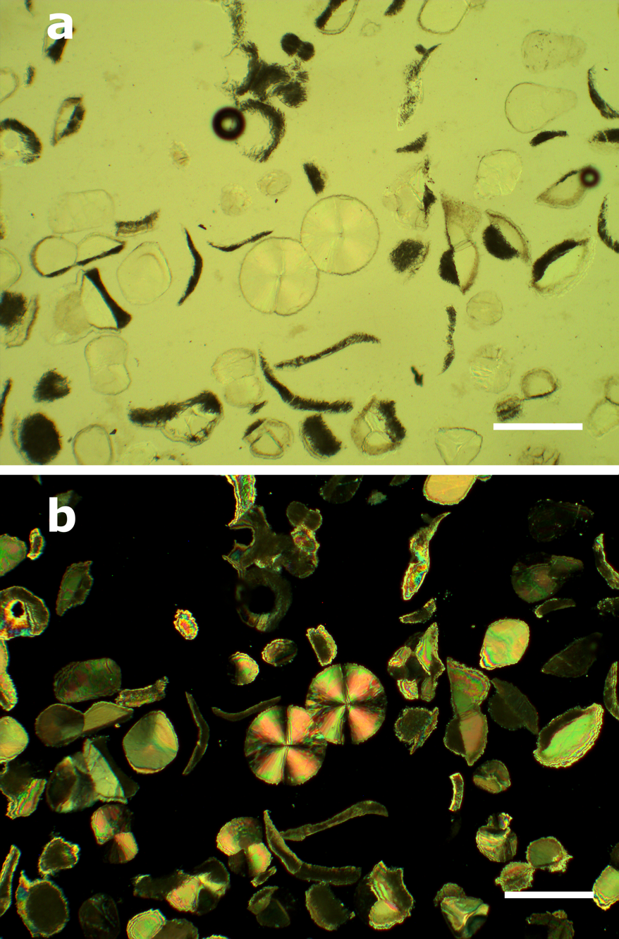
Fig. S2 Thin section micrograph of BCC-ACE observed under bright field and polarized light. Scale: 100 µm.

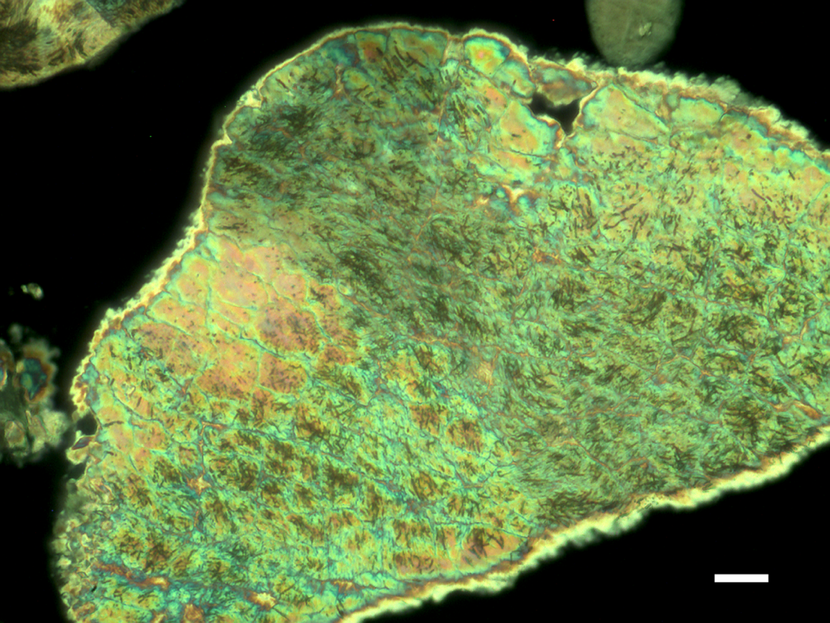

Fig. S3 Thin section micrograph of BCC-GLC observed under polarized light. Mineral botryoidal growth, triple or double joins in twinned crystal, and baciliar shapes are shown. Scale: 10 µm

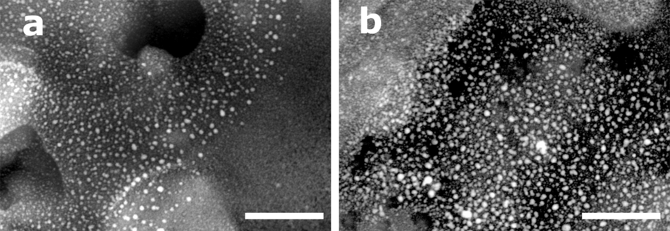
Fig. S4 SEM images showing the crystallites formed over EPS of BCC-GLY (a) and BCC-GLC (b). Scale: 500 nm.

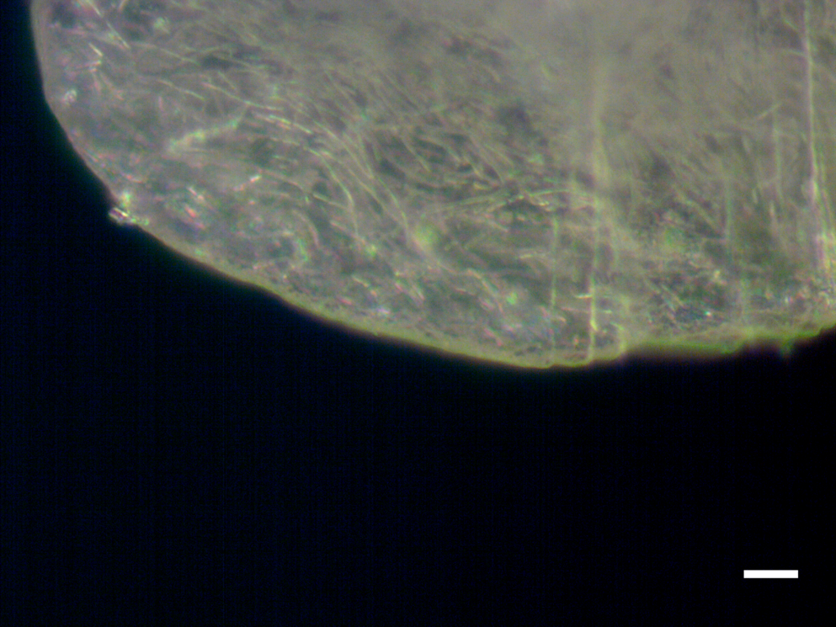
Fig. S5 Micrograph of BCC formed in ACE conditions. The mineralized cell-filaments are observed. Scale: 10 µm.

.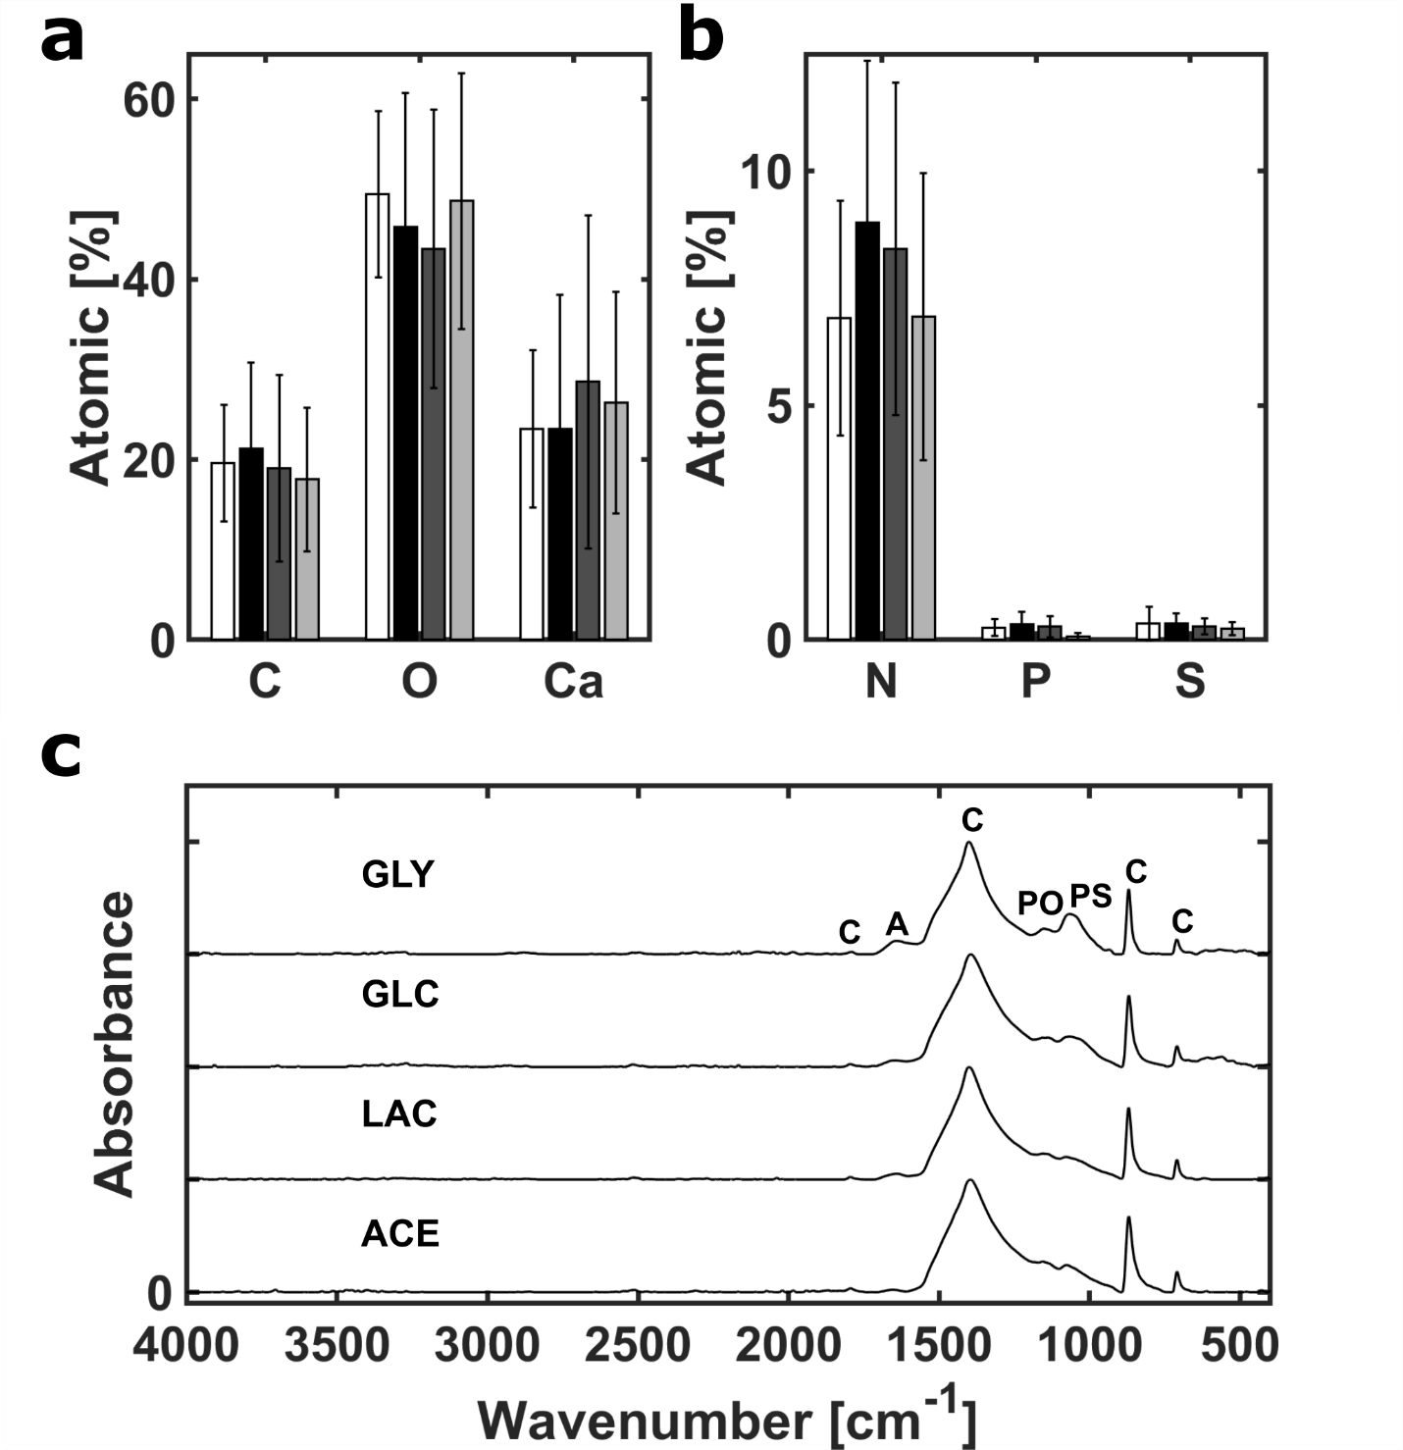
Fig. S6 BCC composition. (a) Bars correspond to the average of six punctual EDX measurements taken over four different crystals of BCC-GLY (white), BCC-GLC (black), BCC-LAC (dark gray) and BCC-ACE (gray). Error bars indicate standard deviation. (b) FTIR-ATR spectrum of all BCC. The main functional vibrations groups for calcite (C), polysaccharides (PS), phosphates (PO) and amides (A) are marked.

