Supplementary document

Enhanced Electrochemical Corrosion Resistance of GO/ZnO/Epoxy Nanocomposite Coatings on Magnesium Alloy in Saline Environment

Khaled A. Jilo ª, Khaled M. Chahrour ^{*a}, Hayrettin Ahlatçı ^{b}, Ahmed Abdel Nazeer ^{c}

- Mechanical Engineering Dept., Faculty of Engineering, Karabuk University, 78050, Karabuk, Turkiye.
- Metallurgical and Materials Engineering Dept., Faculty of Engineering, Karabuk University,78050, Karabuk, Turkiye
- Electrochemistry Laboratory, Physical Chemistry Department, National Research Center, Giza, Egypt.

*Corresponding author email: Khaledchahrour@karabuk.edu.tr

Table S1. Tafel polarization results of bare substrate, Epoxy coating, ${ZnO}_{1.36}$/Ep coating, ${ZnO}_{2.53}$/Ep coating, ${ZnO}_{4.10}$/Ep coating, ${ZnO}_{5.20}$/Ep coating, ${GO}_{0.8}$/${ZnO}_{4.1}$/Ep, ${GO}_{0.4}$/${ZnO}_{4.1}$/Ep, ${GO}_{0.2}$/${ZnO}_{4.1}/Ep$ and ${GO}_{0.05}$/${ZnO}_{4.1}$/Ep.

Coating | $I_{corr}$ (A/${cm}^{2}$) | $$E_{corr} (V)$$ | Corrosion Rate (mmpy)
Bare substrate | 6.682×${10}^{-7}$ | -1.523 | 2940.9
Epoxy Coating | 4.030×${10}^{-7}$ | -1.333 | 854.4
${ZnO}_{1.36}$/Ep | 3.486×${10}^{-7}$ | -1.155 | 793.2
${ZnO}_{2.53}$/Ep | 5..300×${10}^{-8}$ | -0.808 | 193.3
${ZnO}_{4.10}$/Ep | 5.565×${10}^{-9}$ | -0.518 | 43.54
${ZnO}_{5.20}$/Ep | 3.750×${10}^{-8}$ | -0.713 | 233.4
${GO}_{0.8}$/${ZnO}_{4.1}$/Ep | 2.500×${10}^{-7}$ | -1.180 | 442.4
${GO}_{0.4}$/${ZnO}_{4.1}$/Ep | 1.900×${10}^{-7}$ | -1.024 | 234.3
${GO}_{0.2}$/${ZnO}_{4.1}$/Ep | 5.856×${10}^{-8}$ | -0.997 | 195.1
${GO}_{0.05}$/${ZnO}_{4.1}$/Ep | 3.485×${10}^{-9}$ | -0.422 | 4.170

Table S2. EIS fitted Nyquist curve results of bare substrate. The Epoxy coating. ${ZnO}_{1.36}$/Ep coating. ${ZnO}_{2.53}$/Ep coating. ${ZnO}_{4.10}$/Ep coating. ${ZnO}_{5.20}$/Ep coating. ${GO}_{0.8}$/${ZnO}_{4.1}$/Ep. ${GO}_{0.4}$/${ZnO}_{4.1}$/Ep. ${GO}_{0.2}$/${ZnO}_{4.1}/Ep$ and ${GO}_{0.05}$/${ZnO}_{4.1}$/Ep.
Coating | $$R_{ct}$$ (Ω${cm}^{-2}$) | $$R_{s}$$ (Ω${cm}^{-2}$) | $$R_{c}$$(Ω${cm}^{-2}$) | $${CPE}_{dl}$$$(Ω^{-1}{cm}^{-2}s^{n}$ ) |  | $${CPE}_{c}$$$(Ω^{-1}{cm}^{-2}s^{n})$
Bare substrate | 28150 | 25.46 | - |  | 94.02×${10}^{-6}$ | -
Epoxy Coating | 54232 | 22.83 | 38020 |  | 7.318×${10}^{-6}$ | 11.37×${10}^{-6}$
${ZnO}_{1.36}$/Ep | 57105 | 11.72 | 33030 |  | 6.276×${10}^{-6}$ | 8.627×${10}^{-6}$
${ZnO}_{2.53}$/Ep | 81440 | 33.71 | 1681 |  | 5.394×${10}^{-6}$ | 7.326×${10}^{-6}$
${ZnO}_{4.10}$/Ep | 129000 | 0.232 | 3705 |  | 4.248×${10}^{-6}$ | 9.024×${10}^{-7}$
${ZnO}_{5.20}$/Ep | 113580 | 20.1×${10}^{-6}$ | 264.7 |  | 4.376×${10}^{-6}$ | 2.160×${10}^{-6}$
${GO}_{0.8}$/${ZnO}_{4.1}$/Ep | 133475 | 6.607 | 3247 |  | 2.995×${10}^{-6}$ | 6.913×${10}^{-8}$
${GO}_{0.4}$/${ZnO}_{4.1}$/Ep | 165420 | 7930 | 20210 |  | 1.758×${10}^{-6}$ | 5.754×${10}^{-9}$
${GO}_{0.2}$/${ZnO}_{4.1}$/Ep | 319050 | 0.002 | 0.032 |  | 1.471×${10}^{-6}$ | 7.869×${10}^{-10}$
${GO}_{0.05}$/${ZnO}_{4.1}$/Ep | 499020 | 657.4 | 84020 |  | 7.864×${10}^{-7}$ | 9.815×${10}^{-11}$

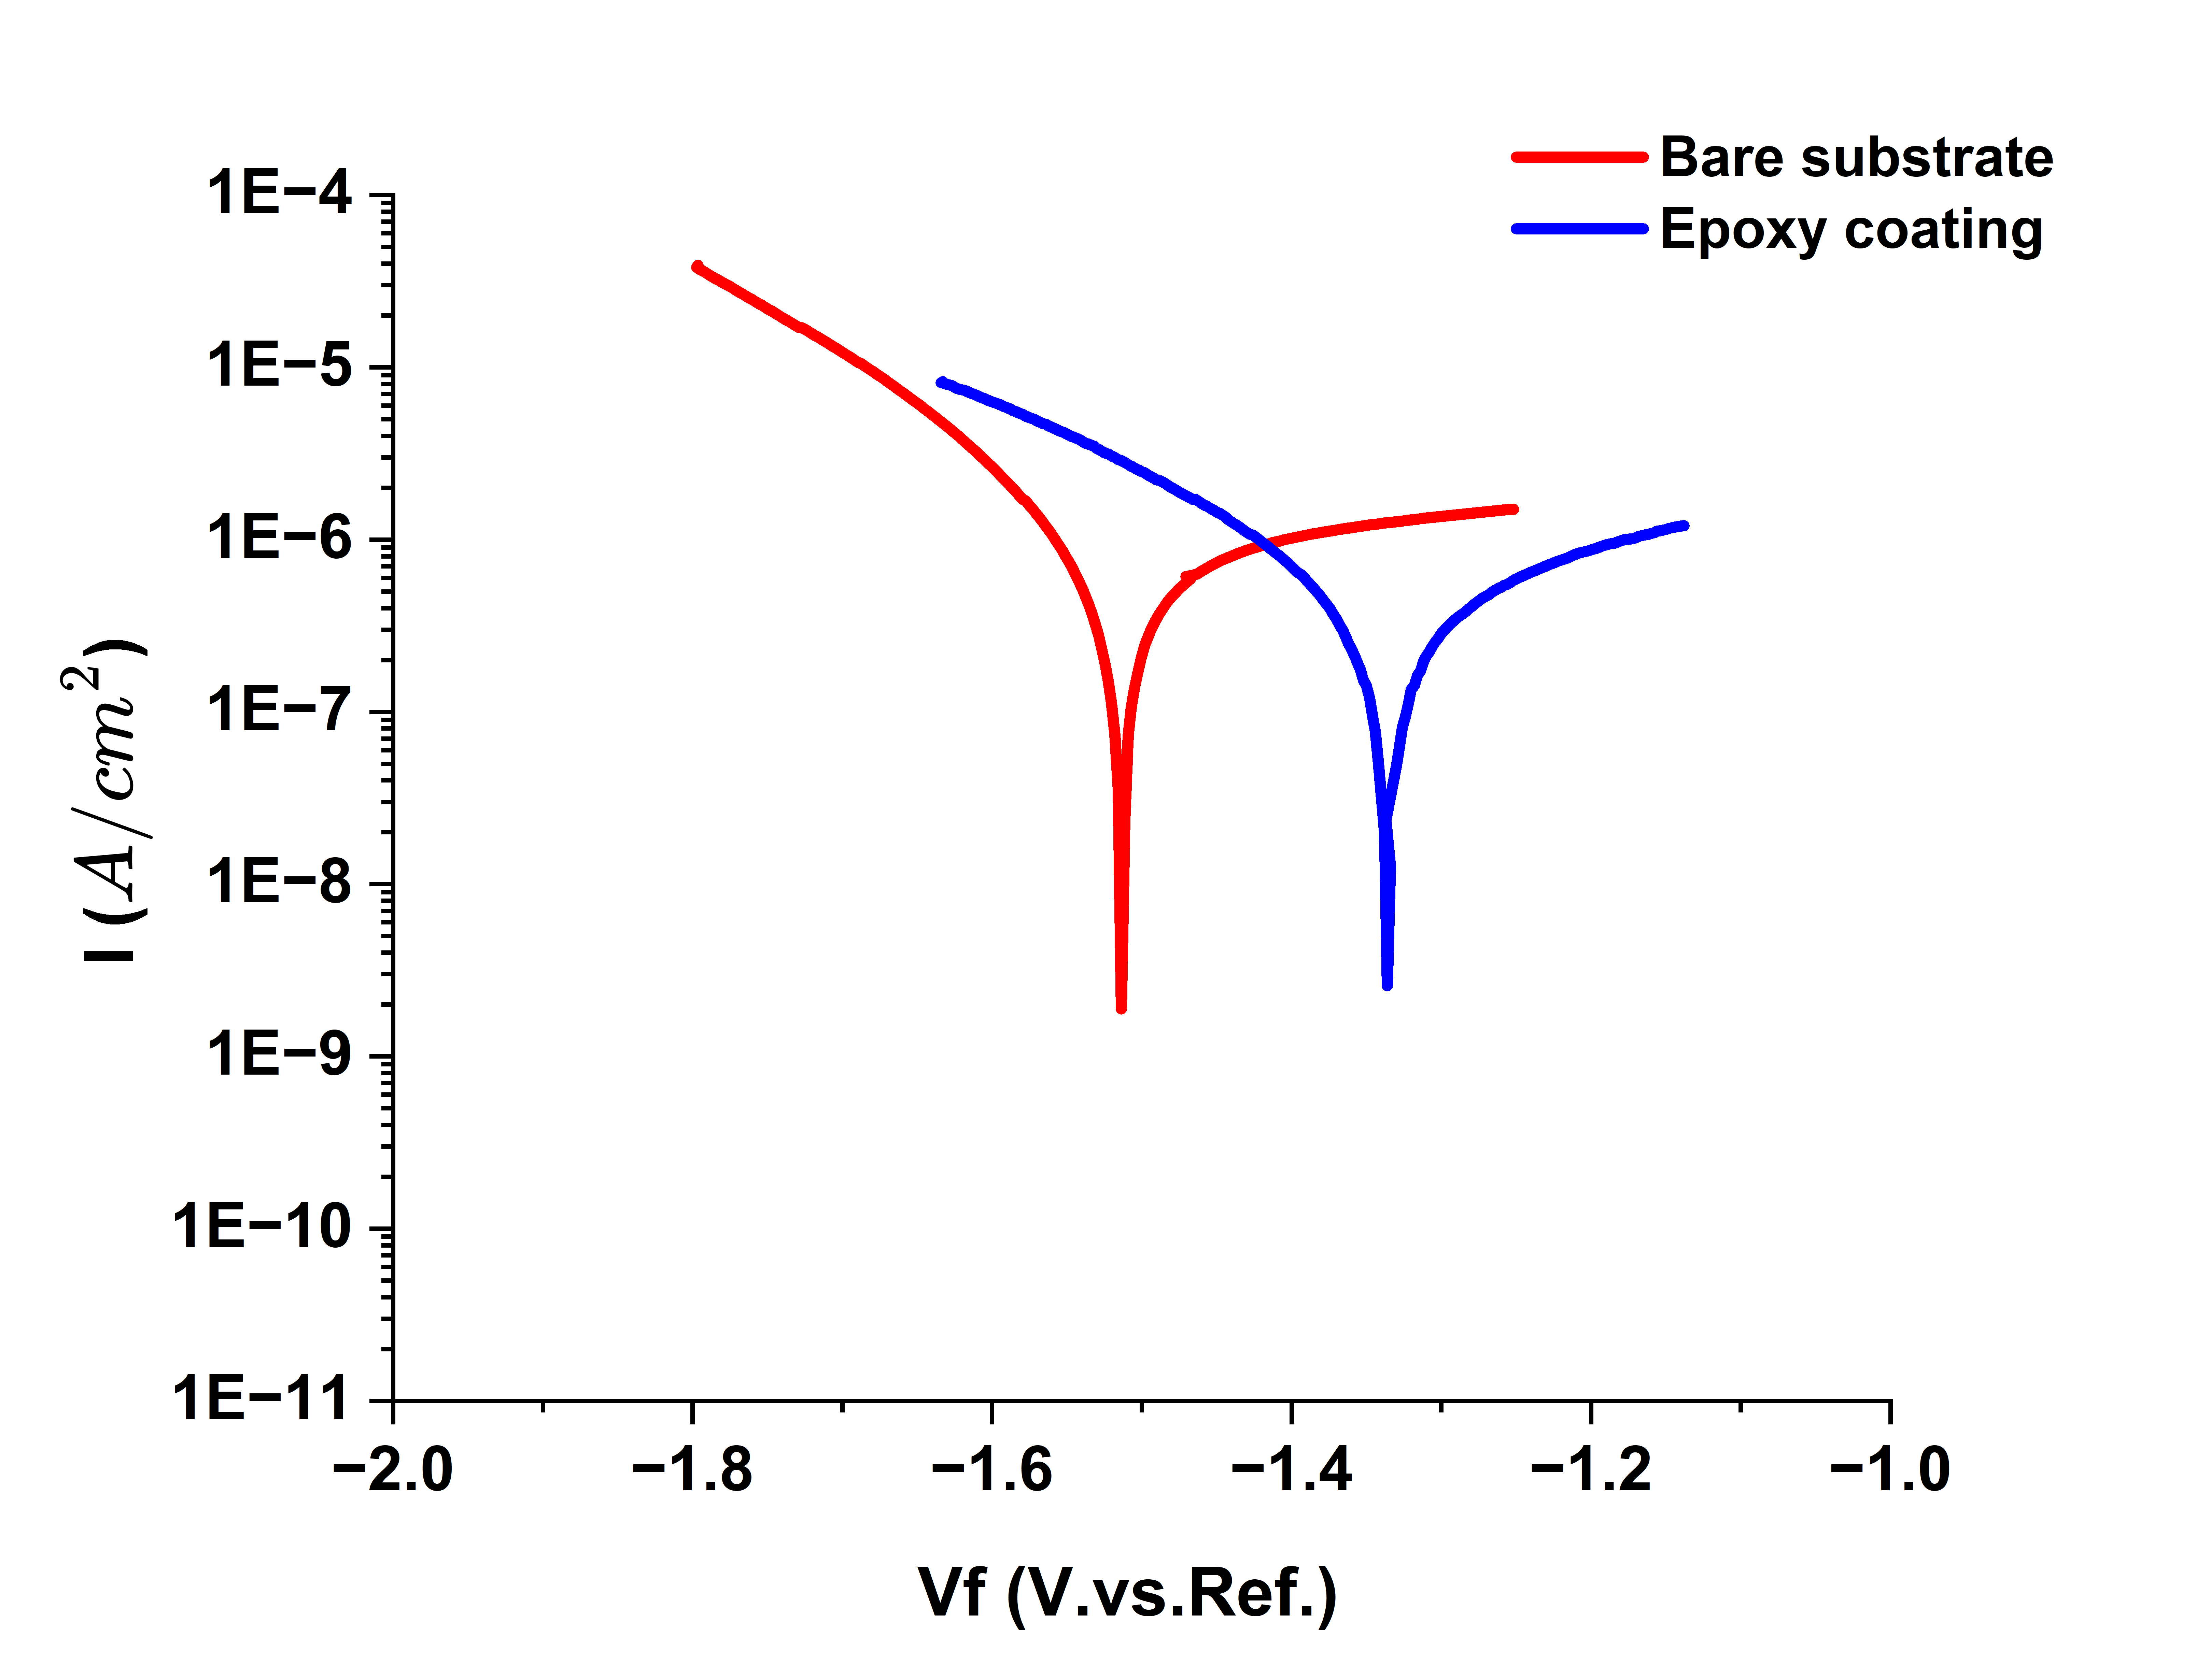
Figure S1. The Tafel plots of bare substrate and Epoxy-coated substrate.

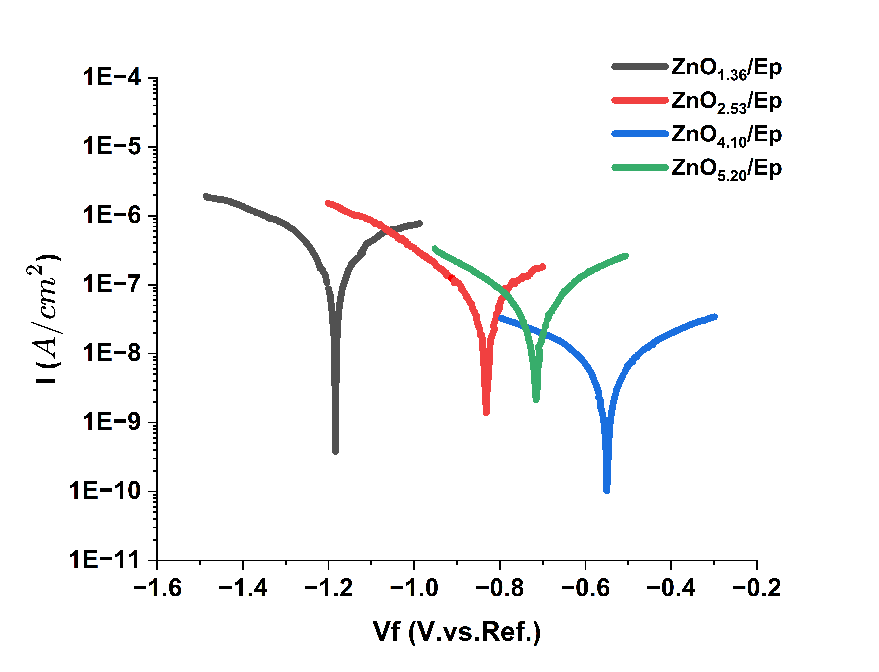
Figure S.2. The Tafel plots of ${ZnO}_{1.36}$/Ep, ${ZnO}_{2.53}$/Ep, ${ZnO}_{4.10}$/Ep and ${ZnO}_{5.20}$/Ep coatings.
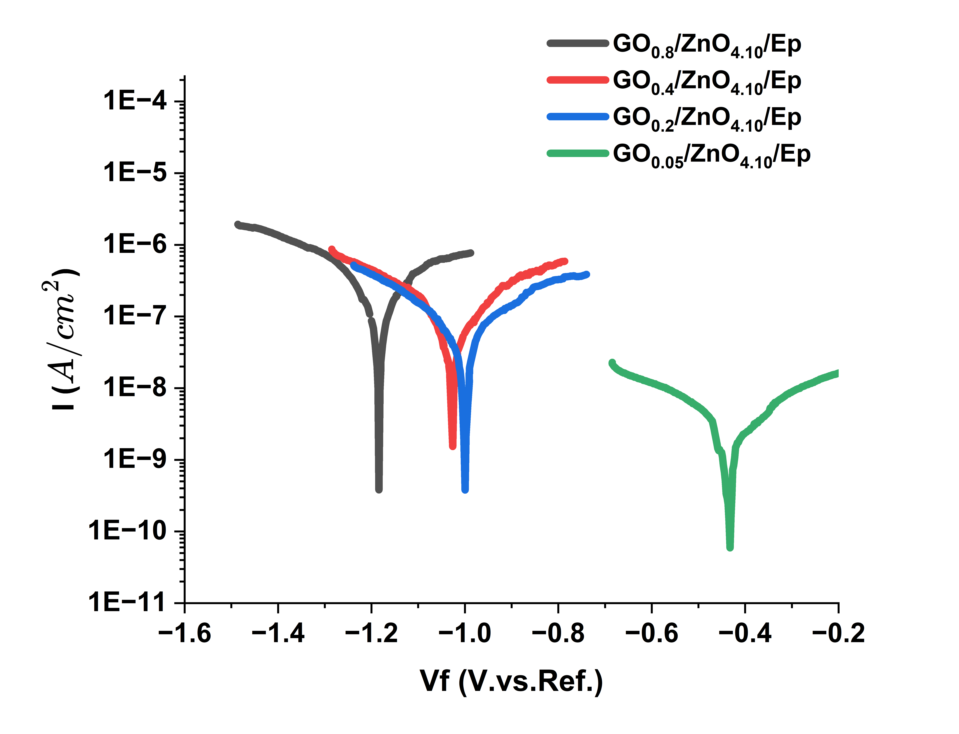
Figure S3. The Tafel plots of ${GO}_{0,8}$/${ZnO}_{4.10}$/Ep. ${GO}_{0,4}$/${ZnO}_{4.10}$/Ep, ${GO}_{0,2}$/${ZnO}_{4.10}$/Ep and ${GO}_{0,05}$/${ZnO}_{4.10}$/Ep coatings.
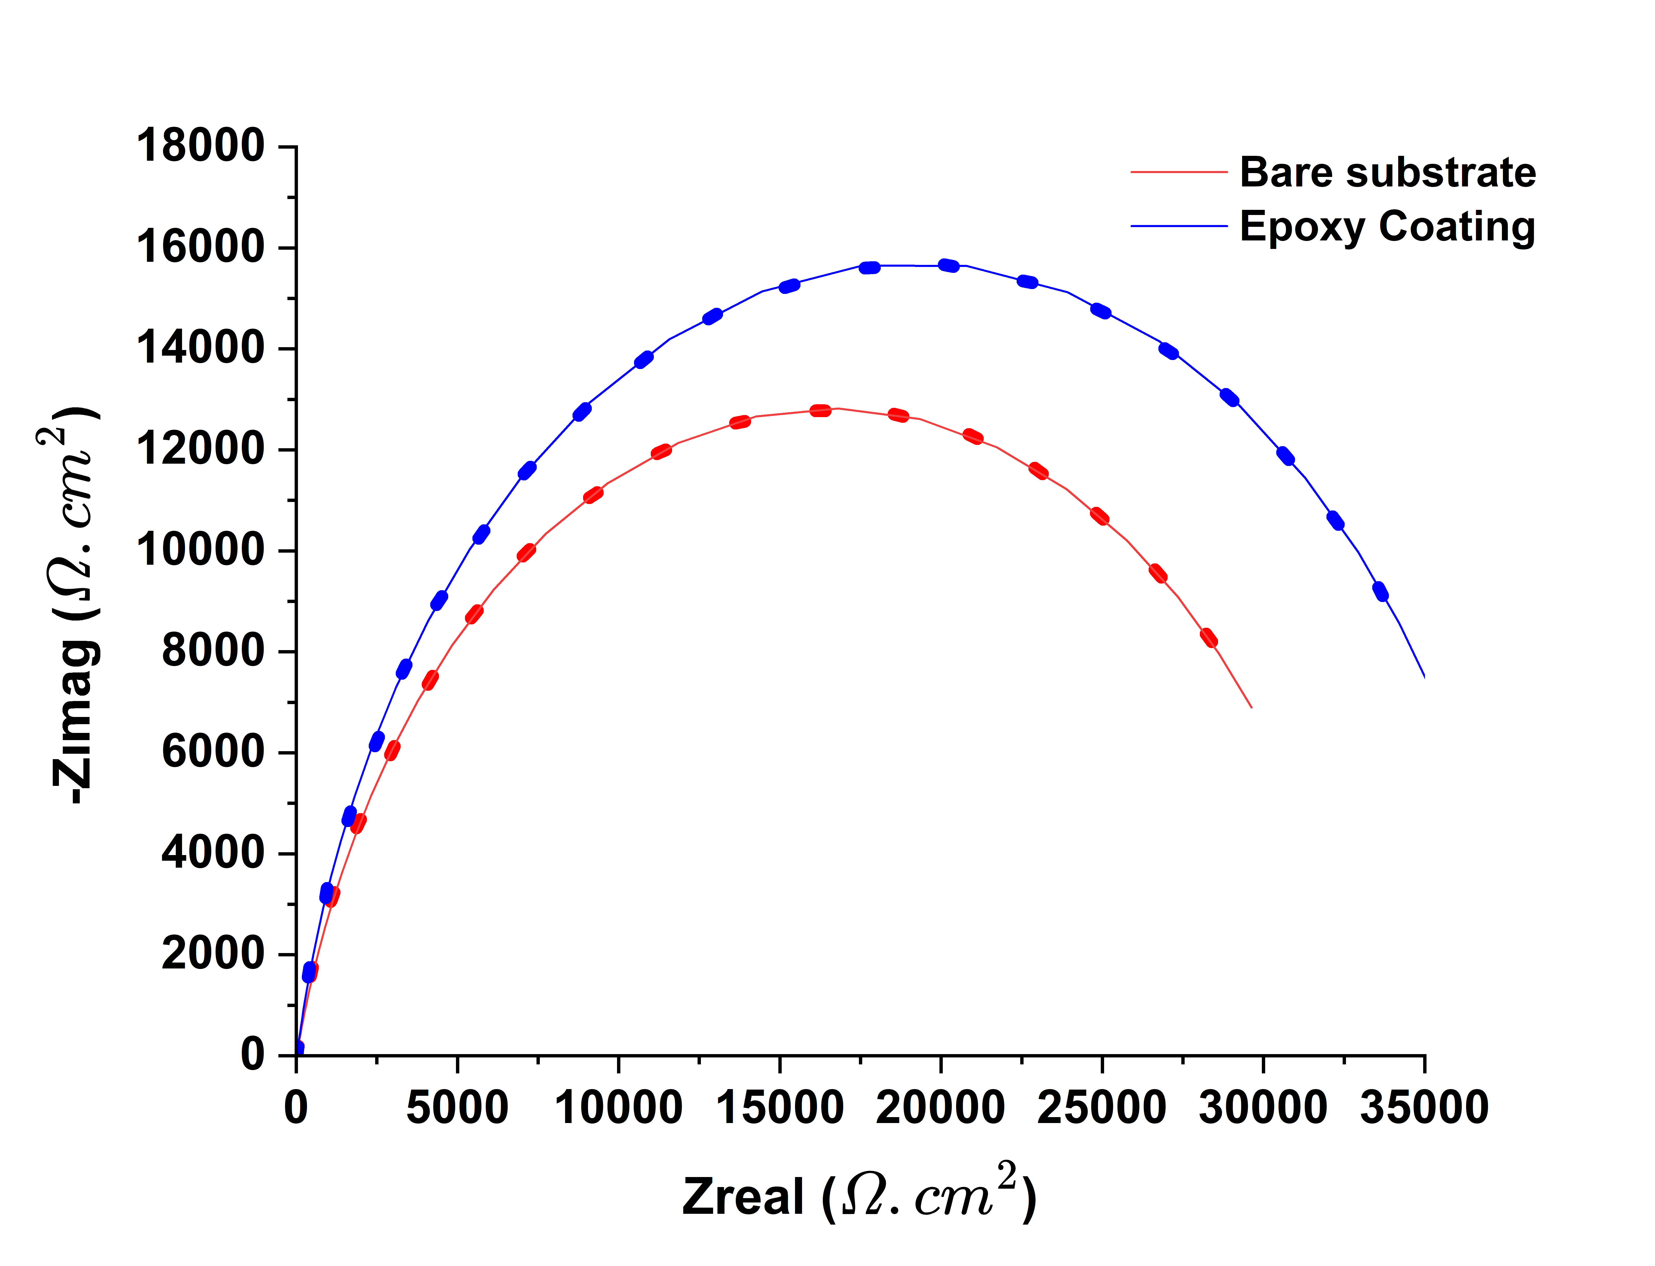
Figure S4. The Nyquist plots of bare substrate and Epoxy-coated substrate.
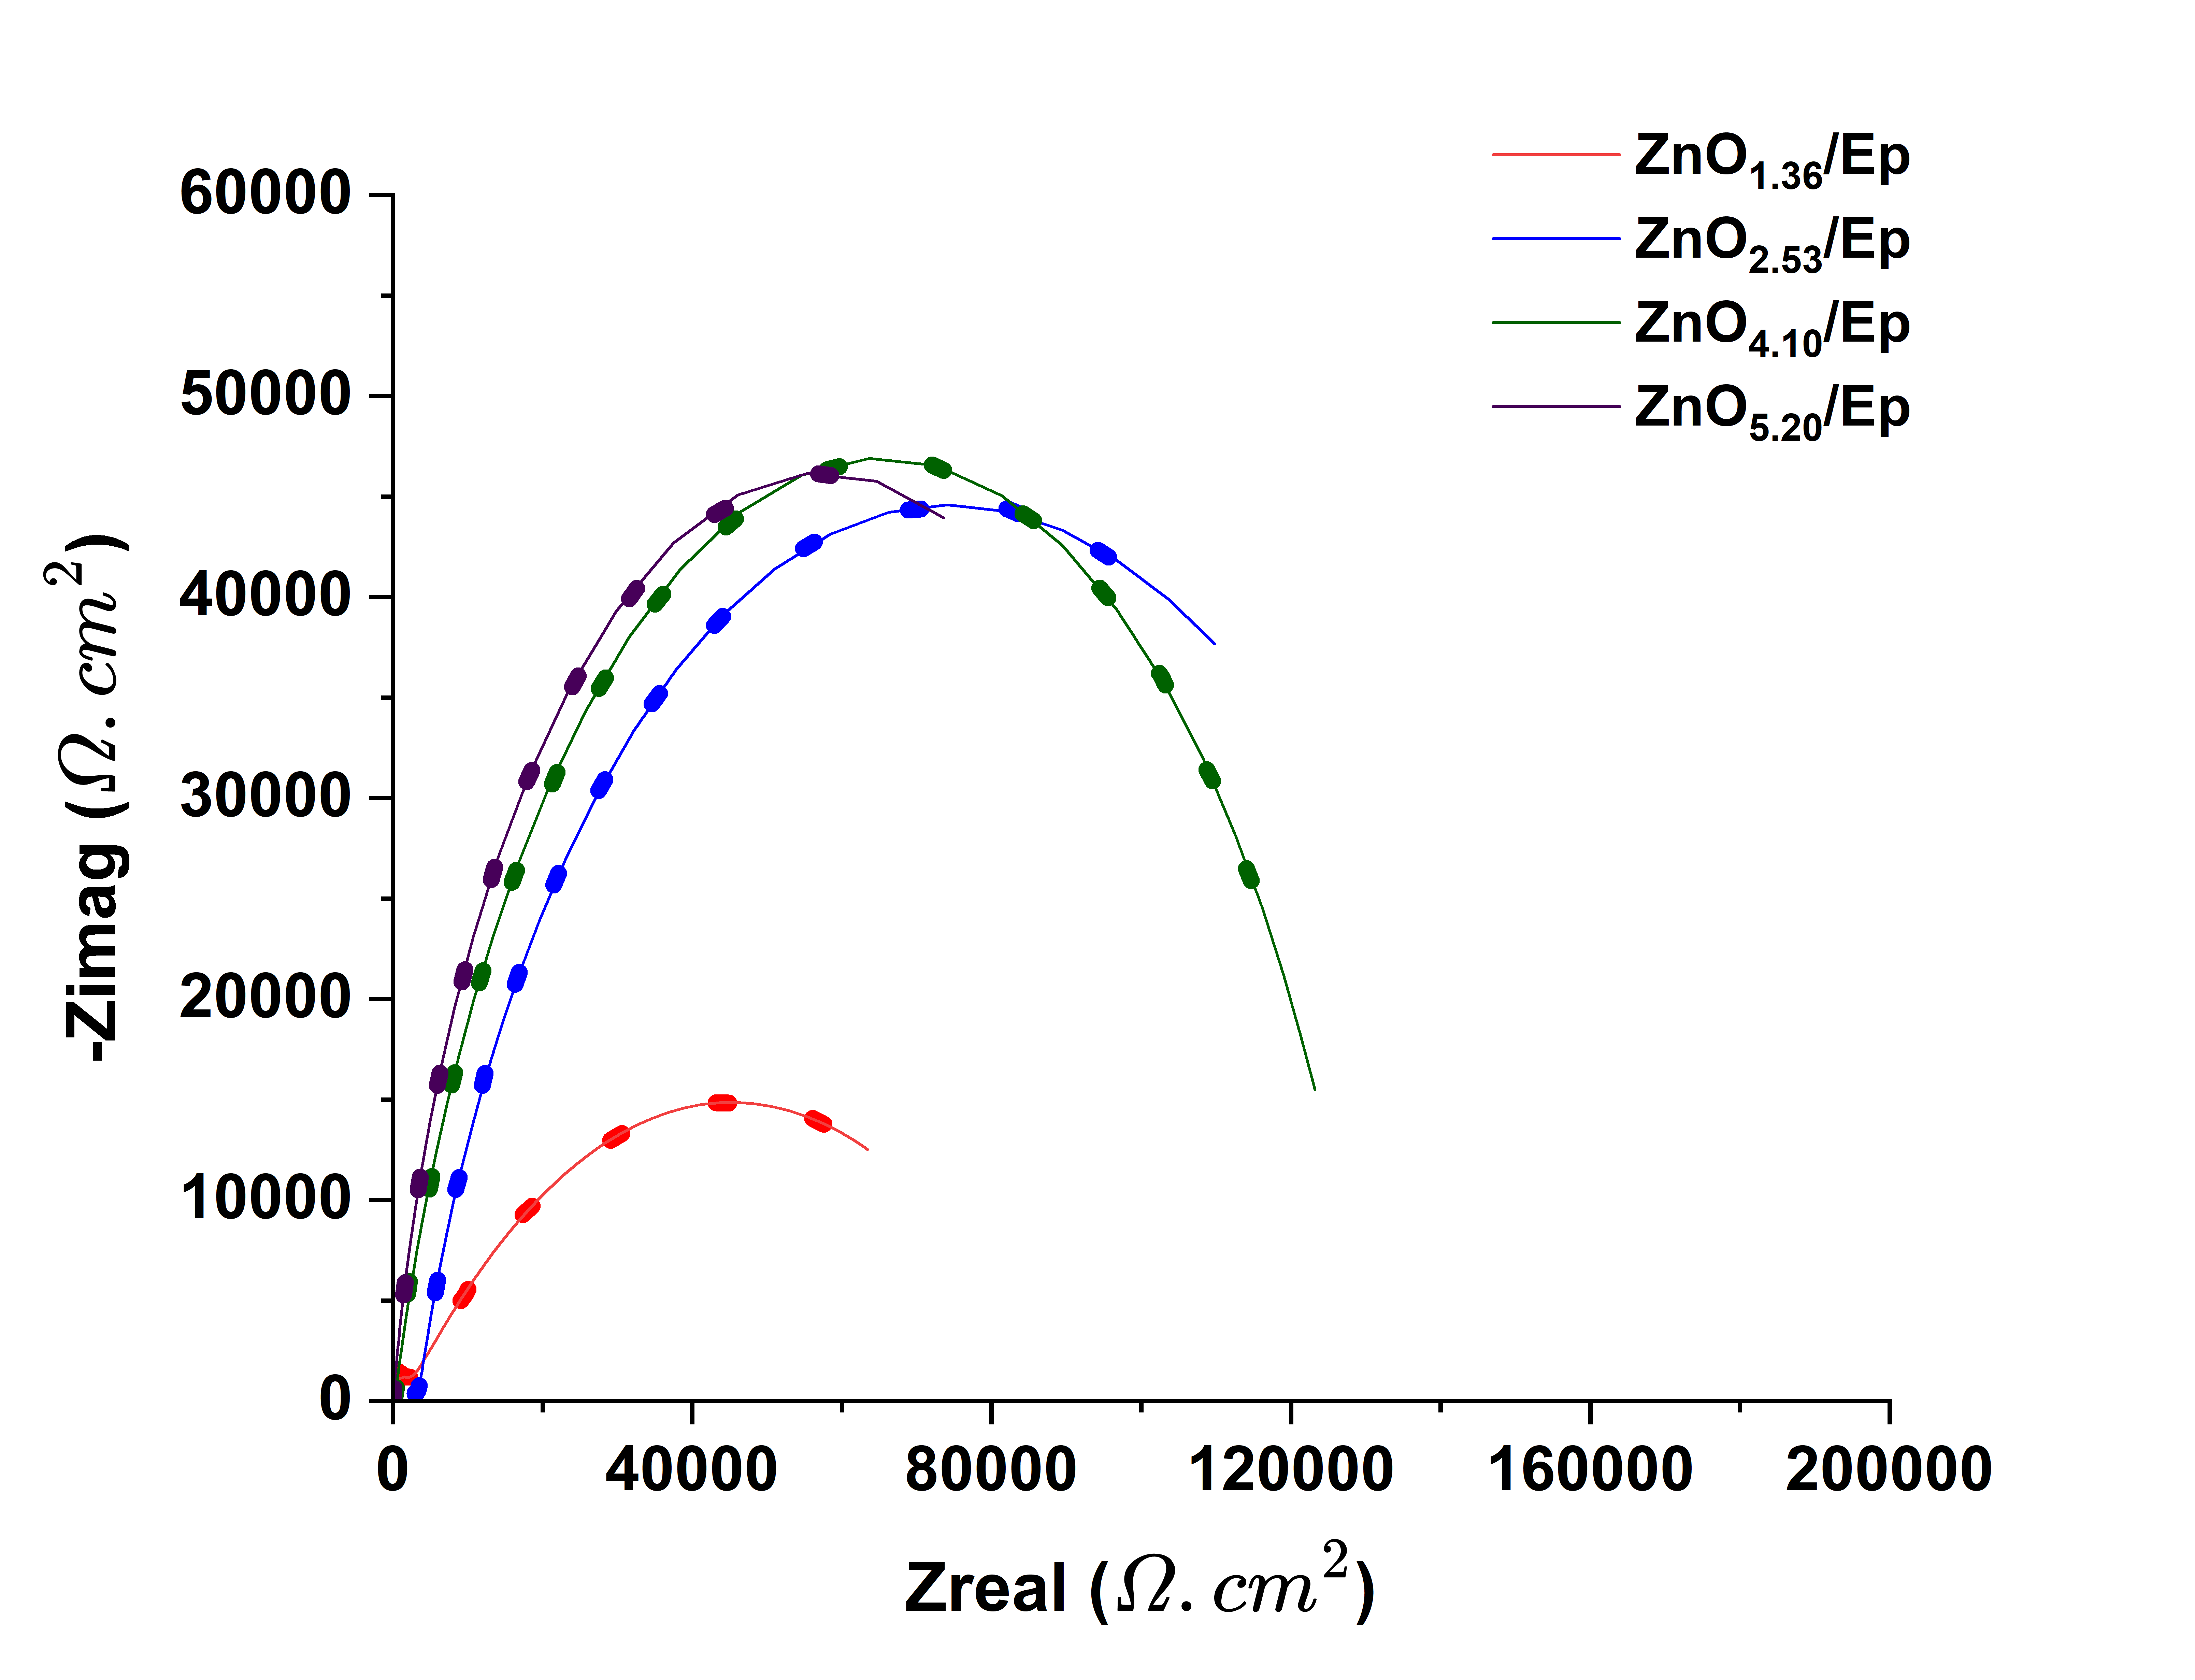
Figure S5. The Nyquist plots of ${ZnO}_{1.36}$/Ep, ${ZnO}_{2.53}$/Ep, ${ZnO}_{4.10}$/Ep and ${ZnO}_{5.20}$/Ep coatings.

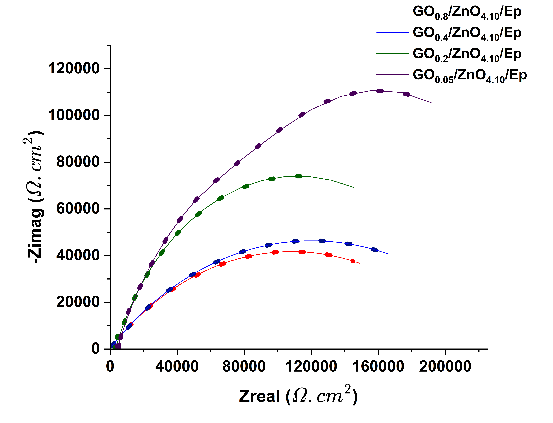
Figure S6. The Nyquist plots of ${GO}_{0,8}$/${ZnO}_{4.10}$/Ep. ${GO}_{0,4}$/${ZnO}_{4.10}$/Ep, ${GO}_{0,2}$/${ZnO}_{4.10}$/Ep and ${GO}_{0,05}$/${ZnO}_{4.10}$/Ep coatings.

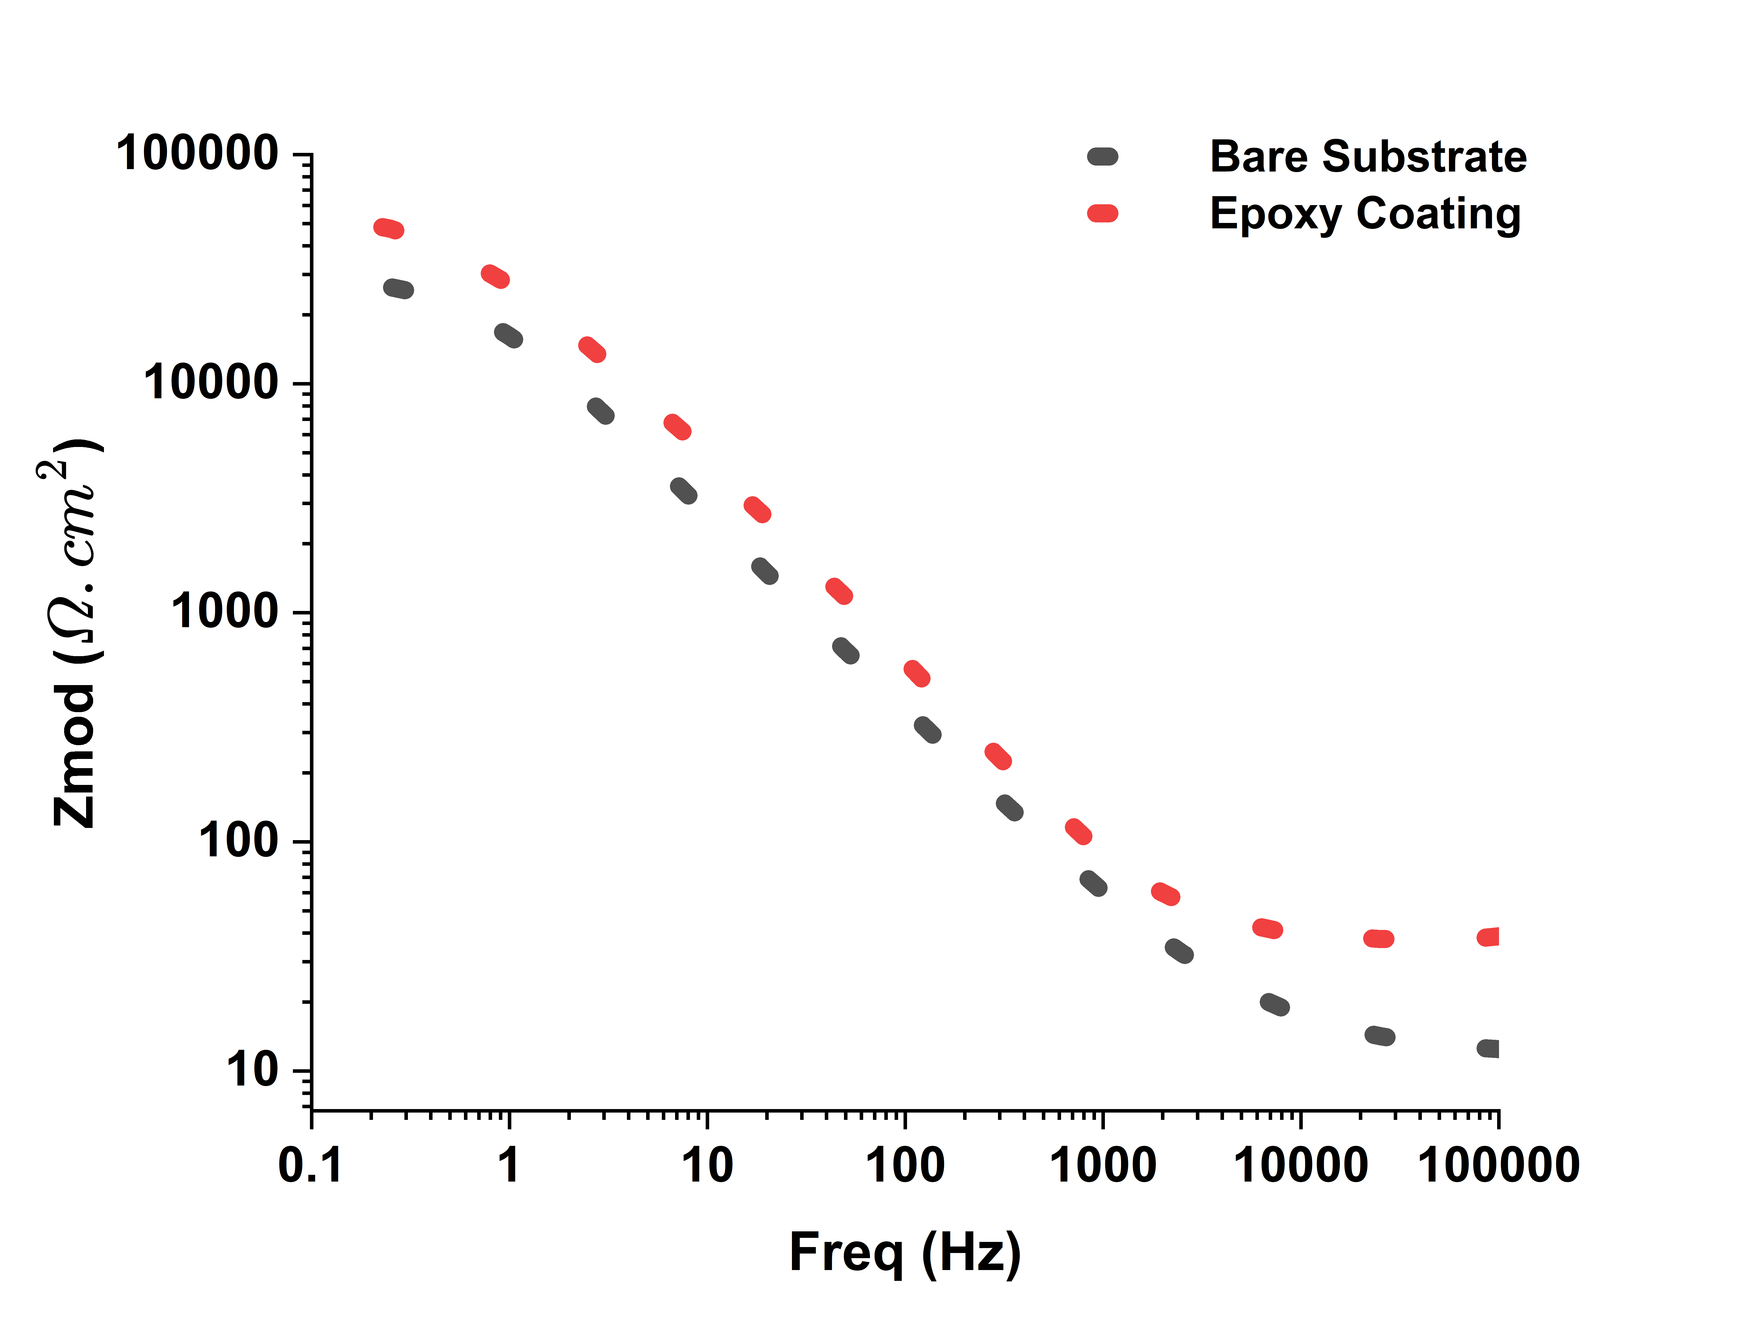
Figure S7. The Bode plots of bare substrate and Epoxy-coated substrate.
Figure S8. The Bode plots of ${ZnO}_{1.36}$/Ep, ${ZnO}_{2.53}$/Ep, ${ZnO}_{4.10}$/Ep and ${ZnO}_{5.20}$/Ep coatings.

Figure S9. The Bode plots of ${GO}_{0,8}$/${ZnO}_{4.10}$/Ep. ${GO}_{0,4}$/${ZnO}_{4.10}$/Ep, ${GO}_{0,2}$/${ZnO}_{4.10}$/Ep and ${GO}_{0,05}$/${ZnO}_{4.10}$/Ep coatings.

