Supplementary materials

Table S1. Fixed Effects Estimates of the Association between Valence and Intensity and Emotion Regulation (Within-Person) 2
Table S2. Within-Person and Between-Person Variances of valence, intensity, and emotion regulation strategies. 3
Table S3. Correlation Among Tendency and Flexibility Indicators Extracted from Multilevel Regression Models 4
Table S4. Correlation Between Tendency and Flexibility indicators and Psychopathology 6
Table S5. Cultural Context Moderates the Association between Valence and Intensity and Emotion Regulation (Within-Person) 7
Table S6. Cultural Context Moderates the Association between Tendency and Flexibility and Psychopathology (Between-Person) 8
Table S7. Ecological Momentary Assessment Measures in China and Germany 9
Table S8. Standardized Regression Coefficients and Their 95% Confidence Interval for the Unique Associations Between Emotion Regulation Tendency/Flexibility and Mental Health in China (Study 1) and Germany (Study 2) 10
Figure S1. Explanatory Power and the Relative Contribution (Ratio) of Emotion Regulation Tendency and Flexibility to Subscales of Brief Symptom Checklist (BSCL) in Germany 12
Figure S2. Emotion Regulation Tendency and Flexibility in Two Cultures 14
Figure S3. The Moderating Role of Cultural Context in the Association between Valence, Intensity, and Emotion Regulation, and in the Association between Tendency, Flexibility, and Psychopathology 15
Figure S4. Explanatory Power of Emotion Regulation Tendency and Flexibility When Modelled Alone to Psychopathology Across Cultures 17

Table S1.
Fixed Effects Estimates of the Association between Valence and Intensity and Emotion Regulation (Within-Person)
 | Study 1 (China) |  |  |  |  | Study 2 (Germany)
 | Est. | 95% CI | β | p |  | Est. | 95% CI | β | p
Outcome: Distraction
Valence | 0.19 | [0.01, 0.37] | 0.04 | 0.04 |  | 2.31 | [2.11, 2.50] | 0.45 | <.001
Intensity | 0.02 | [-0.02, 0.05] | 0.01 | 0.39 |  | -0.06 | [-0.10, -0.02] | -0.04 | .005
Outcome: Rumination
Valence | 0.58 | [0.42, 0.74] | 0.13 | <.001 |  | 1.94 | [1.75, 2.14] | 0.36 | <.001
Intensity | 0.19 | [0.15, 0.23] | 0.19 | <.001 |  | 0.25 | [0.21, 0.30] | 0.17 | <.001
Outcome: Reappraisal
Valence | 0.40 | [0.24, 0.57] | 0.09 | <.001 |  | 0.52 | [0.36, 0.68] | 0.12 | <.001
Intensity | 0.08 | [0.06, 0.11] | 0.08 | <.001 |  | -0.02 | [-0.05, 0.01] | -0.02 | 0.23
Outcome: Acceptance
Valence | -0.64 | [-0.82, -0.47] | -0.15 | <.001 |  | -2.58 | [-2.77, -2.38] | -0.52 | <.001
Intensity | 0.06 | [0.02, 0.09] | 0.06 | .002 |  | 0.11 | [0.07, 0.14] | 0.08 | <.001
Outcome: Expressive suppression
Valence | 1.02 | [0.84, 1.20] | 0.22 | <.001 |  | 1.65 | [1.46, 1.84] | 0.29 | <.001
Intensity | 0.04 | [0.01, 0.07] | 0.04 | 0.01 |  | -0.15 | [-0.19, -0.10] | -0.09 | <.001
Outcome: Social sharing
Valence | 0.16 | [0.00, 0.33] | 0.03 | 0.05 |  | 0.68 | [0.49, 0.85] | 0.11 | <.001
Intensity | 0.16 | [0.12, 0.20] | 0.14 | <.001 |  | 0.26 | [0.21, 0.30] | 0.16 | <.001
Outcome: Avoidance
Valence | 1.01 | [0.81, 1.21] | 0.23 | <.001 |  | 1.25 | [1.08, 1.43] | 0.26 | <.001
Intensity | 0.06 | [0.03, 0.09] | 0.06 | <.001 |  | -.002 | [-0.03, 0.03] | -.001 | 0.91
Outcome: Situation modification
Valence | 1.13 | [0.90, 1.36] | 0.24 | <.001 |  | 1.06 | [0.87, 1.22] | 0.23 | <.001
Intensity | 0.09 | [0.06, 0.12] | 0.08 | <.001 |  | -0.05 | [-0.08, -0.02] | -0.04 | .004

Notes. Study 1: n _{between} = 241 persons, n _{within} = 5472 observations; Study 2: n _{between} = 257 persons, n _{within} = 8639 observations. This model is a random-slope and random-intercept multilevel regression. Time series of observations at the within-person level, as well as person means of valence and intensity at the between-person level, were controlled in all models.

Table S2.
Within-Person and Between-Person Variances of valence, intensity, and emotion regulation strategies
 | Within-person variance |  | Between-person variance |  | Total variance
 | Germany | China | Germany | China | Germany | China
valence | 3.29 | 3.29 | 0.59 | 1.09 | 3.88 | 4.38
intensity | 3.36 | 4.57 | 1.19 | 2.31 | 4.55 | 6.88
distraction | 6.51 | 5.03 | 1.49 | 3.16 | 8.00 | 8.19
rumination | 7.12 | 4.37 | 2.68 | 3.51 | 9.80 | 7.88
reappraisal | 4.64 | 4.22 | 2.19 | 3.96 | 6.83 | 8.18
acceptance | 5.95 | 4.37 | 1.82 | 3.12 | 7.77 | 7.49
expressive suppression | 7.80 | 4.91 | 2.16 | 3.25 | 9.96 | 8.16
social sharing | 8.71 | 5.58 | 1.78 | 3.55 | 10.49 | 9.13
avoidance | 5.60 | 4.54 | 1.78 | 3.42 | 7.38 | 7.96
situation modification | 5.17 | 4.91 | 1.62 | 3.98 | 6.79 | 8.89

Table S3.
Study 1 (China): Correlation Among Tendency and Flexibility Indicators Extracted from Multilevel Regression Models
 | 1 | 2 | 3 | 4 | 5 | 6 | 7 | 8 | 9 | 10 | 11 | 12 | 13 | 14 | 15 | 16 | 17 | 18 | 19 | 20 | 21 | 22 | 23
2 | .28**
3 | .56** | .62**
4 | .22** | -0.01 | .16*
5 | .33** | .57** | .45** | 0.02
6 | .31** | .59** | .49** | .20** | .22**
7 | .55** | .57** | .76** | 0.08 | .63** | .37**
8 | .56** | .54** | .73** | .19** | .52** | .44** | .86**
9 | -.59** | -.13* | -.34** | 0.02 | -.25** | -0.13 | -.41** | -.41**
10 | .13* | 0 | 0.11 | -0.08 | 0.07 | 0.02 | .15* | 0.12 | 0.05
11 | -0.05 | -.56** | -.30** | 0.05 | -.29** | -.31** | -.25** | -.21** | -0.01 | -0.1
12 | 0.02 | .17* | -0.01 | 0.06 | 0 | 0.11 | 0.02 | 0.02 | 0 | -.25** | 0.06
13 | -.22** | -.31** | -.38** | 0.09 | -.31** | -0.12 | -.41** | -.39** | .41** | 0.03 | .26** | -0.05
14 | .30** | .31** | .51** | -0.02 | .20** | .18** | .39** | .33** | -.17** | .17** | -.21** | .19** | -.42**
15 | -0.07 | 0.02 | -0.02 | -.49** | 0.01 | -0.02 | 0 | -0.07 | .17** | .23** | -0.11 | 0.02 | .16* | 0.01
16 | -0.07 | 0.01 | 0.04 | -.21** | 0.02 | -0.05 | 0 | -0.05 | .24** | .37** | -0.07 | -0.05 | .16* | .20** | .63**
17 | -.16* | -.19** | -.15* | 0.08 | -.38** | -.20** | -.29** | -.22** | .25** | 0.09 | .19** | -0.02 | .30** | -0.04 | 0.04 | 0.11
18 | -.14* | -.25** | -.13* | 0.02 | -.50** | -.17** | -.28** | -.24** | .19** | .13* | .19** | 0.04 | .21** | 0.12 | 0.07 | 0.12 | .77**
19 | 0.04 | 0.01 | -0.01 | 0.12 | -0.1 | 0.1 | -0.08 | -0.07 | 0.01 | -.23** | 0.12 | .22** | .14* | -0.04 | -0.07 | 0 | -0.11 | -0.06
20 | 0 | -0.04 | -0.02 | .13* | -0.1 | 0.02 | -0.02 | -0.01 | -0.04 | -.16* | 0.06 | .31** | 0.07 | 0.08 | -0.12 | -0.03 | -0.07 | 0.01 | .71**
21 | -.14* | -.22** | -.20** | .18** | -.38** | -0.11 | -.49** | -.42** | .37** | -0.01 | .18** | 0.04 | .51** | -.15* | 0.03 | 0.06 | .58** | .45** | 0.13 | 0.08
22 | 0.06 | 0.06 | -0.03 | -0.08 | 0.02 | 0.06 | -0.09 | -0.06 | 0.06 | .22** | -0.06 | .15* | 0.11 | .21** | .17* | .18** | 0.1 | .14* | -0.03 | 0.06 | .21**
23 | -0.11 | -.20** | -.29** | .20** | -.36** | -0.07 | -.50** | -.49** | .37** | -0.07 | .16* | 0.11 | .47** | -.16* | -0.01 | 0.06 | .40** | .33** | .14* | -0.03 | .72** | 0.11
24 | 0.08 | 0.09 | 0.01 | -0.1 | 0.09 | 0.02 | 0.11 | 0.11 | -0.01 | .20** | -.15* | 0.1 | -0.05 | .28** | 0.09 | 0.1 | 0.08 | .23** | -0.06 | 0.06 | -0.04 | .40** | -0.12

Notes. n = 241. **, p < 0.01; *, p < 0.05.
Tendency indicators (1-8): 1. Distraction; 2. Rumination; 3. Reappraisal; 4. Acceptance; 5. Expressive Suppression; 6. Social Sharing;
7. Avoidance; 8. Situation Modification;
Flexibility indicators (9-24): 9. Distraction x Valence; 10. Distraction x Intensity; 11. Rumination x Valence; 12. Rumination x
Intensity; 13. Reappraisal x Valence; 14. Reappraisal x Intensity; 15. Acceptance x Valence; 16. Acceptance x Intensity; 17.
Expressive Suppression x Valence; 18. Expressive Suppression x Intensity; 19. Social Sharing x Valence; 20. Social Sharing x
Intensity; 21. Avoidance x Valence; 22. Avoidance x Intensity; 23. Situation Modification x Valence; 24. Situation Modification x
Intensity.

 | 1 | 2 | 3 | 4 | 5 | 6 | 7 | 8 | 9 | 10 | 11 | 12 | 13 | 14 | 15 | 16 | 17 | 18 | 19 | 20 | 21 | 22 | 23
2 | .61**
3 | .71** | .65**
4 | -.53** | -.30** | -.28**
5 | .37** | .28** | .21** | -.32**
6 | .55** | .57** | .55** | -.17** | 0.08
7 | .66** | .45** | .61** | -.40** | .37** | .44**
8 | .71** | .52** | .74** | -.35** | .25** | .52** | .72**
9 | -0.08 | -0.03 | -0.07 | .23** | -0.06 | 0.03 | -.13* | -0.11
10 | -.61** | -.38** | -.38** | .34** | -.21** | -.28** | -.35** | -.38** | 0.03
11 | -.24** | -.26** | -.24** | .27** | -.16* | -.22** | -.34** | -.29** | .29** | 0.07
12 | -0.08 | .20** | 0.01 | .18** | 0.05 | 0.11 | -0.06 | -0.08 | 0.11 | 0.1 | .21**
13 | -.41** | -.22** | -.40** | .30** | -.18** | -.19** | -.33** | -.32** | .23** | .22** | .18** | 0.03
14 | -.15* | -.23** | -.23** | 0.04 | -0.02 | -.13* | -0.1 | -0.11 | -0.09 | .25** | 0.03 | .19** | -.22**
15 | .34** | .26** | .35** | -.45** | .21** | .26** | .31** | .35** | -.24** | -.12* | -.24** | -.14* | -0.09 | -0.03
16 | .29** | .17** | .24** | -.42** | 0.04 | .22** | .22** | .24** | -0.07 | -.23** | -0.01 | -.20** | -0.06 | -.18** | .43**
17 | -.20** | -.14* | -.18** | .19** | -.37** | -.15* | -.21** | -.19** | .31** | 0.02 | .24** | 0.09 | 0.04 | 0.03 | -.47** | -0.05
18 | -0.1 | -.13* | -0.04 | -0.02 | -.38** | -0.02 | -0.07 | -0.07 | -0.07 | .23** | -.13* | -0.06 | 0.02 | 0.11 | 0.02 | -.25** | -0.07
19 | -.24** | -.28** | -.17** | .16** | -.17** | -.23** | -.13* | -.14* | 0.05 | .15* | .17** | -0.03 | .28** | 0.03 | 0.11 | -0.04 | -.18** | 0.07
20 | .18** | .25** | .26** | 0.03 | 0.02 | .56** | .14* | .23** | 0.11 | -0.07 | -.14* | .26** | -0.03 | 0.05 | .16** | 0.11 | -0.02 | -.14* | 0.06
21 | -0.1 | -0.06 | -0.07 | .16* | -0.05 | -0.03 | -0.01 | -0.07 | .38** | 0.09 | 0.08 | 0.12 | .21** | -.16* | -.24** | -0.09 | 0.09 | -0.1 | 0.09 | 0.08
22 | -.35** | -.15* | -.32** | .27** | -.23** | -.22** | -.53** | -.44** | .21** | .22** | .18** | .18** | .15* | 0.04 | -.36** | -.21** | .25** | -0.02 | 0.04 | 0.03 | .45**
23 | -.33** | -.18** | -.19** | .34** | -.24** | -0.09 | -.23** | -.26** | .32** | .12* | .19** | 0.02 | .55** | -.29** | -.18** | -0.01 | 0.09 | 0.01 | .29** | -0.02 | .38** | .22**
24 | -0.04 | -0.07 | -.13* | -0.03 | 0.11 | -.13* | -0.1 | -.17** | -.15* | .18** | -0.01 | 0.1 | -.26** | .44** | -0.05 | -.16* | -0.04 | 0.03 | -.13* | -0.01 | -.25** | .17** | -.62**
Study 2 (Germany): Correlation Among Tendency and Flexibility Indicators Extracted from Multilevel Regression Models.

Notes. n = 257; **, p < 0.01; *, p < 0.05.
Tendency indicators (1-8): 1. Distraction; 2. Rumination; 3. Reappraisal; 4. Acceptance; 5. Expressive Suppression; 6. Social Sharing;
7. Avoidance; 8. Situation Modification;
Flexibility indicators (9-24): 9. Distraction x Valence; 10. Distraction x Intensity; 11. Rumination x Valence; 12. Rumination x
Intensity; 13. Reappraisal x Valence; 14. Reappraisal x Intensity; 15. Acceptance x Valence; 16. Acceptance x Intensity; 17.
Expressive Suppression x Valence; 18. Expressive Suppression x Intensity; 19. Social Sharing x Valence; 20. Social Sharing x
Intensity; 21. Avoidance x Valence; 22. Avoidance x Intensity; 23. Situation Modification x Valence; 24. Situation Modification x
Intensity.

Table S4.
Correlation Between Tendency and Flexibility indicators and Psychopathology
 |  |  | Depression |  | Anxiety |  | Insomnia | Psychopathology
 |  |  | China | Germany | China | Germany | China | Germany
Emotion Regulation Tendency
 |  | Distraction | -.06 | .17** | .02 | .13* | 0 | .14*
 |  | Rumination | .13* | .12 | .25** | .10 | .09 | .11
 |  | Reappraisal | .02 | .07 | .16* | .05 | .03 | .06
 |  | Acceptance | -.18** | -.11 | -.29** | -.11 | -.03 | -.14*
 |  | Expressive Suppression | .25** | .14* | .26** | .04 | .13 | .09
 |  | Social Sharing | -.06 | 0 | .05 | -.02 | -.01 | 0
 |  | Avoidance | .13* | .11 | .24** | .06 | .08 | .06
 |  | Situation Modification | .09 | .10 | .16* | .08 | .11 | .09
Emotion Regulation Flexibility
 |  | Distraction × Valence | -.07 | -.01 | -.12 | -.02 | -.01 | -.05
 |  | Distraction × Intensity | -.08 | -.10 | 0 | -.09 | -.08 | -.06
 |  | Rumination × Valence | .05 | .05 | -.05 | .06 | .02 | .06
 |  | Rumination × Intensity | -.03 | .05 | -0.10 | .04 | -.04 | .05
 |  | Reappraisal × Valence | -.08 | -.22** | -.14* | -.10 | -.06 | -.24**
 |  | Reappraisal × Intensity | -.04 | .06 | .06 | .05 | -.07 | .06
 |  | Acceptance × Valence | -.12 | -.24** | -.03 | -.22** | -.14* | -.21**
 |  | Acceptance × Intensity | -.16* | -.12* | -.07 | -.09 | -.10 | -.12*
 |  | Expressive Suppression × Valence | -.11 | .05 | -.09 | .11 | -.01 | .09
 |  | Expressive Suppression × Intensity | -.17** | -.06 | -.14* | -.02 | -.03 | .03
 |  | Social Sharing × Valence | -.04 | -.15* | -.09 | -.10 | -.08 | -.19**
 |  | Social Sharing × Intensity | .02 | -.09 | -.05 | -.08 | .02 | -.09
 |  | Avoidance × Valence | -.20** | .09 | -.23** | .09 | -.11 | .04
 |  | Avoidance × Intensity | -.13* | .01 | -.04 | .05 | -.05 | .01
 |  | Situation Modification × Valence | -.15* | -.23** | -.18** | -.13* | -.07 | -.22**
 |  | Situation Modification × Intensity | -.03 | .17** | -.01 | .10 | -.01 | .14*
Notes.
Study 1: n = 240 (1 participant did not complete questionnaires after EMA); Study 2: n = 257. **, p < 0.01; *, p < 0.05.

Table S5.
Cultural Context Moderates the Association between Valence and Intensity and Emotion Regulation (Within-Person)
 | Est. | 95% CI | β | p |  | Est. | 95% CI | β | p
Outcome: Distraction |  |  |  |  | Outcome: Rumination
Culture * Valence | 2.13 | [1.86, 2.41] | 0.38 | <.001 |  | 1.41 | [1.12, 1.68] | 0.25 | <.001
Culture * Intensity | -0.07 | [-0.12, -0.02] | -0.04 | 0.01 |  | 0.06 | [0.01, 0.12] | 0.04 | 0.02
Outcome: Reappraisal |  |  |  |  | Outcome: Acceptance
Culture * Valence | 0.14 | [-0.09, 0.39] | 0.03 | 0.23 |  | -1.97 | [-2.26, -1.7] | -0.38 | <.001
Culture * Intensity | -0.10 | [-0.14, -0.06] | -0.07 | <.001 |  | 0.05 | [0, 0.1] | 0.03 | 0.08
Outcome: Expressive suppression |  |  |  |  | Outcome: Social sharing
Culture * Valence | 0.66 | [0.37, 0.93] | 0.11 | <.001 |  | 0.52 | [0.25, 0.78] | 0.08 | <.001
Culture * Intensity | -0.18 | [-0.23, -0.13] | -0.10 | <.001 |  | 0.10 | [0.04, 0.15] | 0.05 | .002
Outcome: Avoidance |  |  |  |  | Outcome: Situation modification
Culture * Valence | 0.27 | [0.02, 0.52] | 0.05 | 0.04 |  | -0.03 | [-0.3, 0.23] | -0.01 | 0.83
Culture * Intensity | -0.06 | [-0.1, -0.01] | -0.03 | 0.01 |  | -0.13 | [-0.17, -0.08] | -0.08 | <.001

Note. The 95% Confidence Interval of the coefficient does not include zero, indicating statistically significance and is therefore shown in bold in the table.
Est., estimate; 95% CI, 95% Confidence Interval.

Table S6.
Cultural Context Moderates the Association between Tendency or Flexibility Indicators and Mental Health Outcomes (Between-Person)
 | Depression |  | Anxiety
 | Est. | 95% CI | Est. | 95% CI
Culture * Distraction | 0.22 | [0.02, 0.42] | 0.14 | [-0.06, 0.34]
Culture * Distraction × Valence | 0.04 | [-0.14, 0.23] | 0.07 | [-0.12, 0.25]
Culture * Distraction × Intensity | 0.03 | [-0.16, 0.22] | -0.04 | [-0.24, 0.15]
Culture * Rumination | -0.07 | [-0.25, 0.11] | -0.21 | [-0.39, -0.03]
Culture * Rumination × Valence | -0.04 | [-0.22, 0.14] | 0.06 | [-0.12, 0.24]
Culture * Rumination × Intensity | 0.07 | [-0.10, 0.25] | 0.13 | [-0.05, 0.30]
Culture * Reappraisal | 0.01 | [-0.18, 0.20] | -0.13 | [-0.33, 0.06]
Culture * Reappraisal × Valence | -0.13 | [-0.31, 0.04] | 0.05 | [-0.13, 0.22]
Culture * Reappraisal × Intensity | 0.15 | [-0.04, 0.34] | 0.06 | [-0.13, 0.25]
Culture * Acceptance | 0.07 | [-0.10, 0.24] | 0.19 | [0.02, 0.36]
Culture * Acceptance × Valence | -0.10 | [-0.27, 0.07] | -0.17 | [-0.34, -0.003]
Culture * Acceptance × Intensity | -0.01 | [-0.18, 0.17] | -0.08 | [-0.25, 0.10]
Culture * Expressive Suppression | -0.12 | [-0.29, 0.06] | -0.23 | [-0.40, -0.05]
Culture * Expressive Suppression × Valence | 0.16 | [-0.01, 0.33] | 0.20 | [0.02, 0.37]
Culture * Expressive Suppression × Intensity | 0.10 | [-0.08, 0.27] | 0.11 | [-0.07, 0.29]
Culture * Social Sharing | 0.02 | [-0.18, 0.21] | -0.09 | [-0.29, 0.11]
Culture * Social Sharing × Valence | -0.12 | [-0.30, 0.05] | -0.01 | [-0.19, 0.17]
Culture * Social Sharing × Intensity | -0.12 | [-0.30, 0.07] | -0.05 | [-0.24, 0.13]
Culture * Avoidance | -0.03 | [-0.23, 0.16] | -0.15 | [-0.35, 0.04]
Culture * Avoidance × Valence | 0.25 | [0.07, 0.43] | 0.27 | [0.09, 0.45]
Culture * Avoidance × Intensity | 0.21 | [0.03, 0.39] | 0.18 | [-0.002, 0.36]
Culture * Situation modification | 0.04 | [-0.14, 0.22] | -0.06 | [-0.24, 0.12]
Culture * Situation modification× Valence | -0.09 | [-0.27, 0.08] | 0.03 | [-0.15, 0.21]
Culture * Situation modification× Intensity | 0.24 | [0.06, 0.42] | 0.15 | [-0.02, 0.33]

Note. Continuous variables including tendency or flexibility indicators and mental health outcomes were standardized before linear regression analysis. The 95% Confidence Interval of the coefficient does not include zero, indicating statistically significance and is therefore shown in bold in the table.
Est., estimate; 95% CI, 95% Confidence Interval.

Table S7.
Ecological Momentary Assessment Measures in China and Germany
 | Chinese items (Study 1) | German items (Study 2)
Situational Factor
Valence | (0) positive or (1) negative | (0) positive or (1) negative
Intensity | (0) not at all to (6) very intense | (0) not at all to (10) very intense
Emotion Regulation Strategy | (0) Not at all to (6) very much | (0) Not at all to (10) very much
Rumination | I kept thinking about the situation or my feelings. | I kept thinking about the situation or my feelings.
Cognitive reappraisal | I saw the things happened or my feelings from a different perspective. | I changed my feelings by thinking about the situation in a different way
Acceptance | I accepted the situation or my feelings. | I allowed and accepted my feelings as they were  I accepted the situation as it is
Expressive suppression | I suppressed the expression of my feelings. | I was careful not to show my feelings
Social sharing | I talked with others about the situation or my feelings. | I talked to someone about my feelings or the situation
Avoidance | I tried to avoid the situations that led to my feelings. | I avoided the situation that led to my feelings.
Situation modification | I tried to change or influence the situation. | I modified or changed something in the situation.
Distraction | I stopped paying attention to the situation or my feelings and shifted to other things. | I distracted myself from my feelings or the situation
Notes. Since different rating scales are used in China and Germany, we rescaled the Chinese datasets in Study 1 to a 0-10 scale for both intensity and emotion regulation strategies to ensure consistency with the German datasets in Study 2.

Table S8.
Standardized Regression Coefficients and Their 95% Confidence Interval for the Unique Associations Between Emotion Regulation Tendency/Flexibility and Mental Health in China (Study 1) and Germany (Study 2)
Emotion Regulation  Tendency/Flexibility Indicators | China |  |  |  |  |  | Germany
Emotion Regulation  Tendency/Flexibility Indicators | Depression |  | Anxiety |  | Insomnia |  | Depression |  | Anxiety |  | General Psychology
Emotion Regulation  Tendency/Flexibility Indicators | Est. | 95% CI | Est. | 95% CI | Est. | 95% CI | Est. | 95% CI | Est. | 95% CI | Est. | 95% CI
Distraction | -0.14 | [-0.30, 0.02] | -0.08 | [-0.24, 0.08] | 0.01 | [-0.15, 0.18] | 0.18 | [0.03, 0.34] | 0.13 | [-0.03, 0.28] | 0.16 | [>0.00, 0.32]
Distraction × Valence | -0.16 | [-0.32, <0.00] | -0.16 | [-0.32, <0.00] | -0.01 | [-0.17, 0.15] | 0.01 | [-0.11, 0.14] | -0.01 | [-0.14, 0.11] | -0.03 | [-0.15, 0.10]
Distraction × Intensity | -0.08 | [-0.21, 0.05] | 0 | [-0.13, 0.13] | -0.08 | [-0.21, 0.05] | 0.02 | [-0.14, 0.17] | -0.01 | [-0.17, 0.14] | 0.04 | [-0.12, 0.19]
Rumination | 0.27 | [0.11, 0.43] | 0.39 | [0.23, 0.55] | 0.19 | [0.03, 0.36] | 0.14 | [0.01, 0.27] | 0.12 | [-0.01, 0.25] | 0.15 | [0.01, 0.28]
Rumination × Valence | 0.18 | [0.03, 0.33] | 0.12 | [-0.03, 0.27] | 0.1 | [-0.06, 0.25] | 0.1 | [-0.03, 0.23] | 0.09 | [-0.04, 0.22] | 0.12 | [-0.01, 0.25]
Rumination × Intensity | -0.06 | [-0.19, 0.07] | -0.15 | [-0.27, -0.02] | -0.07 | [-0.20, 0.06] | 0.02 | [-0.11, 0.14] | 0.02 | [-0.11, 0.14] | 0.03 | [-0.10, 0.15]
Reappraisal | 0.03 | [-0.12, 0.18] | 0.15 | [<0.00, 0.30] | 0.07 | [-0.08, 0.23] | -0.02 | [-0.16, 0.12] | 0.01 | [-0.13, 0.16] | -0.05 | [-0.19, 0.09]
Reappraisal × Valence | -0.09 | [-0.23, 0.05] | -0.1 | [-0.23, 0.04] | -0.06 | [-0.20, 0.08] | -0.23 | [-0.37, -0.10] | -0.1 | [-0.24, 0.03] | -0.26 | [-0.39, -0.13]
Reappraisal × Intensity | -0.07 | [-0.22, 0.08] | -0.03 | [-0.18, 0.12] | -0.11 | [-0.26, 0.04] | 0.07 | [-0.06, 0.20] | 0.06 | [-0.07, 0.18] | 0.07 | [-0.05, 0.20]
Acceptance | -0.31 | [-0.46, -0.17] | -0.4 | [-0.54, -0.26] | -0.12 | [-0.27, 0.02] | -0.31 | [-0.45, -0.17] | -0.29 | [-0.43, -0.15] | -0.33 | [-0.46, -0.19]
Acceptance × Valence | -0.29 | [-0.44, -0.15] | -0.24 | [-0.38, -0.09] | -0.21 | [-0.36, -0.06] | -0.37 | [-0.50, -0.24] | -0.34 | [-0.47, -0.21] | -0.35 | [-0.48, -0.22]
Acceptance × Intensity | -0.22 | [-0.35, -0.09] | -0.14 | [-0.27, -0.01] | -0.12 | [-0.26, 0.01] | -0.22 | [-0.35, -0.08] | -0.18 | [-0.31, -0.04] | -0.22 | [-0.36, -0.09]
Expressive Suppression | 0.23 | [0.08, 0.37] | 0.26 | [0.11, 0.40] | 0.16 | [0.01, 0.30] | 0.19 | [0.05, 0.34] | 0.11 | [-0.04, 0.25] | 0.19 | [0.04, 0.33]
Expressive Suppression × Valence | -0.02 | [-0.15, 0.12] | 0.01 | [-0.13, 0.15] | 0.05 | [-0.09, 0.18] | 0.11 | [-0.02, 0.24] | 0.14 | [0.01, 0.27] | 0.15 | [0.01, 0.28]
Expressive Suppression × Intensity | -0.06 | [-0.21, 0.09] | -0.01 | [-0.16, 0.13] | 0.03 | [-0.12, 0.18] | 0 | [-0.13, 0.13] | 0 | [-0.13, 0.13] | 0.07 | [-0.06, 0.20]
Social Sharing | -0.05 | [-0.18, 0.08] | 0.06 | [-0.07, 0.19] | 0.02 | [-0.11, 0.15] | 0.02 | [-0.14, 0.18] | 0 | [-0.16, 0.16] | 0.02 | [-0.14, 0.17]
Social Sharing × Valence | -0.03 | [-0.16, 0.09] | -0.1 | [-0.23, 0.03] | -0.08 | [-0.21, 0.05] | -0.16 | [-0.29, -0.04] | -0.12 | [-0.24, 0.01] | -0.2 | [-0.32, -0.07]
Social Sharing × Intensity | 0.02 | [-0.11, 0.15] | -0.05 | [-0.18, 0.08] | 0.03 | [-0.10, 0.16] | -0.14 | [-0.29, 0.01] | -0.11 | [-0.26, 0.04] | -0.14 | [-0.29, 0.01]
Avoidance | 0.05 | [-0.10, 0.20] | 0.17 | [0.02, 0.32] | 0.05 | [-0.10, 0.20] | 0.15 | [<0.00, 0.30] | 0.11 | [-0.05, 0.26] | 0.08 | [-0.07, 0.23]
Avoidance × Valence | -0.18 | [-0.32, -0.03] | -0.14 | [-0.29, 0.00] | -0.08 | [-0.23, 0.07] | 0.09 | [-0.03, 0.21] | 0.1 | [-0.03, 0.22] | 0.04 | [-0.08, 0.16]
Avoidance × Intensity | -0.12 | [-0.25, 0.01] | -0.01 | [-0.14, 0.11] | -0.04 | [-0.17, 0.08] | 0.1 | [-0.04, 0.25] | 0.12 | [-0.02, 0.27] | 0.06 | [-0.09, 0.21]
Situation Modification | 0.03 | [-0.12, 0.18] | 0.1 | [-0.04, 0.25] | 0.12 | [-0.03, 0.27] | 0.07 | [-0.07, 0.21] | 0.08 | [-0.06, 0.22] | 0.05 | [-0.09, 0.19]
Situation Modification × Valence | -0.13 | [-0.28, 0.01] | -0.13 | [-0.28, 0.01] | -0.01 | [-0.16, 0.14] | -0.23 | [-0.35, -0.10] | -0.12 | [-0.25, >0.00] | -0.21 | [-0.34, -0.09]
Situation Modification × Intensity | -0.04 | [-0.17, 0.09] | -0.03 | [-0.16, 0.10] | -0.03 | [-0.16, 0.10] | 0.2 | [0.07, 0.32] | 0.12 | [<0.00, 0.25] | 0.16 | [0.03, 0.28]

Notes. Est., standardized estimate; CI, Confidence Interval.
Study 1: n = 238 (1 participant did not complete questionnaires after EMA, and 2 participants reported unreasonable ages, such as 0 or 1, and were excluded from the analysis); Study 2: n = 257.
In models examining tendency indicators, the two flexibility indicators for the same emotion regulation strategy were included as covariates; in models examining flexibility indicators, the corresponding tendency indicator was included as a covariate. Age and gender were controlled in all linear regression models. The 95% Confidence Interval of the coefficient does not include zero, indicating statistically significance and is therefore shown in bold in the table.

Figure S1.
Explanatory Power and the Relative Contribution (Ratio) of Emotion Regulation Tendency and Flexibility to Subscales of Brief Symptom Checklist (BSCL) in Germany

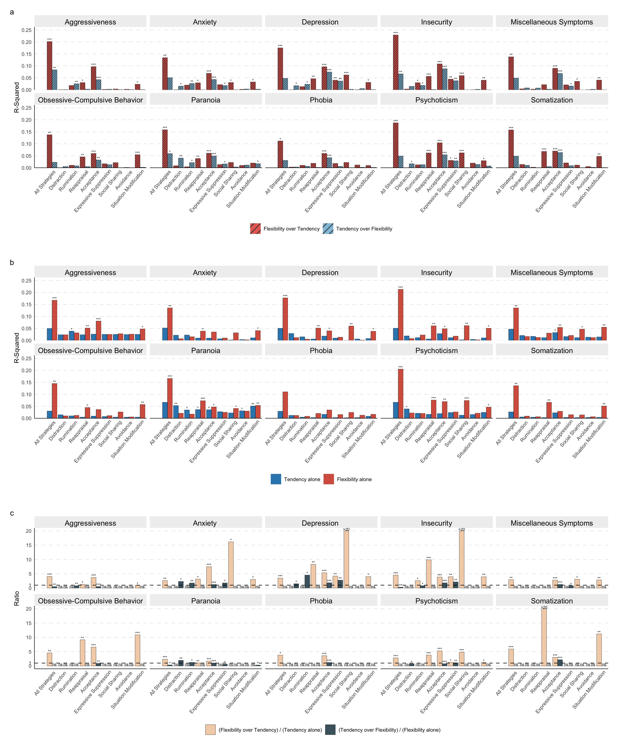

Notes.
***, p < 0.001; **, p < 0.01; *, p < 0.05; ns, non-significance; >20, ratio exceeds 20.
(a) Unique explanatory power of emotion regulation flexibility and tendency for BSCL Subscales in Germany.
(b) Explanatory power of emotion regulation flexibility and tendency when modelled alone for BSCL Subscales in Germany.
(c) Ratios of unique explanatory power (Flexibility over Tendency; Tendency over Flexibility) to standalone explanatory power (Tendency alone; Flexibility alone) in Germany. Ratios with non-significant added R² values are not plotted and are labelled as “ns”.

The reliability for the BSCL subscales in this study were as follows: Depression (ω = 0.897), Anxiety (ω = 0.840), Aggressiveness (ω = 0.809), Paranoia (0.807), Phobia (ω = 0.794), Psychoticism (ω = 0.814), Somatization (ω = 0.848), Insecurity (ω = 0.807), Obsessive-Compulsive Behavior (ω = 0.880), and Miscellaneous Symptoms (ω = 0.645).

Figure S2.
Emotion Regulation Tendency and Flexibility in Two Cultures
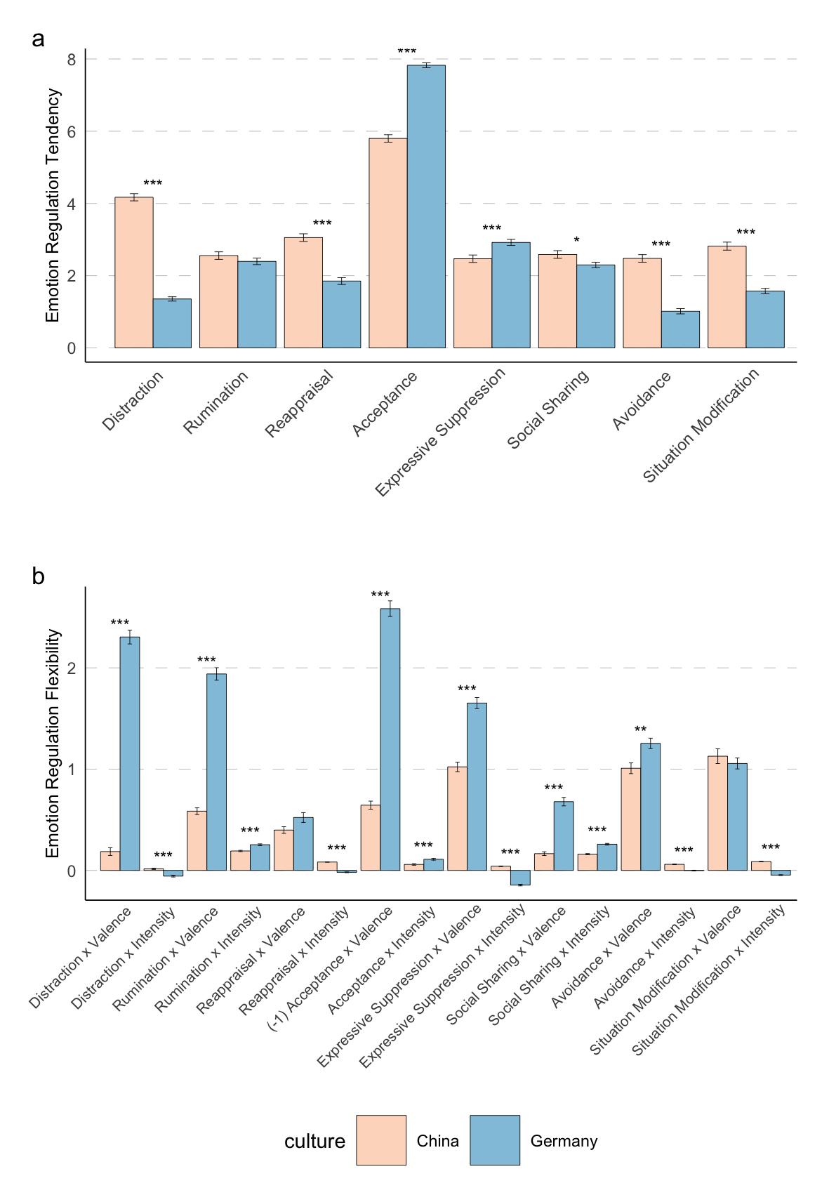

Notes. ***, p < 0.001; **, p < 0.01; *, p < 0.05.

Figure S3.
a. The Moderating Role of Cultural Context in the Association between Valence, Intensity, and Emotion Regulation
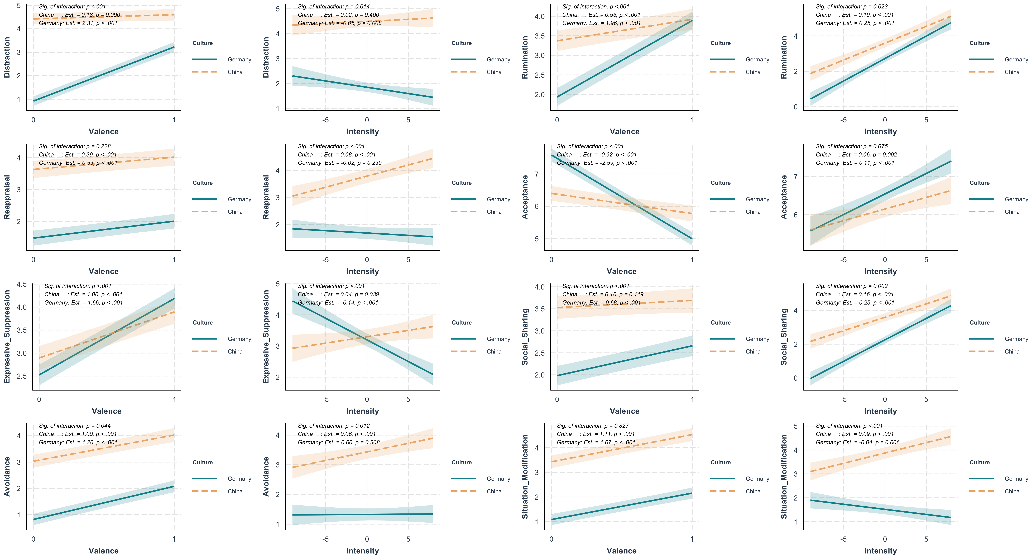

b. The Moderating Role of Cultural Context in the Association between Tendency, Flexibility, and Psychopathology.
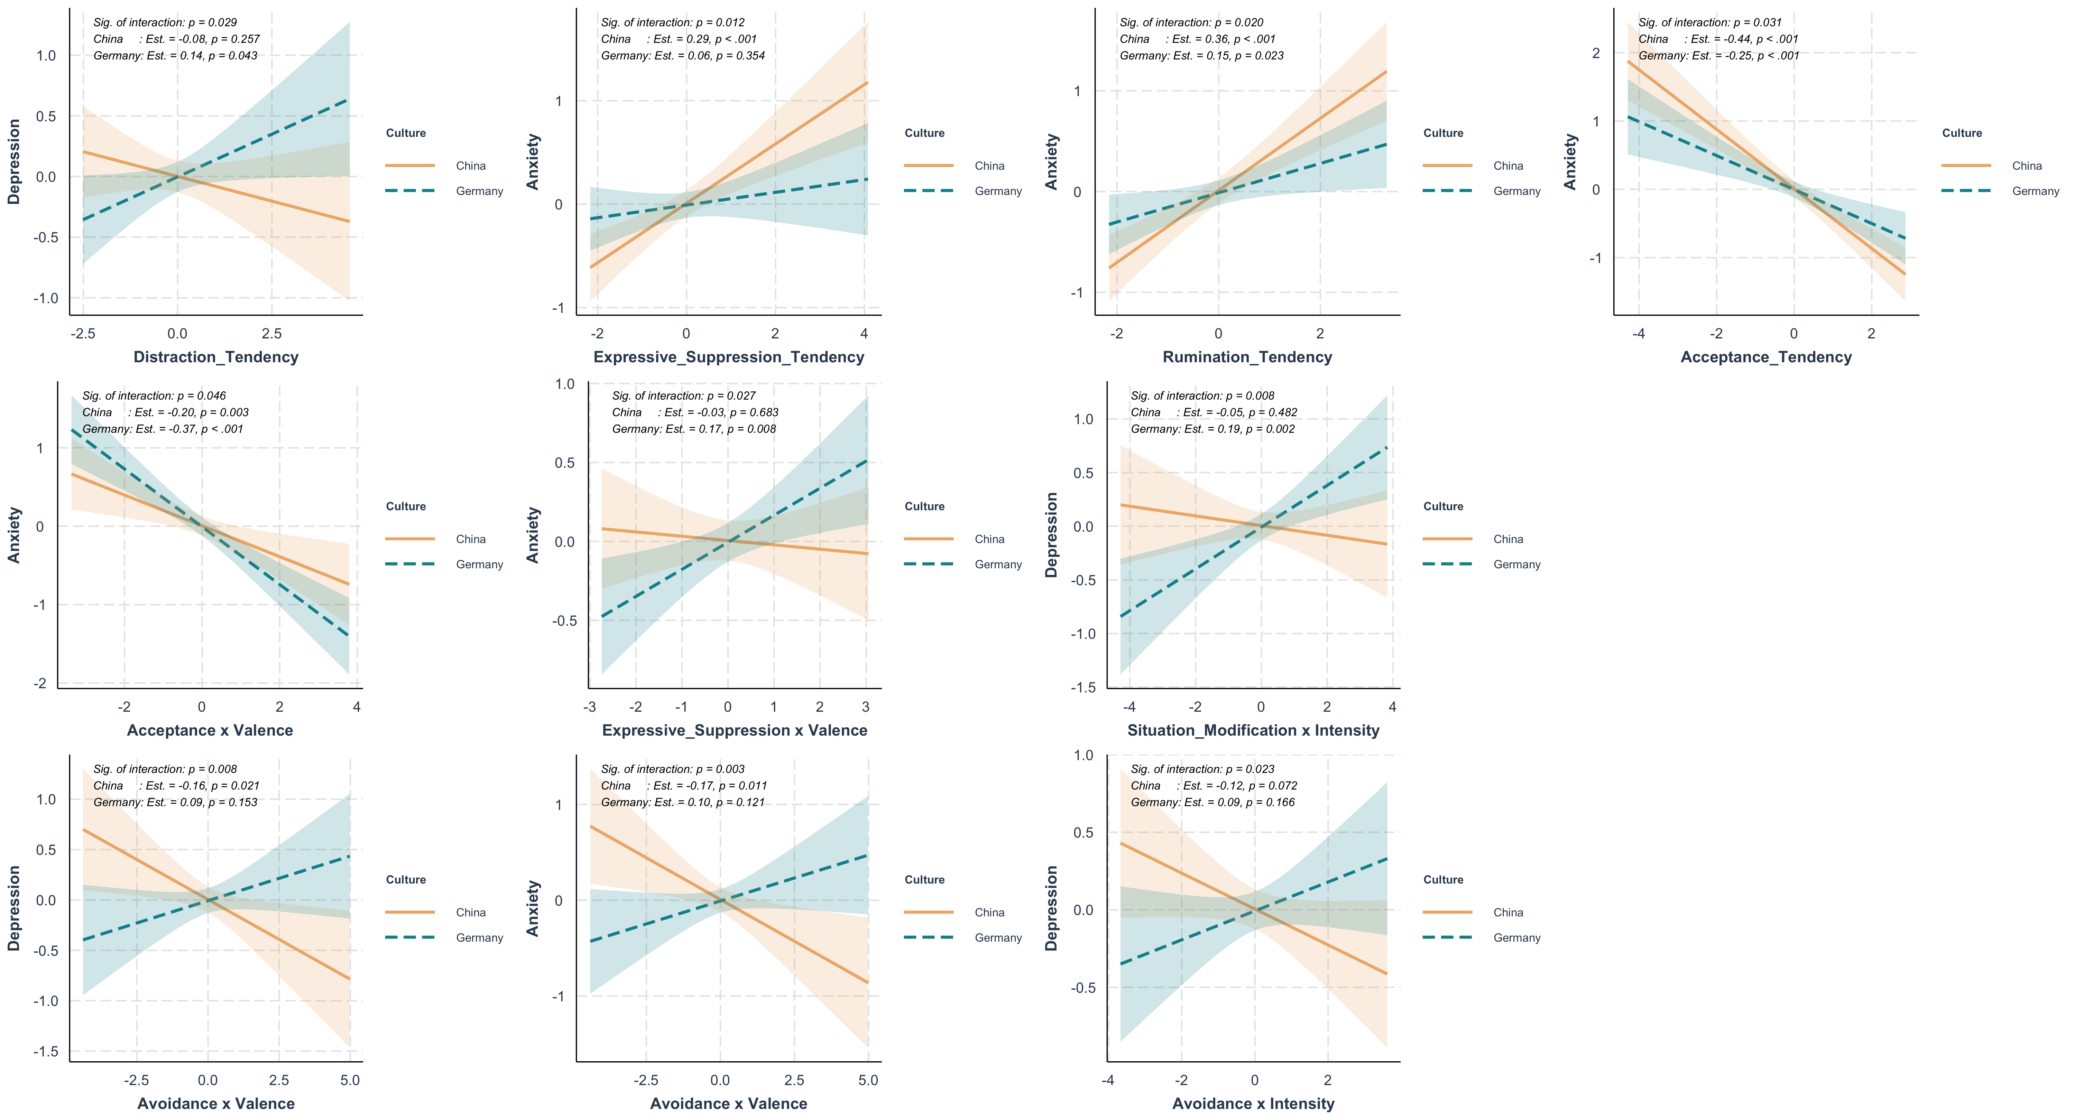

Figure S4.
Explanatory Power of Emotion Regulation Tendency and Flexibility When Modelled Alone to Psychopathology Across Cultures
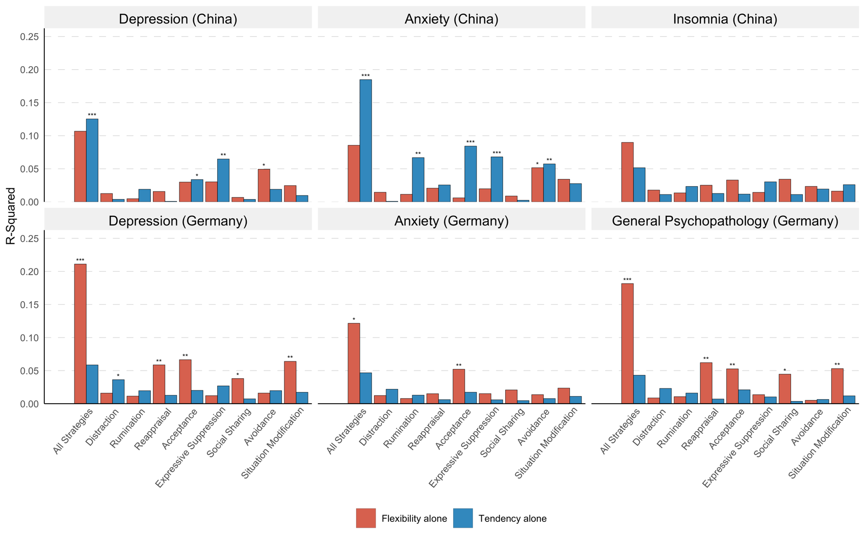
Notes. ***, p < 0.001; **, p < 0.01; *, p < 0.05.

