Supporting Information

Structural Signature in Stokes-shifted Broad Emission of Solution-Processed Hybrid Lead Perovskites

Subhadip Chowdhury, Mrinmay K Mukhopadhyay*, Satyaban Bhunia, Milan K Sanyal*

Synthesis of C₄H₉NH₃Cl:
6 mL of HCl aqueous solution (35 % w/w) gradually was added to a flask containing 1 mL of n-butylamine, the mixture was kept at 0˚C by placing it in an ice bucket and stirring constantly for approximately five minutes. Once the mixture had returned to room temperature, it was stirred for an additional twenty-five minutes or more, until a clear solution of C₄H₉NH₃Cl was achieved.
Synthesis of perovskite (C₄H₉ NH₃)₂ PbCl₄ flakes:
Initially, 5 ml of HCl (35% w/w) and 1.2 g of lead oxide were mixed in a beaker and heated to 80˚C using a magnetic stirrer. A clear solution of the mixture was produced in this process. Then, freshly made C₄H₉NH₃Cl was added, and the mixture was heated for 8 to 10 minutes while being continuously stirred magnetically. After fifteen minutes, the solution was let to cool in a specifically made temperature-controlled device at a steady pace of two degrees Celsius per minute until it reached room temperature. Crystals of perovskite precipitated at the bottom of the beaker flask during this cooling process. To remove the unreacted impurities, the perovskite crystals were then filtered out and repeatedly cleaned with acetone.
Cleaning of Silicon substrate:
Before the sample deposition, the silicon substrate was cleaned using the RCA-1 and RCA-2 processes, which include treating it with ammonia solution (NH₄OH) (25% w/w), hydrochloric acid (HCl) (35% w/w), and hydrogen peroxide (H₂O₂) (20% w/w). The substrate was etched using hydrofluoric acid (HF) (40% w/w) solution (H₂O: HF at a ratio of 10:1) to make it hydrophobic just before the sample deposition.

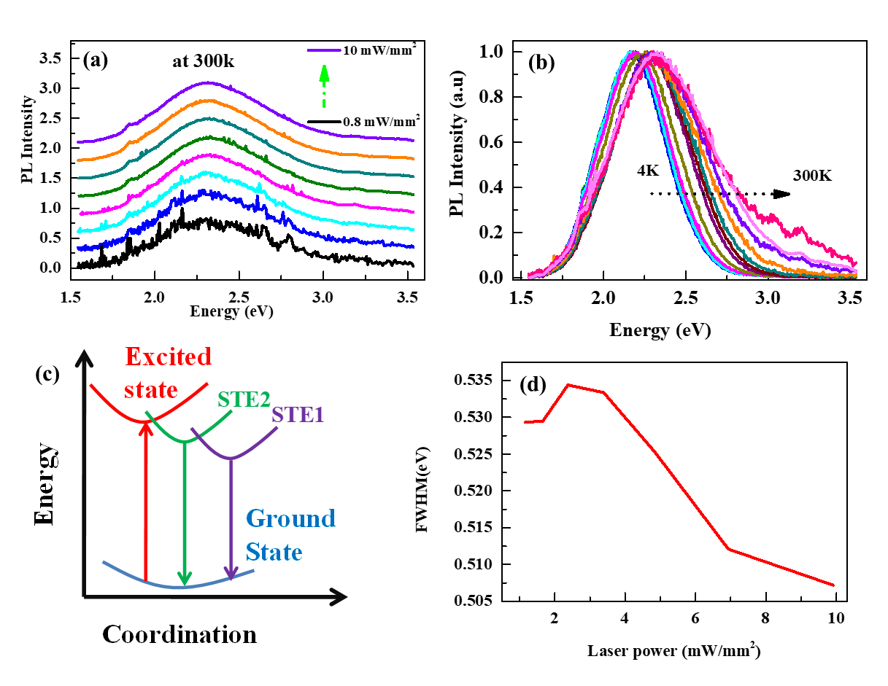
Figure S1: (a) PL spectra measured from the (BA)₂PbCl₄ flakes as a function of excitation power at 300K. (b) Normalized PL spectra of perovskite single flake show that the shape of the emission spectrum remains the same for all the temperatures. There is a little change in peak position but more change has been observed in FWHM of the peaks at different temperatures. (c) Schematic diagram of the STE states as described in the main paper. (d) Variation of the FWHM of the PL peak as a function of laser power at 4K.

Optical microscopic image of perovskite flake has been shown in figure S2.
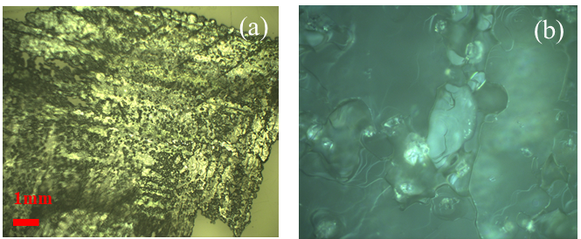
Figure S2: (a) Optical image of perovskite flake and (b) a zoomed view of a Cl perovskite flake.

Photoluminescence and Raman Spectroscopy measurements:
We have shown the PL spectrum of perovskite flakes at 300K as a function of laser powers in Figure S1(a). The normalized temperature-dependent PL spectrum of the perovskite flake has been shown in Figure S1(b). Similar to the spectra shown in Figure 1 in the main paper, we have also noticed here the change in PL peak intensity as a function of laser power at temperature 300K. The normalized PL profiles to indicate the variation of peak energy position and FWHM as a function of temperature were shown in Figure S1(b) for the flake at this temperature. Figure S1(c) shows a schematic diagram of STE formation which is predicted to display the observed wide broadband emission spectrum from the perovskite flakes. The variation in the FWHM calculated with a Gaussian peak fit is shown in Figure S1(d).

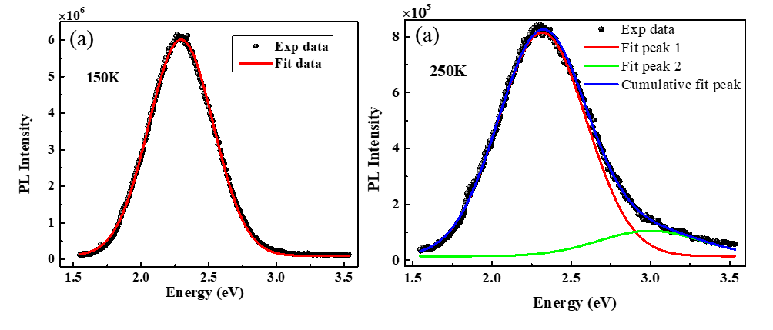
Figure S3: (a) Emission spectra at 150K and (b) 250K having laser power 3.39mW m⁻² of the Cl perovskite flake.

To Understand the emission process with the variation of temperature and laser power each emission spectra is deconvoluted using slandered Gaussian function. Figure S3 display the fitted emission spectrum at 150K and 250K.Similarly laser power dependent fitted emission spectrum is shown in figure S4.

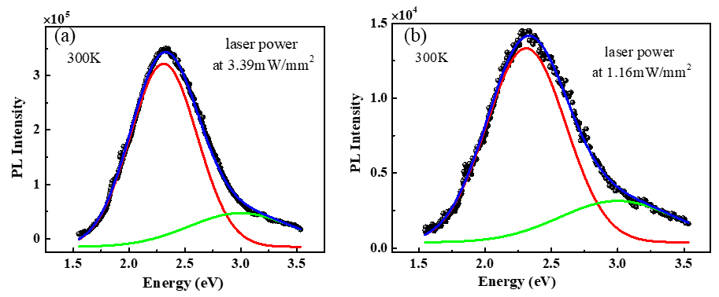

Figure S4: Emission spectrum of a Cl perovskite flake at 300K having laser power (a) 3.39mW m⁻² and (b) 1.16mW m⁻².

Langmuir monolayer and x-ray scattering experiments: We have prepared a high concentration (10mg/ml) perovskite stock solution in DMF and used this stock solution to prepare water subphase for the Langmuir trough of different concentrations as required for our experiments. Highly pure Milli-Q water having resistance 18MΩ and pH 7.0 was used as the subphase for the monolayer experiments. Perovskite mixed SA monolayer is formed by spreading the SA molecules (at 0.5 mg/ml concentration in chloroform) on the water subphase having perovskites dissolved in it. Similarly, perovskite mixed lipid monolayers are prepared by spreading the chloroform solutions (concentration 0.6 mg/ml) of DPPG and DPePC lipids on the water surface of the Langmuir trough. The trough was kept in a closed container for X-ray scattering measurements and a small helium gas continuous flow was maintained to reduce the background air scattering, water evaporation from the subphase, and sample damage due to X-ray radiation. For XRR measurements, X-rays having a wavelength of 0.69Å were used in the LISA configuration at the P08 beamline; PETRA-III, DESY ⁴⁶, and GID measurements were carried out with the Langmuir Trough GID setup ⁴⁷⁻⁴⁸ of the same beamline with monochromatic X-rays of wavelength of 0.83Å.

X-ray fluorescence (XRF) measurements:
XRF provides us with the elemental mapping of the molecules in the system and here we have used the XRF technique to understand the elements present in the Langmuir monolayer of the perovskite stearic acid assembly. We have performed the in-situ XRF spectroscopy experiments of the monolayer at different surface pressures at room temperature, and the XRF spectrum of SA – perovskite monolayer assembly at 20 mNm⁻¹ is shown in Figure S5(a). The peak positions corresponding to different Pb XRF peaks like M_{α1}, M_{α2}, L₁, L_{α1}, L_{β2}, and L_{γ1} are at 2.35, 2.35, 9.18, 10.55, 12.61, and 14.76 KeV respectively as marked in Figure S5(a). XRF spectra from the pristine SA monolayer and pure water surface have also been added in Figure S5(a) to indicate the presence of Pb ions near the water surface in SA – perovskite assembly. It is important to mention that we are getting intense peaks corresponding to Pb ions in the XRF data from the initial surface pressure (∼ 0 mNm⁻¹), and the increment of peak intensity at higher surface pressure is not so apparent from the spectral intensity increase due to pressure change. This observation implies that the self-initiated chemical reaction between the head groups of the SA molecules with the dissolved perovskites happens right after the spreading of the SA over the water surface. The complex structure of the SA molecules with perovskites forms instantly even if the surfactant molecules are in the 2D gaseous phase over the water surface. To understand the role of SA molecules and the charge of the head groups in forming the complex structure with the perovskites in the monolayer, we have performed similar experiments using lipids, namely 1,2-dipalmitoyl-sn-glycero-3-phosphoglycerol (DPPG) having negatively charged PG head groups, and 1,2-dipalmitoyl-sn-glycero-3-ethylphosphocholine (DPePC) having positively charged DPePC headgroups. We observed weak Pb peaks for the DPPG – perovskite assembly but the peak intensities (say L_{α1}) are about 2 to 3 times weaker than the peaks observed for the SA molecules as surfactants having Cl-perovskites in the water subphase. In the case of the DPePC monolayer with Pb-perovskites in the subhase, the Pb peaks are completely absent and we get only weak peaks corresponding to the Cl in the XRF spectra as shown in Figure S5(a). So, the charge of the head group plays an important role in attaching the Pb²⁺ ions or the Cl⁻ ions from the water surface with negatively charged or positively charged headgroups of the lipid molecules respectively. However, the observation of the charge-mediated attachment process of Pb or Cl ions from the water subphase cannot explain the strong peak observed for the SA molecules with the perovskites in the subphase and the Pb structure affinity is much stronger for the SA molecules than DDPG or DPePC lipids. The headgroup of SA molecules forms a new structure through a self-initiated chemical reaction with the Cl perovskites dissolved in the water subphase which gives us the strong Pb peaks in the XRF spectra. The in-situ XRR and GID experiments have been conducted further to understand the presence of Pb atom in the structure monolayer which will be discussed in detail in the following sections. XRF data collected from the monolayer of DPPG, and DPePC having (BA)₂PbCl₄ perovskites dissolved in the subphase is shown in Figure S5(a). The XRF peaks corresponding to Pb M_{α1}, M_{α2}, L_{α1}, L_{β2}, are marked in the figure. The XRF data from the bare water surface indicates the background scattering from the Langmuir trough. Strong Pb XRF peaks from the monolayer have been observed in the case of DPPG molecules as surfactants. The strong intensities of Pb peaks prove the presence of Pb⁺ ions near the negatively charged DPPG head groups in the water subphase. But in the case of positively charged head groups in DPePC molecules – we observed peaks K_{α1}, and K_{α2}, corresponding to the Cl ions in the subphase, and the Pb peaks are almost absent here as shown in Figure S5(a). It is clear from this observation that the negatively charged head group of DPPG attracts Pb²⁺ ions and the positively charged head groups of the DPePC molecules attract the negatively charged Cl⁻ ions of the perovskites from the subphase of the monolayer.
in Figure S5(a). It is clear from this observation that the negatively charged head group of DPPG attracts Pb²⁺ ions and the positively charged head groups of the DPePC molecules attract the negatively charged Cl⁻ ions of the perovskites from the subphase of the monolayer.
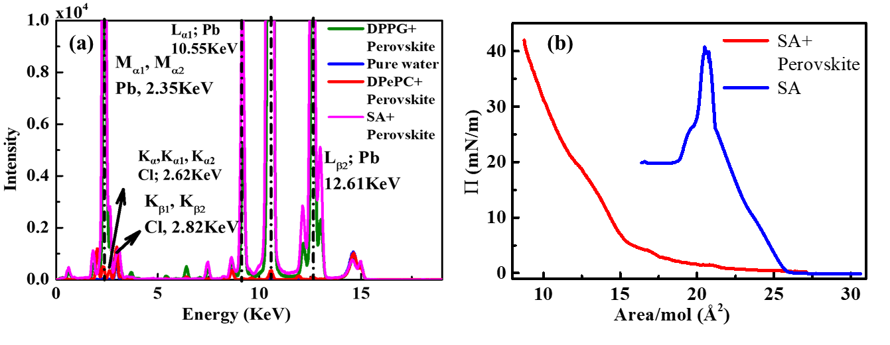

Figure S5: (a) XRF data of DPPG (olive), SA (magenta), and DPePC (red) monolayer containing (BA)₂PbCl₄ perovskite in the subphase. The major peak positions corresponding to Pb and Cl's characteristic X-ray emission lines are marked. XRF data of pure water is displayed in blue colour to indicate the background. (b) Isotherm of pristine SA and perovskite mixed SA monolayer.

Pressure-Area (П-A) Isotherm Experiments
In our previous work ^{8, 19}, we have demonstrated that the hybrid perovskite materials do not form monolayers as normal surfactants on the water surface if we mix the DMF solution of the lead bromide hybrid perovskites with the water. Here, we have added a lead chloride hybrid perovskite [(BA)₂PbCl₄] solution of DMF at a concentration of 2.66 mg/l in the water subphase and spread the SA molecules over this composite subphase to measure the isotherm as shown in Figure S5(b). The Π – A isotherm for the pristine SA has also been shown in the same figure to elucidate the change in area per molecule for the SA surfactants as observed before ^{8, 19}. The comparison of the relative areas of pristine SA, and SA with perovskite in the subphase indicates that there is a significant change in area per molecule and the collapse pressure increases to the higher values for SA with perovskite monolayer. The molecular structure on the water surface with the surface reaction near the air-water interface corroborates with the XRF data mentioned before.
GID measurements
The results of GID experiments at different surface pressures starting from 0 to 30 mN m⁻¹ have been shown in Figure S6. The GID images at 0, 20, and 30 mN m⁻¹ are shown in Figure S6(a) – (c) respectively and the extracted line profiles from the image along q_{xy} and q_{z} directions are shown in Figure S6(d) and (e) respectively. The pristine SA monolayer displays closely spaced double peaks at low surface pressure having distorted centered hexagonal in-plane lattice structure which turn into a single peak corresponding to a regular centered hexagonal in-plane lattice structure at high surface pressure as observed before ⁴⁹. As perovskite (BA)₂PbCl₄ was added to the water subphase, a strong peak was observed at q_{xy} = 1.52 Å⁻¹ and a very weak peak at q_{xy} = 1.71 Å⁻¹ even before the beginning of the compressions (i.e. at 0 mN m⁻¹) as shown in Figure S6(a). As the surface pressure increases, the second peak [at q_{xy}=1.71 Å⁻¹] becomes prominent. There is also very little shift in the peak positions towards low q_{xy} as the surface pressure increases up to 20 mN m⁻¹ indicating little lattice expansion with the pressure increase. But it comes back to the initial positions at a higher surface pressure of 30 mN m⁻¹. The peak at 1.52 Å⁻¹ appears due to the centered hexagonal lattice structure of SA tails having lattice parameter 4.77±0.01 Å and the second peak at 1.71 Å⁻¹ comes from the lattice made of lead atoms in the perovskite structure at the interface as observed previously for lead bromide perovskites ⁸.
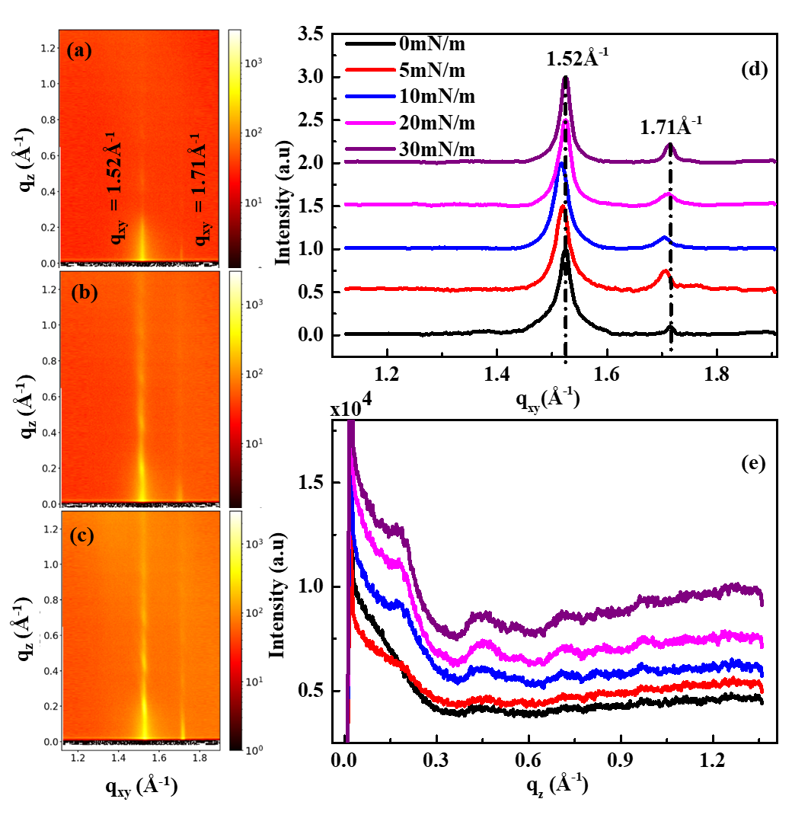
Figure: S6 GID images are (a-c) at П= 0, 5,10, 20, 30 mN/m respectively. Corresponding GID profile (d) and Bragg rod profile (e) of SA monolayer with perovskite in the water subphase at different surface pressures.

X-ray Scattering from thin film and AFM studies:
We have transferred the monolayer on hydrophobic Si (100) substrates using the Langmuir-Schaefer (LS) film deposition technique from the Langmuir monolayer to study the surface morphology using AFM, optical properties using PL and Raman, and structural investigations using x-ray scattering techniques. This film is transferred by touching the monolayer only once from above the air-water interface.
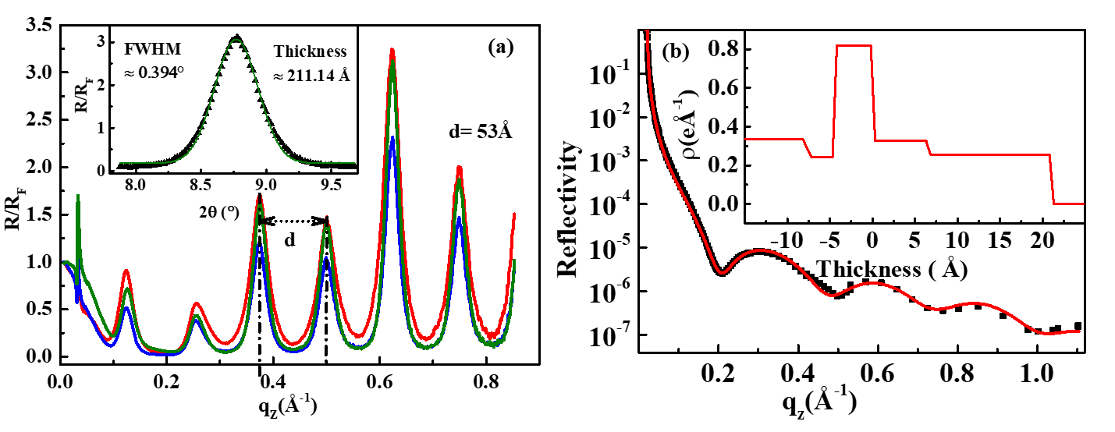
Figure S7: The R_{F} normalized reflectivity profile from the deposited films at 30mN/m (red), 20mN/m (olive), and 10mN/m (blue) surface pressures are shown in (a) and the inset shows the enlarged version of a peak which was used to calculate the coherent thickness of the film in the out-of-plane direction. (b) XRR profiles (symbols are experimental data and line is the fitted profile) from SA monolayer at 0mN/m(red) from water surface with perovskite in the subphase. The inset shows the corresponding electron density profile (EDP).

Figure S7(a) represents the XRR profile normalized by Fresnel reflectivity (R_{F}) of an LS film deposited at 25mNm⁻¹ and shows the multilayer structure formation during the transfer of monolayer on Si substrate. XRR has been performed to investigate the structure of the surface and interfaces of monolayers as well as thin films. The XRR measurement provides us the information about the thickness, electron density of different layers, and the interfacial roughness along the out-of-plane structure of thin films and multilayers. The normalized XRR profile of the SA monolayer having a solution of perovskite [(BA)₂PbCl₄] in DMF at 0 mN m⁻¹ is shown in Figure S7(b), and the inset represents the electron density profile (EDP) extracted from the analysis of the XRR. The EDP is plotted in a way that Z = 0 defines the air-water interface, Z > 0 is the region corresponding to the floating tail above the water surface having an electron density of 0.34 ± 0.05 electrons Å⁻³, and Z < 0 is the region under the water surface having two distinct electron density (ED) layers, one is the headgroups with high ED of 0.82 ± 0.05 electrons Å⁻³ and a submerge tail having ED close to the water, as observed before ⁶. The total thickness of the monolayer comes out to about 29.2 ± 0.1 Å out of which 21.2 ± 0.1 Å is above the water surface as the floating tail part of the monolayer.

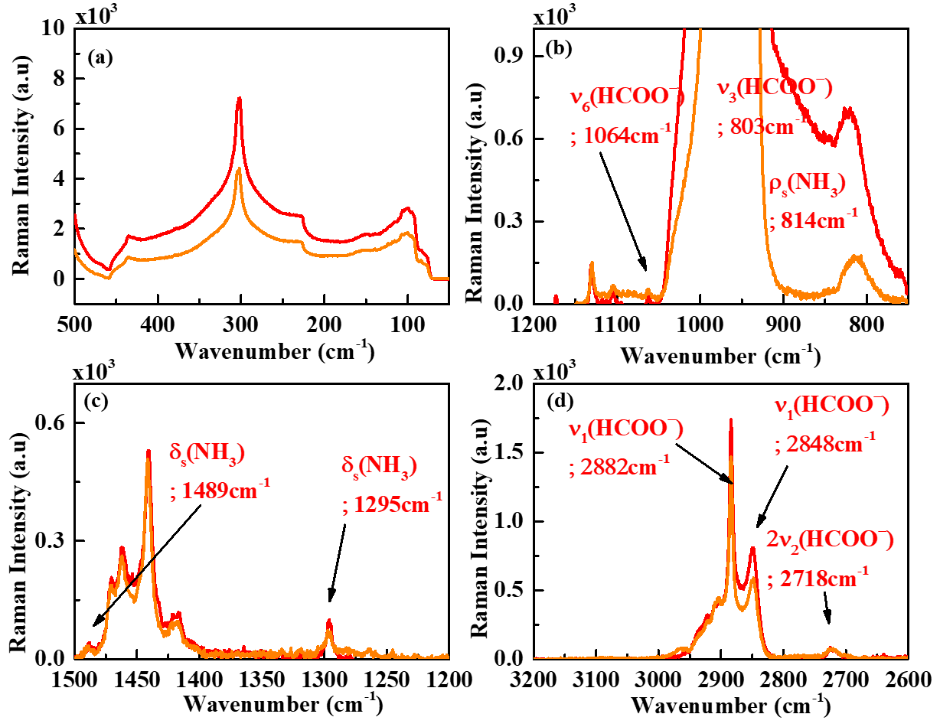
Figure S8: The Raman spectra (a) – (d) measured at 300K in different regions of the wavenumbers. The red-coloured spectrum is from the Cl-perovskite mixed SA LS film, and the orange-coloured spectrum is from the Br-perovskite mixed SA LS film.

Raman spectroscopy:
It is a well-known technique to understand the chemical compositions of the prepared samples. Raman spectroscopy measurements of thin films and flakes of perovskite materials have been performed using Horiba Jobin-Yvon LabRAM HR-800 spectrometer in backscattering geometry at 300K. The He-Ni laser of wavelength 633 nm has been used to excite the samples. Basically in this process sample is excited using a laser, and due to this excitation, chemical bonds in the samples vibrate, and the frequency of vibration is captured as the Raman spectrum. Here, we have demonstrated the Raman spectrum of LS films prepared from (BA)₂PbCl₄ (red) and (BA)₂PbBr₄ (orange) in Figure S8 (a) – (d). Both the LS films prepared from (BA)₂PbCl₄ and (BA)₂PbBr₄ display similar vibration frequencies as the Raman spectrum which confirms that the chemical composition of both the films deposited from two different halide compositions are the same. Both LS films are formate perovskite as reported in our previous report ¹⁹.

REFERENCES
1. Koegel, A. A. et al. Correlating broadband photoluminescence with structural dynamics in layered hybrid halide perovskites. J. Am. Chem. Soc. 144, 1313-1322 (2022).
2. Veldhuis, S. A. et al. Perovskite materials for light‐emitting diodes and lasers. Adv. Mater. 28, 6804-6834 (2016).
3. Tan, Z. et al. Two-dimensional (C₄H₉NH₃)₂PbBr₄ perovskite crystals for high-performance photodetector. J. Am. Chem. Soc. 138, 16612-16615 (2016).
4. Fang Y. et al. Harvesting High-Quality White-Light Emitting and Remarkable Emission Enhancement in One-Dimensional Halide Perovskites Upon Compression. J. Am. Chem. Soc. Au 1, 459-466 (2021).
5. Tsai, H. et al. High-efficiency two-dimensional Ruddlesden–Popper perovskite solar cells. Nature 536, 312-316 (2016).
6. Mao, L. et al. Hybrid Dion–Jacobson 2D lead iodide perovskites. J. Am. Chem. Soc. 140, 3775-3783 (2018).
7. Dohner, E. R. et al. Intrinsic white-light emission from layered hybrid perovskites. J. Am. Chem. Soc. 136, 13154-13157 (2014).
8. Chowdhury, S. et al. Solution Processed Hybrid Lead Perovskite Films for White Light Emission and Lasing Applications. Adv. Funct. Mater. 34, 2401334 (2024).
9. Chen, H. et al. Improved charge extraction in inverted perovskite solar cells with dual-site-binding ligands. Science 384,189-193 (2024).
10. Shockley, W. et al. Detailed balance limit of efficiency of p–n junction solar cells. Renewable energy. Routledge, 35-54 (2018).
11. Liu, K. et al. Chemical formation and multiple applications of organic–inorganic hybrid perovskite materials. J. Am. Chem. Soc. 141, 1406-1414 (2018).
12. Sun, Y. et al. Bright and stable perovskite light-emitting diodes in the near-infrared range. Nature 615, 830-835 (2023).
13. Zhu, H. et al. Lead halide perovskite nanowire lasers with low lasing thresholds and high quality factors. Nat. Mater. 14, 636-642 (2015).
14. Fu, Y. et al. Broad wavelength tunable robust lasing from single-crystal nanowires of cesium lead halide perovskites (CsPbX₃, X= Cl, Br, I). ACS nano 10, 7963-7972 (2016).
15. Yang, Liyan, et al. Progress of 2D Perovskite Solar Cells: Structure and Performance. Small 2410731 (2025).
16. Li, J. et al. Fabrication of single phase 2D homologous perovskite microplates by mechanical exfoliation. 2D Materials 5, 021001 (2018).
17. Stoumpos, C. C. et al. Ruddlesden–Popper hybrid lead iodide perovskite 2D homologous semiconductors. Chemistry of Materials 28, 2852-2867 (2016).
18. Walker, B. et al. Pseudohalides in lead‐based perovskite semiconductors. Adv. Mater. 31, 1807029 (2019).
19. Chowdhury, S., Mukhopadhyay, M.K., Sanyal, M.K. et al. Investigation on the formation of two dimensional perovskite nanostructures at the water surface through self initiated reaction. Sci Rep 15, 6216 (2025).
20. Smith, M.D. et al. Annu. Rev. Mater. Res. 48, 111-136 (2018).
21. Lafuente-Bartolome, Jon, Chao Lian, and Feliciano Giustino. Topological polarons in halide perovskites. PNAS 121, 2318151121 (2024).
22. Schlaus, Andrew P. et al. How lasing happens in CsPbBr₃ perovskite nanowires. Nat. Comm. 10, 265 (2019)
23. Li, Yahui, et al. Phase-pure 2D tin halide perovskite thin flakes for stable lasing. Sci. Adv. 9, eadh0517 (2023).
24. Dou, Letian, et al. Atomically thin two-dimensional organic-inorganic hybrid perovskites. Science 349, 1518-1521 (2015).
25. Sheehan, Thomas John, Seryio Saris, and William A. Tisdale. Exciton Transport in Perovskite Materials. Adv. Mater. 2415757 (2025).
26. Febriansyah, Benny, et al. Metal Coordination Sphere Deformation Induced Highly Stokes‐Shifted, Ultra Broadband Emission in 2D Hybrid Lead‐Bromide Perovskites and Investigation of Its Origin. Angewandte Chemie 132, 10883-10888 (2020).
27. Cai, Peiqing et al. Anti-Stokes Ultraviolet Luminescence and Exciton Detrapping in the Two-Dimensional Perovskite (C₆H₅C₂H₄NH₃)₂PbCl₄. J. Phys. Chem. Lett. 10, 4095-4102 (2019).
28. Shao, Yan, et al. Unlocking surface octahedral tilt in two-dimensional Ruddlesden-Popper perovskites. Nat. Comm. 13, 138 (2022).
29. Guo, Y. et al. Dynamic emission Stokes shift and liquid-like dielectric solvation of band edge carriers in lead-halide perovskites. Nat. Commun. 10, 1175 (2019).
30. Gull, S. et al. Stokes Shift in Inorganic Lead Halide Perovskites: Current Status and Perspective. ChemistryOpen 11, 202100285 (2022).
31. Jung, H. R. et al. UV and Visible Photodetectors of MAPbBr₃ and MAPbCl₃ Perovskite Single Crystals via Single Photocarrier Transport Design. Adv. Optical Mater. 10, 2102175 (2022).
32. Fonoberov, V. A. et al. Photoluminescence investigation of the carrier recombination processes in ZnO quantum dots and nanocrystals. Phys. Rev. B 73, 165317 (2006).
33. Peters, J. A. et al. Optical investigation of defects in semi-insulating T_{l6}I₄S single crystals. Phys. Rev. B 90, 035205 (2014).
34. Zhang, Yuhai, et al. Metal halide perovskite nanosheet for X-ray high-resolution scintillation imaging screens. ACS nano 13, 2520-2525 (2019).
35. Bao, C. et al. High Performance and Stable All-Inorganic Metal Halide Perovskite-Based Photodetectors for Optical Communication Applications. Adv. Mater. 30, 1803422 (2018).
36. Menahem, Matan, et al. Strongly anharmonic octahedral tilting in two-dimensional hybrid halide perovskites. ACS nano 15, 10153-10162 (2021).
37. Dhanabalan, B. et al. Directional Anisotropy of the Vibrational Modes in 2D-Layered Perovskites. ACS Nano 14, 4689-4697 (2020).
38. Zhang, H. et al. Revealing Unusual Bandgap Shifts with Temperature and Bandgap Renormalization Effect in Phase-Stabilized Metal Halide Perovskite Thin Films. Adv. Funct. Mater. 34, 2302214 (2024) .
39. Saidi, W. A. et al. Effects of electron–phonon coupling on electronic properties of methylammonium lead iodide perovskites. J. Phys. Chem. Lett. 9, 7090-7097 (2018).
40. Lautenschlager, P. et al. Temperature dependence of band gaps in Si and Ge. PRB 31, 2163 (1985).
41. Fu, M. et al. Unraveling exciton–phonon coupling in individual FAPbI₃ nanocrystals emitting near-infrared single photons. Nat. Commun. 9, 3318 (2018).
42. Smith, Matthew D. et al. Structural origins of broadband emission from layered Pb–Br hybrid perovskites. Chemical science 8, 64497-4504 (2017).
43. Lu, Teng-Fei et al. Lattice Distortion and Low-Frequency Anharmonic Phonons Suppress Charge Recombination in Lead Halide Perovskites upon Pseudohalide Doping: Time-Domain Ab Initio Analysis. J. Phys. Chem. Lett. 14, 10685-10692 (2023).
44. Lin, Pei‐Ying, et al. Pseudo‐halide perovskite solar cells. Adv. Energy Mater. 11, 2100818 (2021).
45. Sheikh, T. et al. Mn doping in centimeter-sized layered 2D butylammonium lead bromide (BA₂PbBr₄) single crystals and their optical properties. J. Phys. Chem. C. 123, 9420-9427 (2019).
46. Seeck, O. H. et al. The high-resolution diffraction beamline P08 at PETRA III. Journal of synchrotron radiation 19, 30-38 (2012).
47. Murphy, B. M. et al. A novel X-ray diffractometer for studies of liquid–liquid interfaces. Journal of synchrotron radiation 21 45-56 (2014).
48. Shen, C. et al. A grazing incidence diffraction setup for Langmuir trough experiments at the high-resolution diffraction beamline P08 at PETRA III. Journal of Physics: Conference Series. 1, 2380 (2022).
49. Dupres, V. et al. Two-dimensional mixtures of stearic acid and partially fluorinated amphiphilic molecule: a grazing incidence X-ray diffraction study. Langmuir 16, 10189-10192 (2000).

