Supplementary figures
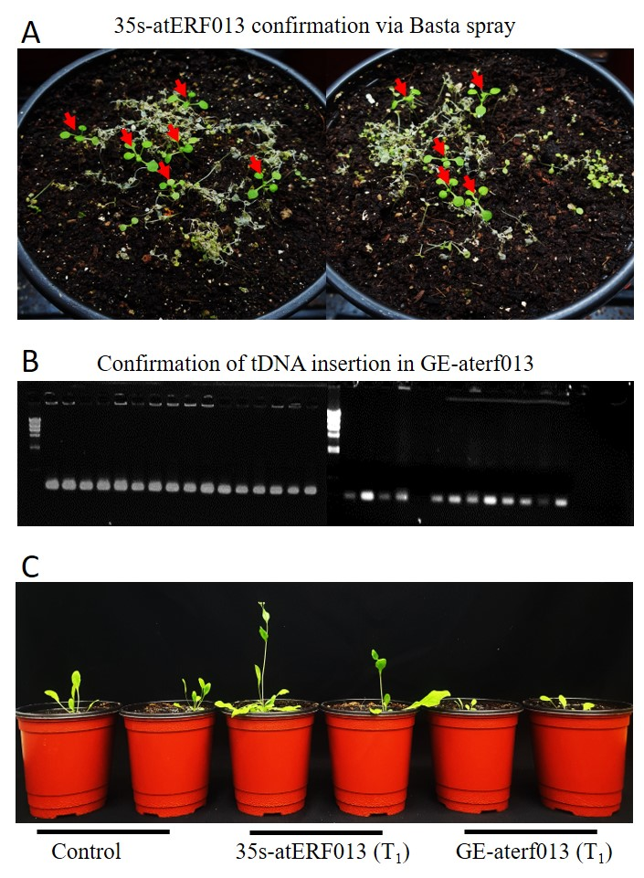
Figure S1. Generation and Characterization of AtERF103 Transgenic A. thaliana Lines. (A) Verification of Basta-resistant transgenic lines. (B) Gel electrophoresis confirming T-DNA insertion in transgenic lines. (C) Growth phenotype comparison of Col-0, 35S-AtERF103, and GE-aterf103 lines.

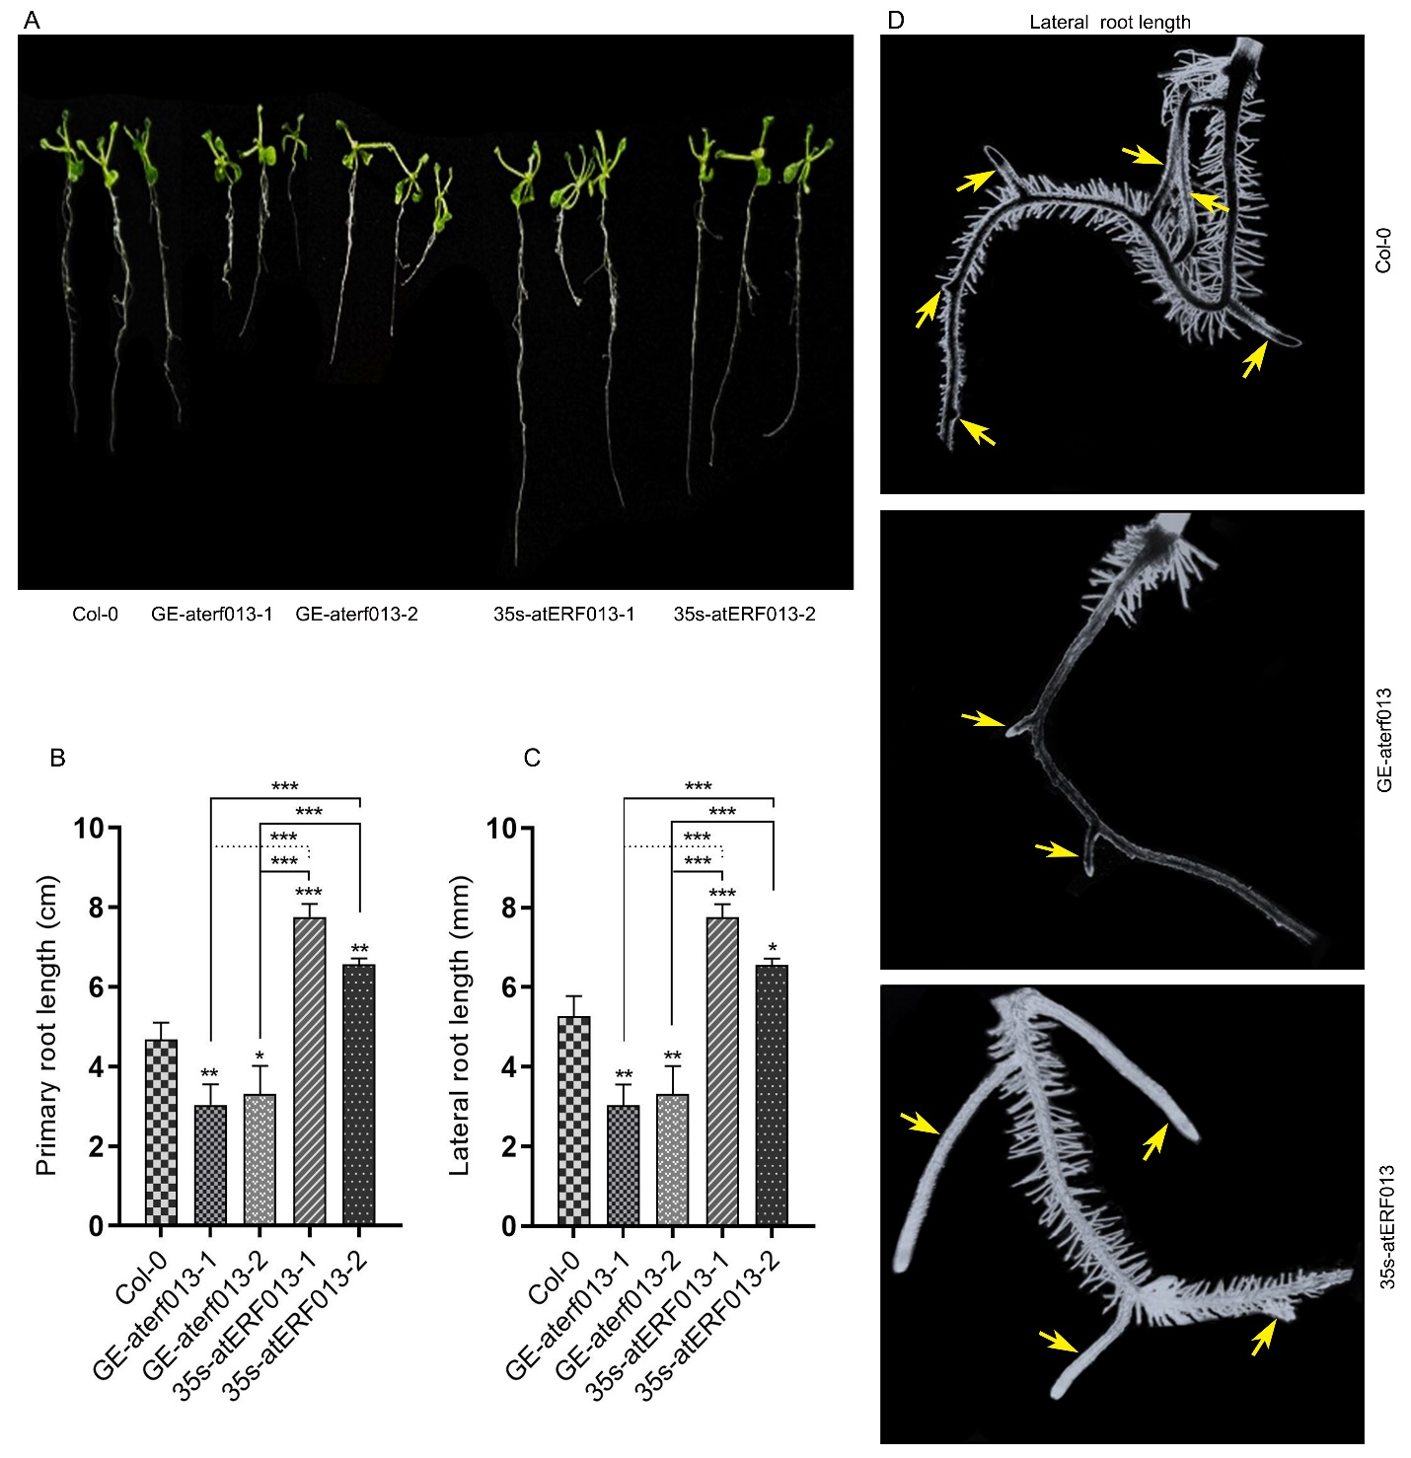
Figure S2. Evolution of Root Phenotypes Regulated by AtERF103. (A) Root growth patterns of the three genotypes after 1 week of growth on vertical agar plates under standard conditions. (B) Measurement of primary root length. (C) Measurement of lateral root length. (D) Lateral roots development in the three genotypes, indicated by arrows. Data are presented as mean ± standard deviation (SD) from multiple biological replicates. Statistical significance was assessed using post hoc multiple comparisons, with significance levels indicated as *P < 0.05, **P < 0.01, and ***P < 0.001.

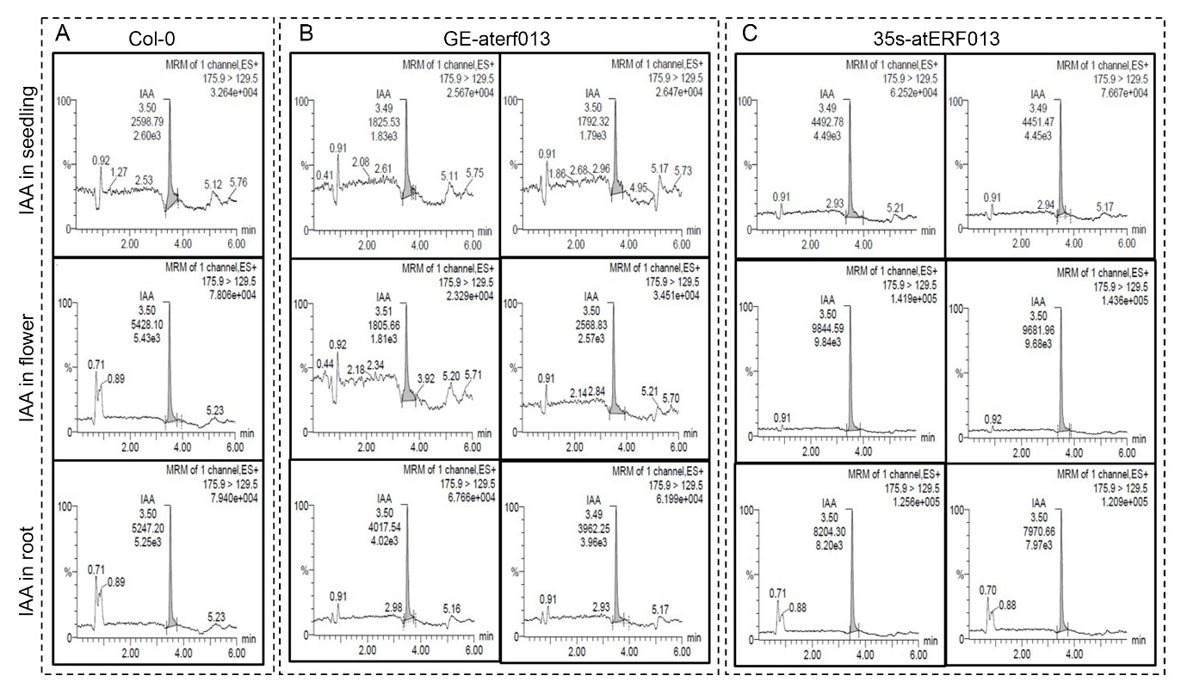
Figure S3. LC-MS/MS Analysis of IAA Peak Area. (A–C): Chromatograms of the peak area corresponding to IAA in the Col-0 (A), GE-aterf103 (B), and 35S-atERF103 (C) genotypes.

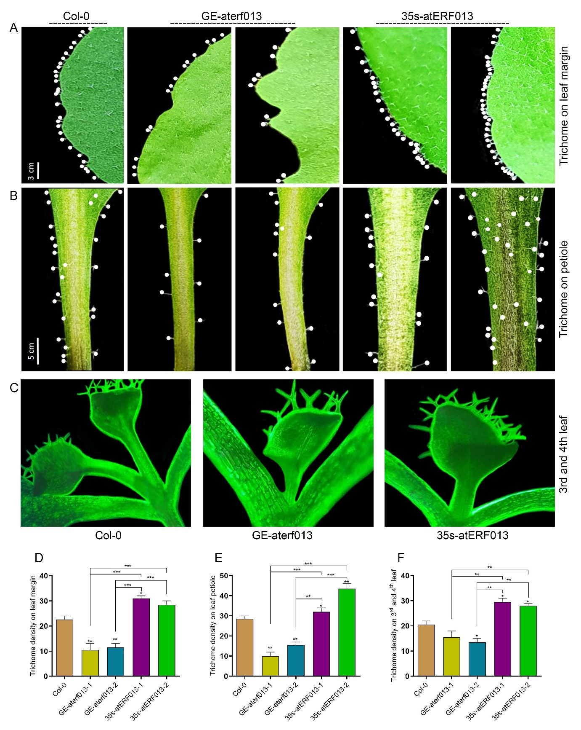
Figure S4. AtERF103 Regulates Trichome Development in Different Organs in A. thaliana under Standard Growth Conditions. (A–C) Trichome visualization on leaf margin (A), leaf petiole (B), and the third and fourth leaves (C). (D–F) Quantitative analysis of trichome density across these regions. Data are presented as mean ± standard deviation (SD) from 10 biological replicates. Statistical significance was determined using post hoc multiple comparisons, with significance levels indicated as *P < 0.05, **P < 0.01, and ***P < 0.001.

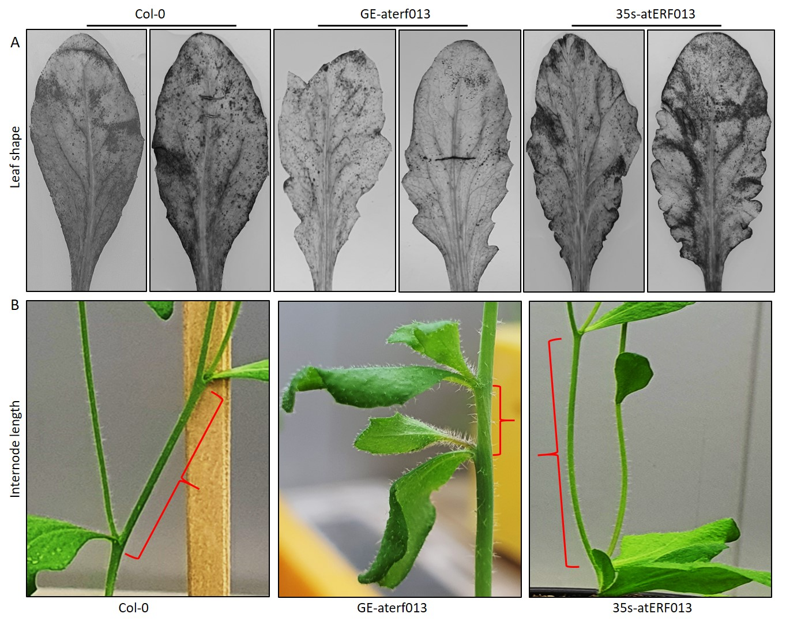
Figure S5. AtERF103 Modulates Leaf Morphology and Internode Length. (A) Illustration of Leaf morphology of all the three genotypes. (B) Visualization of internode length variations among the three genotypes.

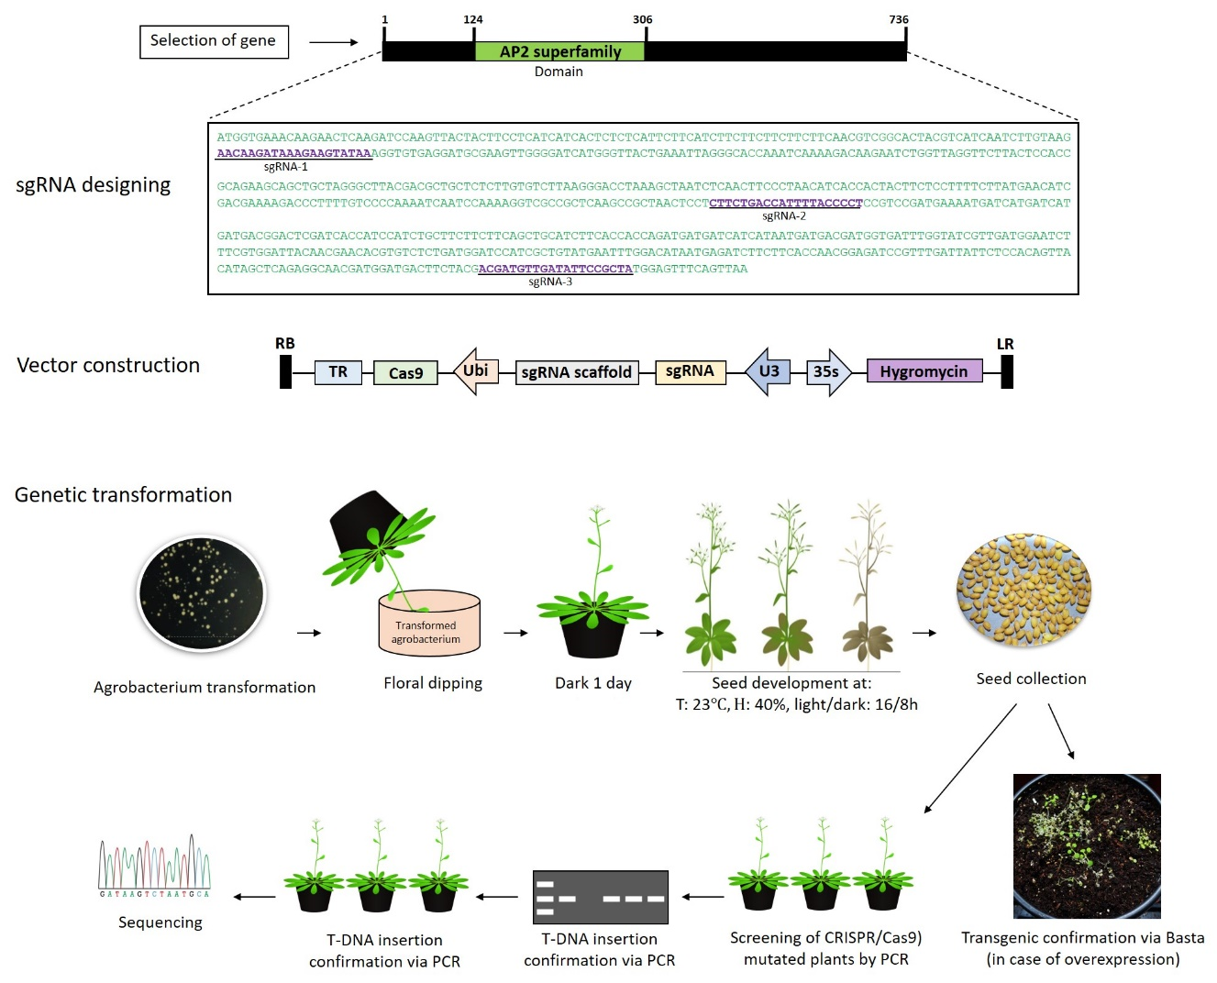
Figure S6. Schematic representation of the workflow for transgenic plant generation.

