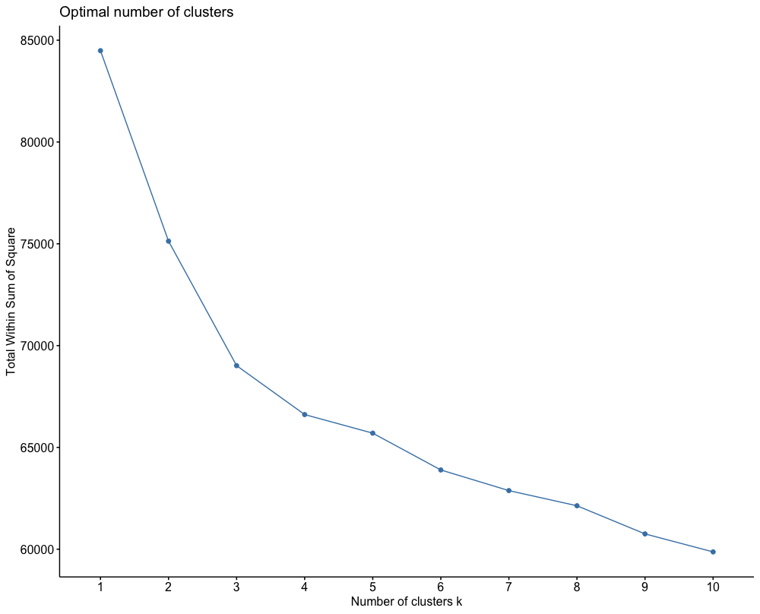
Supplementary Figure 1: Optimal number of clusters

