Supplementary
Table S1 | Information of DAMIP experiments used in this work.
CMIP6 models | Institution | Size of ensemble |  |  | DAMIP References and Availability
CMIP6 models | Institution | historical | Aerosol-only | GHG-only | DAMIP References and Availability
CESM2 | NCAR | 3 | 3 | 3 | Danabasoglu, Gokhan (2023). IPCC DDC: NCAR CESM2 model output prepared for CMIP6 DAMIP. World Data Center for Climate (WDCC) at DKRZ. https://doi.org/10.26050/WDCC/AR6.C6DANRCES
GFDL-ESM4 | NOAA-GFDL | 3 | 1 | 1 | Horowitz, Larry W.; John, Jasmin G.; Blanton, Chris; McHugh, Colleen; Radhakrishnan, Aparna; Rand, Kristopher; Vahlenkamp, Hans; Zadeh, Niki T.; Wilson, Chandin; Dunne, John P.; Ploshay, Jeffrey; Winton, Michael; Zeng, Yujin (2023). IPCC DDC: NOAA-GFDL GFDL-ESM4 model output prepared for CMIP6 DAMIP. World Data Center for Climate (WDCC) at DKRZ. https://doi.org/10.26050/WDCC/AR6.C6DANGGFD
GFDL-CM4 | NOAA-GFDL | 3 | 1 | 1 | Ploshay, Jeffrey; Hurlin, William; John, Jasmin G; Blanton, Chris; McHugh, Colleen; Radhakrishnan, Aparna; Rand, Kristopher; Vahlenkamp, Hans; Zadeh, Niki T.; Wilson, Chandin; Paynter, David J; Winton, Michael; Zeng, Yujin; Knutson, Thomas (2023). IPCC DDC: NOAA-GFDL GFDL-CM4 model output prepared for CMIP6 DAMIP. World Data Center for Climate (WDCC) at DKRZ. https://doi.org/10.26050/WDCC/AR6.C6DANGGFL
GISS-E2-1-G | NASA-GISS | 3 | 3 | 3 | NASA Goddard Institute for Space Studies (NASA/GISS) (2023). IPCC DDC: NASA-GISS GISS-E2.1G model output prepared for CMIP6 DAMIP. World Data Center for Climate (WDCC) at DKRZ. https://doi.org/10.26050/WDCC/AR6.C6DAGIGE1
HadGEM3-GC31-LL | MOHC | 3 | 3 | 3 | Jones, Gareth (2023). IPCC DDC: MOHC HadGEM3-GC31-LL model output prepared for CMIP6 DAMIP. World Data Center for Climate (WDCC) at DKRZ. https://doi.org/10.26050/WDCC/AR6.C6DAMOHGL
IPSL-CM6A-LR | IPSL | 3 | 3 | 3 | Boucher, Olivier; Denvil, Sébastien; Levavasseur, Guillaume; Cozic, Anne; Caubel, Arnaud; Foujols, Marie-Alice; Meurdesoif, Yann; Gastineau, Guillaume (2023). IPSL IPSL-CM6A-LR model output prepared for CMIP6 DAMIP. World Data Center for Climate (WDCC) at DKRZ.
MRI-ESM2-0 | MRI | 3 | 3 | 3 | Yukimoto, Seiji; Koshiro, Tsuyoshi; Kawai, Hideaki; Oshima, Naga; Yoshida, Kohei; Urakawa, Shogo; Tsujino, Hiroyuki; Deushi, Makoto; Tanaka, Taichu; Hosaka, Masahiro; Yoshimura, Hiromasa; Shindo, Eiki; Mizuta, Ryo; Ishii, Masayoshi; Obata, Atsushi; Adachi, Yukimasa (2023). IPCC DDC: MRI MRI-ESM2.0 model output prepared for CMIP6 DAMIP. World Data Center for Climate (WDCC) at DKRZ. https://doi.org/10.26050/WDCC/AR6.C6DAMRME0
NorESM2-LM | NCC | 3 | 3 | 3 | Seland, Øyvind; Bentsen, Mats; Oliviè, Dirk Jan Leo; Toniazzo, Thomas; Gjermundsen, Ada; Graff, Lise Seland; Debernard, Jens Boldingh; Gupta, Alok Kumar; He, Yanchun; Kirkevåg, Alf; Schwinger, Jörg; Tjiputra, Jerry; Aas, Kjetil Schanke; Bethke, Ingo; Fan, Yuanchao; Griesfeller, Jan; Grini, Alf; Guo, Chuncheng; Ilicak, Mehmet; Karset, Inger Helene Hafsahl; Landgren, Oskar Andreas; Liakka, Johan; Moseid, Kine Onsum; Nummelin, Aleksi; Spensberger, Clemens; Tang, Hui; Zhang, Zhongshi; Heinze, Christoph; Iversen, Trond; Schulz, Michael (2023). IPCC DDC: NCC NorESM2-LM model output prepared for CMIP6 DAMIP. World Data Center for Climate (WDCC) at DKRZ. https://doi.org/10.26050/WDCC/AR6.C6DANCCNL

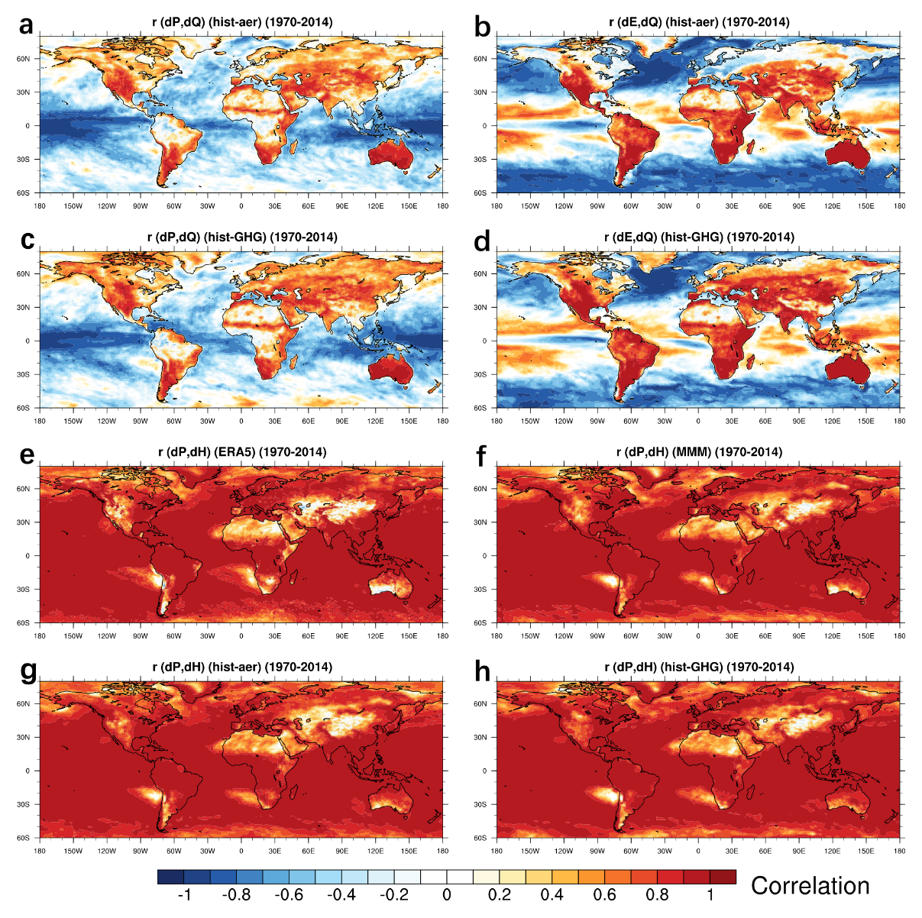
Fig. S1 | The correlations between historical hydrological, energetic, and circulation changes (1970–2014). a–b, Same as Fig. 1a–b, but based on CMIP6 aerosol-only simulations. c–d, based on CMIP6 GHG-only simulations; Light-blue dots cover gridboxes where linear correlations larger than 0.6 in 7 out of 8 models. e–h, Pearson linear correlations between annual mean δP and δH, from ERA5 reanalysis (e), CMIP6 historical all-forcing (f), aerosol-only (g), and GHG-only (h) simulations.

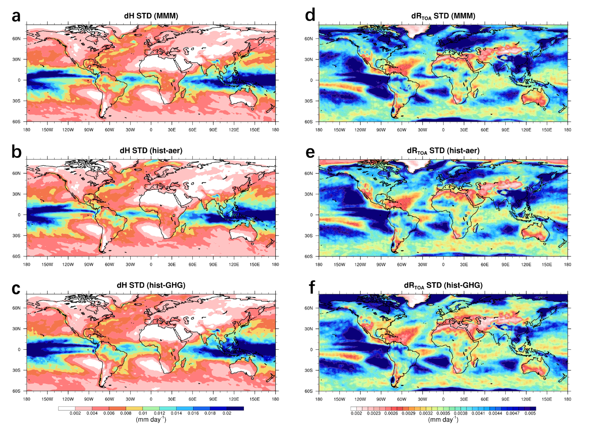
Fig. S2 | The spatial distributions of the standard deviation (a–c) of δH and δR_{TOA} (d–f) in response to radiative forcings.

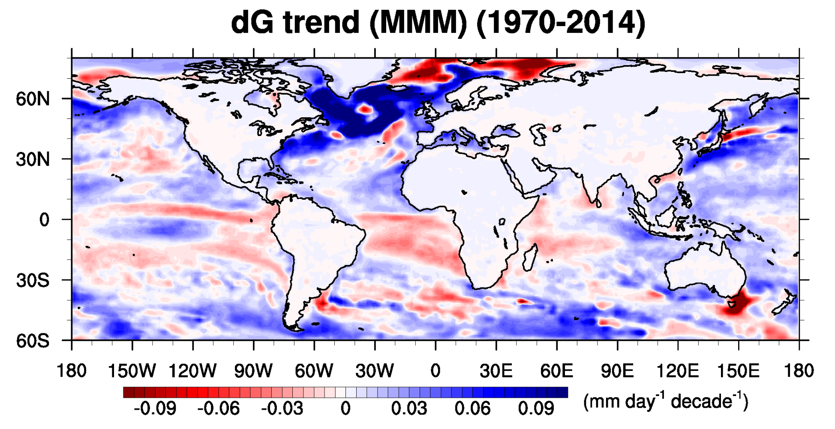
Fig. S3 | Ocean-land contrast of surface heat transport trend (δG) (1970–2014) in CMIP6 multimodel mean simulations.

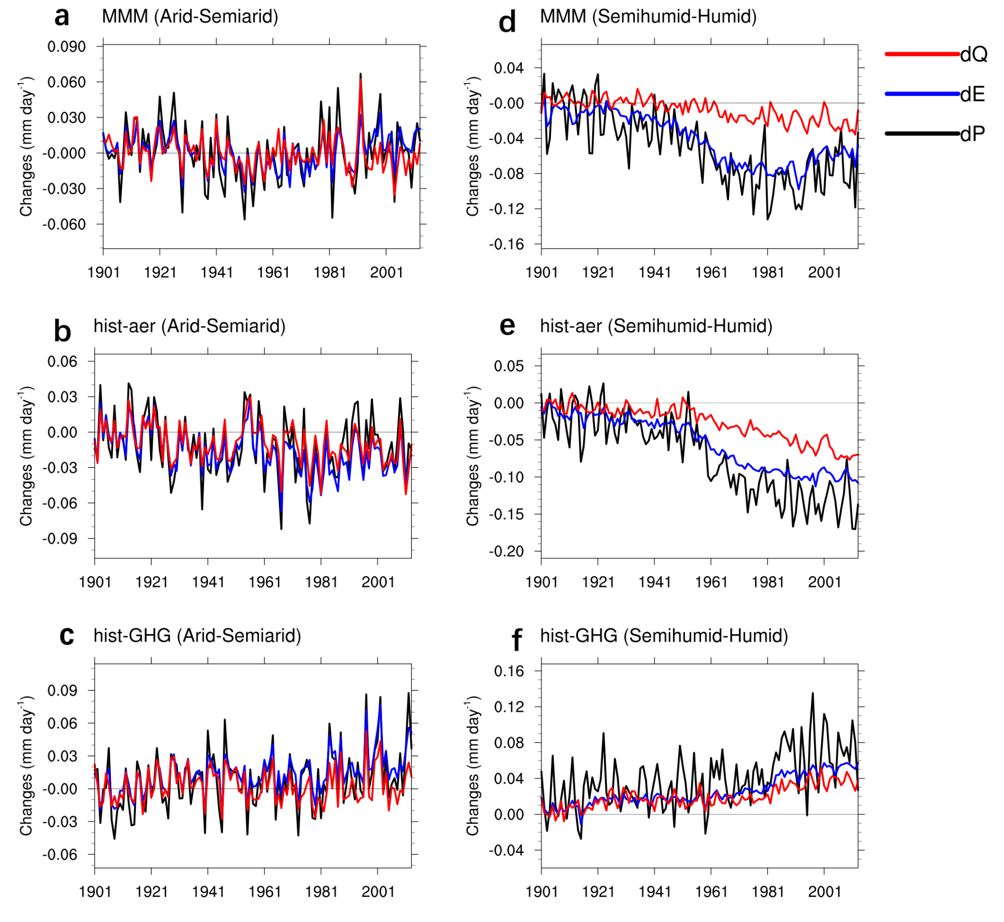
Fig. S4 | Historical hydrological and energetic changes. a-c, Annual time series of CMIP6 MMM δQ (red), δE (blue), and δP (black) changes in dryland in response to historical all forcing (a), aerosol-only (b), and GHG-only forcings (c); b–f, Same as a–c, but averaged over (semi-)humid land.

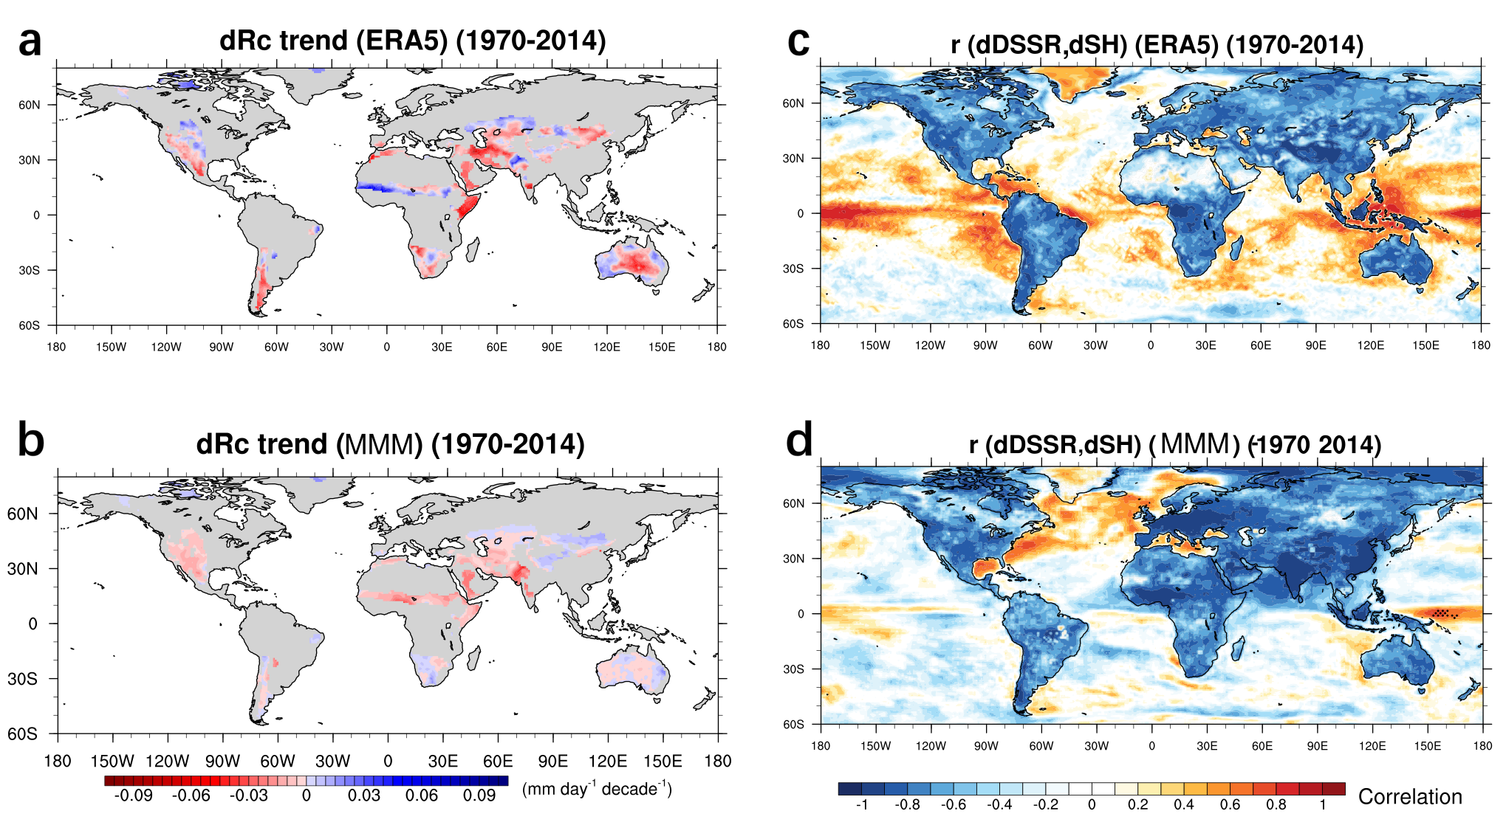
Fig. S5 | Long-term trends of radiative cooling (δRc) over (Semi-)Arid land from ERA5 (a) and CMIP6 historical all-forcing simulations (b). Correlation between δSH_{down} and δDSSR from ERA5 (c) and CMIP6 historical all-forcing simulations (d).

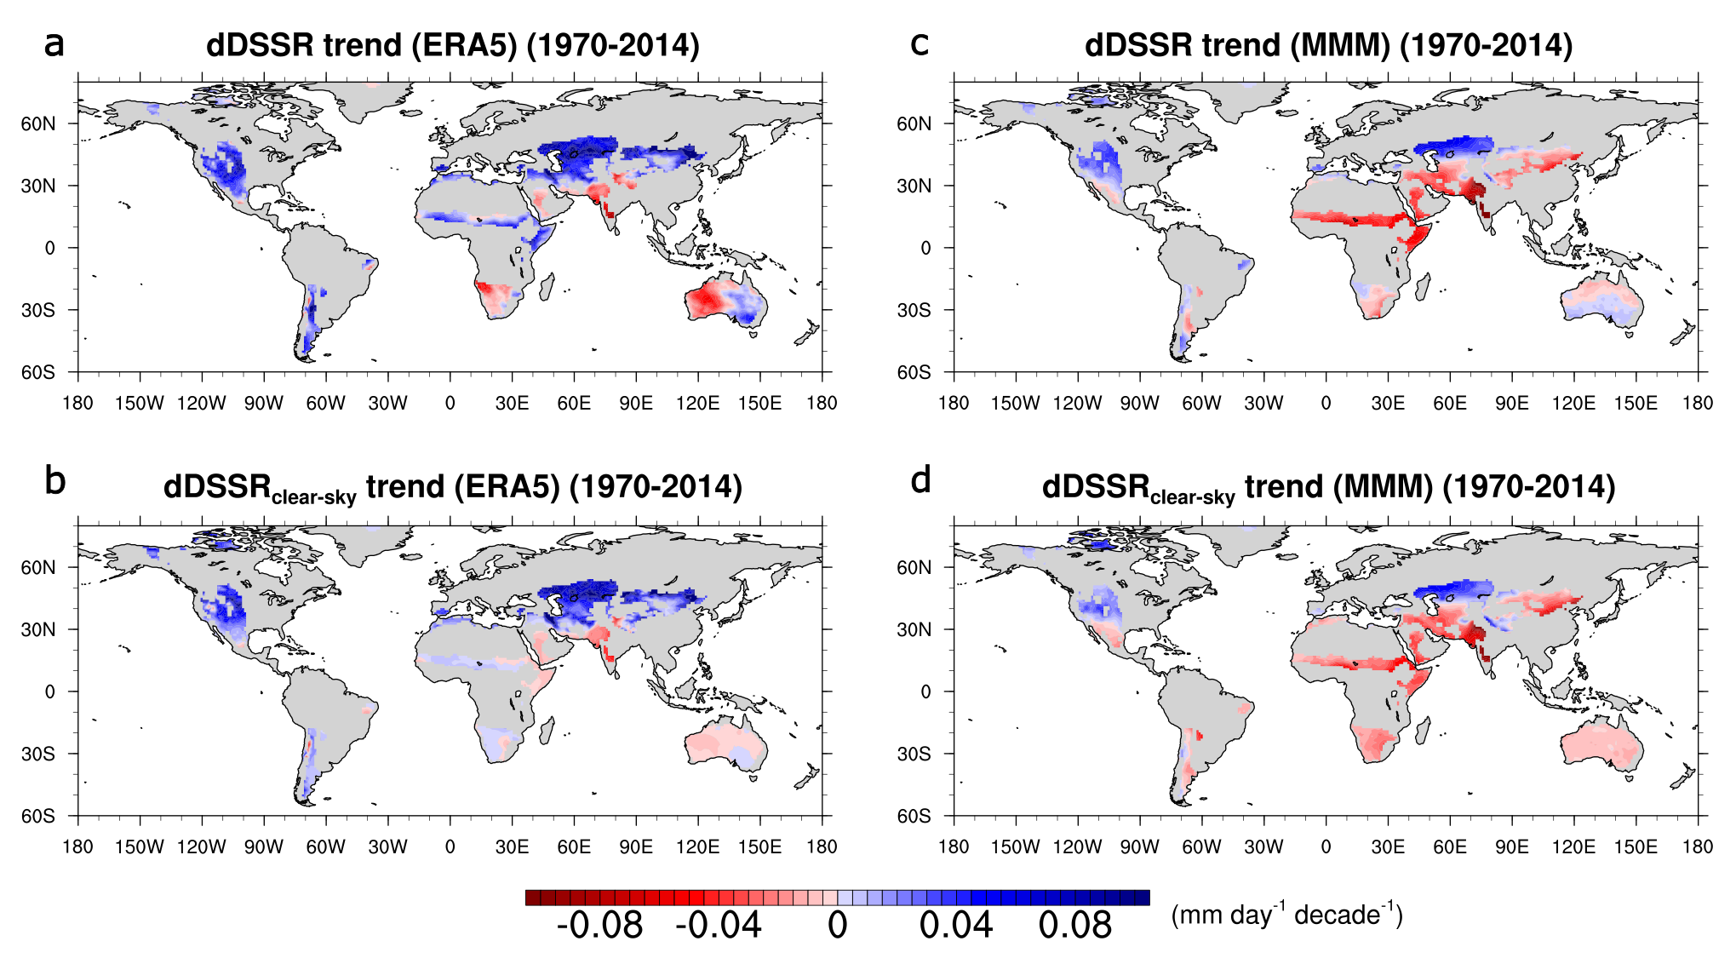
Fig. S6 | Long-term trends (1970-2014) of surface solar irradiance under all-sky (δDSSR) and clear-sky (δDSSR_{clear-sky}) conditions from ERA5 (a, b) and CMIP6 historical all-forcing simulations (c, b).

