Supplementary materials

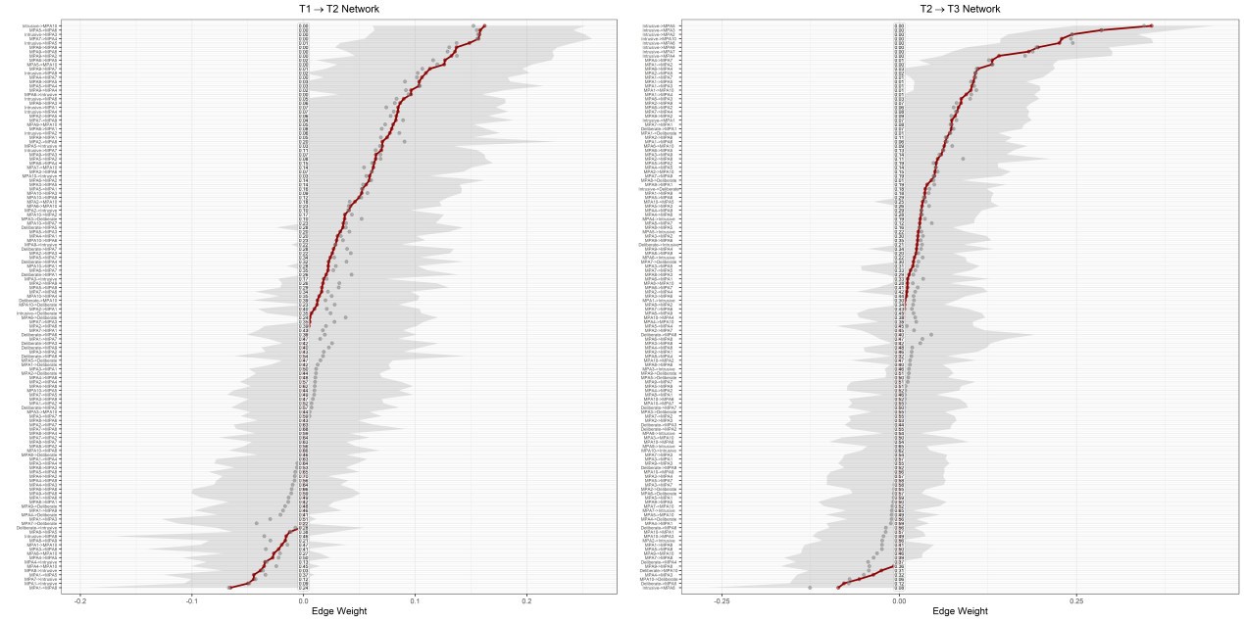
Figure S1. Stability tests for edges

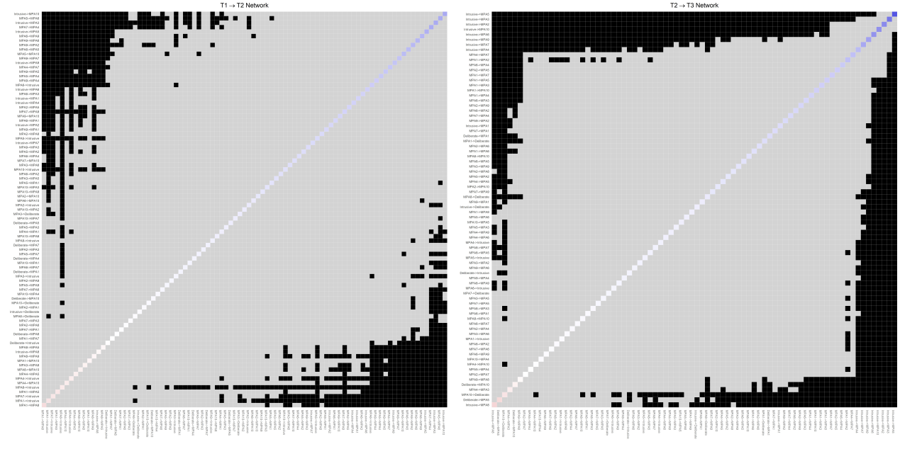
Figure S2. Difference tests for edge weights

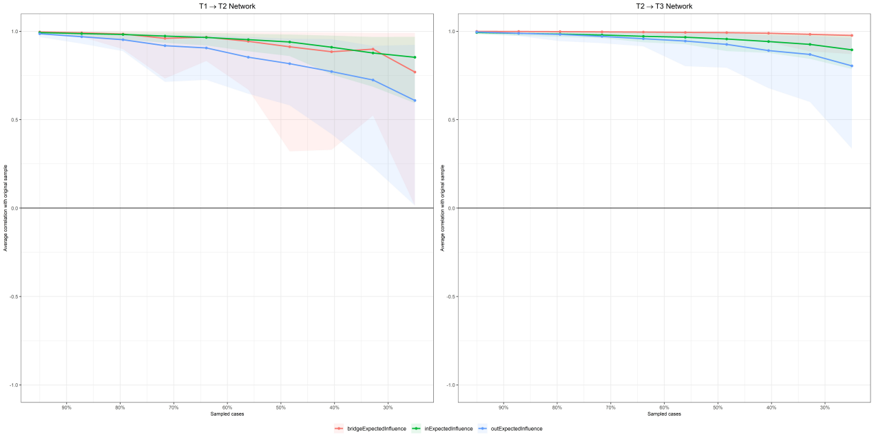
Figure S3. Stability tests for centrality

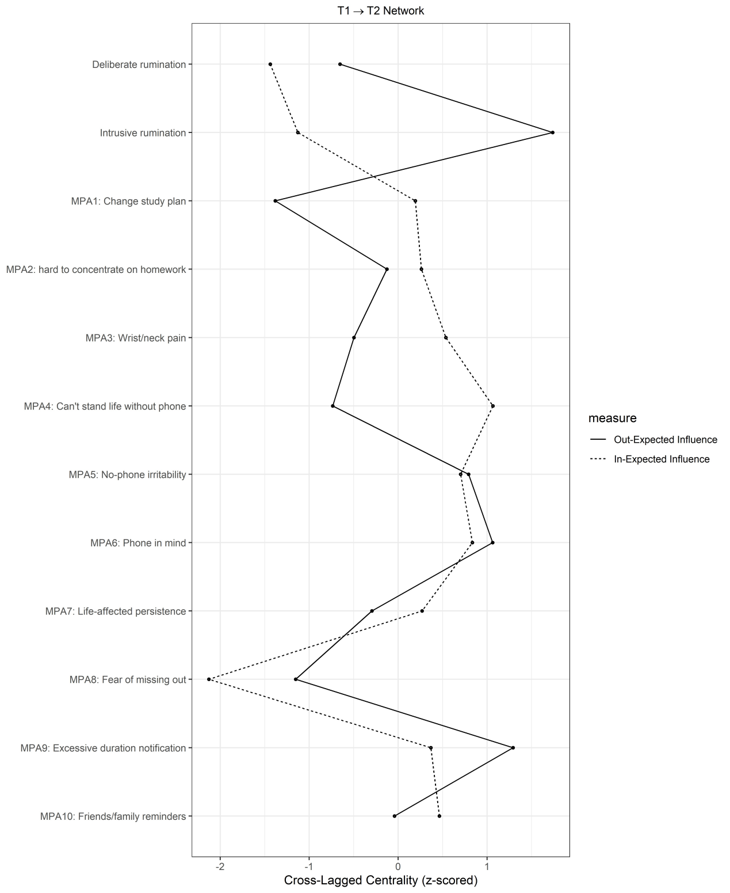
Figure S4. Cross-lagged centrality for T1-T2 network

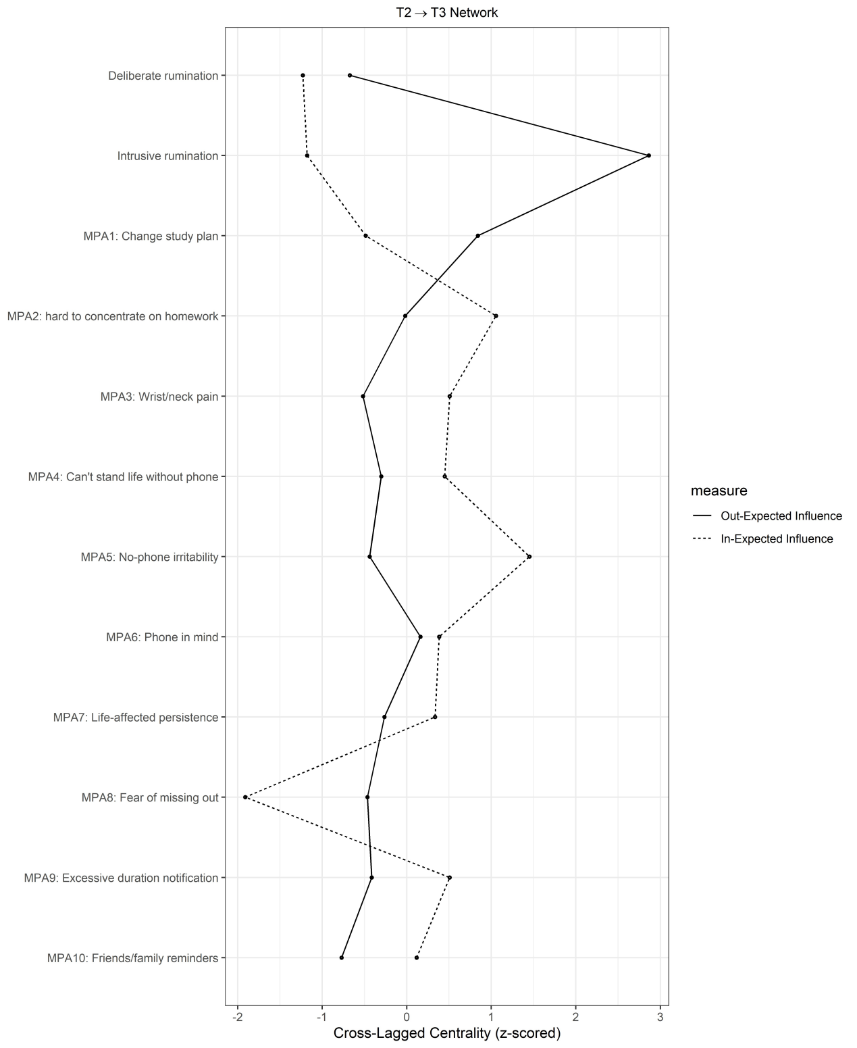
Figure S5. Cross-lagged centrality for T2-T3 network

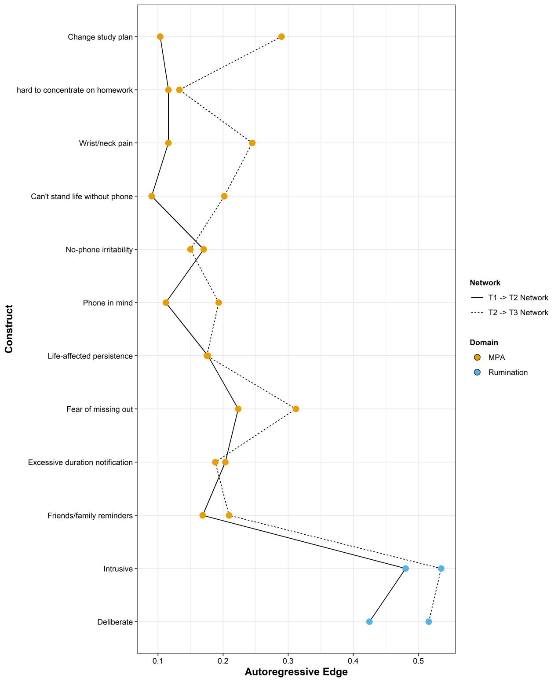
Figure S6. Autoregressive edges of two networks

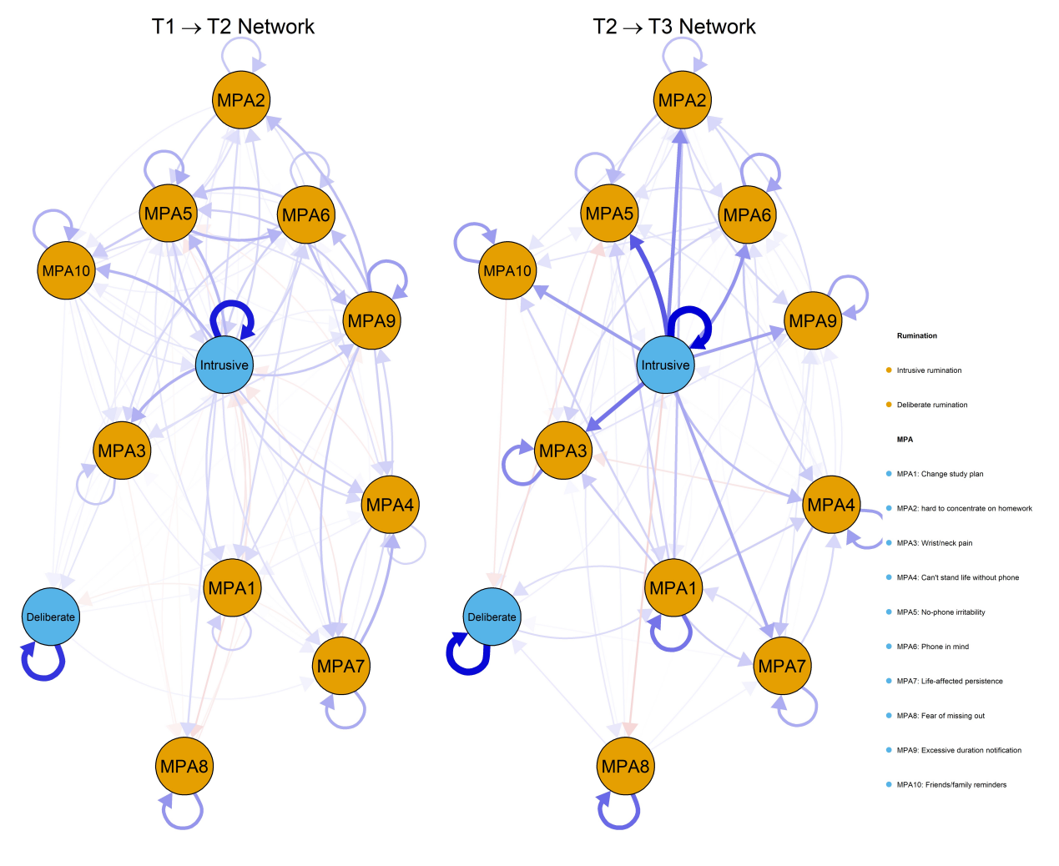
Figure S7. CLPN plots with both autoregressive and cross-lagged edges

