Supporting Information for
High-throughput antioxidant screening of flavan-3-ols via active learning

Zicong Marvin Wong^{a,b}, Dillon W. P. Tay^{b,c}, Yee Hwee Lim^{b,c,d}, Shi Jun Ang^{a,b,e*}

ª Institute of High Performance Computing (IHPC), Agency for Science, Technology and Research (A*STAR), 1 Fusionopolis Way, #16-16 Connexis, Singapore 138632, Republic of Singapore.

^{b} Singapore Integrative Biosystems and Engineering Research (SIBER), Agency for Science, Technology and Research (A*STAR), Singapore, Republic of Singapore.

^{c} Institute of Sustainability for Chemicals, Energy and Environment (ISCE2), Agency for Science, Technology and Research (A*STAR), 8 Biomedical Grove, #07-01 Neuros Building, Singapore 138665, Republic of Singapore.

^{d} Synthetic Biology Translational Research Program, Yong Loo Lin School of Medicine, National University of Singapore, 10 Medical Drive, Singapore, 117597, Republic of Singapore.

^{e} Department of Chemistry, National University of Singapore, 3 Science Drive 3, Singapore 117543, Republic of Singapore.

* Corresponding Author (Email: ang_shi_jun@ihpc.a-star.edu.sg)

Table S1. Final selected hyperparameters for each D-MPNN Model.
Model | Message Passing Depth | Dropout Rate
IP | 11 | 0.2
BDE_{mol} | 11 | 0.3
PA_{mol} | 3 | 0.3
BDE | 11 | 0.0
PA | 7 | 0.0

Table S2. Occurrence of -OH groups at each position in the 1235-molecule DFT dataset and number of times each site determined BDE_{mol} or PA_{mol}.
Site | Number of Molecules with -OH Site | Number of Molecules with Lowest BDE_{mol} | Percentage of Molecules with Lowest BDE_{mol} (%) | Number of Molecules with Lowest PA_{mol} | Percentage of Molecules with Lowest PA_{mol}  (%)
C2 | 435 | 14 | 3.22 | 121 | 27.82
C3 | 1235 | 14 | 1.13 | 8 | 0.65
C4 | 466 | 9 | 1.93 | 0 | 0.00
C4g | 160 | 2 | 1.25 | 17 | 10.63
C5 | 550 | 71 | 12.91 | 105 | 19.09
C6 | 471 | 296 | 62.85 | 59 | 12.53
C7 | 489 | 39 | 7.98 | 110 | 22.49
C8 | 476 | 212 | 44.54 | 67 | 14.08
C2’ / C6’ | 1308 | 218 | 16.67 | 498 | 38.07
C3’ / C5’ | 929 | 319 | 34.34 | 149 | 16.04
C4’ | 535 | 41 | 7.66 | 101 | 18.88

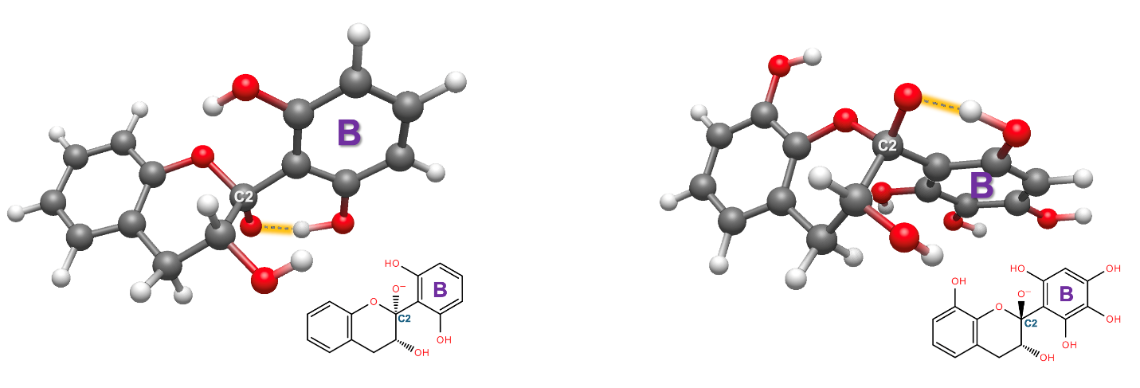
Figure S1. Representative examples of ball-and-stick diagrams of DFT-optimized deprotonated flavan-3-ol derivatives with C2-O⁻ anion that forms an intramolecular hydrogen bonding (grey dashed lines with orange highlight) with the adjacent B-ring C2’/C6’-OH groups. Among the 121 deprotonated flavan-3-ol derivatives with the C2-O⁻ anion corresponding to the structure of PA_{mol}, 104 structures exhibit C2’/C6’-OH substituents on the B-ring, which enables this hydrogen-bonding interaction. The grey, red, and white spheres correspond to the carbon, oxygen, and hydrogen atoms.

Table S3. Occurrence of -OH groups at each position in the 5616-molecule library and number of times each site is predicted by ML to determine the lowest BDE or PA among all the BDEs and PAs of each molecule.
Site | Number of Molecules with -OH Site | Number of Molecules with Lowest BDE | Percentage of Molecules with Lowest BDE (%) | Number of Molecules with Lowest PA | Percentage of Molecules with Lowest PA  (%)
C2 | 2176 | 111 | 5.10 | 380 | 17.46
C3 | 5616 | 18 | 0.32 | 8 | 0.14
C4 | 2840 | 2 | 0.07 | 0 | 0.00
C4g | 756 | 3 | 0.40 | 27 | 3.57
C5 | 2172 | 389 | 17.91 | 665 | 30.62
C6 | 2172 | 1198 | 55.16 | 83 | 3.82
C7 | 2172 | 291 | 13.40 | 571 | 26.29
C8 | 2172 | 1112 | 51.20 | 445 | 20.49
C2’ / C6’ | 4388 | 904 | 20.60 | 2273 | 51.80
C3’ / C5’ | 4388 | 1146 | 26.12 | 670 | 15.27
C4’ | 2560 | 442 | 17.27 | 494 | 19.30

Table S4. Experimental 2,2-diphenyl-1-picrylhydrazyl (DPPH) radical scavenging IC₅₀ and insect phenoloxidase inhibition IC₅₀ values and computed thermodynamic descriptors (IP, BDE_{mol}, PA_{mol}) for representative set of flavan-3-ols used in correlation comparison for Figure 11.
Flavan-3-ol | Structure | DPPH  IC₅₀ ($μ$M) | Insect Phenoloxidase IC₅₀ ($μ$M) | DFT-Calculated |  |  | ML-Predicted
 |  |  |  | IP (kcal/mol) | BDE_{mol} (kcal/mol) | PA_{mol} (kcal/mol) | IP (kcal/mol) | BDE_{mol} (kcal/mol) | PA_{mol} (kcal/mol)
Gallocatechin | 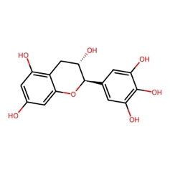 | 31.3 | 37.5 | 111.39 | 77.22 | 25.91 | 111.65 | 77.48 | 25.77
Afzelechin | 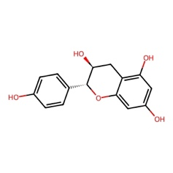 | 138.8 | 230 | 112.05 | 85.33 | 28.61 | 112.37 | 85.57 | 29.19
Epigallocatechin | 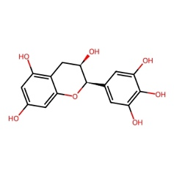 | 23.6 | 83.8 | 110.89 | 77.13 | 25.52 | 111.36 | 77.50 | 25.64
Epicatechin | 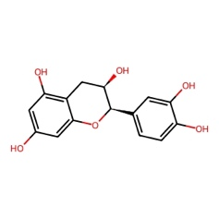 | 15.0 | 176 | 109.97 | 80.20 | 26.04 | 110.58 | 80.40 | 26.42
The experimental IC₅₀ values are obtained from J. Nat. Prod. 2016, 79, 3065-3071.

