Supplementary appendix
Deep learning-based prediction model for pathological complete response to neoadjuvant chemotherapy in different breast cancer subtypes, incorporating peripheral blood inflammatory indicators and clinicopathological features: a multicenter retrospective study

Supplementary Information
- Inclusion and exclusion criteria
The inclusion criteria were as follows: (a) patients with non-specific breast cancer who confirmed by pathological biopsy and without distal metastases ; (b) patients who had received 6-8 cycles of NAC; and (c) patients who had breast surgery after receiving NAC.The exclusion criteria were as follows:(a) patients with no histopathological evaluation results; (b) H&E-stained slides with poor quality; (c) patients with incomplete clinical data or peripheral blood inflammatory indicators missing; and (d) patients with a history of concurrent tumors or other malignancies.
- Biopsy and WSI collection
Before the patient receives NAC, the pathologist collects biopsy samples from breast cancer patients using the coarse needle puncture technique, which are used for subsequent pathological analysis to predict the efficacy of NAC. Firstly, the biopsy tissues were immersed in 10% formalin for 4 hours and embedded in paraffin. Then, the biopsy specimens were cut off at 4 μm intervals and stained with hematoxylin and eosin (H&E) for pathological diagnosis. A digital biopsy scanner (KFBio KF-PRO-020) were used to scan all H&E-stained histopathological sections to identify the tumor cells. The whole slide image (WSI) of breast cancer patients was obtained at ×20 magnification, and all images were saved in SVS format. The two pathologists with over 10 years of clinical experience (W.J.M, C.Z.Y.）were blinded to the clinical records, independently reviewed the tumor-rich regions of interest (ROI) of WSI images. For each patient, five non-overlapping handcrafted patches were cropped from the ROI of per patients. Any discrepancies were discussed to resolve until consensus was reached. The screenshot size was set to 1000×1000 pixels, the image resolution was 300 DPI, and the image output was in JPG format. All the handcrafted patch images were carried out for color regularization to eliminate colour heterogeneity. After a patient has completed NAC and entered the surgical stage, the tumour tissue removed during surgery and the surrounding associated tissue are systematically collected and used for pathological evaluation as the gold standard for evaluating the efficacy of NAC.
- Pathomics feature extraction
The specific analysis steps using CellProfiler were as follows: the “Unmix Colors” module was used to separate the HE pathology stained images into hematoxylin and eosin stained grey images. Then, the “ColorToGray” module was used to convert the H&E stained images into grey images for further analysis. The “ColorToGray” module was used to convert the H&E stained images to grey scale images for further analysis. The quality characteristics of the grey scale HE, hematoxylin and eosin stained images were then assessed using the Measure Image Quality module. Subsequently, the co-localisation and correlation between the intensities of each hematoxylin and eosin image were calculated pixel by pixel over the entire image using the “Measure Colocalization” module. Next, the granularity characteristics of each image are evaluated utilising the “Measure Granularity”module, which outputs the spectra of the size measurements of the textures in the image. Finally, the extent and nature of the texture in each image is evaluated using the“Measure Texture ”module, which calculates the roughness and smoothness of the textures. In this measurement, we obtained 288 raw features that were found to summarize three main types of images. In the second measurement, the hematoxylin images were subjected to further analysis. Firstly, the hematoxylin-stained images were segmented by the modules “Identify Primary Objects” and “Identify Secondary Objects”. Subsequently, the shape, size, texture, and pixel shape of the objects were extracted through the use of multiple modules. Subsequently, the quantitative image features of object shape, size, texture, and pixel intensity distribution were extracted, including object intensity distribution, object intensity, texture, and object size and shape. The measurement models for the dimensions of objects, including their size and shape, were used. Following measurement, the mean, median, and standard deviation were employed as study features. The final value of each pathomics feature was aggregated by averaging the calculated values from the 10 analyzed regions, resulting in a total of 1119 pathomics features.The Vision Transfomer (ViT) model was adopted to extract deep learning pathomics features related to tumor microenvironment from selected 1000×1000 pixel pathological screenshot images. Firstly, we performed data augmentation, including random rotation and flipping, to increase data diversity. Subsequently, we adjusted the image size to 224×224 pixels, and performed color regularization for the small patches within the WSI. Then, we fine-tuned the pre-trained ViT model by adjusting the hyperparameters. The learning rate was set to 0.001, and 50 epochs were trained. After training, the hyperparameters were fixed, and the fine-tuned ViT model was used as a feature extractor. Specifically, we obtained deep learning pathological features from pathological images by applying a global average pooling operation. In our study, a total of 512 deep learning pathological features were distilled from each patch images of per patient.

Supplementary Figures
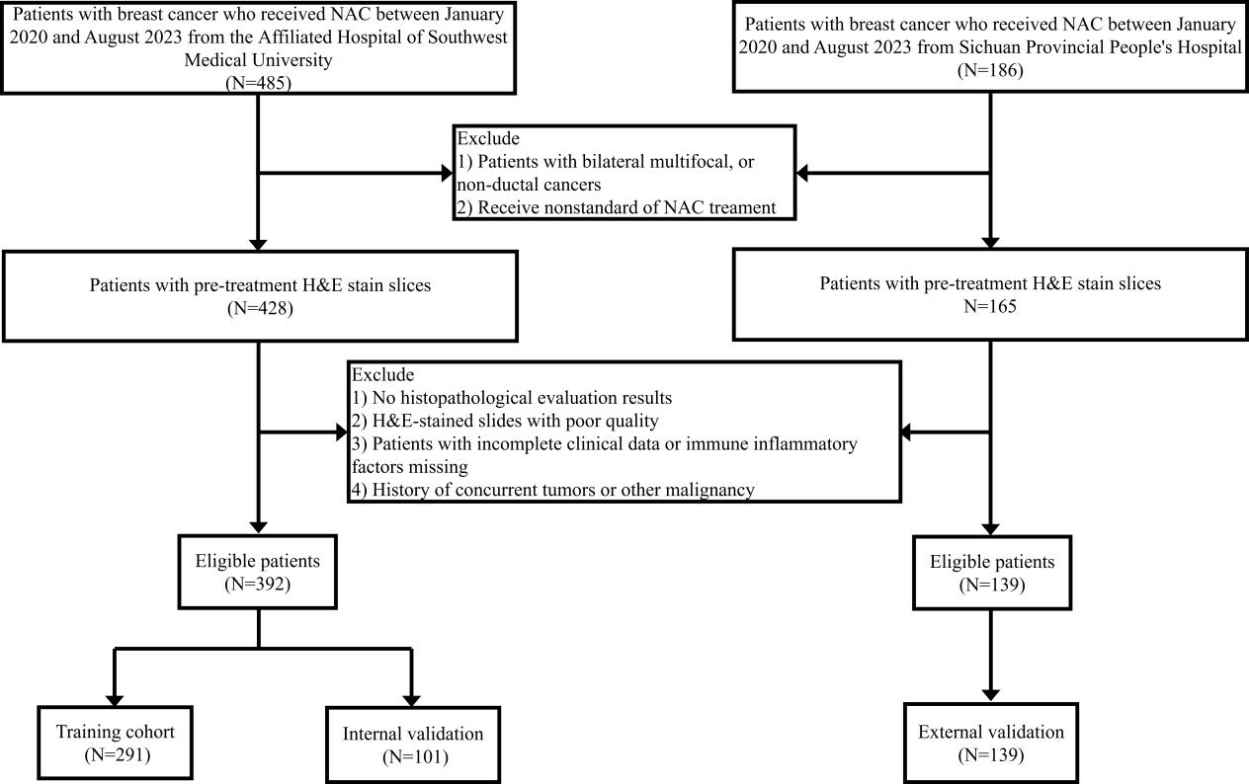
Fig S1.Flowchart of the study population. NAC, neoadjuvant chemotherapy; H&E, hematoxylin and eosin; pCR, pathological complete response;
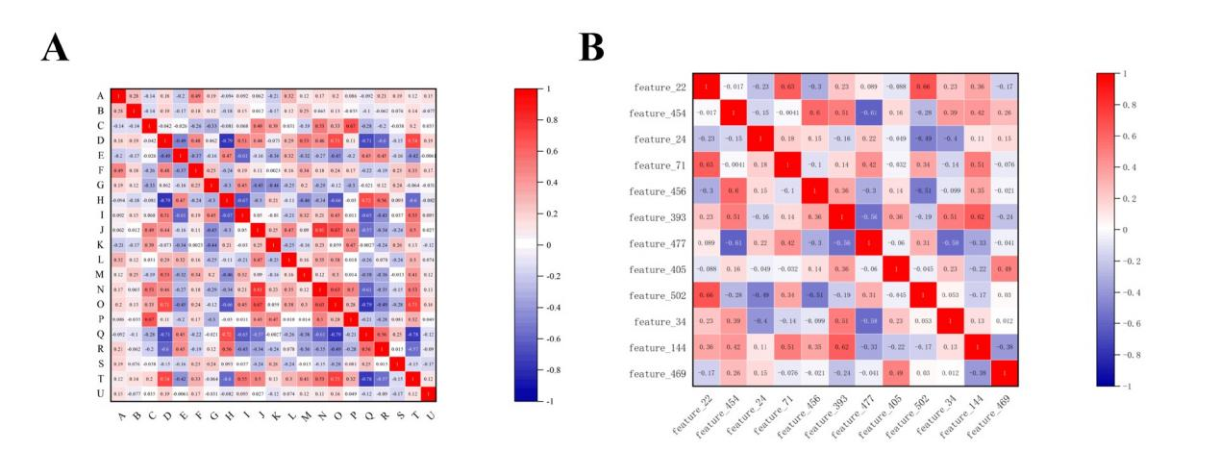
Figure S2.(A) Heatmap of Spearman correlation coefficients between pathomics features. (B) Heat map of Spearman correlation coefficients between deep learning pathomics features.
Fig. S3. Feature selection. (A,B) Handcrafted pathomics feature selection (C,D) Deep learning pathomics feature selection.

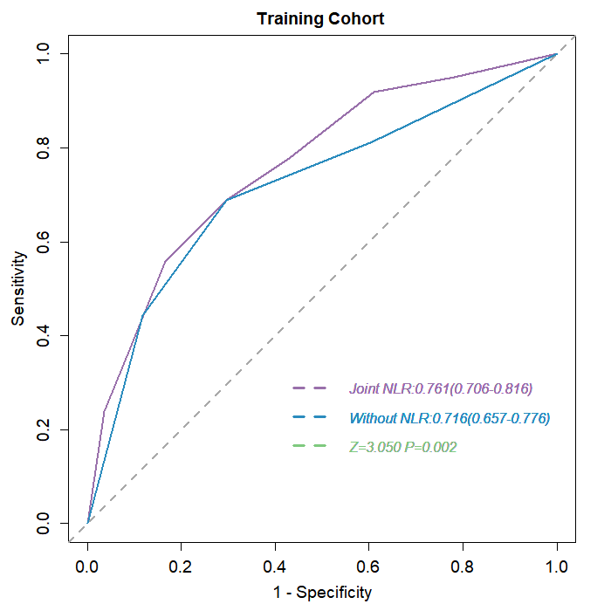
Figure S4. Comparison of model efficacy before and after adding NLR,and a delong test was performed with a Z value of 3.050, p=0.002

Supplementary Tables
Tabel S1a:HPS Performance of each model for prediction in training cohort.
Model | AUC(95%CI) | SEN (%) | SPE (%) | PPV (%) | NPV (%)
SVM | 0.816（0.766,0.865） | 77.05 | 75.74 | 69.63 | 82.05
XGB | 0.667（0.566,0.769） | 59.26 | 68.52 | 65.31 | 62.71
LR | 0.822（0.774,0.871） | 78.69 | 72.78 | 67.61 | 82.55
RF | 0.698（0.639,0.758） | 81.15 | 49.70 | 53.80 | 78.50
AUC, area under the curve; SEN, sensitivity; SPE, specificity; ACC, accuracy; PPV, positive predictive value; NPV, negative predictive value.

Tabel S1b:DLPS Performance of each model for prediction in training cohort.
Model | AUC(95%CI) | SEN (%) | SPE (%) | ACC(%) | PPV (%) | NPV (%)
SVM | 0.659（0.597,0.721） | 72.95 | 55.03 | 62.54 | 53.94 | 73.81
XGB | 0.669（0.607,0.731） | 74.60 | 52.66 | 61.86 | 53.22 | 74.17
LR | 0.611（0.542,0.676） | 77.05 | 42.01 | 56.70 | 48.96 | 71.72
RF | 0.698（0.638,0.757） | 74.59 | 61.54 | 67.01 | 58.33 | 77.04
AUC, area under the curve; SEN, sensitivity; SPE, specificity; ACC, accuracy; PPV, positive predictive value; NPV, negative predictive value.

Tabel S2a:The selected handcrafted pathomics features
Handcrafted Pathomics Features(n=20) | coefficient
ImageQuality_PercentMinimal_Eosin | 0.093956769
Granularity_10_Eosin | -0.086072104
Mean_IdentifySecondaryObjects_Texture_DifferenceVariance_Hematoxylin_3_03_256 | 0.081158634
Granularity_2_Hematoxylin | 0.076989065
Correlation_Overlap_Eosin_Hematoxylin | 0.076836028
StDev_IdentifyPrimaryObjects_Intensity_MADIntensity_Hematoxylin | 0.072327661
StDev_IdentifySecondaryObjects_AreaShape_Zernike_9_9 | -0.071813981
StDev_IdentifyPrimaryObjects_Intensity_IntegratedIntensity_Hematoxylin | -0.07072962
Mean_IdentifyPrimaryObjects_AreaShape_Zernike_6_6 | 0.067521179
StDev_IdentifyPrimaryObjects_Texture_AngularSecondMoment_Hematoxylin_3_03_256 | -0.059995362
StDev_IdentifyPrimaryObjects_Texture_Correlation_Hematoxylin_3_02_256 | 0.056894924
Granularity_4_Eosin | -0.052788266
Granularity_6_Hematoxylin | 0.051574527
StDev_IdentifySecondaryObjects_Texture_AngularSecondMoment_Hematoxylin_3_03_256 | -0.044337187
Median_IdentifyPrimaryObjects_AreaShape_Zernike_9_1 | 0.042590411
StDev_IdentifySecondaryObjects_Texture_DifferenceVariance_Hematoxylin_3_02_256 | -0.038063422
Median_IdentifyPrimaryObjects_Texture_Correlation_Hematoxylin_3_03_256 | -0.035874987
ImageQuality_ThresholdOtsu_Hematoxylin_2W | 0.032491454
Texture_SumVariance_Eosin_3_00_256 | -0.027319475
Mean_IdentifySecondaryObjects_AreaShape_Zernike_7_3 | -0.02448456

Tabel S2b:The selected deep learning pathomics features
Deep learning Pathomics Features(n=12) | coefficient
feature_22 | 0.09541214537240635
feature_456 | -0.01704501617899605
feature_393 | 0.015589910983055323
feature_71 | -0.024730592069909525
feature_477 | 0.01550680021867333
feature_24 | -0.03629634674077988
feature_405 | 0.015408140666109781
feature_502 | 0.011834901340530455
feature_144 | 0.009252696801396766
feature_469 | -0.005022781394396434
feature_34 | -0.011175488715029413
feature_454 | 0.07496698168143129

Table S3:Multivariate logistic regression analysis of breast cancer patients with clinical factors and pathological complete response.
Clinical variable | Estimate | Wald | OR（95%CI） | P value
Clnical T stage | - | 6.733 | - | 0.081
ER status | 1.091 | 13.993 | 2.978（1.681-5.275） | <0.001
PR status | 0.655 | 3.440 | 1.925（0.963-3.846） | 0.064
HER-2 | -1.846 | 43.032 | 0.158（0.091-0.274） | <0.001
NLR | -0.559 | 5.242 | 0.572（0.355-0.923） | 0.022
ER, oestrogen receptor; PR, progesterone receptor;HER-2, human epidermal growth factor receptor 2; NLR, neutrophil-lymphocyte ratio.

Tabel S4:Multivariate logistic regression analysis of breast cancer patients with various factors and pathological complete response.
Characteristics | Estimate | Wald | OR（95%CI） | P value
HPS | 5.643 | 37.222 | 282.181（46.056-1728.907） | <0.001
DLPS | 4.258 | 7.208 | 70.648（3.157-1581.169） | 0.007
ER status | 0.898 | 7.653 | 2.455（1.299-4.638） | 0.006
HER-2 | -1.611 | 24.578 | 0.2（0.106-0.377） | <0.001
NLR | -0.675 | 5.260 | 0.509（0.286-0.906） | 0.027
HPS, Handcrafted Pathomics Signature; DLPS, Deep Learning Pathomics Signature; ER, oestrogen receptor;HER-2, human epidermal growth factor receptor 2; NLR, neutrophil-lymphocyte ratio;

Table S5a:Delong test for prediction improvements of DLPC compared to single-scale models in multiple cohorts.
Model | Training Cohort | p value | Internal Validation | p value | External validation | p value
DLPC | / | / | / | / | / | /
HPS model | 3.125 | 0.001 | 2.772 | 0.006 | 3.576 | 0.0003
DLPS model | 5.536 | <0.0001 | 3.213 | 0.001 | 4.298 | <0.0001
Clinical model | 4.626 | <0.0001 | 2.404 | 0.016 | 2.649 | 0.0081
CS, Clinical Signature; HPS, Handcrafted Pathomic Signature; DLPS, Deep Learning Pathomic Signature;DLPC，Deep Learning Pathomics Clinical model.

Tabel S5b:NRI test for prediction improvements of DLPC compared to single-scale models in multiple cohorts.
Model | Training Cohort |  | Internal Validation |  | External validation
Model | NRI（95％CI） | p value | NRI（95％CI） | p value | NRI（95％CI） | p value
DLPC | / | / | / | / | / | /
HPS model | 0.1953  (0.0734~0.3172) | 0.0017 | 0.4661  (0.2653~0.6669) | <0.0001 | 0.4045  (0.1977~0.6112) | 0.00013
DLPS model | 0.7292  (0.5858~0.8726) | <0.0001 | 0.548  (0.3833~0.7127) | <0.0001 | 0.7306  (0.4631~0.998) | <0.0001
Clinical model | 0.3355  (0.204~0.4669) | <0.0001 | 0.4968  (0.3107~0.6829) | <0.0001 | 0.2874  (0.0903~0.4845) | 0.00427
NRI, net reclassification improvement; CS,Clinical Signature; HPS, Handcrafted Pathomics Signature; DLPS, Deep Learning Pathomic Signature;DLPC,Deep Learning Pathomics Clinical model; CI, confidence interval.

Table S5c:IDI test for prediction improvements of DLPC compared to single-scale models in multiple cohorts.
Model | Training Cohort |  | Internal Validation |  | External validation
Model | IDI（95％CI） | p value | IDI（95％CI） | p value | IDI（95％CI） | p value
DLPC | / | / | / | / | / | /
HPS model | 0.1235  (0.0836~0.1633) | <0.0001 | 0.23  (0.1464 - 0.3137) | <0.0001 | 0.2534  (0.1712~0.3356) | <0.0001
DLPS model | 0.3111  (0.2548~0.3673 ) | <0.0001 | 0.2968  (0.2017 - 0.3919) | <0.0001 | 0.2924  (0.206~0.3787) | <0.0001
Clinical model | 0.2089  (0.1597~0.2533) | <0.0001 | 0.1504  (0.0834 - 0.2174) | 0.0002 | 0.1217  (0.0599~0.1836) | 0.00011
IDI, index integrated discrimination improvement; CS, Clinical Signature; HPS, Handcrafted Pathomics Signature; DLPS, Deep Learning Pathomic Signature;DLPC，Deep Learning Pathomics Clinical model; CI, confidence interval.

Table S6. pCR rates of different molecular types of breast cancer.
Molecular subtypes | n (%)
Molecular subtypes | pCR | non-pCR
TNBC | 48（44.5％） | 60（55.5％）
Luminal A | 31（17.3％） | 148（82.6％）
Luminal B | 52（35.8％） | 93（64.1％）
HER2+ | 70（77.8％） | 20（22.2％）
TNBC, triple-negative breast cancer. HER2+,HER2 overexpression. pCR, pathological complete response.

