Appendix 1
Urine drug screening immunoassay panel and ICD-10 code categories

Urine drug screening (UDS) immunoassay panel included the following drug classes: amphetamines, benzodiazepines, cocaine metabolite, and opiates. The UDS cutoff for: amphetamine was 1000ng/mL; benzodiazepine was 100ng/mL; cocaine metabolite was 150 ng/mL; 11-nor-9-carboxy-delta-9-tetrahydrocannabinol (THC-COOH) was 150ng/mL; and opiate was 300ng/mL.

Blood alcohol level (BAL) was infrequently ordered for adolescents (ages 12-17), with test data available from only 14 individuals pre-commercialization and 43 individuals post-commercialization, which is less than 6% and 18% of the UDS panel data available at each period. We thus determined that we did not have a sufficiently representative sample to evaluate trends in alcohol use prevalence among adolescents.

Immunoassays have limitations including variable cross-reactivity to drugs within a class and the potential for false negative or false positive results. We did not exclude patients on drugs, such as dronabinol, efavirenz, or pantoprazole which may rarely cause false-positive tetrahydrocannabinol (THC) immunoassay results. The THC immunoassay used for clinical testing also does not detect cannabidiol (CBD) or synthetic cannabinoids and would not reflect the use of these drugs. Additionally, the benzodiazepine assay may be falsely negative in patients taking lorazepam and clonazepam and the opiate assay does not cross-react with synthetic opioids such as oxycodone and buprenorphine. Despite these limitations, drug confirmations by liquid chromatography-tandem mass spectrometry are infrequently requested by providers due to the limitation of longer turnaround time.

Table S1 lists the ICD-10 codes that were considered positive for current cannabis-related disorders during the psychiatric emergency service encounter. Diagnoses of cannabis-related psychiatric disorders in remission (F12.11, F12.21, and F12.91) were not categorized as positive. In our dataset, there were no cases of cannabis-related harms, such as cannabis poisoning and adverse effects (T40.X) or cannabinosis (J66.2). Since individuals with primary psychiatric and behavioral health problems are triaged to the study’s psychiatric emergency service setting, other cannabis-related harms may be better captured in all-cause emergency departments.

Table S1. ICD-10 codes indicative of cannabis-related psychiatric disorders
Diagnoses | ICD-10 code included
Cannabis abuse and dependence | F12.10, F12.12, F12.120, F12.121, F12.122, F12.129, F12.13, F12.15, F12.150, F12.151, F12.159, F12.18, F12.180, F12.188, F12.19, F12.20, F12.22, F12.220, F12.221, F12.222, F12.229, F12.23, F12.25, F12.250, F12.251, F12.259, F12.28, F12.280, F12.288, F12.29
Cannabis use, unspecified, with a physical, mental, or behavioral disorder | F12.9, F12.90, F12.92, F12.920, F12.921, F12.922, F12.929, F12.95, 12.950, F12.951, F12.959, F12.98, F12.980, F12.988, F12.99

Appendix 2
Effects of age and commercialization on other substance positivity rates

When analyzed by four age groups, there were no significant age by commercialization interaction effects for stimulants (amphetamine and cocaine metabolite) and benzodiazepine immunoassay positivity on the UDS. There was a significant interaction effect for opiate positivity rates, with a decrease in opiate positivity found among those above legal age (5.3% vs.2.6%, AOR = 0.47 [0.35, 0.63], p<.001), particularly in older adults (4.7% vs. 3.8%, AOR=0.81 [0.49, 1.34], p <.001). Overall, besides THC, all other substance positivity rates either stayed stable or trended downwards from pre- to post-commercialization. See Figure S1. Test statistics for four age groups (12-17, 18-25, 26-49, 50-70 years) are presented in Table S2 and Table S3.

Table S2. Main and interaction effects of age and pre/post-commercialization for immunoassay positivity rates across four age groups

Comparison | Chi-square test statistic
Comparison | Stimulants  (amphetamines, cocaine)  (N=7402) | Benzodiazepines  (N=7327) | Opiates  (N=7322)
Main effect: Age | χ²(3) = 402.74, p < 0.001 | χ²(2) = 207.96, p < 0.001 | χ²(2) = 77.96, p < 0.001
Main effect: Commercialization | χ²(1) = 0.02, p = 0.888 | χ²(1) = 12.83, p < 0.001 | χ²(1) = 23.6, p < 0.001
Interaction: Age x Commercialization | χ²(3) = 1.52, p = 0.677 | χ²(2) = 3.44, p = 0.179 | χ²(2) = 9.19, p = 0.010
Note. Nested chi-square model comparison test of main effects of age (12-17, 18-25, 26-49, 50-70) and commercialization (pre vs. post), and their interaction. THC: tetrahydrocannabinol.

Table S3. Pairwise comparisons and simple effects in fully adjusted model examining effects on immunoassay positivity rates across four age groups

 |  | Stimulants  (amphetamines, cocaine)  (N=7402) |  |  | Benzodiazepines  (N=7327) |  |  | Opiates  (N=7322)
Type | Contrast | OR | 95% CI | p | OR | 95% CI | p | OR | 95% CI | p
Main Effects
Pairwise: Age
 | (18-25) - (12-17) | 2.04 | 1.19 to 3.53 | < .050 | NA | NA | NA | NA | NA | NA
 | (26-49) - (12-17) | 9.59 | 5.74 to 16.02 | < .001 | NA | NA | NA | NA | NA | NA
 | (50-70) - (12-17) | 4.70 | 2.78 to 7.94 | < .001 | NA | NA | NA | NA | NA | NA
 | (26-49) - (18-25) | 4.69 | 3.79 to 5.81 | < .001 | 3.35 | 2.60 to 4.31 | <.001 | 4.69 | 2.63 to 8.36 | <.001
 | (50-70) - (18-25) | 2.30 | 1.80 to 2.92 | < .001 | 3.32 | 2.53 to 4.36 | <.001 | 4.42 | 2.41 to 8.08 | <.001
 | (50-70) - (26-49) | 0.49 | 0.42 to 0.57 | < .001 | 0.99 | 0.84 to 1.17 | .995 | 0.94 | 0.69 to 1.29 | .925
Pairwise: Commercialization | Post - Pre | 0.86 | 0.65 to 1.14 | .299 | 0.78 | 0.65 to 0.94 | .009 | 0.73 | 0.50 to 1.08 | .116
Interaction Effects
Simple: Commercialization
18-25 | Post - Pre | 1.04 | 0.69 to 1.55 | .970 | 0.72 | 0.45 to 1.15 | .249 | 1.22 | 0.41 to 3.65 | .724
26-49 | Post - Pre | 1.00 | 0.86 to 1.17 | .970 | 0.70 | 0.58 to 0.85 | .001 | 0.38 | 0.26 to 0.54 | <.001
50-70 | Post - Pre | 0.98 | 0.75 to 1.28 | .970 | 0.95 | 0.73 to 1.25 | .728 | 0.81 | 0.49 to 1.34 | .611
Covariates
Sex | Female – Male | 0.82 | 0.77 to 0.88 | <.001 | 0.97 | 0.9 to 1.04 | .526 | 0.89 | 0.79 to 1.01 | .157
Race | Asian – White | 0.42 | 0.31 to 0.57 | <.001 | 0.83 | 0.66 to 1.06 | .291 | 0.4 | 0.16 to 1.03 | .157
Race | Black – White | 1.35 | 1.17 to 1.55 | <.001 | 0.86 | 0.72 to 1.03 | .281 | 1.32 | 0.9 to 1.93 | .276
Ethnicity | Hispanic/Latine – Non-Hispanic/Latine | 1.24 | 1.06 to 1.45 | .018 | 1.03 | 0.84 to 1.26 | .880 | 0.84 | 0.5 to 1.41 | .335

Figure S1. Rates of immunoassay positivity for stimulants, benzodiazepines, and opiates pre- vs. post-commercialization across four age groups

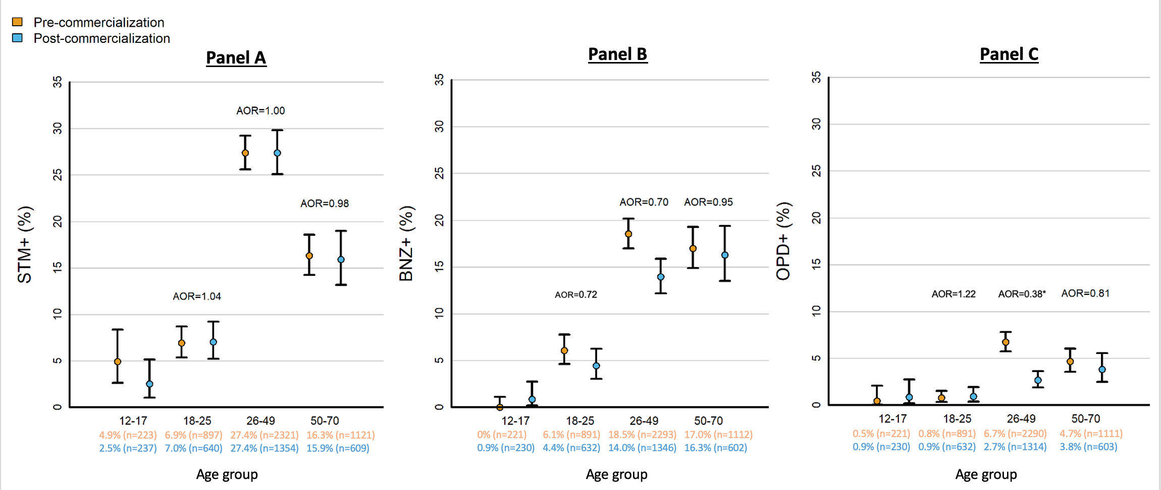

Figure S1 compares rates of stimulant (amphetamine and cocaine) (‘STM+’), benzodiazepines (‘BNZ+’), and opiates (‘OPD+’) immunoassay positivity on urine drug screen from pre- to post-commercialization within each age group. ‘AOR’ indicate odds ratio of having a positive substance use outcome post-commercialization compared to pre-commercialization within each age group, adjusted for sex, race, and ethnicity. ‘*’ indicate statistical significance of p < .01 for test of age by commercialization simple effect.

Appendix 3
Effects of legal age and commercialization on cannabis use outcomes (N=7350)

We examined changes in urine tetrahydrocannabinol (THC) positivity and cannabis-related disorder rates from pre- to post-commercialization for ages with (21-70 years) and without legal access to cannabis (12-20 years), controlling for sex, race, and ethnicity. For THC positivity, there were significant main effects from age group (χ²(1) = 42.29, p < 0.001) and commercialization period (χ²(1) = 18.35, p < 0.001). For cannabis-related disorder rates, there were no significant main effects from age group (χ²(1) = 0.48, p = 0.490) or commercialization period (χ²(1) = 3.08, p = 0.079).

Notably, there were significant age by commercialization interaction effects on THC positivity (χ²(1) = 9.08, p = 0.003) and cannabis-related disorder (χ²(1) = 9.05, p = 0.003). Disproportionately larger increases in THC positivity and CUD rates after commercialization were found for those without legal access (12-20 years) to recreational cannabis compared to those with legal access (pre- vs. post-commercialization THC+ in 12-20: 17.9% vs. 29.5%, AOR = 1.95 [1.43, 2.65], p <.001; CUD: 7.8% vs. 14.8%, AOR = 2.07 [1.36, 3.15], p <.001) (Table S4, Figure S2).

Table S4. Pairwise comparisons and simple effects in fully adjusted model examining effects on cannabis use outcomes for those with and without legal access

Type | Contrast | THC positivity rates |  |  | Cannabis-related disorder rates
Type | Contrast | OR | 95% CI | p | OR | 95% CI | p
Main Effects
Pairwise: Age | (21-70) - (12-20) | 1.74 | 1.47 to 2.05 | < .001 | 0.96 | 0.76 to 1.20 | .720
Pairwise: Commercialization | Post - Pre | 1.52 | 1.29 to 1.79 | < .001 | 1.47 | 1.17 to 1.84 | .001
Interaction Effects
Simple: Commercialization
12-20 | Post - Pre | 1.95 | 1.43 to 2.65 | < .001 | 2.07 | 1.36 to 3.15 | .001
21-70 | Post - Pre | 1.18 | 1.06 to 1.31 | .002 | 1.04 | 0.89 to 1.23 | .598
Interaction contrasts | Post - Pre /  (12-20) - (21-70) | 1.65 | 1.19 to 2.29 | .003 | 1.98 | 1.26 to 3.11 | .003
Covariates
Sex | Female – Male | 0.8 | 0.76 to 0.84 | < .001 | 0.77 | 0.72 to 0.84 | < .001
Race | Asian – White | 0.68 | 0.59 to 0.78 | < .001 | 0.9 | 0.74 to 1.09 | .341
Race | Black – White | 1.34 | 1.21 to 1.47 | < .001 | 1.21 | 1.04 to 1.4 | .024
Ethnicity | Hispanic/Latine – Non-Hispanic/Latine | 1.05 | 0.93 to 1.19 | .552 | 1.11 | 0.93 to 1.32 | .341
Note. P-values were adjusted for multiple comparisons using the Benjamini-Hochberg correction. THC: tetrahydrocannabinol.

Figure S2. Rates of THC positivity and cannabis use disorder pre- vs. post-commercialization for those with and without legal access

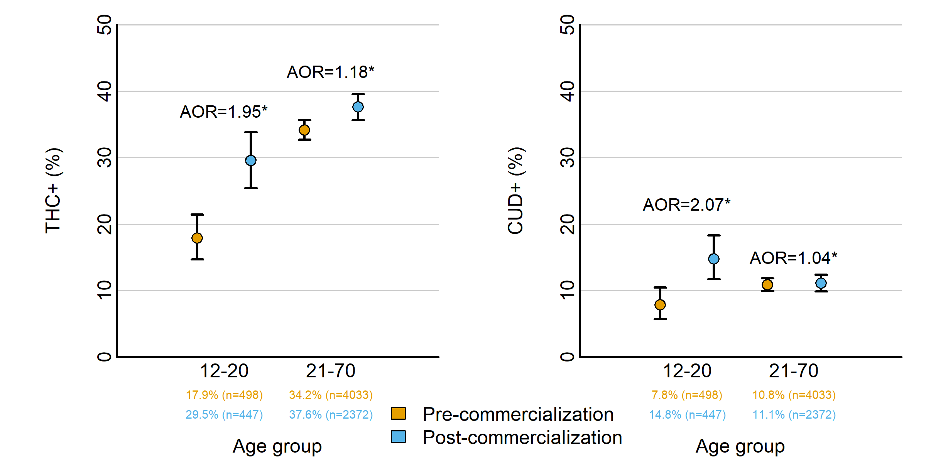

Figure S2 compares rates of cannabinoid immunoassay positivity (‘THC+’) and cannabis-related disorder (‘CUD+’) from pre- to post-commercialization for those with and without legal access. ‘AOR’ indicate odds ratio of having a positive cannabis use outcome post-commercialization compared to pre-commercialization within each age group, adjusted for sex, race, and ethnicity. ‘*’ indicate statistical significance of p < .01 for test of age by commercialization simple effect.

